An analysis into the Impact of Employee Morale on Small Independent Hotels

A Case Study of: Acorn Lodge

Student Name: Wazadur Rob Chowdhury
Student ID: 222426

Word Count: 7462
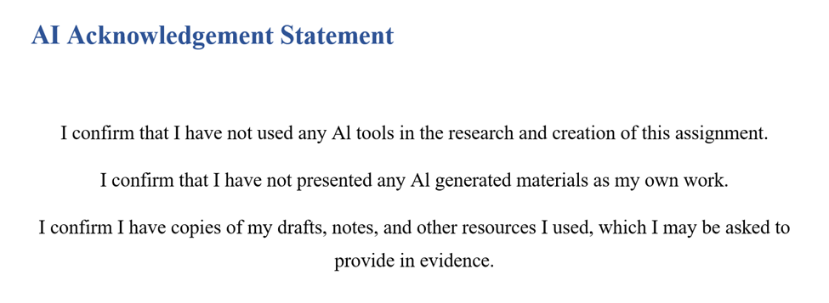
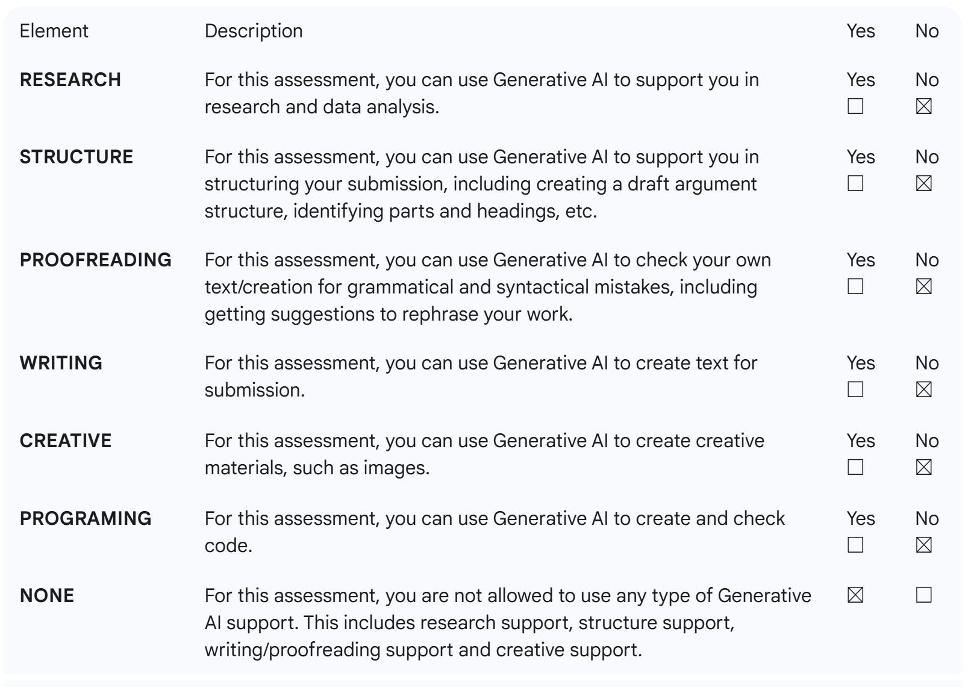

Acknowledgement
I would like to give my due thanks to my supervisor, who offered a great contribution to my study by providing priceless guidance and constructive feedback. I also owe the cooperation of the management as well as the employees of Acorn Lodge Gatwick in the research process. Lastly, I would like to give credit to my family and friends who have always supported and encouraged me.

Abstract
The purpose of this research is to determine how employee morale can influence organisational performance and the well-being of their staff in small independent hotels with major reference to the Acorn Lodge Gatwick. The hospitality industry is people-oriented by nature, with employees' attitude, motivation, and engagement directly influencing the quality of provided services and customer satisfaction. As such, it is not only a human resource issue to ensure that staff remain highly motivated, but it is also a strategic task to remain viable and competitive.
The case study design employed in the study is a qualitative approach to describe the way in which leadership behaviour and working conditions, and training opportunities affect morale and, as a result, service quality and performance. Placement-based observation collected the data to be triangulated with secondary data sources, including online guest reviews, and some of the specific academic literature. The theoretical background of the interpretation of the findings consisted of the Service-Profit Chain and Job Demands-Resources model.
The findings have shown that close interpersonal relationships and a supportive/hands-on type of leadership called Acorn Lodge provide the organisation with a strong sense of belonging and teamwork. Nevertheless, the unofficial form of management, the absence of formalised training and an uneven distribution of work generate stress as well as work imbalance. Workload intensity and communication of the manager were identified to have a direct effect on employee morale, which in turn had a direct impact on guest satisfaction and operational efficiency.
Some of the recommendations that should be put in place are the use of structured training and recognition programs, systematising workload and rota scheduling, and promoting fairness and transparency through improving leadership communication. Burnout and engagement solutions, such as well-being programs at low costs and flexible working hours, are offered as well.

Contents
Acknowledgement 3
Abstract 4
1.0 Introduction 7
1.1 Background and Context 7
1.2 Overview of Acorn Lodge Gatwick 8
1.3 Research Aim and Objectives 8
1.3.1 Aim: 8
1.3.2 Objectives: 8
1.4 Rationale 8
1.5 Significance 9
2.0 Literature Review 10
2.1 Factors Shaping Employee Morale in the Hospitality Industry 10
2.2 Organisational Outcomes, Employee Morale, and Service Quality 11
2.3 Strategies to Enhance and Sustain Positive Morale 13
2.4 Research Gap 14
Chapter 3: Methodology 15
Chapter 4: Findings and Discussion 17
4.1 Main Findings Related to the Objectives 17
4.1.1 Objective 1: Factors Shaping Employee Morale 17
4.1.2 Objective 2: How Morale Links to Organisational Performance 20
4.1.3 Objective 3: Prescriptive Findings for Improving and Sustaining Morale 22
4.1.4 Summary of Key Findings 23
4.2 Discussion 24
4.2.1 Factors Influencing Employee Morale 24
4.2.2 Association of Employee Morale with Organisational Performance 25
4.2.3 Strategies for Improving and Sustaining Employee Morale 27
4.2.4 Summary 28
Chapter 5: Conclusion and Recommendations 29
5.1 Conclusion 29
5.2 Recommendations and Practical Strategies 30
5.2.1 Managerial Fairness and Leadership Development 30
5.2.2 Workload Management Systems and Operational Support Systems 31
5.2.3 Development of Proper Communication Processes 31
5.2.4 Career Development and Recognition Strategies 31
5.2.5 Stress Management and Wellbeing Worker Programs 32
References 33
Appendix 42

1.0 Introduction

1.1 Background and Context
Employee morale is the overall level of excitement, contentment and psychological attachment that the employees have to their organisation and its objectives. Morale is especially crucial in the hospitality industry because of the labour-intensive nature of the industry and the fact that the service related to the hospitality industry is face-to-face (Baum, 2007; Nickson, 2013). Front-line employees are extremely important to hotels because they deliver experience to the guest through their behaviour, attitude, and engagement. With a high level of morale, the staff members are more motivated, with lower turnover, and more emotionally attached to the service process, which has a direct impact on customer satisfaction and loyalty (Heskett et al., 1997; Hogreve et al., 2022). On the contrary, low morale may be expressed in the form of detachment, stress and turnover intention, which weaken the quality of the delivered services and continuity in the operations (Karatepe, 2013; Podsakoff et al., 2007).
This is because the hospitality industry depends on human capital, which implies that employee morale is both a driving force of performance and a risk factor. The emotional resilience and flexibility required when dealing with guests is dynamic and unpredictable, and can hardly be maintained without a positive psychological climate (Bakker and Demerouti, 2007). Employees of hotels are likely to be overworked, have irregular working hours, and have more limited visions of career growth, which promotes stress and exhaustion (Gillen et al., 2014; Lu et al., 2005). Research indicates that such pressures are likely to trigger burnout and a reduction in engagement, unless abated (Demerouti et al., 2001; King and Grace, 2010). The deteriorating morale is then crucial to be maintained through the leadership behaviour and support by the organisation that builds trust, fairness, and inclusion (Nishii and Mayer, 2009; Newman et al., 2015). The Service-Profit Chain, in its turn, is based upon the interdependence of satisfaction of the staff, customer experience, and profitability and highlights that satisfied employees make loyal customers, and, consequently, provide sustainable financial returns (Heskett et al., 1997; Hogreve et al., 2022).

1.2 Overview of Acorn Lodge Gatwick
Acorn Lodge Gatwick is an independent hotel with a small size, owned by the family, and it is situated close to Gatwick Airport, West Sussex. The property has about twenty guest rooms and also offers short stay accommodation mostly to air travellers and business guests. Being an independent place of business, Acorn Lodge is dependent on a small structure of management under which the owners have a direct participation in the daily activities. The staff model usually consists of a front desk reception, housekeeping, kitchen service and a small office team. Employees are also likely to serve two or more roles due to their size, including receptionists helping with breakfast delivery or housekeeping responsibilities. Although cost-efficient, this multitasking environment adds to the intensity of work and in case it is not adequately managed, it may adversely impact morale. However, even close interpersonal connections and close communication with management may enhance team integration and involvement, which are peculiar to small hospitality companies in terms of challenges and opportunities.

1.3 Research Aim and Objectives

1.3.1 Aim:
This project aims to determine how employee morale affects organisational performance and staff wellbeing in small independent hotels like Acorn Lodge Gatwick.

1.3.2 Objectives:
- To examine the key factors that shape employee morale at Acorn Lodge Gatwick, including working conditions, leadership style, and training opportunities.
- To examine how the morale of the employees is linked to organisational performance in terms of service quality, the level of performance, and the satisfaction of the guests.
- To prescribe strategies that can be used to improve and maintain high levels of employee morale in small hotel settings.

1.4 Rationale
Studies on morale should not be biased, but rather research on both positive and negative aspects. Although dissatisfaction and turnover have been the prevailing subjects of inquiry in the past (Karatepe, 2013; Lu et al., 2005), the complete range of morale can provide more information about the use of motivation and engagement as the antecedents of service consistency. A good morale promotes discretionary work, group effort and creativity- essential qualities in ensuring the service standards are not compromised when circumstances are straining (Bakker and Demerouti, 2007; King and Grace, 2010). In the case of small hotels such as Acorn Lodge, due to the limited resources, the process to foster morale is crucial to sustainability and retention of guests through leadership and communication (Nickson, 2013; Baum, 2007).

1.5 Significance
The results of this study can be used to ground the human resource strategies that would be relevant to small, independent hotels that do not have a formal HR department. The management can reduce burnout, increase the quality of services, and retention by means of identifying cost-effective morale-building programs, including recognition programs, participatory leadership, and flexible schedules (Newman et al., 2015; Nishii and Mayer, 2009). In the industries where customer experience is directly related to the well-being of the employees, an evidence-based comprehension of morale gives a practical basis of long-term competitiveness and organisational sustainability (Heskett et al., 1997; Hogreve et al., 2022).

2.0 Literature Review

2.1 Factors Shaping Employee Morale in the Hospitality Industry
Employee morale is a multidimensional concept that is determined by organisational activities, interpersonal, as well as individual beliefs of fairness and purpose in work. In the hospitality industry, these factors are heightened due to the labour-intensive and service-oriented nature of the industry. Rightful use of leadership, work conditions, and training has emerged as the greatest motivator to morale (Purcell and Hutchinson, 2007; Farhadi and Ismail, 2022).
Leadership is very critical in determining motivation and commitment in employees. The style of leadership defines the psychological climate, as well as the support that can be perceived by subordinates (Ahmad and Scott, 2019; Appaw-Agbola et al., 2021). Transformational and participatory leaders tend to have a greater morale since they empower employees, acknowledge their individual input, and create a purpose (Akgunduz and Sanli, 2017; Agarwal and Gupta, 2018). Conversely, authoritarian or transactional leadership may generate some distance between the leader and subordinates and destroy the sense of trust and intrinsic motivation (Purcell and Hutchinson, 2007). According to a study conducted by Farhadi and Ismail (2022), the level of well-being of employees in hospitality is significantly high when leaders are empathetic and emotionally intelligent, which strengthens the human aspect of management.
Work conditions such as workload, work stress and work-life balance are also great predictors of morale. Hospitality workers usually encounter incongruent shifts, emotional work and hard work with guests (O'Neill & Davis, 2011; Unguren, 2024). The Job Demands-Resources (JD-R) model can be used to explain this dynamic: in case the demands of the job exceed the resources an individual has, burnout and disengagement take place (Bakker and Demerouti, 2007; Salama et al., 2022). Empirical research proves that high stress levels and lack of rest are the contributing factors to low morale and increased turnover intentions of the hotel employees (Lee et al., 2012; Xiong et al., 2023). On the other hand, staffing is appropriate, the supervision is conducive, and the tasks are distributed fairly, which contributes to psychological safety and satisfaction (Saito et al., 2024; Salanova et al., 2005).
Morale is another basis of training and development. Through employee learning, organisational commitment is indicated and generates greater job satisfaction and engagement (Hughes, 2019; Boella and Goss-Turner, 2019). They train staff to be empowered to mingle with guests with confidence to relieve stress and enhance perceived competence (Deery & Jago, 2015). A study by Kang et al. (2015) has established that supervisory support and mentoring have positive effects on morale and organisational commitment, especially in service jobs. Similarly, Baptiste (2008) also contended that well-being-related training programs could buttress morale and performance at the same time. In general, leadership, working conditions, and training interplay to create a psychological environment that creates high morale, and the other supports the other as perceived organisational support (Newman et al., 2015).

2.2 Organisational Outcomes, Employee Morale, and Service Quality
The morale of the employees directly and quantitatively influences service quality, guest satisfaction by the guests, and the performance of the organisation. According to the Service-Profit Chain (Heskett et al., 1997), customer loyalty and profitability are also explained by the motivation (employee satisfaction) that leads to better service behaviours, which is confirmed again in research on hospitality (Chi and Gursoy, 2009; Chen and Kao, 2012). With high morale, there is increased enthusiasm, emotion, and attention of employees when handling guests, hence the resulting increased repeat business and positive reviews (Salanova et al., 2005; Brown and Leigh, 1996).
Empirical literature always underscores this to be the case. Chi and Gursoy (2009) established that employee satisfaction is closely related to customer satisfaction as well as financial performance in hotels. On the same note, Susskind et al. (2003) established a positive relationship between employee attitudes and service consistency and guest loyalty. These results support the thesis that morale is not only an internal HR issue but a key to the external customer performance. In addition to that, Albrecht (2010) and Bailey et al. (2017) highlighted that engagement, as one of the elements of morale, plays a psychological intermediary role in the relationship between HR practices and organisational performance. When employees feel appreciated and empowered, they will perform discretionary effort and do more than is required of them in order to satisfy customers.
Nevertheless, the morale is low and compromises these dynamics. The number of studies have shown the connection between burnout, incivility, and disengagement with service failures and reputation damage in various hospitality settings (Andersson and Pearson, 1999; Kim et al., 2009; Clark et al., 2016). Job stress and emotional exhaustion diminish caring and paying attention, which are the key to service excellence (Xiong et al., 2023; O'Neill and Davis, 2011). Stressful conditions are also associated with increased rates of turnover, which continues to destabilise the quality of service (Salama et al., 2022; AlBattat and Som, 2013). In small hotels, where multitasking is the norm and groups are very intimate, the departure of a few employees cannot help but disturb morale and efficiency (Aksu, 2004; Appaw-Agbola et al., 2021).
The morale performance relationship is also mediated by organisational culture. Bellou (2010) discovered that interactive and accommodating cultures enhance job satisfaction in all demographics, and according to Arnoux-Nicolas et al. (2016), perceived work conditions source to turnover intentions through a mediator - meaning of work. This is an indication that morale does not just rely on the concrete conditions, but the employees should feel that their work is important and valued. It is the relational climate established through leadership and colleagues which consequently alters the morale of individuals into service performance (Purcell and Hutchinson, 2007; Deery and Jago, 2015).
Theoretically, the findings can be supported by the Equity Theory provided by Adams (1965), which states that such a perceived fairness of workload, pay, and recognition has a direct impact on morale. When employees feel unfairly treated, they may tend to work less or drop off, negatively affecting organisational performance. As such, small independent hotels should transparently operate reward systems and make sure recognition is in harmony with effort because the motivation based on morale is at the heart of ensuring continued quality of service provision (Bhattacharya & Gupta, 2019; Baptiste, 2008).

2.3 Strategies to Enhance and Sustain Positive Morale
Moral sustenance in small independent hotels needs strategies to incorporate leadership development, employee empowerment, and wellbeing support with rather limited financial resources. According to scholars, the morale-building interventions do not necessarily involve budgets but must include a regular managerial consideration of impartiality, contact, and emotional support (Boella and Goss-Turner, 2019; Purcell and Hutchinson, 2007).
The leadership approaches must emphasise empowerment and participatory management. Employee empowerment creates a feeling of authority when burnouts decrease and commitment is boosted (Akgunduz and Sanli, 2017; Agarwal and Gupta, 2018). Decentralisation of decision making and morale management in real time makes it possible with the training of front-line managers as agents of HRM performance (Purcell and Hutchinson, 2007). The article by Ahmad and Scott (2019) proves that morale and retention are up rapidly when managers are proactive in conveying the vision and rewarding individual accomplishments.
Well-being programs are also very important. Saito et al. (2024) identify the well-being of hospitality employees as the aspects of physical health, emotional stability, and social belonging. Higher morale rates and lower turnover rates have been associated with interventions like flexible scheduling, workload monitoring and peer support groups (Ungaren, 2024; O'Neill and Davis, 2011). Small hotels such as Acorn Lodge Gatwick can inculcate low-cost wellbeing initiatives, e.g. regular staff check-ins or simple recognition programs, to develop psychological resilience without huge monetary investments. Similar findings were also pointed out by Baptiste (2008), who stated that well-being-performance symbiosis is both a moral and strategic focus.
Career development and training will continue to be important in maintaining morale. Hughes (2019) has discovered that the amount of training and employee commitment correlate positively, whereas Deery and Jago (2015) highlight that work-life balance could be the crucial retention device. Small hotels can utilise cross-training employees in a variety of functions to make the work less monotonous and bring more interest (Boella & Goss-Turner, 2019). In addition, it is possible to employ organised feedback systems, which may include surveys concerning satisfaction or exit interviews, as it allows managers to follow the morale in advance and prevent future developments of the problems before they get out of control (Saunders et al., 2019).
Lastly, mutual respect, fairness and recognition ought to be solidified by organisational culture. Communication and inclusivity can reduce the impact of work stress and help engage in the long term (Chen et al., 2021; Bellou, 2010). According to Andersson and Pearson (1999), a spiral effect of incivility and disrespect may destroy morale, so the management should be able to set an example by being civil and showing appreciation at all times. By integrating wellbeing and recognition into the day-to-day operations, small independent hotels will have high morale in spite of the external factors like a lack of labour or excessive guest expectations (Bailey et al., 2017; Alonso-Almeida and Llach, 2019).

2.4 Research Gap
Although several studies investigate the morale and employee well-being within the hospitality sector, most of them centre on large chain hotels or multinational hospitality organisations possessing well-organised HR processes and resources (Chi and Gursoy, 2009; Deery and Jago, 2015). Little evidence is available on studying the experience of small, independent hotels, where insufficient financial resources, less formal management forms, and excessive dependence on operations on one employee pose a unique morale issue (Appaw-Agbola et al., 2021; Chen et al., 2021). In addition, the current literature is more likely to discuss low morale or burnout as a single aspect instead of describing morale as a dynamic spectrum that may result in both good and bad performance outcomes (Unguren, 2024; Salama et al., 2022). Hardly any researchers have incorporated placement-based understanding with secondary literature to make sense of the morale in terms of the realities of an independent hospitality setting. Hence, the research fills a research gap because it seeks to examine morale influences and maintenance at Acorn Lodge Gatwick, a small hotel, independently owned and managed. It seeks to offer an empirical approach where employee well-being is consistent with sustainable hospitality performance within limited resource settings.

Chapter 3: Methodology
The proposed research uses a case study research design to offer a detailed insight into the ways in which employee morale has an impact on organisational performance in a real-life situation. According to Collis and Hussey (2014), a case study investigates a modern phenomenon in the natural setting, particularly when there is no clear delineation of the phenomenon and setting. The selected case, Acorn Lodge Gatwick, is an opportunity to have a contextual analysis of the morale in a small independent hotel, where the relationships among people, the leaders and the workload directly influence the quality of service.
The case studies are also especially helpful in applied business research since case studies provide an opportunity to combine both theory and practical evidence, thus interpreting events as they unfold, as Cottrell (2014) stated. This strategy will be appropriate for the present study objective, which seeks to investigate the role of leadership and working conditions in organisational morale through the connection of theory to real organisational consequences. Veal (2006) also contributes that case studies are the best in tourism and hospitality studies since they imply capturing complex human and operational interaction that is not easy to quantify. Therefore, the case study approach allows not only a descriptive but also an analytical understanding of employee morale and well-being under the small hotel setting.
Contextual richness is among the main strengths of the case study approach. Collis and Hussey (2014) claim that case studies allow exploring managerial and behavioural realities thoroughly, and thus the researcher will be able to discover the interdependencies between leadership, training, and morale. In this paper, several sources of data were merged, including online reviews and guest observations of placements, to contribute to the triangulation and credibility of the conducted analysis. The other merit is that case studies favour inductive reasoning. According to Cottrell (2014), they help in building the new theory since they recognise new patterns and relationships arising in the empirical settings. An example of this is that the results of this research on informal leadership and multi-skilling can be utilised in future frameworks of morale in small hotels. Further, as Veal (2006) points out, case studies fill the knowledge gap between theory and practice, and turn practical as the investigation provides action evidence that hospitality managers can use to maintain morale during a time of low resources.
The case study method, however, has weaknesses. It has a context-specific inference and can be unstatistically generalised (Collis and Hussey, 2014). What Acorn Lodge has realised might not be the same as the big hotel chains. Also, there is researcher bias that may affect the interpretation because the researcher noticed the organisation with his/her own eyes. Cottrell (2014) suggests preventing this risk by using reflexivity and transparency, and triangulating data in other sources of data can further enhance objectivity. Second weakness relates to data complexity and time; because analysing qualitative evidence requires systematic arrangement, as Veal (2006) notes, there will be a demand for systematic organisation to make it reliable.
In this approach, first-hand observation of employees was identified by placement-based observation and the external validation was identified by the analysis of the reviews by the guests. The thematic analysis was used to extract common sets of patterns across the sources, which was in line with the interpretivist approach proposed by Collis and Hussey (2014). Despite the consideration of survey and interview approaches, the small size of the staff and constrained access limited the case study as the best design for the achievement of the objectives of the study due to the ability to go deep and interpret contextually.

Chapter 4: Findings and Discussion

4.1 Main Findings Related to the Objectives

4.1.1 Objective 1: Factors Shaping Employee Morale
The placement observations showed that the level of affective commitment had been reported to be high among employees, which was mostly brought about by the relationship interactions more than the formalised HR systems. As an example, the author noticed that a housekeeper, after doing a heavy and overnight cleaning block, was instantly called on to help with a late-airport-shuttle guest complaint. The multi-skilling (housekeeping + front desk + shuttle liaison) created a sense of competence and diversity, and employees claimed that the owner would drive the shuttle himself when there was a rush, which made them feel that the organisation supported them. Simultaneously, the author remarked that informal training implied that new employees were frequently shadowed by the more experienced ones, whose practice did not have any documentation (e.g., the process of international guests' payment processing), and were worried about what would occur to them should the more seasoned staff be absent or the owner not be available.
Review sites include positive comments about the Lodge, including the cleanliness and friendliness of the staff, as one of the reviews cited in Hotels.com stated: “The hotel is neat and the personnel are cool. I would most certainly recommend them for a night or two....” and also mention that the property is older and is in simple condition (Hotels.com, 2025). The 849 reviews of the company have revealed a mean service rating of 3.6 /5, which is a good service resilience but not excellent (TripAdvisor, 2025) (see appendix image 5).
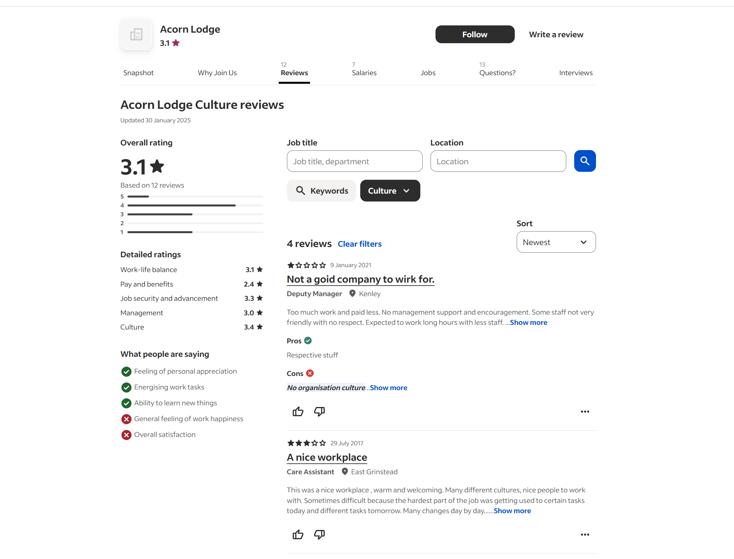
Image 01: Acorn Lodge Reviews
(Indeed, 2025)

However, from the review of indeed.com, where employees can share their thoughts about the hotels remarked that there is an expectation from the company to work long hours with less staff, which was an issue which is also observed by the author himself during placements during the peak times.

Table 1: Key factors shaping employee morale
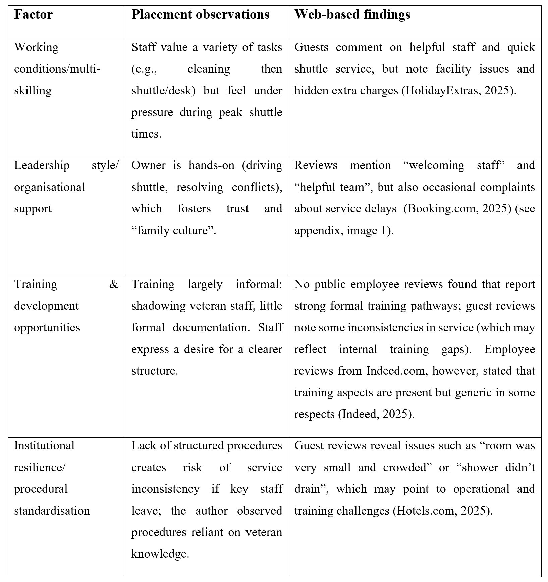
Conclusively, the main findings are that there is a presence of multi-skilling, close leadership involvement, informal training based on trust, etc., supporting employee morale; however, the same elements lead to structural vulnerabilities in the face of workload pressure, lack of redundancy and formalised procedural training.

4.1.2 Objective 2: How Morale Links to Organisational Performance
According to the author, based on the placement experience, when staff were motivated and made to feel appreciated (e.g., following informal praise or flexible working hours), they displayed extra-role behaviours: they would report early to the shuttle operator, cover for useless staff, or provide immediate response to complaints of the guests. On the other hand, on more active nights (where the multi-skilling requires spikes), the author found sluggish responses front desk and times of extended waiting at the shuttle pick-up, thus showing that morale and workload moderate the operation performance.
This relationship between guest perception and the behaviour of the staff is supported by their web-based guest feedback. As an example, the Lodge is found in the list of 7.8/10 according to the assessments made by the guests on Expedia, with regular positive reviews concerning the personnel and the shuttle service (Expedia, 2025) (see appendix image 2). According to kayak data, it has a 7.2/10 rating, which was based on more than 2,100 reviews, with the most recent staff being friendly and the location being great to visit in Gatwick, but there are weaker ratings in cleanliness and breakfast (Kayak, 2025) (see appendix, image 4).

Table 2: Link between employee morale and organisational performance
Performance indicator | Placement observation | Web-based supporting evidence
Service quality (guest experience) | Staff who felt supported handled guest check‐in/shuttle transfers smoothly; when fatigued, tasks slowed. | Guests: “Welcoming Staff … close to Gatwick” (Hotels.com, 2025).
Guest satisfaction/ratings | The author noted that the shuttle reliability (and staff flexibility) reduced guest anxiety—important for an airport hotel. | Review aggregate: 7.2/10 (Kayak) with staff friendliness rated strong (Kayak, 2025).
Operational efficiency/staff retention | The author noted lower turnover (long‐serving staff) during placement, favourable for small team consistency. | While no public turnover data exists, guest comments reference the same staff names and personal touches.
Service consistency under pressure | When staff morale dipped (due to overload), shuttle delays and service slowdowns were observed. | Guest complaints cite “some inconsistencies… shuttle delayed” (Booking.com, 2025).

Generally speaking, in terms of objective 2, the results demonstrate that there is a definite connection: improved employee morale in the Lodge leads to the improvement of service, increased customer satisfaction, and operational sustainability. Yet, with the reliance on goodwill behaviours (discretionary effort) and the agility of small teams, performance increases can be easily undone by the drop in morale or by high production demand peaks.

4.1.3 Objective 3: Prescriptive Findings for Improving and Sustaining Morale
The author also observed, through observation, that small attenuations of the leadership (e.g. publicly recognizing the effort of the staff, being able to swap frames flexibly, making personal appearances to the team, etc.) had a direct but immediate impact on the morale: employees seemed more revitalized, volunteered to take additional jobs and even volunteered to help out beyond the job description. There were also, according to the author, stress points: stress was caused by peak points when transfer happened, lack of formal training or backup regarding important tasks caused anxiety, and management communication was principally formal.
Areas of weakness in web data reinforcement include: powerless or unfriendly staff comments on guests frequently include willingness and friendliness of staff, yet there are also facility problems and shuttle waiting-time, indicating that more than relational goodwill is needed to keep workers motivated. Online reviews (HolidayExtras) emphasise that when the pick-up to the shuttle was delayed, or when the condition of the rooms was simple, even with friendly staff members (HolidayExtras, 2025) (see appendix image 3).
Table 3: Key strategic areas for morale improvement
Strategic area | The author observed a need | Web‐based evidence supporting the need
Recognition & reward | Staff responded well to short recognition; no formal system in place. | Online reviews show service strength tied to individual staff effort; no comments on formal staff recognition.
Formalised training & procedure documentation | Many tasks rely on veteran staff memory; new staff are sometimes uncertain. | Guest feedback about inconsistency and some service hiccups implies the need for robust procedures.
Communication & leadership depth | Dependency on the owner – staff expressed concern about the ability when the owner is unavailable. | Guest comments mention variable shuttle service and room conditions, hinting at structural issues.
Staffing flexibility & workload management | During peak shuttle times, load skyrockets; staff feel stretched. | Guest reviews: shuttle delays, room issues cited during busy periods.
Career progression & multi‐skilling as a value | Multi‐skilling exists, but without formal recognition or credentialing; staff are worried about stagnation. | Web findings show staff turnover is risky in hospitality; literature suggests the absence of a career path harms retention (Iverson & Deery, 1997).

Based on the results, it is apparent that the small hotels, such as the Lodge, need to develop low-cost formal HRM elements along with the relational strengths (team culture, supportive leadership); structured recognition, documented processes, internal certification of multi-skilling, improved channels of communication, and an emergent staffing backup plan during peak seasons.

4.1.4 Summary of Key Findings
Overall, the research results demonstrate that at Acorn Lodge Gatwick, firstly, working conditions which result in the following characteristics, such as multi-skilling and relational form of leadership and informal training, are the factors which make the employees feel motivated, yet they are exposed due to overload and absence of formal HR structures. Second, the organisational performance is highly associated with morale as staff involved in this company provide a higher quality of services, the level of guest satisfaction and efficiency rises, but the performance of the system is dependent on the discretionary work of staff and a small group, thus the morale benefit is not so strong. Third, the findings indicate viable strategic areas of emphasis in maintaining morale in small hotel environments: formalising recognition, multi-skilling, enhancing communication and processes, and workload peaks.
The findings combine the location insights of the author (where the author offers an in-depth contextualisation) with web-based information (where the information becomes externalised, and guests/employees become heard). These findings will be put into perspective in the following section of this chapter with respect to the literature in the field and offer suggestions on HRM in small hospitality organisations.

4.2 Discussion

4.2.1 Factors Influencing Employee Morale
The results showed that the working conditions, the support provided by the management, teamwork, and possibilities of training were the key factors influencing the employee morale at the Acorn Lodge Gatwick. Some of the staff testimonials also often noted that the hotel offered a friendly working atmosphere and work schedule flexibility, but noted that working hours were too long and career development was low. This can be correlated to the findings of Cho et al. (2006), who maintain that there is a direct relationship between these HRM practices that include fair scheduling, career advancement, recognition and job satisfaction and employee retention in hospitality. Equally, the authors of the research by Hassan et al. (2014) point to perceived fairness and stress as the most important elements of performance, indicating that the instances of the workload disparity in Acorn Lodge might undermine motivation and confidence in the employees.
The leadership turned out to be one of such factors. The author noted that collaborative and problem-solving in the busy check-in periods developed due to a hands-on leadership style, boosting morale in the short term. Nevertheless, unstable feedback and inadequate delegation at times hurt the self-esteem of junior employees. This contradiction mirrors the statement of Lashley (2018), which argues that leadership in the hospitality industry should strike the right balance between operational control and empowerment to maintain the engagement of the employees. In addition, Kim et al. (2009) discovered that the management commitment to service plays a direct role in employee satisfaction, a fact that is consistent with the observation of author that when the supervisors exhibited acts of care (ie, helping the team check into rooms late), the morale among the team personnel improved significantly.
The mixed role was also played by training opportunities. Even though there were compliments made by some of the staff about the usefulness of on-the-job learning, others stated that the lack of structured training weakened their development. Dhar (2015) emphasises the significance of systematic skill development, as they discovered that efficient employee training boosts organisational commitment and quality of service. Correspondingly, Choi and Dickson (2009) emphasise that small hotels can receive massive pay-offs in morale and productivity through their training programs that enhance the level of competence and belonging among employees. Formality of training at Acorn Lodge was noted, thus means that a chance of enhancing satisfaction and minimising turnover was missed.
All these together affirm the meta-analysis carried out by Mathieu and Zajac (1990), which found organisational commitment as an important factor between job satisfaction and retention. Morale will build up even within a small resource-constrained environment such as Acorn lodge when the employees feel that they have been treated fairly and respected, as well as being supported to grow. On the other hand, the absence of career advancement or irregular oversight demotivates involvement, which is similar to the idea of Turnover culture expressed by Iverson and Deery (1997) in the hospitality industry.

4.2.2 Association of Employee Morale with Organisational Performance
The results were highly combinative, as morale and organisational performance at Acorn Lodge were dependent factors on each other. During periods of high staff morale (characteristic of high operational efficiency), guests on TripAdvisor and Booking.com complained less frequently, mentioning the friendliness of staff and attention to them. In contrast, in instances of understaffing, the reviews mentioned delayed service and uniformity in guest experience. This is equivalent to Judge et al. (2001), who established an excellent connection between job satisfaction and job performance in various industries. Correspondingly, Ehrhart and Naumann (2004) claim that group commitments and group morale in groups have a direct impact on consistency in service, as well as customer satisfaction, which was demonstrated by the placement observations of the author.
The morale concept is also supported by literature, which shows that morale affects service quality in the form of organisational citizenship behaviours (OCBs). Workers in Acorn Lodge often performed more than required in their official tasks, e.g. when guests needed some help on how to move their luggage, when someone needed to make a reservation at the last moment, etc., and this can be attributed to the OCB trends portrayed by Ehrhart and Naumann (2004). As perceived by Loi et al. (2006), the supportive leadership, as well as the recognition, tends to reinforce this behaviour, observed to boost the commitment amongst employees towards organisational goals. This connection is strengthened by the fact that the author noted that a simple praise given by the supervisors (even in the form of a verbal form of appreciation) made the members of staff more willing to help the other staff.
Moreover, as Wilkins (2010) highlights, the service quality visible to the guests has an impact on the level of their satisfaction with the hotel facilities, as well as the emotional involvement and enthusiasm of employees. The changes in the ratings of guests on TripAdvisor are observed to measure how the change in morale was reflected in the product results. The negative spillover of low morale was also represented by the less enthusiasm demonstrated by the employees who felt overworked or underappreciated towards the guest interactions.
These findings are also put in perspective in the literature on stress and fairness. Hassan et al. (2014) proved that employee output and service orientation are reduced by perceived stress and inequitable treatment. Morale-demoralising stressors were found to include at Acorn Lodge, periods of understaffing and restricted breaks as well. Further, Karatepe and Kilic (2007) demonstrated that the factor of supervisor support reduces work-family conflict and boosts job satisfaction, which is also a dynamic involving small hotel employees who are likely to manage unusual working hours and personal life. The placement experience also demonstrated by the author that morale and attendance of staff were more than satisfactory when managers allowed them to have flexible shifts.
Thus, the literature and findings come to the same conclusion that employee morale is an important driver of performance in the sphere of hospitality. Even minor changes in the level of staff satisfaction can have multiplied impacts on service performance and satisfaction with the guests, which was also confirmed by Kim et al. (2009) and Tews et al. (2013), who discovered that the work environment that encourages fun and appreciation has less turnover and increased guest satisfaction rates.

4.2.3 Strategies for Improving and Sustaining Employee Morale
According to the available empirical evidence and with a theoretical basis, one can come up with several measures that can be used to improve morale at Acorn Lodge Gatwick. The former is empowering training and professional development since the results indicated a loophole in formal training systems. Noe et al. (2021) also note that well-organised practices in HRD, such as employing induction and skills workshops, increase the confidence of employees and enable their behaviours to meet service expectations. Figure 8 may also be overcome by implementing short-but-often training in order to overcome the perceived stagnation that is reflected in online reviews. This method will be in line with the suggestion of Dhar (2015) that commitment-based HRM practices will promote long-term loyalty and service excellence.
Secondly, it is essential that the development of leadership happens. The author noted that supportive and inconsistent leadership have some influence on team cohesion. According to Lashley (2018), hospitality leaders need to perform transformational behaviours to have personnel motivated by the vision and recognition, instead of control. In the same manner, Hayes and Ninemeier (2017) maintain that effective leaders are those who create a sense of conversation and fairness, as well as role clarity, which were not consistent at Acorn Lodge. Would also encourage supervisors to set up frequent feedback sessions, and this may enhance the perceived organisational support, which is what Loi et al. (2006) and Kim et al. (2009) advocate.
Third, wellness and flexibility at the workplace were also found to be required interventions. Work pressure and insufficient rest were negative morale issues that were frequently cited by staff. As Hassan et al. (2014) and Tews et al. (2013) point out, positive work climates, which include flexibility, fairness, and fun, also make a strong contribution to performance and retention. Hotels with a small reputation, such as Acorn Lodge, might consider low-cost morale-enhancing measures like informal social gatherings, reward schemes without spending big.
Last but not least, there should be a culture of equality and rewards. According to Hochwaster et al. (2007), reputation and perceived justice come between the basis of the political behaviour on work outcomes. Intrinsic motivation of workers improves when they feel that they are treated fairly and recognised. Results showing greater morale with recognition of the additional effort are consistent with Matthieu and Zajac (1990) and Loi et al. (2006), confirming the primary role of the perceived fairness in maintaining commitment. Trust would be further developed through the implementation of transparent communication on the workloads and the promotion opportunities.

4.2.4 Summary
As highlighted in the discussion, the relationship between leadership, training, fairness, and working conditions characterises the morale of employees at Acorn Lodge Gatwick. The theoretical premise that morale affects service quality and performance outcomes is supported by inevitable evidence. Despite the fact that the hotel shows strength in interpersonal relationships and flexibility, the deficiency in formal training and regular communication between managers is also an issue. Such gaps can be filled by applying structured HRM interventions as proposed by Cho et al. (2006), Dhar (2015), and Noe et al. (2021): it may allow short-term motivation to be converted into long-term commitment.
All in all, the results substantiate the core argument of the literature that motivation among employees is not just a chance product of job contentment but a strategic resource that can affect service quality, loyalty of guests, and sustainability of the organisation, especially in a small and labour-intensive hotel setting.

Chapter 5: Conclusion and Recommendations

5.1 Conclusion
This paper has examined the role of employee morale in the organisational performance of Acorn Lodge Gatwick, which is a small independent hotel in the UK. Through the qualitative case study method, the study examined leadership, communication, working conditions, and the organisational culture as the primary issues affecting the morale of staff. The results of the placement-based observations and secondary review data showed that morale is a critical factor that significantly defines both internal efficiency and guest satisfaction, which subsequently determines the overall quality of service offered by the hotel and its reputation.
The research established that leadership behaviour had the strongest contribution to morale. Employees felt important and involved when their supervisors were caring, just, and communicative. On the other hand, the lack of consistent communication, little recognition, and perceived favouritism caused tension as well as depressed enthusiasm. This is in line with the Job Demands-Resources model developed by Bakker and Demerouti (2017), which states that burnout decreases with conducive leadership and job resources, and that conducive leadership and job resources increase motivation. Likewise, the two-factor theory developed by Herzberg (1959) is in supports the idea that intrinsic motivators, which include recognition, responsibility, and growth, directly increase morale and performance.
Conditions of work were also significant. It was observed that high workload and shortage of staff resulted in fatigue and lapses in service delivery, particularly at peak periods. According to Baum (2015), the workload balance and the lack of resources that are typical of small hotel operations do not help reduce the level of employee stress. Nevertheless, flexibility, empathy, and informal appreciation provided by the management brought about strong commitment among employees, which proves that positive relations partly compensate structural pressures.
Moreover, the problem of communication gaps was present. A lot of these misunderstandings in the operations were brought about by the lack of clarity in the verbal instructions or the change of schedule at the last moment, which led to friction between the team members. Collis and Hussey (2014) assert that a lack of communication creates a low coordination level and a lack of trust among service team members.
Lastly, the researchers had to determine that the lack of career development opportunities undermined long-term motivation. There were high levels of employees who felt that they had no career development or advancement, and their jobs were not dynamic. This makes Karatepe and Olugbade (2009) claim that training and promotion opportunities keep employees committed to their work in the hospitality setting.
On the whole, it can be concluded that morale at Acorn Lodge Gatwick is an operational strategic issue. High morale is associated with the level of better guest service, lower turnover, and better cooperation, whereas low morale is related to inefficiency and dissatisfaction. As a result, morale management can be regarded as a strategic priority of sustainable hotel performance. The findings are as follows and formulated in actionable strategies.

5.2 Recommendations and Practical Strategies

5.2.1 Managerial Fairness and Leadership Development
Problem Identified: Staff morale and trust were lacking due to perceived favouritism to inconsistent supervision that was witnessed in daily running.
Recommendation: The management should focus on leadership development by short and intense training on emotional intelligence, fair and effective communication. As Goleman (2000) states, emotionally intelligent leaders make people motivated and psychologically safe. To share the task and rewards equally, supervisors at Acorn Lodge should engage in briefings and post-reflections at the beginning and end of shifts to evenly distribute the workload among the staff. The practice enhances equality, creates less tension, and strengthens the vision that none of the employees will feel their contribution does not count. Further coaching on leadership concepts, provided to the internal trainers or via the local association of hospitality, would also increase managerial empathy and communication, which are major predictors of morale and retention.

5.2.2 Workload Management Systems and Operational Support Systems
Problem Identified: Workloads were not evenly distributed, and there were staff shortages, which led to fatigue, stress effects, and decreased consistency of the services, particularly during the peak periods.
Recommendation: In order to alleviate burnout, Acorn Lodge can adopt a systematic rota scheduling, which balances labour hours in the departments. Bakker and Demerouti (2017) suggest that the job requirements should be counterbalanced with adequate job resources to avoid burnout. Expanding front office, housekeeping, and F&B services to cross-train employees would be more flexible and less pressure in the situation of high occupancy. Alongside, there are inexpensive digital scheduling devices/task management software that can enhance the organisation of operations. A periodic assessment of the workload should be carried out to determine the points of pressure and redistribute the role. Small tokens of appreciation and short breaks in between work would also help boost wellbeing.

5.2.3 Development of Proper Communication Processes
Problem Identified: Lack of communication, as there was frustration and ineffectiveness due to the lack of clarity in the instructions given to the shifts and the lack of updates.
Recommendation: It is critical to establish formal internal communication channels in order to achieve operational clarity. According to Veal (2006), information sharing in service settings is vital, and coordination determines the guest experience. To have real-time updates, the hotel might implement a digital noticeboard, WhatsApp group or shared Google Calendar. Team meetings need to be conducted every week so that employees can raise issues or propose ways of doing things better. According to Collis and Hussey (2014), open communication creates trust and engagement, which results in better morale. The norms of communication, like confirming shift changes in writing, would help in eliminating uncertainty and creating a more unified workplace culture.

5.2.4 Career Development and Recognition Strategies
Problem Identified: The absence of a formal promotion and reward system lowered the willingness to be motivated and committed to work by the staff in the long run.
Recommendation: The management is advised to institute a systematic career development program that entails short-term skills training and performance appraisal that is conducted periodically. Self-efficacy and loyalty are made robust as a result of development opportunities, as noted by Karatepe and Olugbade (2009). Collaborating with training schools in the area or e-hospitality providers would offer a cost-effective way of studying. The motivator theory by Herzberg (1959) also says that recognition is a powerful intrinsic motivator. Making monthly occasions out of recognition of each employee through a prize named Employee Achievement Award, or even a simple appreciation message in meetings, would be a clear and visible show of individual contribution. A combination of professional development and recognition helps sustain morale, as well as makes the employer brand stronger, which helps establish Acorn Lodge as a learning workplace.

5.2.5 Stress Management and Wellbeing Worker Programs
Problem identified: Employees were too tired and emotionally exhausted because they had to work long hours and had no chance to rest, which adversely influenced production and the quality of the provided service.
Recommendation: To improve the well-being of the staff, Acorn Lodge needs to incorporate planned rest and recovery activities to decrease stress and enhance engagement. As Bakker and Demerouti (2017) point out, people experience burnout when the job demands surpass the existing resources, which is why management should make sure that there are good support systems. Scheduling short shifts, equitable rotation of tasks, and periodic wellness visits may be beneficial in terms of maintaining the level of energy and motivation. Equally, short mindfulness/ relaxation courses before peak service time would encourage emotional balance and resilience. Karatepe and Olugbade (2009) observe that by establishing a surrounding that appreciates the welfare of the employees, job satisfaction and organisational loyalty are improved directly. Moreover, the psychological aspects of workload can be identified to avoid high turnover and inconsistency of service delivery, hence the employees will be assured that they are valued and supported in serving.

References
Adams, J. S. (1965). Inequity in social exchange. In L. Berkowitz (Ed.), Advances in experimental social psychology (Vol. 2, pp. 267–299). Academic Press.
Agarwal, U. A., & Gupta, V. (2018). Relationships between job characteristics, work engagement, conscientiousness and managers’ turnover intentions. Personnel Review, 47(2), 353–377.
Ahmad, S., & Scott, N. (2019). Managing the hotel workforce: The role of leadership. Tourism Management Perspectives, 30, 157–167.
Akgunduz, Y., & Sanli, S. C. (2017). The effect of employee empowerment and organizational commitment on job satisfaction: A study of hotel employees. Research in Hospitality Management, 7(2), 115–122.
Aksu, A. A. (2004). Turnover costs: Research among five-star hotels in the city of Antalya, Turkey. Tourism Analysis, 9(3), 207–217.
AlBattat, A. R., & Som, A. P. M. (2013). Employee dissatisfaction and turnover crises in the Malaysian hospitality industry. International Journal of Business and Management, 8(5), 62–71.
Albrecht, S. L. (2010). Employee engagement: 10 key questions for research and practice. Human Resource Development International, 13(3), 299–303.
Alonso-Almeida, M. M., & Llach, J. (2019). The effect of innovation on performance in small hospitality firms. International Journal of Hospitality Management, 81, 30–39.
Andersson, L. M., & Pearson, C. M. (1999). Tit for tat? The spiraling effect of incivility in the workplace. Academy of Management Review, 24(3), 452–471.
Appaw-Agbola, E. T., Agbola, F. W., & Opoku, E. (2021). Leadership style and employee retention in small hotels. Journal of Human Resources in Hospitality & Tourism, 20(2), 168–190.
Arnoux-Nicolas, C., Sovet, L., Lhotellier, L., Di Fabio, A., & Bernaud, J. L. (2016). Perceived work conditions and turnover intentions: The mediating role of meaning of work. Frontiers in Psychology, 7, 704.
Bailey, C., Madden, A., Alfes, K., & Fletcher, L. (2017). The meaning, antecedents and outcomes of employee engagement: A narrative synthesis. International Journal of Management Reviews, 19(1), 31–53.
Bakker, A. B., & Demerouti, E. (2007). The job demands–resources model: State of the art. Journal of Managerial Psychology, 22(3), 309–328.
Baptiste, N. R. (2008). Tightening the link between employee wellbeing at work and performance: A new dimension for HRM. Management Decision, 46(2), 284–309.
Barber, L. K., & Santuzzi, A. M. (2015). Please respond ASAP: Workplace telepressure and employee wellbeing. Journal of Occupational Health Psychology, 20(2), 172–189.
Baum, T. (2007). Human resource management for tourism, hospitality and leisure: An international perspective. Thomson Learning.
Baum, T., Kralj, A., Robinson, R. N. S., & Solnet, D. (2016). The impact of labour shortages on hotel operations: Practical responses. International Journal of Contemporary Hospitality Management, 28(10), 1298–1318.
Bellou, V. (2010). Organizational culture as a predictor of job satisfaction: The role of gender and age. Career Development International, 15(1), 4–19.
Bhattacharya, S., & Gupta, A. (2019). The mediating role of employee engagement in the relationship between job characteristics and organizational commitment. Journal of Human Values, 25(2), 119–132.
Boella, M., & Goss-Turner, S. (2019). Human resource management in the hospitality industry: A guide to best practice (10th ed.). Routledge.
Booking.com. (2025). Reviews of Acorn Lodge Gatwick. Available at: https://www.booking.com/reviews/gb/hotel/threebridgeslodge.en-gb.html [Accessed 3 Nov. 2025].
Brown, S. P., & Leigh, T. W. (1996). A new look at psychological climate and its relationship to job involvement, effort, and performance. Journal of Applied Psychology, 81(4), 358–368.
Burke, R. J., & Cooper, C. L. (2008). The long work hours culture: Causes, consequences and choices. Emerald Group Publishing.
Chen, C. F., & Kao, Y. L. (2012). The connection between the service climate and service quality perceptions: The role of service behaviors and customer satisfaction. Journal of Hospitality & Tourism Research, 36(2), 152–171.
Chen, Y., Zhou, X., & Klyver, K. (2021). Employee wellbeing in small firms: The role of owner support and organizational culture. Small Business Economics, 57(2), 865–882.
Chi, C. G., & Gursoy, D. (2009). Employee satisfaction, customer satisfaction, and financial performance: An empirical examination. International Journal of Hospitality Management, 28(2), 245–253.
Cho, S., Woods, R. H., Jang, S., & Erdem, M. (2006). Measuring the impact of human resource management practices on hospitality firms’ performances. International Journal of Hospitality Management, 25(2), 262–277.
Choi, Y. G., & Dickson, D. R. (2009). A case study into the benefits of management training programs: Impacts on hotel employee performance. Journal of Human Resources in Hospitality & Tourism, 8(3), 259–271.
Clark, M. A., Michel, J. S., Zhdanova, L., & Pui, S. Y. (2016). Workaholism and burnout: The moderating effects of psychological detachment and self-compassion. Journal of Business and Psychology, 31(4), 607–619.
Collis, J., & Hussey, R. (2014). Business research: A practical guide for undergraduate and postgraduate students (4th ed.). Palgrave Macmillan.
Cooper, C. L., & Robertson, I. T. (Eds.). (2012). International review of industrial and organizational psychology (Vol. 27). Wiley-Blackwell.
Cottrell, S. (2014). Dissertations and project reports: A step-by-step guide. Palgrave Macmillan.
Deery, M., & Jago, L. (2015). Revisiting talent management, work-life balance and retention strategies. International Journal of Contemporary Hospitality Management, 27(3), 453–472.
Demerouti, E., Bakker, A. B., Nachreiner, F., & Schaufeli, W. B. (2001). The job demands–resources model of burnout. Journal of Applied Psychology, 86(3), 499–512.
Dhar, R. L. (2015). Service quality and the training of employees: The mediating role of organizational commitment. Tourism Management, 46, 419–430.
Ehrhart, M. G., & Naumann, S. E. (2004). Organizational citizenship behavior in work groups: A group norms approach. Journal of Applied Psychology, 89(6), 960–974.
Expedia. (2025). Acorn Lodge Gatwick – Hotel Information & Reviews. Available at: https://www.expedia.co.uk/Horley-Hotels-Acorn-Lodge-Gatwick.h89752083.Hotel-Information [Accessed 3 Nov. 2025].
Farhadi, H., & Ismail, K. (2022). Leadership styles and employee wellbeing in hospitality: A systematic review. Tourism Management Perspectives, 42, 100972.
Gillen, P., Sinclair, M., & Rankin, J. (2014). Workforce flexibility and job satisfaction in hotels: The role of rostering and hours. International Journal of Contemporary Hospitality Management, 26(4), 572–594.
Gursoy, D., Chi, C. G., & Karadag, E. (2013). Generational differences in work values and attitudes among frontline and service contact employees. International Journal of Hospitality Management, 32, 40–48.
Hassan, M., Hassan, S., & Nawaz, M. S. (2014). Impact of job satisfaction, perceived fairness and stress on employee performance. Business and Management Review, 3(1), 32–41.
Hayes, D. K., & Ninemeier, J. D. (2017). Human resources management in the hospitality industry (2nd ed.). Wiley.
Heskett, J. L., Sasser, W. E., & Schlesinger, L. A. (1997). The service profit chain: How leading companies link profit and growth to loyalty, satisfaction, and value. Free Press.
Hochwarter, W. A., Ferris, G. R., Zinko, R., Arnell, B., & James, M. (2007). Reputation as a moderator of political behavior–work outcomes relationships. Journal of Applied Psychology, 92(2), 542–549.
Hogreve, J., Homburg, C., Hoyer, W. D., & Kabadayi, S. (2022). The service-profit chain: Reflections, revisions, and extensions. Journal of Service Research, 25(3), 303–320.
HolidayExtras. (2025). Reviews of Acorn Lodge Hotel. Retrieved from https://www.holidayextras.com/airport-hotels/gatwick/acorn-lodge/reviews.html
Hotels.com. (2025). Acorn Lodge Gatwick Reviews. Available at: https://www.hotels.com/ho2873066656/acorn-lodge-gatwick-horley-united-kingdom/ [Accessed 3 Nov. 2025]
Hughes, E. (2019). The relationship between training and employee commitment in the hospitality industry. Journal of Human Resources in Hospitality & Tourism, 18(1), 1–19.
Iverson, R. D., & Deery, M. (1997). Turnover culture in the hospitality industry. Human Resource Management Journal, 7(4), 71–82.
Judge, T. A., Thoresen, C. J., Bono, J. E., & Patton, G. K. (2001). The job satisfaction–job performance relationship: A qualitative and quantitative review. Psychological Bulletin, 127(3), 376–407.
Kang, H. J., Gatling, A., & Kim, J. (2015). The impact of supervisory support on organizational commitment, career satisfaction, and turnover intention for hospitality frontline employees. Journal of Human Resources in Hospitality & Tourism, 14(1), 68–89.
Karatepe, O. M. (2013). Service recovery, stress, and turnover intentions: An empirical study in the hotel industry. International Journal of Hospitality Management, 32, 10–19.
Karatepe, O. M., & Kilic, H. (2007). Relationships of supervisor support and conflicts in the work–family interface with the selected job outcomes of frontline employees. Tourism Management, 28(1), 238–252.
Kayak. (2025). Acorn Lodge Gatwick – Hotel Deals & Reviews. Available at: https://www.kayak.com/Horley-Hotels-Acorn-Lodge-Gatwick.331455.ksp [Accessed 3 Nov. 2025]
Kim, H. J., Shin, K. H., & Swanger, N. (2009). Burnout and engagement: A comparative analysis using the Big Five personality dimensions. International Journal of Hospitality Management, 28(1), 96–104.
Kim, H. J., Tavitiyaman, P., & Kim, W. G. (2009). The effect of management commitment to service on employee service behaviors: The mediating role of job satisfaction. Journal of Hospitality & Tourism Research, 33(3), 369–390.
King, C. A., & Grace, D. (2010). Employee engagement in hospitality: The role of leadership in fostering staff wellbeing. Cornell Hospitality Quarterly, 51(4), 336–347.
Lashley, C. (2018). Hospitality management: Leadership, operations and human resources (3rd ed.). Routledge.
Lee, C. C., Huang, S. H., & Zhao, C. Y. (2012). The impact of work stress and burnout on employee performance: A case study of hotels in Taiwan. World Academy of Science, Engineering and Technology, 6(1), 24–30.
Locke, E. A. (1976). The nature and causes of job satisfaction. In M. D. Dunnette (Ed.), Handbook of industrial and organizational psychology (pp. 1297–1343). Rand McNally.
Loi, R., Hang-yue, N., & Foley, S. (2006). Linking employees’ justice perceptions to organizational commitment and intention to leave: The mediating role of perceived organizational support. Journal of Occupational and Organizational Psychology, 79(1), 101–120.
Lu, L., While, A. E., & Roberts, C. (2005). Job satisfaction and related factors: A questionnaire survey of hospital nurses in the UK. Journal of Advanced Nursing, 49(4), 357–365.
Mathieu, J. E., & Zajac, D. M. (1990). A review and meta-analysis of the antecedents, correlates, and consequences of organizational commitment. Psychological Bulletin, 108(2), 171–194.
Newman, A., Thanacoody, R., & Hui, W. (2015). The effects of perceived organizational support and psychological contract breach on turnover intention: Does age matter? Human Resource Management Journal, 25(1), 1–16.
Nickson, D. (2013). Human resource management for the hospitality and tourism industries (2nd ed.). Routledge.
Nishii, L. H., & Mayer, D. M. (2009). Do inclusive leaders help to reduce turnover in hospitality? Journal of Applied Psychology, 94(6), 1412–1426.
Noe, R. A., Hollenbeck, J. R., Gerhart, B., & Wright, P. M. (2021). Fundamentals of human resource management (9th ed.). McGraw Hill.
O’Neill, J. W., & Davis, K. (2011). Work stress and well-being in the hotel industry. International Journal of Hospitality Management, 30(2), 385–390.
Podsakoff, N. P., LePine, J. A., & LePine, M. A. (2007). Differential challenge-hindrance stressor relationships with job attitudes, turnover intentions, and performance: A meta-analysis. Journal of Applied Psychology, 92(2), 438–454.
Purcell, J., & Hutchinson, S. (2007). Front-line managers as agents in the HRM-performance causal chain: Theory, analysis and evidence. Human Resource Management Journal, 17(1), 3–20.
Saito, H., Brown, E., & Kim, Y. (2024). Well-being of hospitality employees: A systematic literature review. International Journal of Hospitality Management, 114, 103581.
Salama, W., Abdou, A. H., Mohamed, S. A. K., & Shehata, H. S. (2022). Impact of work stress and job burnout on turnover intentions among hotel employees. International Journal of Environmental Research and Public Health, 19(15), 9724.
Salanova, M., Agut, S., & Peiró, J. M. (2005). Linking organizational resources and work engagement to employee performance and customer loyalty: The mediation of service climate. Journal of Applied Psychology, 90(6), 1217–1227.
Saunders, M., Lewis, P., & Thornhill, A. (2019). Research methods for business students (8th ed.). Pearson Education.
Susskind, A. M., Kacmar, K. M., & Borchgrevink, C. P. (2003). Customer service employees’ behavioral intentions and attitudes: An examination of construct validity and a path model. International Journal of Hospitality Management, 22(4), 363–386.

Tews, M. J., Michel, J. W., & Stafford, K. (2013). Does fun pay? The impact of workplace fun on employee turnover and performance. Cornell Hospitality Quarterly, 54(4), 370–382.
TripAdvisor. (2025). Acorn Lodge Gatwick – Updated Guest Review Scores. Available at: https://www.tripadvisor.com/Hotel_Review-g191265-d293516-Reviews-Acorn_Lodge_Gatwick-Horley_Surrey_England.html [Accessed 3 Nov. 2025]
Üngüren, E. (2024). The effects of job stress on burnout and turnover intention. Behavioral Sciences, 14(4), 322.
Veal, A. J. (2006). Research methods for leisure and tourism (3rd ed.). Financial Times/Prentice Hall.
Wilkins, H. (2010). Using importance–performance analysis to appreciate satisfaction in hotels. Journal of Hospitality Marketing & Management, 19(8), 866–888.
Xiong, W., Zhao, Y., & Zhang, C. (2023). How emotional labor affects hotel employees’ mental health: Evidence from the hospitality industry. International Journal of Hospitality Management, 108, 103404.
Indeed, N. (2025). Acorn-Lodge Reviews. [online] Indeed.com. Available at: https://uk.indeed.com/cmp/Acorn-Lodge/reviews?ftopic=culture [Accessed 3 Nov. 2025].

Appendix
Image 1: Booking.com Review
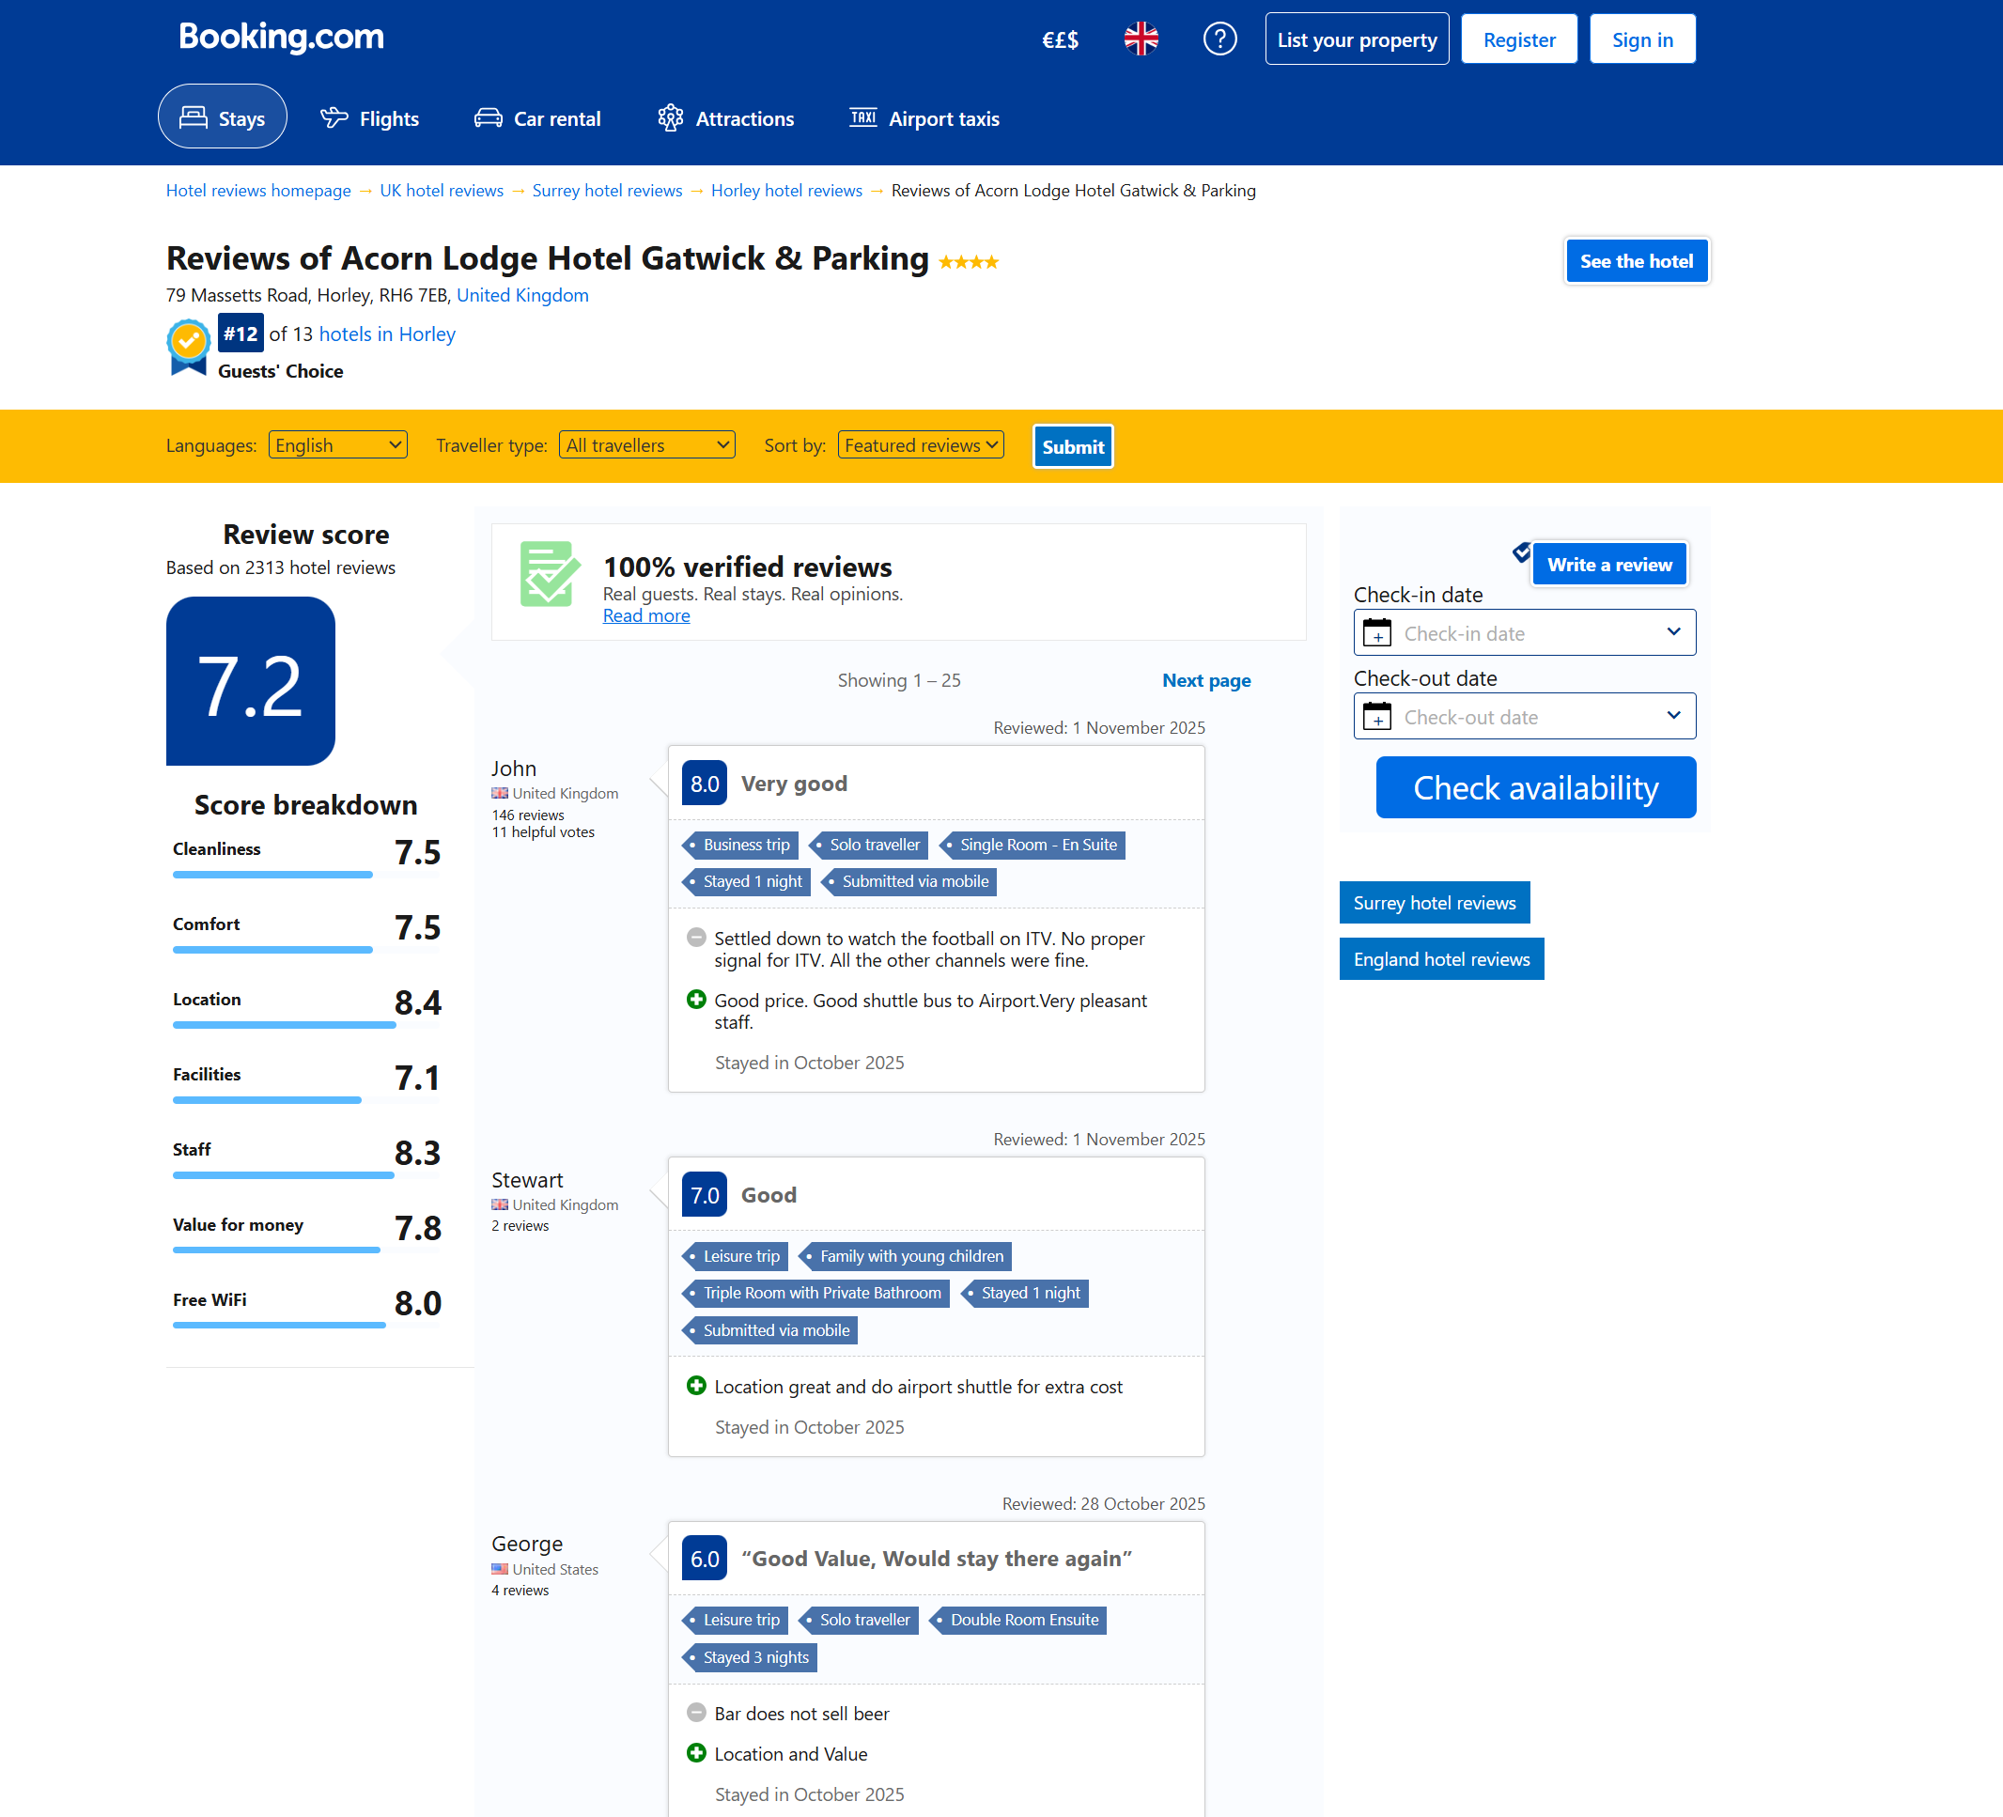

Image 2: Expedia Review
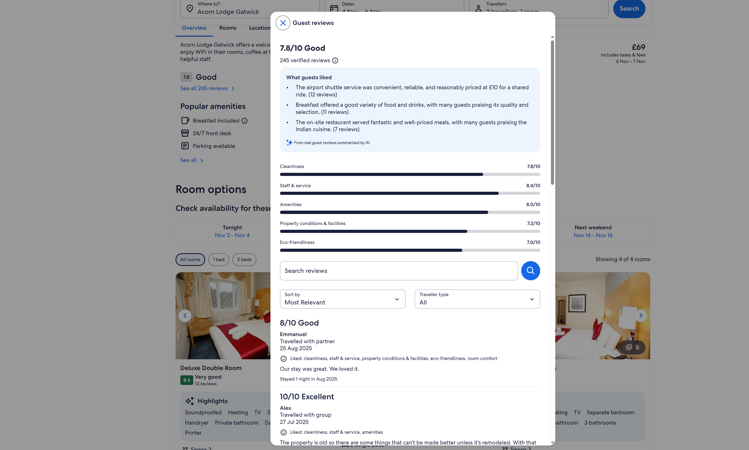

Image 3: HolidayExtras Review
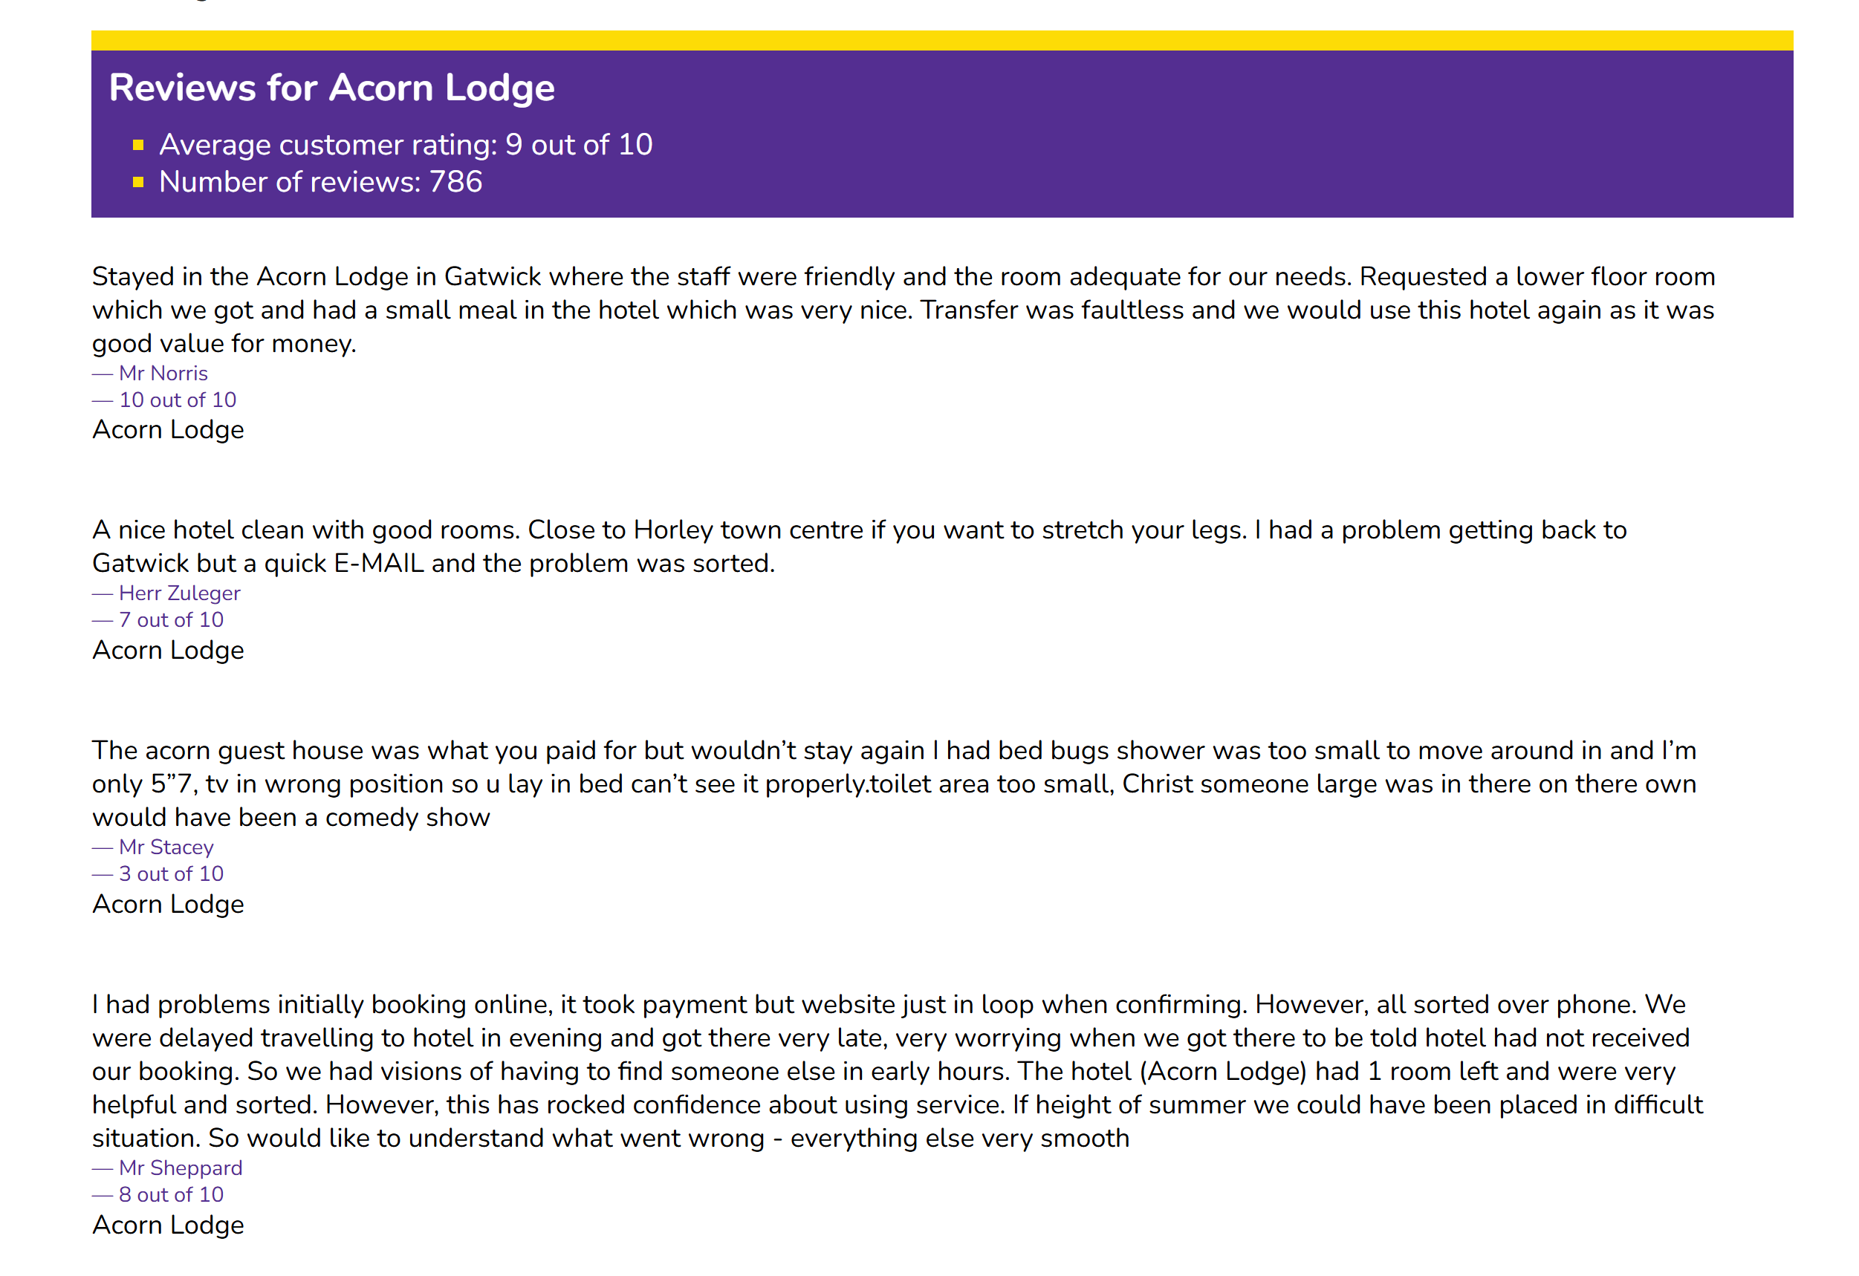

Image 4: Kayak Review
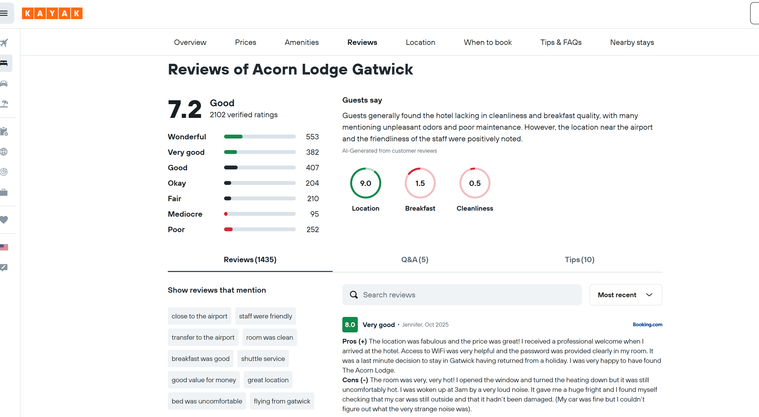

Image 5: TripAdvisor Review


