Master of Business Administration Programme

LCMB7035 - Dissertation

Exploring the Impact of Digital Marketing Strategies on Customer Engagement and Retention in the Financial Services Sector: A Comparative Study of Traditional Banks and FinTech Startups

Table of Contents
Introduction & Background 3
Research Problem & Significance 3
Research Objectives & Questions 3
Literature Review Overview 4
Research Methodology 8
Expected Outcomes & Contributions 9
Limitations 9
Timeframe 10
Conclusion 10
References 11

Introduction & Background
Over the last few years, the concept of digital marketing has completely transformed the manner in which business operates with their customers. The financial services industry has not been left out because it has undergone this revolution from the branch-based service to the online and mobile services. The existing banks are changing according to these changes so that the trust and loyalty of their customers can remain, yet the FinTech startups are adapting to the changes and are finding new customers and communicating with them through new digital tools (Gupta, 2023). The proposed research paper will examine how traditional banks and FinTech companies are implementing digital marketing, so that insight can be gained on how to create better relationships and how to engage and retain customers in an increasingly digital banking world.

Research Problem & Significance
The digital transformation effect on the finance sector has been well documented, and information and research are scarce on the success of traditional banks and the Fintech Startups in digital marketing efficiencies (Mittal et al. 2024). These are critical differences to better customer experiences and long-term retention. This study fills that gap by analysing the effects of the digital marketing approaches in terms of engagement and loyalty. The research is both academically important in extending the theory of marketing and also practically important to provide knowledge for financial marketers to help them improve their competitiveness in a digital-first marketplace.

Research Objectives & Questions
Objectives:
- To analyse the major digital marketing strategies adopted by traditional banks and FinTech start-ups
- To evaluate the effect of these strategies on the customer engagement level
- To assess the role of digital marketing in customer retention for both sectors
- To recommend best practices and lessons to enhance the effectiveness of digital marketing in the financial services industry.
Research Questions:
- What are some of the digital marketing strategies that are most commonly used by banks and FinTech companies?
- How do these strategies impact the outcomes of customer engagement?
- What is the role of digital marketing in customer retention?
- What are the best practices that can be adopted to improve digital marketing in the financial sector?

Literature Review Overview
Digital Marketing Transformation in the Financial Services Industry
Existing studies highlight that digital marketing helps to increase the engagement of the customer through personalisation, analytics, and interactive content (Theodorakopoulos and Theodoropoulou, 2024). Research on financial services points to digital transformation as essential to competitiveness, but few studies compare banks and FinTechs directly (Alt et al. 2018). Whereas banks are based on trust and reputation, FinTechs are innovative and user experience. This research helps address the current gap by assessing the strategies of the two sectors in terms of engagement and retention via the digital channel.
More recent literature focuses on the emergence of digital marketing as an inseparable element of competitive advantage in the financial services sector. A specific case study carried out by Murti et al. 2023 deals with the idea of implementing the digital marketing strategy in the business and, more specifically, financial service companies. Through their research that was informed by careful review of the literature, the authors have suggested the importance of social media marketing, search engine optimisation (SEO) and email marketing as key instruments of digital marketing with regard to enhancing customer engagement and personalisation. As noted in the study, personalisation and customer-centric engagement strategies help to enhance brand visibility and increase the number of customers retained. Nonetheless, Murti et al. 2023 also indicate such critical obstacles as the lack of experienced digital marketers and the growing complexity of data protection laws. It is their suggestion that, as much as there are great prospects in digital strategies, their success can only be achieved when effective implementation frameworks and performance evaluation mechanisms are put into place.
In addition to this, Vasyl’tsiv, 2021 offers a more macroeconomic approach by examining how digital marketing in the banking sector was transformed in the COVID-19 pandemic. Based on the statistical and econometric modelling, it becomes apparent that the number of operating banks dropped significantly between 2017 and 2020, thus financial institutions became more inclined to employ new technologies in digital marketing and become competitive. It is specifically that the research commends Raiffeisen Bank about its digital leadership and emphasises the implementation of Internet banking, virtual reality, and augmented reality as customer experience and communication tools. Collectively, these papers shed light on the current digital transformation in financial services: Murti et al. 2023 focus on strategic design and implementation on a firm scale and Vasyl’tsiv, 2021 on the technological adjustment on a sectoral scale. In aggregate, they indicate that strong digital marketing incorporation is crucial to interaction with clients, service innovation, and sustainability in a dynamic economic environment.
Customer Engagement through Digital Platforms
The increasing digitalisation of financial services has altered customer engagement strategies, since more financial institutions are using technology-driven platforms to enhance customer relationships. Egbuhuzor et al. 2021 discuss the transformation of customer engagement in the financial industry between cloud-based Customer Relationship Management (CRM) systems that are driven by Artificial Intelligence (AI). In the study, the researchers describe maintaining AI resources, e.g., natural language processing, predictive analytics, and machine learning, to streamline customer relations and provide individuals with personal services. These cloud-based platforms help the financial institutions to handle real-time analytics, workflows, and scalability is economically friendly. Importantly, the study emphasises the significance of omnichannel engagement, or the connection between mobile applications, social media, and physical, in-store interactions, to guarantee uniform customer experiences. Nonetheless, Egbuhuzor et al. 2021 also note that such implementation presents certain issues, such as cybersecurity, regulatory compliance, and the fact that the workforce needs to be upskilled in order to take advantage of these technologies.
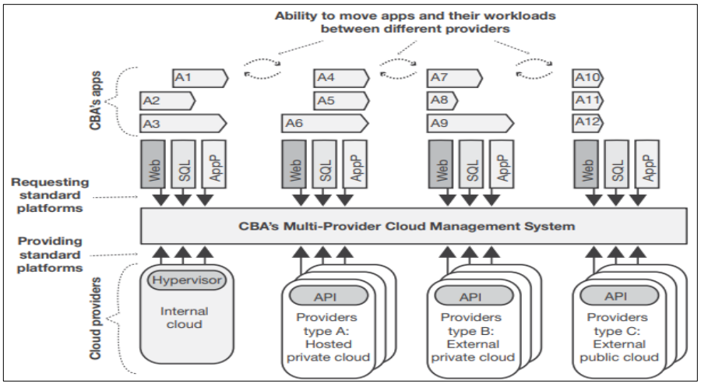
Figure 1: CBA's Multi-Provider Model of Cloud Computing
(Source: Egbuhuzor et al. 2021)
To this end, Kowsar et al. 2025 offer a more comprehensive, regional overview of digital transformation in South Asian retail banking and discuss the role of digitisation in engaging customers and adopting products. Their research, concluded through the PRISMA 2020 systematic review process, gathers the evidence offered by 84 academic papers and proves the idea that digital wallets, mobile banking, and biometric authentication, as innovations, have increased financial inclusion and improved interaction. According to the authors, digital interfaces that are personalised, behavioural nudges, and AI-facilitated financial tools also boost customer contact and loyalty drastically. In addition, the study confirms the synergistic nature of fintech innovation and regulations as the driving factor in producing sustainable and inclusive banking systems. All that results in the idea that digital engagement is not the area of enhanced technologies but rather a move towards data-driven personalisation, persistence of contact and participation in service delivery which are some of the pillars of remaining a modern financial consumer and competitive in the changing digital economy.
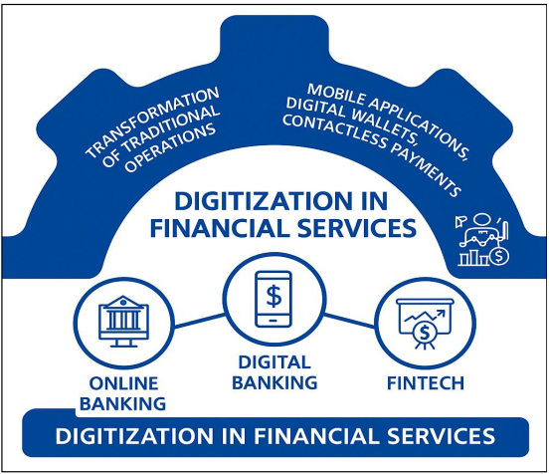
Figure 2: Framework of Digitization in Financial Services
(Source: Kowsar et al. 2025)
Digital Marketing and Customer Retention Strategies
Digital marketing has been redefined as no longer a tool of creating brand awareness as a tactic but rather as a tool of creating long-term customer loyalty and retention. According to Galib and Rijal, 2025, this change is seen through the lens of embedded finance, and how this is able to make marketing more powerful and the user experience easier through the ability to include financial services within non-financial applications. They use a systematic literature review (SLR) approach to demonstrate that embedded finance can enhance marketing efficiency since it involves the utilisation of user data to optimise individual marketing campaigns to result in 20% conversion improvements. In addition, the absence of frictionless digital experiences, such as uninterrupted payments and integrated financial applications, results in up to five-fold customer satisfaction and loyalty. The research is also able to conclude, using an embedded financial-based loyalty programme, that the loyalty retention rate can increase by 30, proving that the convergence of the convenience, trust, and long-lasting engagement is powerful. However, Galib and Rijal, 2025 note that high threats to data security and privacy are associated with such developments, and therefore, the governance and compliance machinery ought to be resolute.
Similarly, Rahayu, 2024 also highlights the importance of interconnected digital marketing systems to underpin the concept of customer loyalty and financial sustainability. According to the systematic review, as mentioned in reference to relationship marketing and resource-based view (RBV) theories, Rahayu identifies the following drivers of customer retention: as personalised content, Customer Relationship Management (CRM) systems, and social media marketing. The study concludes that the integration of CRM knowledge with customised content on multiple channels enhances the customer experience, reduces customer acquisition costs, and increases customer lifetime value (LTV). According to Rahayu, 2024, trust and emotional connection with customers is an integration of information to continue communication uniformity throughout digital engineering. Both articles agree on the finding that customer retention in the digital age is based on personalisation that is supported by data and available across multiple channels and ongoing innovation. Nonetheless, a balance between technological modernisation and ethical data management scaling has been a decisive ingredient in sustainable loyalty within the financial services industry.

Theories and Models
This study takes two important theoretical lenses to think about the issues examined in this research: Relationship Marketing Theory and the Technology Acceptance Model (TAM). Relationship Marketing theory originated from the core of the long-standing relationships with the customers. It is also connected with customer trust, their engagement and value and their commitment with digitalisation. On the other hand, TAM covers the importance of perceive usefulness and customer willingness towards digital banking and marketing channels.
Taken together, these two theories clarify the combined picture of the explanation of digital marketing strategies considering customer engagement, perceived value, loyalty and retentions towards fintech markets.

Research Methodology
There is support by an interpretivist research philosophy, as this study acknowledges that customer engagement and retention in digital marketing are subject to contextual, behavioural, and experiential factors, which are not entirely measurable. The interpretivist position enables understanding the impact of digital strategies on customer perceptions and loyalty in conventional financial institutions and FinTech start-ups more profoundly. The study is inductive and qualitative in nature, as it seeks to construct conceptual knowledge and not to verify existing theories. It is aimed at recognising the new trends and best practices in digital marketing within the environment of financial services.
This research is based on the case study approach with a secondary data analysis. Selected institutions will be major banks (e.g. HSBC, HDFC) and FinTechs (e.g. Revolut, Paytm). Data will be taken from annual reports, marketing analytics, industry databases and published studies. These will include such metrics as engagement metrics (website visits, app usage, social media reach) and retention metrics (loyalty programs, churn rates, satisfaction scores). Digital performance will be compared to reveal trends and differences. Findings will be thematically organised to point to effective strategies and context-specific differences in traditional and digital-first financial institutions. The data sources will offer comparative information on the application and performance of digital marketing. To analyse the data, a thematic analysis approach will be utilised to outline possible trends and shared themes concerning customer engagement, personalisation, and retention policies. The results will be classified and interpreted within the scope of the relationship marketing and digital transformation theories, which will give a subtle idea of the contribution of various strategies of digital marketing to gaining a competitive advantage in the financial services sector.

Expected Outcomes & Contributions
The study anticipates that FinTechs will be found to be better at engagement (through innovation), and traditional banks will retain their customers through trust and history of relationships.

Limitations
The research has limitations because it uses secondary data, which is not entirely accurate in real-time in digital marketing efforts or customer perceptions. Other possible differences in the comparative analysis of the traditional banks and FinTech start-ups could be the access to data, the reporting standards, and the market size. Also, the interpretive style emphasizes qualitative insight over quantitative generalization, restricting informational validity. The issue of time and the dynamism of digital marketing can only further harm the possibility of incorporating the most recent technological advances and the fast-changing marketing practices in the analysis.

Timeframe


Conclusion
This proposed study will aim at establishing whether digital marketing practices and customer engagement and retention in the financial services sector are transformative. Comparing the traditional banks with the FinTech start-ups, the researchers will produce a grasp of the ways in which the technological marketing assists in achieving loyalty, personalisation, and competitiveness. The qualitative and interpretivist paradigm will permit to pursue the revolution of the customer experiences and the organisational responses on a more deep level. The research is bound to identify the most appropriate practises and also identify problematic issues such as data privacy, failure of digital capability as a result of using secondary data and thematic analysis. In conclusion, the findings will not only be applicable in academic outputs but also in the real life strategy development on the job which would help the financial organisations become smoother, consumer centred digital marketing practises and frameworks.

References
Alt, R., Beck, R. and Smits, M.T., 2018. FinTech and the transformation of the financial industry. Electronic markets, 28(3), pp.235-243.
Egbuhuzor, N.S., Ajayi, A.J., Akhigbe, E.E., Agbede, O.O., Ewim, C.P.M. and Ajiga, D.I., 2021. Cloud-based CRM systems: Revolutionizing customer engagement in the financial sector with artificial intelligence. International Journal of Science and Research Archive, 3(1), pp.215-234.
Galib, M. and Rijal, S., 2025. Exploring Embedded Finance in Digital Marketing Impact on Marketing Strategy, User Experience and Customer Loyalty. Jurnal Administrasi Bisnis, 14(1), pp.27-38.
Gupta, A., 2023. Fostering Symbiosis between Traditional and Modern Banking.
Kowsar, M.M., Islam, S., Mohiuddin, M. and Siddiqui, N.A., 2025. Digitization In Retail Banking: A Review of Customer Engagement And Financial Product Adoption In South Asia. ASRC Procedia: Global Perspectives in Science and Scholarship, 1(01), pp.42-46.
Mittal, S., Tayal, A., Singhal, S. and Gupta, M., 2024. Fintech's transformative influence on traditional banking strategies and its role in enhancing financial inclusion. Journal of Informatics Education and Research, 24(1), pp.86-107.
Murti, A.K., Endrawati, T., Kurniawan, M.S., Sutjiatmo, B.P. and Wicaksono, A., 2023. Digital marketing strategy for business services: A case study of a financial services company. International journal of business, economics & management, 6(3), pp.255-262.
Rahayu, S., 2024. Digital Marketing Strategies to Build Customer Loyalty: A Systematic Review of Sustainable Financial Benefits. Atestasi: Jurnal Ilmiah Akuntansi, 7(1), pp.792-806.
Theodorakopoulos, L. and Theodoropoulou, A., 2024. Leveraging big data analytics for understanding consumer behavior in digital marketing: A systematic review. Human Behavior and Emerging Technologies, 2024(1), p.3641502.
Vasyl’tsiv, N.M., 2021. Digital marketing of banking services: transformations in the pandemic period. The actual problems of regional economy development, 2(17), pp.87-94.

