[Name:_Christian Evans______________________________]
[Student Number: _2526458________________________]
[WORKSHEET 2 -- TESTING (Parking Fee Calculator)]
[Copy and paste your original code from Moodle into this box. Do not change it.]
carWeekdayHourlyRates = float(2.50)
motorcycleWeekdayHourlyRates = float(1.00)
vanWeekdayHourlyRates = float(4.00)
carWeekendHourlyRates = float(3.00)
motorcycleWeekendHourlyRates = float(1.20)
vanWeekendHourlyRates = float(4.80)
coachWeekdayHourlyRates = float(5.00)
coachWeekendHourlyRates = float(6.00)
carMaximumChargePerDay = float(15.00)
motorcycleMaximumChargePerDay = float(6.00)
vanMaximumChargePerDay = float(25.00)
coachMaximumChargePerDay = float(30.00)
vehicleType = input("Please enter the vehicle type: ")
durationOfParking = float(input("Please enter the duration of parking: "))
if durationOfParking < 1:
print("Sorry, please enter a valid duration, less than the required amount of hours")
durationOfParking = float(input("Please enter the duration of parking: "))
elif durationOfParking > 72:
print("Sorry, please enter a valid duration, over the maximum amount of hours")
durationOfParking = float(input("Please enter the duration of parking: "))
print("")
weekdayOrWeekend = input("Parking on a weekday or weekend? ")
carParkingFeesWeekday = carWeekdayHourlyRates * durationOfParking
motorcycleParkingFeesWeekday = motorcycleWeekdayHourlyRates * durationOfParking
vanParkingFeesWeekday = vanWeekdayHourlyRates * durationOfParking
carParkingFeesWeekend = carWeekendHourlyRates * durationOfParking
motorcycleParkingFeesWeekend = motorcycleWeekendHourlyRates * durationOfParking
vanParkingFeesWeekend = vanWeekendHourlyRates * durationOfParking
coachParkingFeesWeekday = coachWeekdayHourlyRates * durationOfParking
coachParkingFeesWeekend = coachWeekendHourlyRates * durationOfParking
if vehicleType == "car" or vehicleType == "Car" and weekdayOrWeekend == "Weekday" or weekdayOrWeekend == "weekday":
print (f"Your weekday parking fee is: £{carParkingFeesWeekday}")
elif vehicleType == "motorcycle" or vehicleType == "Motorcycle" and weekdayOrWeekend == "Weekday" or weekdayOrWeekend == "weekday":
print (f"Your weekday parking fee is: £{motorcycleParkingFeesWeekday}")
elif vehicleType == "van" or vehicleType == "Van" and weekdayOrWeekend == "Weekday" or weekdayOrWeekend == "weekday":
print (f"Your weekday parking fee is: £{vanParkingFeesWeekday}")
elif vehicleType == "coach" or vehicleType == "Coach" and weekdayOrWeekend == "Weekday" or weekdayOrWeekend == "weekday":
print(f"Your weekday parking fee is: £{coachParkingFeesWeekend}")
else:
print ("Sorry, please enter a valid vehicle type")
if vehicleType == "car" or vehicleType == "Car" and weekdayOrWeekend == "Weekend" or weekdayOrWeekend == "weekend":
print (f"Your weekend parking fee is: £{carParkingFeesWeekend}")
elif vehicleType == "motorcycle" or vehicleType == "Motorcycle" and weekdayOrWeekend == "Weekend" or weekdayOrWeekend == "weekend":
print (f"Your weekend parking fee is: £{motorcycleParkingFeesWeekend}")
elif vehicleType == "van" or vehicleType == "Van" and weekdayOrWeekend == "Weekend" or weekdayOrWeekend == "weekend":
print (f"Your weekend parking fee is: £{vanParkingFeesWeekend}")
elif vehicleType == "coach" or vehicleType == "Coach" and weekdayOrWeekend == "Weekend" or weekdayOrWeekend == "weekend":
print (f"Your weekend parking fee is: £{coachParkingFeesWeekend}")
else:
print ("Sorry, please enter a valid vehicle type")
if carParkingFeesWeekday > 15.00 or carParkingFeesWeekend > 15.00:
print(f"You have reached the maximum charge per day, the fee you need to pay is £{carMaximumChargePerDay}")
elif motorcycleParkingFeesWeekday > 6.00:
print(f"You have reached the maximum charge per day, the fee you need to pay is £{motorcycleMaximumChargePerDay}")
elif vanParkingFeesWeekday > 25.00:
print(f"You have reached the maximum charge per day, the fee you need to pay is £{vanMaximumChargePerDay}")
elif coachParkingFeesWeekday > 30.00:
print(f"You have reached the maximum charge per day, the fee you need to pay is £{coachMaximumChargePerDay}")
if carParkingFeesWeekend > 15.00:
print(f"You have reached the maximum charge per day, the fee you need to pay is £{carMaximumChargePerDay}")
elif motorcycleParkingFeesWeekend > 6.00:
print(f"You have reached the maximum charge per day, the fee you need to pay is £{motorcycleMaximumChargePerDay}")
elif vanParkingFeesWeekend > 25.00:
print(f"You have reached the maximum charge per day, the fee you need to pay is £{vanMaximumChargePerDay}")
elif coachParkingFeesWeekend > 30.00:
print(f"You have reached the maximum charge per day, the fee you need to pay is £{coachMaximumChargePerDay}")

[Code Testing]
For each test below, run your code and enter the values provided. Provide a screenshot of what happened when the programme ran. Did the programme behave correctly or did it do something unexpected? Fill in a box for each test below. You should present 12 separate boxes, 1 for each test. (Note: the first box is provided as a template)
Test the following values for your calculator:
i) 2 hours parking with a car on weekday
ii) 0.5 hours parking with a motorcycle on weekday
iii) 8 hours parking with a van on weekend
iv) 0.25 hours parking with a car (short stay outlier)
v) 100 hours parking with a motorcycle (long stay outlier)
vi) 24 hours parking with a van on weekday
vii) 72 hours parking with a car on weekend
viii) -2 hours parking with any vehicle
ix) Enter an outlier value, click "n", then enter another outlier value
x) Suitable "normal" parking duration for your chosen 4th vehicle
xi) Suitable out of range parking duration for your chosen 4th vehicle
xii) Test your menu -- what happens if you enter "5" for vehicle type?

For each test provide screenshots(s) of output: and answer the following questions
- Result: Did the program behave as expected ie syntactically and logically correct? YES/NO
If NO, what problems were encountered and why? Suggest how things could be improved.

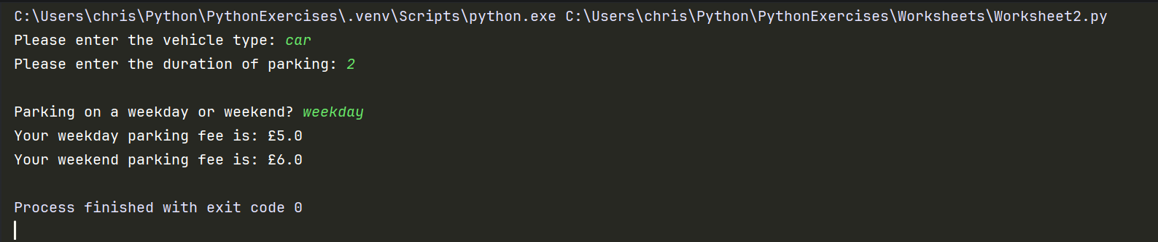

Result - No
It did behave as I expected it to however it should only display your weekday parking fee, the conditional logic will need to be looked at to amend this.

- 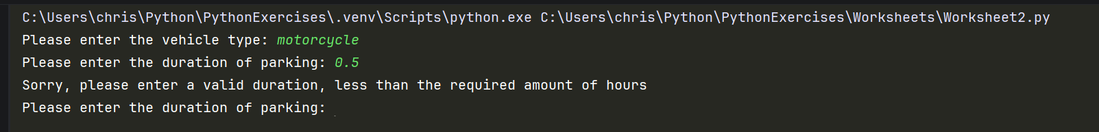
Result - Yes
Test executed as expected.

- 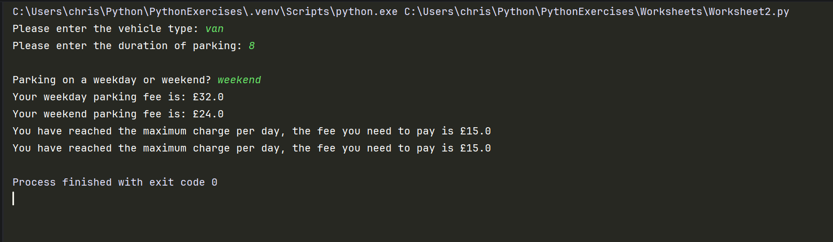

Result - No
It is working as expected however the console shouldn’t prompt the user for weekday parking and display 2 messages stating maximum charge per day.

- 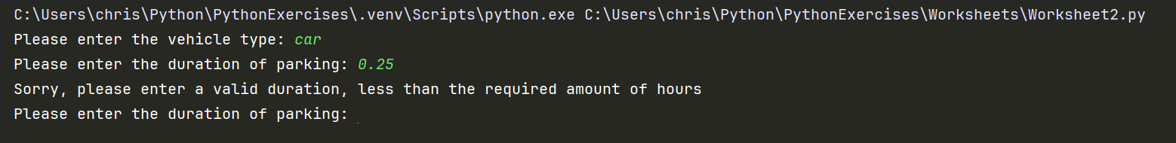
Result - Yes
Working as expected.
- 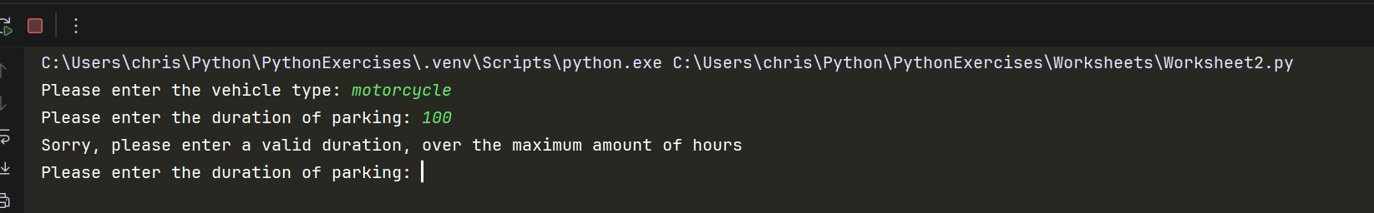
Result - Yes
Working as expected.
Vi) 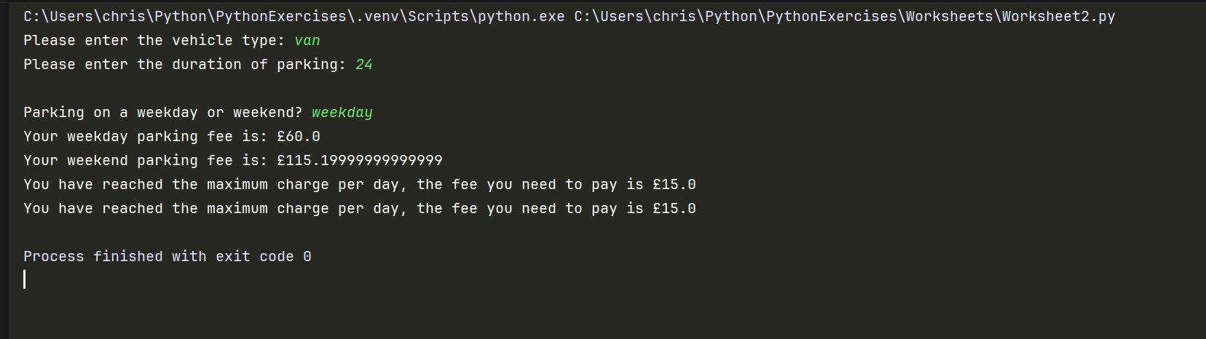
Result - No
This test worked as I expected it too given the other tests. I would need to adjust the conditional logic as it is printing out more messages to the console than needed.

- 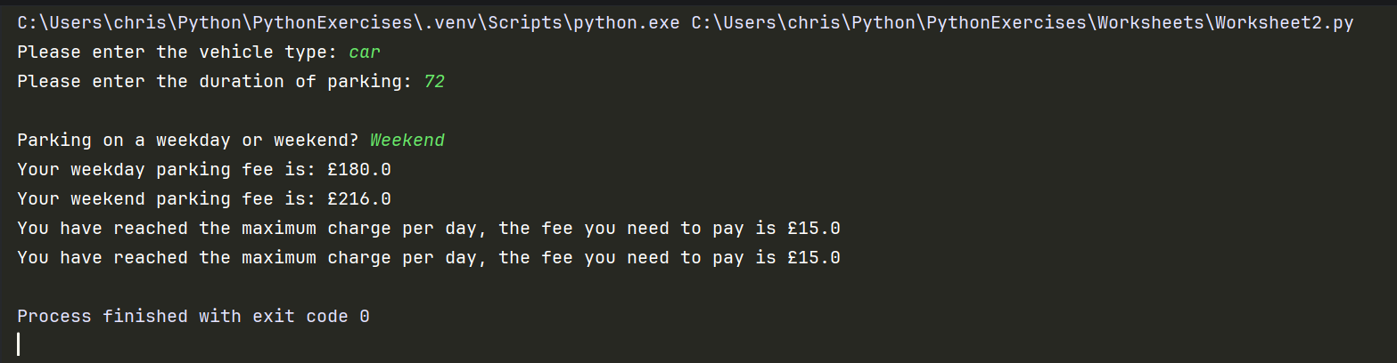
Result - No
This test worked as expected given the other test. However some things to look at.

- 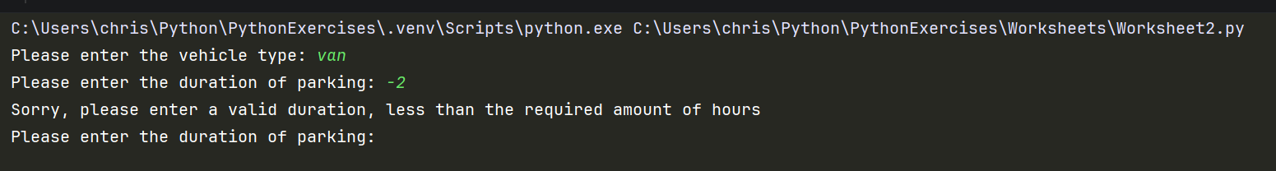
Result - Yes
This test is working as expected.
- 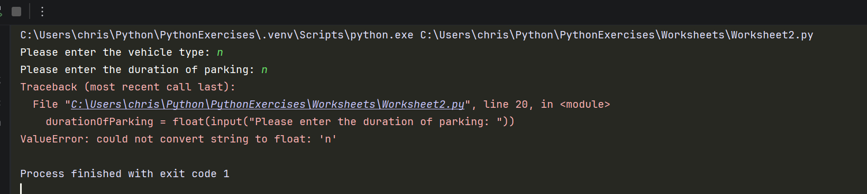
Result - No
This let me put n in for vehicle type as it is a string variable so would need to add validation to stop user from entering unwanted characters.
- 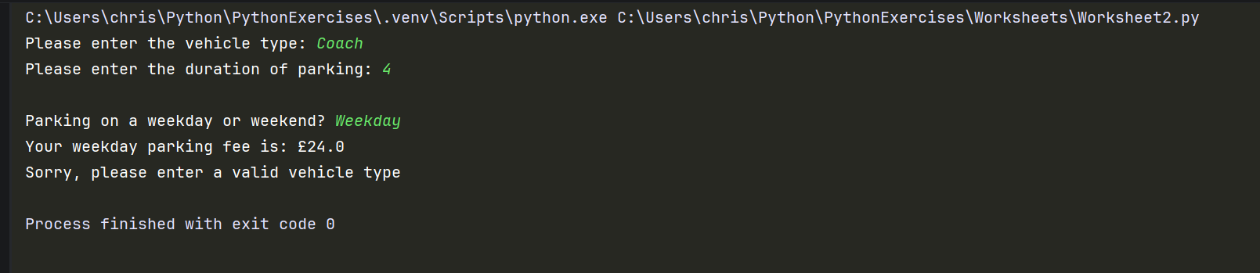
Result - No
This test is not working as expected, wouldn’t expect to see message asking to enter valid vehicle type. However, everything else is working as expected.
- 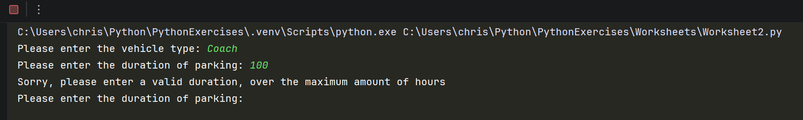
Result - Yes
Test working as expected.
Result - False
This is accepting 5 as a string, would need to add validation to stop users from entering numbers.

