Student name: Hina Saeed
Student ID number: 2513317
Programme: Master of Business Administration
Module: Marketing Management
Module code: LCMB7024
Lecturer: Taonga Kaonga Sobere-Snithers

Table of Contents
1. Introduction 3
2. Segmentation, Targeting, Differentiation and Positioning (STDP). 3
2.1 Market Segmentation 3
2.2 Targeting Strategy 5
2.3 Differentiation Strategy 6
2.4 Positioning Strategy 7
3. Marketing Mix (7Ps) Tesla Home Energy Hub. 8
4. Reflection 13
5. References 15
6. Appendix 17
1: Brand Extension Poster Presentation 17

TESLA
Brand Extension Proposal: Tesla Home Energy Hub

1. Introduction
This analysis is a strategic brand extension proposal of Tesla in the residential renewable energy market. It uses the major marketing management models, such as Segmentation, Targeting, Differentiation and Positioning (STDP) and the extended marketing mix, to analyse the commercial feasibility of the proposed Tesla Home Energy Hub. The analysis focuses on the attractiveness of the market, the new trends in sustainability, and competition forces affecting strategic decision-making. Moreover, the report evaluates the compatibility of the extension with the environmental goals and long-term brand equity.

2. Segmentation, Targeting, Differentiation and Positioning (STDP).
Segmentation, Targeting, Differentiation and Positioning (STDP) is the systematic approach to recognising appealing markets and developing competitive advantage (Kotler et al., 2024). In the case of Tesla Home Energy Hub, STDP is especially significant since the smart home energy market is a technologically sophisticated, capital-intensive, and competitive market globally. According to the International Energy Agency (IEA, 2023), the residential solar PV capacity increased by over 30 percent worldwide in 2022, and battery storage expanded twice in 2022 as compared to 2021. These trends imply high growth of demand and at the same time growth in competition and therefore requires accurate strategic focus.

2.1 Market Segmentation
Market segmentation separates a heterogeneous market into different segments that share similar needs and behaviours (Kotler et al., 2024). In the case of Tesla, geographic, demographic, psychographic, and behavioural variables are effective segmentation variables that improve strategic clarity.
- Geographic Segmentation
The major geographic target must be developed economies with a well-developed renewable infrastructure and favourable policy framework, specifically the United States, Western Europe, and China. The IEA (2023) reports that these areas are the locations of most residential solar growth in the world. In these markets, the high electricity-price markets like California and Germany offer more economic incentives to energy optimisation systems. The most viable sub-segment is the urban and suburban homeowners because of the property ownership and installability. Nonetheless, the difference in regulations between jurisdictions creates complexity in operations and compliance risk.
- Demographic Segmentation
The core segment is the group of homeowners aged between 30 and 55 years with high and upper-middle income levels. Solar and battery systems are integrated systems that demand high initial investment, which in most cases is above 20,000 dollars and disposable income is a very crucial variable. Deloitte (2023) confirms that the use of renewable technology is positively correlated with income and education. The current customer base of Tesla is very similar to this demographic, which allows cross-selling and ecosystem growth.
- Psychographic Segmentation
The focus of this strategy is psychographic factors. The target market appreciates sustainability, innovation and technological sophistication. According to McKinsey (2023), more than 60 percent of consumers are taking into account environmental impact when making a purchasing decision, and more of the affluent households are more engaged. Such consumers view the renewable adoption as a practical investment and an identity (Belz and Peattie, 2012). The brand of Tesla is highly innovative and fits this mentality. Nevertheless, increasing scepticism regarding environmental assertions implies that Tesla will have to prove quantifiable carbon and cost-saving to remain credible.
- Behavioural Segmentation
Tesla should focus on early adopters and current users of the ecosystem behaviourally. Rogers (2003) emphasises early adopters as being important in speeding up diffusion of innovation. The existing Tesla EV and Powerwall customers are a high-value market since they are familiar with the brand and have lower perceived risk. Accenture (2024) observes that ecosystem integration has the potential to double customer retention and lifetime value. Nonetheless, the use of early adopters may slow down the expansion to the wider market.

2.2 Targeting Strategy
Tesla ought to use differentiated targeting strategy. The main target audience is high-income environmentally conscious homeowners who are already involved in smart home or EV technologies. This segment is a combination of buying strength and strong compatibility with the ecosystem.
One of the secondary targets is the premium property developers who have introduced sustainability to new residential developments. According to the World Green Building Council (2023), there is an increasing demand in energy-efficient housing, and the creation of partnership opportunities that instal Tesla systems at the construction phase will minimise the barriers to retrofit.
Although premium targeting is compatible with Tesla brand, the price sensitivity is heightened by competition in the battery provider market by LG Energy Solution and Sonnen. Thus, Tesla has to fight on integration, AI optimisation, brand trust, not price. Funding approaches or energy services on subscription might expand access and maintain premium positioning.

2.3 Differentiation Strategy
Differentiation establishes high perceived value (Porter, 1985). The ecosystem integration, AI capability, brand equity, and sustainability leadership form the basis of Tesla differentiation.
To begin with, Tesla combines solar panels, battery storage, EV charging, and smart energy management into one platform. A large number of competitors provide separate components, which create fragmented experiences. Integration increases switching cost and convenience.
Second, predictive optimisation with AI enhances efficiency by controlling the consumption patterns and charging cycles. PwC (2024) lists AI-based energy management as one of the primary sources of residential cost savings and resilience.
Third, Tesla has a good brand equity, which lowers the perceived risk of purchase and favours high prices (Keller, 2013). Nevertheless, differentiation should be backed by clear performance measures. Inability to deliver on efficiency gains may undermine trust and brand image.

2.4 Positioning Strategy
Positioning identifies the perception of the offering in comparison to the competitors (Kotler et al., 2024). Tesla ought to market the Home Energy Hub as an upscale, smart, and complete renewable energy system to the future-oriented homes.
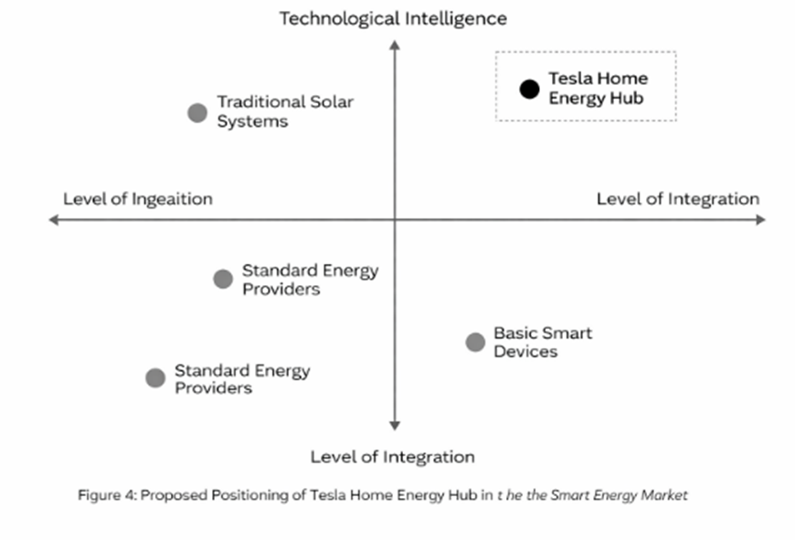
Proposed Positioning Statement.
To the eco-friendly homeowner who wants to be energy independent and minimise carbon footprint, the Tesla Home Energy Hub provides an all-encompassing, AI-driven renewable energy system that optimises energy usage and minimises carbon impact, as opposed to fragmented smart energy systems that do not integrate.
The STDP approach is very compatible with macro-environmental forces, such as increasing energy prices, ESG investment development, and distributed renewable energy development (IEA, 2023; UNEP, 2023). The cross-selling and retention are improved by the ecosystem advantage of Tesla.
Risks however include high capital requirements, regulatory diversity, technological imitation and economic downturns that impact discretionary spending. Tesla needs to integrate technological leadership with affordable financing and articulation of quantifiable financial and environmental value to achieve sustainable growth.

3. Marketing Mix (7Ps) Tesla Home Energy Hub.
The marketing mix offers an operationalisation approach to strategic goals and value delivery to the target consumers (Kotler et al., 2024). In the case of Tesla Home Energy Hub, the 7Ps framework, which includes Product, Price, Place, Promotion, People, Process and Physical Evidence, makes sure that it is in line with the STDP strategy. All of the elements are meant to support the branding of Tesla as a high-end, AI-driven, integrated renewable energy system to the environmentally conscious households.

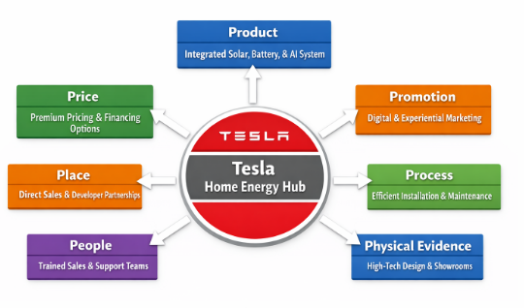
1. Product
Tesla Home Energy Hub is an all-in-one system that includes solar panels, Powerwall battery storage, EV charging, and AI-based energy optimisation. A brand extension product strategy should be coherent with the core brand identity to enable its acceptance by the consumer (Aaker, 2021). The image of Tesla as an innovative and sustainable company helps consumers believe that the Hub has a better technological performance and environmental effect. Unity of all elements in one ecosystem makes it less complex and more convenient than modular solutions of competitors, which results in a high differentiation advantage (Accenture, 2024). The AI-based optimisation enables the predictive control of energy consumption, saves money and enhances the efficiency of the system, which is attractive to early adopters and environmentally responsible consumers. In addition, the fact that Tesla provides constant software updates, maintenance, and real-time monitoring enhances reliability and creates trust, which is essential in products with high investments by households (Kotler et al., 2024).
2. Price
Pricing is a strategic instrument that indicates quality and places the product in the market (Nagle and Muller, 2022). In the case of Tesla Home Energy Hub, a premium pricing strategy based on value is suitable, as the system is integrated, has AI features, and Tesla has a high brand equity. Premium pricing conveys exclusivity and technological advantage whereas tiered package pricing enables the entry into various consumer sub-segments. Also, large initial investment could become an obstacle, and financing opportunities like instalment plans, leasing, or energy-as-a-service model are essential to adopt (World Bank, 2023). The economic advantages of the Hub such as long-term savings on energy and government incentives should also be emphasised by Tesla to justify the cost. Although Tesla faces competitive substitutes in the form of LG Energy Solution and Sonnen, the pricing strategy focuses on the performance of the system and integration with the ecosystem instead of price competition, which supports the premium positioning (IEA, 2023).
3. Place (Distribution)
Distribution makes the product easily and effectively accessible to the target consumers (Kotler et al., 2024). Tesla can apply a hybrid distribution approach to Home Energy Hub, which is direct-to-consumer channels with strategic B2B relationships. Personalised consultation, system customisation, and high-quality installation is facilitated by direct contact via Tesla showrooms and the company site, which supports the high-quality brand experience (Accenture, 2024). Premier property developers are strategic partners that may offer opportunities to incorporate the Hub into new-build homes, which would make retrofit less complex and make adoption efficient. In addition, the current network of Tesla services and EVs and Powerwall can be used to provide continuous installation, maintenance, and software upgrades, improving the reliability and convenience of use after sales. Nevertheless, the international growth will involve overcoming the regulatory complexity and local installation requirements, which can limit the fast-scale expansion in certain areas (IEA, 2023).
4. Promotion
Promotion conveys worth, reinforces brand equity, and leads to adoption (Kotler et al., 2024). Tesla needs to employ the multi-channel promotion strategy that incorporates digital marketing, experiential interaction, and content-based communication. The digital campaigns should be focused on the more affluent and environmentally conscious homeowners with an emphasis on the integrated features of the Hub, AI optimisation, and environmental benefits (McKinsey, 2023). Showroom marketing can be done through experience marketing where the consumer can have a live demonstration of the Hub, visualising on how much energy will be saved and how convenient the system will be. The credibility and reach can be improved through strategic partnerships with sustainability organisations and green building councils in order to reach developers and eco-conscious households. The use of content marketing such as case studies, energy-saving reports and customer testimonials enhances trust and reduces perceived risk in high-investment purchases, especially in a time when consumers are hypersensitive to greenwashing (Belz & Peattie, 2012).
5. People
High-involvement products and services require the critical role of people (Kotler et al., 2024). The sales and support staff of Tesla should be proficient in technical specifications, AI functionality, and financing options to train consumers and make purchasing decisions. Customer support teams should offer responsive post-installation service to ensure customer satisfaction, build trust and ensure long term adoption. Quality integration and delivery of projects on time can be guaranteed by dedicated relationship managers who are in charge of property developer partnerships. Together, the experienced staff strengthens the high-end positioning of Tesla and makes the brand stand out in terms of the best customer experience.
6. Process
Process is defined as the processes by which the product is delivered, installed, and maintained (Kotler et al., 2024). Tesla needs to create standardised and efficient installation and service processes that are reliable and reduce consumer friction. Convenience is increased through pre-installation tests of property energy requirements, synchronised component supply, and automated system calibration. Predictive maintenance based on AI enables the optimisation of energy consumption and system performance in advance. Live tracking will offer feedback on the ongoing improvement, and the consumers will get tangible gains, and Tesla will reinforce its reputation as a brand that is innovative and technology-oriented.
7. Physical Evidence
Physical evidence assists consumers to assess high-investment products by giving them tangible evidence of quality (Kotler et al., 2024). The slick high-tech appearance of solar panels, Powerwall units, and EV chargers can be used by Tesla to strengthen brand prestige. The visible manifestation of AI-driven optimisation and efficiency is the digital interface like intuitive applications to track energy performance. Live installations and showroom demonstrations enable consumers to feel the ecosystem, which builds credibility and perceived value. All these physical evidences reinforce the premium positioning of Tesla as they make the advantages of the integrated Hub tangible and visible to the consumers.
The marketing mix of 7Ps shows a high level of consistency with the STDP strategy of Tesla. The premium positioning of the brand is supported by product integration, AI optimisation and sustainability differentiation. Pricing and financing strategies bring exclusivity and accessibility, whereas distribution and people strategies increase trust, customer experience and scalability. The clear value propositions are communicated through promotion and physical evidence, and the efficient processes strengthen the reliability of the system and ecosystem convenience. Nonetheless, the major obstacles may be the high capital costs, the complexity of the regulations, and the threat of being imitated by the competitors. To maintain competitive advantage, mitigation should be based on available financing, ongoing technological development, and open performance reporting (Kotler et al., 2024; IEA, 2023; PwC, 2024).

4. Reflection
The Tesla Home Energy Hub brand extension was a good experience of testing the theoretical marketing concepts in the real world. In the process, I was able to learn more about strategic models like STDP and the 7Ps marketing mix, and the ways in which they interrelate to develop consistent brand strategies. The segmentation, targeting, differentiation and positioning analysis helped me to better understand how to identify consumer groups, evaluate the potential of the market and explain strategic decisions based on both qualitative and quantitative information. The combination of demographic, psychographic and behavioural aspects promoted critical thinking, especially in the balancing of the high positioning of Tesla with the necessity to attract the first adopters and high income families. This exercise further supported the necessity of basing strategic recommendations on the trends in the industry, including the growing residential solar use, AI-based energy management, and ESG-based consumer behaviour (IEA, 2023; Deloitte, 2023).
The marketing mix aspect also enhanced my operationalisation of strategy. To translate the STDP insights into actionable decisions, product, price, place, promotion, people, process, and physical evidence, interdependencies among each of the elements had to be taken into account. As an example, I realised that the high prices should be supported by the performance of the integrated systems, AI optimization, and brand equity, and the distribution strategy should be such that it would provide convenience without reducing the quality of the services. Creating the 7Ps diagram and visually matching it with the brand message helped me to enhance my knowledge of strategic communication and the role of clarity in communication of complicated marketing ideas.
The process of preparing and delivering the poster presentation was also informative. The need to summarize a large amount of research in a brief, visually stimulating format necessitated prioritisation and generalisation of the main findings. The practise of delivery facilitated the enhancement of my skills in articulating complex ideas in a clear and confident manner, which underscores the importance of storytelling in marketing communication. I also got to know how to foresee the possible questions that the stakeholders may have and justify them with evidence-based arguments, which is a necessary skill in the field of consultancy and professional marketing.
On the whole, this project helped me to develop both personally and professionally. It has improved my analytical, research and presentation skills, as well as strategic thinking and problem solving skills. In the future, I would like to enhance my practise by using more sophisticated data analytics to forecast the market and using interactive tools to communicate visually. A prior involvement with industry knowledge and stakeholder views might also enhance the practicality of future projects. This has strengthened the need to combine theoretical concepts and practical application and it will guide my future approach to strategic marketing issues.

5. References
Aaker, D.A. (2021) Brand Relevance: Making Competitors Irrelevant. San Francisco: Jossey-Bass.
Accenture (2024) Energy Consumer Survey 2024: The Rise of Integrated Energy Ecosystems. Available at: https://www.accenture.com (Accessed: 2 February 2026).
Belz, F.M. and Peattie, K. (2012) Sustainability Marketing: A Global Perspective. 2nd edn. Chichester: John Wiley & Sons.
Deloitte (2023) 2023 Renewable Energy Industry Outlook. Available at: https://www2.deloitte.com (Accessed: 3 February 2026).
IEA (2023) Renewables 2023: Analysis and Forecast to 2028. Paris: International Energy Agency. Available at: https://www.iea.org/reports/renewables-2023 (Accessed: 1 February 2026).
Keller, K.L. (2013) Strategic Brand Management: Building, Measuring, and Managing Brand Equity. 4th edn. Harlow: Pearson Education.
Kotler, P., Keller, K.L. and Chernev, A. (2024) Marketing Management. 16th edn. Harlow: Pearson.
McKinsey & Company (2023) The State of Climate and Sustainability 2023. Available at: https://www.mckinsey.com (Accessed: 4 February 2026).
Nagle, T.T. and Müller, G. (2022) The Strategy and Tactics of Pricing: A Guide to Growing More Profitably. 7th edn. New York: Routledge.
Porter, M.E. (1985) Competitive Advantage: Creating and Sustaining Superior Performance. New York: Free Press.
PwC (2024) AI in Energy: Transforming Residential Energy Management. Available at: https://www.pwc.com (Accessed: 5 February 2026).
Rogers, E.M. (2003) Diffusion of Innovations. 5th edn. New York: Free Press.
UNEP (2023) Emissions Gap Report 2023. Nairobi: United Nations Environment Programme. Available at: https://www.unep.org/resources/emissions-gap-report-2023 (Accessed: 2 February 2026).
World Bank (2023) Scaling Solar and Energy Storage in Emerging Markets. Washington, DC: World Bank. Available at: https://www.worldbank.org (Accessed: 6 February 2026).
World Green Building Council (2023) Global Status Report for Buildings and Construction 2023. Available at: https://www.worldgbc.org (Accessed: 4 February 2026).

6. Appendix

6.1: Brand Extension Poster


