

E-Portfolio

ECPS4018- Study Skills

2314129 (Louis Cursio)

Contents page

Article summary........................................................................................................................................... 3
Infographic................................................................................................................................................... 4
Assignment plan .......................................................................................................................................... 5
Library search............................................................................................................................................... 6
Source use summary.................................................................................................................................... 7
References................................................................................................................................................... 8

Article summary (300 words)
Nendick (2022), suggests there is a link between music and emotion and how it is a part of one’s day to day life. The author discusses the question: How does music make you feel? ‘Music is a significant part of the everyday lives of many of us’ (Nendick, 2022). It suggests that music can play an instrumental role in people's lives and can make them feel a particular way.
In their research the author found that major music sounds can connote happiness and minor sounds can make the listener feel melancholy. During the research they asked the question does music have an influence on modern culture? Although it is suggested that music can have an impact on the way we feel, it is also inferred that there are external and internal factors such as social context and physical environment, also, emotional state.
The BRECVEMA framework is an acronym for eight psychological mechanisms which show us how music can influence ones emotions, however, there is much scope for further research into emotional responses from the music (Juslin & Västfjäll, 2008; Juslin, 2013). Most of us will have memories attached to some songs, perhaps of a specific event or period of time, or about a person or place, and these can have a strong impact on how a song makes us feel (Belfi et al., 2016)
Major music is suggested to be better at relieving stress than minor music. However, it is important to know that music does not induce feeling in everyone. People who have little to no pleasure listening to music have music anhedonia and people who are the complete other end of the scale is musicophilia.

Infographic
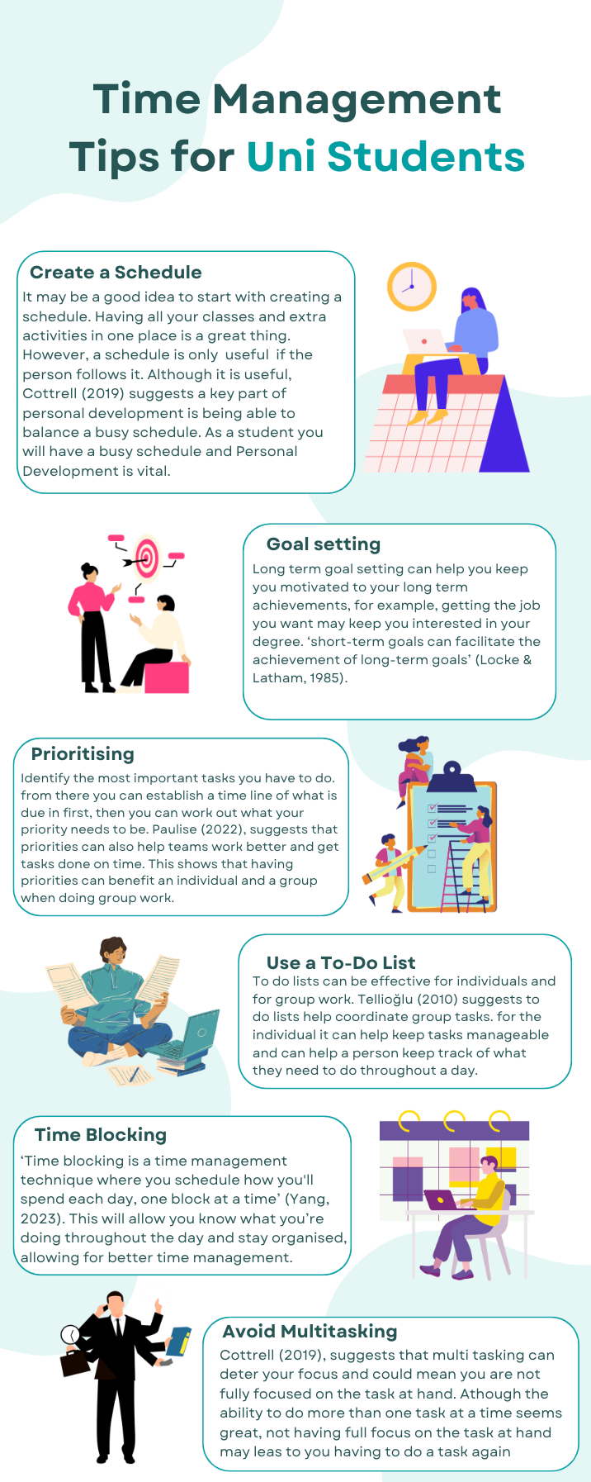
Assignment plan

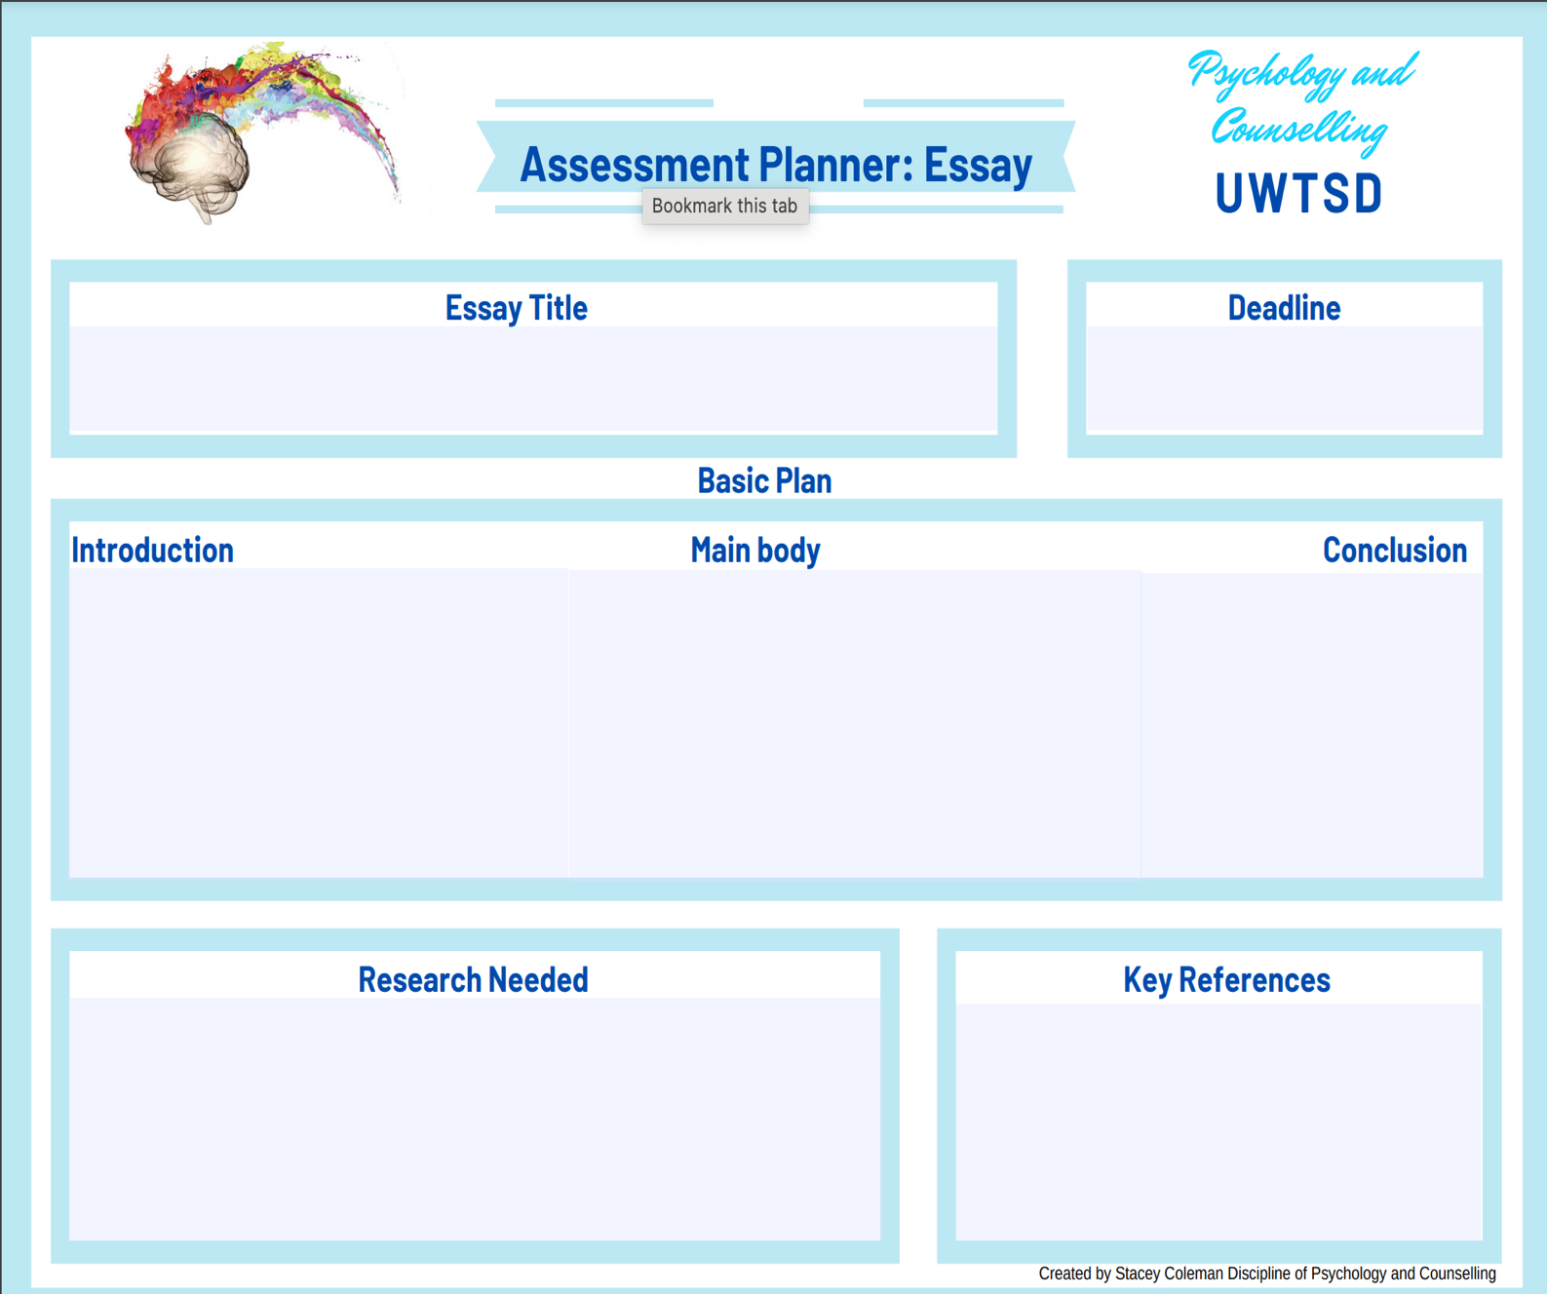
British Psychological Society. (2023). Occupational psychologist job profile. https://www.bps.org.uk/occupational-psychologist-job-profile

British Psychological Society. (2023). Code of Ethics and Conduct. https://www.bps.org.uk/guideline/code-ethics-and-conduct

BPS code of conduct
BPS Training to becoming an Occupational Psychologist.
Ethics surrounding an Occupational Psychologist role.
This section will be a summary of the document as a whole. It will include the main topics: the key professional and personal developments I am required to make.
This section will include: Ethical concerns within the case study. It will also include: Personal and professional developments I would need in order to be competent within an Occupational Psychologist.
This section will include: An introduction to the case study, what an Occupational Psych is. Finally, the training routes to becoming an Occupational Psychologist.
28/11/23
Ethical, Personal and Development needs for an Occupational Psychologist
Library Search

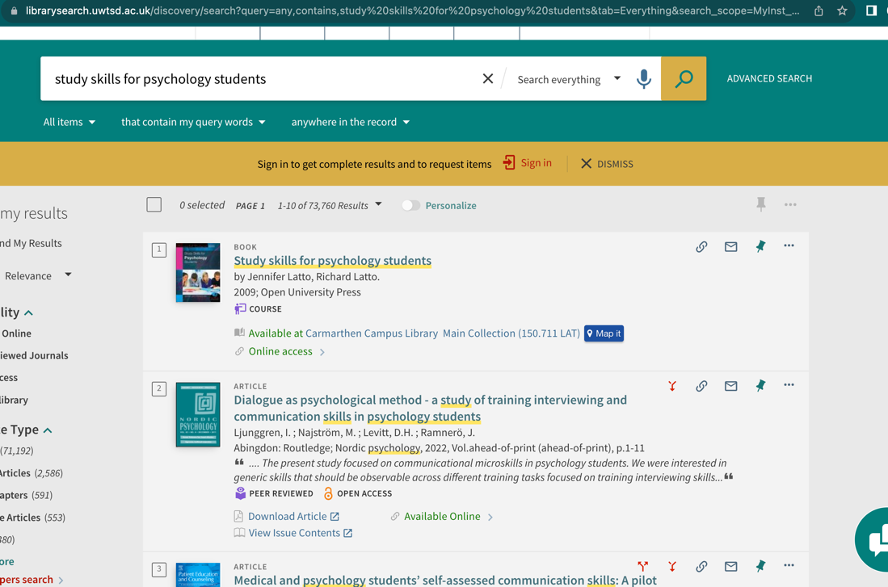

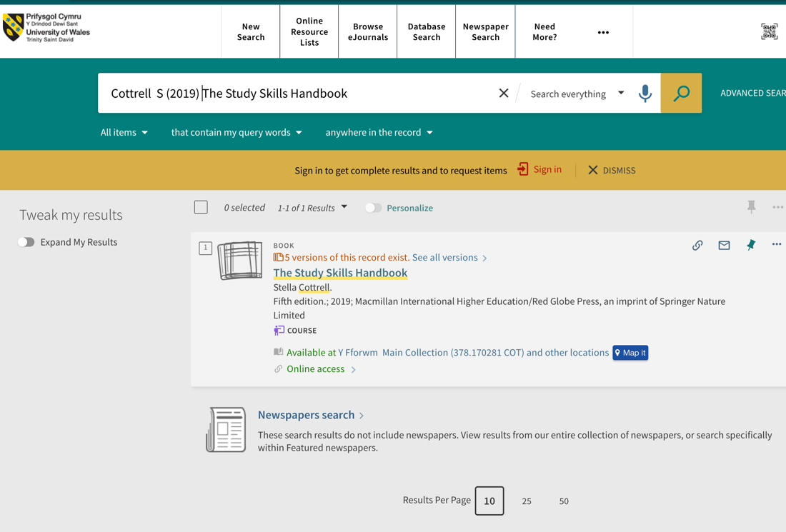

Summary of sources
Before I decide on what sources I will use, I will first determine whether they are relevant, peer reviewed, reliable and of recent time. I have chosen to use both Cottrell’s Study skills handbook and Study skills for psychology students for a plethora of reasons. Firstly, I believe both to be relevant to the task. Both books are regarding psychology students and helpful things to encourage students to do well. Furthermore, Cottrell’s book is from 2019 and study skills for psychology students is from 2009. Although the Cottrell book is more recent, it is good to have a range of help from previous years. Due to the book being about study skills, although it is older it can still apply to study skills today. Finally, both books are suggested from lecturers in UWTSD and can be found within the library, thus making them reliable for students to use.

References
Belfi, A. M., Karlan, B., & Tranel, D. (2016). Music evokes vivid autobiographical memories. Memory, 24(7), 979-989.
Cottrell, S. (2019). The Study Skills Handbook (Fifth edition.). Macmillan International Higher Education/Red Globe Press, an imprint of Springer Nature Limited. P.39
Juslin, P.N. & Västfjäll, D. (2008). Emotional responses to music: The need to consider underlying mechanisms. Behavioral and brain sciences, 31(5), 559-575.
Locke, E. A., & Latham, G. P. (1985). The application of goal setting to sports. Journal of Sport and Exercise Psychology, 7(3), 205-222.
Paulise, L. (2022). Forbes. 5 Tactics to help your team prioritise work. https://www.forbes.com/sites/lucianapaulise/2022/12/22/5-tactics-to-help-your-team-prioritize-work/?sh=3bf2cec34646
Tellioğlu, H. (2010). Coordination of work by using to-do lists: Practices and requirements. In Proceedings of the International Conference on Information Technologies (InfoTech-2010). Elena, Bulgaria: InfoTech.
Yang, A. (2023). 3 time blocking methods to boost productivity. https://zapier.com/blog/time-blocking-method/

