Principles of Health and Social Care Practice
Student name: Emeline Tatiana Loemba Yagazou
Student ID:2416832
Module name:Principles of Health and Social Care Practice
Component:1
Module code:BMHP5016
Lecturer name: Lou Wells

Table of Contents
1.Task 1: Reflection on the Importance of the Principles of Health and Social Care 3
2.Task 2: Practical Example of the Concepts in Practice 4
3.Task 3: Self-Reflection as a Health and Social Care Professional 6
4.Conclusion 9
5.References 9

1.Task 1: Reflection on the Importance of the Principles of Health and Social Care
In the United Kingdom health and social care rely on three concepts which work in harmony: person centred care, partnership working, and ethics. These all shape the way the care is experienced, but none of them is effective on its own. In this section we examine why each principle is important, and how much value is gained against the practical challenge of applying it.
Person centred care is about meeting a person's needs, desires and values rather than their diagnosis. This is supported by Maslow's hierarchy of needs as follows: Physical safety and treatment are not the only needs that need to be satisfied, people also need to feel respected and have the opportunity to make their own decisions. There have been recent developments to demonstrate that this individualized focus in care planning leads to improved care experiences and outcomes and to better protection of dignity for people. Nevertheless, this term is not used for all services in the UK. The term “person centred” can be used by services as a policy rather than a particular way of working and they can claim this while providing fairly standardised care . One of the strongest guarantees of an individual's dignity and autonomy is also person centred care – but it must be part of the way a service is delivered rather than merely part of the service description (Forsgren et al., 2025).
Partnership working means health and social care professionals, patients and their families working together to provide co-ordinated care. This is promoted in England via the development of ‘Integrated Care Systems' by the Health and Care Act 2022, which aims to enhance partnerships, planning and sharing of information between NHS organisations and local government (NHS England, 2023). But these NHS-led systems do not always give equal weight to adult social care providers which can lead to decisions that do not adequately consider social care views (Thomson and Chatterjee, 2024).
Ethics institutes a set of principles for healthcare professionals to use as a guideline for making tough decisions. They are united by a consistent and defensible approach to decision making in UK practice, as supported by the Nursing and Midwifery Council's Code, which are supported by the four principles of Beauchamp and Childress (1994): autonomy, beneficence, non-maleficence and justice. These principles are not always in harmony though, especially when balancing autonomy and patient safety falls short when it comes to patient safety. The Mental Capacity Act 2005 aims to address this by introducing a legal procedure to determine capacity to make a decision; this is to be based on professional values and on legislation rather than on the individual's professional judgement alone.
These three principles should not be regarded as individual boxes to be ticked. In many cases, partnership working offers the structures that are required to achieve this goal, while ethics offers the guardrails when the two do part ways, as illustrated in the following figure: Figure 1: Partnership working and ethics as structures for person-centred care (Fraser and Mays, 2024).
Figure 1. How person-centred care, partnership working and ethics interact to produce quality care (author's own diagram, based on the Health Foundation's principles and the NMC Code).
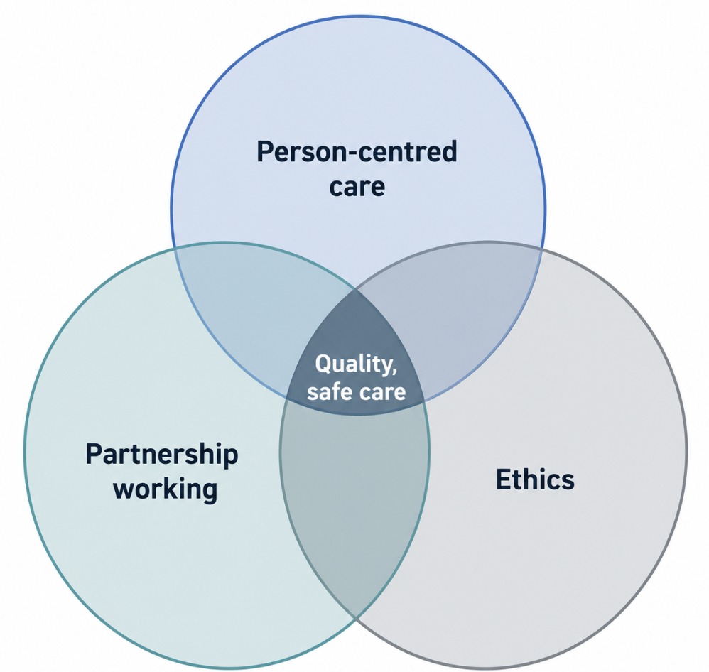

2.Task 2: Practical Example of the Concepts in Practice
Mrs A is an 82 year old (composite, not a real patient) chronic obstructive pulmonary disease and early stage dementia who has been admitted to hospital for discharge planning. She is the only one in her house and she would like to go back home. Her case demonstrates the interplay of the three principles in a “typical” UK hospital and care environment and the challenges that remain with the “joined up” approach.
Person-centred care influenced the point from which she came up with her discharge plan. The team didn't just assume that a residential placement would be the safest option, but started with Mrs A's wish to remain living in her own home in relation to the Care Act 2014 'wellbeing principle' which prioritises the views and outcomes of the person being looked after when needs are being assessed (Care Act 2014). This gave her a plan which was not based on the easiest service but one which was based on her time and tastes.
This was implemented through partnership working. Working in collaboration, a multidisciplinary team, comprising a nurse, GP, occupational therapist and social worker, worked with Mrs A and her family, due to the Health and Care Act 2022 (Health and Care Act , 2022) coming into effect. Table 1 details how each principle applied to a particular legal basis and action in her case.
Principle | Key legislation / policy | How it appeared in Mrs A's case
Person-centred care | Care Act 2014 (wellbeing principle) | Discharge plan built around her stated goal of staying at home
Partnership working | Health and Care Act 2022 (Integrated Care Systems) | Joint MDT and family decision-making across health and social care
Ethics | Mental Capacity Act 2005; NMC Code (2018) | Formal capacity assessment instead of an assumed 'unsafe' decision
Table 1. Mapping of person-centred care, partnership working and ethics to legislation and practice in the case example.
Ethics was incorporated into the plan because the team assumed Mrs A was not able to consider returning home herself, when this was actually tested by carrying out a formal Mental Capacity Act 2005 assessment. This was a means of preserving her autonomy, rather than giving way to her fears of the unknown by making safety the automatic choice, and consequently provided her with protection by following a legal and documented path.
There is more evidence to support this kind of joined up working: reviews of integrated care in the UK have found that, when well implemented, closer working between health and social care benefits the reduction of avoidable readmission and delay (Thomson and Chatterjee, 2024). The real challenge in reality, however, is timing – social care is often integrated into discharge planning at a late stage in the process, as indicated by the evidence, and the influence and strength of social care's voice may be weaker in place-based ‘Health and Care Partnerships’ led by the NHS (Thomson and Chatterjee, 2024). For Mrs A, this would be demonstrated by the social worker being called for availability when it would not have been their professional opinion.
So for UK practice in more general terms, that means there is one specific, but very important action to take: social care must be integral to discharge and care planning discussions from referral, not added to the mix when a plan is in place; every capacity and best interests decision should be documented rather than assumed. In this way the principles of person-centred care, partnership working and ethics become one integrated process ensuring the person's independence and safety too.

3.Task 3: Self-Reflection as a Health and Social Care Professional
The section has been written in the first person, and has been structured according to Gibbs' (1988) Reflective Cycle (Figure 2) which enables the reflection to be kept systematic rather than a narration of events.
Figure 2. Gibbs' (1988) Reflective Cycle
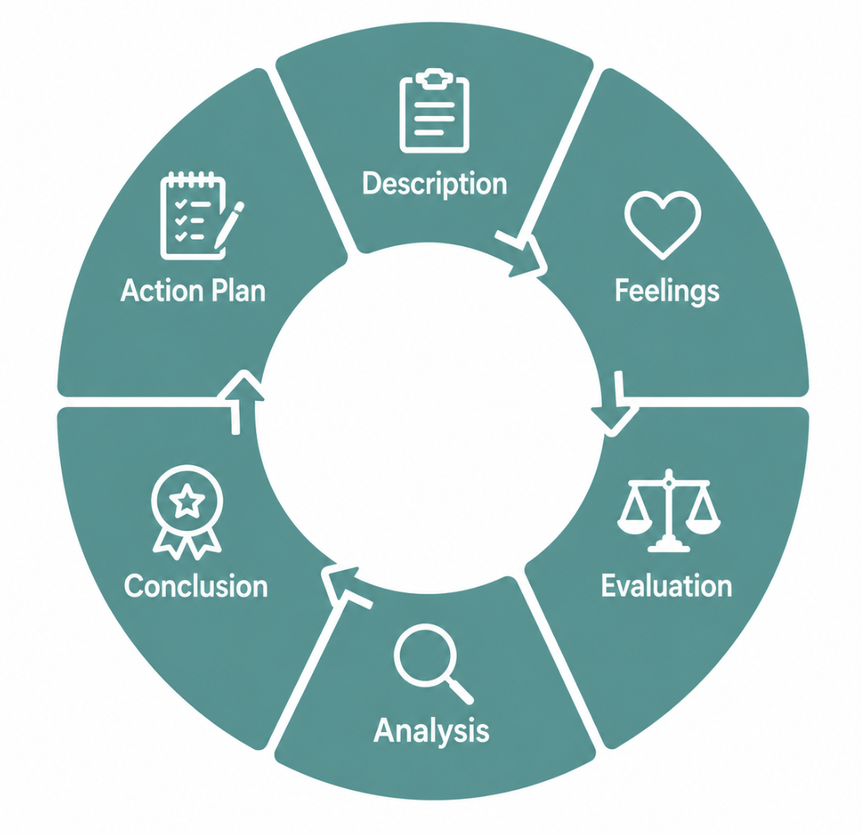

Description
During my placement, I supported the team working on Mrs A's discharge – preparing background information for the multidisciplinary meeting and speaking with Mrs A and her daughter about what mattered most to her before the plan was finalised (Rutherford et al., 2025).
Feelings
The first time I attended the meeting I was really not sure what to expect. I didn't want to say the wrong thing about her capacity, and I could see that Mrs A wanted to go home and the team was worried about her safety were both reasonable. I also had a slight sense of obligating myself to her, because what I returned with my conversation with her was part of the plan (Gibbs, 1988).
Evaluation and analysis
Perhaps the most effective component of my practice was to listen to what Mrs A had to say and take her stated goal seriously. It was important to make her autonomy and belonging visible to the rest of the care team to report her clinical state and also ask her what she wanted, as Maslow's hierarchy of needs implies that care begins with meeting her physical needs, but goes beyond it ( Maslow, 1943). This is also consistent with the Care Act 2014, which is based on the wellbeing duty for practitioners for assessments to be made around a person's own outcomes (Care Act 2014).
At the multidisciplinary meeting, I had a hard time asserting myself when it came to the point of having the child placed, as the discussion was moving toward a 'safety first' placement, while Mrs A's voice was loud and clear that she wanted 'to stay at home'. This is a typical difficulty to face in practice, as newer professionals may not be sure of giving the individual's voice the same attention even when in partnership arrangements set out by the Health and Care Act 2022 (Thomson and Chatterjee, 2024). This experience was a great reflection of the difference between what was expected of the policy and what was done in practice and reinforced my reflective learning.
The placement was a time to see that in practice, implementing the Mental Capacity Act 2005 is more difficult than understanding it in theory. It took careful judgement to decide whether Mrs A should stay in her home or leave it, given her wish for independence. The Nursing and Midwifery Council's Code places a strong emphasis on the need to respect an individual's right to make their own choices, as it is a professional duty (Nursing and Midwifery Council, 2018). This principle made me not assume that I know better, not assume that I have the right to dictate to Mrs A what she should do, even if I don't know what it is.

Neutral writing doesn't exist in this context either: reflective writing. After analysing insights from nurses' use of Gibbs' cycle following challenging experiences, the researchers discovered that nurses' reflections were found to be of benefit in the early stages of their careers to develop their clinical thinking, but also that some nurses were concerned that a written reflection might be a permanent record held against them later in their practice, thereby encouraging cautious rather than candid writing (Li et al., 2020). There is a bit of that same warning that resonated with me when I wrote this reflection and it is better to call that out than to keep it under a blanket (McCormack et al., 2021).
Conclusion (of the cycle)
In this case, I would have made one sentence in advance to share, putting the other individual's words back into the discussion exactly when the discussion goes towards a decision, so that what matters to them is not lost when the clinical and safety arguments begin.
Action plan
For the next year, I'm going to improve my knowledge and confidence around three vital areas. Firstly I will undertake formal training on Mental Capacity Act 2005 to enhance the application of the legal principles with confidence in practice. Second I will organise to observe a social worker to understand the Care Act 2014 assessment and value the social care input to multidisciplinary working. Third, I will keep a reflective journal based on Gibbs' reflective cycle after multidisciplinary meetings, rather than justify, in a way of honest self-evaluation (Li et al., 2020). I will also stay updated on the evolution of Integrated Care Systems and NHS policy so that my work continues to reflect changes in partnership working practice.

4.Conclusion
The concepts of 'partnership working', 'ethics' and 'person centred care' are all important in health and social care practice. They are together responsible for decisions being made in respect to the individual's needs, values and preferences and not in terms of organisational priorities. But their success relies on effective partnership working, on the partnership of social care and ethical decision-making in complex situations. I was able to see my strengths and my areas for development after having reflected on Mrs A's case. This experience has given me a direction for my confidence, knowledge and professional practice in the future.

5.References
Beauchamp, T.L. and Childress, J.F., 1994. Principles of biomedical ethics. Edicoes Loyola.
Care Act 2014. (2014) Care Act 2014 (c. 23). London: The Stationery Office. Available at: https://www.legislation.gov.uk/ukpga/2014/23/contents/enacted (Accessed: 9 July 2026).
Forsgren, E., Feldthusen, C., Wallström, S., Thunström, L., Kullman, L., Sawatzky, R. and Öhlén, J., 2025. Person-centred care as an evolving field of research: a scoping review. Frontiers in health services, 5, p.1534178.
Fraser, A. and Mays, N., 2024. Health policy in the UK. In Research Handbook on Health Care Policy (pp. 497-552). Edward Elgar Publishing.
Gibbs, G., 1988. Learning by doing: A guide to teaching and learning methods. Further Education Unit.
Health and Care Act 2022 (2022) Health and Care Act 2022 (c. 31). London: The Stationery Office. Available at: https://www.legislation.gov.uk/ukpga/2022/31/contents/enacted (Accessed: 9 July 2026).
Li, Y., Chen, W., Liu, C. and Deng, M., 2020. Nurses’ psychological feelings about the application of gibbs reflective cycle of adverse events. Am J Nurs Sci, 9(2), pp.74-8.
Maslow, A.H., 1943. A theory of human motivation. Psychological review, 50(4), p.370.
McCormack, B., McCance, T., Bulley, C., Brown, D., McMillan, A. and Martin, S. eds., 2021. Fundamentals of person-centred healthcare practice. John Wiley & Sons.
NHS England (2023) Working in partnership with people and communities: statutory guidance. London: NHS England. Available at: https://www.england.nhs.uk/publication/working-in-partnership-with-people-and-communities-statutory-guidance/ (Accessed: 9 July 2026).
Nursing and Midwifery Council (Great Britain), 2018. The code: professional standards of practice and behaviour for nurses, midwives and nursing associates. NMC.
Rutherford, C., Boehnke, J., Greenhalgh, J., Tyagi, V., McCance, T. and McCormack, B., 2025. Time is now to consider how we evaluate person-centred care—the role of patient-reported outcomes. Frontiers in health services, 5, p.1578037.
Stationery Office ed., 2005. Mental Capacity Act 2005: Elizabeth II. 2005. Chapter 9. The Stationery Office.
The King's Fund (2022) Integrated care systems: how will they work under the Health and Care Act? London: The King's Fund. Available at: https://www.kingsfund.org.uk/insight-and-analysis/data-and-charts/integrated-care-systems-health-and-care-act (Accessed: 9 July 2026).
Thomson, L.J. and Chatterjee, H.J., 2024. Barriers and enablers of integrated care in the UK: a rapid evidence review of review articles and grey literature 2018–2022. Frontiers in Public Health, 11, p.1286479.

