BSc Applied Computing
Data Warehousing & Data Mining
ACCB6026
Data Warehousing
Rajeev Nath



31st July 2026
Word count – 2500
Ima David - 2321435

Contents

Table of Contents

Introduction 3
Task 1.1 OLTP vs. Data Warehouse 3
1.2 Data Warehouse Architecture & ETL 6
1.3: Data Marts for Management Decision-Making 10
1.4: OLTP Normalisation vs. Data Warehouse Dimensional Modelling 12
Task 2.1: Source System Identification 14
2.2: Star Schema Design 14
2.3: Data Marts and Schema 17
2.4: ETL Plan 20
2.5: Data Quality & Governance 21
Conclusion 21
References 22

Introduction
NHS England relies on electronic patient records (EPR), patient administration systems (PAS), clinical applications, workforce platforms and financial systems. These systems support local services, but their separate formats make it difficult to obtain one reliable national view of waiting times, beds, staffing, cost and quality. The Data Saves Lives strategy identifies secure and effective use of health data as an important part of improving services and outcomes [1]. This report proposes an enterprise data warehouse (EDW) that integrates analytical copies of operational data without replacing or slowing frontline systems.

Task 1.1: OLTP vs. Data Warehouse
Online Transaction Processing (OLTP) systems record current events. For example, PAS records an admission, an EPR updates a diagnosis and a workforce system records a shift. They process many short inserts and updates and normally use related, normalised tables to reduce duplication and protect transaction integrity. A data warehouse has a different purpose. Inmon defines it as subject-oriented, integrated, time-variant and non-volatile [2]. It brings consistent historical data together so managers can compare periods, organisations and care pathways. Dimensional modelling then makes measures such as waiting time, length of stay and cost easier to analyse [3].
Table 1. Comparison of NHS OLTP systems and the proposed data warehouse
Feature | OLTP systems | Enterprise data warehouse
Purpose | Run daily patient, workforce and finance processes | Support analysis, planning and performance management
Data | Current, detailed and application-specific | Integrated, historical and subject-focused
Workload | Frequent short inserts and updates | Read-heavy queries and large aggregations
Design | Normalised relational tables | Dimensional star schemas
Users | Clinicians and operational staff | Analysts, managers and directors
NHS example | Record one admission or discharge | Compare waiting-time trends across Trusts and ICSs

The EDW complements rather than replaces operational systems. Clinicians continue to use live applications, while authorised analysts query a separate analytical copy [2], [3]. OLTP therefore answers, “What is happening to this patient now?” The EDW answers, “What pattern has developed across services and time?” This separation gives the board a governed view of capacity, expenditure and outcomes without placing complex reporting demand on systems used for patient care.

1.2 Data Warehouse Architecture and ETL
The proposed architecture uses a central EDW with dependent data marts. Internal systems supply patient activity, clinical, workforce and financial data, while selected external sources provide population, public-health and payment context. Data first enters a restricted staging area. The ETL service then validates, standardises and reconciles it before loading the warehouse. This layered design separates analytical work from live transactions and provides a controlled historical record [3], [4]. Recent clinical-data-warehouse research also emphasises integration, documentation, governance and data-quality controls rather than treating the warehouse as only a storage platform [4].
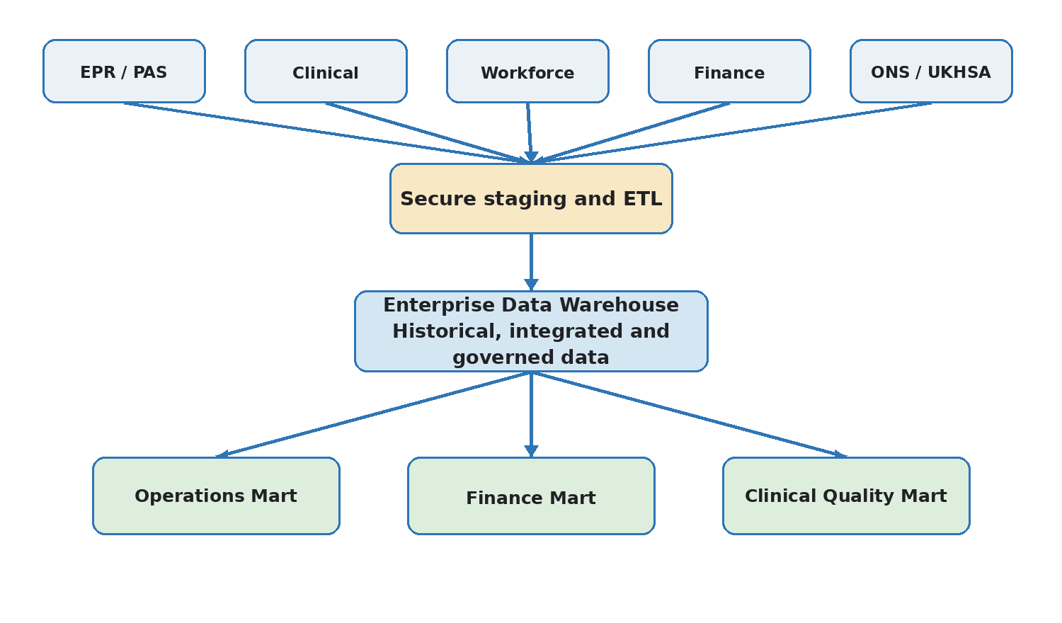
Figure 1. Proposed NHS England enterprise data warehouse architecture (author’s design, informed by [2]–[4]).
Figure 1 shows a single governed route from source systems to the EDW and then to role-specific marts. Extract captures new or changed records so that full databases are not repeatedly copied. Transform removes duplicates, validates NHS numbers and clinical codes, standardises dates and organisation identifiers, resolves missing or conflicting values and creates surrogate keys. Load writes conformed dimensions before fact tables, followed by approved aggregate tables. Incremental processing, provenance records and repeatable mappings make the pipeline easier to monitor and rerun [5].
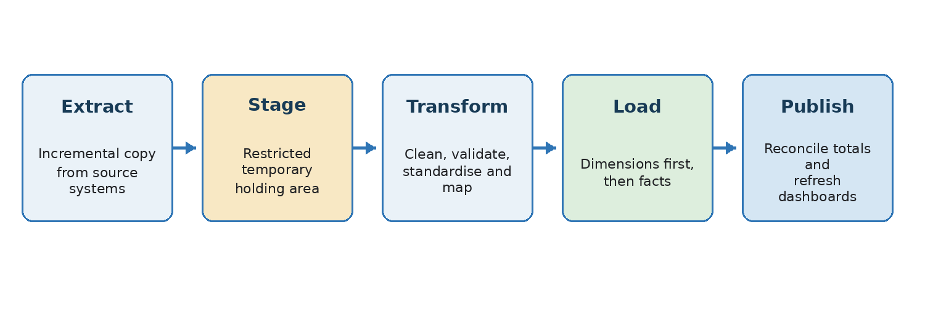
Figure 2. Controlled ETL workflow from extraction to publication (author’s design, informed by [5], [6]).
Refresh frequency should match business need rather than applying “real time” to every dataset. Urgent operational measures may use small hourly loads; workforce and finance can normally load overnight or after ledger processing. Reconciliation compares source totals with staged and loaded totals. Failed records are quarantined, and dashboards are published only after validation. This protects frontline performance and prevents incomplete data from replacing the last trusted report [5], [6].
The architecture also needs clear recovery boundaries. Source extraction should be read-only and restartable, while staging records retain a batch identifier, source timestamp and processing status. If a job fails, it can restart from the last successful checkpoint instead of repeating every load. Separate development, test and production environments reduce the risk that an untested mapping changes published figures. Data lineage should connect each dashboard measure to its fact field, transformation rule and original source, allowing managers and auditors to understand how a result was produced [4]–[6].

1.3 Data Marts for Management Decision-Making
NHS England should use dependent data marts sourced from the EDW. Unlike independent marts, they reuse governed data, conformed dimensions and KPI definitions. This reduces duplicated processing and conflicting results while giving each director a simpler view of the measures relevant to their role [3].
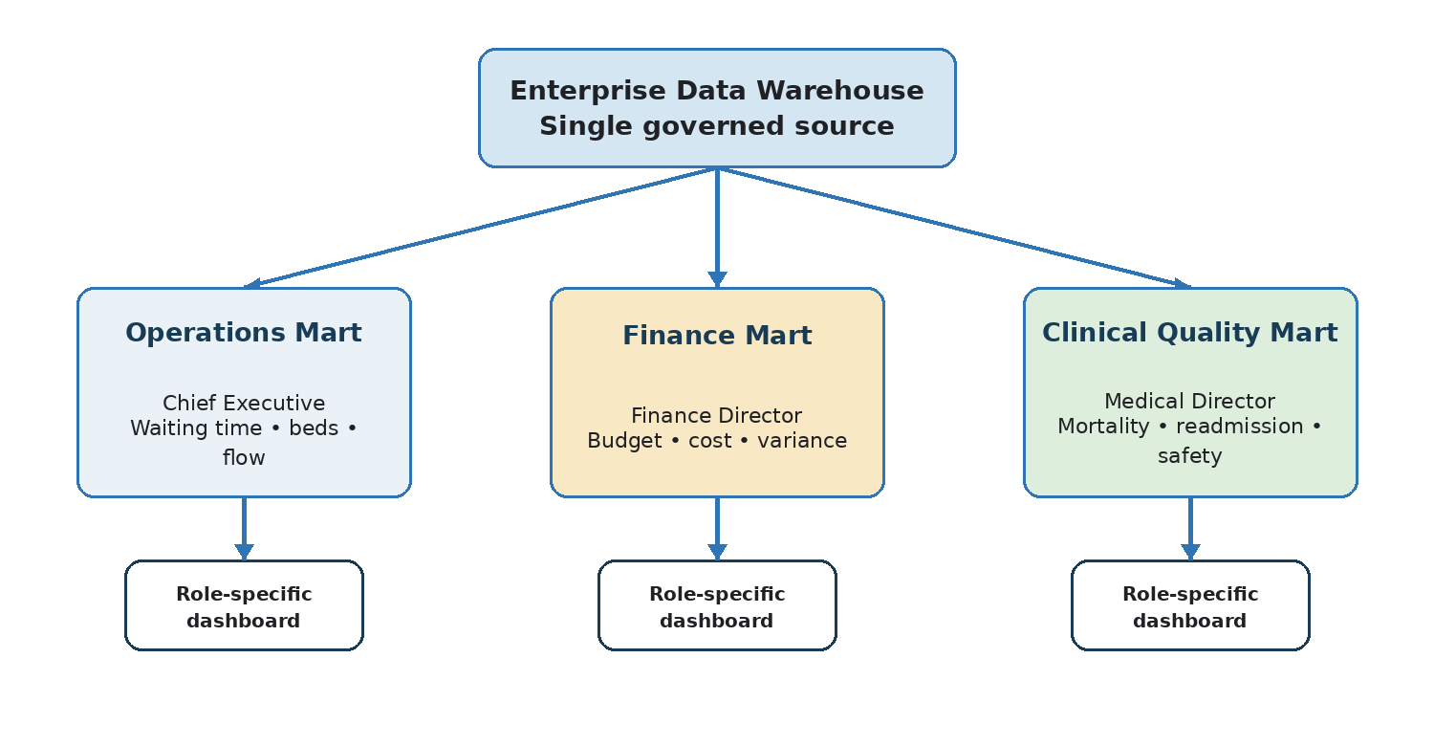
Figure 3. Executive data marts and decision responsibilities (author’s design, informed by [3], [7], [8]).
Operations Mart — Chief Executive: Combines patient activity and monthly summaries to show Referral-to-Treatment waiting times, admissions, discharges, bed occupancy and delayed discharge. The Chief Executive can compare Trusts and Integrated Care Systems (ICSs), identify patient-flow pressure and decide where operational support is required. These measures align with NHS performance oversight, but the dashboard should show definitions and reporting periods so that comparisons are fair [7].
Finance Mart — Finance Director: Links expenditure and budget measures to hospital, service and date dimensions. It supports budget-versus-actual analysis, treatment-cost comparison and forecasting. The current NHS Payment Scheme supplies relevant rules and prices for financial benchmarking [8]. The mart should separate actual expenditure, budget and variance rather than combining measures with different meanings.
Clinical Quality Mart — Medical Director: Uses validated clinical-quality facts to monitor mortality indicators, 30-day readmissions, hospital-acquired infections, outcomes and safety incidents. The Medical Director can identify unusual variation and target clinical review. Patient-level access should be limited to approved purposes; most board reporting should use aggregated or pseudonymised data. Clinical warehouse studies show that useful reuse depends on clear governance and documentation as well as technical integration [6].
These marts answer different questions but must not become separate versions of the truth. Shared dimensions allow a waiting-time result, related expenditure and clinical outcome to be compared for the same hospital, service and period. A common semantic layer should define every KPI, including its numerator, denominator, exclusions, owner and refresh date.
A direct EDW query offers maximum detail but exposes a complex model and may use more computing resources; a mart provides simpler, more secure access but introduces another managed layer. Dependent marts provide the better balance because they remain traceable to the EDW. Directors should see summary indicators and exceptions first, with controlled drill-down to Trust, service and permitted patient-level detail.

1.4 OLTP Normalisation vs. Dimensional Modelling
Operational databases are normally highly normalised, often to Third Normal Form (3NF), so each fact is stored once and inserts or updates do not create anomalies. This is suitable for recording a live admission accurately, but an analytical question may require many joins across patient, treatment, staffing and organisation tables. Running those queries against live systems could compete with operational work. A warehouse instead uses controlled denormalisation. In a star schema, measures are stored in a central fact table and descriptive attributes are grouped into surrounding dimensions [3].
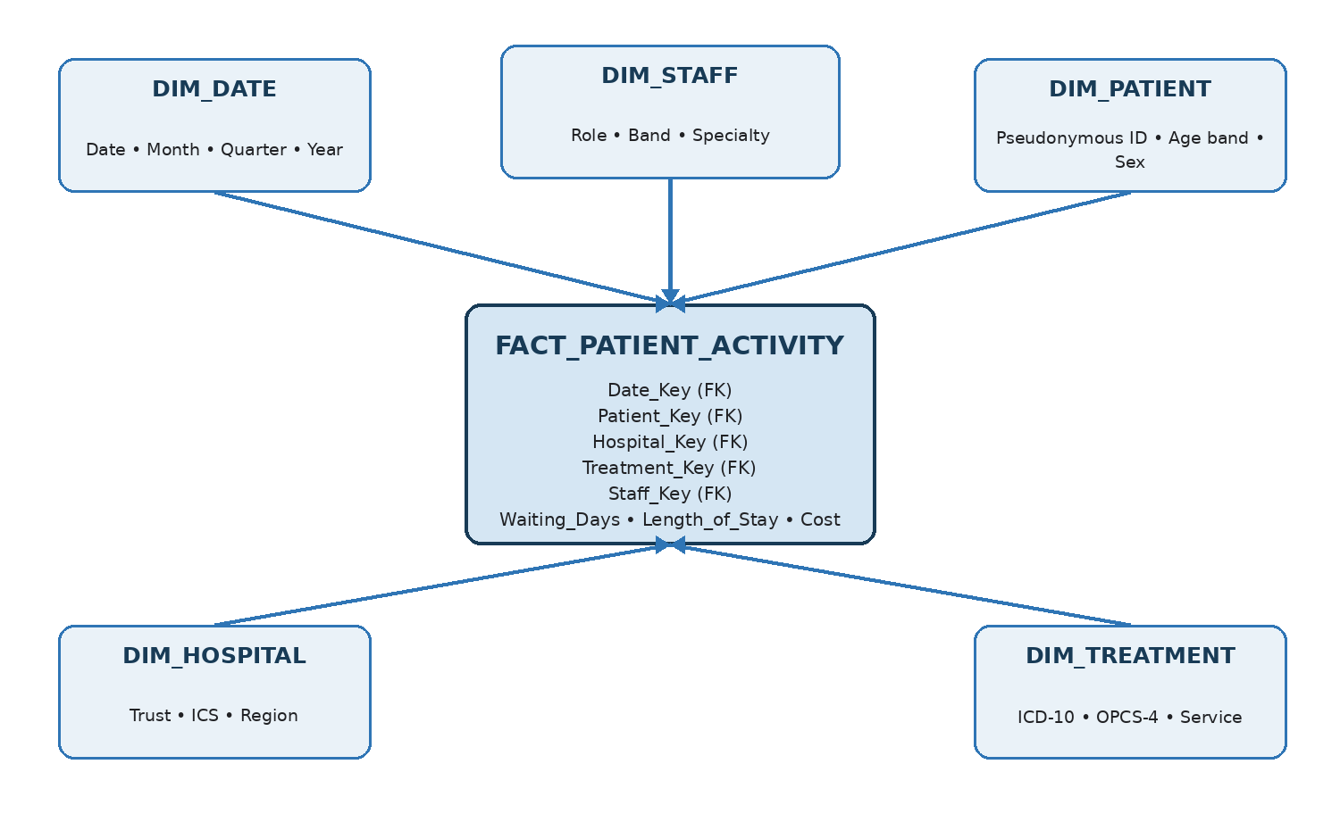
Figure 4. Patient-activity star schema showing fact-table grain and descriptive dimensions (author’s design, informed by [3]).
In Figure 4, FACT_PATIENT_ACTIVITY has one row per completed patient-care activity or episode. Foreign keys connect each event to date, patient, hospital, treatment and staff dimensions, while measures include waiting days, length of stay and cost. Surrogate dimension keys protect the warehouse from changing source identifiers and allow historical versions of attributes to be retained. The star schema is easier for analysts to understand and generally requires fewer joins for aggregation. Its trade-off is controlled duplication in dimensions, so ETL and governance must keep those descriptions consistent [3].
Normalisation should still be used where it protects operational accuracy; dimensional modelling is not automatically superior for every workload. Conversely, copying the normalised source structure into the warehouse would make board reporting harder to understand and maintain. The design decision therefore follows purpose: normalised OLTP for reliable transactions and dimensional models for historical analysis. Measures must also follow their grain. Waiting days can be averaged across episodes, but a patient count should use a distinct patient key to avoid counting one person several times.

Task 2.1: Source System Identification
Internal sources include PAS admissions, discharges and waiting lists; EPR and clinical systems for diagnoses, procedures and outcomes; Electronic Staff Record or workforce platforms for roles, shifts, absence and agency use; and financial ledgers for budgets, expenditure and treatment costs. External sources add context: Office for National Statistics population data supports rates and demographic comparison [9]; the UK Health Security Agency dashboard contributes public-health surveillance [10]; and the 2026/27 NHS Payment Scheme supplies current payment rules and prices [8]. Organisation reference data and approved ICD-10 and OPCS-4 classifications standardise hospitals, diagnoses and procedures [11].
Each source should have an agreed owner, extract method, refresh frequency and data-quality contract. Source identifiers and timestamps must be retained for traceability. External datasets should be versioned because later releases may revise population estimates, public-health figures or prices; otherwise a historical dashboard could change without an explained business reason.

2.2 Star Schema Design
A data-warehouse bus architecture is appropriate because it supports several star schemas without forcing unlike measures into one fact table. Conformed dimensions—DIM_DATE, DIM_HOSPITAL, DIM_PATIENT, DIM_STAFF and DIM_SERVICE_TYPE—are shared across the facts. This creates consistent filtering and allows cross-functional analysis while each fact retains its own declared grain [3].
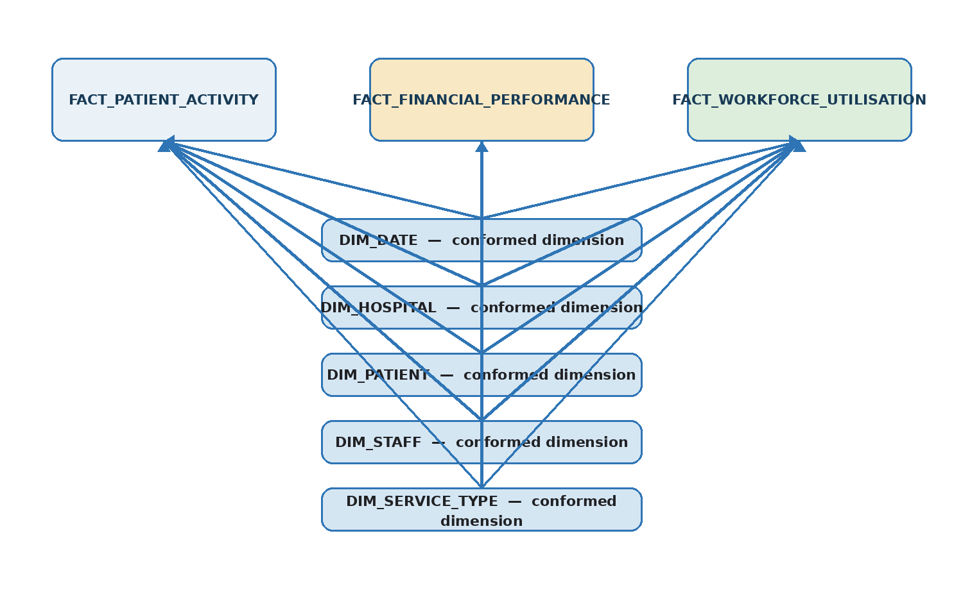
Figure 5. Multi-fact bus architecture with conformed dimensions (author’s design, informed by [3]).
Table 2. Proposed fact-table grain and measures
Fact table | Declared grain | Example measures
FACT_PATIENT_ACTIVITY | One completed patient-care activity or episode | Waiting days, length of stay, activity count, cost
FACT_FINANCIAL_PERFORMANCE | One hospital, service and accounting period | Budget, expenditure and variance
FACT_WORKFORCE_UTILISATION | One staff member, organisation unit and period | Worked, overtime, agency and sickness hours
FACT_CLINICAL_QUALITY | One validated clinical event or outcome | Readmission, infection, mortality and safety-event counts

Declaring grain before choosing fields prevents double counting. Dimension surrogate keys become foreign keys in each fact table. DIM_PATIENT holds pseudonymous identifiers and permitted demographic bands; DIM_HOSPITAL records Trust, ICS and region; DIM_STAFF records role, band and specialty; and DIM_SERVICE_TYPE maps local descriptions to governed service categories. Slowly changing dimension rules should retain previous organisation or staff attributes where historical reporting requires them. A metadata catalogue should record field meaning, source, owner, transformation, sensitivity, lineage and refresh frequency [3], [4].
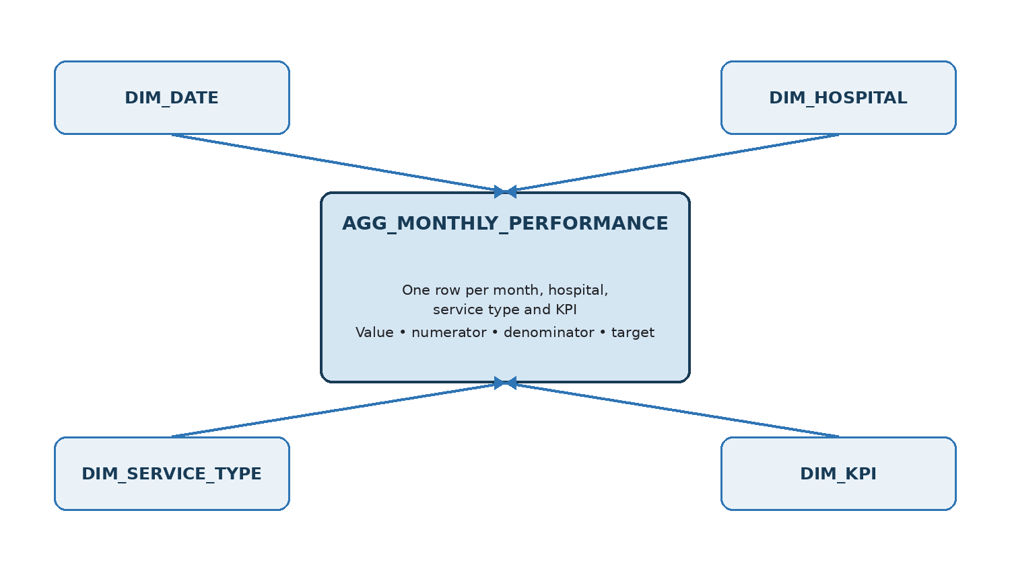
Figure 6. Aggregate star schema for monthly performance reporting (author’s design, informed by [3]).
AGG_MONTHLY_PERFORMANCE should have one row per month, hospital, service type and KPI. It stores the approved value plus numerator, denominator and target, rather than only a displayed percentage. Pre-aggregation reduces repeated dashboard calculation, but the detailed facts remain the audit source. Additive measures such as expenditure can be summed across hospitals and time; ratios such as occupancy or readmission rate must be recalculated from their components. This distinction prevents incorrect totals. The aggregate refresh must therefore run only after detailed facts pass reconciliation and quality checks.
The model supports executive decisions without mixing incompatible records. The Chief Executive can compare operational pressure with workforce availability, the Finance Director can relate expenditure to activity, and the Medical Director can examine outcome variation. Access controls and the semantic layer determine which facts and attributes each role may see; the physical star schema alone does not provide governance.
Key design risks must be managed explicitly. A many-to-many relationship, such as one episode involving several diagnoses or staff members, should use a bridge table rather than duplicating the episode fact. Late-arriving records should initially use an “unknown” dimension member and be corrected when the matching master record becomes available. Degenerate identifiers such as an episode number may remain in the fact for traceability, but direct patient identifiers should not. Partitioning large facts by reporting period and indexing common foreign keys can support performance without claiming a guaranteed response time.
Master data and metadata play different roles. Master data identifies governed entities such as hospitals, patients, staff and services; metadata explains the fields, rules and processing used to create them. Both require ownership. The model should also record effective and expiry dates for historical dimension versions, load batch identifiers for audit, and a quality status showing whether a record is approved for publication. These controls make the schema testable and give analysts enough context to interpret measures correctly [3], [4].

2.3 Data Marts and Schema
Figure 7 presents three dependent marts. Each exposes a subject-specific star schema but reuses governed dimensions from the EDW. The Operations Mart centres on patient activity and monthly performance; the Finance Mart centres on financial performance; and the Clinical Quality Mart centres on validated outcome facts. Shared date, hospital, patient, staff and service dimensions mean departments use the same reporting periods and organisational definitions [3].
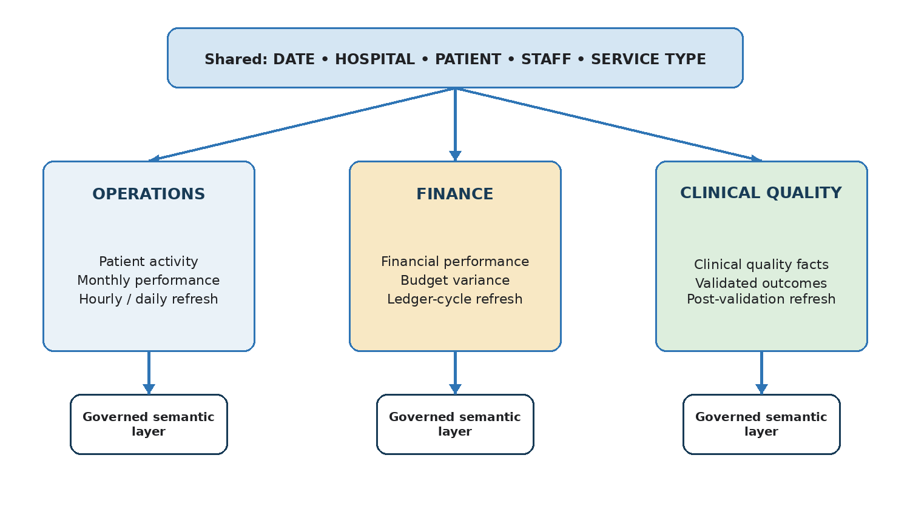
Figure 7. Departmental data-mart schemas derived from the EDW (author’s design, informed by [3], [6]).
Refresh schedules reflect risk and need. Operations may refresh hourly or daily, finance follows the ledger cycle, and clinical quality publishes only after clinical validation. A governed semantic layer defines KPIs and hides unnecessary technical detail from directors. Row-level security restricts organisations or records, while role-based access limits functions. Pseudonymisation reduces exposure of direct identifiers, although pseudonymised data remains personal data and still requires protection [12]. Dependent marts are preferable here because independent copies would duplicate transformations and could produce inconsistent results.
The Operations Mart should permit comparison by hospital, ICS, service and month, with drill-through from an aggregate KPI to validated activity. The Finance Mart should preserve accounting periods and distinguish budget, committed cost and actual expenditure. The Clinical Quality Mart should retain numerator and denominator components for rates and apply disclosure controls where small groups could identify individuals. Cross-mart analysis should occur through shared conformed keys rather than manual spreadsheet matching.
A mart is ready for use only when its reconciliation, access and acceptance tests pass. Business owners should confirm that KPI definitions match policy, analysts should test totals against the EDW, and information-governance staff should approve the permitted level of detail. This creates accountability: the technical team operates the pipeline, but named business owners remain responsible for meaning and appropriate use.

2.4 Secure ETL Plan
Incremental extraction copies only new or changed records, reducing pressure on live EPR and PAS systems. A restricted staging area holds each batch temporarily for validation, cleansing and reconciliation before publication.
Table 3. Secure ETL source-to-target mapping
Target | Source | Main transformation
DIM_PATIENT | EPR / PAS | Deduplicate, validate NHS number, pseudonymise, create surrogate key
DIM_STAFF | Workforce / ESR | Standardise role, band and specialty
DIM_HOSPITAL | Reference data | Map provider to Trust, ICS and region
DIM_TREATMENT | Clinical systems | Standardise ICD-10, OPCS-4 and local codes
FACT_PATIENT_ACTIVITY | PAS / EPR | Calculate waiting time, length of stay and activity measures
FACT_FINANCIAL_PERFORMANCE | Financial ledger | Standardise cost and calculate budget variance
FACT_WORKFORCE_UTILISATION | Workforce systems | Calculate worked, agency, overtime and sickness hours

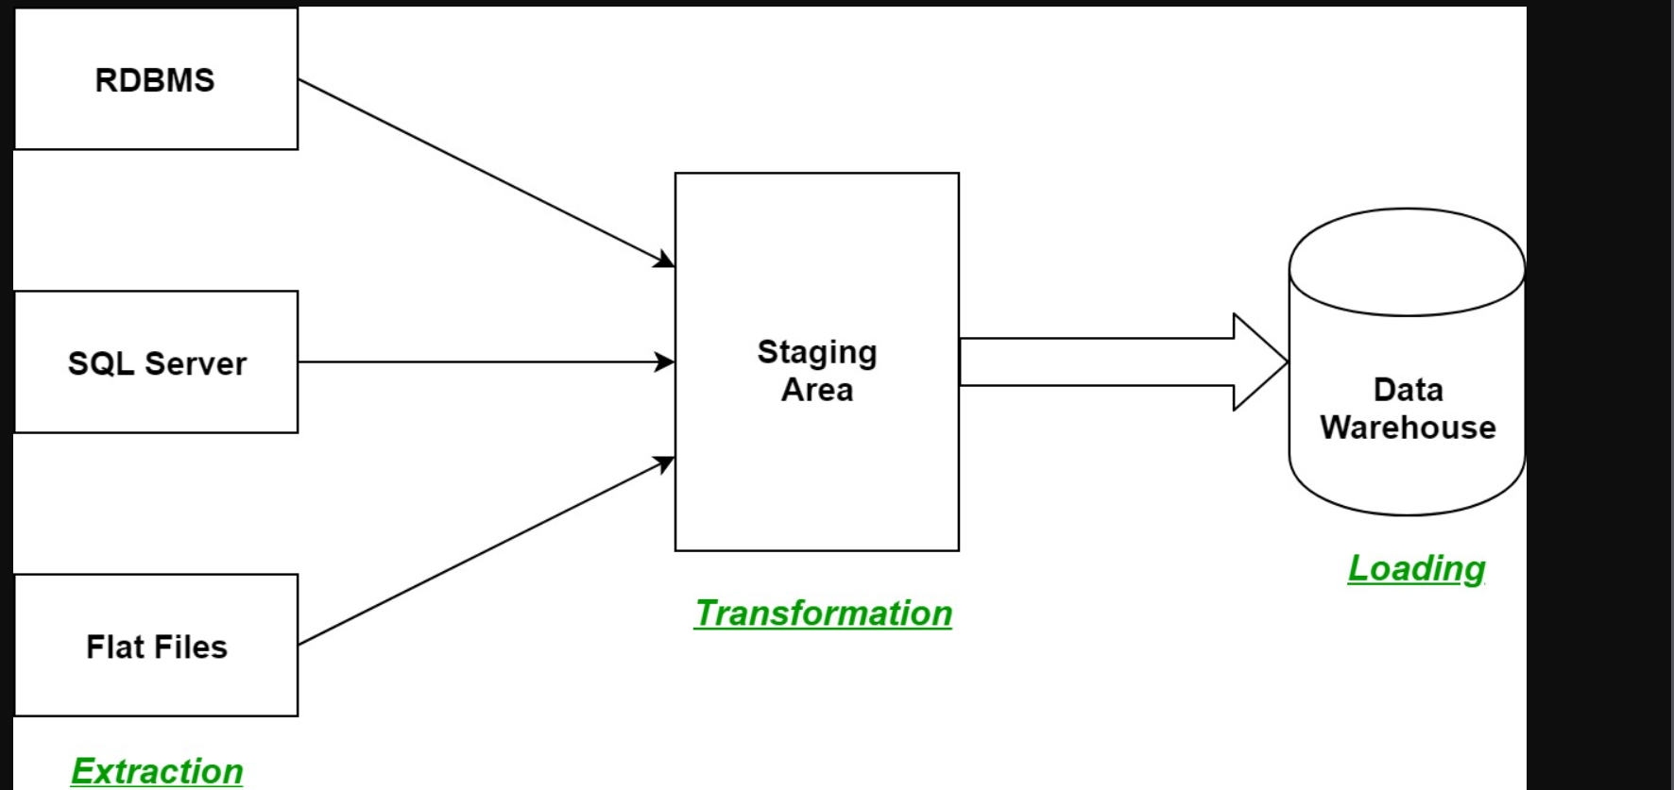
ETL Process Overview

Figure 8: General ETL Process from Source Systems through a Staging Area to the Data Warehouse [1], [2].
The figure shows the ETL process: data is extracted from different source systems, temporarily stored and transformed in a staging area, and then loaded into the data warehouse for reporting and analysis.

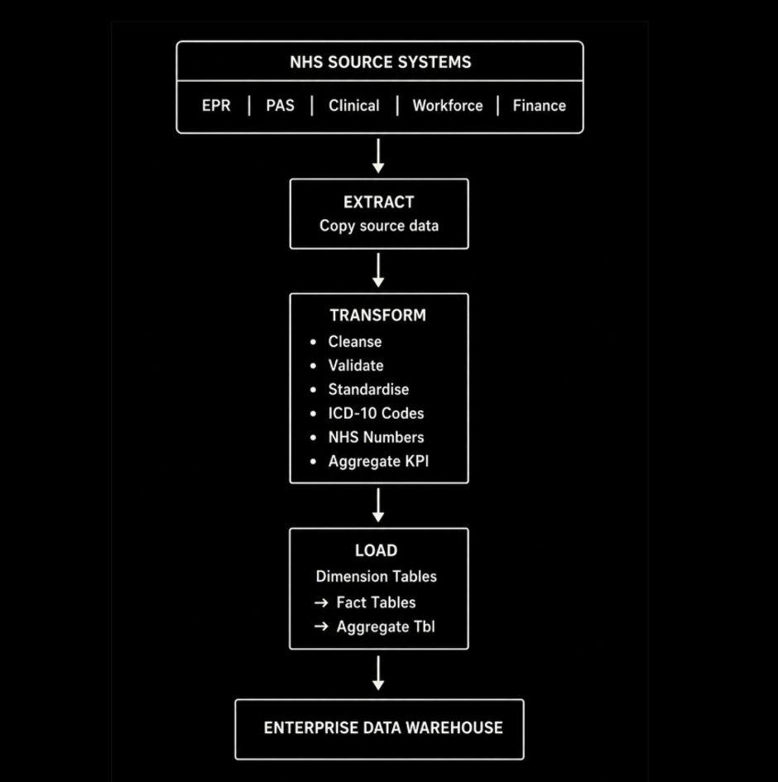
Figure 8. ETL process for loading NHS operational data into the Enterprise Data Warehouse (author’s design, informed by [3], [5]).
Figure 8 shows data moving from EPR, PAS, clinical, workforce and finance systems through extraction and transformation. Cleaned and validated records are loaded into dimension tables first, followed by fact and aggregate tables in the EDW.

ETL Security and Resilience
Security is applied throughout ETL. Data is encrypted during transfer and storage, while direct patient identifiers are pseudonymised before loading. Role-based access and least privilege ensure that users and service accounts can access only the information required for their work. Managed credentials prevent unauthorised system access, and audit logs record extraction, transformation, access and deletion. Failed records are quarantined for investigation; if a critical validation or security check fails, publication stops and the previous trusted dashboard remains available. These controls protect patient information, maintain accountability and prevent ETL failures from disrupting frontline healthcare systems [12]–[17].

2.5 Data Quality and Governance
Automated rules should measure accuracy, completeness, validity, consistency, uniqueness and timeliness. Examples include valid NHS numbers, complete mandatory fields, unique patient records, mapped clinical codes, reconciled totals and delivery within the agreed refresh window [6]. Named data owners approve use and definitions; data stewards investigate exceptions and maintain metadata and lineage. Because health data is special-category personal data, NHS England should apply data minimisation, pseudonymisation, retention controls, encryption, access reviews and privacy by design [12]–[16]. Compliance with the Data Security and Protection Toolkit provides an additional assurance process

Conclusion
The proposed EDW integrates analytical copies of NHS operational, clinical, workforce and financial data without replacing frontline systems. A secure ETL process, conformed dimensional model, governed aggregates and dependent data marts provide consistent information for operational, financial and clinical decisions. Clear grain, reconciliation, metadata, role-based access and measurable quality controls are essential: the value of the warehouse comes not only from combining data, but from making its meaning, history and use trustworthy.

References
[1] Department of Health and Social Care, "Data Saves Lives: Reshaping Health and Social Care with Data," Department of Health and Social Care., 2022.
[2] William H. (W. H.), Building the Data Warehouse, : Indianapolis, Indiana, USA: : Wiley Publishing, Inc., 2005, .
[3] &. Kimball Ralph, Ross&nbsp and Margy, The Data Warehouse Toolkit: The Definitive Guide to Dimensional Modeling, John Wiley & Sons, Inc., 2013, .
[4] Zhan Wang, Catherine K. Craven, Mahanaz Syed, Melody Greer, Emel Seker, Shorab Syed and Meredith N. Zozus, "Clinical Data Warehousing: A Scoping Review," Journal of the Society for Clinical Data Management, vol. 4, pp. 1–19, 28 August. 2024.
[5] Matthieu Doutreligne, Adeline Degremont, Pierre-Alain Jachiet, Antoine Lamer and Xavier Tannier, "Good Practices for Clinical Data Warehouse Implementation: A Case Study in France," PLOS Digital Health, vol. 2, pp. 1–16, 6 July. 2023.
[6] Information Commissioner’s Office, "Pseudonymisation," Information Commissioner’s Office, .
[7] Shiyang Lyu, Simon Craig, Gerard O’Reilly and David Taniar, "The Development and Use of Data Warehousing in Clinical Settings: A Scoping Review," Frontiers in Digital Health, vol. 7, 5 June. 2025.
[8] Antoine Lamer, Chloé Saint-Dizier, Nicolas Paris and Emmanuel Chazard, "Data Lake, Data Warehouse, Datamart, and Feature Store: Their Contributions to the Complete Data Reuse Pipeline," JMIR Medical Informatics, vol. 12, 17 July. 2024.
[9] Office for National Statistics, "Population and Migration," Office for National Statistics, .
[10] UK Health Security Agency, "UKHSA Data Dashboard," GOV.UK, 2026.
[11] NHS England, "NHS Payment System," NHS England, .
[12] Somchart Fugkeaw and L. Hak, "PPAC-CDW: A Privacy-Preserving Access Control Scheme With Fast OLAP Query and Efficient Revocation for Cloud Data Warehouse," IEEE Access, vol. 12, pp. 78743–78758, 2024.
[13] UK Parliament, "Data Protection Act 2018," The National Archives/UK Legislation, 23 May. 2018.
[14] Information Commissioner’s Office, "What Are the Conditions for Processing Special Category Data?" Information Commissioner’s Office, .
[15] Information Commissioner’s Office, "Data Protection by Design and by Default," Information Commissioner’s Office, 5 February. 2026.
[16] NHS England, "Data Security and Protection Toolkit," Data Security and Protection Toolkit, 2025.
[17] Doyeon An, Minsik Lim and Suehyun Lee, "Challenges for Data Quality in the Clinical Data Life Cycle: Systematic Review," Journal of Medical Internet Research, vol. 27, 23 April. 2025.

