Naremore believes that ‘it has always been easier to recognize a film noir than to define the term’. Consider and discuss the ‘darkness’ of film noir through the critical analysis of at least TWO module texts.

The two texts I’d like to discuss are Kiss Me Deadly (Aldrich, 1955) and Touch of Evil (Welles, 1958).

Firstly, I’d like to look at what Film Noir means, is it a genre or just simply a term that’s descriptive. Naremore (2008) says ‘Whatever noir “is,” the standard histories say that it originated in America, emerging out of the synthesis of hard-boiled fiction and German expressionism.’
Ross (2016) states that some would argue with Naremore (2008) such as Raymond Durgnat and Paul Schrader who suggest that film noir is not a genre but simply reflects a tone and mood of a film. Film Noir is the ‘art of darkness… [along with] pessimistic themes and signature motifs such as alienated antiheroes’ (Ross, 2016).
Schrader (1972) says ‘since film noir is defined by tone rather than genre, it is almost impossible to argue one critic descriptive definition against another’s.’
Film Noir (dark film) definitely reflects the attitudes and fears of post war America society and culture, even if at the time they didn't realise it.
Kuhn and Westwell (2012) explains that ‘The term is thought to have been first used by French critic Nino Franks, in a 1946 review of four Hollywood crime thrillers...that pointed to the films’ complex narration and moral ambivalence.’
This style of film making from its inception reflected the attitude of filmmakers and American society at the time. Looking at Kiss Me Deadly (1955) as a starting point and how it mirrored the society of post-war America, with all its fears and insecurities (Pierce, 2009).
This film definitely gives you an insight into the dark underbelly of American society, the hidden world of crime and punishment.
A part of society that ordinary working people wouldn’t have come into contact with, for example the private detective, police, and the underworld.
At the time there was a lot of uncertainty, and people were disillusioned with what the future held for them personally and as a nation. Especially with the Cold War, the threat from communism and a very unstable economy (Pierce, 2009).
You could read this as not only the American film industry becoming disillusioned with the America dream and portraying that through their work, but also the American public becoming aware that the world had changed for ever. Film Noir of the time I think, was portraying a very realistic view of post war America.
According to Hoerneman (2018) ‘Post-war Americans wanted an authenticity that was lacking in earlier high-class melodramas. Americans wanted a harsh view of society from the perspective of everyday people on the streets.’
The public wanted something different from Hollywood, they wanted the films to relate to how life really was in post war America; they wanted realism.
At the beginning of Kiss Me Deadly (1955), we see this young girl Christina Baily (Cloris Leachman) running, but from whom. She appears to be, a damsel in distress and is finally rescued by who we perceive to be the hero of the film, but his credentials as a hero are brought into question. Mike Hammer (Ralph Meeker) a down on his luck Private Detective, whose only real motivation at this point in his career, is entrapment of disillusioned couples. He just happens to be in the right place at the wrong time as many antiheroes are prone to do.
Hammer likes to use women for his own benefit and convenience. His only concern is what's in it for him and that’s seems to be the way he thinks about everything and everyone in his life.
He treats everybody with the same contempt, especially any kind of authority, whom he sees as being just as corrupt as himself.

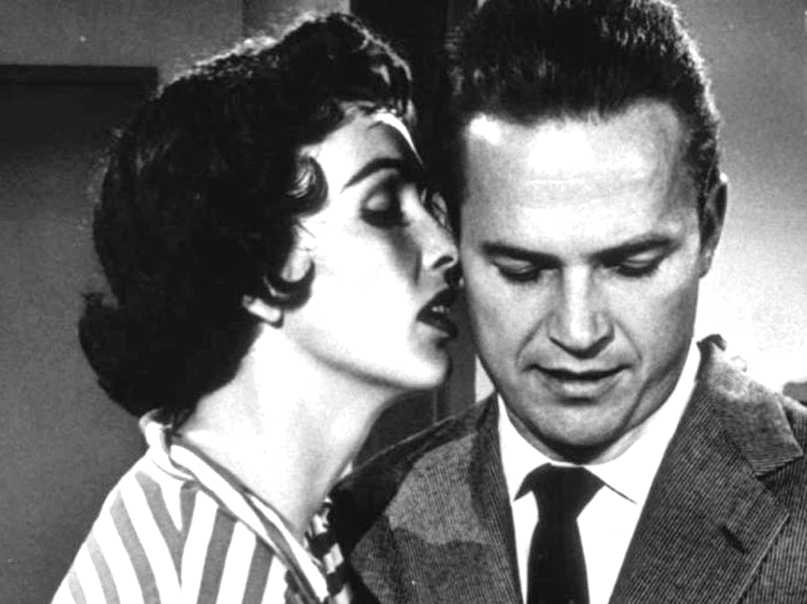
Fig.1 (Aldrich, 1955)

At the time a lot of men would have seen Hammer, as a man's man, a drinker, smoker, driver of fast cars and a womaniser, which would also have been quite acceptable for the time, even by women. Some of whom would find this illicit attraction to a man like Hammer quite exciting. A lot of men from that period would have liked to have been him, they would have also found his lifestyle quite exciting, but, Hammer is a very flawed character, someone you would not like to come across in a dark alley. He definitely represents the darker side of law enforcement, if you could call his line of work law enforcement. He is a very self-seeking character and up until now only had one thing on his mind, how to exploit the next client. He doesn't care who he uses to sustain his lifestyle.
Hiller and Phillips (2009) say... ‘The savage portrayal all the virtual disintegration of the disreputable male protagonist situates the politics of Aldrich’s film a generation away from the more idealistic, if no less convoluted, scenarios of Murder, My Sweet (Dmytryk 1944) and The Big Sleep (Hawks 1946).’
We can see this in the way he Hammer, uses his secretary Velda Wickman (Maxine Cooper) to use her sexuality to entrap clients and obtain information that he can use against them. She does this thinking that one day he will give up his wild life style and settle down with her. But like any hard-nosed detective he has no intention of doing anything of the sort. He just uses her like everyone else in his life, he sees her as just another tool of his trade. His relationship with his secretary is very destructive, dangerous and damaging for her. Hammer has no real interest in her, he just sees her as his fall-back position when he can’t find anyone else to do his dirty work for him.
Schrader (1972) explains ‘He is a small-time “bedroom dick,” and makes no qualms about it because the world around him isn’t much better.’
Hammer’s world is very dark and seedy, which he feels very much at home in, as he rubs shoulders with corrupt cops, gangsters and the odd femme fatale. His world has all the characteristics of what you might expect film noir to include. Urban environment, criminal underworld, hopelessness and the femme fatale.
Hammer is a character that wouldn’t be able to function in normal society, he wouldn't know how to react under normal circumstances and with normal people. This darkness that surrounds his character is fundamental to film noir.
This film definitely communicates that there is no hope for Hammer or any relationship he has, especially with his secretary Velda Wickman. From the very beginnings of the film Hammer has been following a very self-destructive course of events.
From his first encounter with Christina Baily on the highway, he suspected she was trouble, but he still chose to get involved with her and the events that were to follow. Aldrich is making a social statement through this film about that particular time in American history.
Is America is on a self-destructive course like Hammer, only thinking of itself and its own self-preservation by any means necessary. According to Wigley (2018) ‘Kiss Me Deadly is film noir at its most cynical and apocalyptic.’ Even going as far as the use of nuclear weapons to preserve and protect what they see as the American dream.
According to Ross (2016) ‘Aldrich’s… Hammer [is] a rage fuelled amoral misanthrope bulldozing his way through a storyline of Cold War paranoia in the nuclear age barely pauses for breath or releases its brutal hold on the viewer until the literally apocalyptic ending’.

The second film I’d like to look at is Touch of Evil (1958).
Hiller and Phillips (2009) state that ‘Touch of Evil marked the end of Hollywood’s fascination with film noir until the form’s rediscovery and re-evaluation during the 1970s.’ Even though Touch of Evil (1958) marked the end of film noir, it is thought to have been the most influential and greatest film noir ever made and film noir was once again to be rediscovered and reimagined in the early 1970s, by the likes of Scorsese in his film The Taxi Driver (1976).
Bradshaw (2015) states...’Adapted by Welles from Whit Masterson’s pulp thriller Badge of Evil, it had streaks of teen degradation and reefer madness, and the most intense interracial relationship since The Searchers.’
This film can be read as how America at the time and definitely today see Mexico as a dark and corrupt country. Where all the Mexicans excerpt for Vargas are either criminals, drug takers or dealers. Well’s character Captain Hank Quinlan is portrayed as strong and in control, while Mike Vargas played by Charlton Heston seems to be distracted. Quinlan comes over is the one we should trust.
The first impression we have of the Mexican city is that it’s very run down and in some sort of decay. That this is a hot bed for crime and corruption, darkly lit and plenty of places to hide away out of sight. That there’s no alternative for people living there but to turn to crime, that it was the natural thing for them to do. What other choice do they have they’re Mexican. There was no hope for them, this was the dark under belly of Mexican society. It was the opposite to the clean-living ideal of the American way of life and this is the way Orson Wells wanted us to see it.
Hirsch (1981) says ‘Orson Wells depicts a Mexican border town (actually Venice, California) in Touch of Evil as a hothouse of filth and corruption, its buildings and people rotting away in the steamy Mexican climate.’
Wells’ character is a very racist individual and his attitude is if they are Mexican, then they must be guilty. He sees them all as either thief’s, liars or drug takers. He doesn’t care if their guilty or not.
Hirsch (1981) observers that Quinlan is ‘...an officer of the law suffering from a God complex plants evidence against people he wants to prove guilty ....’
He proves this when he catches up with Manelo Sanchez played by Victor Millan and plants the dynamite in his bathroom. Quinlan always targets the weak and vulnerable the easy option to get a quick conviction. He has very racist views especially towards anyone who isn’t white, he sees all Mexicans a potential suspect. If anyone gets in his way he will deal with them one way or another, even if it does mean colluding with people he’s supposed to be protecting the innocent against.
There is definitely a conflict between Vargas and Quinlan, it may be as simple as good versus evil. Especially after Vargas confronts Quinlan about the evidence found in Sanchez bathroom. Quinlan knows he’s been caught out and not for the first time, this is when he decides to deal with Vargas.
This is when the dark side of law enforcement rears its head and Quinlan agrees to work with Joe Grandi played by Akim Tamiroff, which seals his fate later on in the film (narrative).
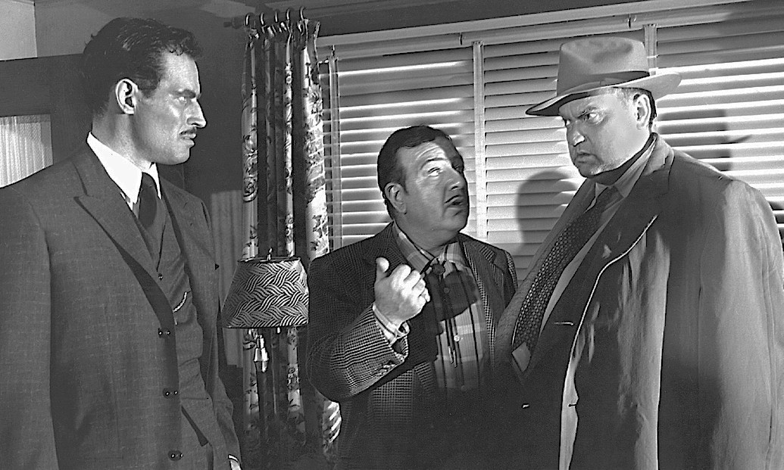
Fig. 2 (Wells, 1958)

The Mexican under world and law enforcement blend into one, it becomes difficult to distinguish between them. Both seem as corrupt as each other, even if one them, Quinlan, is deluded. Maintaining his reputation and getting justice by any means has become his is only goal, no matter who or what gets in his way. Even if it is an old and loyal friend such as Sergeant Pete Menzies played by Joseph Calleia.
As the film moves forward Wells’ character starts to lose a grip on reality, it’s like he’s in some kind of dream like state, as if he has no control over his own actions any more. He’s falling deeper into a darker reality, one he can’t see any way out of, one which has been self-induced by his twisted antihero actions. This dark place he now finds himself, reminds him of the loss of his murdered wife, a case where he failed to catch and prosecute the right suspect for her murder.
Which could be where it all started, this self-destructive path where he finds himself now. This depth of darkness Quinlan is immersed in is noir at its darkest.

An old friend and partner Menzies, begins to see what Quinlan has become and even though he has some reservations about helping Vargas he decides Quinlan needs to be stopped. Ross (2016) describes it as ‘The inevitable demise of the monstrous Quinlan plays like a Shakespearean tragedy’.
In the last moments of Touch of Evil (1958) Quinlan is cornered like a rat in a barrel, he has nowhere else to run to. The world he has created, in his own mind is staring to collapse around him, the excuses he has made, the lies he has told, don’t make senses, even to him.
Time had run out not only for Quinlan but for Film Noir as well. Touch of Evil (1958) was definitely and end of an era, for not only Film Noir but Wells himself. It was his last master piece and his swansong, which was unfortunately ruined by the very studio that hired him to make it.
Wigley (2018) says ‘...the studio....ordered significant changes...new footage by studio hack Harry Keller, and a thorough re-edit by Aron Stell...’. There were many changes made to the film that Wells was not happy with, but fortunately a restored version was released in the 1990’s, which was pretty close to Wells’ original vision.

According to Screen Craft (2017) ‘The thing about darkness in Film Noir is that it is not just a physical thing, even though it seems that much of the action in classic Film Noir occurs at night. The darkness and its expressive shadows is a reflection and manifestation of the both the psychological and emotional darkness that besets the characters and of the true nature of the treacherous reality that they inhabit’

For both Hammer (Ralph Meeker) in Kiss Me Deadly (1955) and Quinlan (Orson Wells) in Touch of Evil (1958), both have deep and sometimes worrying psychological issues. Both men also have difficulty when it comes to relationships with women, both struggle in normal social situations. Neither Hammer or Quinlan couldn’t or wouldn’t fit the social norms, both are a prime example of the anti-hero protagonist.
Sehayek (2016) says, ‘Noir films mostly revolve around a central, male anti-hero – they’re hard-boiled tough guys with tragic flaws, cynical detectives, aimless grifters, callous gangsters,....’ They look like they are doing the right thing but, it’s not for the benefit of person they are helping. It’s a self-serving act. They also treat the people around them with contempt and cynicism.
The darkness of Film Noir is not only consists of theme, style and setting that makes up the narrative but the characters themselves. Without all of these elements interacting with each other, it simply wouldn’t work, all of the above are needed to weave the darkness throughout the narrative.
‘Film noir’s most distinctive qualities are always accompanied by its darkly compelling themes’ (Sehayek, 2016).

Word Count: 2639

Reference List for Film Noir

Bradshaw, P. (2015) Touch of Evil review – brilliant noir drama restored to Welles's vision. Available at: https://www.theguardian.com/film/2015/jul/09/touch-of-evil-review-orson-welles (Accessed: 24 November 2018)

Hillier, J. and Phillips, P. (2009) 100 Film Noirs, BFI Screen Guides. London: Palgrave Macmillan.

Hirsch, F. (1981) The Dark Side of the Screen. Cambridge: Da Capo Press.

Hoerneman, C. (2018) What Is Film Noir, Available at: https://www.librarypoint.org/blogs/post/what-is-film-noir/ (Accessed: 20 November 2018).

Kuhn, A. and Westwell, G. (2012) Oxford Dictionary of Film Studies. Oxford: Oxford University Press.

Naremore, J. (2008) More Than Night Film Noir In Its Contexts. London: University of California Press.

Pierce, D. (2009) America in the Post War Period. Inquiries Journal. 1(10), pp. 1-1

Ross, G. (2016) Art of Darkness: the top 20 film noirs. Available at: https://www.independent.co.uk/arts-entertainment/films/art-of-darkness-top-20-film-noirs-a7353866.html (Accessed: 6 December 2018).

Schrader, P. (1972) Notes on Film Noir. Film Comment, 8(1). pp. 1-16 New York: Film Society of Lincoln Centre.

Screen Craft. (2017) Film Noir: Adding Darkness to Your Story. Available at: https://screencraft.org/2017/02/17/film-noir-add-darkness-story/ (Accessed:10 December 2018)

Sehayek, M. (2016) The Dark And Distinctive Elements Of Film Noir. Available at:
https://theculturetrip.com/north-america/usa/california/articles/the-dark-and-distinctive-elements-of-film-noir/ (Accessed: 6 December 2018).

Wigley, S. (2018) BFI, Available at: https://www.bfi.org.uk/news-opinion/news-bfi/lists/one-great-film-noir-every-year-1940-59 (Accessed: 15 November 2018).

Fig. 1 Kiss Me Deadly (Aldrich 1955) Art of Darkness: the top 20 film noirs. Available at: https://www.independent.co.uk/arts-entertainment/films/art-of-darkness-top-20-film-noirs-a7353866.html (Accessed:12 December 2018)

Fig. 2 Touch of Evil (Wells 1958) How Orson Welles shattered the Hollywood image.
Available at: https://www.theguardian.com/film/2015/jul/02/orson-welles-a-touch-of-class (Accessed:12 December 2018)

