Rekha Rahman
1920443
DSR Term 2: Jan 2021
DSR Term 2 investigative report

Contents
Abstract: 1
Background: 1
Aims and Objectives: 2
Method: 2
Results: 2
Discussion 8
Conclusion 9
Bibliography 9
Appendix: 9

Abstract:
The design and development of virtual learning environments (VLE) has changed the delivery of education significantly. Since the beginning of the COVID-19 pandemic, universities and other educational institutions have rushed to convert physical sessions to digital ones. Today a VLE is one of the most common ways to deliver teaching materials and to communicate with students. This investigative report will explore the impact of VLEs (Moodle) on students learning experience at the University of Wales Trinity Saint David London Campus. The survey finds various impacts of Moodle, including effects on motivation, feelings and final grades of students. The significant findings show that the use of Moodle results in improvements in learning and motivation as reported by the student participants. The findings will be of broad interest to teachers and educational institutions because they indicate areas for attention in promoting VLEs to enhance learning.

Background:
A VLE is an online system that allows the delivery of learning materials to students via the web (Oxford University Press, 2016). It provides materials, tasks and interactions within a course structure and deliver different stages of assessment. VLEs are a place where students can ask questions, explore resources and ideas and engage in tasks which enable them to further their learning. It is not exactly known when the first VLE was introduced. The Open University has been utilising computers for learning since 1970 and in 1997 one of the UK’s most popular virtual learning platforms- Blackboard, was launched and is still used worldwide today. In fact, by 2010, Blackboard was used by almost 4000 places of secondary and higher education in more than 60 countries (Blackboard, 2011). In 2001 another popular VLE- Moodle- was introduced. The development and aim of Moodle was to help educational institutions to create web-based courses with a focus on interaction and collaboration in learning. It became so popular among the educators that within a very short period of time many educational institutions started to use it. At the beginning of 2011 it had a user base in more than 200 countries and about 50,000 active sites and in more than 50 languages (Moodle, 2011). The 2010 survey of technology Enhanced Learning for higher education in the UK (USICA) surveyed 167 higher education institutions all over UK and found out that all of the institutions were using VLEs and 55% of them were using Moodle and 40% were using Blackboard. With the rapid ease and availability of broadband and social media in every corner of the world, it was found that almost all educational institutions around the world had introduced web learning courses and virtual learning environments became more interactive, collaborative and conversational. (firefly, 2020).

Virtual learning environments were not intended to function as alternatives or replace real classroom education, despite some people saying VLEs are an artificial world and are replacing the traditional classroom education. But the truth is that VLEs are not doing any of this but are actually helping and supporting the existing educational system. The use of technology has always made things better, faster and simpler and the use of VLE in education did the same. Through VLEs, delivery of educational materials has become more flexible, faster and convenient for educators and learners. Students can access materials 24 hours a day, 7 days a week and are able to do a full time or part time job while they are studying. Degrees at a top universities have become cheaper as there is no need to pay any campus fees for foreign students, they do not need to move to another country. VLEs help teachers and educators plan their lessons more easily, engage with student activities, keep records and provide extra materials when needed. Though the advantages of the VLEs are huge, there are a few negatives VLE to think about. Less disciplined or unmotivated students can become more inactive due to the flexibility. Also, many learning activities cannot be delivered through VLEs. For example, science students requiring lab work, and courses with professional placements have components that can’t be replaced virtually. Even though VLEs are good communication systems, the level of communication is not same as the face-to-face conversations. This prevents development of connections among students and between teachers and students. However, to overcome some of the disadvantages, it is important to remember that VLEs don’t replace the classroom but only enhance it. Secondly, mixing and blending VLEs with traditional classrooms can enhance the learning experience. (firefly, 2020).

Aims and Objectives:
This reported aimed to explore the impact of using Moodle on learning and was based on four research areas which investigated impact and use Moodle in communication, feedback, assessment and support. The findings will be of interest to teachers and educational institutions as they indicate areas of improvement and how further VLE use may enhance learning.

Method:
This investigation looked at the use of a specific virtual learning environment called Moodle. The investigation was carried out in the form of a questionnaire that wanted to gain an idea of student opinions on the following areas concerning virtual learning environments: 1. communication and collaboration on Moodle (e.g., using the messaging function, comments etc.) 2. methods of feedback from teachers available on Moodle, 3. summative assessments on Moodle and 4. pastoral support. The questionnaire was created using Microsoft Office and then sent to students attending the University of Wales Trinity St David London Campus only. All of the students were above the age of 18 and there were 10 males and 10 females to give a total of 20 responses. All participants completed the questionnaire online and results were sent back and analysed to visualise data collected. None of the participants were asked to give names or student numbers, so were anonymous.

Results:

How often do you use the communication functions on Moodle to interact with your classmates and teachers a week?
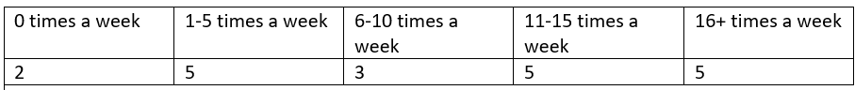
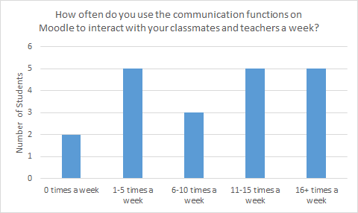
These results show a fairly mixed response across the board, the number of times participants use Moodle for communication seems to vary. Most popular responses were 1-5, 11-15 and 16+ times a week.
To what extent do you agree that the communication functions on Moodle are useful for your learning and education?
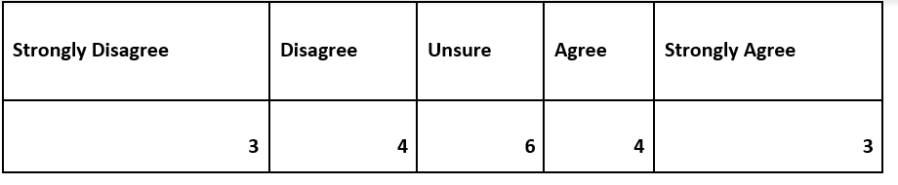
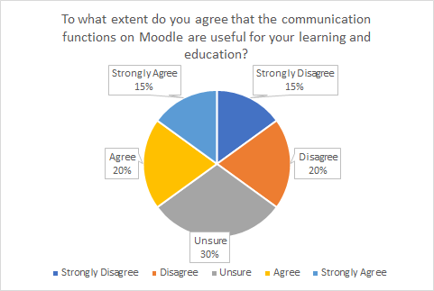
Again, the results for this question seem to vary across the board, the majority of people responding said that they were unsure whether Moodle communication was useful in their education.

To what extent do you agree that your course effectively utilises the feedback functions on Moodle for your work?

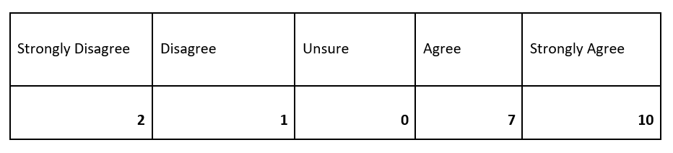
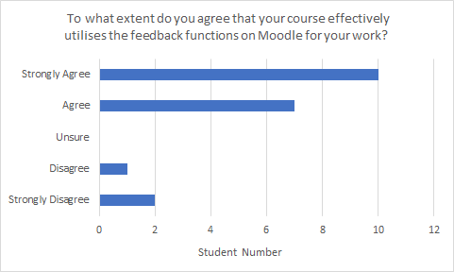
The responses for the question above were mostly agree (10) and disagree (7).

To what extent do you agree that feedback on Moodle from teachers has a positive impact on your final grade?

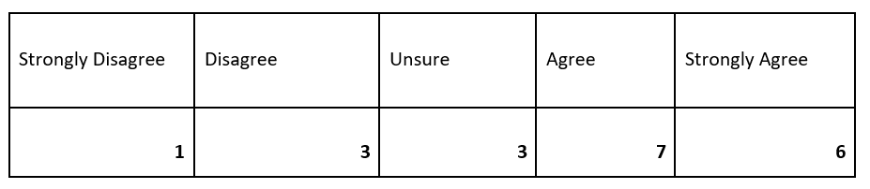
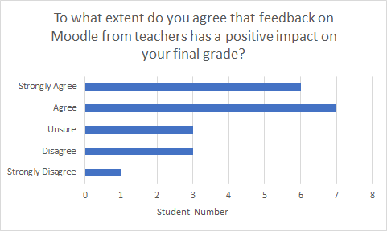
Most responses came into the category of ‘agree’ and ‘strongly agree’. Equal number of responses of 3 for ‘unsure’ and ‘disagree’.
To what extent do you agree that using Moodle for summative assessment submission is easy and simple?
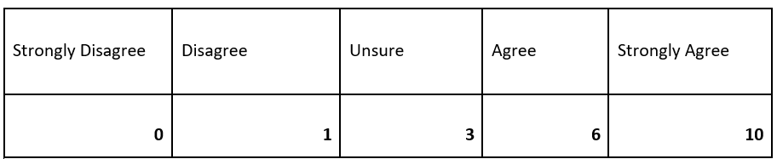
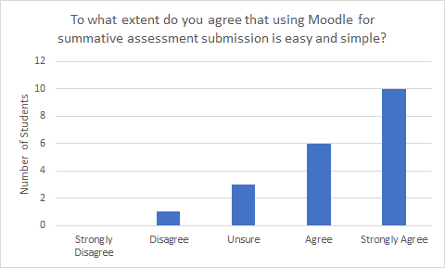
These responses were strongly positive, 50% of students said they strongly agree.

To what extent do you agree that more final module components should be based on Moodle submissions versus in-class assessments like presentations or exams?

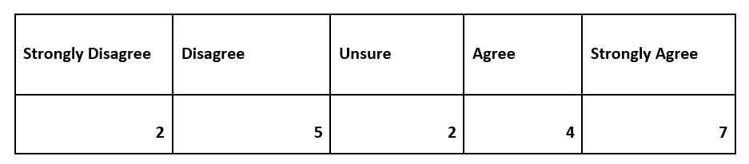
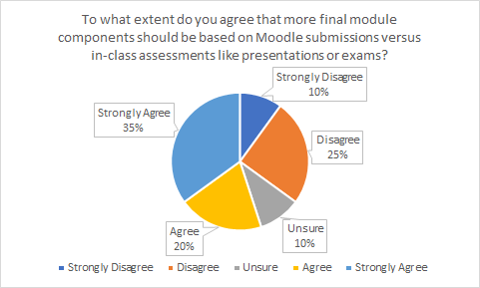
More varied results than the previous question however predominant response was ‘strongly agree’ at 35%.

How often per academic year do you use Moodle to access pastoral support services offered by the university? (This includes things like student mental health, personal tutors, self-help courses).

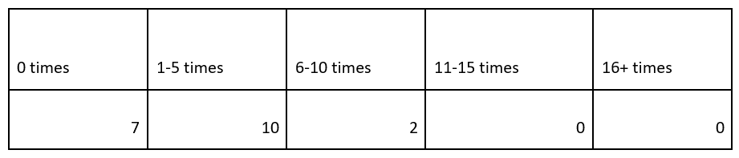
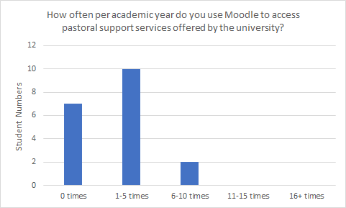
Results show that predominant response was 1-5 times, no responses recorded for any number above 11.
To what extent do you agree that Moodle is an appropriate way to access pastoral services offered by the university?
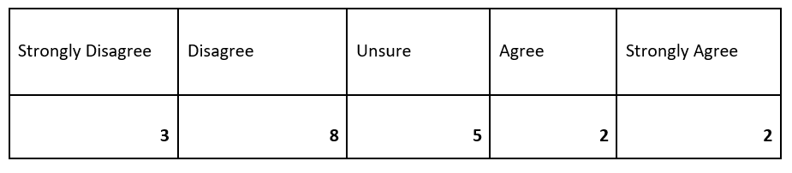
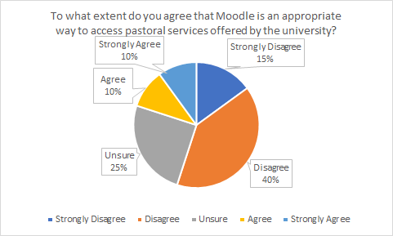
The majority of students responded with either ‘disagree’ or ‘strongly disagree’.

Discussion
This questionnaire revealed some interesting views that students of UWTSD had about using Moodle during their studies and time at university. The questionnaire was split up into 4 sections to get a better idea of some specific components of using virtual learning environments.
Component 1 asked about communication and collaboration on Moodle. When asked how often they use Moodle for communication, there was not really any significant category. 5 students used Moodle to communicate for each of the following categories 1-5, 11-15 and 16+ times a week so this shows that Moodle is fairly popular. Only 2 students responded with 0 times a week. This is a positive thing, as using Moodle and other types of technology in education may improve productivity and collaboration between students. More could be done to encourage students to be using Moodle 16+ times a week for communication, perhaps more tutorials as some students may not be comfortable using it. When asked if Moodle communication was useful for their learning, students also were varied across the options however about a third were unsure. Again, as mentioned before it might be a good idea to increase tutorials available for Moodle, so all students are comfortable using it.
Component 2 was used to explore the concept of feedback for students on Moodle. Receiving feedback is an important part of a student’s learning experience so it was encouraging to see that 85% of students thought that their course of study effectively utilises feedback. This shows that there is a good connection between lecturers and students on their work. On the other hand, when asked if Moodle feedback had a significant impact on final grades, the results were just a bit less positive. 13 students responded with either ‘agree’ or ‘strongly agree’ and 7 for ‘unsure’ or ‘disagree/strongly disagree’. This could be due to the fact that many students prefer feedback face to face, as it is easier to understand, but further work must be done to determine if this is true.
Component 3 looked at using Moodle for summative assessment submissions. Results for the question asking if submission to Moodle was ‘easy and simple’ were positive, no students responded with ‘strongly disagree’, and half of students said, ‘strongly agree’. This is beneficial as this ensures students can accurately submit their work without any panic and problems. The results for the question asking if students agreed that Moodle submissions should replace in-person exams was more mixed. Just over half of students said ‘agree’ or ‘strongly agree’ but the rest of the students were either unsure or disagreed. This might be expected during this time as most universities have had to transition to online learning for months, so students might want some in-campus time back, rather than more Moodle work.
Finally, component 4 looked at pastoral support on Moodle. Pastoral support for students is important as many different things can impact their ability to learn, and during the COVID-19 pandemic time it is important students can access appropriate resources easily. Unfortunately, many students responded that they used Moodle to access pastoral support ‘0 times’ per academic year. Half of students responded that they only used Moodle ‘1-5 times’ a year to access support. These results are supported by the fact that 40% of students said ‘disagree’ to Moodle being an appropriate way to access pastoral support. This is interesting, perhaps students prefer to be on campus to access support and discuss personal issues. More work can be done to explore this and ensure students are getting the support that they need.

Conclusion
In conclusion, this investigation yielded mixed results about the impact of Moodle on student experiences. Some aspects students liked and said had positive effects, some things they did not like. Perhaps it would be useful to repeat the questionnaire at different points in the year to see if attitudes change.

Bibliography
Blackboard, 2011. About Bb. [Online]
Available at: www.blackboard.com/about-Bb/Company.aspx
[Accessed January 2021].
firefly, 2020. What is a Virtual Learning Environment (VLE)?. [Online]
Available at: https://fireflylearning.com/what-is-a-virtual-learning-environment-vle
[Accessed adecember 2020].
Moodle, 2011. Moodle. [Online]
Available at: http: /moodle.org/
[Accessed January 2021].
Oxford University Press, 2016. Learn about Virtual Learning Environment/Course Management System Content. [Online]
Available at: https://global.oup.com/uk/orc/learnvle/
[Accessed January 2021].

Appendix:
The following section contains the questionnaire that was provided to student and which was used to obtain data for this investigative report:
This page is just to collect information to ensure that this questionnaire collects a fair representation
of the student body.
- What is your age?
18-30 | 31-45 | 46-70 | 70+

- What is your gender?
Female | Male | Other | Prefer not to say

- What course are you currently enrolled in?
………………………………………………………………………………………………………………………………………………………

- What mode is your course, full time or part time?
Full time | Part time

Component 1: Communication and Collaboration
- How often do you use the communication functions on Moodle to interact with your classmates and teachers a week? (Tick ONE box)
0 times a week | 1-5 times a week | 6-10 times a week | 11-15 times a week | 16+ times a week

- To what extent do you agree that the communication functions on Moodle are useful for your learning and education?
Strongly Disagree | Disagree | Unsure | Agree | Strongly Agree

Component 2: Feedback from Teachers
- To what extent do you agree that your course effectively utilises the feedback functions on Moodle for your work?
Strongly Disagree | Disagree | Unsure | Agree | Strongly Agree

- To what extent do you agree that feedback on Moodle from teachers has a positive impact on your final grade?
Strongly Disagree | Disagree | Unsure | Agree | Strongly Agree

Component 3: Summative Assessments
- To what extent do you agree that using Moodle for summative assessment submission is easy and simple?
Strongly Disagree | Disagree | Unsure | Agree | Strongly Agree

- To what extent do you agree that more final module components should be based on Moodle submissions versus in-class assessments like presentations or exams?
Strongly Disagree | Disagree | Unsure | Agree | Strongly Agree

Component 4: Pastoral Support on Moodle
- How often per academic year do you use Moodle to access pastoral support services offered by the university? (This includes things like student mental health, personal tutors, self-help courses).
0 times | 1-5 times | 6-10 times | 11-15 times | 16+ times

- To what extent do you agree that Moodle is an appropriate way to access pastoral services offered by the university?
Strongly Disagree | Disagree | Unsure | Agree | Strongly Agree

