Motorcycle suspension simulation.
University of Wales Trinity Saint David
simon hughes
P147135
26/01/2020
Vehicle Stability and Control
M7X00436
Owen Williams.

2020
Table of Contents
2 Introduction 2
3 Stiffness and damping calculations 2
4 Simulation 6
5 Results 11
5.1 Solidworks 11
5.2 MATLAB 13
6 conclusions 14
7 References 15

Figure 1 semi detailed model of linkage system 3
Figure 2 link ratio data from Solidworks 4
Figure 3 spring stiffness and damping calculations 5
Figure 4 Changes in Zeta value (University of kurdistan, 2020) 6
Figure 5 Detailed motorcycle CAD model 7
Figure 6 4 degree of freedom model (Cossalter, 2006) 7
Figure 7 version 1 of simple CAD model 8
Figure 8 version 2 of simple CAD model 8
Figure 9 location of input force 9
Figure 10 spring, damper, contact and force setup 10
Figure 11 location of front spring and damper in simulation 10
Figure 12 CoG position with calculated values (Solidworks) 11
Figure 13 CoG position with zero damping (Solidworks) 12
Figure 14 Pitch angle with calculated values (Solidworks) 12
Figure 15 sprung mass and suspension displacement (MATLAB) 13
Figure 16 CoG position with calculated values (MATLAB) 13
Figure 17 pitch angle with calculated values (MATLAB) 14

Introduction
Correct suspension setup is important to the handling characteristics of a motorcycle both from the rider’s point of view and a safety aspect.
In this report the use of a CAD model as a tool to predict the movement of a ‘4 degree of freedom’ motorcycle model will be explored and discussed, to aid the CAD model MATLAB will be used as a verification tool to see that the model functions in the expected way.
The motorcycle being used as a basis in this report is a KTM 450 SX-F in a Supermoto setup. Though several of the needed parameters are known about the motorcycle, there are some unknowns, therefor educated estimations will be used.

Stiffness and damping calculations
When calculating the front and rear spring stiffness and damping values; the mass, centre of gravity, front and rear un-sprung masses, wheelbase, rake and linkage ratio need to be known.
A sports motorcycles has a ride frequency of around 2.1Hz, this figure comes from the measured data of many different motorcycles. Different styles of motorcycle have varying ride frequencies, cruising motorcycles have a lower value of around 1.8Hz whereas more sport orientated motorcycles have frequencies upwards of 2Hz.
The front and rear sprung masses can be calculated using the total mass of the motorcycle multiplied by the mass bias percentage to the front or rear, minus the un-sprung mass for the front and rear respectively. These sprung masses are then used alongside the ride frequency in the following equation to get the vertical spring stiffness.
$$K_{(v)}=((2×π×ride frequency)^2 )*sprung mass.$$
The actual spring stiffness differs from the vertical stiffness as the rake and linkage ratio interact with the stiffness values. The equation for the front suspension is as follows.
$$K_{f}=K_{f(v)}×{\left(\cos\left(Rake angle\right)\right)}^{2}$$
And the equation for the rear suspension is.
$$K_{r}=K_{r(v)}×{link ratio}^{2}$$
Once the spring stiffness have been worked out the damping for the front and rear can be calculated, the equation for the vertical damping is as follows.
$$C_{crit(v)}=2×\sqrt{K_{(v)}×sprung mass}$$
The actual damping values for the front and rear use the same equations as the spring stiffness but using the vertical damping values instead. The equations are a follow,
$$C_{crit f}=C_{crit f(v)}×{\left(\cos\left(Rake angle\right)\right)}^{2}$$
$$C_{crit r}=C_{crit r(v)}×{link ratio}^{2}$$
The damping values then need to be multiplied by a damping ratio to get the system to be slightly under damped, and therefore more comfortable to ride.
To find the link ratio of the given setup, the displacement of the rear wheel and the shock absorber were compared. This required a semi detailed CAD model of the linkage system used on the motorcycle, seen in figure 1.
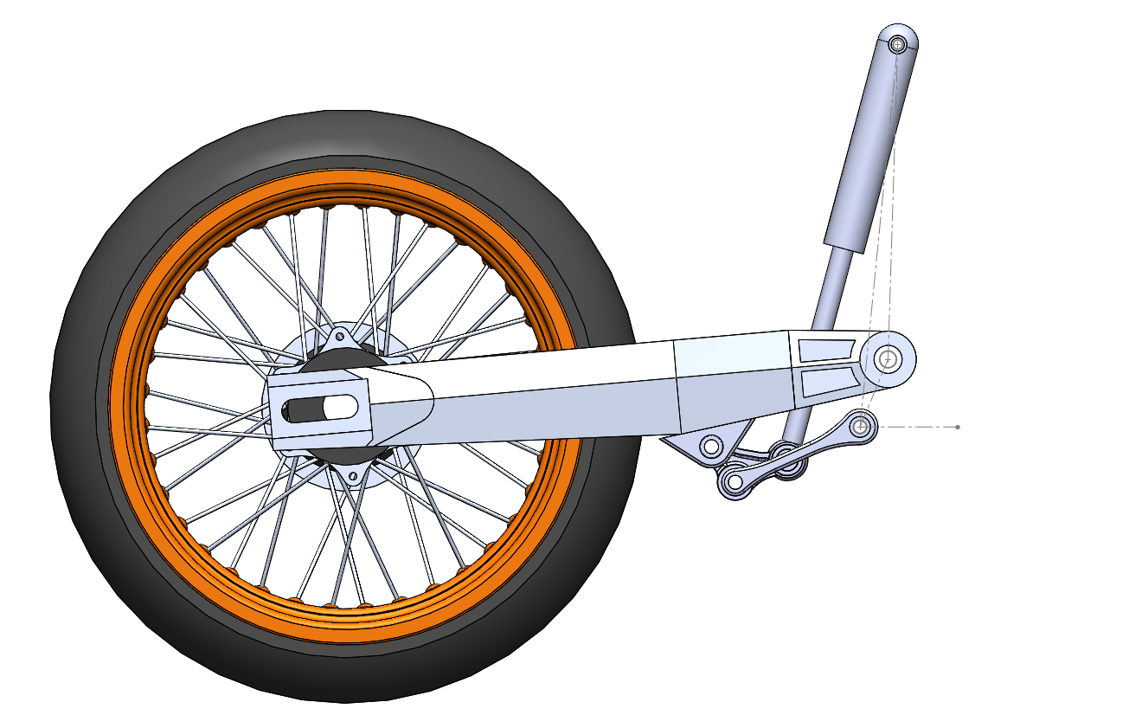
Figure 1 semi detailed model of linkage system
The data obtained from the linkage model was then processed in excel, the limit of rear wheel displacement set was 100mm, the graph in figure 2 shows the interaction of the rear wheel motion on the shock absorber. The two data traces were then divided by each other to find a ratio between each data point gathered, seen as the grey line, this trace still had an oscillation in it so the average of the whole data series was taken to give the link ratio.

Figure 2 link ratio data from Solidworks
For simple simulation the values that are calculated with the previous equations are appropriate, but if real would applications are being pursued the front spring stiffness would need to be halved, this is because the front suspension on a motorcycle has two forks.
All of the aforementioned equations can be seen in the form of the excel workbook in figure 3.
The below equation is the second order differential equation, which is the equation of motion for a single spring damper system, it can be used once the spring stiffnesses and damping values have been calculated to find the displacement, velocity and acceleration of a system, displacement and velocity being arguably more important then the acceleration and velocity in terms of suspension setup.
$$Ma+Cv+Kx=0$$

Figure 3 spring stiffness and damping calculations
Figure 4 shows the change in the damping ratio. It shows that when the ratio is below 1 the system is under damped but once the ratio reaches 1 the system becomes critically damped and then when it goes above 1 the system becomes overdamped. Normally only the under damped regime is observed in any kind of vehicle as if it were critically or over damped the vehicle would be extremely uncomfortable to pilot, but if it were too underdamped the vehicle will also be uncomfortable, both scenarios can also possibly cause damage to the suspension in extreme circumstances.
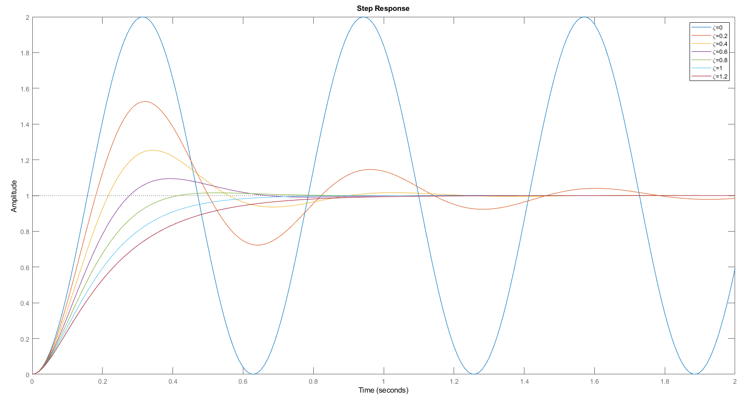
Figure 4 Changes in Zeta value (University of kurdistan, 2020)

Simulation
To simulate the previously calculated stiffness and damping figures a model was created in Solidworks. This simulation could have been done in any of several software packages though Solidworks was chosen as it has a comprehensive set of simulation tools.
An existing detailed CAD model of a motorcycle, figure 5, was initially used for the simulation, but proved to be too complex for Solidworks to provide any results, thus a much simpler model was used for the task.
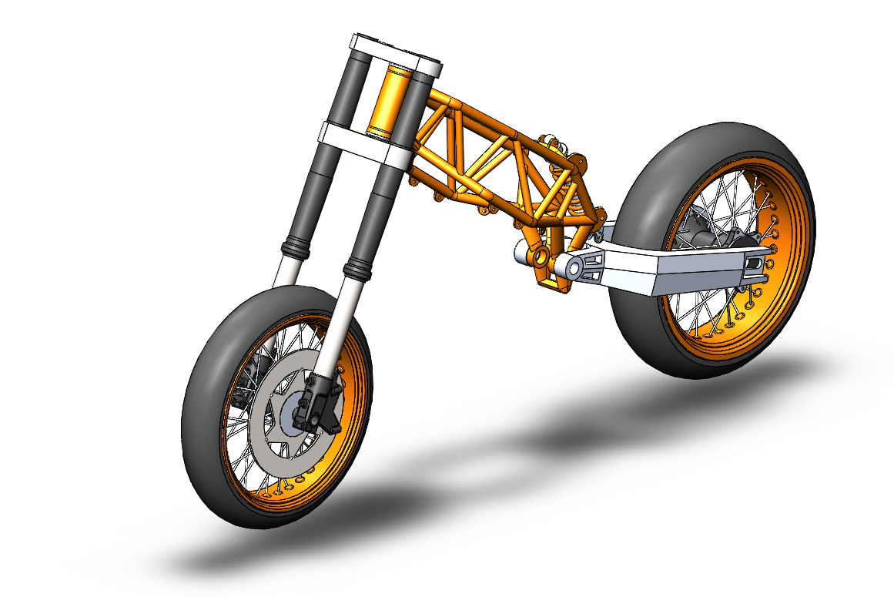
Figure 5 Detailed motorcycle CAD model
This simple model, initially figure 7, was based on a representation used by Vittore Cossalter in motorcycle dynamics and consisted of several different blocks in place of key components of the motorcycle, seen in figure 6.
Figure 6 4 degree of freedom model (Cossalter, 2006)
One large block was used to simulate the main sprung mass of the motorcycle, two more blocks were used for the front and rear un-sprung masses and a final block for the ground plane. This set up showed promise but ultimately failed to display correct behaviour in the form of constantly traveling in an upwards direction regardless of constraints.

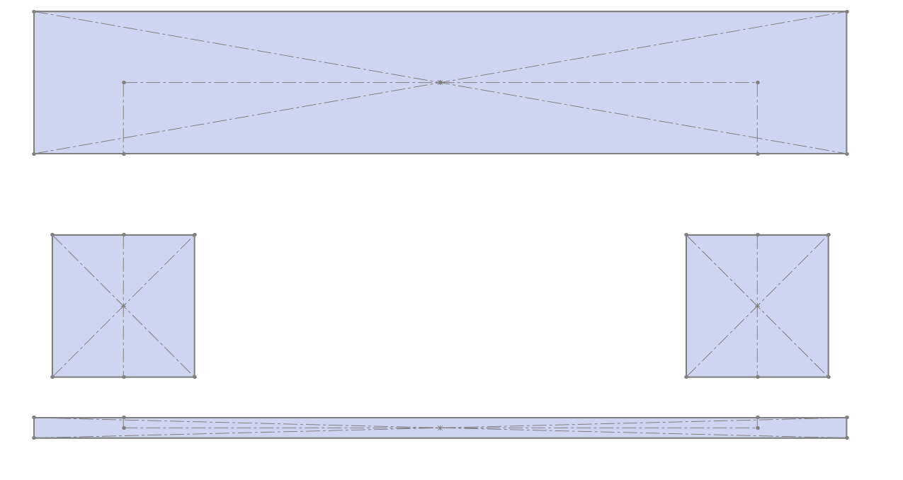
Figure 7 version 1 of simple CAD model
A revision of the simple model, figure 8, used cylindrical blocks instead of square blocks to represent the wheels, these were accompanied by a hollow partner cylinder which represents the contact surface of the tyres and the ground. These outer cylinders have no role other than being a method to anchor the part to the ground plane and offer a point for the spring and dampers of the tyres.
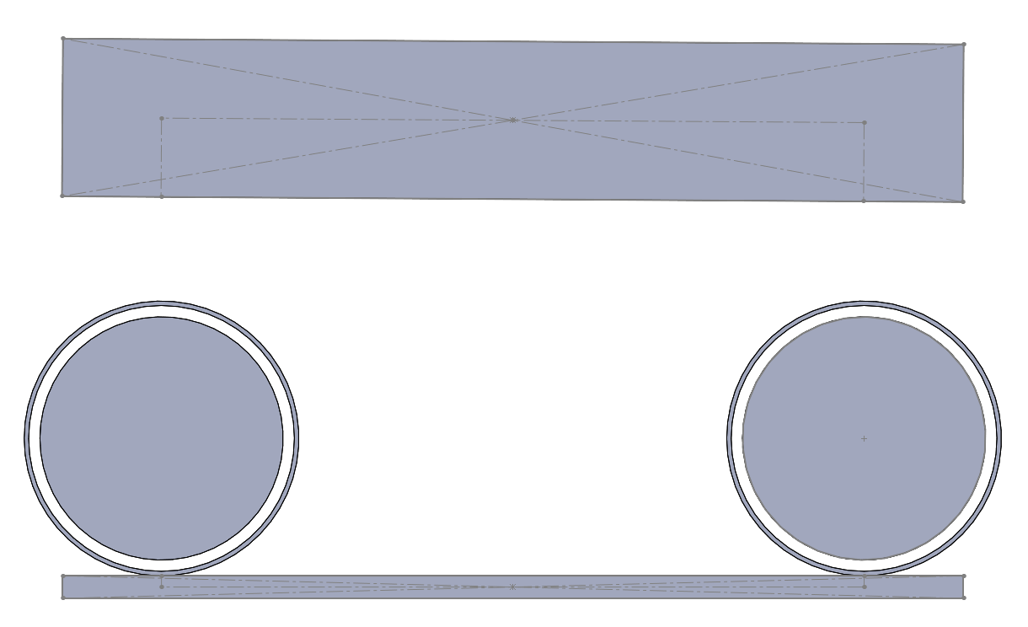
Figure 8 version 2 of simple CAD model
This second simple model also showed promise and initially gave somewhat reasonable results.
The setup of the motion study, seen in figure 10, required four spring mates, two of the of which represented the front and rear suspension, figure 11, and two which represented of the tyres. Four damper mates were also, required to accompany each of the spring mates.
One input force was used, this force acted in an upward direction on a centre point of the front wheel to simulate the shock of the wheel traveling across a small bump. This is seen in figure 9.
Four Solid body contacts were used, these being between the outer cylinders and the ground plane, and the outer cylinder and the main body to stop excessive downward displacement.
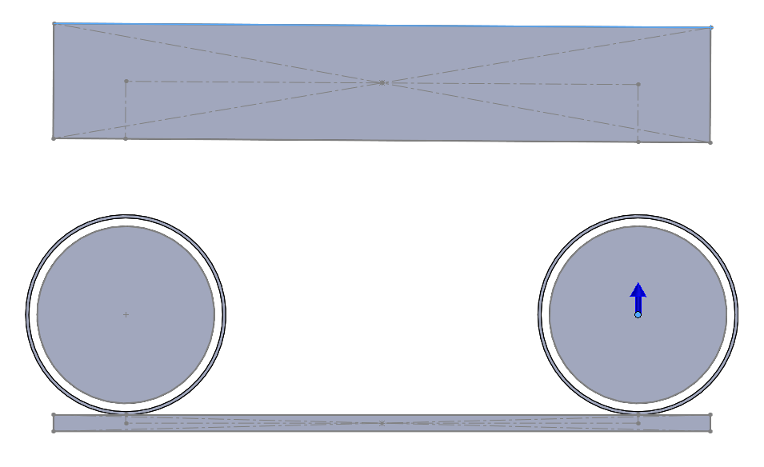
Figure 9 location of input force
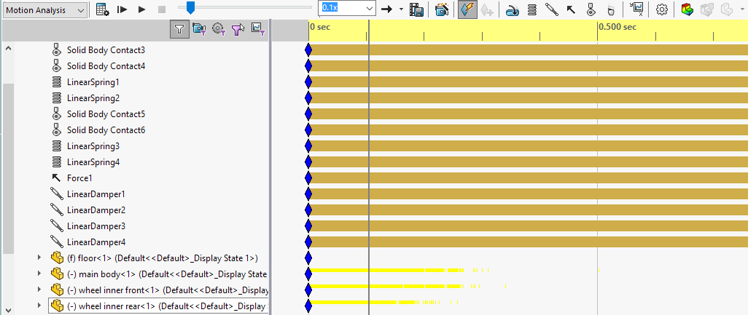
Figure 10 spring, damper, contact and force setup
The setup of the front spring and damper can be seen in figure 11, this was deemed to be the most appropriate place to set them in this model though still not the most ideal due to not including the rake angle.
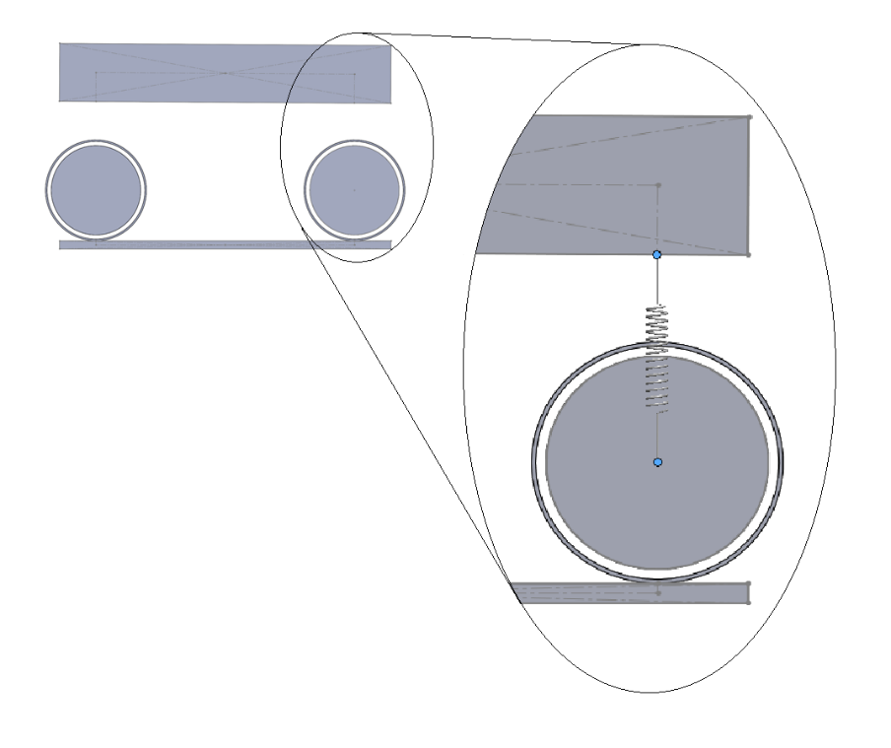
Figure 11 location of front spring and damper in simulation

Results
The results of the simulation conducted were inconclusive as there were several discrepancies that didn’t not match expected outputs of a normal 4 degree of freedom model.
In addition to the main Solidworks simulation an analysis of was also conducted in MATLAB using the same calculated parameters. This was done using code that is known to out put reliable results, this is due to the code using specific input data such as the ride frequency with Solidworks does not.

Solidworks
At first glance figure 12 seems to show an acceptable data trace when compared to the later MATLAB output, though upon closer inspection the time in which the motion occurs is drastically less than the MATLAB output.

Figure 12 CoG position with calculated values (Solidworks)
In figure 13 all the values of system damping were set to zero to confirm if the system would act in an appropriate way, as can be seen the undamped nature of the system is plainly evident as a non-reducing sine wave is produced.

Figure 13 CoG position with zero damping (Solidworks)
As can be seen in figure 14 the pitch angle closely matches the CoG displacement, which is acceptable apart from the magnitude of the angle itself which was expected to be much greater.

Figure 14 Pitch angle with calculated values (Solidworks)

MATLAB
The simulation run in MATLAB is slightly different to the one run in Soildworks because it is technically moving the model along a road surface with a bump on it, this causes both the front and rear wheel to displace. This can be observed in figure 16 where the initial rise starts to fall and then accelerates back upwards as the rear wheel traverses the bump.
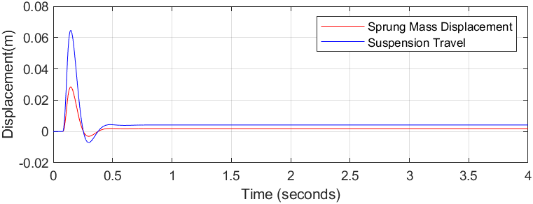
Figure 15 sprung mass and suspension displacement (MATLAB)
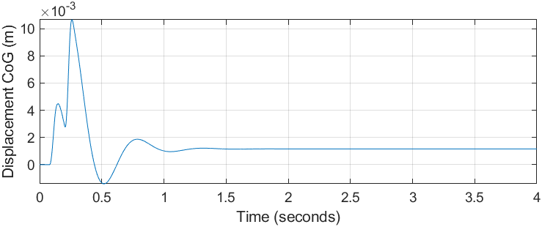
Figure 16 CoG position with calculated values (MATLAB)
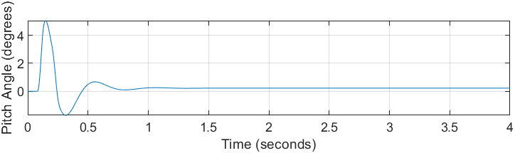
Figure 17 pitch angle with calculated values (MATLAB)

conclusions
The complex motorcycle model that was used for the simulation used many detailed components; these needed to have many different constraints to fully define the parameters of the motorcycle. This proved to make the model quite complicated, which in turn caused many different errors in the simulation that were difficult to solve or were unsolvable. Due to this a much simpler model was used, this model was based on a standard visual model of a half car system, which has 4 degrees of freedom.
Although Solidworks has a good simulation package it seems flawed when trying to calculate a multi body system such as a motorcycle. This could be due to the software not being specialised to handle the specific equations used for the dynamic systems evident in a motorcycle.
Though results were obtained from Solidworks they did not conform to what would be expected from a half car model with correct setup. This is shown in the fact that changing the spring stiffness and damping values of the main suspension yields little or no change to the output results, though any small change to the tyre stiffness and tyre damping values changes the output greatly.
It also differs from the MATLAB results in frequency and amplitude, this could be due to Solidworks not having the capacity to use a ride frequency as an input parameter but rather creating its own system frequency. Looking at the totally undamped Solidworks output the system has a frequency of around 20Hz which is much greater than the MATLAB specified 2.1Hz.
As can be seen in figure 14, Solidworks outputs a maximum pitch of 0.5 degrees in the positive direction and 0.4 degrees in the negative direction, these results do not match the output of MATLAB which outputs a positive pitch of 5 degrees and a negative pitch of 2 degrees, seen in figure 17.
As can be seen in all the different data outputs the amplitude decay is extremely different between Solidworks and MATLAB, this would indicate that the total damping of the system is not accurately represented in Solidworks, again this could be due to Solidworks not being specialised to handle scenarios using 4 degree of freedom systems.
These factors would ultimately indicate a failure of the CAD simulation at this point, though more investigation is needed.
Suspension can be set up theoretically perfectly, but the rider may dislike the feel of the bike in that state, due to this, rider input on suspension settings are important when correctly setting up for racing, though riders can sometimes not know what may need to be changed, so therefore good communication and relations need to be maintained between rider and suspension technician.

References
Cossalter, V. (2006). Motorcycle dynamics.
S.S.Patole, D. (2015). Theoretical and Numerical Analysis of Half Car Vehicle Dynamic Model Subjected to Different Road Profiles with Wheel Base Delay and Nonlinear Parameters.
University of kurdistan. (2020, 01 25). Zeta. Retrieved from https://eng.uok.ac.ir/mfathi/courses/Control%20Systems/MatlabEx/html/Zeta.html

