University of Wales Trinity Saint David

Wales Institute of Science & Art


Torsional stiffness test

Mechanics and Dynamics (ACHA4026)

Jack Cheatle
2405699
Date (01/2026)
Contents
1. Introduction 1
2. Experimental Procedure 2
3. Results 4
4. Analysis 5
5. Conclusion 6
6. Evaluation 7
7. Further Work 8
8. Reference List 9

Introduction
This report presents an experimental investigation into the torsional behaviour of three shaft materials: brass, aluminium, and steel. The primary objective of the experiment is to evaluate how each material responds to an applied load when subjected to torsion and to compare their mechanical performance under identical testing conditions. This allows for meaningful comparison of their elastic properties and resistance to twisting.
During the experiment, incremental weights were applied to each shaft to generate a controlled torsional load, resulting in measurable angles of twist. These angular displacements were recorded and used to calculate the corresponding torque applied to each shaft. From this data, the polar second moment of area (J) was determined for each material. The calculated values were then analysed to assess the torsional stiffness and elastic behaviour of the shafts, as well as to examine how differences in material properties influence torsional deformation and overall mechanical performance.

Experimental Procedure
The kit provided for data collection included step-by-step instructions outlining the procedure for measuring the response of each material under different applied loads. The materials tested in this experiment were brass, aluminium, and steel, allowing for direct comparison of their torsional behaviour.
The experimental equipment consisted of a work panel of sufficient width to securely mount all required components with required mounting screws. One end of the workpiece was held in place using a fixed chuck, ensuring it remained stationary throughout testing, while a rotating chuck was positioned 340 mm from the fixed end. Incremental loads were applied by attaching varying amounts of weight to the rotating chuck, generating torsional stress within the shaft. This arrangement allowed the angular displacement of each material to be measured as the applied load increased, providing data for analysing their torsional response.

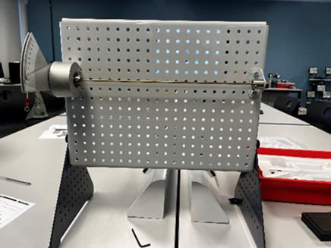
Figure 1- Full Torsion assembly

for each material tested, the same procedure was followed. The material was first clamped securely to ensure it did not move freely when a load was applied. The rotating chuck was then checked and set to zero with no weight attached. Weight was added in 100 gram increments, and at each stage the amount of twist in the material was measured. This process was repeated until a maximum load of 500 grams was reached, with care taken to ensure the material returned to zero each time the load was changed. A vernier calliper was used to accurately measure the diameter of each piece tested all recoding to 3.1mm.
When testing aluminium, an exception was made by limiting the maximum applied load to 400 grams. This precaution was necessary because aluminium has a lower elastic limit than the other materials tested. Applying loads beyond this limit could cause the material to undergo plastic deformation, meaning it would not return to its original shape once the load was removed. Such permanent deformation would invalidate the assumption of elastic behaviour and compromise the accuracy of the results. Limiting the applied load ensured that all measurements for aluminium remained within the elastic region, allowing for valid and reliable data to be collected.
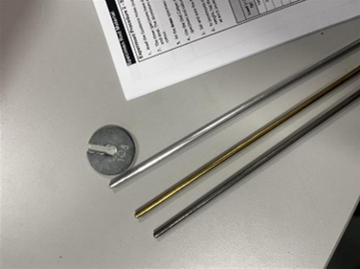
Figure 2- Example of a single weight and each material tested
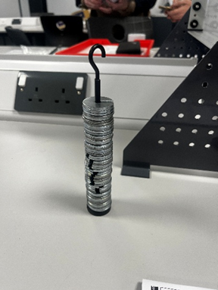
Figure 3- Hook assembly with 500grams
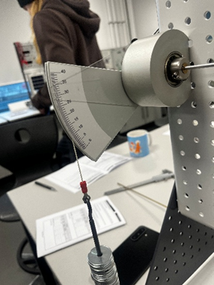
Figure 4-Rotating chuck with weight attached

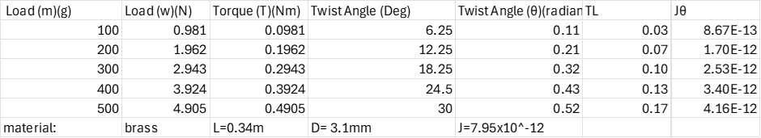
Results
Table 1- Brass results
Table 2- Aluminium results
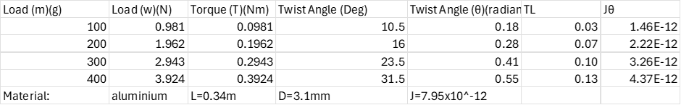
Table 3- Steel results
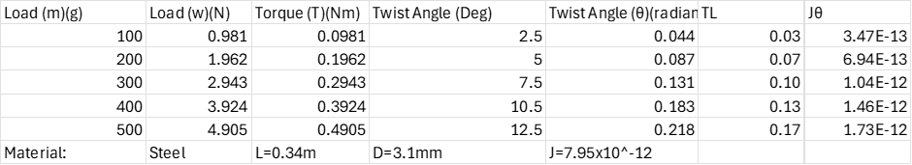

Analysis
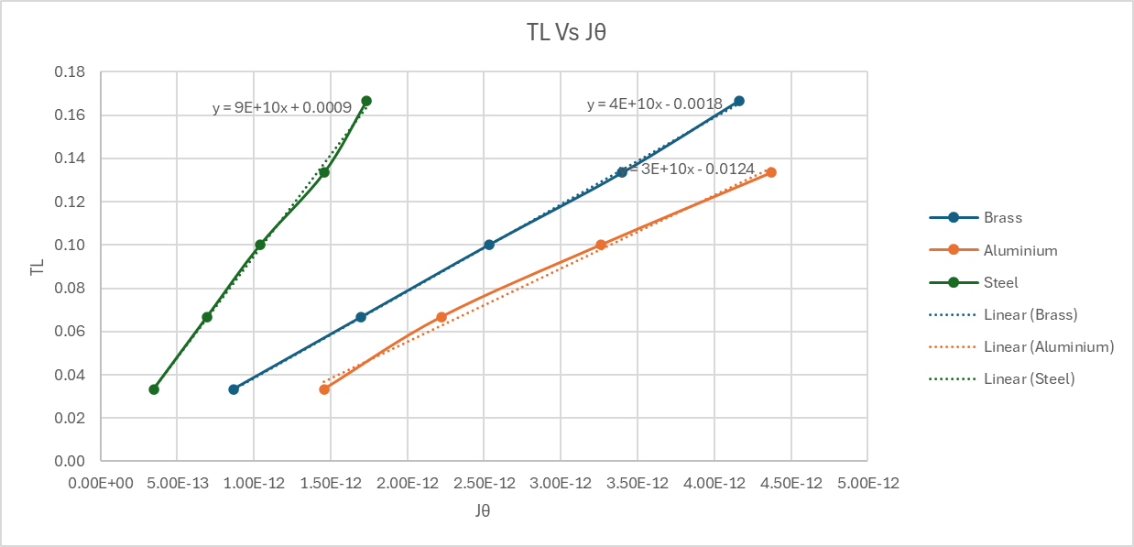
Normal stress, such as compression or tension, acts directly on the cross-section of an object. Torsional stress works differently, acting around the cross-section and causing the object to twist about its centre. For compression or tension to occur on its own, the forces must be applied concentrically. If they are off-centre, shear stress is introduced instead. Torsional stress occurs when forces are parallel, equal in size, opposite in direction, and applied the same distance from the centre. McClements, D. (2023).
Figure 5- Tl vs Jθ
This graph shows a linear relationship for steel, brass, and aluminium, indicating elastic torsional behaviour across all specimens. The gradient of each linear relationship corresponds to the shear modulus, G. Steel exhibits the steepest gradient, followed by brass and aluminium, indicating that steel has the highest shear modulus while aluminium has the lowest. This trend is consistent with established material properties and supports the validity of torsion theory.
Although the overall trend of the data is linear, small deviations from linear are observed. These discrepancies may be attributed to experimental measurement uncertainties during data collection, such as slight errors in measuring . Additional sources of error may include assumptions made during calculations, instrument calibration limitations, and small misalignments of the zeroed measing point. Despite these variations, the data remains sufficiently linear to support the underlying theory.
The shear modulus (G), also referred to as the modulus of rigidity, describes a material’s resistance to twisting when subjected to an applied torque. It can be calculated using the relationship:
$$G=\frac{TL}{Jθ}$$
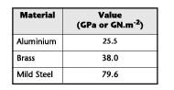
Figure 6- GPa results given by the Torsion of circular sections kit

The given values vary moderately compared to the actual data. For aluminium, the value provided is 25.5 GPa, whereas the trendline indicates approximately 30 GPa, which is a significant overestimation. For brass, the given value is 38 GPa, while the actual value is 40 GPa. This is also an overestimation but much smaller, showing that the discrepancy is less severe. Finally, for steel, the provided value is 79.6 GPa, while the calculated value is 90 GPa, again representing a notable overestimation.

Conclusion
In conclusion to this report , the experiment successfully demonstrated the torsional behaviour of brass, aluminium, and steel shafts under applied loads. All materials exhibited a linear twist, confirming elastic behaviour within the tested load ranges. Steel showed the greatest torsional stiffness, followed by brass, while aluminium displayed the highest angular deformation for a given torque. These findings are consistent with established material properties and validate the theoretical principles governing torsional stress and deformation.

Evaluation
One consistent source of error in the experiment was the workpiece moving freely within the clamp. This movement caused inaccuracies in either the zero point or the measured angle of twist, as some of the applied torque was lost due to slippage rather than being fully transferred to the rod. Consequently, the measured angular displacement was lower than the true value, reducing the reliability and accuracy of the results. To reduce this source of error, the ends of the rods could be lightly scored or roughened to increase friction within the clamps. This would improve grip and ensure that the applied torque resulted in uniform twisting of the specimen.
Another limitation of the experiment was the choice of material, particularly aluminium. Aluminium displayed a smaller range of elastic behaviour compared to steel or brass, reaching its elastic limit at lower applied torque values. This limited the range over which aluminium could be tested and reduced the number of valid data points within the elastic region. As a result, comparisons between aluminium and the other materials were less reliable. This issue could be addressed by using a thicker aluminium rod or selecting an aluminium alloy with a higher elastic limit, allowing the material to be tested over a range more comparable to that of steel and brass.

Further Work
There are a few ways to improve the practical to make data collection more viable, an example of this is when setting up the gauge on how far each piece shifted the zeroed number wasn’t repeatable to the exact point creating a variable.
Another source of measurement inconsistency could arise from differences in how each observer within the group reads the measured values. Although having multiple people verify the same result can improve the reliability of the data, consistency is further enhanced when each individual maintains the same role throughout the experiment. This reduces variability caused by different interpretation or reading techniques and removes the need for observers to adjust to unfamiliar roles.
A few minor improvements include before adding each weight for the materials the hook and the weights combined can be weighed to make sure the values are what are needed. Also, during the practical the hook used was not counted for the total weight so each measurement wasn’t completely accurate.

Reference List
McClements, D. (2023). What Is Torsional Stress? How It Works and How It Is Calculated. [online] www.xometry.com. Available at: https://www.xometry.com/resources/materials/torsional-stress/.
TecQuipment. (2025). TORSION OF CIRCULAR SECTIONS KIT. [online] Available at: https://www.tecquipment.com/torsion-of-circular-sections-kit.

