ACBA5009 – WORK BASED PROJECT

LEARNING CONTRACT

Is plastic waste in road construction sustainable in the construction industry?

  - KERRI LEIGH FARMER 2100037

ABSTRACT

Contents
ABSTRACT 2
CHAPTER ONE 4
1.1 Introduction 4
1.2 Aims 4
1.3 Objectives 4
1.4 Summary 5
CHAPTER TWO 5
2.1 Literature Review 5
2.1.1 Recycling Handbook 5
2.1.2 ScienceDirect – Pyrolysis of Polyolefin plastic waste and potential applications in asphalt road construction: A Technical Review 6
2.1.3 ScienceDirect – Recycling Waste Plastics in Roads: A life-cycle assessment study using primary data. 6
2.1.4 BBC – Could Plastic Roads Make for a Smoother ride? 6
2.1.5 TRVST – Plastic Waste in Road Construction for Sustainable Plastic Paving. 6
2.1.6 UK Government – Use of Waste Plastics in Road Construction. 6
2.2 Methodology 6
2.2.1 Introduction 6
2.2.2 Research Approach 7
2.2.2 Methods of Analysis 7
2.2.3 Summary 9
References 10

CHAPTER ONE

1.1 Introduction
Plastics are organic molecules formed by extrusion, molding, casting, or spinning and the use of plastics in everyday life will not decrease due to plastics low cost, versatility, light weight, and recyclability. Prior to 1980 very few governments considered plastic recycling. A prediction by 2050 states 50% increase in incineration rates and 44% in recycling while discarded plastic waste will be at 6%. Plastic wastes lack bio-decomposition quality, making them unsuitable for landfilling or combustion. Both processes are environmentally unhealthy and lead to land and air contamination. Recycling plastic helps reduce the impact on the environment and ecosystems, plastic waste will continue to increase with a negative effect on ecosystems and more plastic will be stored on the planet. As a result of this increase in plastic waste and production there have been many studies on how to use plastic waste in asphalt binders as well as concrete paving (Science Direct, 2022).
The world produces 381 million tonnes of plastic waste yearly, this is also predicted to double by 2034 and half of this is single use plastic, and only 9% of that has ever been recycled (Condor Ferries, 2022).
With an ever changing and growing world and a housing shortage along with population growth, the need for housing arises with new and old infrastructure required as well as repairing old roads and paving. The norm is building, creating, and developing with natural resources and other materials that produce some sort of carbon footprint such as concrete, wood, and steel. The question arises as to why not reuse plastic waste that has already been produced (TRVST, 2022)?
When talking about sustainability and avoiding the depletion of our natural resources, it makes sense to try and use a product in construction that will have a low carbon footprint and last for the entire life cycle of the product or building by recycling or reusing (Parson, 2021).
There have been many debates and research on the use of plastic waste in building materials from using a plastic bottle as a brick, adding plastic waste into concrete production as well as constructing infrastructure like roads from plastic waste (Parson, 2021).
A recent article in an online magazine that offers opinion, analysis, reporting and debate on global environmental issues, stated that, paving with plastic could make a dent in the global waste problems we face (Parson, 2021).
The idea of using plastic in road construction is a fairly new research area, there have however been various examples of plastic being used in road construction around the world, some countries that have already put this case study into practice are the UK, Netherlands, Ghana, Ethiopia and South Africa (Government, United Kingdom, 2019).

1.2 Aims
- The aim of this research is to discover and understand if plastic or plastic waste can be used in the construction of roads in the United Kingdom to reduce plastic waste pollution?

1.3 Objectives
The research will answer the questions below by looking at case studies, and secondary research such as science and academic papers within the United Kingdom and other countries such as India and Australia to determine whether using plastic waste in road construction in the United Kingdom is viable.
- Defining recycling and the different types of plastic waste produced.
- Examining the current data on the different methods of adding plastic waste to road construction.
- Analysis of the performance levels of roads constructed with plastic and asphalt and complete a comparison against traditional roads.
- Would using plastic in road construction reduce the plastic waste problems we currently face?

1.4 Summary
With the current issues on climate change and sustainability in the world today, mainly focusing on the construction industry, this research sets out to determine if using plastic in construction is sustainable and the way forward for the future of civils construction.
The conclusion of this research paper will determine if using plastic in road construction, is viable in the United Kingdom to lesson the impact on the environment.
The significance of this research is the fact, we need to ensure in a constantly growing world, construction and other industries become more sustainable for the future, it makes sense to use a product that is not biodegradable and is landing up in landfills and oceans while very little is being recycled would be the way forward. We need to look after our natural resources, and fossil fuels.
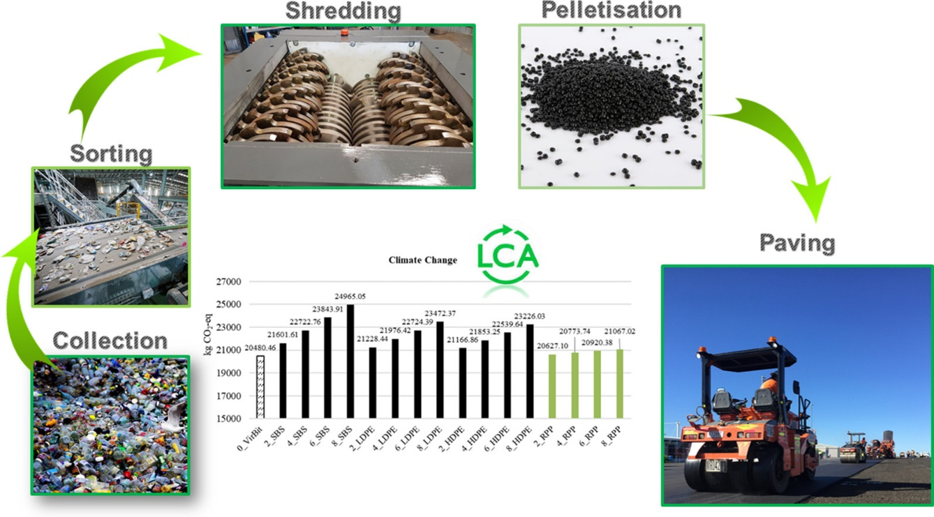
Figure 1 Recycling waste plastic for use in infrastructure like roads (Science Direct, 2021).
The image above taken from a Science Direct research paper represents the process in using plastic for road construction, and the environmental impact using plastic waste can have.

CHAPTER TWO

2.1 Literature Review

2.1.1 Recycling Handbook
The definition of recycling is “the environmentally preferred method of solid waste management.” Early humans being the hunter gathers did not require a solid waste management strategy, as humans began to settle permanently within communities with higher concentrations of waste being produced a waste management plan was needed. Recycling occurs for three main reasons: altruistic, economic, and legal (McGraw-Hill, 2001).
Plastics most recovered via community recycling include PET (Polyethylene Terephthalate) and HDPE (High-Density Polyethylene) bottles (McGraw-Hill, 2001).

2.1.2 ScienceDirect – Pyrolysis of Polyolefin plastic waste and potential applications in asphalt road construction: A Technical Review
Plastic is petroleum-based material, that is non-biodegradable and is in high demand, this has led to a depletion of non-renewable fossil fuels, therefor plastic is not sustainable, and the recycling of plastic is still at a very low rate. Pyrolysis could become the strategy used for recycling plastics to products that can be matched with other applications throughout different industries. However, there are limitations in using these plastic waste materials from an environmental and technical perspective. Design from Recycling examines the concept of different application routes for plastic waste (Science Direct, 2022).
Polyethylene makes up 40% of plastic in the plastic waste streams, leaving PO Polyolefin making up the majority of the waste. Valorisation has been thoroughly researched over the years from low grade recycled plastics via thermochemical processes recycling the low grade plastics into petrochemical feedstock. More recently pyrolysis (heating of an organic material in the absence of oxygen) has been used on various scales and presented promising (Science Direct, 2022).

2.1.3 ScienceDirect – Recycling Waste Plastics in Roads: A life-cycle assessment study using primary data.
There are currently two processes of using waste plastic in road construction, either the plastic has been recycled and pellets formed, and it is then added as an additive this is called the wet method, or the dry method of plastic recycling for roads is where it is used as a replacement for natural aggregate. Recent case studies in Australia have been carried out with the results showing that using recycled plastics as a polymer for bitumen as a synthetic aggregate in asphalt can be very advantageous to the environment compared to natural aggregates used (Science Direct, 2021).

2.1.4 BBC – Could Plastic Roads Make for a Smoother ride?
India has been a leader in the world constructing roads out of plastic-tar since the early 2000’s. Using plastic in road construction, helps prevent the plastic waste landing up in the oceans, and landfills, early data has shown that using plastic in road construction also increases the life expectancy of the average road. Plastic roads seem to deteriorate slower and have less potholes. The process is not complicated and does not require the use of high-tech equipment. Using plastic in roads also saves tonnes of carbon dioxide by incineration. (Lee, 2021)

2.1.5 TRVST – Plastic Waste in Road Construction for Sustainable Plastic Paving.
Some advantages of using plastic waste in road construction would be the reduction in plastic waste. Plastic is extremely durable; it takes hundreds of years for plastic to break down. Using plastic waste would in turn lead to a reduction on our natural resources, the main advantage with plastic is once we have made it, it can be reused there is no need for reproduction of plastic again. Plastic in roads and paving can assist in the prevention of flooding. Plastic paving and roads can remove rainwater, by using hidden channels and direct it to run off areas (TRVST, 2022).

2.1.6 UK Government – Use of Waste Plastics in Road Construction.
A helpdesk report conducted in 2019 for the United Kingdom government by the University of Birmingham, investigated the use of waste plastic in construction of roads what the latest innovations and the possible future of and maintenance. The idea is a new idea and there are still many tests and studies taking place, laboratory test however showed that 5 – 10% by weight of plastic used in bitumen asphalt mixes produced higher stability, strength, and durability. The limitations of the study are the fact the roads developed using these methods are approximately 10 years old, long-term results cannot be determined (Sasidharan, et al., 2019).

2.2 Methodology

2.2.1 Introduction
The aim of this research is to determine if plastic waste can be used in the construction of roads in the United Kingdom to reduce plastic waste pollution? The research briefly looked at how plastic is collected and recycled, in everyday life and what types of plastic are produced, the research looked at science papers on the different methods of adding plastic to road construction. The performance levels were examined with a comparison to traditional road construction. Finally, the research discusses the plastic waste pollution issue and would using the plastic waste in civil construction reduce the current pollution levels and issues we face in the United Kingdom.

2.2.2 Research Approach
To reach the objectives stated, various quantitative and qualitative data had to be collected from several secondary sources, such as academic research papers and science journals this was mainly collected online. This research was interpreted and analysed. Various data was then used to correlate the findings and apply the findings and methods within the United Kingdom. The data clarified if any of the critical data research was applicable to the United Kingdom by comparing the type of plastic waste used in other countries for road construction, the processes, and methods of incorporating that plastic waste into bitumen and asphalt, as well as looking at the type of plastic waste pollution and recycling taking place. Secondary research data was collected from British Plastics Federation, statista and Commons Library to gather statistics and information on the type of plastic that is recycled in the United Kingdom as well as the percentages recycled in the United Kingdom and various other countries. The United Kingdom exports approximately 60% of its plastic waste, with a goal in mind to ban all United Kingdom exports of plastic waste by 2027 (House of Commons Committees, 2022).
It was imperative to understand the use of plastic waste in road construction, as well as the types of plastic most produced and landing up in oceans and or landfills and incinerators. How these plastics are collected, sorted, cleaned, and finally recycled. The data presented the different methods used in recycling plastic waste for road construction, the performance levels as well as the limitations in these methods. There were limitations and variables not considered in this research paper for instance climate in the United Kingdom. Although the United Kingdom has begun to follow the trend and currently there is an existing company that makes use of plastic waste for road construction, it remains extremely new, and the roads may not be old enough to understand the long-term benefits or downfalls. Other factors that needed to be considered was the environmental hazards and impact created by using these methods. Education is key to all including the public as well as those that work within the industry. Regulations would need to be set and followed.

2.2.2 Methods of Analysis
Selective data was extracted from science journals such as Science Direct and existing data on plastic waste in road construction internationally already using this method of road construction and correlating it and comparing that data to the current data and reports set out in the United Kingdom. There was a mix of qualitative and quantitative data collected from research papers and journals the data was analysed using a form of triangulation.

1.Types of plastic
There are seven common basic types of plastic produced:
- Polyethylene Terephthalate (PET or PETE)
- High-Density Polyethylene (HDPE)
- Polyvinyl Chloride (PVC or Vinyl)
- Low-Density Polyethylene (LDPE)
- Polypropylene (PP)
- Polystyrene (PS or Styrofoam)
- Other

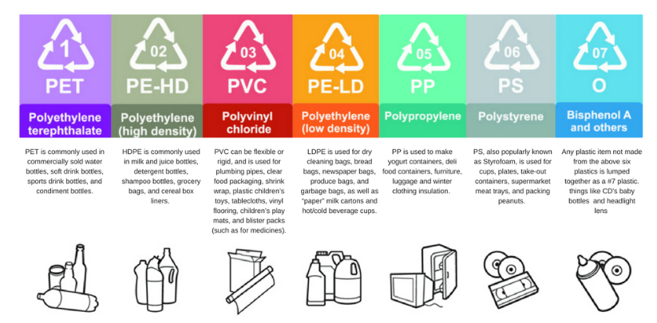
Figure 2 The Basic 7 Types Common Types of Plastic (Plastic Oceans, 2021)

2. Methods of Adding Plastic Waste to Road Construction
The secondary data collected looked at the collection, sorting, shredding and palletisation of the plastic waste collected as well as the methods and procedure of adding the plastic waste to the asphalt or bitumen mixes.
The limitations in the collecting and sorting plastic were completed by a study that collected primary data from three Australian companies that specialise in different stages of recycling plastics. The modelling completed on this study was completed on the assumption that all the recycling processes to convert to waste to recycled plastic waste took place within the same recycling facility (Science Direct, 2021).
The two basic methods in the production of adding plastic to asphalt mixes as an additive which is the wet method or the replacement of natural aggregates the dry method. The types of plastic used in the process would determine the method chosen for the mixing processes, as different types of plastic have various melting points. The data that was looked at for the wet method in the science paper titled ‘Recycling waste plastics in roads: A life-cycle assessment study using primary data’ used polyethylene-based (PE) plastics to analyse due to the low melting point of this type of plastic. The dry method used recycled plastic waste as a substitute for natural aggregate higher melting point plastics are used in this method the benefits and limitations were highlighted in the comparison of the methods used (Science Direct, 2021).

3. Performance Levels
This research looked at studies conducted that evaluated the use of a very common and largely available soft plastic - recycled linear low-density polyethylene (R-LLDPE). The research paper conducted tests on the viscosity, softening point, penetration test and penetration index on various plastic-bitumen blends using various plastic % concentration for testing. These tests covered physical, chemical, rheological and thermal evaluations (Science Direct, 2020).

4. Reducing carbon footprint and pollution
The data collected was used to determine the potential environmental impacts associated with the production of recycled plastic waste substitute for virgin polymer and compare these to the polymer-modified bitumen. The limitations in this data however were the fact these were completed from a product orientated process and not a process orientated perspective (Science Direct, 2021).
The data also looked at the carbon footprint when comparing producing virgin plastic versus recycling plastics and the impact on the environment and greenhouse gases, these were also compared between the two mixing methods being the wet versus dry method and the environmental impact each has.

2.2.3 Summary
Qualitative and quantitative data collection from secondary sources and research papers were collected to analyse, interpret, and compare the data. By deductive reasoning this paper can determine if plastic waste is viable in civil engineering in the construction of roads and would this method of recycling plastic waste assist in plastic waste pollution the United Kingdom. In conclusion the research looked at the types of plastic produced, recycled and the methods for adding and mixing recycled plastic waste in bitumen/asphalt mixes which methods proved better for the environment and the comparison of performance levels in recycled plastic waste roads to virgin aggregate roads.

References
Condor Ferries, 2022. Condor Ferries. [Online]
Available at: https://www.condorferries.co.uk/plastic-in-the-ocean-statistics#:~:text=The%20world%20produces%20381%20million,9%25%20has%20ever%20been%20recycled.
[Accessed 31 October 2022].
Enfrin, M. & Guistozzi, F., 2022. Wiley Online Library. [Online]
Available at: https://onlinelibrary.wiley.com/doi/full/10.1002/pi.6405
[Accessed 11 November 2022].
Government, United Kingdom, 2019. Gov.UK. [Online]
Available at: https://www.gov.uk/research-for-development-outputs/using-waste-plastics-in-road-construction#:~:text=Laboratory%20tests%20have%20shown%20positive,stability%2C%20strength%2C%20and%20durability.
[Accessed 31 October 2022].
Highways, 2019. Major Report Investigates Plastic In Roads. [Online]
Available at: https://www.highwaysmagazine.co.uk/Major-report-investigates-plastic-in-roads/5301
[Accessed 11 November 2022].
House of Commons Committees, 2022. UK Parliament. [Online]
Available at: https://ukparliament.shorthandstories.com/the-price-of-plastic/index.html#
[Accessed 22 February 2023].
Lee, C., 2021. BBC. [Online]
Available at: https://www.bbc.com/future/article/20210302-could-plastic-roads-make-for-a-smoother-ride
[Accessed 14 November 2022].
McGraw-Hill, 2001. Recycling Handbook. Second ed. s.l.:The McGraw-Hill Companies Inc.
Parson, A., 2021. Yale Environment 360. [Online]
Available at: https://e360.yale.edu/features/how-paving-with-plastic-could-make-a-dent-in-the-global-waste-problem
[Accessed 14 November 2022].
Plastic Oceans, 2021. Plastic Oceans. [Online]
Available at: https://plasticoceans.org/7-types-of-plastic/
[Accessed 4 March 2023].
Sasidharan, M., Eskandari Torbaghan, D. M. & Burrow, D. M., 2019. Using waste plastics in road, Birmingham: University of Birmingham.
Science Direct, 2020. Recycled plastic as bitumen modifier: The role of recycled linear lowdensity. Elsevier, pp. 1 - 2.
Science Direct, 2021. Recycling waste plastics in roads: A life-cycle assessment study using. Elsevier, Volume 751, pp. 1 - 8.
Science Direct, 2021. Resources, Conservation and Recycling. Elsevier, Volume 173.
Science Direct, 2022. Environmental Impact Assessment Review. Elsevier, Volume 96.
Science Direct, 2022. Journal of Cleaner Production. Elsevier, Volume 359.
Science Direct, 2022. Pyrolysis of polyolefin plastic waste and potential applications in asphalt. Elsevier, Volume 180, pp. 1 - 6.
Science Direct, 2022. Review of recycling waste plastics in asphalt. Journal of Traffic and Transportation Engineering (English Edition), 14 July, 9(6), p. 2.
TRVST, 2022. Plastic Waste in Road Construction For Sustainable Plastic Paving. [Online]
Available at: https://www.trvst.world/waste-recycling/plastic-pollution/paving-roads-plastic-waste/
[Accessed 11 November 2022].

