

Web & Mobile Technologies
  - Harry Morris
  - 29/01/2021

Table of Contents
Introduction 1
Implementation of JavaScript 1
Misc. 7
Conclusion 8

Introduction
The purpose of this document is to show the development and creation of each JavaScript within my website. By doing this I will be able to clearly show the approach which I had taken when adding these features to the webpages. I have included a screenshot of each webpage and code to prove that they are running correctly without any issues.

Implementation of JavaScript
In total my website consists of 3 pages; each page contains different JavaScript elements which effect the users experience with the website.
Home Page
The first page which the user is greeted is the index page. The image below is a screenshot of the home page.
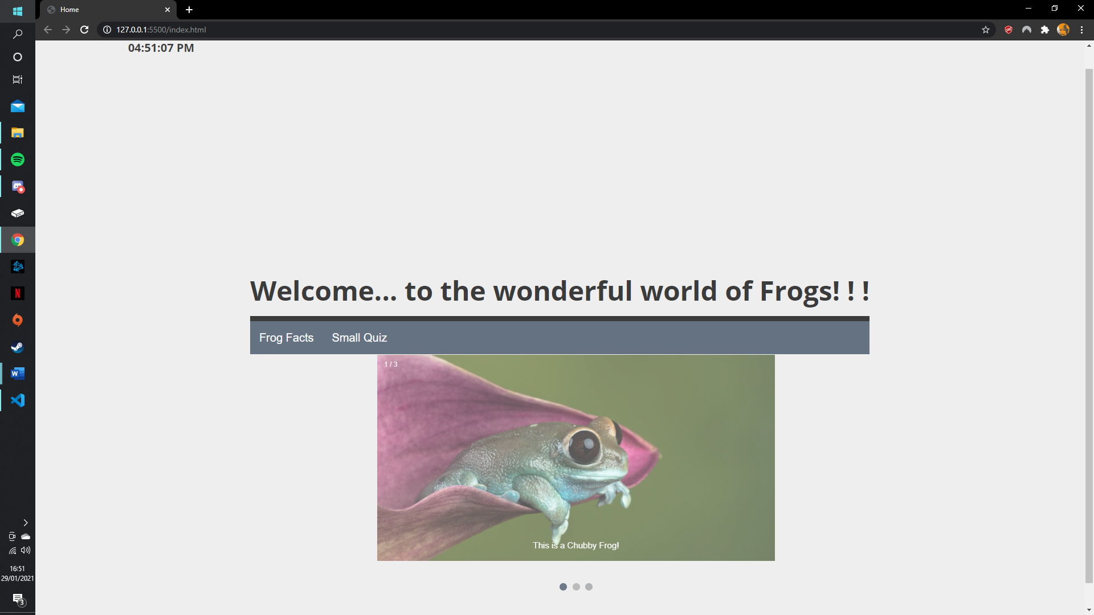
The home page has two different pieces of JavaScript. The first one I’m going to talk about is the clock which is located on the top left hand conner of the home page.
JavaScript code for the Clock
The clock uses onload which function which is activated whenever a user loads up the home page. The var are used to store and collect the current time in order to display it to the user. There are also if statement which are used to show the user if its AM or PM. The reason why the clock was added was because it a useful tool which the user can use to tell the time.
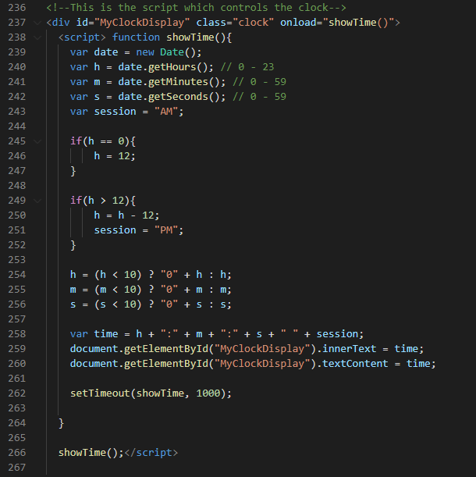
The other JavaScript which I used is the gallery. On this website the gallery shows 3 different images of frogs. The reason whys this was implemented was to make the home page more interesting as prior to its implementation the home page lack content for a use to look at.
JavaScript code for the Gallery
Within this code there are two key aspects. The first is the dots, the dots reparent the small circles underneath the gallery, this feature is important at it informs the user which image they are looking at. In this case the gallery only has 3 images, however more could be added in future iterations of the website. The other key bit of code is the setTimeout(showSlides, 2000) this line of code is used to set how long each image is on the screen before switching to the next image on the slide show.
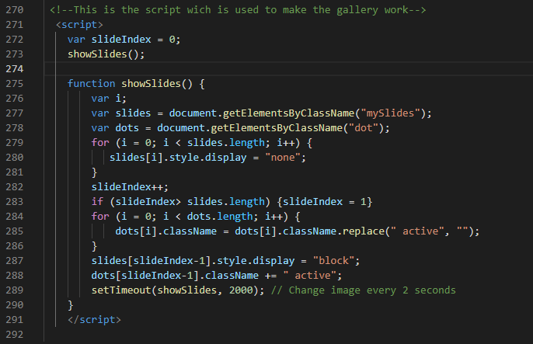
Frog Facts
This page contains some random facts about frogs. The image below is a screenshot of the frog facts page.
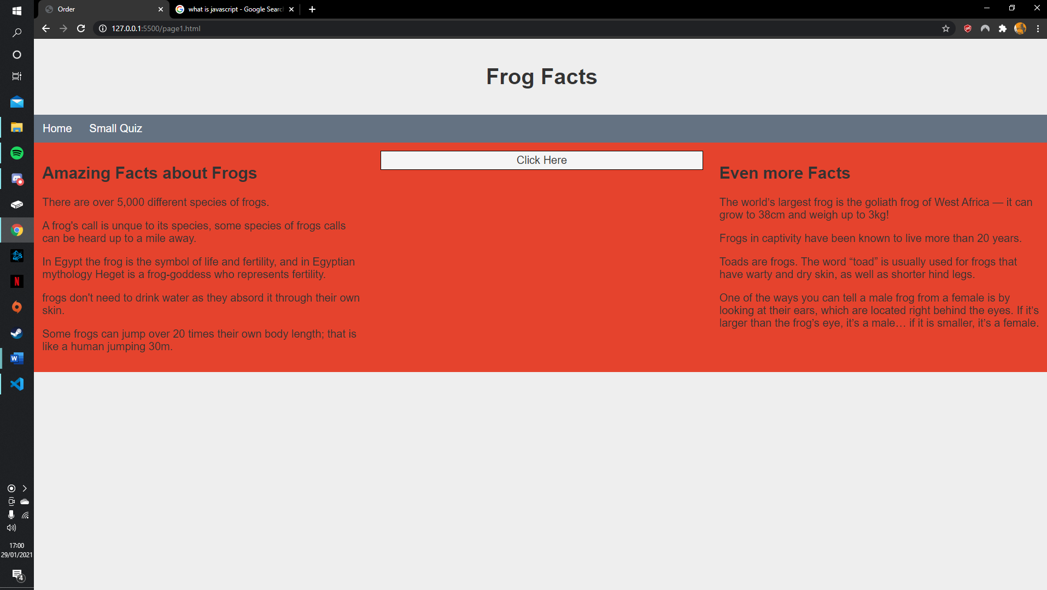
On this page there is a total of 9 frog facts for the user to enjoy. The other feature is the click here button which is located in the middle of this webpage, once a user has click on the click here button an image of a frog wearing a hat will appear (as shown below).
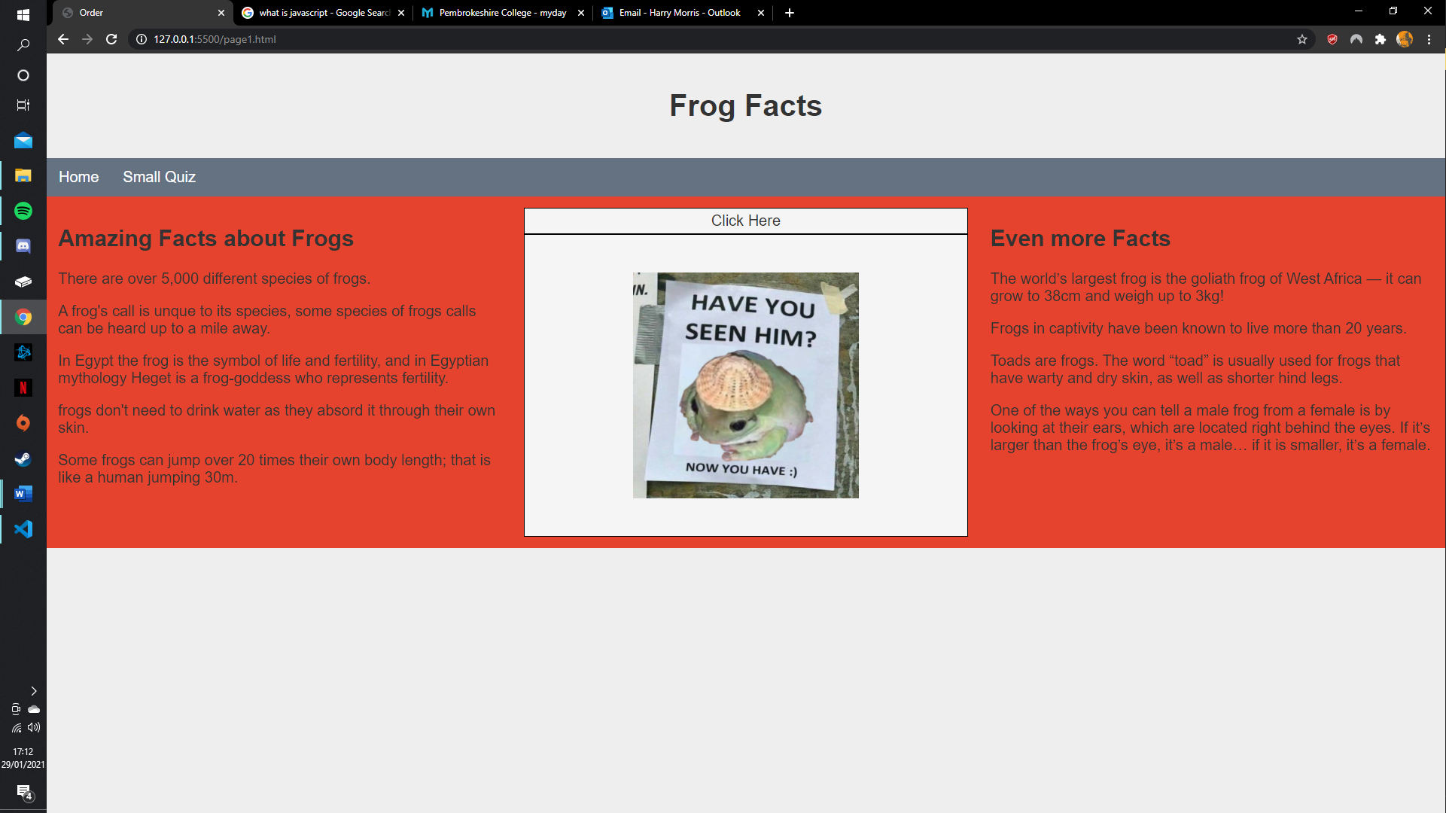
jQuery code for the Click Here Button
This is the only bit of jQuery used on the website. Personally, I think is a nice feature to the website as it allows the user to interact directly with the website. Once the user clicks on the function get activated and frog is revealed.
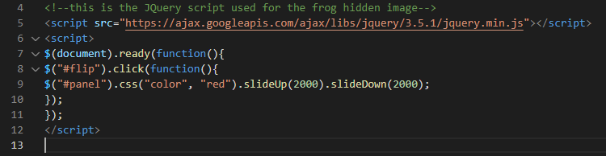
Small Quiz
The final page on this website is dedicated to a small quiz. This is shown in the screen shot below.
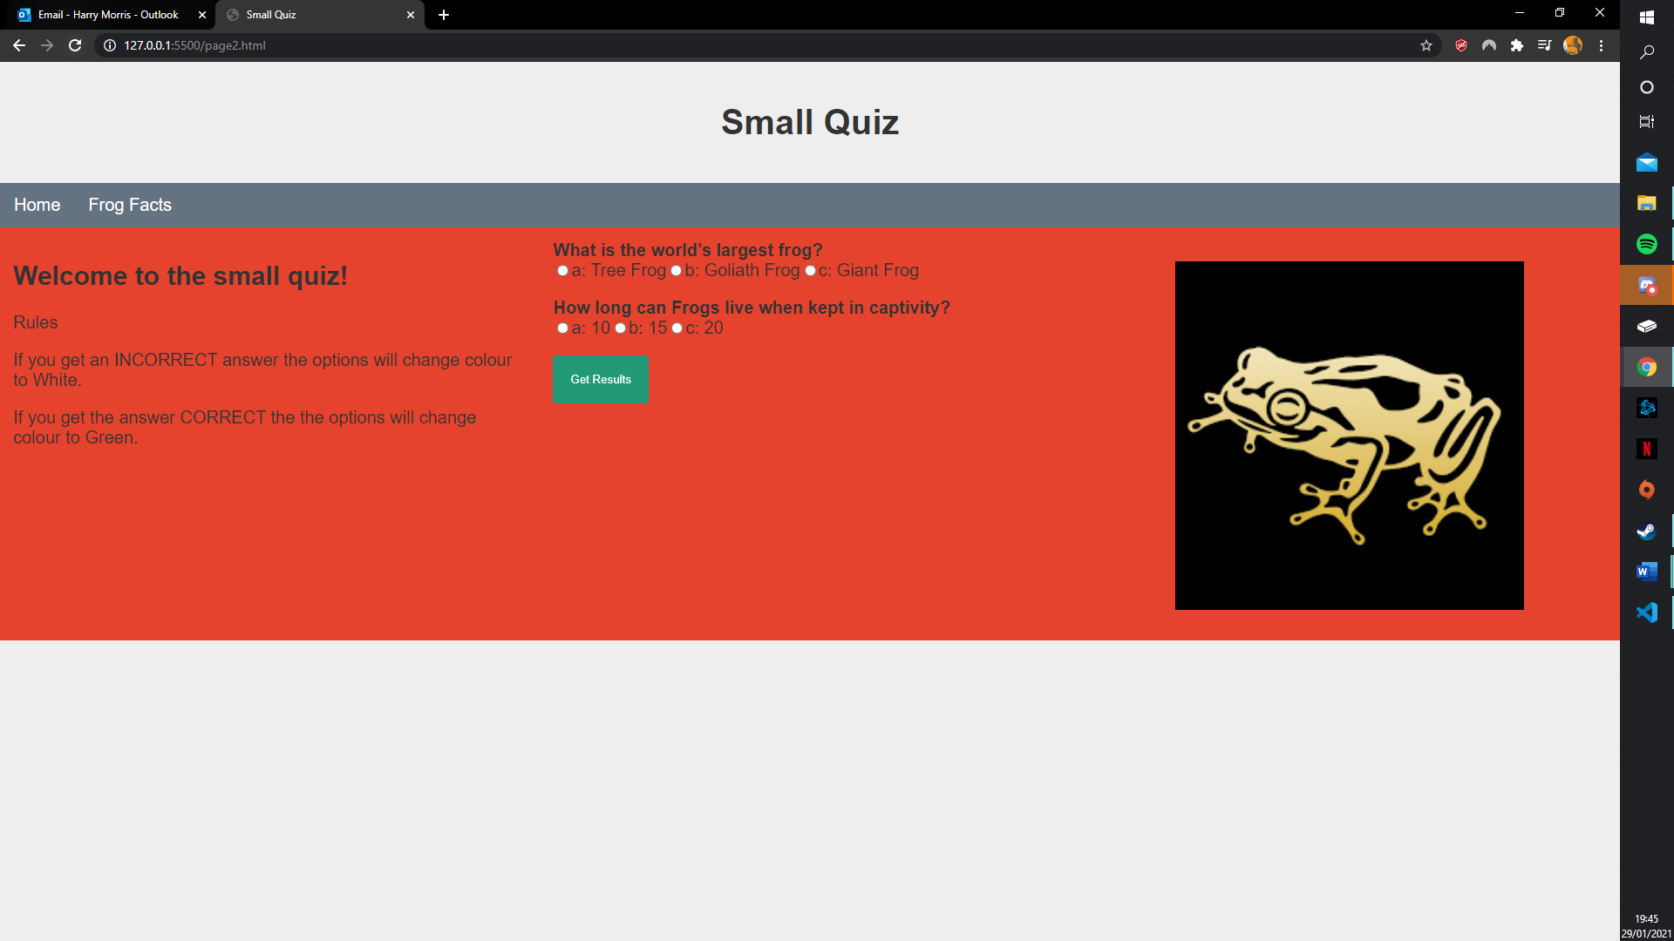
The small quiz consists of only 2 questions, the answer for these questions is located on the frog fact page. By having the answers to the quiz on the frog fact page allow user to find the answers without having to google them.
JavaScript code for the Small Quiz
The quiz a multiple-choice quiz, if the user enters an incorrect answer then the text will turn white if the answer is correct then the text will turn green.
Incorrect answer
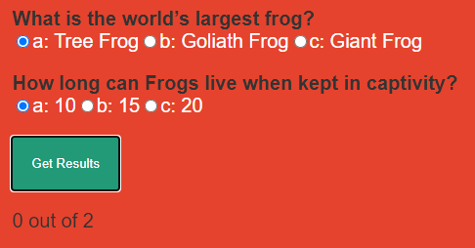
Correct Answer
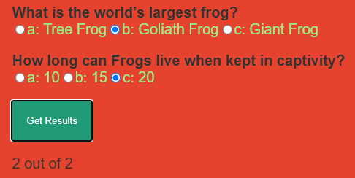
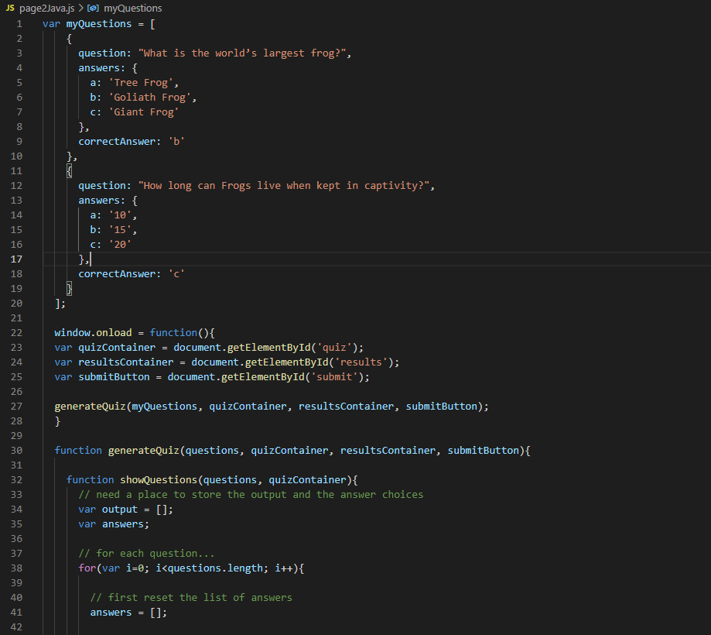
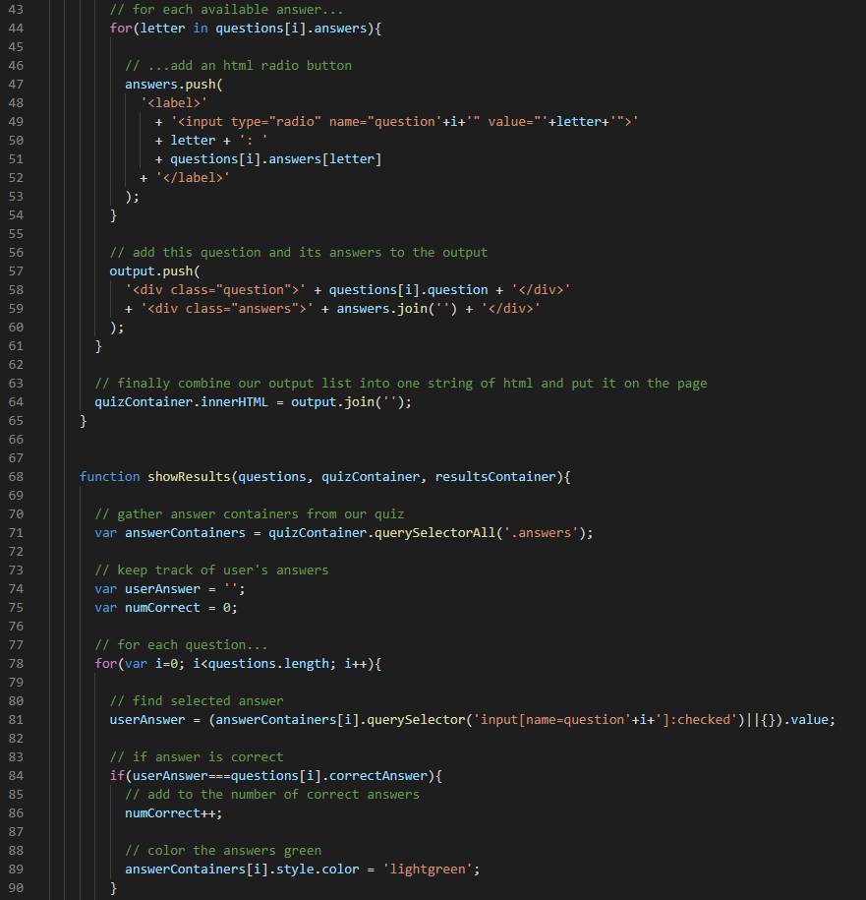
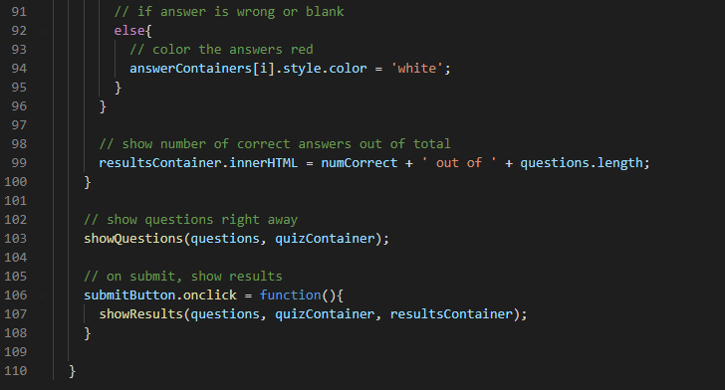

Misc.
Bootstrap
The whole website utilises bootstrap. This allows the website to resize itself whenever a user decides to change the size of the browser. Another benefit of using bootstrap to develop my website is the fact that it can automatically resize itself on any device, this benefits the user who are using mobile phone and tables.
On the frog facts page the bootstrap is a massive help as it resizes the divs when a user clicks the click here button. This allows the page to look professional whenever the divs changes their size.
Below is a screen shot of the code.
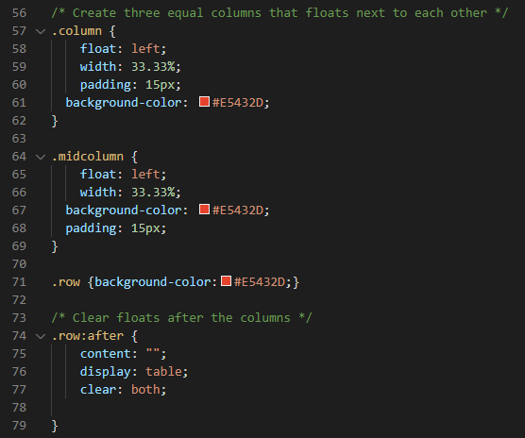
Animation
On the home page there is animation which floats the text on to the webpage, this feature was implemented to make the home page more interesting, as there is a lack of content on the page. However, I’m really pleased with the way it turned out. While developing it I had a few issues but with some hard and determination I was able to get it working.
Below is a screen shot of some code which was used for the amination.
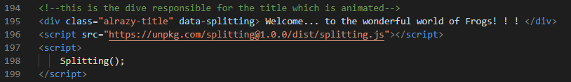

Conclusion
In conclusion I am happy with the website which I have developed. I have included some interesting feature which I haven’t implemented in a website before, these things include the quiz and the jQuery drop down. The inclusion of an animation makes the home page stand out compared to other websites which I have developed in the past. I still feel like some improve could be made to this website, some of these addental features could include; additional content on each page, more pages about frogs and I could also add some accessibility features. Overall, I feel like this website was a success, even though it could do with some more features.

