Joseph Ieuan Woodhouse-Thomas
Jthomas.151048@student.uwtsd.ac.uk
Abstract
An investigation into the necessity for finite element analysis and computer aided engineering utilizing comparison of case studies as a form of research.
should finite element analysis replace physical testing?
An investigation into finite element analysis and its correlation to physical testing

Contents
Introduction 1
Introduction to stress analysis 2
FEA testing 2
Physical Testing 3
Why do companies typically carry out FEA alongside physical testing? 4
How does a physical test correlate to FEA? 5
Can or should FEA ever replace physical testing? 6
Conclusion 8
Bibliography 9

Figure 1 - Example of FEA results 2
Figure 2 - Four-point bend set up (Wagner, 2010) 4
Figure 3 - Force Vs. Displacement Graph 7
Figure 4 - Spring stiffness correlation 7

Introduction

The following report aims to answer 3 questions concerning finite element analysis (FEA). The first being, why do companies typically carry out FEA alongside physical testing? Following this, how does a physical test correlate to a FEA? And finally, can or should FEA replace physical testing?
A variation of case studies have been considered to further understand the need for FEA. The first case study researches a simulation and physical experiment to refine the FEA model currently being used and validate the findings.
The following test investigates a CAD related FEA experiment using a diesel engines V8 crankshaft, and the effects of the torsional loads from the torque caused by the combustion forces and bending moments caused by a combination of the combustion forces and the inertia forces produced by the engine speed.
The final case study is an experiment investigating into road holding methods on large vehicles. The investigation examines the FEA and physical testing of leaf springs, and a comparison of these methods, with the aim to validate and further develop the simulation model with considerations to the criteria necessary when designing suspension systems.

Introduction to stress analysis

FEA testing

There are three methods to undertaking engineering problems, these are:
- Analytical method – A traditional approach with 100% accurate results, however, only viable for basic problems like cantilever and simple supported beams.
- Numerical method – The numerical method gives a mathematical representation. Within this method, assumptions must be made towards the model. This method is applicable even when a physical model is not produced, however different software offers different advantages and diss-advantages, and the results cannot be taken as 100% correct.
- Experimental method – The experimental method uses real-life measurements however is very time consuming, even if small iteration is to be made, the numerical method is far quicker.

Finite element analysis (FEA) is the simulation of any physical phenomenon using a numerical technique called finite element method (FEM) (Simscale, 2020). Used by engineers worldwide, FEA reduces the design process by allowing the user to simulate tests without manufacturing a physical component. FEM uses nodes to calculate stress and strain, a node is a co-ordinate location in space where the degrees of freedom (DOF) are defined. For mechanical application, the location of the node displaces and the change in displacement is used to calculate the necessary results.
Not all the elements of a specimen have 6 DOFs, the number of nodes is dependant on the element type and group of elements. The element type can be 1D, 2D or 3D, the group that element is between thin shell, plane stress, membrane, and plane stress.

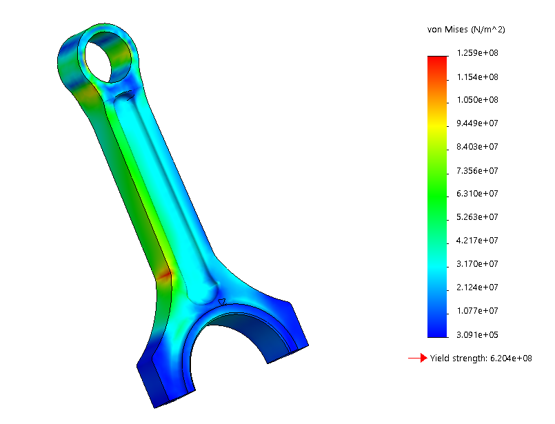
Figure 1 - Example of FEA results
The above figure shows an example of the results found when carrying out an FEA study. The key on the right-hand side of the figure shows the amounts of stress being put through the component within this frame of the study, the key is colour co-ordinated, and provides the yielding point of the material if it is exceeded.
There are numerous types of finite element analysis for different types of applications.
- Linear static analysis is less realistic than non-linear, and all forces act on the part must be equal
- Non-linear static analysis is more realistic but takes longer to solve.
- Dynamic analysis is split into two areas. One being free, and due to natural frequencies, the second is forced and is in response to external excitation, such as road activity in a car.
- Buckling analysis is only applicable for comprehensive loads on slender beams and sheet metal parts.
- Thermal analysis corresponds with conduction, convection and radiation.
- Fatigue analysis relates to the life of a component, and its durability.
- Optimisation analysis correlates to the study of topology, topography, size and shape to make improvements to the component.
- Crash analysis is heavily used in the automotive industry as it relates to the safety of the passengers and how the vehicle performs in an incident.
- Computation fluid dynamics (CFD) considers the fluid mechanics of a system, involving fluid motion and fluid at rest (Altair).

Physical Testing

Physical testing can be described as a trail and improve method of development. Physical tests use strain gauges to find the stresses and forces acting on a component of a system. In a circumstance where FEA is unavailable the only way to seek failure in a component is by producing the specimen and field testing it, this comes with its advantages and disadvantages.
The advantages come in the form of certainty and reliability in the work being carried out. Cancelling out any odd scenarios or questionable cases where a part has broken or even lasted un-explainable longer that anticipated, a physical test will give reliable results to tests being undertaken. For that reason, field testing would seem like the ideal method to carry out any development in products and parts.
However, at this time with the computer software available, field testing is considered inefficient to a certain extent. Whereas an FEA run will take a day or two, max, a field test can take up to weeks to organise, alongside the need to manufacture the specimen being analysed every time it is necessary to make an adaptation (Wen, 2011).

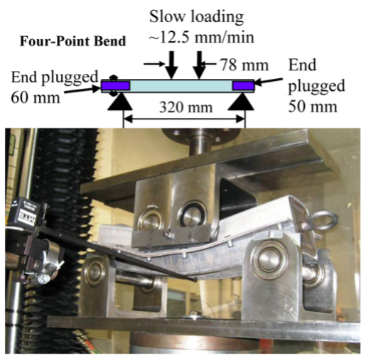
Figure 2 - Four-point bend set up (Wagner, 2010)

Wagner (2010) discusses a quanti-static axial compression test using a range of materials. Another disadvantage of physical testing comes in the form of costing, whereas a computer simulation can show results of any chosen metal, wood, or plastic, the engineer is forced to purchase necessary metals for an experiment, and this can increase costing dramatically if the procedure doesn’t commence smoothly.

Why do companies typically carry out FEA alongside physical testing?

Pozolo (1999) writes of a case study where a trailor on the front of a trailer is put under two different experiments. The first being a FEA motion simulation of a trailer drawbar and frame that had been created to simulate the predicted outcome using ABAQUS standard FEA program. Within this motion simulation the point loads had been rigidly constarained, and located at the vertical centre of gravity.
In addition to this, a physical test was undertaken with a fully loaded trailer that was tested using strain gauges at an army testing ground. The data was collected over 30 second intervals on random proportions of test courses.
The initial results of the motion simulation showed 8.3% under prediction in comparison to the field testing. With the end goal to improve the safety factor of the trailers mounting point, the motion simulations load points where better located and refined for more accuracy.
The reason for carrying out the motion simulation alongside the physical testing is to improve the simulated results and gain a greater understanding of the loads and strains acting on the trailer while undertaking the simulation. This combination of motion simulation and physical testing assists the engineers when troublshooting to reduce the time in the design process (Prathamesh J. Baikerilkar, 2017).
Although the motion simulation, with the correct constraints and boundary conditions, provided results similar to the field testing, there where scenarios in which the FEA study was unable to re-make.
Furthermore, by combining the capabilies of the analytical techniques such as the FEA study and the physical testing together, the design, prototype and testing process time was significantly reduced, alongside the changes made to the motion simulation being beneficial towards using the FEA model in future investigations.
To conclude and answer the initial question, a company will benefit significantly from utilising finite element analysis alongside physical testing to save time, money and resources throughout the development and production of parts and components, moreover, FEA gives the engineer the ability to jump leaps through the early stages of a project and gain a general understanding of the stresses through a part before its even been considered into manufacturing.

How does a physical test correlate to FEA?

An FEA models’ accuracy is greatly dependant on the boundary conditions set when building the motion simulation/ static simulation. These boundary conditions consist of:
- Appropriate application of load bearing faces is crucial within motion simulation, without appropriate allocation of loads the system is unaware to forces being implemented, and therefore ignores them.
- Correct and accurate mates are an essential role to the motion simulation as it prevents any faults or errors in the system while contributing real-life elements.
- Contacts between parts in an assembly create collisions in a motion simulation if applicable, which present inaccuracies and problems to be solved, rather than the study being intangible and idealistic.
- Changing the frame rates to increased frames per second increases accuracy in data but consequently also increases run time, a certain amount of compromise is therefore necessary (Underwood, 1989).
- Operation speed, such as engine speed, can also affect the running time of a scenario, thus the need for compromise is, once again, essential (Trovey, 2002).
- Considering gravity in a situation adds realistic measures when gathering data.
- Material allocation is a very important step in conducting a motion simulation especially when the setting is based on an engine in real life conditions (Peterson, 2008).
- The materials of the components possess different masses depending on the density and this can differ the results significantly.
- Accounting for frictional losses increases the precision within the experiment, thus providing more accurate results (Polycarpou, 2006).
- Mesh size makes a large difference to the intricacy of the area it is allocated to, however, like other areas of the conditions, it adds a significant amount of time to the overall run.

Sergio Gradella Villalva (2010) writes of a case study using a computer aided engineering (CAE) simulation in comparison to an experimental real-life test. The tests where carries out using a crankshaft from a diesel V8 configuration.
Within the experiment, bending and torsional loads where implemented on the components to achieve a direct comparison to the FEA results and the experimental testing. When testing with a torsional strain gauage, the comparative difference came to 4.52% between the FEA and physical model. The investigation then followed on to test the bending moment of the specimen, the results presented a 1% difference in deviation between the two methods.
This case study shows a very similar correlation between the two tests, however this resemblance comes at a price of time on the behalf of the simulation side. Due to the boundary conditions and requirement for similarity, the simulation runs take a large amount more time (Roszkos, 2019). This, however, is still a lot shorter than if the speciment had to be manufactured as it would take up more time to produce it than to simulate(Hongfeng Ma, 2019).
Therefore, the correlation between physical testing and FEA testing can be seen from this review of the case study investigated. The results show a small difference in magnitude of stress; however, the trend of stress is identical between the two methods.
Sergio Gradella Villalva (2010) concludes that the positives that can be draw from the study are the FEA findings can be utilised to develop the products further, however, physical test will still need to be undertaken to validate the fatigue life of the specimen.

Can or should FEA ever replace physical testing?

To answer this question, a case study considering leaf springs has been researched to gain a thorough understanding of the outcomes and requirements when simulating an FEA study. Tank (2017) writes of the suspension system needing to:
- Maintain the correct vehicle ride height.
- Reduce the effort of implemented forces produced by the road.
- Assure the wheel alignment is correct.
- Support the vehicles stability while in use.
- Keeping the maximum amount of friction between the tyre and the road.
- Assure that implemented change in direction is controlled.
To simulate the leaf springs it is first essential to perform hand calculations to determine the correct value of spring stiffness for the vehicle. It is also necessary to calculate the amount of preload implemented on the system before commencing in a test. Following this the amount of damping being used adds reality factors to the simulation, if the damping rates are incorrect then the values produced by the FEA study will be inaccurate.

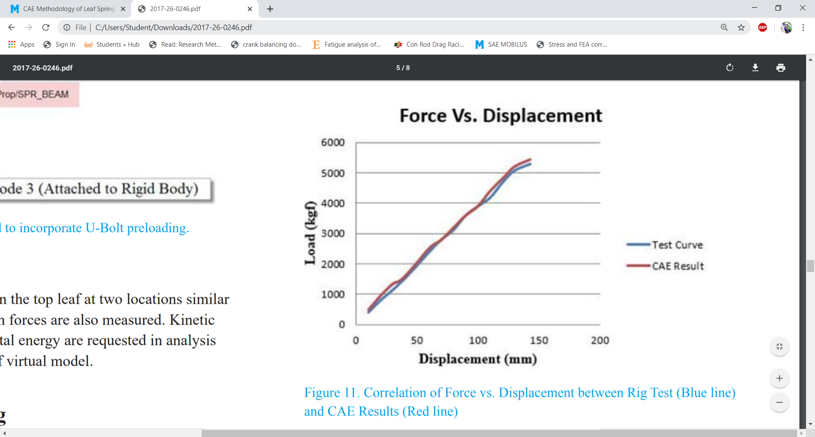
Figure 3 - Force Vs. Displacement Graph

The results show a similar displacement when the load is implemented onto the leaf speings in a simulated and rig test situation.
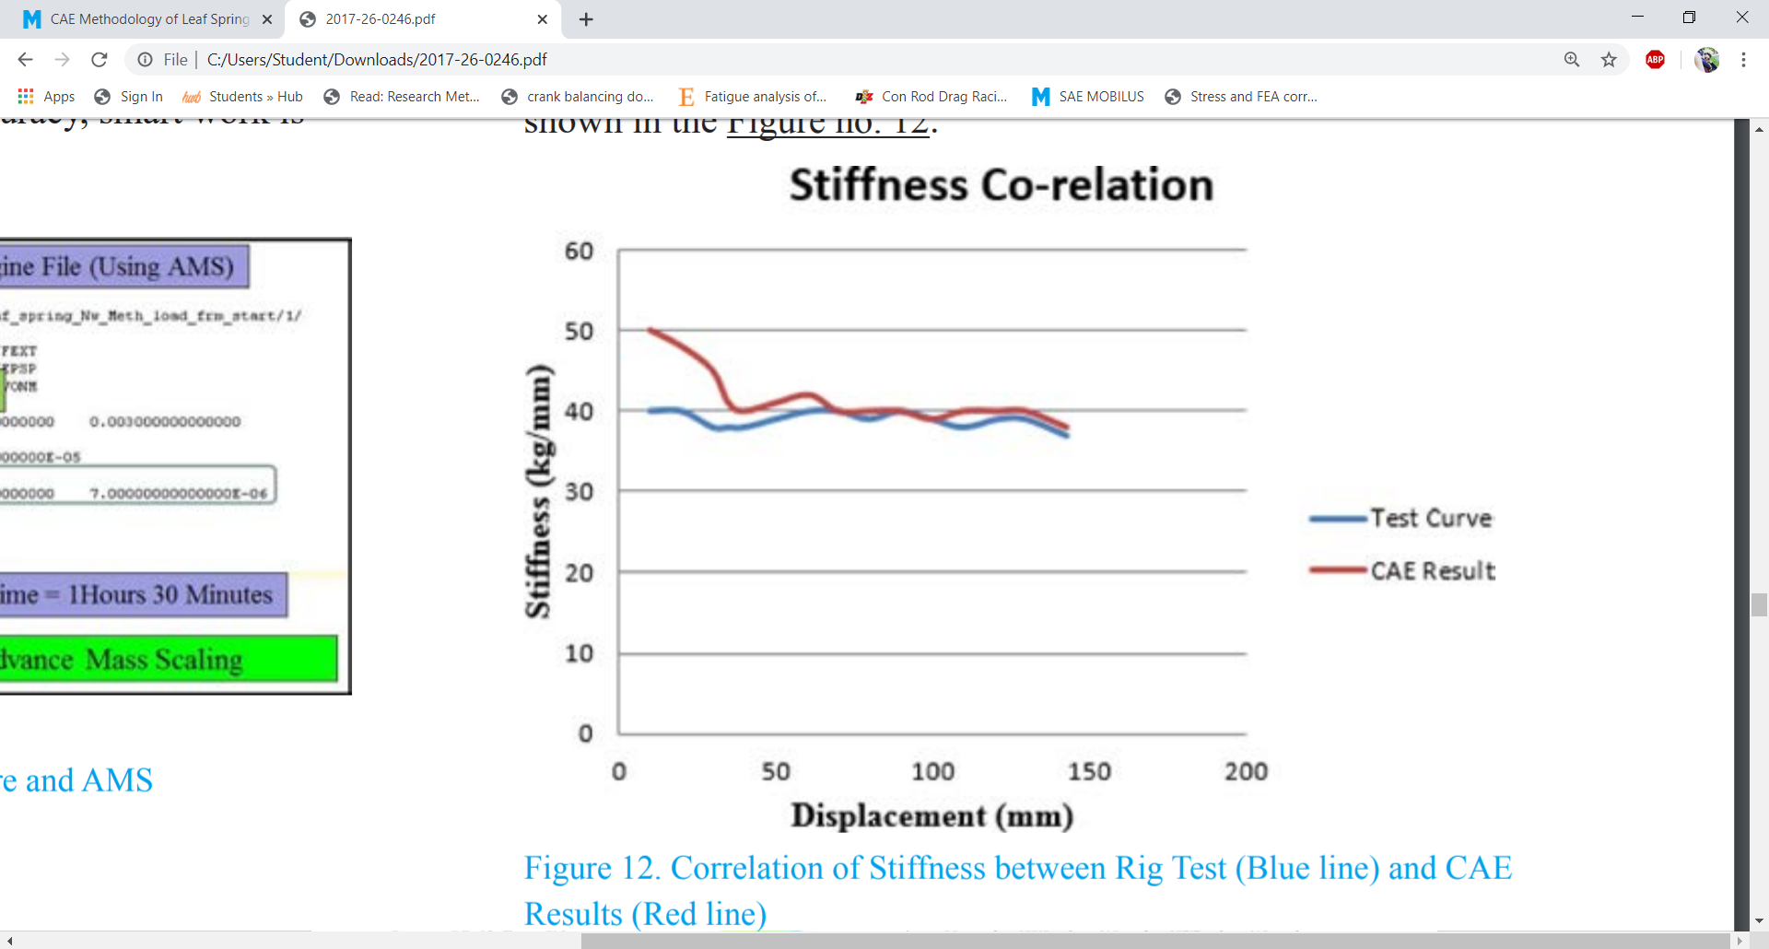
Figure 4 - Spring stiffness correlation

The correlation shown by figure 4 presesnt far different results to that of figure 3, whereas the displacement shows small amounts of deflection within its findings, the stiffness of the leaf springs between the two methods are very different, this can produce un-realistic results and therefor lead an investigation in the wrong direction if only utlilising FEA until a final model is produced.
That said, with correct loads being implemented and further investigation into the characteristics of the leaf spring being simulated, correct and accurate results can be obtained. The biggest downfall to any simulating is the user, therefore, precision and attention must be taken into every allocation of boundary condtition and load on the specimen.
With the increasing age of computers doing more and more at increasing rates it is easy to pass by details that may jeopardize a simulation, Van Dyke (2015) discussed the dangers in modern FEA when using programmes such as when allocating materials, mesh sizing and the general question of what assumptions the software being used is making.
In relation to the question in hand, the development of computer aided engineering is quickly becoming more involved within the engineering industy. With the increasing amount of change facing the automotive side of industry, large amounts of tests and simulations are being undertaken to win the race to development. However, the need for physical testing is still a necessity over a large amount of the engineering world, from fatigue testing to final designs being validated. Therefore, FEA should not replace physical testing completely, at this point in time, but, continue to assist engineers in making the design process more cost effective and time effieicent (Hemez, 1998).

Conclusion

The initial case study showed a trailer undertaking physical tests and FEA experiments, the report wrote of an iterative approach to refining the difference between the two techniques of testing to learn more about the abilities in the FEA software. The findings proved that an open approach to using both FEA and physical testing sped up the process.
The following case presented an experiment into the FEA and physical testing of a crankshaft on a V8 diesel. The consensus drawn from this study was that the boundary conditions in which the FEA simulation is put under makes the biggest difference to outcome of the results, therefore showing that the main contribution towards inaccuracies when conducting an FEA study is the operator.
The final case explains the case study utilising a leaf spring. The results held many similarities between the FEA and physical testing when comparing the force and displacement, however large disparities became apparent when the spring stiffness was considered over the course of the test. With that said, many inaccuracies can come from this and the results may be incorrect.
In conclusion, all three case studies presented positive and negative feedback from both the physical and finite element testing, the FEA testing does decrease the time taken to find the basics of an engineering product however the results show deflections from the physical testing and the user is the main participant, whereas physical testing provides better and more significant results, therefore, the design process is greatly prolonged because of this.

Bibliography
Altair. (n.d.). Practical Aspect of Finite Element Simulation. Altair University.
Dyke, D. V. (2015). Dangers of modern FEA. Portland, Oregon: OVGO.
Hemez, F. M. (1998). Test-Analysis Correlation and Finite Element Model updating for nonlinear, transient dynamics.
Hongfeng Ma, J. W. (2019). Fatigue redesign of failed sub frame using stress measuring, FEA and British Standard 7608. Engineering Failure Analysis, 103-114.
Peterson, J. (2008). Finite Element Analysis of Carbon Fiber Composite Ripping Using ABAQUS. tigerprints.
Polycarpou, A. C. (2006). Introduction to the Finite Element Method in Electromagnetics. Retrieved from IEEE Xplore: https://ieeexplore-ieee-org.ezproxy.uwtsd.ac.uk/document/6812584
Pozolo, M. J. (1999). Using Modeling and simulation for failure analysis. Michigan: SAE.
Prathamesh J. Baikerilkar, C. J. (2017). Comparison of As-Built FEA Simulations and Experimental Results for Additively Manufactured Dogbone Geometries . ASME Digital Collection, 14.
Roszkos, C. S. (2019). Static and dynamic analyses of aluminum foam geometric models using the homogenization procedure and the FEA. Composites Part B: Engineering, 361 - 374.
Sergio Gradella Villalva, E. G. (2010). Correlation between CAE and Experimental Fatigue bench tests for automotive Crankshafts. Brasil: SAE.
Simscale. (2020). What is FEA? Retrieved from Simscale: https://www.simscale.com/docs/content/simwiki/fea/whatisfea.html
Tank, S. K. (2017). CAE Methodology of Leaf Spring Suspension and Its. SAE.
Trovey, M. (2002). Concept design CAD for the automotive industry. Journal of engineering design, 5 - 18.
Underwood, J. .. (1989). Applications and Limitations of Finite Element Analysis To Armament Components. New York.
Wagner, D. A. (2010). FEA Predictions and Test Results from Magnesium Beams in Bending and Axial Compression. SAE International.
Wen, J. (2011). Strength Prediction of Bumper by Correlating FEA with Test. SAE International.

