

Programme: Certificate of Higher Education
Employability Skills

Modul: Managing Enterprise
Module code: BMSW4011

Assignment 1 Part 1: Business Plan
Lecturer: Melanie Squire

Name: Andreea-Mihaela Tanasa

Student Number:2332157

Word count: 1100 Submission deadline: 21.03.2025

Contents
1.Company concept 3
2.Company name and type of business ownership 3
3.Mission statement 4
4.Physical location 5
5.Human resources. How many people will the business employ? Where will you source these people? What will their job roles be? 5
6. Marketing activities 6
7. Market research 7
9. SWOT Analysis 9
10..References 11

Business plan

1. Company concept
Busy Bee is a cleaning firm designed primarily for freelancers, sole traders, and small enterprises functioning out of homes, offices, or small commercial premises. Offering tailored, flexible, reasonably prices cleaning solutions, and eco-friendly products, this service satisfies the specific needs of small businesses sometimes overlooked by larger cleaning companies (Kocsis, 2010).
The concept originated from the increasing number of small enterprises and single traders—particularly those operating from home or small offices—especially during the pandemic (Peters, Freeman & Wilson, 2020). Most commercial cleaners focus on big operations; hence, these businesses sometimes have trouble finding cleaning services that meet their specific need (Bradley, 2017). Moreover, these individuals require priced, but competent, cleaning services to offer a healthy working environment, considering the increasing focus on hygiene and cleanliness in the workplace (Sundararajan, 2016).
Our service maintains surfaces in offices look professional and tidy (Bradley, 2021). Designed for home-based businesses, home office cleaning handles work surroundings, kitchen cleanliness, and toilet sanitation. Environmentally friendly cleaning products promise a safe place of living (Crane, Matten & Spence, 2019). Offering ease for single stores, client customising of their cleaning schedules according to their needs—daily, weekly, or monthly—offers (Peters et al., 2020). Using non-toxic and biodegradable cleaning products will assist environmentally minded clientele (Crane et al., 2019). Complete cleaning for businesses when entering or leaving sites (Varga, 2021).

2. Company name and type of business ownership: 
Busy Bee Cleaning Company is set up as a sole trader company, and this structure is a perfect choice because of its adaptability, and simplicity of setup (Sheedy, 2010). Being a single trader allows me to control decisions, allowing a quick and effective reaction to client needs (Rye, 2020).
Benefits of sole trader:
- Complete control over all business choices, I do not have to contact partners or shareholders (Burns, 2016).
- With less regulations, setting up this kind of business is cheap and simple when compared to other ones (Mandviwalla, Flanagan, 2021).
- Retention of Profits: Without distribution to others, all earnings directly go to the owner. The company can readily adjust to changes in client needs or demand (Shukla, 2025).

The cons include bearing liability for all company debts and obligations, which compromises personal assets (Burns, 2016), and difficulty in finance and growing my business. From operations to money, I can take complete accountability, which could cause burnout and stress.

3. Mission statement
- Our mission statement at Busy Bee Cleaning Services is to deliver economically cost, environmentally friendly, and premium cleaning. The dependable, professional services we offer will help our clients' workstations to be more orderly and efficient.
- We aim to be the preferred cleaning service provider for our customers, single traders, and small companies, offering customised services appropriate for their specific needs and thereby supporting sustainability using environmentally friendly solutions.
- My objectives (Conzemius and O'Neill, 2009):
- research the products I need (January-March)
- promote my business as much as possible (January- July)
- to do a management course that will help me improve my knowledge (March-June)
- achieve a 20% increase in repeat customers (July-December)
- implement targeted marketing strategies (All year round)
- offer promotions
- introduce new services such as eco-friendly cleaning options and higher revenue that will support business growth, allow for potential expansion, and ensure financial stability.
All this I wish to achieve in the next 12 months, providing tailored, flexible cleaning solutions catered to small company requirements and schedules helps one build a committed customer base. Through constant improvement of quality and feedback, keep customer satisfaction over ninety percent. Using sustainable products and cutting the usage of harmful chemicals will assist one in adopting and disseminating ecologically friendly cleaning solutions (Crane, Matten & Spence, 2019).
- USP: Providing adaptable, eco-friendly cleaning solutions, my own cleaning product composed of vinegar, baking soda, lemon juice, and essential oil, Busy Bee Cleaning Company sets itself out by focusing mostly on independent businesses and single traders. By providing customised cleaning plans and unique treatment, unlike more established corporate cleaning companies, Busy Bee guarantees ease and savings for its clients.

4. Physical location
All cleaning products will be stored in a spare room in my house.
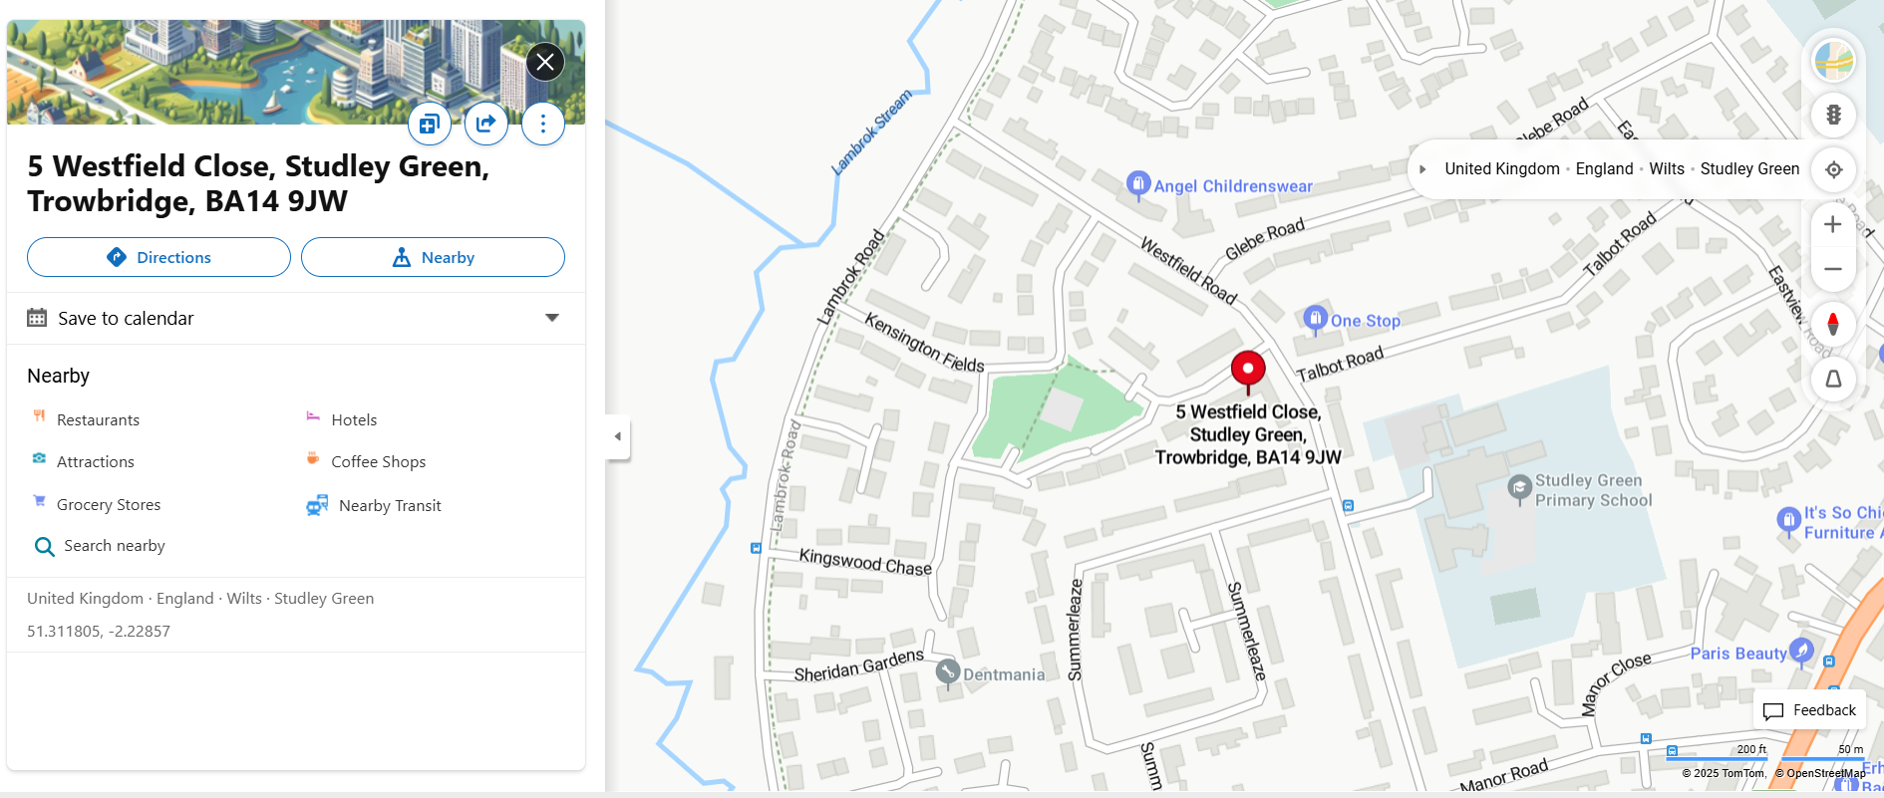

5. Human resources. How many people will the business employ? Where will you source these people? What will their job roles be?

The business will have two cleaners:
I will be one of the cleaners and I will hire my sisters for the busy periods.

6. Marketing activities
To promote my business, I will:
- utilize a business website
- platforms like Facebook, Instagram, and LinkedIn to showcase services
- share customer testimonials
- regularly post before and after photos
- I will use targeted email campaigns to announce special offers or discounts to attract new clients and retain existing ones
- I will distribute flyers in the local neighborhood community centers to raise awareness of the cleaning services offered, participate in local events, and offer free cleaning services to local charities (Ghoshal, 2019).



7. Market research
I began a market research poll distributed among various local social media groups to assist my business by analysing other cleaning companies and pointing out their shortcomings and offers. Analysing the graphs from the questionnaire and other corporate competencies, I collected all the information and responded to all client requests, guaranteeing total coverage, Increased flexibility, temporary contracts, and coverage for weekend schedules.
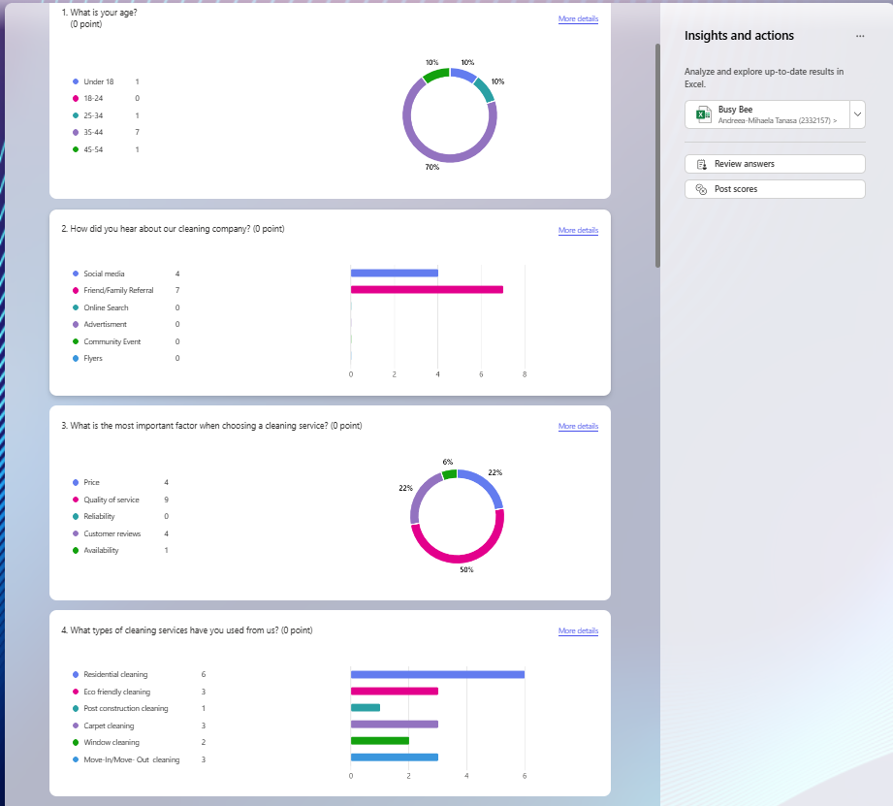

8. Cashflow forecast
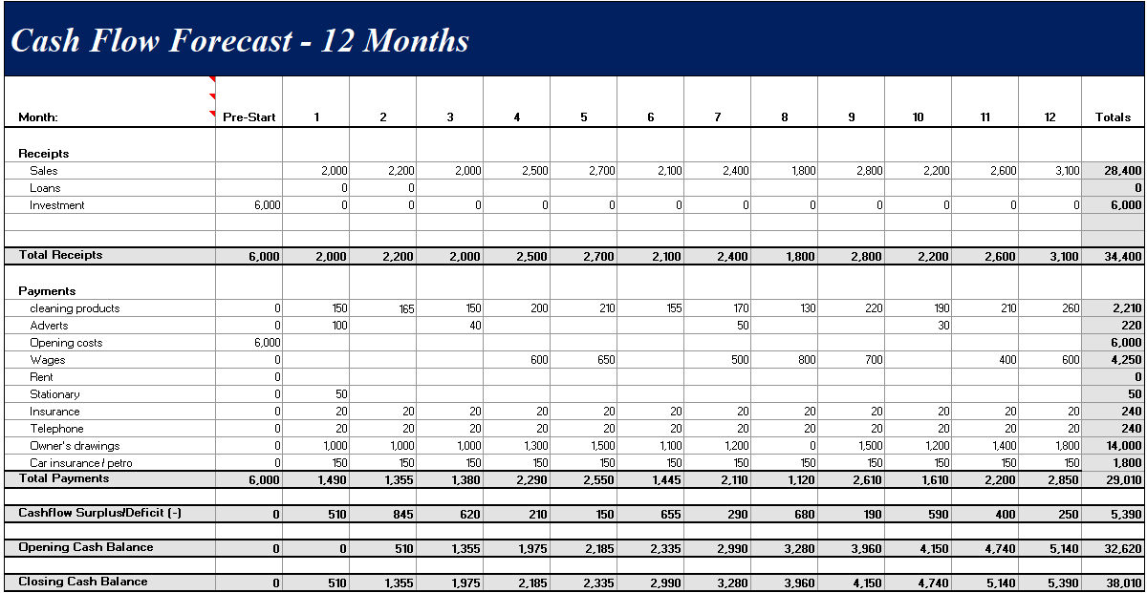

9. SWOT Analysis

- Strengths

- Low overhead costs, no salaries, and no rent for an office, which maximizes profitability (Harrison & Mason, 2019).
- Flexibility
- Personalised services, leading to strong customer relationships and loyalty (Burns, 2016).
- Quick decisions making, without consulting with someone.

- Weaknesses
• Limited resources to invest and limited ability to expand (Perry, 2020).
• Sole trader may reach capacity quickly and struggle to meet increased demand or manage growth (Harrison & Mason, 2019).
• Skills limitation in marketing and accounting, which can affect long-term business development (Burns, 2016).
- Opportunities
• Niche Market
• Awareness
• Engagement with local communities using online marketing tools
• Building partnerships with other local businesses
- Threats
• Intense Competition (Ngo Ntomp, R.G., 2025).
• Economic Uncertainty
The biggest threat to the success of a sole trader cleaning company is competition from larger cleaning businesses. Larger firms can offer lower prices, have more sophisticated marketing, and offer a broader range of services, making it hard for sole traders to retain clients and grow their market share (Harrison & Mason, 2019).
Proposal to Overcome This Threat:
- Focus on offering specialized services like eco-friendly cleaning, deep cleaning, or high-end residential services that larger competitors may not cater to.
- Differentiation can help carve out a dedicated customer base (Perry, 2020).
- More direct communication and customized services can foster loyalty (Burns, 2016).
- Local Marketing
- Flexible Pricing and Service Packages

References

Mandviwalla, M. and Flanagan, R. (2021) ‘Small business digital transformation in the context of the pandemic’, European Journal of Information Systems, 30(4), pp. 359–375. doi: 10.1080/0960085X.2021.1891004. (Accessed on: 20th February ).

Gursida, H., Herdiyana, H., Muharam, H., Pranowo, A.S., Hanan, S. and Hadiyat, Y., 2025. Implementation of Management Practices in MSMEs’ Village for Business Performance and Sustainability Improvement: A Case Study in Bantargadung Village, Bantargadung Sub-Dicstric, Sukabumi Regency, West Java. Jurnal Kabar Masyarakat, 3(1), pp.191-216.

Shukla, G., 2025. Administration in Business Practices. Educohack Press. https://books.google.co.uk/books?hl=en&lr=&id=gutBEQAAQBAJ&oi=fnd&pg=PT25&dq=related:r8EPWtIbGqcJ:scholar.google.com/&ots=umUbwy2j1L&sig=6499VyH8NrYQqDu28W2wqYs4yKs#v=onepage&q&f=false. (Accessed on: 23 February).

Tien, N.H., Anh, N., Dung, H., On, P., Anh, V., Dat, N. and Tam, B., 2021. Factors impacting customer satisfaction at Vietcombank in Vietnam. Hmlyan J. Econ. Bus. Manag, 2, pp.44-51.
https://www.researchgate.net/profile/Hoang-Tien-Nguyen-2/publication/354218913_Factors_impacting_customer_satisfaction_at_Vietcombank_in_Vietnam/links/6718d913acba566ad5f9cd2b/Factors-impacting-customer-satisfaction-at-Vietcombank-in-Vietnam.pdf

Ngo Ntomp, R.G., 2025. The Small Business Dilemma. Washington and Lee Law Review, 81(5), p.1939. https://scholarlycommons.law.wlu.edu/wlulr/vol81/iss5/5/. (Accessed on 6th March ).

Burns, P. (2016) Entrepreneurship and Small Business. 4th edn. London: Palgrave Macmillan.

Harrison, R. and Mason, C. (2019) Small Business and Entrepreneurship. 3rd edn. London: Sage Publications.
Perry, C. (2020) The Sole Trader’s Guide to Success: Strategies for Small Business Owners. New York: Wiley.

Sheedy, M., 2010. The Small Business Success Guide. John Wiley & Sons. https://books.google.co.uk/books?hl=en&lr=&id=L2LpqHM5YZwC&oi=fnd&pg=PR7&dq=the+sole+trader+guide+to+success+strategies+for+small+business+owners+&ots=inOhn6se1j&sig=YAVvKMMbWNEHoGimny835ukdt_Y#v=onepage&q&f=false

Bradley, S.W., Kim, P.H., Klein, P.G., McMullen, J.S. and Wennberg, K., 2021. Policy for innovative entrepreneurship: Institutions, interventions, and societal challenges. Strategic Entrepreneurship Journal, 15(2), pp.167-184.

Crane, A., Matten, D., & Spence, L. J. (2019). Corporate Social Responsibility. Cambridge University Press.
Peters, M., Freeman, D., & Wilson, J. (2020). The Future of Work: Hygiene Expectations. Harvard Business Publishing.
Varga, J., 2021. Defining the economic role and benefits of micro, small and medium-sized enterprises in the 21st century with a systematic review of the literature. Acta Polytechnica Hungarica, 18(11), pp.209-228.

Mathieu, P., 2019. Sundararajan A., The Sharing Economy. The End of Employment and The Rise of Crowd-Based Capitalism, Cambridge MA., The MIT Press, 2016. RIMHE: Revue Interdisciplinaire Management, Homme & Entreprise, 358(2), pp.92-102.

Kocsis, A., 2010. The Complete Guide to Eco-Friendly House Cleaning: Everything You Need to Know Explained Simply. Atlantic Publishing Company. Google Scholar. (Accessed on 14th February 2025).

Ghoshal, M., 2019. Social media as an effective tool to promote business-an empirical study. Global Journal of Management and Business Research, 19(1), pp.15-25. https://d1wqtxts1xzle7.cloudfront.net/77705168/2574-libre.pdf?1640877694=&response-content-disposition=inline%3B+filename%3DSocial_Media_as_an_Effective_Tool_to_Pro.pdf&Expires=1739717753&Signature=ZZGlhGUNaS-BBb~DvzZDSkYJ5Bo89om0DP4DWHgDoT-66p4kzMEDvgHJ2p-p6U84QubxFlg7IJl4N~~erfqIM1y5TfIxuNR7V8Xcr~bIdyxadYXs4AvdYeyUx9JzFZBvU5LTE1GmYtyJ5jFqYdBDpCdYuDh3M3tXrGkHZ4yn68B9bucqJkbrsqYXSGuFNQx4-Bd~oDF86-QEXE~Q7DpDKkzCWZLeUTsvwJHRY~0wbGvmPfTMMTMBle5gLrYxY4Pvp4sn9V0hfo48MdX57Nya7gMTCE-LPmrcvsDOmg4sFXu2GGUy8qML1~TGpv3ikkIIiWNwRnzHOegbjakT1ZgabA__&Key-Pair-Id=APKAJLOHF5GGSLRBV4ZA
Rye, J., 2020. What is the difference between a sole trader and a limited company? In Setting Up and Running a Therapy Business (pp. 132-134). Routledge. https://www.taylorfrancis.com/chapters/edit/10.4324/9781003096320-38/difference-sole-trader-limited-company-james-rye
Conzemius, A. and O'Neill, J., 2009. The power of SMART goals: Using goals to improve student learning. Solution Tree Press. https://books.google.co.uk/books?hl=en&lr=&id=VWwXBwAAQBAJ&oi=fnd&pg=PT15&dq=smart+objectives+sole+trader+cleaning+company&ots=24KTrcNCbB&sig=BXi8Yf4ctsGLp23v9BpTSEfGAII#v=onepage&q&f=false

Programme: Certificate of Higher Education
Employability Skills

Modul: Managing Enterprise
Module code: BMSW4011

Assignment 1 Part 2: Individual reflection
Lecturer: Melanie Squire

Name: Andreea-Mihaela Tanasa

Student Number:2332157

Word count: 514 Submission deadline: 21.03.2025

- Business skills and knowledge which I have acquired during the process of formulating and developing my business plan.

Creating my company strategy taught me some quite valuable business information and skills that have drastically changed my attitude toward entrepreneurship.
Making a business plan motivated me:
- to apply several business models
- carefully organise data
- Apply critical thinking
I have learned:
- How to assess customer behaviour
- Evaluate the competitive landscape
- Identify possible markets.
This meant gathering data from many sources and looking for trends to confirm that my company's idea made sense.
Knowing client needs, preferences, and pain points helped me to build my business to show value. Creating budgets, estimating expenses, and projecting income helped the company get somewhat ready for financial equilibrium.

- My entrepreneurial strengths

I sharpened my performance analysis, financial estimate development, profitability evaluation, and cash flow prediction-generating abilities. Knowing the financial outcomes of the choices I made enabled me to identify areas requiring the most careful planning and probable risk. Good control of startup resources and guarantees of sustainability depends on this growing financial understanding.
Strategic thinking turned out to be still another quite useful ability I developed. As I worked through the business model, I had to strike a compromise between the operations required to satisfy the benchmarks I aimed for and the long-term concentration of the organisation. This also implies considering general and temporary strategies.
I gained knowledge on how to balance operational specifics with a high-level strategy such that every activity complemented the overall company goal. Regarding my business ability, I believe that conquering challenges is crucial.
Along the road of developing the firm plan, I faced several difficulties, including how to ensure scalability, govern restricted resources, and produce my good or service unique from competitors.
I greatly value my ability to methodically approach challenges, break them down into manageable chunks, and provide unique answers.
Entrepreneurs must be able, as the road usually consists in overcoming challenges with limited resources and changing market conditions. I became aware of my flexibility as well. Business is continuously changing, and as I worked on my strategy, I came to see how much under-uncertainty adaption requires. Whether it was reevaluating the distribution model to cut expenses or changing my marketing approach relying on fresh customer insights, my ability to quickly pivot helped me to create a stronger and solid plan. This adaptability will be crucial in the actual world when change is assured.

- Entrepreneurial trait
Resilience is one trait I came to know about in myself that would be fit for a businessperson. Creating a company plan is an ongoing process; occasionally, mistakes or obstacles made me wonder if the idea made sense.
Still, my capacity to push on and create goals has revealed some degree of resilience needed by every business owner. Managing the ups and downs of entrepreneurship requires these kinds of skills since success usually results from several tries and blunders. All things considered, improving and developing my firm strategy supplied strategic thinking, financial awareness, and market research-based, fundamental corporate knowledge. My will kept me focused on my entrepreneurial objectives; my capacity for adaptation and problem-solving helped me past difficulties.

