1.Define skill in the context of your own practice and the work of two artists/makers/designers from the lecture series.

P148982

Surface Pattern Design: Textiles for Fashion

Word Count: 2182

Tutors: Julia Lockheart, Rodney Bender

1. Define skill in the context of your own practice and the work of two artists/makers/designers from the lecture series.
In this essay I will explore the skill within printed textiles. I want to see how skill is seen between traditional printing techniques and the development of skill as technology has advanced and have become more Computer Aided Design (CAD) based. I will compare these with skills I use in my practice creating printed textiles. I will be focusing on 2 designers: William Morris and Eley Kishimoto. Another factor I will be including is analyzing the sustainability of the techniques used to make these printed textiles. It will be interesting to see if traditional techniques have been improved over the years to make the processes more sustainable.
Some might see skill as the time it takes to do something and some may think that skill is the effort gone into making something. This is the definition of skill according to the Collins dictionary: “A skill is a type of work or activity which requires special activity or knowledge.” Collins Dictionary, (2017). This means that people have a great understanding of what they’re doing. I define skill in my practice as things I can do which others in different fields cannot.
As a surface pattern designer I create things which require a lot of skill. I know methods to transfer patterns onto different surfaces including textiles, glass, wood, ceramics or metal. For this essay I will only focus on the skills I need to print patterns onto textiles.
There are many traditional printing methods but I want to focus on two: wood block printing and screen printing. I feel like these are the methods that have been used the most throughout history and require a lot of skill.
Wood Block Printing
Wood block printing is a form of printing where you carve a pattern into wood, roll ink onto it and press down onto fabric or paper to create a pattern. According to: Robinson, P. (1972), wood block printing has been around since 200 B.C and used to print in China. The book also says that the most common wood used is sycamore. These blocks cost a lot and require a lot of precision in cutting and carving. Recently, wood block printing has become lino printing which involves carving into flexible rubber. This is cheaper.
William Morris used wood block printing to create his textile work. “William Morris was an English textile designer, artist, writer and socialite.” VAM, (2016). Morris used wood block printing instead of the more modern engraved rollers. The book says that Morris would have a block carver that was in “Bethnal Green Road, London” and that the pattern Morris had designed would be put onto the block by using tracing paper. Before James Barett transferred the design onto the wood he would show it to Morris again to ensure it was perfect. A dye pad would be nearby to press the block into it before printing. Parry, L. (1983), ‘p49-50’.
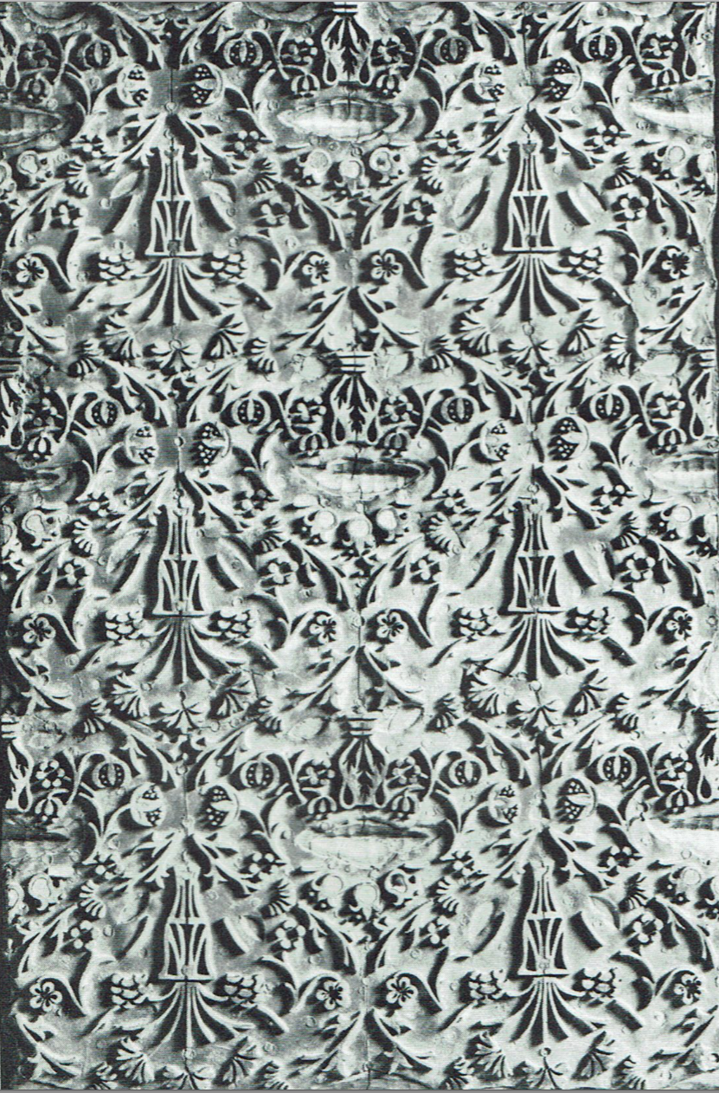
There is a lot of skill involved with wood block printing in my opinion. I haven’t used wood to create a block print but I have used Lino. It’ s a long process which can be very difficult but also very rewarding and organic. You first draw a design onto paper and transfer onto the block or draw straight onto the block. William Morris would design his block to repeat as seen in Figure 1. This takes a lot of skill because of how accurate the design must be for the repeat to work.
After drawing the design accurately, the next step is carving. This has to be done very slowly from experience because the tools are very sharp and you need to have the correct pressure to carve at the correct depth. There are three knives: “A pointed one for the outline, another for removing wide unwanted areas…and another for trimming waste near the printing areas.” Monoprinting, (2012). You also must remember when designing that the carved sections of the block will be blank so it takes skill to design in reverse. Carving the wood block can take hours or even days to finish. Ross, C. (2016).

FIGURE 1
Another skill for this process is marking out the registration marks along the print table. This process means marking out where the block should be pressed down in order for the pattern to repeat perfectly. This is a skill in itself because of the precision and measuring involved.
As a designer I believe it’s important to consider sustainability when printing textiles. We as designers need to consider how this affects the environment and how we can change how things are produced to create a sustainable future. Sustainability is trying to meet the demands of now but thinking about preserving the future sustain.ucla, (2017). I think that wood block printing is a sustainable process as the blocks can be re used. Also there is “zero carbon emission” with this process. Sight Mode, (2017).
But, we cut down trees in order to have the wood. This would have a negative effect on the environment as there would be less trees to absorb carbon dioxide. This means there are more greenhouse gases being released into the atmosphere; raising the temperature of the Earth. National Geographic, (2017). Maybe it’s better that lino prints are becoming more popular as they are much more durable than wood.

Screen Printing
The other traditional process I wanted to discuss was the skill in screen printing. Screen printing is the process I am most familiar with and I know how much skill goes into the process. Screen printing is a method of printing where a stencil is put onto a “woven mesh” usually made of synthetic fabrics. Then ink is pressed through the screen using a squeegee that applies pressure, printing your design. Screen Printing, (2017). From workshops I have learnt that there are many different inks that can be used to screen print. These include: pigment paste, reactive dyes, clear discharge paste, devore paste, etc.
There is a long process before printing. First you need an image for the stencil. This image could be anything and can be hand drawn or digital but will only work if the image is pure black and white. This process takes skill as you could have a detailed drawing which could take hours. You have to remember when drawing that black lines will be visible when printing. So you must consider positives and negatives. You then coat your screen using ultra violet(UV) sensitive emulsion, called “photo emulsion”. This needs to be done with care and skill. If the emulsion isn’t smooth or doesn’t cover the entire screen it won’t work when printing. You also have to ensure that the emulsion isn’t too thin or thick on the screen. This has to dry before exposing your image onto the screen.
To expose you must place your image facing upwards on the exposure unit. The exposure unit is the UV emitting machine that exposes your screen or “burning your screen”. ASPA staff, (2013). After exposing you must wash the screen to remove the exposed parts to reveal the stencil.
Eley Kishimoto are a design company based in Brixton that design by the phrase: “Print the World”. They have worked for many big fashion designers like Alexander McQueen and Louis Vuitton but have grown into a large name themselves. Eley Kishimoto, (2017). Eley Kishimoto like to screen print even though digital printing is the most popular printing method. They say that digital printing doesn’t have the “crispness” to it compared to screen printing. Fashion Review, (2017). Recently they’ve made hand screen printed wallpapers which are printed in Brixton. Dahlsen, R. (2017). I like the fact that they keep the traditional methods of printing. The company have their own screen printers that have the best skills in this process.
There is a lot of skill in screen printing. Mixing your pastes or dyes means following strict recipes and know exactly how much of chemicals must be used. You also need skill when printing to have a clean, crisp print which means applying the correct pressure with the squeegee onto the fabric. If your image is a repeat, it takes a lot of skill to measure where the screen needs to be each time for the repeat to be seamless. To do this you must use registration points on the printing. The screen printing process is very long especially when making a large piece with different colors but also has the reward of making something by hand which you cherish.

Screen printing can be a sustainable process if done correctly. Once the mesh screen is made; you can change the imagery as often as you want. The only time you might have to change the mesh is if a hole appears from wear. The only unsustainable aspect is the dyes and pastes used. These are full of chemicals and could be very toxic to the environment unless disposed of properly. In our print room we have large blue plastic containers to throw away unwanted inks to be recycled. There is also a picture of these containers in Eley Kishimoto’s print room in Brixton shown in Figure 2. Dahlsen, R. (2017) Screen printing is very sustainable and has little effect on the environment as long as the waste is disposed of responsibly.

FIGURE 2

Digital Printing
The main form of digital printing we use our course is using the inkjet digital printer which is a form of CAD design. The inkjet printers are usually used at printing companies or in universities but should be used under supervision of technical staff as they are costly and complex. Briggs-Goode, A. (2013)
The printer can print any design imaginable: photographs, drawings or textures. These images have to be in the format of a digital file. In our university the file has to be in an Adobe Photoshop format.
It is questionable how much skill goes into the design of the digital file as you could just upload a photograph. But, you could also create a complex repeated design which could take hours to create. I would say that this process requires a lot less skill compared to some traditional methods of printing. This is because there’s a lot less hand work and more is done on computers.
The skill is mostly required when setting up the machines and loading the fabrics. Also when finishing the process, you must steam the fabric for 20 minutes then wash for 1 hour, dry and press. This process needs to be done very carefully otherwise the print could ruin. It is arguable that the method requires; a lot of skill because the technicians have a great knowledge of the machine and software. This can relate back to the definition I found at the beginning saying that skill means having a special “knowledge”; which they have. Collins Dicitonary, (2017).
I have digitally printed a lot in my practice and it’s a more efficient and precise way of printing compared to screen printing as you can print different colors at the same time and the design is a copy of the digital file. So even though digital printing has less skill involved, it’s quicker and more effective which is why it’s now the most popular from of printing.
Digital printing can be very sustainable. The company Print & Press London say that they use “water based pigment inks” which are sustainable and non-toxic. They also say that compared to screen printing you only use the volume of ink needed so there is no waste. Print and Press London, (2017). Not every company use non-toxic inks but there would still be little waste of inks.

To conclude. After researching all these methods of printing textiles along with knowledge from my practice I have realized that there is a lot of skill needed. This skill may seem simple to designers as it’s their norm. It’s the same as neurosurgeons performing brain surgery. I believe that the technique that requires most skill is wood block printing. This is because the skill and craftsmanship has been passed down the generations and only a few highly skilled individuals would be able to do this now in 2017. Saying this, you can now digitize wood block printing. You can use a laser engraver the engrave the wood without needing to hand carve so the is less skill. Screen printing has advanced in the past decade in industry and use machines to aid in the process. Digital printing is straightforward as long as you know how to set up the machines. I believe that William Morris would be amazed to see the technical development that has happened since the 1800s. The skill in textile printing has reduced over the years because there is more demand so companies have to work faster and in a more sustainable and cheaper way. I believe skill is an important quality to have as designers and traditional skills should be preserved like Eley Kishimoto are trying to do.

Bibliography
- ASPA staff, (2013), ‘exposing a screen’, [online]. http://www.screenprinting-aspa.com/how-to-articles/exposing-a-screen, [Accessed date:2017,12,01].
- Briggs-Goode, A. (2013), Printed Textile Design, London: Laurence King Publishing.)
- Collins Dictionary, (2017), ‘Definition of skill’, [online]. https://www.collinsdictionary.com/dictionary/english/skill, [Accessed date:2017,11,29]).
- Dahlsen, R. (2017), ‘Eley Kishimoto in Conversation’, [online]. http://www.houseandgarden.co.uk/interiors/news/eley-kishimoto, [Accessed date:2017,12,01].
- Eley Kishimoto, (2017), ‘company profile’, [online]. http://eleykishimoto.com/profile/, [Accessed date:2017,112,01].
- Fashion Review, (2017), ‘. Eley Kishimoto- Design, Fashion, Art and Collaboration’ [online]. http://www.fashionreview.co.uk/eley-kishimoto-fashion/, [Accessed date:2017,12,02].
- Monoprints, (2012), ‘Woodblock Printmaking’, [online]. http://www.monoprints.com/techniques/woodblocks.php, [Accessed date:2017,11,30].
- National Geographic, (2017) ‘Deforestation’. [online]. https://www.nationalgeographic.com/environment/global-warming/deforestation/, [Accessed date:2017,12,01].
- Parry, L. (1983), William Morris Textiles, London: George Weidenfeld & Nicholson Limited.)
- Print and Press London, (2017) ‘Eco Friendly Textile Printing’. [online]. http://www.printandpresslondon.co.uk/eco-friendly-textile-printing/, [Accessed date:2017,12,01].
- Robinson, P. (1972), Exploring Fabric Printing, London: Mill & Boon Limited.)
- Ross, C. (2016), ‘The Beauty of Hand Block Printing’, [online]. https://theswatchbook.offsetwarehouse.com/2016/04/07/beauty-hand-block-printing/, [Accessed date:2017,11,30].
- Screen Printing, (2017), [online]. https://www.dice.com/skills/Screen-printing.html, [Accessed date:2017,12,01].
- Sight Mode, (2017), ‘Hand Printed vs Machine Printed’ [online]. https://sightmode.com/hand-printed-vs-machine-printed/, [Accessed date:2017,11,30].
- Sustain.ucla, (2017), ‘What is Sustainability?’, [online]. https://www.sustain.ucla.edu/about-us/what-is-sustainability/, [Accessed Date: 2017,12,12].
- VAM, (2016), ‘Biography of William Morris’, [online]. http://www.vam.ac.uk/content/articles/b/biography-of-william-morris/, [Accessed date:2017,11,29].)

