
University of Wales Trinity Saint David
Wales Institute of Science & Art

Material Selection Report
Engineering Design and Materials
ACHA4001

Dylan Brierley
2304450
04/2024

Contents
1 Introduction 3
2 Component Design Specification 4
3 Material Selection 6
3.1 Material Properties 7
4 Manufacturing Process Selection 9
4.1 High Pressure Die Casting 9
4.2 Squeeze Casting 10
4.3 Sand Casting 10
5 Conclusion 12

Introduction

The aim of this material selection report is to suitably select a material and manufacturing process for an engine block. This means analysing the material, specification and process needed to get this component made to a high quality and to meet the application requirements detailed.

Component Design Specification

The component I have chosen to select a material for is an engine block. The cylinder block is the basic framework of a car engine. It supports and holds all the other engine components (Woodyard, D.F, 2009). This engine block will be used in a mid-engine sports car for the road, meaning that there is not a huge amount of space available, and centre of gravity will also be a large consideration.

Specification Point | Business Needs | Consumer Needs | Component Spec
Cost | This engine block design and manufacture process needs to be cost effective as this component will need to be produced in very large quantities to match the demand of the car model. | The consumer cost isn’t really a massive consideration as it isn’t a hugely replaced part but the lower cost the better to ensure things like repair and replace costs are low. | £500 - £600
Environment | Good environmental credentials would be good for the business showing they’re taking the lifecycle of the car into account. For this component, this may mean making it so that the block is able to be recycled or repaired easily without completely throwing the whole component away. | The consumer may be concerned with where the engine block resources are found, for example, if the metals used in the engine block were unethically sourced meaning environmental harm, then it could cause bad reputation amongst consumers. | Over 50% recyclable.
Size | The size of the engine block matters for the business as it will need to meet specifications for what type and displacement the car requires. The size of the block also effects how the engine fits in the car, which includes layout of cylinders and how tightly packaged the engine can be. | The block size caters to the size of the car which is what the consumer is considered for. Larger engines are often designed for larger cars therefore larger blocks are considered for larger cars in the same way. | Range between 2.0L-3.0L displacement.
Safety | The safety of the component needs to be considered from a business point of view as it needs to be safe to work on and safe to go together during assembly. | This component needs to meet the safety criteria so that there aren’t large failures of units which could put the consumer at risk. It also needs to be able to not get in the way of areas where the consumer will be near like the oil and engine fluid caps as this could harm the user. | Keep sharp edges to a minimum and strong block to avoid fracturing during failure.
Function | This engine block needs to function the same for every vehicle produced. This means that the process needs to be able to be replicated the same every time without large differences between blocks as this could lead to reliability or power issues. | The consumer will need the engine to function reliably for use within the car, without any constant need for repair and without catastrophic failure. | Less than 5% reliability issues due to block.

Material Selection

The material for an engine block can vary, however, there two main materials used. These materials are Iron or Aluminium alloy. Here are some advantages and disadvantages to begin the comparison:

 | Aluminium |  | Iron
Design Considerations | Better heat conductor for quicker cold start ignition and peak acceleration. | Cylinder walls need reinforcing with another material. | Much higher tensile strength meaning better longevity. | Harder to repair iron blocks.
Performance Considerations | Much lighter than iron (30-40%). | Prone to deformation under lots of heat and pressure. | Higher pressure capability meaning higher power and boost possibilities. | Dense material adding weight to the block.

For this application, aluminium looks to be a strong choice due to the considerably lower weight and improved heat transferability, allowing the sports car to have potentially better handling and cooling where it might struggle, being mounted in the middle of the car. However, aluminium does lose out on areas like power and reliability at high pressure. This would need to be considered when designing the block as reinforcement may have to be added to allow the block to suit the application better.

Material Properties

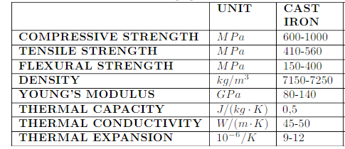
Figure 1 (Kępczak, N. and Pawlowski, W. 2013)

 | Yield stress (MPa) | Tensile stress (MPa) | Young’s modulus (GPa) | Density (kg/m3) | Thermal conductivity  (W/m.K)
Aluminium alloys | 30-500 | 58-550 | 69 | 2705 | 244
Figure 2 (Francis, R. 2023)

From these material property tables we can see the differences between the metals in areas such as tensile stress, density and thermal conductivity. We can see that aluminium has much better thermal conductivity meaning that the heat from the block can be conducted better to allow the engine to warm up quicker and potentially cool better at operating temperature. The density of cast iron is also much higher than aluminium alloy showing how the weight of cast iron would be much higher. Tensile stress has been given in a wide range for aluminium alloy and this may suggest that different alloy mixes give different strength but, on the whole, cast iron is tested to be stronger.
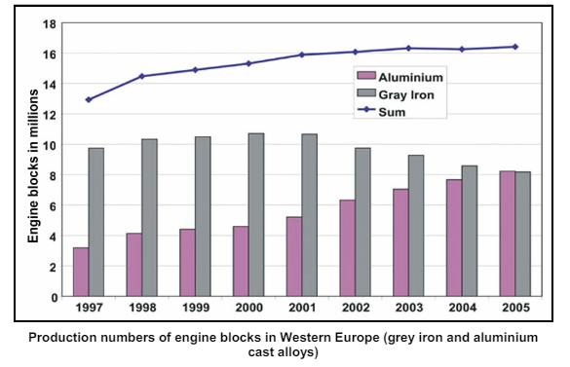
Figure 3 (E.A.A. 2011)
Figure 1 shows the increase in aluminium engine blocks from 1997 to 2005. This is showing how the use of aluminium became more popular very quickly to the point where it was being used more than iron in 2005, focusing on Western Europe. A reason for this could be that the process and design improved lots to the point where the disadvantages like lower strength and heat capability were less of a factor.

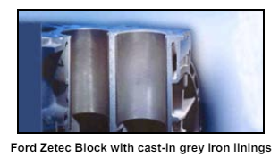
Figure 4 (E.A.A. 2011)
Figure 2 shows a perspective view of a zetec engine block using cast-in iron linings. This method is used for nearly every aluminium engine block to protect it, as the wear on the inside of the cylinder walls is excessive without cast iron inserts (Lombardi, A. et al, 2020). This method also provides an extra advantage to aluminium engine blocks as it makes repairing them easier. If there is scoring or wear on the inside of the cylinder then the cast inserts can be replaced, giving the engine block another chance to be used without having to throw it away. Good clamping between the liner and the block can also aid heat transfer meaning that the block is less likely to distort or change shape over different environments and heat cycles (Soares, E., Rejowski, E. and Maurizi, M., 2012).

Manufacturing Process Selection

All the engine blocks are cast with molten metal, despite the material being used. There are multiple different manufacturing processes for casting, and these will all be considered before deciding a suitable method.

High Pressure Die Casting

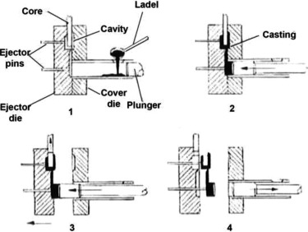
Figure 5 (Mallick, P.K. 2021)
This process involves forcing molten metal die into a negative mould of the geometry of the component using a ram in a very short space of time around 10 to 100ms. This casting method can trap air or cool the component too fast which reduces the mechanical strength. Despite these disadvantages this is a quick way to get a solid piece into a formed component and is best suited for high volume production (Midland Pressure Diecasting, 2021).

Squeeze Casting

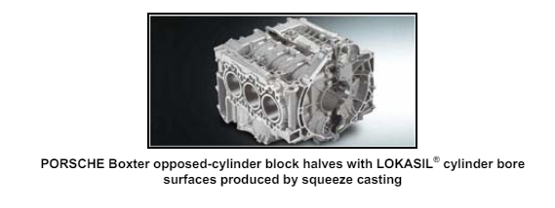
Figure 6 (E.A.A. 2011)
Figure 3 shows a squeeze casting example in the form of the famous Porsche flat six engine, used in many of their high-performance cars. Squeeze casting is a mix of low-pressure and high-pressure casting to eliminate defects associated with high pressure die casting. Disadvantages include less flexibility in part geometry, lower productivity, high machining requirements, and greater cost (Mallick, P.K. 2021). Despite these disadvantages, this process gives a strength close to the strength of forging (Smith, E.H. 1994).

Sand Casting

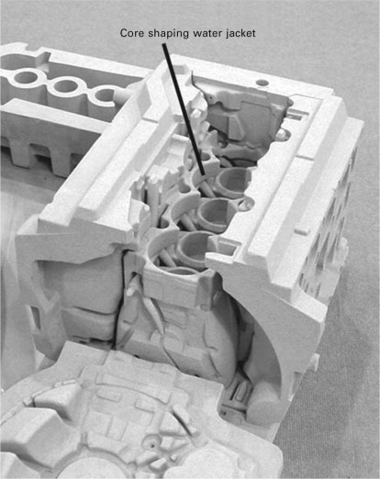

Figure 7 (Yamagata, H. 2005)

Figure 4 shows the sand mould that is used for sand casting and how detailed these moulds need to be. Sand casting involves pouring the moulten metal into these moulds and leaving it to solidify. An advantage of sand casting is the low cost of the moulds in comparison to these other processes detailed. However, the strict tolerances is where sand casting can be a disadvantage leaving the mechanical strength lacking (Mouritz, A.P. 2012).

Conclusion

In conclusion, this report has shown the differences between a cast iron engine block against an aluminium alloy engine block, including the change in popularity and commercial use in recent years. I think that aluminium was a suitable choice for the application of a mid-engine sports car as it helps to reduce the weight and centre of gravity as well as improve the chance of repair. After analysing all the different processes, the process I select to suit this application would be squeeze casting. This process already has previous uses within sports cars, being used by Porsche in their Boxster models, and suits the slightly lower production numbers that sports cars fall into, while providing a good finish and strong mechanical strength.

Reference List

Applications – power train – engine blocks (2011) European Aluminium Association. Available at: https://european-aluminium.eu/wp-content/uploads/2022/11/aam-applications-power-train-2-engine-blocks.pdf (Accessed: 21 April 2024).
Francis, R. (2023) How aluminium compares with steel in high volume manufacturing, Keronite Blog. Available at: https://blog.keronite.com/how-aluminium-compares-with-steel-in-high-volume-manufacturing (Accessed: 21 April 2024).
Kępczak, N. and Pawlowski, W. (2013) Application of Mineral Casting for Machine Tools Beds. Mechanics and Mechanical Engineering. .
Lombardi, A. et al. (2020) Residual stress, microstructure, and mechanical properties analysis of HPDC aluminum engine block with cast-in iron liners, Materials Today Communications. Available at: https://www.sciencedirect.com/science/article/abs/pii/S2352492820328257 (Accessed: 21 April 2024).
Mallick, P.K. (2021) Materials, design and manufacturing for Lightweight Vehicles. Duxford: Woodhead Publishing.
Mouritz, A.P. (2012) Introduction to aerospace materials. Cambridge: Woodhead Publishing.
Pressure die casting (2021) Midland Pressure Diecasting Limited. Available at: https://midlandpressurediecasting.co.uk/pressure-die-casting/ (Accessed: 21 April 2024).
Smith, E.H. (1994) Mechanical Engineer’s reference book, ScienceDirect. Available at: https://www.sciencedirect.com/book/9780750611954/mechanical-engineers-reference-book (Accessed: 21 April 2024).
Soares, E., Rejowski, E. and Maurizi, M. (2012) Cast-in cylinder liners designs to improve bonding and shear strength for aluminum block, SAE International. Available at: https://www.sae.org/publications/technical-papers/content/2012-36-0449/ (Accessed: 21 April 2024).
Woodyard, D.F. (2009) Pounder’s marine diesel engines and Gas Turbines. Amsterdam: Elsevier/Butterworth-Heinemann.
Yamagata, H. (2005) The Science and Technology of materials in Automotive Engines. Cambridge: Woodhead Publishing.

