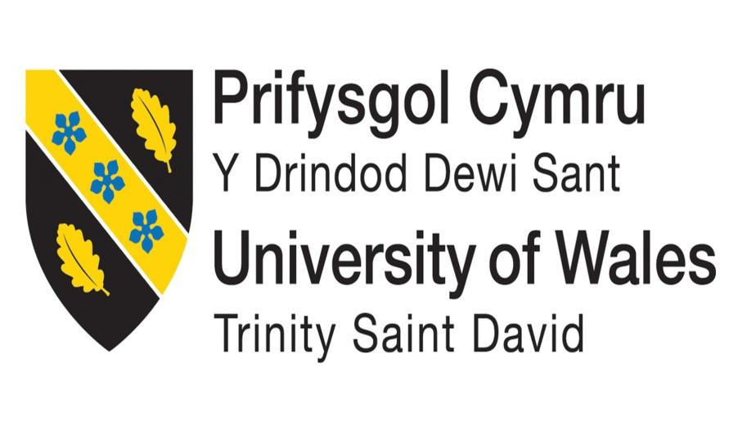

BMSW4009: Effective Team-working and Communication

Part 1: Individual Report

Building Effective Teams in Organisations

Name: Ana Maria Novac
ID:2325698

Table of Contents
Introduction 2
Importance of effective teamwork for organisational success 2
Purpose and objectives of the report 2
Theoretical Framework 2
Key theoretical models 2
Overview of models and their concepts 3
Relevance of models in understanding team dynamics and improving teamwork 3
Team roles 4
Belbin’s model and its purpose 4
9 team roles identified by Belbin 4
Examples of applying the Belbin model in optimising task allocation and team composition 5
Understanding Team Development 6
Stages of team development in the Tuckman model 6
Evaluating stages with challenges and opportunities in team development 6
Examples of navigating each stage effectively by teams in achieving high-performance 6
Managing Conflict in the Workplace 7
Thomas Kilmann's model 7
Significance of understanding these conflict management styles 8
Examples of applying this model organisation in resolving conflict 8
Conclusion 8
Key findings and insights 8
Reflecting the importance of effective teamwork for organisational success 9
Recommendations for organisations to build and maintain high-performing teams 9
References 10

Introduction

Importance of effective teamwork for organisational success
Effective teamwork has been important in improving performance efficiency and organisational productivity entirely. As suggested by Musheke and Phiri (2021), effective teamwork influenced communication patterns, which facilitated the team in enhancing performance efficiency and accelerating organisational success relatively. Relatively, it has been evaluated that teamwork steered individual performance that leads to better outcomes in strengthening the collaborative problem-solving skill potential of both the individual and teams. This has stimulated organisational success.

Purpose and objectives of the report
The report will be formed by exploring key insights and concepts of models and theories related to team roles, team development and managing conflict within an organisational context that have been objectives of this report. Additionally, the purpose of the report is to explain ways organisations apply the core context of models and theories in enhancing teamwork, strengthening team development and managing conflict in attaining organisational success.

Theoretical Framework

Key theoretical models
The 9 roles mentioned in the Team Roles theory depict the importance of different team roles following the right tendency required in team behaviour and maintaining a supportive interrelation among the team members (Belbin, 2010). The team roles are divided into 3 segments such as action-oriented, people-oriented, and cerebral roles depending on the requirements of the team activities in different organisational contexts. Moreover, the 5 stages in the team development model of Tuckman are used in considering the areas of team development with required changes in the leadership efficiency for each working group (Tuckman and Harper, 2012, p. 532). Moving through these 5 stages is important in developing the confidence of the team members by promoting collaborative understanding in the team behaviour.

Overview of models and their concepts
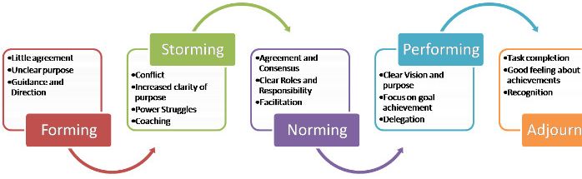
Figure 1: Tuckman’s 5 stages of team development
(Source: Sonal, 2015)
According to Aranzabal, Epelde and Artetxe (2022), the contribution of Bebin’s team roles is observed in developing individuals of a working team by identifying their potential strengths and speculating weaknesses as well. This works as a method of reducing challenges in teamwork and developing the right understanding among the team members. The concept of Tuckman’s model shows that collaborative development in the team’s perception is important in terms of guiding them in the right direction to achieve the best performance (Sonal, 2015). This could be achieved by focusing on the ability of the team members and using their maturity to establish better professional relationships and understanding in the process.

Relevance of models in understanding team dynamics and improving teamwork
The core theoretical aspects of the above-mentioned models aided the organisation in applying them to real-life situations to manage the skilled employees, prioritising their opinions and retaining them over a long tenure to accelerate organisational success. As suggested by Aranzabal et al. (2022), the implication of “Belbin’s Team Roles” lies in enforcing interpersonal skills, interdependence and team engagement of learners that reflected in team performance. Following this, an implication of 'Belbin team roles' has been effective in strengthening team performance and improving teamwork relatively. Meanwhile, the “Tuckman Model” explains an agile framework of team development lifecycle that aids an organisation in enhancing team performance and enhancing employees' job satisfaction that encourages them in improving team performance. This has been evident that employees understood team dynamics and adjusted to it to accelerate individual and team performance.

Team roles

Belbin’s model and its purpose
The Belbin model has been established by Dr. Meredith Belbin to elucidate the roles of a team in the context of facilitating team progress, which resulted in enhancing organisational success. As opined by Belbin (2010), a team represents a cohesive work framework that depicts a collaborative work pattern of individuals. In relevance to this, the Belbin model described types of employee behaviour that has been dependent on team roles. The purpose of the “Belbin Team Role” model is to identify behavioural strengths and weaknesses of roles that affect the workplace environment.

9 team roles identified by Belbin
Belbin identified nine team roles that are “resource investigator”, “teamworker”, “coordinator”, “plant”, “monitor-evaluator”, “specialist”, “shaper”, “implementer” and “complete finisher”. In this context, facts have been obtained from the report of Belbin (2010), that resource investigator is outgoing and enthusiastic while teamwork is cooperative, diplomatic and perceptive.
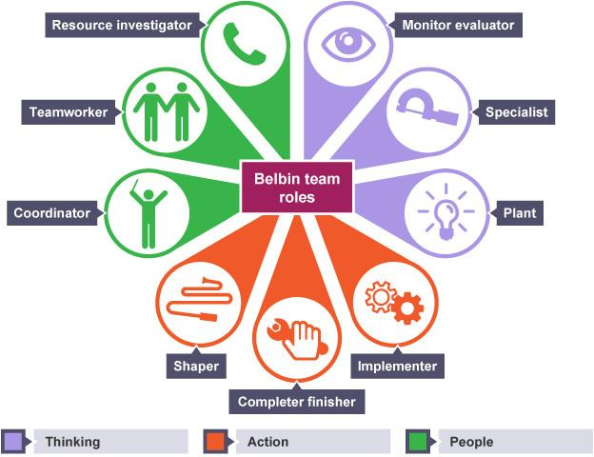
Figure 2: Belbin team roles
(Source: Belbin, 2010)
Meanwhile, the coordinator is quite confident in dealing with changes and clarifying goals to employees to achieve them within the timeframe. Plant as a team role is effective in fostering creativity while shaper is dynamic and thrives on pressure. In addition, the complete finisher is conscientious and polishes the work adequately while the implementer is practical and reliable to accept change and adjust to work dynamics.

Examples of applying the Belbin model in optimising task allocation and team composition
The leaders of Tesco fostered the role of “teamworker” to lead and motivate their team to steer service excellence and improve operational efficiency. According to the report of Tesco (2023), leaders developed an operation team, resource planning team, people and learning and development team to distribute work among the team ideally and optimise the functionalities adequately. In addition, the leadership of Marriott International focuses on steering team engagement to improve team performance and attain organisational success relatively (Ferry, 2023). This has been evident that Marriott’s leaders use the ‘monitor evaluator’ role to optimise operational efficiency.

Understanding Team Development

Stages of team development in the Tuckman model
The stages of team development designed by Tuckman are “Forming”, “Storming”, “Norming”, “Performing” and “Adjourning”. These 5 stages have been developed by Bruce Tuckman describing the opportunities for the team members for better performance (Tuckman and Harper, 2012, p. 532).

Evaluating stages with challenges and opportunities in team development
Forming: Members of the team get acquainted with one another and recognise the roles of the individuals (Mullins, 2023, p. 649).
Storming: The dynamics of the team change and the members begin to argue with each other and this sometimes leads to loud arguments.
Norming: Team members work out the conflict and understand how to cooperate and find a common solution or a battle plan. Poor Performance reduces productivity, thus the feeling of accomplishment is diminished.
Performing: Companies able to perform and manage these phases are regarded as top performers.
Adjourning: Possible feelings that team members may have regarding the dissolution of the team for project accomplishment.

Examples of navigating each stage effectively by teams in achieving high-performance
In consideration of “Forming”, it is required to clarify the vision of the team members by fostering better engagement and intention towards right communication among them. After that, “Storming” could help to focus on the activities of conflict resolution. Moreover, in “Norming”, the team should receive a space to prepare for better performance (Sonal, 2015). After that, the “Performing” stage will follow the changes in performance as per the expectations. However, “Adjourning” will indicate wrapping the complete project following the results in the project team with proper acknowledgement of the team members’ contribution to the success.

Managing Conflict in the Workplace

Thomas Kilmann's model
The theoretical perspective of ‘Thomas Kilmann's conflict management model’ assessed the conflict management styles. In the view of Nischal (2014), conflict management styles emphasise that managers accelerate skill sets such as conflict resolution and self-awareness in managing conflict among employees.
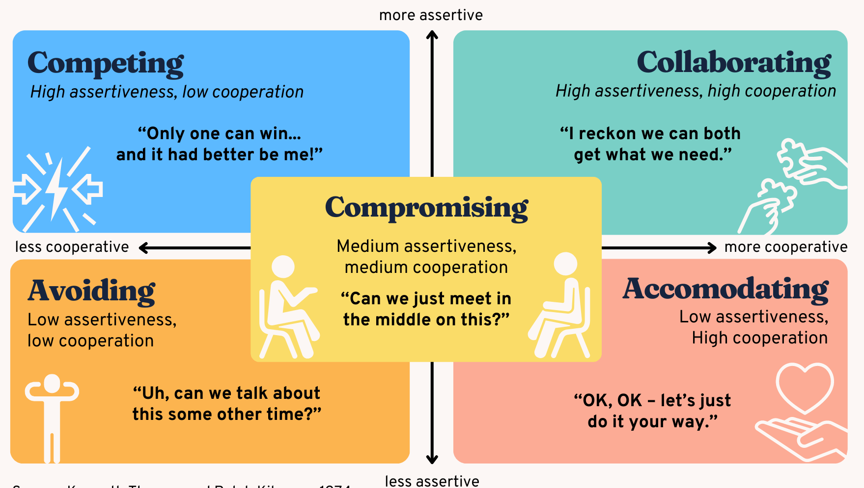
Figure 3: Thomas Kilmann's model of conflict
(Source: Nischal, 2014)
Additionally, assertiveness and cooperation have been the two core contexts of conflict management models and competing and collaborating styles are depicted high assertive nature of conflict management style. Meanwhile, avoiding and accommodating are the two less assertive styles. Relatively, competing and avoiding are less cooperative while collaborating and accommodating are highly cooperative.

Significance of understanding these conflict management styles
The significant aspect of 'Thomas Kilmann's conflict management style lies in steering intercultural communication and enabling it to prevent conflict onset effectively (Stadler, 2019). As suggested by Mills et al. (2020), conflict needs to be managed not only to reduce the conflict among teams but also to ensure employee well-being to spur individual performance efficiency. Relatively, competing management styles facilitated managers in facing the problems and resolving the issues adequately whereas the collaborative style obtained employees' opinions and encouraged them to steer team collaboration for enhancing team and organisational performance entirely.

Examples of applying this model organisation in resolving conflict
The organisational leaders applied the theoretical aspect of the conflict management model to assess the hidden conflict and used suitable conflict management styles to reduce the conflict relatively. As opined by Mustac (2024), Zara’s marketing leaders fostered a 'collaborative’ style to overcome the communication crisis and take accountability to identify fundamental qualities that were lacking in Zara. Moreover, Vodafone implemented “Companies Act 2006” within the organisation to set relevant practices to aid the leaders in avoiding such situations that lead to conflict (Vodafone Group Plc, 2021). Additionally, the board of members has been instructed to propose interest related to existing transactions to avoid transactional conflict.

Conclusion

Key findings and insights
Theoretical concepts of team development and team roles elaborate leaders' roles in steering team performance and enhancing the performance efficiency of an individual resulting in accelerating organisational performance.

Reflecting the importance of effective teamwork for organisational success
Effective teamwork played a role in enhancing individual job interests, which encouraged them to perform best. This has resulted in enhancing organisational success by spurring team performance. Moreover, effective teamwork shaped managers' roles and strengthened team dynamics to adjust to the changes and attain organisational success relatively.

Recommendations for organisations to build and maintain high-performing teams
It is to be recommended that organisational leaders maintain effective communication patterns between teams to steer employees' performance within the team. In addition, performance appraisals have been another suggestion that organisations can use in addressing employees' core strengths and weaknesses to build high-performing teams.

References
Aranzabal, A., Epelde, E. and Artetxe, M. (2022) ‘Team Formation on the Basis of Belbin’s Roles to Enhance Students’ Performance in Project Based Learning’, Education for Chemical Engineers, 38(1), pp. 22–37. Available at: https://doi.org/10.1016/j.ece.2021.09.001.
Belbin, R.M. and Brown, V. (2022) ‘Team Roles at Work’, Team Roles at Work, 3(9781003163152). Available at: https://doi.org/10.4324/9781003163152.
Belbin, R.M. (2010) Team Roles at Work. 2nd Edition, Google Books. 2nd Edition. Routledge. Available at: https://books.google.co.in/books/about/Team_Roles_at_Work.html?id=hF2yJzYfUBAC&redir_esc=y (Accessed: 22 May 2024).
Belbin, R.M. (2010) Management Teams: Why They Succeed Or Fail. 2nd Edition, Google Books. 2nd Edition. Routledge. Available at: https://books.google.co.in/books/about/Management_Teams.html?id=3ggtqaoxVf4C&redir_esc=y (Accessed: 22 May 2024).
Ferry, K. (2023) Marriott: Where everyone belongs, www.kornferry.com. Available at: https://www.kornferry.com/insights/this-week-in-leadership/marriott-where-everyone-belongs (Accessed: 22 May 2024).
Mills et al. (2020) ‘Conflicts and Its Management In An Organisation: A Theoretical Review’, International Journal of Scientific and Research Publications (IJSRP), 10(05), pp. 540–545. Available at: https://doi.org/10.29322/ijsrp.10.05.2020.p10162.
Mullins, L.J. (2023) Management & Organisational Behaviour. 11th edn. Harlow: Pearson, p. 649.
Musheke, M.M. and Phiri, J. (2021) ‘The Effects of Effective Communication on Organizational Performance Based on the Systems Theory’, Open Journal of Business and Management, 9(2), pp. 659–671. Available at: https://doi.org/10.4236/ojbm.2021.92034.
Mustac, T. (2024) Crisis PR: Lessons From Zara Ad Campaign That Critics Said Resembled Gaza Destruction, PRNEWS. Available at: https://www.prnewsonline.com/crisis-pr-lessons-from-zara-ad-campaign-that-critics-said-resembled-gaza-destruction/ (Accessed: 22 May 2024).
Nischal, S. (2014) Application of Thomas Kilmann Conflict Resolution Mechanism for Conflict Management in HR of Manufacturing Sector, www./iisjcm.org/, pp. 62–70. Available at: https://iisjcm.org/sites/default/files/IISJCM/2014/5.pdf (Accessed: 22 May 2024).
Sonal, P. (2015) Tuckman’s Model of Group Development, www.linkedin.com. Available at: https://www.linkedin.com/pulse/tuckmans-model-group-development-sonal-solanki (Accessed: 22 May 2024).
Stadler, S. (2019) Conflict, Culture and Communication, Routledge & CRC Press. Available at: https://www.routledge.com/Conflict-Culture-and-Communication/Stadler/p/book/9781138328174 (Accessed: 22 May 2024).
Tesco (2023) Team Leader | 596526 | Tesco Careers, www.tesco-careers.com. Available at: https://www.tesco-careers.com/jobdetails/596526 (Accessed: 22 May 2024).
Tuckman, B.W. and Harper, B.E. (2012) Conducting Educational Research, 6th Edition. 6th edn, rowman.com. 6th edn. Rowman & Littlefield Publishers, p. 532. Available at: https://rowman.com/ISBN/9781442209640/Conducting-Educational-Research-6th-Edition (Accessed: 22 May 2024).
Vodafone Group Plc (2021) Protocol for directors’ conflicts of interest, www.investors.vodafone.com. Available at: https://investors.vodafone.com/sites/vodafone-ir/files/our-purpose-esg-performance/governance/codes-of-compliance/vodafone-directors-conflicts-of-interest-protocol_0.pdf (Accessed: 22 May 2024).

