Part B - Reflections from the feedback received from tutor and peers
The feedback from my tutor and peers showed that my project plan has several strong points. One of the main things I did well was structure. My work was clearly organised into sections, which made it easy to read and follow. The use of boxes and charts was also highlighted as a positive feature. These helped present information in a clear and simple way, making complex ideas easier to understand. I will keep using this approach in my final project, as it improves readability and presentation.
The feedback showed that my work was clear and easy to understand. I avoided using too much complicated language, which made my ideas accessible to readers. My explanations of key points were also seen as effective. This shows that I can communicate ideas well. However, I need to improve how I explain some technical terms. In the final version, I will make sure all key terms are clearly defined and used correctly throughout the project.
Even though there were strengths, there are also areas I need to improve. One key issue was lack of critical analysis. My work was more descriptive than analytical. This means I explained ideas but did not always evaluate or compare them. To improve this, I will add more critical thinking by discussing different viewpoints and supporting my arguments with stronger evidence. This will make my work more academic and show deeper understanding. While I included references, they were not always well connected to my points. Sometimes they felt separate from the main discussion. In my final project, I will focus on linking sources more clearly to my arguments. I will also make sure my referencing style is consistent throughout.
Also, my charts and boxes were useful, I need to improve their consistency. Some of them did not have clear titles or explanations. This could confuse the reader. To fix this, I will make sure every visual element is clearly labelled and explained. This will help readers understand how the visuals connect to the written content.
Time management was another issue mentioned in the feedback. Some parts of my project were more detailed than others, showing that I did not spend equal time on each section. For my final project plan, I will create a clear schedule to manage my time better and make sure all sections are equally developed.
The feedback helped me clearly understand both my strengths and the areas I need to improve. I will continue using a clear structure and effective visual elements such as boxes and charts, as these made my work easier to follow and understand. At the same time, I will focus on improving my critical analysis by going beyond description and adding more evaluation and comparison of ideas. I will also strengthen how I use sources by linking them more directly to my arguments and ensuring consistent referencing. I will improve the clarity and labelling of all visual elements to make them more effective.

Introduction
In July 2025, an Atlantic weather system triggered severe flooding across the West Midlands, significantly impacting towns such as Worcester, Shrewsbury, and Kidderminster. The River Severn, already operating at critical capacity due to sustained rainfall, breached its flood defences at multiple points. Within a matter of hours, large sections of urban and residential areas were submerged, causing extensive damage to infrastructure, disruption to essential services, and displacement of local communities. Electricity networks failed, transport systems were rendered unusable, and both public and private properties suffered substantial losses.
Local councils, emergency responders, and community organisations were quickly overwhelmed, highlighting significant gaps in preparedness, coordination, and resilience. The aftermath of the disaster has created an urgent need for a structured and strategic recovery effort focused on rebuilding infrastructure, restoring essential services, and enhancing long-term flood resilience.
This Project Management Plan (PMP) outlines a comprehensive approach to the reconstruction of damaged infrastructure across the affected areas. The project aims not only to restore functionality but also to improve the resilience and sustainability of local systems to mitigate the impact of future flooding events. The plan applies established project management methodologies, tools, and techniques to ensure effective delivery within defined constraints of time, cost, scope, and quality.
The primary objectives of this project are to assess and prioritise damaged infrastructure across affected regions, design and implement reconstruction works that meet modern resilience standards, restore critical services, including transport, utilities, and public facilities, ensure stakeholder engagement and community involvement throughout the project lifecycle and to deliver the project efficiently while managing risks, costs, and resources effectively.

Project description
The consequences of the flooding were immediate. Towns such as Worcester, Shrewsbury, and Kidderminster were significantly impacted, with flooding of residential areas, commercial properties, and essential infrastructure within a very short period of time. Streets became impassable, electricity networks failed, and water supply systems were disrupted or contaminated. Hundreds of homes and businesses were submerged, resulting in economic losses, displacement of residents, and long-term social disruption. Critical infrastructure—including roads, bridges, drainage systems, and public facilities—sustained extensive damage, severely limiting access to essential services.
Despite early warnings issued by the Environment Agency, including “Severe Flood Warnings – Danger to Life,” many residents underestimated the speed and severity of the situation. Local councils, emergency services, and community organisations were quickly overwhelmed by the scale of the disaster. This event has emphasised the urgent need for a structured and well-managed recovery effort to restore essential services and rebuild infrastructure in a more sustainable manner.
The proposed project focuses on the reconstruction and rehabilitation of infrastructure across the affected areas. The primary aim is not only to restore pre-existing functionality but also to enhance the resilience of infrastructure systems to withstand future flooding events. This will involve a comprehensive approach engineering solutions, improved flood defence mechanisms, and sustainable design principles.
The key objectives of the project are to assess the extent of damage, prioritise critical infrastructure, and deliver reconstruction works efficiently within defined constraints of time, cost, and quality. Essential services such as transport networks, electricity supply, water systems, and drainage infrastructure will be restored as a priority. This project will aim to strengthen flood defences by reinforcing riverbanks, upgrading drainage systems, and incorporating advanced monitoring and early warning technologies.

Project Scope
The scope of the project is the assessment, repair, reconstruction, and upgrading of infrastructure damaged by the flooding. The project will focus on restoring essential services and improving the long-term infrastructure systems.
Damage Assessment and Planning
- The project will begin with a comprehensive assessment of all affected infrastructure. This includes structural inspections of roads, bridges, utilities, and public facilities. Risk assessments will be conducted to prioritise reconstruction efforts based on criticality, safety, and community impact. Outputs from this phase will include detailed project plans, cost estimates, and scheduling frameworks.
Reconstruction of Transport Infrastructure
- The project will include the repair and rebuilding of damaged roads, bridges, and transport routes. Improvements will be made to ensure that infrastructure is more resilient to future flooding, including enhanced drainage systems and the use of flood-resistant materials. Restoring connectivity is a priority to support economic recovery and access to essential services.
Restoration and Upgrade of Utilities
- Critical utilities such as electricity, water supply, and sewage systems will be restored and upgraded. This includes repairing damaged substations, pipelines, and treatment facilities, as well as implementing flood-resistant designs to minimise future service disruptions. Smart monitoring systems may also be introduced to improve early detection of faults.
Flood Defence Improvements
- The project will incorporate enhancements to flood defence systems, including reinforcement of riverbanks, embankments, and barriers. Drainage systems will be upgraded to improve water flow and reduce the risk of future flooding. Where feasible, modern flood monitoring and early warning technologies will be integrated.
Reconstruction of Community Infrastructure
- Public facilities such as schools, healthcare centres, and community buildings will be repaired or rebuilt. These facilities are essential for community recovery and social stability, and their reconstruction will follow resilient and sustainable design principles.

Work Breakdown Structure
Following the catastrophic flooding in July 2025 across Worcester, Shrewsbury, and Kidderminster, there is a critical need for a structured and systematic reconstruction of damaged infrastructure. The Work Breakdown Structure (WBS) is a key project management tool used to decompose the overall project into smaller, manageable components. It enables effective planning, resource allocation, cost estimation, and performance monitoring. The Work Breakdown Structure helps organise the entire reconstruction project into smaller, clear tasks. This makes the project easier to manage, track, and complete successfully. By combining structured methods. This ensures that infrastructure is rebuilt efficiently while meeting the needs of affected communities. To effectively manage the reconstruction project following the July 2025 flooding in Worcester, Shrewsbury, and Kidderminster, the project is broken down into four main components: governance, flood defence reconstruction, roads and bridges repair, and safety & environmental management. This WBS helps organise the work into clear sections to ensure smooth planning, resource allocation, and progress tracking. This clear, focused WBS will help guide the project team and stakeholders through the critical stages of flood recovery and infrastructure rebuilding, ensuring the work is organised, efficient, and aligned with community needs. It supports strong governance and control through the governance section, while the reconstruction and repair sections focus on technical delivery. Safety and environmental management ensure compliance and risk mitigation, which is critical in post-disaster recovery. (Siami-Irdemoosa, E., Dindarloo, S.R. and Sharifzadeh, M., 2015)
By dividing the project into these four main areas, teams can focus on their responsibilities while maintaining coordinated progress. This balance of structure and flexibility supports effective project delivery under complex and evolving conditions.
Project Governance - This covers the management and control activities necessary to deliver the project successfully. (Derakhshan, R., Turner, R. and Mancini, M., 2019)
Reconstruction of Flood Defences - Rebuilding and strengthening flood protection to reduce future risks.
Repair of Roads and Bridges - Restoring transport infrastructure to enable safe travel and economic recovery.
Safety and Environmental Management - Ensuring the project complies with safety standards and minimises environmental impact. (Duijm, N.J., Fiévez, C., Gerbec, M., Hauptmanns, U. and Konstandinidou, M., 2008.)

Qaud Chart
PURPOSE  - Restore essential public services disrupted by damage  - Infrastructure | CUSTOMERS  - Residents  - Businesses  - government  - Contractors
SUCCESS FACTORS  - Completion.  - Budget management.  - Compliance with safety regulations  - Community | CRITERIA  - Infrastructure safety standards.  - Project completed within approved budget and schedule.  public access.

Gantt Chart

All tasks completed within time frame between six and eight weeks, all variety of tasks to be completed within time frame. All including in Gantt chart provided.

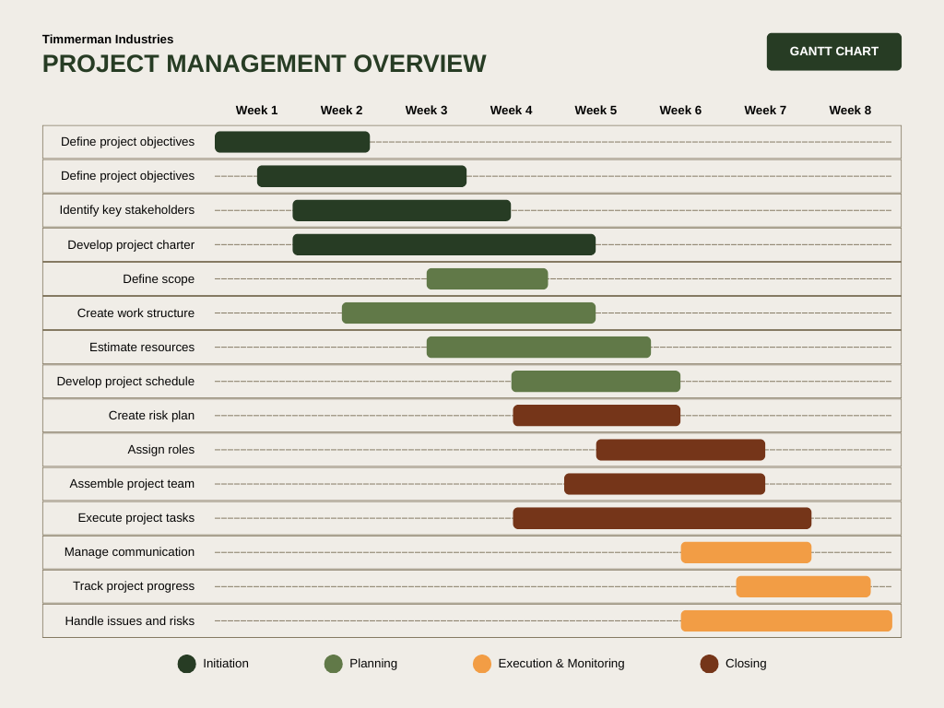

Stakeholders’ Involvement
Stakeholder involvement is essential to the success of the Flood-Resilient Infrastructure Reconstruction Project in Worcester, Shrewsbury, and Kidderminster. Because the flooding affected many parts of the community and different services, it is important to involve all relevant stakeholders in a clear, simple, and structured way. This ensures that the project meets local needs, stays within budget, and is completed on time.
Stakeholders are individuals or groups who are affected by the project or have an interest in it. For this project, stakeholders are grouped based on their level of influence (power) and how much they are affected (interest). This helps the project manager decide how closely each group should be involved.
The local councils are key stakeholders with high power and high interest. They are responsible for approving plans, providing funding, and ensuring that the project follows regulations. Their involvement starts from the beginning of the project, where they help define what needs to be rebuilt and which areas should be prioritised. Throughout the project, they will attend regular meetings, review progress, and approve major decisions. Their support is critical for the project to move forward. (Au-Yong, C.P., Ali, A.S., Ahmad, F. and Chua, S.J.L., 2017.)
The Environment Agency is another important stakeholder, mainly providing technical knowledge. They help assess flood risks and guide the design of flood defences and drainage systems. Their role is especially important during the planning and design stages. They ensure that all solutions meet environmental standards and are strong enough to handle future flooding. The project team will work closely with them to get approvals before construction begins.
Emergency services, such as fire, police, and ambulance teams, are also involved. Their main role is to ensure that rebuilt infrastructure allows quick and safe access during emergencies. For example, they will advise on road layouts and evacuation routes. They will also take part in testing the new systems to make sure they work well in real-life emergency situations.
Utility companies (electricity, water, and telecommunications providers) play a key role in restoring essential services. During the flood, many services failed, so these companies must be involved in rebuilding stronger and more resilient systems. They will coordinate with the project team to repair damaged networks and protect them from future floods. Regular coordination meetings will help avoid delays and ensure all systems are connected properly.
Local residents and communities are highly affected by the project, so their involvement is very important. Even though they may not have high decision-making power, their input helps ensure the project meets real needs. Public consultations will be held to gather their opinions and concerns. For example, residents can highlight the most flood-prone areas or suggest improvements. Communication with the public will be kept simple and regular through meetings, social media, and local updates. This helps build trust and keeps everyone informed.
Contractors and engineering companies are responsible for carrying out the actual work. They will design and build the infrastructure, such as flood barriers and drainage systems. These stakeholders will be selected through a fair procurement process. Once selected, they will work closely with the project manager to ensure the work is completed on time, within budget, and to the required quality standards. Their performance will be monitored regularly.
To manage all these stakeholders effectively, a clear communication plan will be used. This includes weekly team meetings, monthly progress reports, and regular updates to the public. Different communication methods will be used depending on the stakeholder group—for example, formal reports for government bodies and simple updates for residents. (Magassouba, S.M., Tambi, A.M.B.A., Alkhlaifat, B. and Abdullah, A.A., 2019.)
Also, the project manager will handle any conflicts that may arise between stakeholders there may be disagreements between budget limits and community expectations. These issues will be resolved through open discussions and fair decision-making. Stakeholder involvement in this project is continuous and well-organised. By keeping all stakeholders informed and involved, the project is more likely to succeed, deliver effective flood protection, and meet the needs of the community.

Allocation of Resources
The allocation of resources is a critical component of the Flood-Resilient Infrastructure Reconstruction Project. Effective resource management ensures that the project is delivered on time, within budget, and to the required quality standards. Resources in this project include human resources, financial resources, physical materials, and technology. Proper planning and allocation of these resources will support efficient project execution and reduce the risk of delays or cost overruns.
1. Human Resources
Human resources are essential for the planning, design, and construction phases of the project. A skilled and well-structured project team will be established, led by the Project Manager who is responsible for overall coordination and decision-making. Supporting the Project Manager will be civil engineers, environmental specialists, construction workers, procurement officers, and quality assurance personnel. Civil engineers will focus on designing flood defences, drainage systems, and infrastructure repairs. Environmental specialists will ensure that all designs meet environmental regulations and sustainability standards. Construction workers and contractors will carry out the physical rebuilding work, while procurement officers will manage sourcing of materials and services. Quality assurance teams will monitor work standards and ensure compliance with project specifications.
2. Financial Resources
The estimated project budget is £45 million, which will be carefully allocated across different project activities. A large portion of the budget (approximately 60%) will be dedicated to infrastructure repair and construction, including rebuilding flood barriers and drainage systems. Around 20% will be allocated to labour costs, while 15% will fund technology systems such as flood monitoring and early warning tools. The remaining 5% will be set aside as a contingency fund to manage unexpected costs. (Momeni, K. and Martinsuo, M.M., 2018.)
3. Material Resources
Material resources include construction materials such as concrete; steel, pipes, and equipment needed for rebuilding infrastructure. These materials are critical for constructing durable and flood-resistant systems. To avoid delays, materials will be procured in advance through reliable suppliers using framework agreements. Sustainable materials will be prioritised where possible to reduce environmental impact. Inventory management systems will be used to track materials and ensure they are available when needed. Proper storage and handling procedures will also be implemented to prevent waste and damage.
4. Equipment and Technology
Specialised equipment such as excavators, cranes, and drainage installation tools will be required during construction. These will either be rented or sourced through contractors, depending on cost efficiency. Equipment allocation will be scheduled carefully to avoid downtime and ensure continuous workflow.
5. Time Resources
Time is a valuable resource in this project, especially given the urgency of restoring infrastructure. The project is planned over 18 months, and time will be managed using scheduling tools such as Gantt charts. Activities will be carefully sequenced to ensure efficient use of time and resources. Critical path analysis will be used to identify key tasks that must be completed on time to avoid delays. Buffer time will also be included to manage risks such as bad weather or supply chain disruptions. Proper allocation and management of resources will ensure that the project is delivered successfully. By carefully planning human, financial, material, and technological resources, the project team can rebuild infrastructure efficiently and improve long-term flood resilience in the affected areas. (Hames, R., 2017.)

Risk Analysis
This project may face several risks during its delivery. Bad weather could delay construction work and slow progress. Costs may increase due to higher prices for materials or labour, which could affect the budget. There is also a risk of delays if materials are not delivered on time. Local residents may become unhappy if they are not kept informed or if the work causes disruption. In addition, there is a chance that the new flood systems may not work as expected. To reduce these risks, the project team will plan ahead, monitor progress regularly, communicate clearly, and keep backup plans in place.
Conclusion
In conclusion, the Flood-Resilient Infrastructure Reconstruction Project aims to restore and improve critical infrastructure in the affected areas following the severe flooding. By applying effective project management practices, including careful planning, resource allocation, stakeholder involvement, and risk management, the project can be delivered successfully. The focus on building stronger and more resilient systems will help reduce the impact of future flooding. Continuous communication and collaboration among stakeholders will ensure that the project meets community needs. Overall, this project will not only rebuild damaged infrastructure but also enhance safety, sustainability, and long-term resilience for the communities involved.

References
Zecheru, V. and Olaru, B.G., 2016. Work Breakdown Structure (WBS) in Project Management. Review of International Comparative Management/Revista de Management Comparat International, 17(1).
Elsye, V., Latief, Y. and Sagita, L., 2018. Development of work breakdown structure (WBS) standard for producing the risk based structural work safety plan of building. In MATEC Web of Conferences (Vol. 147, p. 06003). EDP Sciences.
Sarkar, D. and Hinds, T.J., 2022, July. GIFTS: Introducing Quad Chart to Reinforce Technical Communication Skills. In 2022 First-Year Engineering Experience.
Wadhwa, K., 2024. The Role of Gantt Chart in the Project Management.
Benn, S., Abratt, R. and O'Leary, B., 2016. Defining and identifying stakeholders: Views from management and stakeholders. South African journal of business management, 47(2), pp.1-11.
Kolahi, M., 2021. Natural resources stakeholders.
Paraschivescu, A.O., 2009. Identifying Stakeholders. Metalurgia International, 14(1), pp.58-61.
Söderholm, P., Holmgren, M. and Klefsjö, B., 2007. A process view of maintenance and its stakeholders. Journal of quality in maintenance engineering, 13(1), pp.19-32.
Raftery, J., 2003. Risk analysis in project management. Routledge.
Widianti, U.D., Harihayati, T. and Sufaatin, S., 2018, August. Risk project management analysis. In IOP Conference Series: Materials Science and Engineering (Vol. 407, No. 1, p. 012087). IOP Publishing.

