Assignment 2 – Guidance
Marketing Plan – written using a report format

Cover Page –

Contents Page –

Executive Summary –

Introduction –
A marketing plan is one of the most important steps in a marketing campaign. It helps outline the specific objectives, strategies and tactics an organization will use to promote its products or services, attract customers and achieve its business goals. Ensuring that resources are used effectively for marketing activities maximizes the return on the campaign investment.SOSTAC is a popular framework for creating a marketing plan. It stands for Situation, Objective, Strategy, Tactics, Action and Control. SMART is an acronym that stands for Specific, Measurable, Attainable, Relevant and Time-bound. It is a guideline used when setting goals in a marketing plan. This study will help KFC to develop a unique marketing plan to achieve its goals by using these two models.

Main Findings –
KFC, a popular fast food chain known for its fried chicken, has entered the plant-based food market with its own line of vegetarian and vegan options. Through previous research, KFC was found to have great potential in the vegetarian fast food category. Vegetarian products are increasingly valued by consumers, according to a Gallup Network survey that found 4 in 10 Americans have eaten plant-based meat products. Vegetarian culture is also very popular in India and the Middle East.
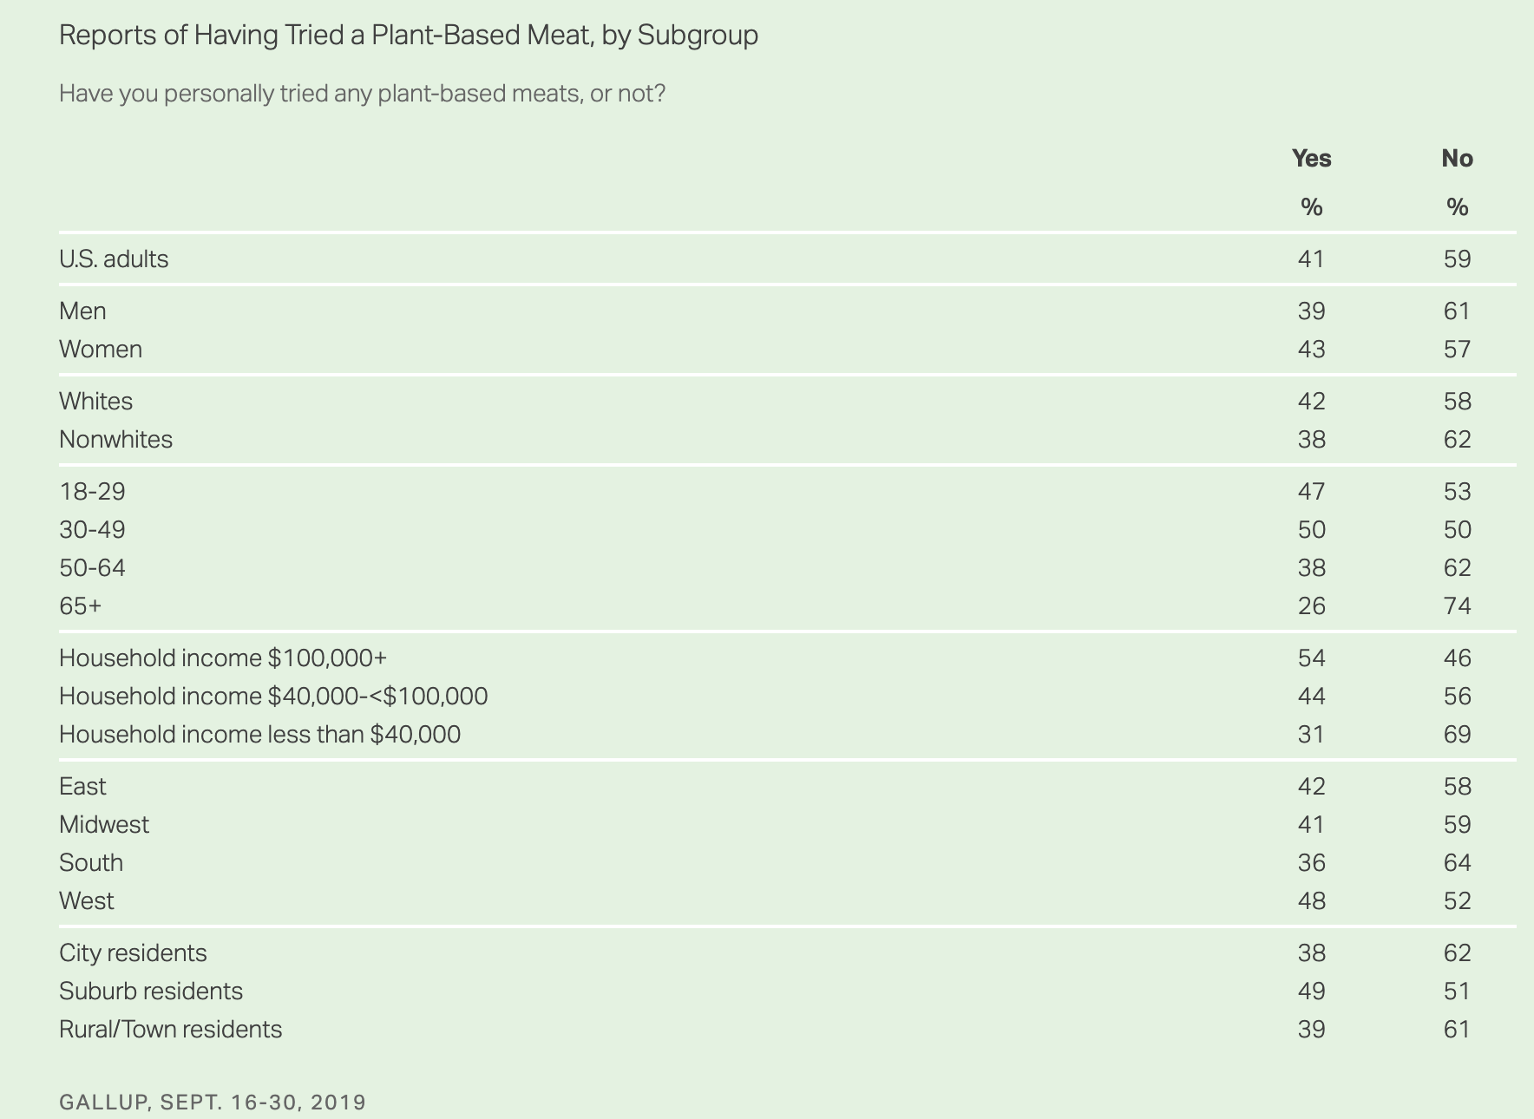The goal of this campaign is to increase market share in the plant-based food segment.SMART is an acronym that stands for Specific, Measurable, Achievable, Relevant, and Time-bound. By using the SMART framework, the following is a specific analysis of defining a strategic marketing objective for KFC:
Specific: The goal should be clear, well-defined, and specific. It should leave no room for ambiguity or misinterpretation.KFC specific goal with its plant-based fast food business segment is to cater to the growing demand for vegetarian and vegan options in the market. They aim to provide plant-based alternatives to their traditional chicken-based menu items to appeal to a wider customer base.
Measurable: The goal should have a quantifiable or observable indicator of progress. It should be possible to measure whether the goal has been achieved or not.KFC can measure the success of its plant-based business segment by tracking sales data, customer feedback, and market share. They can analyze the growth in sales of their plant-based options over time, monitor customer satisfaction through surveys and reviews, and compare their market share with competitors in the plant-based food industry.
Achievable: The goal should be realistic and attainable. It should consider the available resources, capabilities, and constraints of the organization.The plant-based fast food market has been rapidly expanding, with an increasing number of consumers adopting vegetarian and vegan diets or looking for more sustainable food options. This trend presents a viable opportunity for KFC to enter the plant-based food segment and capture a share of the market. KFC has the resources, brand recognition, and distribution channels to make its plant-based offerings widely available and compete with existing plant-based fast food options.
Relevant: Objectives should be aligned with the overall business goals and the marketing strategy. They should contribute directly to the success of the organization.
The plant-based fast food segment is highly relevant to KFCoverall business strategy as it aligns with the changing preferences and values of consumers. By offering plant-based options, KFC can cater to the growing demand for more sustainable, ethical, and healthier food choices. It allows them to diversify their menu and attract a broader range of customers, including those who may not consume animal products.
Time-bound: Objectives should have a specific time frame or deadline associated with them. This helps create a sense of urgency and provides a clear timeline for implementation and evaluation.KFCentry into the plant-based fast food segment should be time-bound to capitalize on the current market trends and gain a competitive advantage. They need to set clear timelines for product development, marketing campaigns, and expansion plans to establish a strong presence in the plant-based food market. Regular assessments of their progress and adjustments to their strategies will help them stay on track and achieve their objectives.
Overall, KFC plant-based fast food business segments show promise within the SMART model framework. By setting specific goals, measuring their progress, ensuring achievability, staying relevant to consumer demands, and adhering to a time-bound approach, KFC can successfully navigate the plant-based food market. Through effective execution and continuous improvement, they have the potential to establish themselves as a significant player in the plant-based fast food industry while meeting the changing needs of their customers.

SOSTAC :
Situation Analysis
KFC vegetarian offerings are evolving and becoming increasingly popular in the marketplace. Five years ago, vegan options at KFC seemed completely out of the question. Now, KFC Vegan is entering a new era where vegans can walk into almost any fast food restaurant and expect to be satisfied, and vegan options at the restaurant chain have become the norm. In 2019, KFC tested the UK plant-based market with its "Imposter Burger," which was launched in January in select restaurants across the country. The impostor burger was intended to last a month, but sold out in just a few days, and its overwhelming popularity prompted a major roll out the following year.
Although currently, KFC can only offer a limited number of vegetarian products to satisfy the demand for plant-based food. But KFC has recognized the potential of this market segment and hopes to further strengthen its position by expanding its vegan product line. Vegan products are marketed through various channels, including traditional advertising, social media and in-store promotions.
Objectives
The primary objective of this marketing plan is to increase consumer awareness, trial and adoption of KFC vegetarian products. By doing so, KFC aims to achieve several specific objectives:
Expand the customer base: KFC wanted to attract a new group of health-conscious and environmentally conscious consumers who enjoy vegetarian food. This is especially true in India and the Middle East, where vegetarian products are the primary type of food and beverage for consumers due to religious beliefs. At the same time, these regions have a large number of middle-class consumers who can afford to consume the range of vegetarian products offered by KFC.
Increase sales and revenue: By promoting vegetarian products, KFC aims to drive sales growth and generate additional revenue from this expanding market segment.
Increase brand recognition: KFC wanted to position itself as a brand that caters to different dietary preferences and promote a positive brand image and reputation. Break the consumer bias that fast food companies only sell junk food by promoting healthy eating such as vegetarian products. Improve the favorable perception of the business among consumers with religious beliefs, etc.
Foster customer loyalty: By offering a variety of high-quality and nutritionally healthy vegetarian options, KFC seeks to build a loyal customer base that will appreciate KFC commitment to sustainability and corporate social responsibility choices.
Drive innovation: KFC aims to encourage product innovation in the vegetarian category by continuously improving the quality and variety of vegetarian products. Enriching product types in the fast food industry.
Strategy
Based on the above set of marketing objectives for plant-based machine foods, the following marketing strategies are proposed for KFC in this thesis.
Product development:
To establish a strong position in the vegetarian fast food market, KFC should focus on developing a diverse range of high-quality vegetarian products. This includes introducing plant-based alternatives to their signature dishes, such as veggie burgers, fried chicken and sandwiches. Partnering with reputable vegetarian suppliers and investing in R&D will ensure the creation of innovative and delicious vegetarian options that appeal to a broad customer base.
Menu integration and promotion:
KFC should highlight its vegetarian offerings on the menu to increase its visibility. This can be achieved by creating a dedicated section for vegetarian options with enticing descriptions and mouth-watering visuals. To promote these products, KFC can run targeted marketing campaigns both online and offline. Use social media platforms, email marketing and influencer partnerships to reach and engage a growing number of health-conscious and environmentally conscious consumers.
Employee training and knowledge:
To provide exceptional service and ensure customer satisfaction, KFC employees should have a thorough understanding and knowledge of vegetarian options. Implement a comprehensive training program to educate employees about vegetarian menu items, their ingredients, and the reasons behind the shift to vegetarian products. This will give employees the confidence to address customer queries, make appropriate recommendations, and reinforce the brand's commitment to veganism.
Collaborations and partnerships:
Forming strategic partnerships with local farmers, suppliers and organizations in the vegan industry can further enhance KFC's credibility and commitment to the vegan cause. Partnering with prominent vegan chefs or organizations involved in promoting sustainable food choices can lead to joint marketing efforts, exclusive product launches and increased brand awareness. By leveraging these partnerships, KFC can develop a new customer base and strengthen its position as the market leader in vegetarian fast food.
Transparent communication:
KFC should take a transparent approach to communication to build trust and credibility among its customers. This includes providing detailed information about the ingredients used in its vegetarian products, highlighting their nutritional benefits, and showcasing any certification or eco-friendly initiatives. Transparent communication will reassure customers about the quality and integrity of vegetarian products and further strengthen KFC's position as a market leader.

Community Engagement and Social Responsibility:
Engaging with the community and demonstrating social responsibility will play an important role in KFC's marketing strategy. By sponsoring local vegetarian events, supporting charitable organizations dedicated to sustainable food systems, or organizing educational events on the benefits of vegetarianism, KFC can establish itself as a responsible and ethical brand. These initiatives will resonate with socially conscious consumers and generate positive word-of-mouth, expanding the customer base and increasing brand loyalty.
Continuous innovation:
To maintain its leadership position, KFC should continuously innovate and develop its vegetarian menu offerings. Regularly introduce new vegetarian products, experiment with unique flavor combinations, and incorporate customer feedback to refine existing offerings. Regular updates and limited-time promotions will create anticipation among customers and encourage them to keep coming back to KFC for new and exciting vegetarian options
By implementing this comprehensive marketing strategy, KFC can position itself as a leader in the vegetarian fast food industry. Through product development, menu integration, staff training, collaboration, transparent communication, community engagement and continuous innovation, KFC can attract health-conscious consumers, gain a competitive advantage and strengthen its brand image. By successfully establishing itself as the destination of choice for great taste and sustainability.
Tactics
To promote plant-based food and beverage products, KFC can utilize various strategies and elements of the marketing mix. The marketing mix consists of 4 P's: product, price, place and promotion. Here is how KFC can use these strategies:
Product: First, develop a range of plant-based foodservice products that are consistent with KFC's brand image and meet the needs and preferences of the target market. These products should be tasty, visually appealing, and provide a similar experience to traditional meat products. At the same time, collaborate with specialty plant-based machine brands for research and development, such as the Ollie's Oats milk brand. to ensure that plant-based products have the taste, texture and aroma that customers expect from Kentucky.
Price: Price plant-based food service products competitively, taking into account factors such as production costs, market demand, and the price of similar products in the market. Next, offer bundled deals or promotions to encourage customers to try plant-based foods at attractive price points. For example, offer discounted all-vegetarian packages, and discounted semi-vegetarian packages to attract consumers with different tastes.
Place: Offer plant-based dining products at KFC restaurants worldwide or in specific target markets. Second, ensure that plant-based food products are prominently displayed and easily accessible to customers on in-store and online menus and promotional materials. Finally, consider partnering with popular food delivery platforms to expand the reach and convenience of plant-based products.
Promotion: Develop a comprehensive marketing campaign to raise awareness of and interest in plant-based food service products.Utilize various channels such as TV, radio, print, online advertising and social media to reach a wide audience. For example, work with influential vegan celebrities or food bloggers who are aligned with your target market and have a strong following to advocate for plant-based products. Most importantly, highlight the key benefits of plant-based products, such as being cruelty-free, environmentally friendly, and healthier than traditional meat products.The next step is to conduct sampling and sampling events or offer special promotions to allow customers to try plant-based products and experience their quality firsthand. Positive feedback and reviews from customers are used to showcase positive experiences with plant-based foodservice products.
By implementing these strategies, KFC can effectively promote their plant-based food service products and attract the attention and interest of new and existing customers.
Actions
In order to achieve the plant-based machine food marketing rollout, the various stakeholders within KFC will have different roles and responsibilities. This may include the work of five different teams. The first is the marketing team, which is responsible for creating and implementing marketing strategies, campaigns and promotions. The second is the product development team, which is responsible for developing and refining the plant-based machine food program. The third is the operations team, which is responsible for ensuring the availability and quality of plant-based food options in KFC stores. The fourth is the training team, which is responsible for training staff on how to prepare, handle and promote plant-based machine foods. The fifth is the sales team, which introduces the new products to customers and drives sales.
The implementation time of the action plan will depend on various factors, such as product readiness, marketing activities and operational capabilities. KFC should set a timeline for each phase of the action plan, taking into account product development, marketing activities, training, and operational adjustments.
To effectively promote plant-based machine foods, KFC may consider the following actions: First, marketing activities: Use various marketing channels (digital, print, social media) to raise awareness of the new product. Highlight the taste, health benefits and sustainability aspects of plant-based foods. This point is the most important part of the whole operation. The second point was in-store promotions: displaying signs, menu boards and table tents to draw attention to plant-based foods. The third point is staff training: Provide staff with comprehensive training on the new product, its features and benefits. Train them on handling and preparation techniques to ensure consistency and quality. The fourth point is public collaboration: Work with influence, nutritionists and environmental groups to increase credibility and reach a wider audience. Lastly, customer feedback: Encourage customers to provide feedback on new products and actively listen to their suggestions for improvement.
To ensure employee excellence and the success of the plant-based machine food marketing roll-out, KFC can implement the following strategies:The first and most effective way is training and development: Provide a comprehensive training program to educate employees about plant-based food options, their benefits, and how to effectively promote them to customers. Provide clear guidelines and information to employees about the value proposition of plant-based foods. Ensure they understand the importance of these products in KFC's overall marketing strategy. Next is proper motivation and recognition: Establish an incentive program or recognition program to reward employees who actively promote and facilitate the success of plant-based machine food marketing. At the same time, encourage employees to share their experiences, ideas and challenges. Actively listen to their feedback and make necessary improvements based on their insights. Finally, build a supportive culture: Foster a supportive and inclusive work environment that encourages employees to take ownership of their roles and motivates them to excel.
Control
To determine whether KFC is meeting its marketing objectives for promoting plant-based machine foods, it can track the following metrics: First, sales data: Monitor the sales performance of plant-based foods compared to traditional products. The second is market share: measuring the increase in market share of plant-based foods in the fast food industry. Third is customer feedback: Regularly evaluate customer feedback and reviews related to plant-based foods to measure customer satisfaction. Fourth is Awareness and Influence: Analyze the reach and engagement of marketing campaigns through various channels to assess brand awareness and recognition. Fifth is Return on Investment (ROI): Evaluate the financial performance and profitability of plant-based machine food marketing campaigns. Sixth is monitoring and evaluation: KFC should establish a monitoring and evaluation process to assess the progress and effectiveness of its marketing efforts.When it comes to the marketing strategy for KFC's plant-based vegan products, here are three suggestions:
Emphasize health and environmental features: Plant-based vegan products are often considered to be a healthier and more environmentally friendly choice. KFC can emphasize these features through marketing campaigns and advertising. For example, emphasize that vegan products contain less saturated fat and cholesterol, which contribute to heart health, while reducing reliance on animal resources and helping to reduce carbon emissions. Such promotions that emphasize healthy and environmentally friendly features will attract more consumers who are concerned about healthy eating and sustainable lifestyles.

Recommendations
When it comes to the marketing strategy for KFC's plant-based vegan products, here are three suggestions:
Emphasize health and environmental features: Plant-based vegan products are often considered to be a healthier and more environmentally friendly choice. KFC can emphasize these features through marketing campaigns and advertising. For example, emphasize that vegan products contain less saturated fat and cholesterol, which contribute to heart health, while reducing reliance on animal resources and helping to reduce carbon emissions. Such promotions that emphasize healthy and environmentally friendly features will attract more consumers who are concerned about healthy eating and sustainable lifestyles.
Provide diverse choices: To attract more consumers, KFC can develop a diverse range of plant-based organic vegetarian products. This includes different flavors of plant-based organic veggie burgers, fried chicken nuggets, salads and breakfast options. By offering diverse choices, KFC can cater to different consumers' tastes and dietary habits, thus expanding the market share of its plant-based organic vegetarian products.
Partner with a well-known vegetarian or environmental organization: Partnering with a well-known vegetarian or environmental organization can add credibility and appeal to KFC's plant-based machine vegetarian products. Partners can help promote plant-based machine vegan products through social media, event participation and co-promotion. Such partnerships will help attract more vegetarians and environmental advocates to become consumers of KFC's plant-based machine vegetarian products and increase the social impact of the brand.
These offers will help KFC gain a competitive advantage in the plant-based vegan products market and attract more consumers to choose its plant-based vegan products.

Conclusions
This paper focuses on KFC's marketing strategy regarding plant-based machine foods and identifies the objectives and specific measures for marketing this product type. By using the SMART model, this paper identifies clear marketing objectives for vegetarian products that will directly contribute to measurable outcomes such as profits, market share, new consumers, market growth, and new products generated by the company. It makes the whole marketing strategy more concise and clear and helps us as well as the team to set specific, measurable, achievable, relevant and time-bound goals.Secondly, this paper is a good example by SOSTAC is applied to build a marketing specific plan. It mainly includes the analysis of the current state of marketing of the product, the goals to be achieved afterwards, the recommended overall strategic direction and broad marketing strategies, the specific implementation departments and the follow-up monitoring and evaluation of the implementation activities.
Finally, regarding the marketing recommendations for the plant-based machine product, this paper argues that it can help the product increase its competitive advantage and attract more consumers by emphasizing healthy and environmental features, offering more diverse choices and cooperating with vegan organizations.

Reference List –

