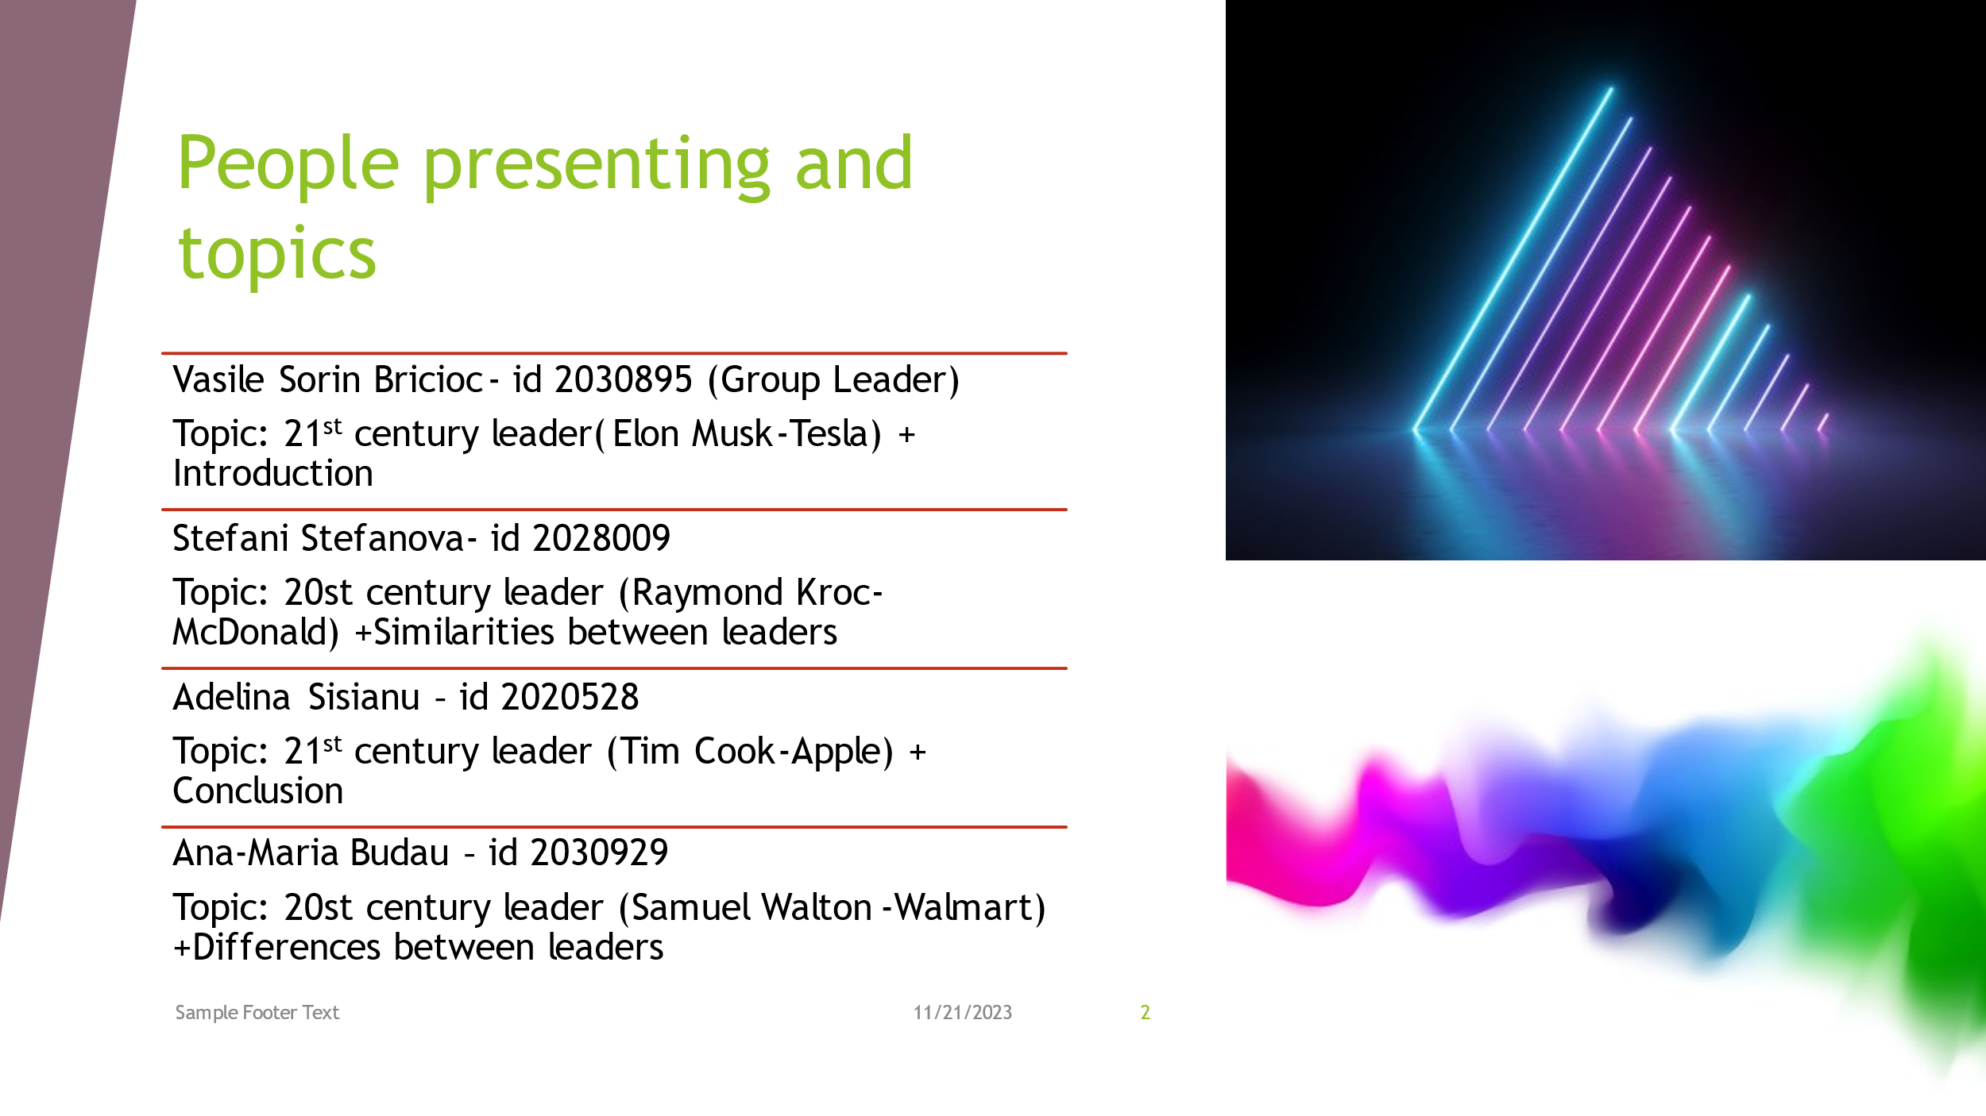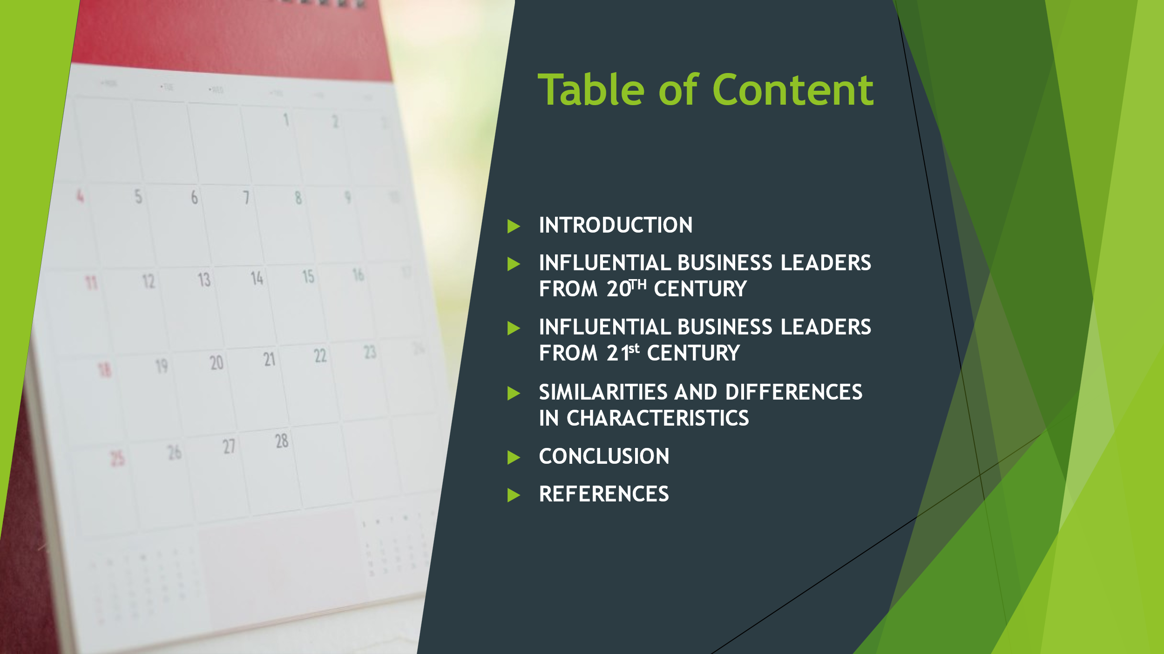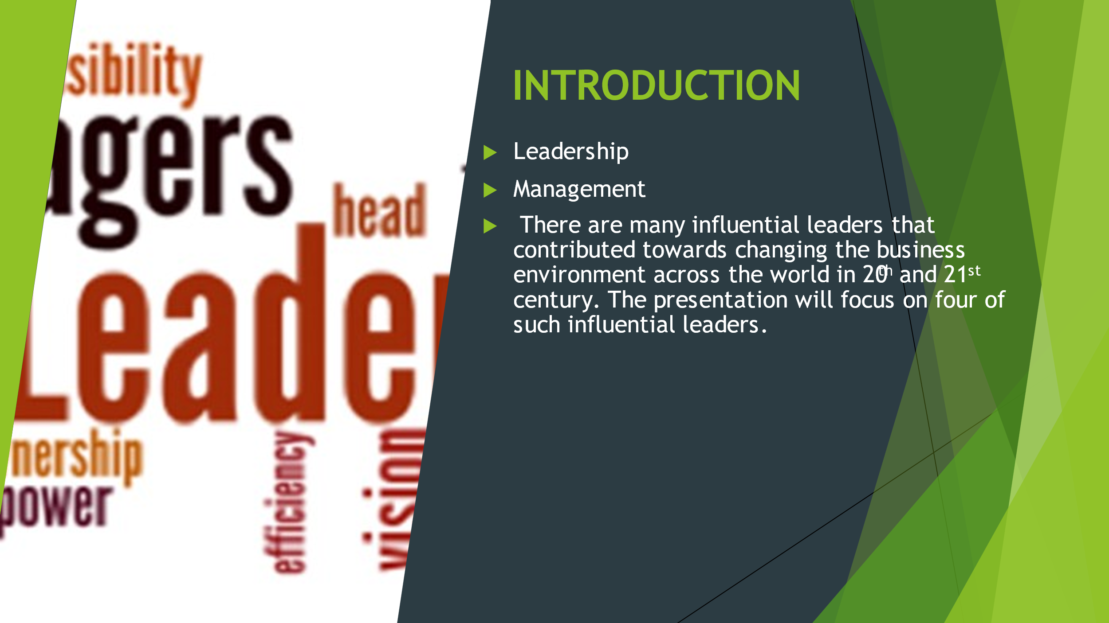- can be defined as a skill of a person to influence, encourage and motivates other so that they can make contribution for the success of the business entity.
- is known as the responsibility of an organisation for the monitoring and control of all the tasks and activities performed by a team, group of departments or the entire organisation to accomplish a specific desired goal.
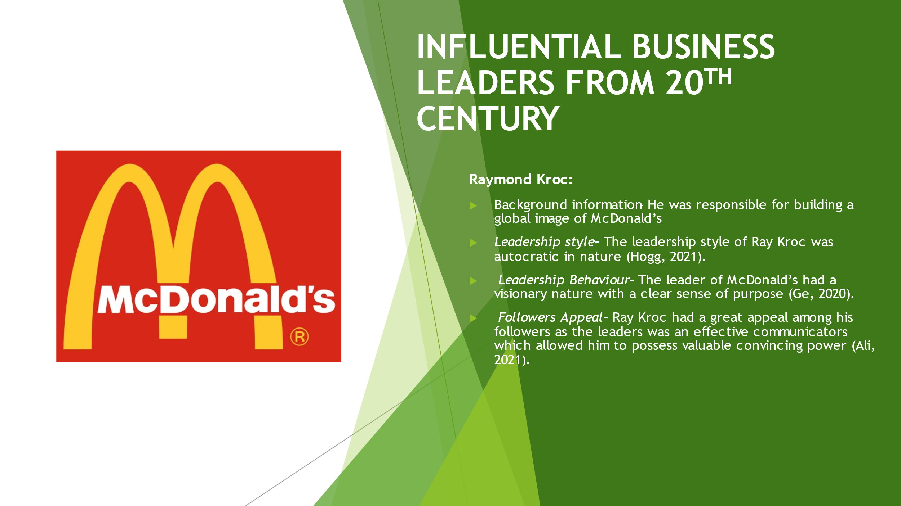Raymond Kroc:
Introducing new ways of doing a restaurant business with his visionary business ideas.
He was an American businessman and a paper cup seller in his early career.
The leader is known to be one of the most influential business leaders across the globe. He was responsible to transform the idea of restaurants and fast-food chains.
Leadership style - With an ambitious attitude, Ray was always ready for making transformations even when it was not necessary.
-He was accountable for taking all the decisions for the organisation and took less or no opinions from the workforce and regional managers.
Leadership Behaviour - His optimistic behaviour with effective decision-making traits adds to his autocratic leadership style. The leader was also was honest regarding his actions due to high level of confidence, and also had great communication skills and patience.
-His behaviour regarding the sheer commitment and passion towards his work made him a quality leader.
Followers Appeal – The leaders also took care of every individual in contributing their hundred percent towards the business which also made the workforce feel valuable and therefore enhanced the appeal of the leader. His optimistic nature with the decisions he took, built a great sense of trust among the subordinates and employees with the positive results.
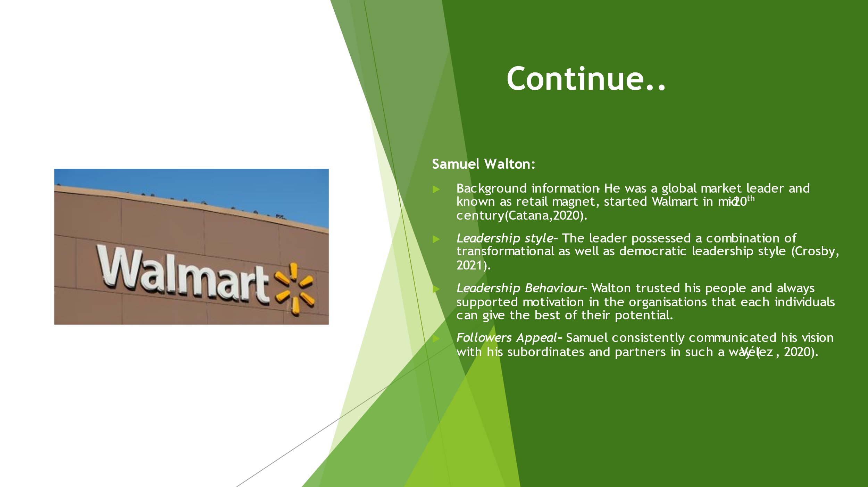Samuel Walton:
Further developed the company into one of the largest retail organisation across the globe with various partnership and acquisitions in many countries (Catana, 2020)
The leader was once among the richest men in the world in early 90s and left a great impact over the business world, influencing many new entrepreneurs in a positive way.
He served as the captain of US AIC in his early age and later gained retail experience.
Leadership style – He not just supported effective participation of employees but also fosters innovativeness for better business opportunities. Samuel had a great trust over his employees and subordinates fostering open communication and feedbacks which allowed effective change management and alignment of the business goals and objectives.
Leadership Behaviour – He even gave the employees autonomy allowing them to take small scale decisions like for a regional store. The leader focused on relationship building and keeping himself self-aware about the improvements that can be made in the business. He always used to thrive for success and motivated other for the same with a positive impression.
Followers Appeal – He created a sense of faith and confidence among the individuals working for the company
-His inclusiveness with every individuals and sharing of success made him a great icon which added to his appeal as a successful and valuable leader. His appeal was not just limited to Walmart but in every other small retail organisation and customer base as he used to focus on the benefits of both his employees as well as the customers
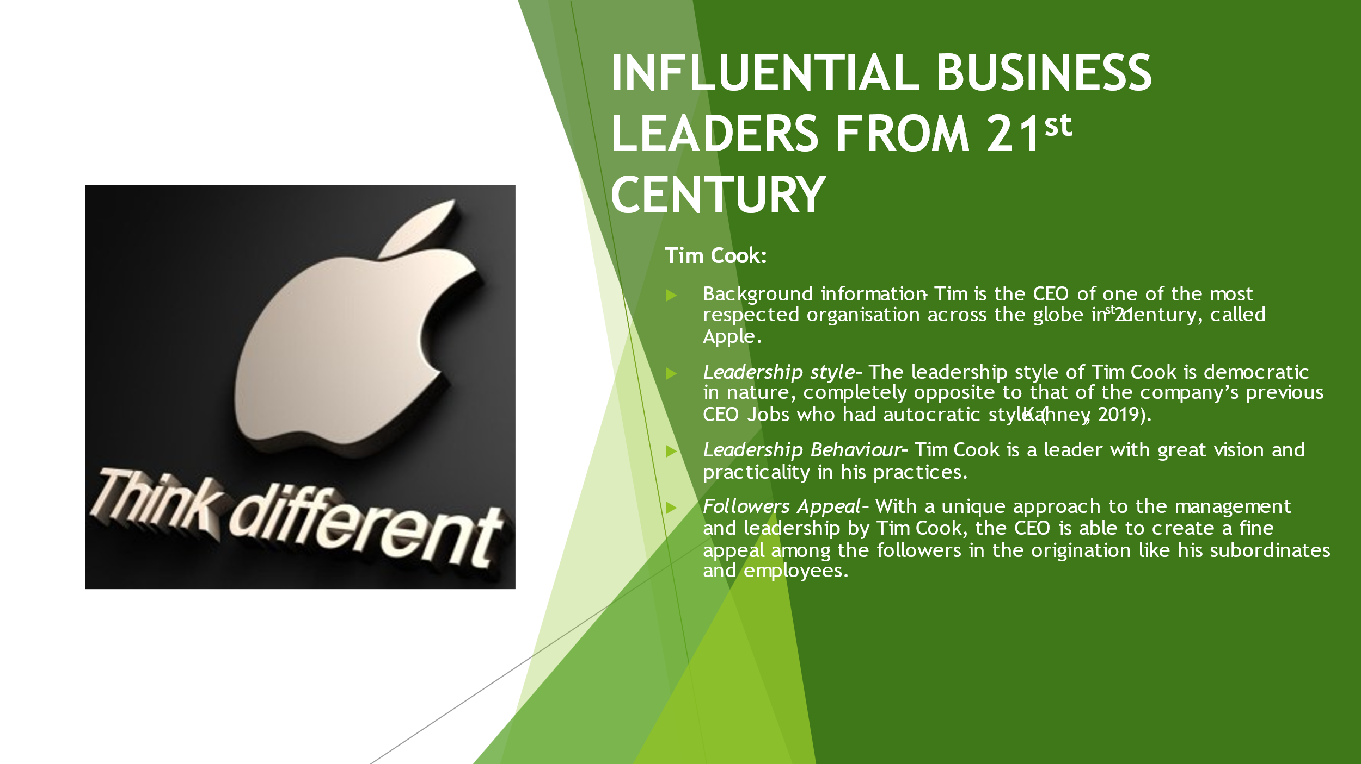Tim Cook:
He promoted creativity and innovativeness in the products creating a strong global recognition for the company with effective stability in the business.
The CEO tool over the responsibility of the business after Steve Jobs and proved to be influential in transforming the organisation.
He pursued bachelor degree in industrial engineering and worked for many IT companies in his early career like IBM.(Kahney,2019)
Leadership style – This type of leadership style focuses on the participation of team members contributing effectively to the decision-making process for the benefit of the organisation.
Leadership Behaviour – He also encourages harmony and better understanding of the company’s goals among the high-level personnel of the organisation.
The leader is logical and tremendously dedicated to towards the accomplishment of organisational goals and fosters collaborative work culture in the skilful environment of Apple.
Followers Appeal – Instead of just motivating the subordinates and managers with inspirational speeches or direct instructions, Tim choose to listen and let the ideas and suggestion process before offering nay advice. His support to innovativeness and cooperative style of management appeals to his followers.
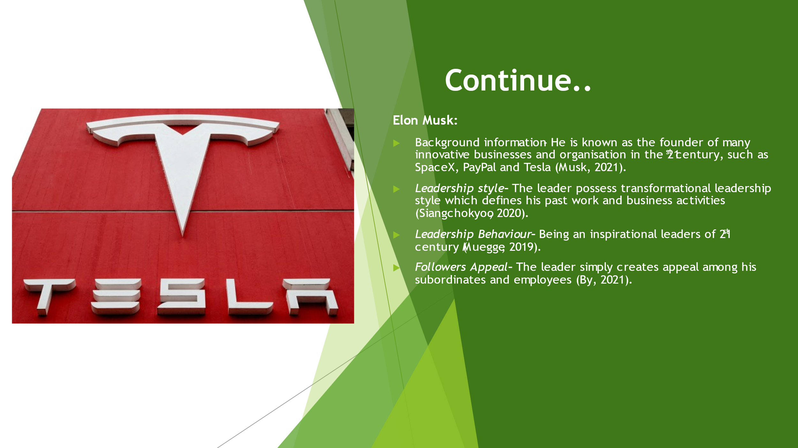Elon Musk:
The leader is a dedicated entrepreneur who consistently fosters innovative ideas and transforms them into a successful business.
The leader was born in south Africa and was a technologist and innovator in his early career.
Leadership style – His decision-making is fast and tactical, and the risk taking ability supports the transformational capability of the leader. Elon is not just a leader who challenges the modern-world problems but is also dedicated towards finding valuable solutions. His decision-making is fast and tactical, and the risk taking ability supports the transformational capability of the leader.
Leadership Behaviour
- His dynamic optimism with the innovations, strong ethics in work and life, futuristic goals and extreme decisiveness make him the leader that pushes the boundaries or business transformation and expansion. His dynamic optimism with the innovations, strong ethics in work and life, futuristic goals and extreme decisiveness make him the leader that pushes the boundaries or business transformation and expansion.
-The leadership behaviour of Elon comprises of ambitiousness, sense of motivation with every new task which is inspirational in nature, sheer determination and willingness to foster participation within the organisation (Muegge, 2019).
Followers Appeal
- Working side-by-side with the team in order to mitigate challenges and figure out valuable solutions. His commitment towards the company goals also appeals to his followers within the organisation (By, 2021).
- He involves himself with most of the organisational activities which simply supports sense of companionship, and thus motivates and influence his followers to contribute with the best efficiency.
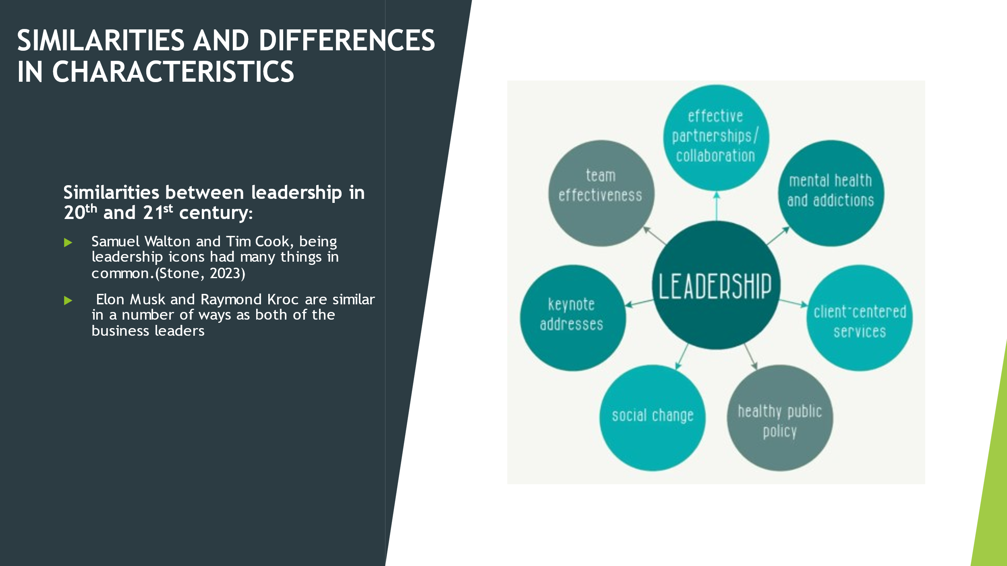Similarities:
Both Samuel Walton and Tim Cook, were visionary and improvised their business strategies with each success and failure to build their business impactful and transformative in nature.
They are focused towards building an appealing and positive the brand image with great sales efforts and work ethics, supported by integrity client focus and empathy (Stone, 2023).
As Elon Musk and Raymond Kroc known for giving opportunities to their people and effective monitoring with every successful accomplishment of specific objectives (Porfírio, 2021).
They put aside their ego and allow their subordinates, employees and other workforce to take the credit of success according to the contribution made.
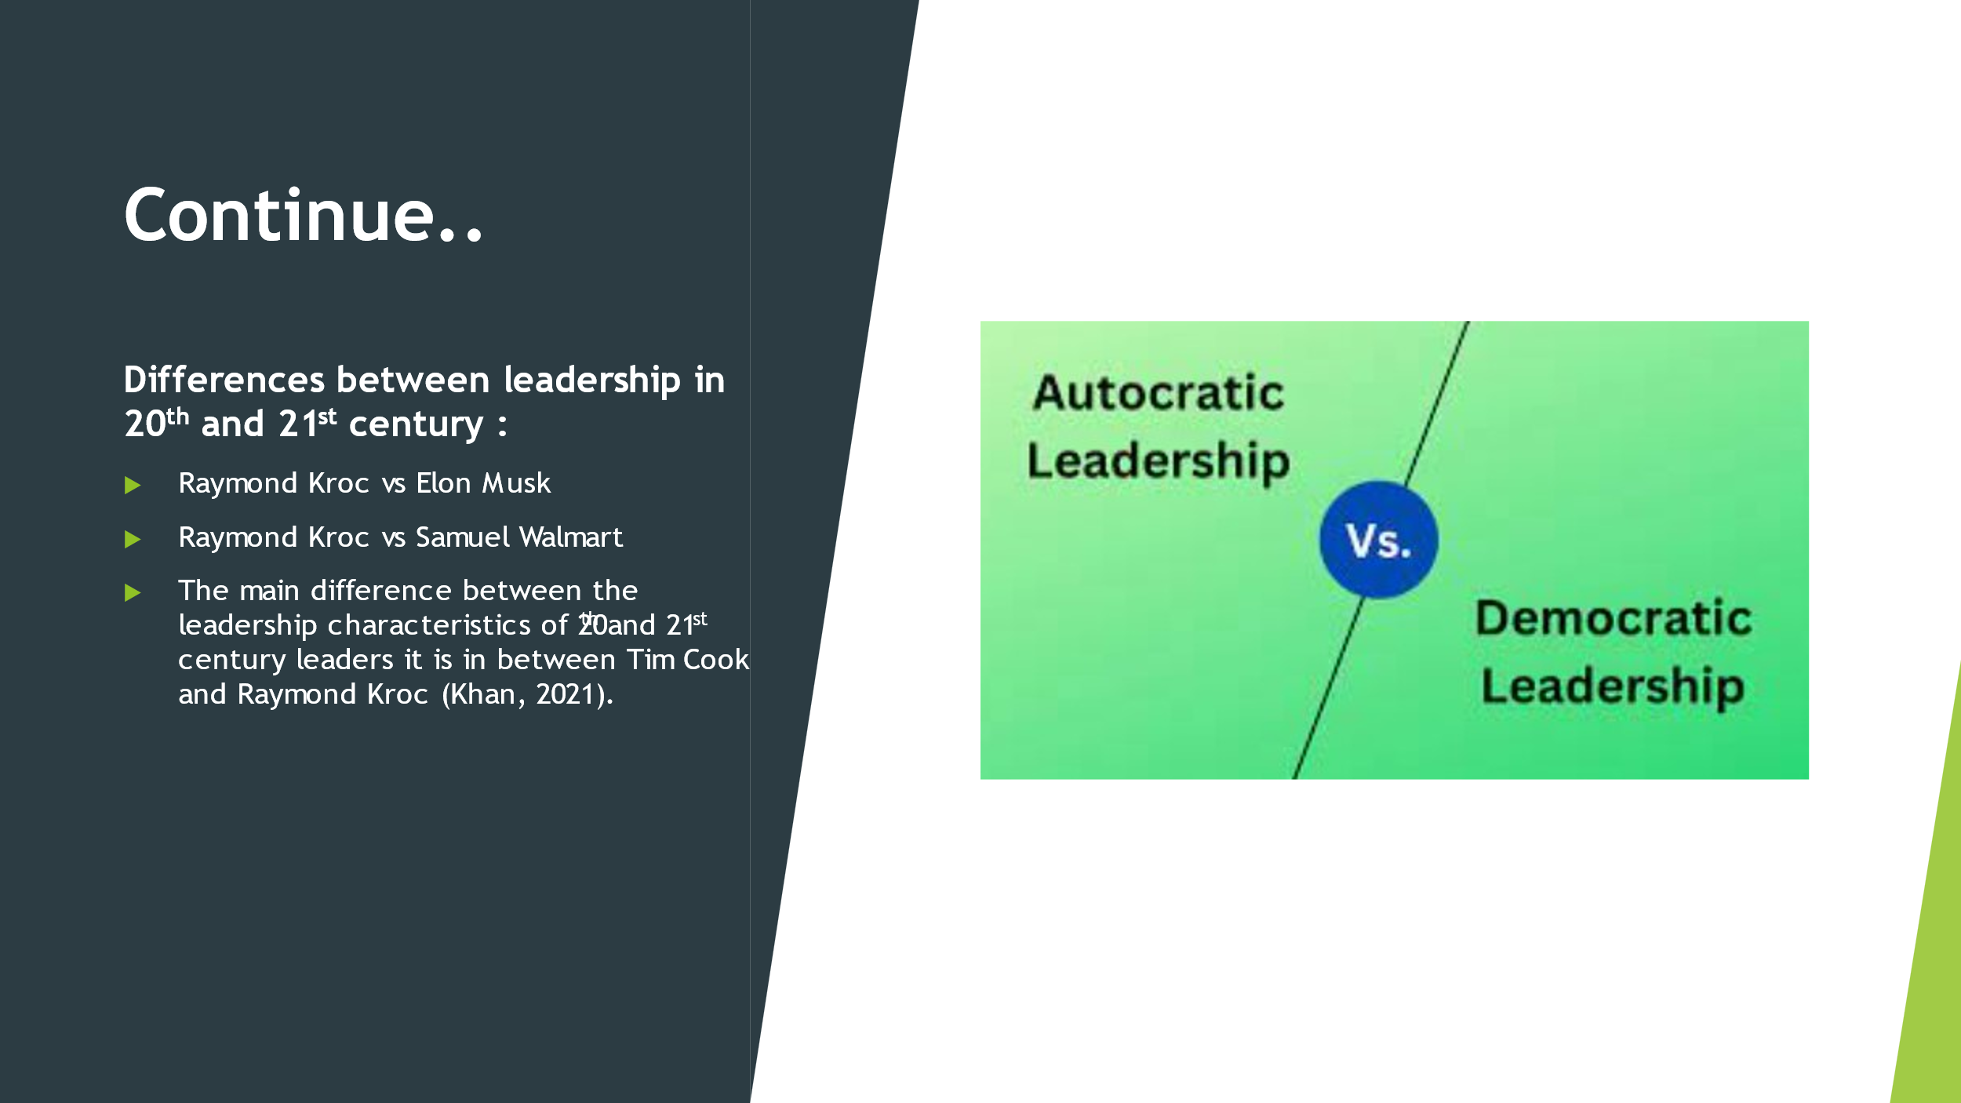
Differences:
Raymond had an autocratic leadership styles which allowed him to take all the necessary decisions of the business by himself, he never involved the ideas, and suggestions from the subordinates but Elon Musk on the other hand had democratic leadership style that enables the participation of each and every individuals of the organisations to contribute to the decisions taken for the development of the business (Bolden, 2023).
The major Difference between the leaders of McDonald’s and Walmart is their leadership styles.
Raymond Kroc never asked for feedbacks whereas Samuel Walton continuously looked for advices from the subordinates.
Tim Cook is generally admired for his quiet and understated leadership but on the other hand Raymond Kroc was known as a rigid personality who was famous for his controversial decision-making along with heavily ambitious initiatives (Khan, 2021).


