

BA International Hotel Management
Module: Managing Hotel Administration
Code: BMIH6004
Title: Student Learning Log

Student Name: Daniela Gabriela Vartolomeu
Student Id:2130495
Lecturer Name:Jessica Newport BA

Table of Contents
Introduction 3
Section 1: Reflection on Experience and Personal Development 4
Description 4
Feelings 4
Evaluation 5
Analysis 5
Conclusion 5
Action Plan 5
Section 2: Analysis of Work-Based Skills and Technical Knowledge 7
Section 3: Reflection on Organisational Issues 8
Conclusion 9
References 10

Introduction
My hotel placement at Ibis Birmingham New Street Station was in the Front Office and Back Office departments for 10 weeks, where I gained lots of skills and knowledge. These skills and knowledge were related to the ongoing tasks and responsibilities of the firm, customers, and general office management. From this experience, I was able to acquire functional work experience and technical expertise that is needed for the management of hotels. Ibis Birmingham Centre New Street Station’s staff takes great satisfaction in consistently going above and beyond, offering the city’s fastest check-in processes and a pleasant welcome (Visit Birmingham, 2024). The administrative department plays an important role in managing the guest relations, booking as well as offering the necessary support in the operations (Kimani and Scott, 2023). During my 10-week placement, my goals were:
- To develop strong communication and teamwork skills.
- To learn about task management in a hotel setting.
- To improve my understanding of guest services in Front and Back Office roles.

Section 1: Reflection on Experience and Personal Development
Using Gibbs' Reflective Cycle (1988), I will reflect on this journey, examining the skills I developed, challenges I encountered, and the solutions I implemented to overcome them. A theoretical framework consisting of six steps, Gibbs’ reflective cycle may be used to direct reflection during organised debriefing (Galli and New, 2022).
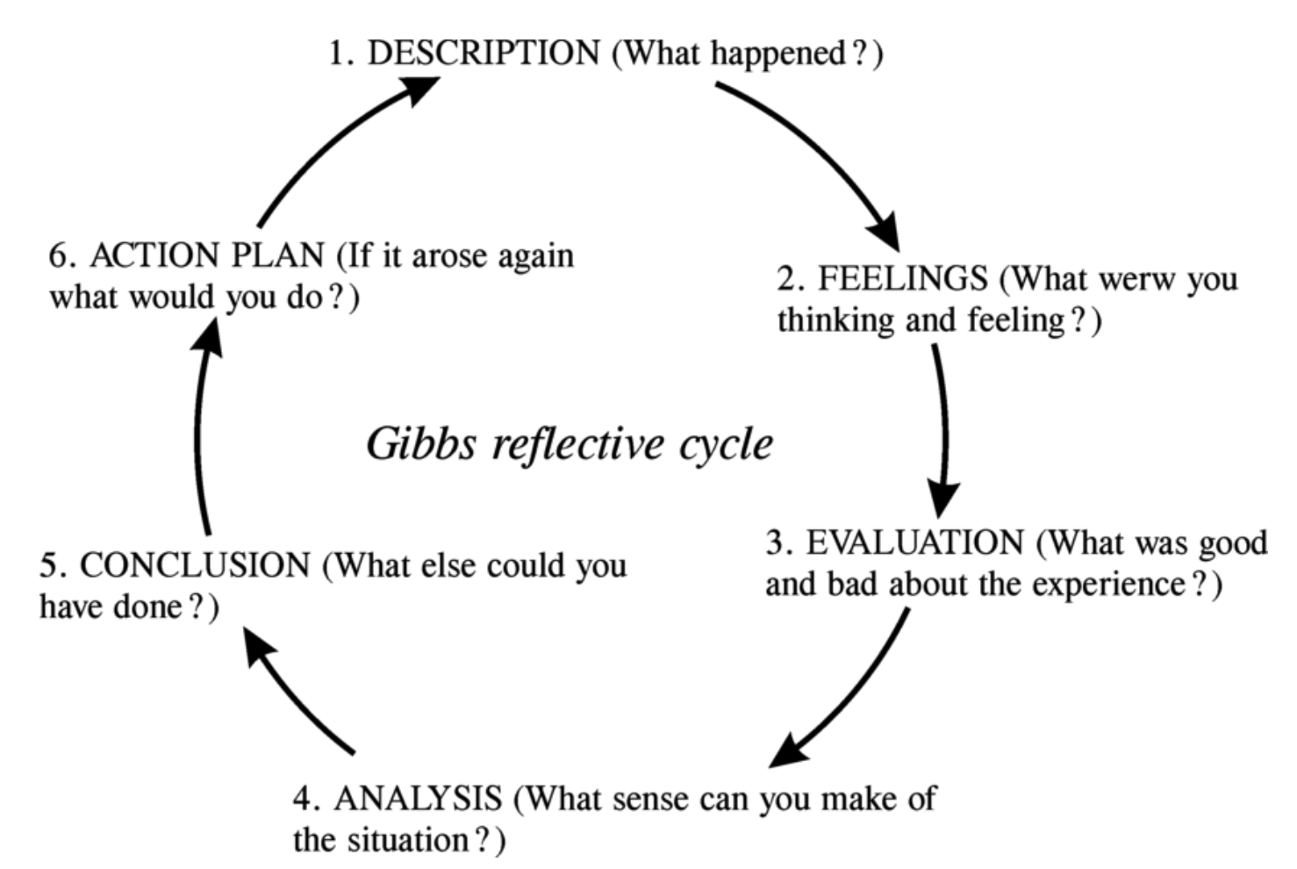
Figure 01: Gibbs Reflective Cycle
Source: (Gibbs, 1988)
Description
In my placement organisation, I received online training as well as in-person training in the area of guest service. Though the primary job was simultaneously assigned as Front Office and Back Office, I was trained on how to welcome the guests, assigning rooms, doing check in and check out and handling cash transactions. I got training in reserving the table for guests, addressing requests from guests such as additional pillows, and reporting it to guests or interpersonal members. From the training, I understood good posture, friendliness and respect and this formed the basis to achieve a good guest experience.
Feelings
In the beginning I experienced severe pressure in terms of tasks that fell under my responsibilities in the Front Desk. While managing check-ins, bookings of rooms, and attending to the guests’ concerns, I feared whether I would cope with the high demand. However, day by day, I felt that I could manage more, and seeing the guest’s response if I provided them best and friendly service made me all the more confident. Sometimes there was pressure during the rush hour but I managed to be organised, focus, and maintain a good attitude at work. I slowly started regaining my control of the situation as I started understanding that this job requires both practical and communication skills to some extent.
Evaluation
I learned a number of skills that are important in managing a hotel from this placement experience. The job most stressful was the front desk where communication and conflict solving were noticed as crucial aspects. For instance, when a guest had a complaint, I was observing that the best thing to do was to listen carefully, then reassure and suggest the solution which benefits the guest and at the end the guest was satisfied. According to Karina (2023), active listening is a significant component in hospitality in order to create trust and rapport with the guests. Working in the Back Office, I interact with members of other teams and realized the value of cooperation and cooperation. Bella (2023) found that positive interaction between or within the team increases guest satisfaction and staff productivity.
Analysis
The ability to communicate effectively with guests and colleagues was essential. Walelign (2019) indicate that positive communication directly impacts guest satisfaction. My academic background in customer service was helpful, but practical experience highlighted areas where I needed improvement, such as handling difficult situations calmly (Cepeda-Carrión et al., 2023).
Conclusion
This placement has shown me the value of teamwork and adaptability in hotel management. Moving forward, I plan to focus on developing my problem-solving skills, as these are essential in resolving guest issues effectively.
Action Plan
In the future, I aim to continue developing my communication and task management skills to prepare for a managerial role in hospitality. I have outlined a few specific action steps:
Attend Further Training: I plan to attend workshops focused on communication and conflict resolution in customer service. Understanding various approaches to handling guest concerns and requests will strengthen my ability to manage similar situations confidently (Dinnen and Hassanien, 2019).
Build Team Collaboration Skills: By participating in team-building activities, I will work on fostering a stronger sense of teamwork. Londhe (2024) shows that teamwork is a significant contributor to successful hotel operations.
Improve Time Management: I noticed that managing tasks efficiently is essential in a busy environment like a hotel. Setting daily goals and prioritizing tasks will help me improve in this area, ultimately benefiting both my personal performance and the team’s workflow.

Section 2: Analysis of Work-Based Skills and Technical Knowledge
Work-based skills, such as communication and task management, are critical in hotel administration. My placement showed that these skills contribute significantly to maintaining high guest satisfaction levels, as even small actions like smiling or attentive listening positively affect guests. Technical knowledge, such as room booking software and payment systems, is equally essential to provide smooth service. For example, using the Property Management System (PMS) required accuracy to avoid overbooking rooms (Jones and Dent, 2016).
Effective communication with guests and colleagues is crucial. Working at the Front Office helped me understand how tone, body language, and clear explanations play a role in guest satisfaction. Teamwork was vital, particularly during busy hours when quick coordination with the housekeeping team was needed to ensure rooms were ready for new guests. Learning to balance guest needs with team collaboration taught me the importance of seamless communication in hotel administration.

Section 3: Reflection on Organisational Issues
During my placement, a common issue was managing guest complaints effectively during peak hours. This often-involved complaints about long wait times for check-in or room unavailability. Such complaints disrupted Front Office operations and negatively affected guest satisfaction.
They raised awareness on the matters associated with check-in processes, as well as pre-arrival preparations. As mentioned by Fatma and Kumar (2024), service quality determines customer loyalty, and delays in guest services cause dissatisfaction. It was a good lesson on how important it is to keep guests informed and to set their expectations correctly, if there is likely to be a delay by some time.
To help with this, I suggest introducing a check-in kiosk during the busiest hours to help guests who would rather not have to wait for a check-in attendant. Furthermore, common areas such as reception areas could also benefit from being prevented from frustrating guests by notifying them of potential delays ahead of time.

Conclusion
Doing my placement at Ibis Birmingham New Street Station has been an enlightening experience. Having interacted closely with the booking software, handling of guest relations and complaints, I have gained ample appreciation of the practical aspects of hotel administration. These are attitude, communication, and teamwork, all of which will be useful in any other placement I will be handling in the future and the hospitality industry in general.

References
Bella, K.M.J. (2023). EXPLORING THE IMPACT OF WORKPLACE RELATIONSHIPS AND EMPLOYEE JOB SATISFACTION. International Journal of Scientific Research in Modern Science and Technology, [online] 2(8), pp.55–62. doi:https://doi.org/10.59828/ijsrmst.v2i8.136.
Cepeda-Carrión, I., Alarcon-Rubio, D., Correa-Rodriguez, C. and Cepeda-Carrión, G. (2023). Managing customer experience dimensions in B2B express delivery services for better customer satisfaction: a PLS-SEM illustration. International Journal of Physical Distribution & Logistics Management, 9(9). doi:https://doi.org/10.1108/ijpdlm-04-2022-0127.
Dinnen, R. and Hassanien, A. (2019). Handling Customer Complaints in the Hospitality Industry. International Journal of Customer Relationship Marketing and Management, 2(1), pp.69–91. doi:https://doi.org/10.4018/jcrmm.2011010105.
Fatma, A. and Kumar, M. (2024). Exploring the Correlation Between Service Quality and Customer Satisfaction in the Hospitality Industry. The International Journal of Indian Psychology, 4(7). doi:https://doi.org/10.25215/1201.131.
Galli, F. and New, C.J. (2022). Gibbs’ Cycle review. Emotions as a Part of the Cycle. e-Motion: Revista de Educación, Motricidad e Investigación, [online] 19(19), pp.92–101. doi:https://doi.org/10.33776/remo.vi19.7224.
Gibbs, G. (1988). Learning by Doing: A Guide to Teaching and Learning Methods. Oxford: Oxford Further Education Unit.
Jones, P. and Dent, M. (2016). Improving Service: Managing Response Time in Hospitality Operations. International Journal of Operations & Production Management, 14(5), pp.52–58. doi:https://doi.org/10.1108/01443579410056795.
Karina (2023). Communication in Hospitality Industry - Skills & Tips 2023. [online] Complete Hospitality Management. Available at: https://completehospitalitymanagement.com/communication-in-hospitality/.
Kimani, C.J. and Scott, Dr.J. (2023). Introduction to Front Office Operations and Administrations in Hospitality Management Diploma Level. Finstock Evarsity Publishers.
Londhe, R.C. (2024). THE IMPORTANCE OF TEAM WORK IN HOSPITALITY INDUSTRY FOR INTERDEPARTMENTAL CO-ORDINATION. [online] ResearchGate. Available at: https://www.researchgate.net/publication/378906572_THE_IMPORTANCE_OF_TEAM_WORK_IN_HOSPITALITY_INDUSTRY_FOR_INTERDEPARTMENTAL_CO-ORDINATION.
Visit Birmingham (2024). Ibis Birmingham New Street Station. [online] Visitbirmingham.com. Available at: https://visitbirmingham.com/listing/ibis-birmingham-new-street-station/132747101/.
Walelign, A. (2019). Communication and Its Impact on Customer Satisfaction in Hospitality Industry. iRASD Journal of Management, 1(2), pp.97–104. doi:https://doi.org/10.52131/jom.2019.0102.0009.

