

UNIVERSITY OF WALES: TRINITY SAINT DAVID
PRIFYSGOL CYMRU: Y DRINDOD DEWI SANT
School of Business
London Campus
Dissertation
LCMB7020

MODULE CODE: LCMB7020
TITLE: Dissertation
DATED: 17/05/2018
LEVEL: 7
CREDITS: 60
JACS CODE: X210

A STUDY TO ASSESS THE CONSUMER BUYING BEHAVIOUR OF UNIVERSITY STUDENTS IN THE UK TOWARDS A LUXURY FASHION, ADIDAS

Table of Contents
Chapter 1: Introduction 5
1.1 Research Background 5
1.2 Research Rationale 7
1.3 Problem Statement 8
1.4 Research Focus and Scope 8
1.5 Research Aim and Objectives 9
1.6 Research Question 9
1.7 Dissertation Structures 9
1.8 Theoretical Framework 10
1.8.1 Theory of Planned Behaviour (TPB) 10
1.8.2 Keller's Brand Equity Model 11
1.9 Summary 12
Reference List 13

List of Figures
Figure 1.1: Luxury fashion market revenues in the UK 5
Figure 1.2: Brand profile of Adidas in the UK 6
Figure 1.3: The global revenues of Nike, Adidas and Puma 8
Figure 1.4: Dissertation Structure 11
Figure 1.5: Theory of Planned Behaviour (TPB) 12
Figure 1.6: CBBE Model 13
Figure 1.7: Conceptual framework 14

Chapter 1: Introduction

1.1 Research Background
The luxury fashion market is one of the major markets in the UK. According to a Statista report, it is expected that the fashion apparel and fashion footwear market is expected to reach US$ 6.52 billion and US$ 2.16 billion, respectively in 2028 (Statista, 2024a) (Refer to Figure 1.1). The following figure also shows that the revenue of this market is constantly growing, signifying a constantly high demand for luxury fashion products. As per another Statist report, the forecasted value of the fashion market will be surpassed and is expected to reach US$7.39bn in 2024 (Statista, 2024b). One of the major reasons behind this growth is the increased per capita spending on fashion. The per capita figure is expected to be US$108.70 in 2024. Even though British multinational luxury fashion brands like Alexander McQueen and Burberry attract customers for unique design and craftsmanship, other fashion brands also lead this market (Reuters, 2021).
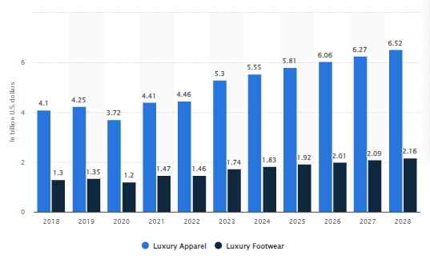

Figure 1.1: Luxury fashion market revenues in the UK
(Source: Statista, 2024a)
One of the largest companies in the luxury fashion industry is Adidas, mainly well-known for its sportswear. This German company was traced back to 1936 but started operating as Adidas in 1949 (Adidas, 2024a). It registered as ‘Adi Dassler adidas Sportschuhfabrik’ and started work with only 47 employees in the small town of Herzogenaurach. Adidas is the leading sportswear manufacturer in Europe and is the second largest in the world, after Nike. This makes Nike the largest competitor of Adidas (Tighe, 2024a). This fifth-largest globally recognised luxury apparel brand had US$ 15 billion. In the UK, Adidas has 96% of brand awareness, followed by 58% popularity and 37% loyalty (Kunst, 2024) (Refer to Figure 1.2). However, considering the fact the brand has 47% usage, the brand loyalty of Adidas is 79%.
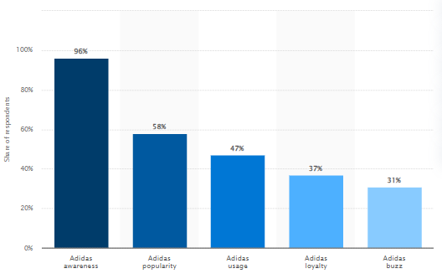

Figure 1.2: Brand profile of Adidas in the UK
(Source: Kunst, 2024)
The net sales of the company worldwide were approximately 21.4 billion euros and it employs around 60k employees over all locations in the world (Tighe, 2024b). Adidas is popular for manufacturing apparel, footwear, as well as accessories and its three-stripes logo, is globally recognisable. Bags, watches, eyewear and shirts. Overall, it is one of the most valuable luxury sportswear brands, known for its great quality products.
In the UK, around 2.86 million students study in higher education institutions as of 2021/2922 (Bolton, 2024). Besides, a significant proportion of students also enrol in part-time classes in the UK. Even though the popularity of Adidas is significantly high in the UK, there is a considerable knowledge gap in understanding the popularity of this luxury fashion brand among UK university students. This research aims to shed light on this area for an in-depth investigation.

1.2 Research Rationale
Luxury fashion brands face some major challenges. Wang et al. (2019) stated that consumer trends, brand visuals and the demands for highly creative designs impact the purchase intentions of customers. Place, people, preferences as well as perspectives of customers change or vary consumer purchase intentions. The affordability of luxury fashion brands is another major factor that creates barriers to customers' purchase intentions. Appealing to price-sensitive customers is the most challenging thing for fashion brands. The university students belong to Gen Z, who are the primary consumers of luxury fashion brands. Customers belonging to Millennials and Gen Z are accountable for 45% of the total sales of luxury brands (Faria, 2024). In order to appeal to affluent millennial shoppers, the marketers of luxury fashion brands adopt Instagram to reach millennial shoppers. On the other hand, TikTok is the most popular tool for reaching Gen Z. The fashion brands often consider social media marketing to attract brand. Kaundal (2024) stated that even Adidas significantly spends on the social media marketing to attract customers.
The leading competitor of Adidas is Nike globally. Another competitor is Puma, even though in terms of sales and revenues worldwide, Nike is the only competitor of Adidas. As per another Statista report, the global revenue of Nike was around 47.78 billion euros. Nevertheless, Adidas could not even make half of this revenue. It only had a revenue of 22.51 billion euros in the same year (Refer to Figure 1.3).
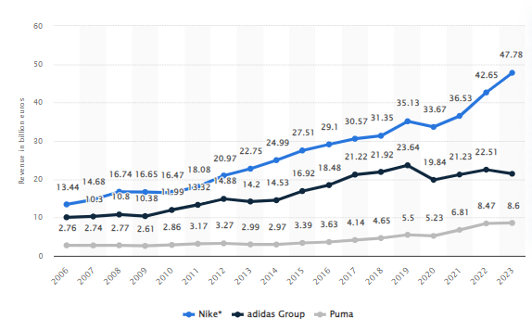

Figure 1.3: The global revenues of Nike, Adidas and Puma
(Source: Tighe, 2023c)
Mangalasserri et al. (2021) emphasised that price becomes the primary barrier to customers' purchase intention for fashion brands. Price becomes an obstacle in buying behaviour. In contrast, quality, as well as perceived values of luxury fashion brands, contribute to the purchase behaviour of customers. Therefore, it becomes crucial to investigate which factors majorly contribute to the purchase intentions of fashion brands, especially Adidas among UK university students.

1.3 Problem Statement
Based on the findings from the previous two sections, it can be stated that Adidas and other fashion brands face significant challenges in comprehending the purchase intentions of Gen Z customers. Price is a major barrier even though Adidas has substantially high brand awareness and popularity in the UK (Kunst, 2024). In this regard, Ajitha and Sivakumar (2019) and Kapferer and Valette-Florence (2021) stated that the high price point of luxury brands quite often creates barriers for price-sensitive customers. It is highly likely that this might also be a probable barrier for University students, impacting the company's sales. The target customers are university students, mostly Gen Z, so it is worth investigating the consumer buying behaviour of this fashion brand. Considering this area for investigation, the aim and objectives of the research are formed in the 1.5 section.

1.4 Research Focus and Scope
The main focus of the research is consistent in evaluating different factors and assessing their impacts on influencing the purchasing behaviour of UK university students towards luxury brands like Adidas. According to Ang et al. (2022), current university students mainly belong to Generation Z whose purchasing behaviour is influenced by various social factors. The importance of product quality and social recognition in influencing the purchasing intentions of university students is the most significant. On the other hand, street fashions rule the heart of college and university students along with youth subculture (Maliene et al. 2022). Thus, Adidas has significantly developed a positive brand awareness among UK university students which influence their buying behaviour and purchasing intentions. On the contrary, the research has also focused on marketing strategy and aims to present it as an essential factor that influences the purchasing intentions of companies towards luxury fashion brands like Adidas.
Similarly, the main scope of the research lies in proving the significant impact of factors like product quality, marketing influence and peer pressure on developing a positive brand awareness for Adidas among University students in the UK. This is also evident in the findings of Kunst (2024) who reported 96% brand awareness of Adidas in the UK. However, the brand usage and loyalty of the brand are significantly lower compared to the brand awareness. Thus, the research scope lies in investigating the key reasons that develop a negative brand perception of university students and lower their engagement and loyalty towards Adidas.

1.5 Research Aim and Objectives
This research aims to assess the consumer buying behaviour of university students in the UK towards the luxury fashion brand Adidas. Based on this research aim, the objectives are created below.
Objectives
- To assess the impacts of different factors that influence the buying behaviour of UK university students for Adidas products
- To measure the effectiveness of different digital marketing strategies in shaping the attitudes and purchasing intentions of university students towards Adidas in the UK
- To determine the impacts of brand loyalty on university students to facilitate repeat purchases and brand recommendations for Adidas products
- To identify some barriers and measure their effects on the purchasing behaviour of university students of the UK towards Adidas

1.6 Research Question
- What are the impacts of different factors that influence the buying behaviour of UK university students for Adidas products?
- What is the effectiveness of different digital marketing strategies in shaping university students' attitudes and purchasing intentions towards Adidas in the UK?
- What are the impacts of brand loyalty on university students to facilitate repeat purchases and brand recommendations for Adidas products?
- What are some barriers and measure their effects on the purchasing behaviour of UK university students towards Adidas?

1.7 Outline of the methodology
The research has proceeded by adopting a primary quantitative research method. Positivism philosophy and deductive approach have been adopted to collect factual data and prove the causal relationship between the variables associated with the research topic. A survey strategy has been adopted where 25 close-ended questionnaires have been formed to collect data from the participants. The students of UWTSD are the key research participants and the sample size is 60. The collected quantitative data will be analysed statistically using SPSS software. Statistical tests like correlation, regression and ANOVA would be performed to generate valid outcomes.

1.8 Dissertation Structures
The dissertation has six main chapters which bear various significance. The first chapter is “Introduction” which introduces the topic by offering a brief outline. The aim, objectives and questions are framed in this chapter along with identifying the main research issue. The second chapter, "Literature Review” analyses the existing literature evidence to develop a robust overview of the research topic. The third chapter is “Methodology” which is focused on identifying and further justifying the key research design adopted for this study. This chapter has justified its relevance in addressing the research objectives to achieve the main research aim. The fourth chapter is “Results” where the key findings are interpreted statistically. These statistical findings have been further discussed and triangulated with literature findings in the fifth chapter, i,e., “Discussion”. Furthermore, the overall research findings were summarised and a specific conclusion is generated in the final chapter “Conclusion and Recommendation”. Effective recommendations based on the research findings were also provided in this chapter.
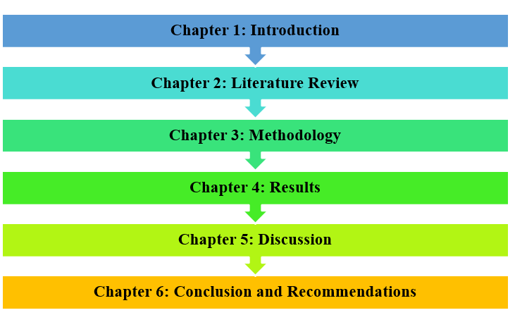

Figure 1.4: Dissertation Structure
(Source: Self-developed)

1.9 Theoretical Framework

1.9.1 Theory of Planned Behaviour (TPB)
TPB is a psychological theory that offers a foundational structure to evaluate the consumer behaviour and purchasing intentions of potential customers (here, university students). According to TBP, the behavioural intentions of an individual are influenced by their attitudes, societal norms and perceived behavioural control (Chicoine, 2023; Figure 1.5). The application of TPB is relevant in this context because it discusses the behavioural beliefs and attitudes of university students for purchasing Adidas products. On the contrary, as per Adegeest (2022), Adidas has transformed its brand identity from streetwear to high-street luxury fashion after collaborating with Gucci and Balenciaga. This fashion statement of Adidas gained media attention and attracted university students. Similarly, Adidas’s customised collections for university students acted as a major factor that shaped their brand attitude towards the chosen high-street fashion brand (Adidas News, 2023). This symbolises that the students of UK universities purchase Adidas products as a symbol of their elevated social status among their peers (Eastman et al. 2020). This helps them to be recognised socially showcasing their desire for luxury and elegant yet comfortable and trendy fashionwear. This further aligns with subjective or social norms where the students’ purchasing intentions align with peer influence for buying premium streetwear fashion products like Adidas. However, perceived behavioural control is a potential factor that identifies the key reasons that disrupt purchasing intentions (Kaur and Bhardwaj, 2021). These align with financial constraints, degraded product quality of declined brand reputation.
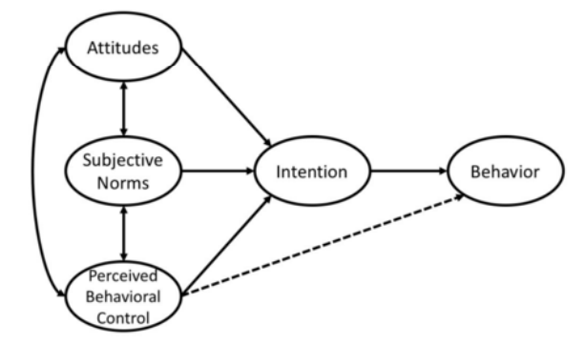

Figure 1.5: Theory of Planned Behaviour (TPB)
(Source: Chicoine, 2023)

1.9.2 Keller's Brand Equity Model
“Keller’s Brand Equity Model or Customer-Based Brand Equity (CBBE) Model” is a theoretical framework that offers the foundation for effective brand management. According to Tran et al. (2020), the CBBE model is distinguished into four layers: identity, meaning, response and relationships. Brand identity or salience determines consumers’ perception towards a brand (Liao et al. 202; Figure 1.6). On the other hand, the second layer is focused on communicating the brand's meaning to customers. This relates to brands’ performance in meeting customers’ demands and expectations. The key performance indicators for this include product quality, durability, customer service, designs and price. In the case of luxury streetwear brands like Adidas, these factors are highly crucial in shaping consumer perception (Ozuem and Ranfagni, 2021; Kelleci, 2022). In contrast, brand imagery determines the brand's appearance to the customers which includes its logo and marketing strategies. The next two layers brand response and relationships determine customers’ judgement and loyalty towards luxury fashion brands like Adidas. Therefore, the CBBE model depicts that university students’ perception towards Adidas and their purchasing intentions are shaped and influenced by the salience and meaning of the chosen brand.
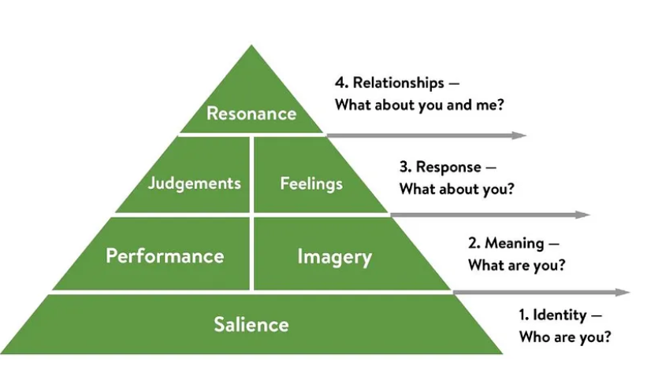

Figure 1.6: CBBE Model
(Source: Inspired by Stukalina and Pavlyuk, 2021)

1.10 Hypotheses and conceptual framework
H1: Brand perception of UK university students towards Adidas significantly impact their purchasing behaviour
H2: Digital marketing strategies of Adisas significantly influence the purchasing intentions of UK university students for Adidas products
H3: Brand loyalty of the university students has a significant impact on their repurchasing intentions for Adidas products
H4: Barriers of brand perception influence the purchasing behaviour of UK university students towards Adidas
Conceptual framework
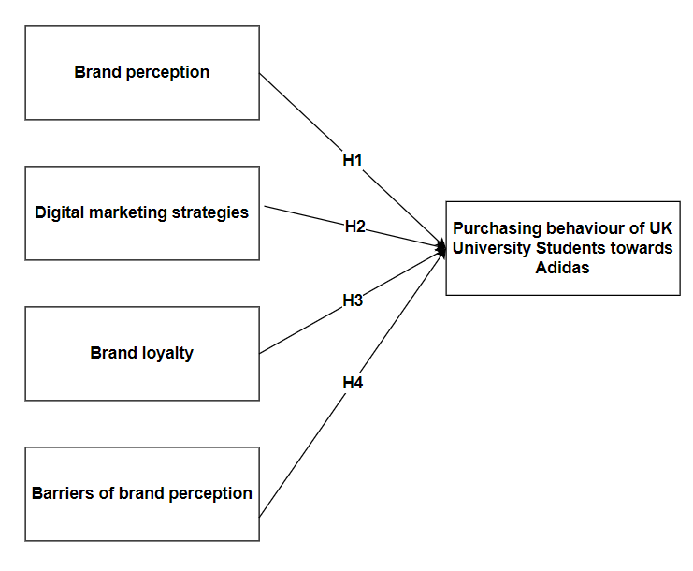

Figure 1.7: Conceptual framework
(Source: Self-created)

1.10 Summary
Therefore, the study summarises that researching the chosen topic is significant as it would provide significant brand management opportunities and similar luxury brands in the UK. As Gen Z holds a significant market share for luxury fashion products in the UK, researching university students is justified. The application of TPB and CBBE are identified as two core theoretical frameworks which explain consumer behaviour and brand management of Adidas effectively.

Reference List
Adegeest, D.A., (2022). How Adidas went from street to luxury. Available at: https://fashionunited.com/news/fashion/how-adidas-went-from-street-to-luxury/2022060147910 [Accessed on: 15.07.2024]
Adidas News (2023). ADIDAS ORIGINALS UNVEILS FIRST-EVER FOOTWEAR COLLECTION CUSTOMIZED FOR UNIVERSITY STUDENTS AND FANS. Available at: https://news.adidas.com/basketball/adidas-originals-unveils-first-ever-footwear-collection-customized-for-university-students-and-fans/s/4f05a815-4526-467f-8b83-50ff9c417d23 [Accessed on: 15.07.2024]
Adidas, 2024a. HISTORY. Available at: https://www.adidas-group.com/en/about/history [Accessed On: 15 July 2024]
Ajitha, S. and Sivakumar, V.J., (2019). The moderating role of age and gender on the attitude towards new luxury fashion brands. Journal of Fashion Marketing and Management: An International Journal, 23(4), pp.440-465. https://doi.org/10.1108/JFMM-05-2018-0074
Ang, W.H.D., Shorey, S., Lopez, V., Chew, H.S.J. and Lau, Y., (2022). Generation Z undergraduate students’ resilience during the COVID-19 pandemic: a qualitative study. Current Psychology, 41(11), pp.8132-8146. https://doi.org/10.1007/s12144-021-01830-4
Bolton, P., (2024). Higher education student numbers. https://commonslibrary.parliament.uk/research-briefings/cbp-7857/#:~:text=Key%20data%20on%20the%20overall,at%20UK%20higher%20education%20institutions.
Chicoine, D., (2023). Counterfeit Impact on High-end Luxury Products| investigating French Generation Z Consumers’ Attitude towards High-end Luxury Counterfeit Products and Purchasing Intention. https://www.theseus.fi/handle/10024/797745
Eastman, J.K., Shin, H. and Ruhland, K., (2020). The picture of luxury: A comprehensive examination of college student consumers' relationship with luxury brands. Psychology & Marketing, 37(1), pp.56-73. https://doi.org/10.1002/mar.21280
Faria, J., (2024). Luxury advertising and marketing. https://www.statista.com/topics/4149/luxury-advertising-and-marketing/#editorsPicks
Kapferer, J.N. and Valette-Florence, P., (2021). Which consumers believe luxury must be expensive and why? A cross-cultural comparison of motivations. Journal of Business Research, 132, pp.301-313. https://doi.org/10.1016/j.jbusres.2021.04.003
Kaundal, S., 2024. Adidas' Digital Marketing Strategy Unpacked with the 5W & 1H Framework. Available at: https://www.linkedin.com/pulse/adidas-digital-marketing-strategy-unpacked-5w-1h-shubham-kaundal-dak1c/ [Accessed On: 15 July 2024]
Kaur, J. and Bhardwaj, N., (2021). Their control will make or break the sustainable clothing deal-a study of the moderating impact of actual behavioural control on the purchase intention-behaviour gap for sustainable clothing in india. Australasian Accounting, Business and Finance Journal, 15(5), p.59. http://dx.doi.org/10.14453/aabfj.v15i5.6
Kelleci, A., (2022). Key determinants of luxury marketing accordant with sustainability-oriented value perspectives. Sustainability, 14(10), p.5916. https://doi.org/10.3390/su14105916
Kunst, A., 2024. Adidas brand awareness, usage, popularity, loyalty, and buzz among sneakers owners in the UK in 2023. Available at: https://www.statista.com/forecasts/1352058/adidas-sneakers-brand-profile-in-the-uk [Accessed On: 15 July 2024]
Liao, J., Dong, X., Luo, Z. and Guo, R., (2021). Oppositional loyalty as a brand identity-driven outcome: a conceptual framework and empirical evidence. Journal of Product & Brand Management, 30(8), pp.1134-1147. https://doi.org/10.1108/JPBM-08-2019-2511
Maliene, V., Fowles, S., Atkinson, I. and Malys, N., (2022). A sustainability assessment framework for the high street. Cities, 124, p.103571. https://doi.org/10.1016/j.cities.2022.103571
Mangalasserri, K., Regin, R., Venkateswaran, P.S., Kumar, A. and Rajest, S.S., (2021). A research for the determinants leading for counterfeit purchase and a genuine product. Turkish Journal of Physiotherapy and Rehabilitation, 32(3), pp.45415-45452. Available at: https://www.researchgate.net/profile/Anil-Kumar-739/publication/358635406_A_RESEARCH_FOR_THE_DETERMINANTS_LEADING_FOR_COUNTERFEIT_PURCHASE_AND_A_GENUINE_PRODUCT/links/636924d32f4bca7fd03d73c4/A-RESEARCH-FOR-THE-DETERMINANTS-LEADING-FOR-COUNTERFEIT-PURCHASE-AND-A-GENUINE-PRODUCT.pdf
Ozuem, W. and Ranfagni, S., (2021). Art of Digital Marketing for Fashion and Luxury Brands. Springer International Publishing. https://www.academia.edu/download/107946471/The_Art_of_Digital_Marketing_for_Fashion_and_Luxury_Brands_Wilson_Ozuem_Silvia_Ranfagni.pdf
Reuters, (2021). UK's Burberry poaches Versace boss Jonathan Akeroyd as CEO. https://hr.economictimes.indiatimes.com/news/industry/uks-burberry-poaches-versace-boss-jonathan-akeroyd-as-ceo/87181264
Statista, (2024a). Revenue in the Luxury Fashion market for different segments United Kingdom from 2018 to 2028 (in billion U.S. dollars). https://www.statista.com/forecasts/1443858/revenue-luxury-fashion-market-for-different-segments-united-kingdom
Statista, (2024b). Luxury Fashion - United Kingdom. https://www.statista.com/outlook/cmo/luxury-goods/luxury-fashion/united-kingdom#:~:text=In%20terms%20of%20per%20capita,way%20in%20innovation%20and%20craftsmanship.
Stukalina, Y. and Pavlyuk, D., (2021). Using customer-based brand equity model in the higher education context: simulating the current university’s brand. Business, Management and Economics Engineering, 19(2), pp.272-288. https://doi.org/10.3846/bmee.2021.14692
Tighe, D., 2024a. adidas - statistics & facts. Available at: https://www.statista.com/topics/1257/adidas/ [Accessed On: 15 July 2024]
Tighe, D., 2024b. The adidas Group's net sales worldwide from 2000 to 2023 (in million euros). Available at: https://www.statista.com/statistics/268416/net-sales-of-the-adidas-group-worldwide-since-2000/ [Accessed On: 15 July 2024]
Tighe, D., 2024c. Global revenue of adidas, Nike and Puma from 2006 to 2023 (in billion euros). Available at: https://www.statista.com/statistics/269599/net-sales-of-adidas-and-puma-worldwide/ [Accessed On: 15 July 2024]
Tran, K., Nguyen, P.V., Do, H. and Nguyen, L.J.M.S.L., (2020). University students’ insight on brand equity. Management Science Letters, 10(9), pp.2053-2062. http://dx.doi.org/10.5267/j.msl.2020.2.006
Wang, S.W., Pelton, L.E. and Hsu, M.K., (2019). Analysis of consumers’ attitudinal and emotional factors on luxury apparel brand purchase intentions. The Service Industries Journal, 39(11-12), pp.836-854. https://doi.org/10.1080/02642069.(2018).1494158
Yougov.co.uk, (2024). The Most Famous Luxury Brands (Q2 2024). https://yougov.co.uk/ratings/consumer/fame/luxury-brands/all

Appendix: Survey Questionnaire
1. What is your age?
- 18-25
- 26-30
- 31-35
- Above 35
2. What is your gender?
- Male
- Female
- Prefer not to say
3. What is your current education level?
- Undergraduate
- Post Graduate
4. I decided to purchase frequently from Adidas because I am satisfied with their products and services. Please rate your agreement.
- Strongly Agree
- Agree
- Neutral
- Disagree
- Strongly Disagree
Objective 1
5. I buy products from Adidas based on its product quality.
- Strongly Agree
- Agree
- Neutral
- Disagree
- Strongly Disagree
6. Brand equity, image and reputation of Adidas influence my purchasing behaviour. Please rate your agreement.
- Strongly Agree
- Agree
- Neutral
- Disagree
- Strongly Disagree
7. I purchase products from Adidas because they are stylish and comfortable.
- Strongly Agree
- Agree
- Neutral
- Disagree
- Strongly Disagree
8. I buy products from Adidas because it offers customised high-fashion streetwear which enables me to look elegant and trendy.
- Strongly Agree
- Agree
- Neutral
- Disagree
- Strongly Disagree
9. My purchase behaviour is often influenced by peer influence from my friends and seniors.
- Strongly Agree
- Agree
- Neutral
- Disagree
- Strongly Disagree
10. I purchase fashion products from Adidas because it offers a diverse brand portfolio.
- Strongly Agree
- Agree
- Neutral
- Disagree
- Strongly Disagree
11. Continuous product innovation of Adidas attracts me towards the brand and make purchasing decisions/
- Strongly Agree
- Agree
- Neutral
- Disagree
- Strongly Disagree
Objective 2
12. I see Adidas ads on social media frequently.
- Strongly Agree
- Agree
- Neutral
- Disagree
- Strongly Disagree
13. I explore products of Adidas through online banners and sponsored posts.
- Strongly Agree
- Agree
- Neutral
- Disagree
- Strongly Disagree
14. User-generated content posted by Adidas often influence my purchasing decisions for Adidas product
- Strongly Agree
- Agree
- Neutral
- Disagree
- Strongly Disagree
15. Targeted advertising and campaigns shape positive brand perception towards Adidas.
- Strongly Agree
- Agree
- Neutral
- Disagree
- Strongly Disagree
16. Promotional emails and personalised recommendations through email marketing enhance your likelihood of purchasing Adidas products. Please rate your agreement.
- Strongly Agree
- Agree
- Neutral
- Disagree
- Strongly Disagree
17. I buy fashion products from Adidas because of product reviews and recommendations by influencers.
- Strongly Agree
- Agree
- Neutral
- Disagree
- Strongly Disagree
Objective 3
18. I have developed a strong emotional connection with Adidas.
- Strongly Agree
- Agree
- Neutral
- Disagree
- Strongly Disagree
19. I will stay loyal to Adidas despite the price.
- Strongly Agree
- Agree
- Neutral
- Disagree
- Strongly Disagree
20. I will make repeat purchase from Adidas.
- Strongly Agree
- Agree
- Neutral
- Disagree
- Strongly Disagree
21. I will recommend Adidas to my friends and family.
- Strongly Agree
- Agree
- Neutral
- Disagree
- Strongly Disagree
Objective 4
22. How far do you agree that the quality deterioration of some luxury products is a potential barrier to your purchasing decisions?
- Strongly Agree
- Agree
- Neutral
- Disagree
- Strongly Disagree
23. To what extent do you agree that price sensitivity often affects your purchasing decisions from luxury brands?
- Strongly Agree
- Agree
- Neutral
- Disagree
- Strongly Disagree
24. Unethical operations practiced in Adidas often disrupt my purchasing intentions?
- Strongly Agree
- Agree
- Neutral
- Disagree
- Strongly Disagree
25. Adidas is slow to fast-fashion trends which sometimes affect my purchasing decisions.
- Strongly Agree
- Agree
- Neutral
- Disagree
- Strongly Disagree

