Kara Thomas (2304862)

Configure, and manage Virtualised network

Contents
1. In Swansea Network, 2
1.1. Install Routing and Remote access Service and modify firewall rules to allow ICMP Traffic. 2
1.2. Configure Site-to-Site VPN to London Network. Set the connection type to “persistent connection”. 4
1.3. Create a forest named yourname.acca 8
1.4. Create all appropriate A records for all servers on 10.1.1.0/24 and 172.16.1.0/24. 10
And 1.5. Create a reverse lookup zone creating PTR records for all servers. 10
1.6. Create user accounts for yourname.acca domain with all the parameters defined in the users_list_updated.xlsx document. This document will be shared by your lecturer. You must use first letter from first name with a dot and last name as SAM Account Name. Eg: First Name: Nitheesh Last Name: Kaliyamurthy. → n.kaliyamurthy. 12
1.7. Mount second disk drive to D:\SwanseaFiles. 13
1.8. Configure DHCP Services. The range is 172.16.1.10 – 172.16.1.20. Determine other DHCP options as per the infrastructure. 15
1.9. Join the ClientS1 to yourname.acca domain. 25
1.10. Assign ClientS1 with DHCP IP Address. 26
2. In Cardiff Network, 28
2.1. Install Routing and Remote access Service (equivalent) and modify firewall rules to allow ICMP Traffic. 28
2.2. Configure Site-to-Site VPN to Swansea Network. Set the connection type to “persistent connection”. 29
2.3. Join devices in this network to the yourname.acca domain. 32
2.4. Configure DHCP Services. The range is 10.1.1.10 – 10.1.1.20. Determine other DHCP options as per the infrastructure. 33
3. Test the network for Connectivity. Note that at this stage, the Swansea and Cardiff networks are connected and fully operational. If not, Troubleshoot. 43
4. Sharing Disk Drive: To the earlier created D:\SwanseaFiles, set access permissions to allow users in the users_list_updated.xlsx has full control permissions and other network users have only read access. Share the drive to both Cardiff and Swansea network. 43
5. Configure IIS Server 43
5.1. Create https://webs. yourname.acca website and enable windows internal authentication. 43
5.2. All the users can be authenticated. 43
5.3. All authenticated users should be presented a text “Welcome to Swansea Website”. 43
6. Remote Desktop Services: Configure remote access for S-DC from any other machines in the network. Make sure that the Remote Desktop Services login page should be accessed via https://rds.yourname.acca and necessary certificates are signed. 43
Sort 44

1. In Swansea Network,

1.1. Install Routing and Remote access Service and modify firewall rules to allow ICMP Traffic.
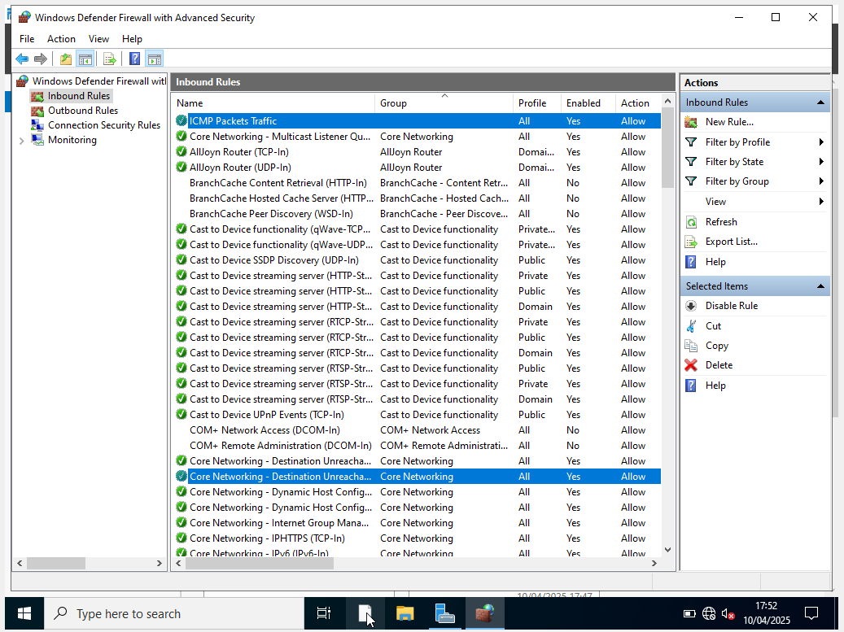
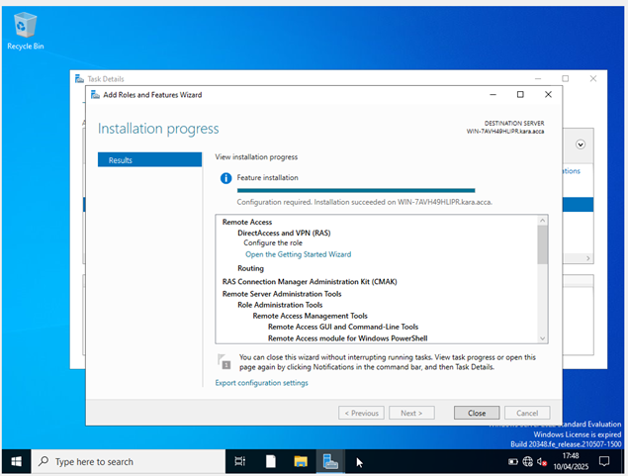

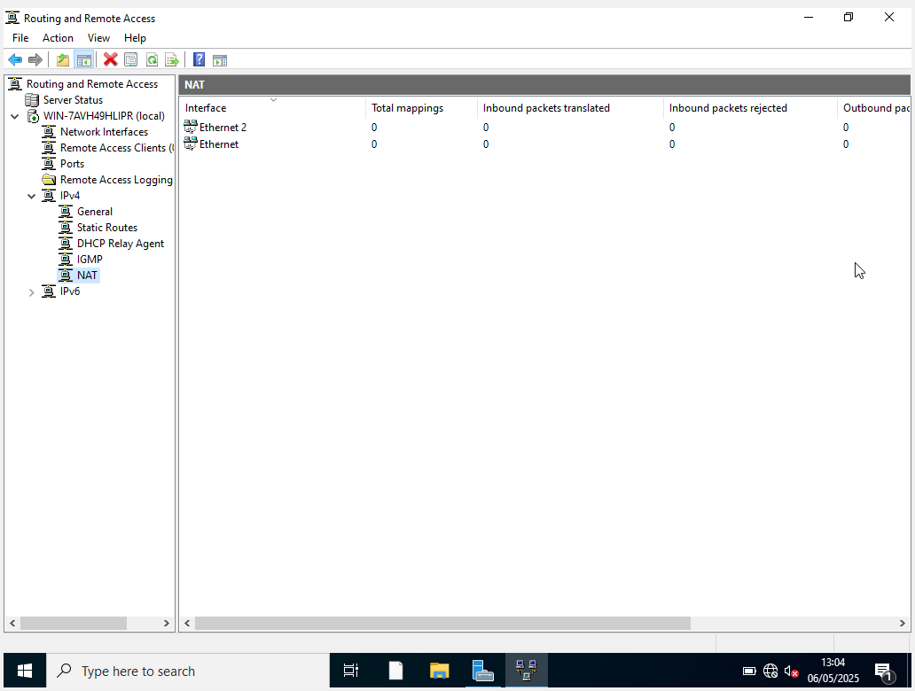
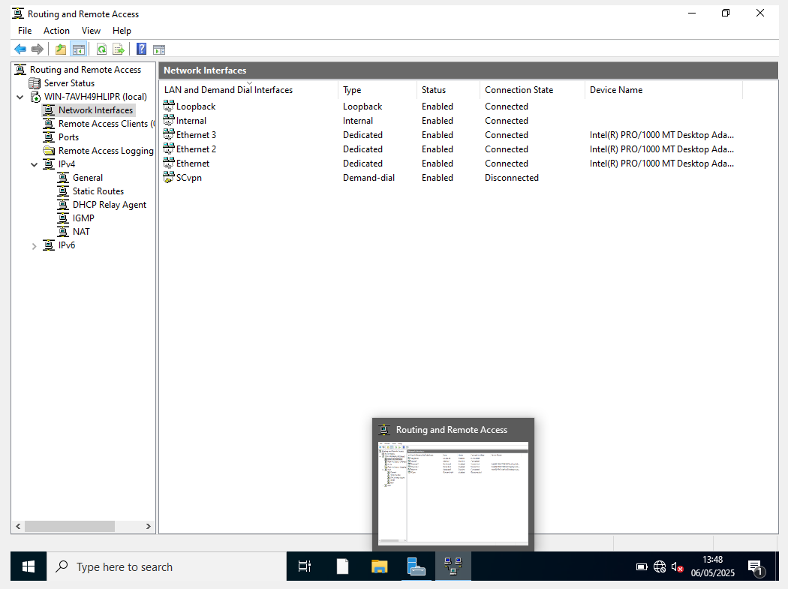

1.2. Configure Site-to-Site VPN to London Network. Set the connection type to “persistent connection”.

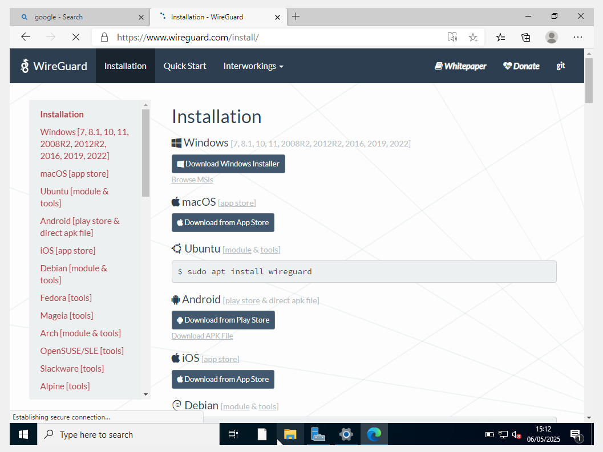

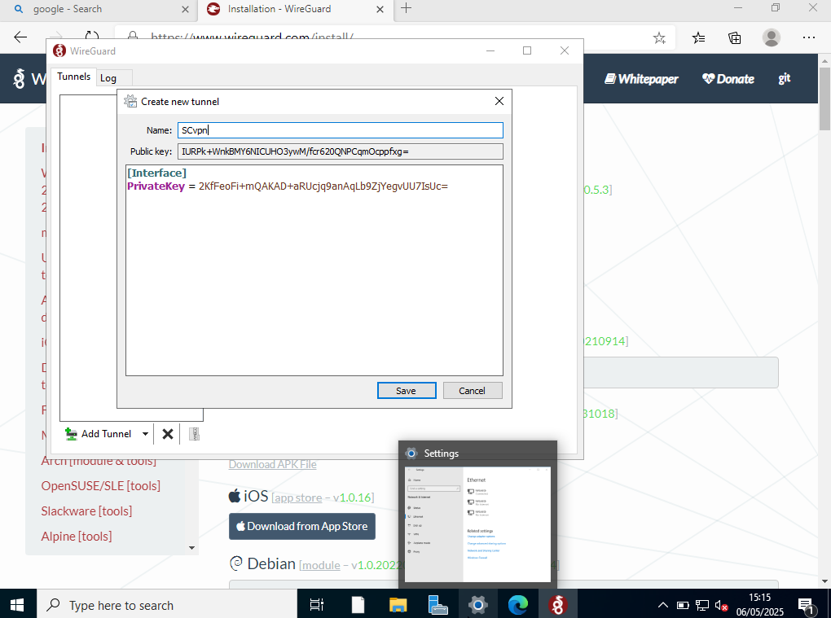
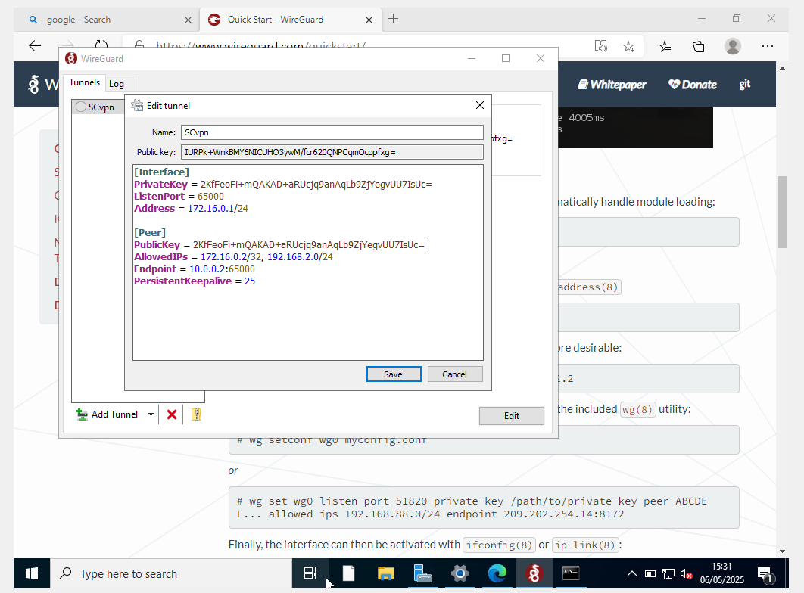

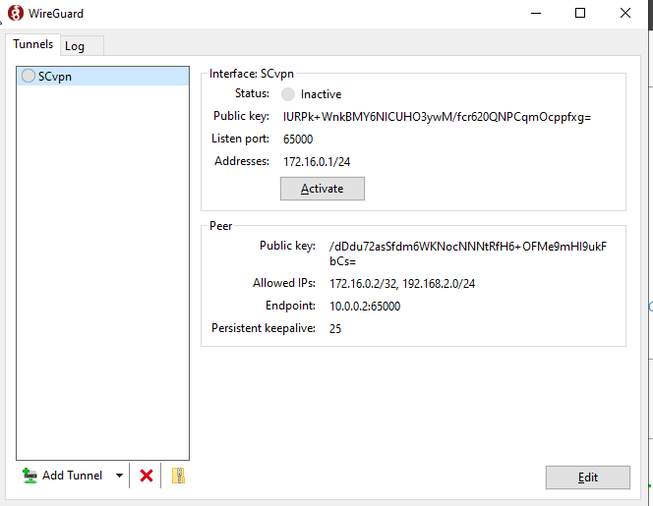

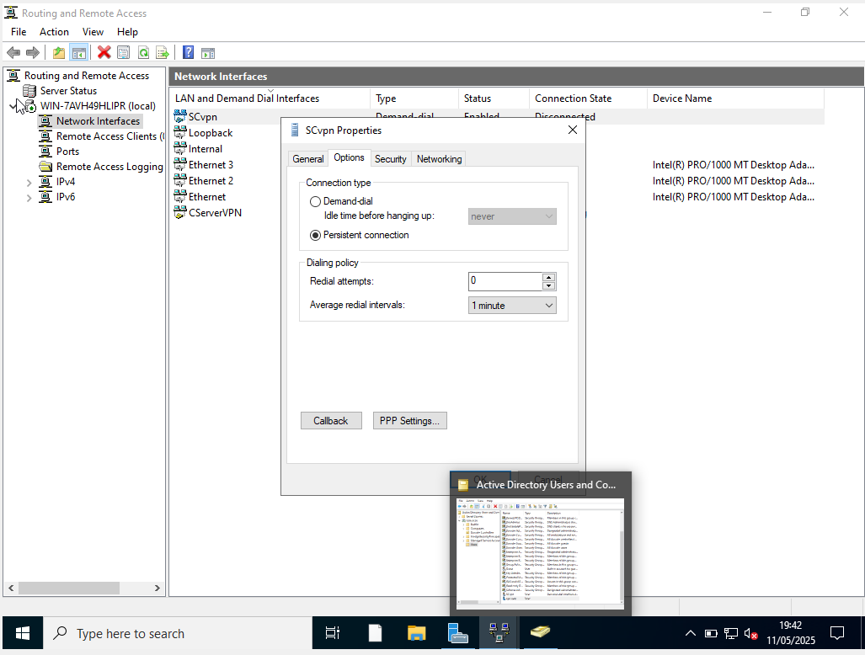

1.3. Create a forest named yourname.acca
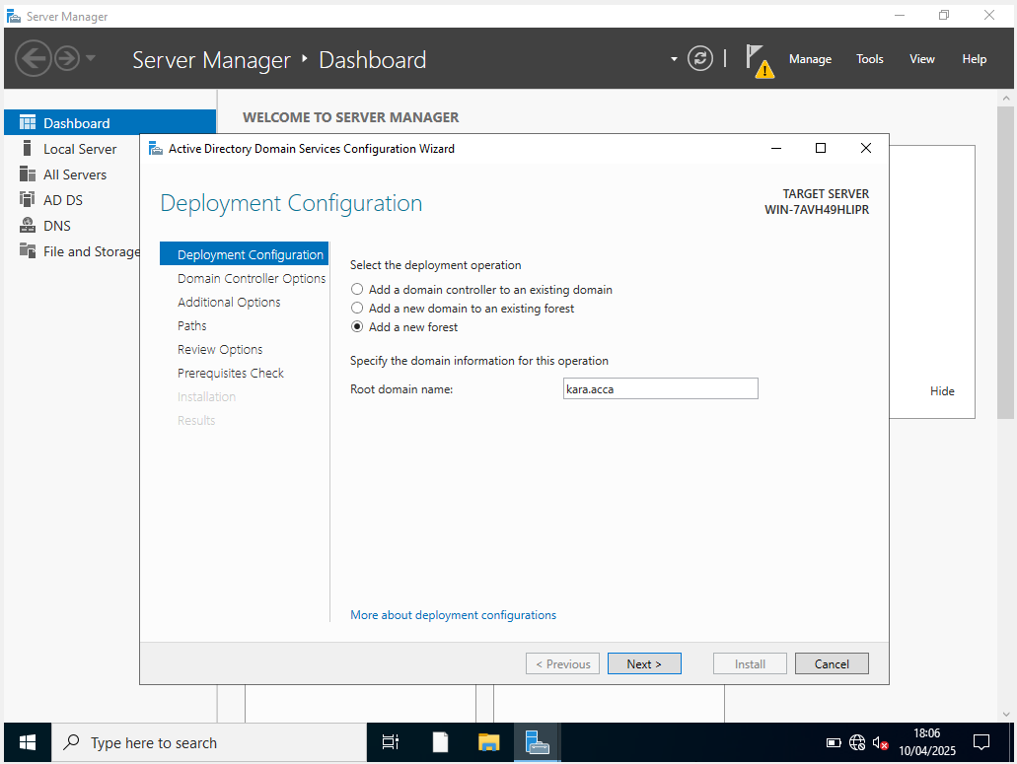
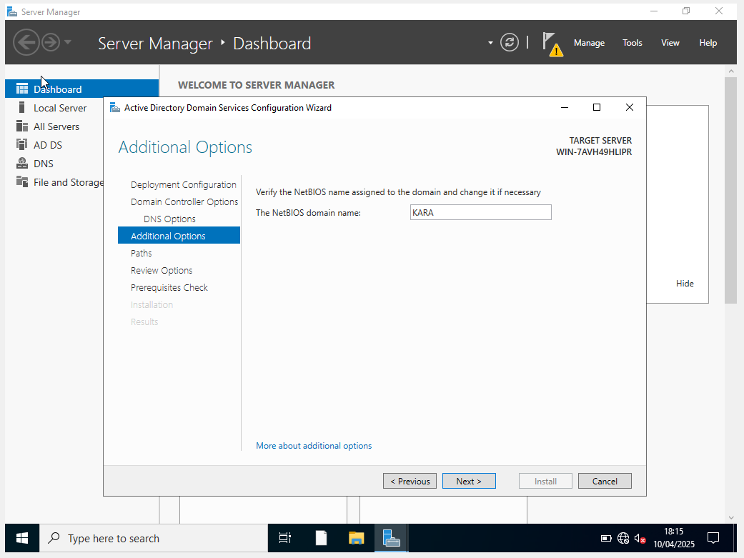
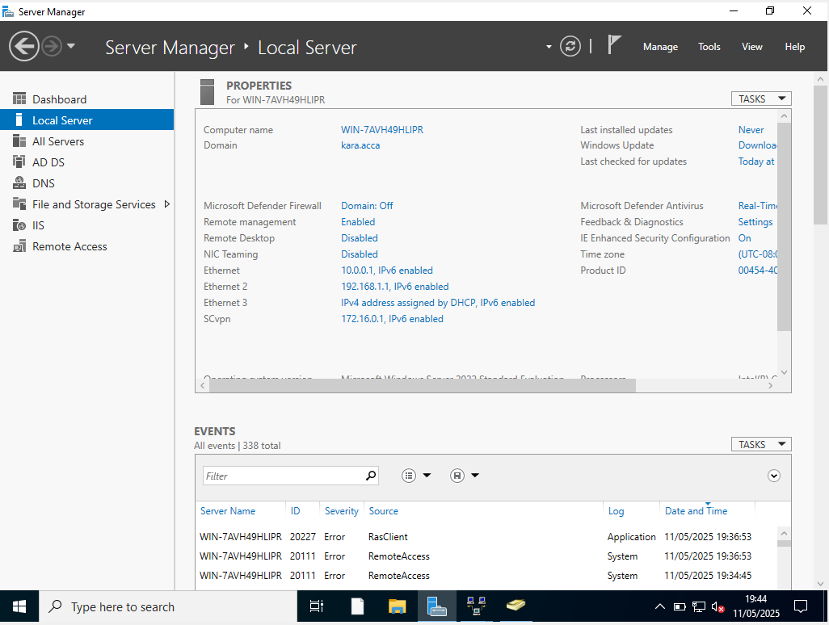

1.4. Create all appropriate A records for all servers on 10.1.1.0/24 and 172.16.1.0/24. and 1.5. Create a reverse lookup zone creating PTR records for all servers.
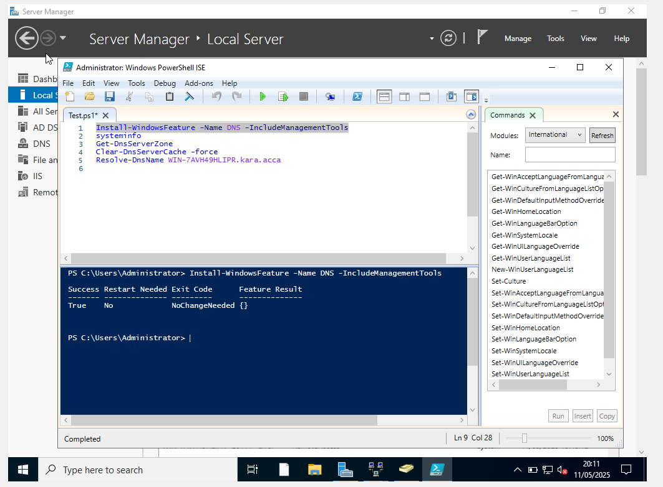
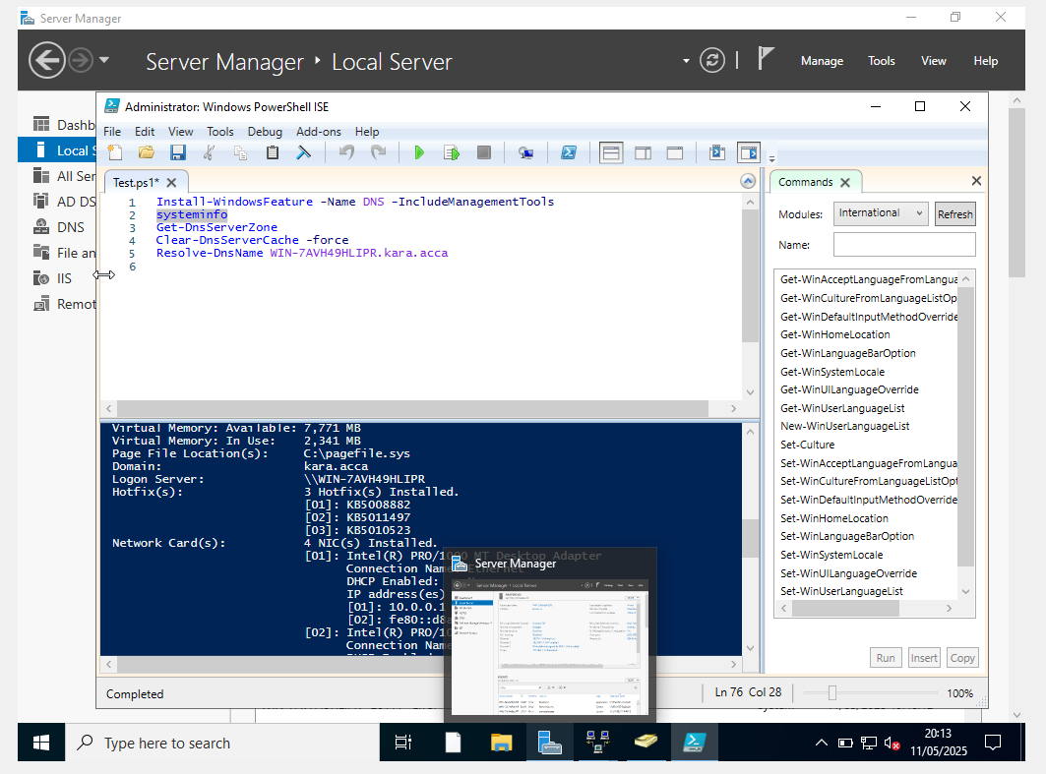
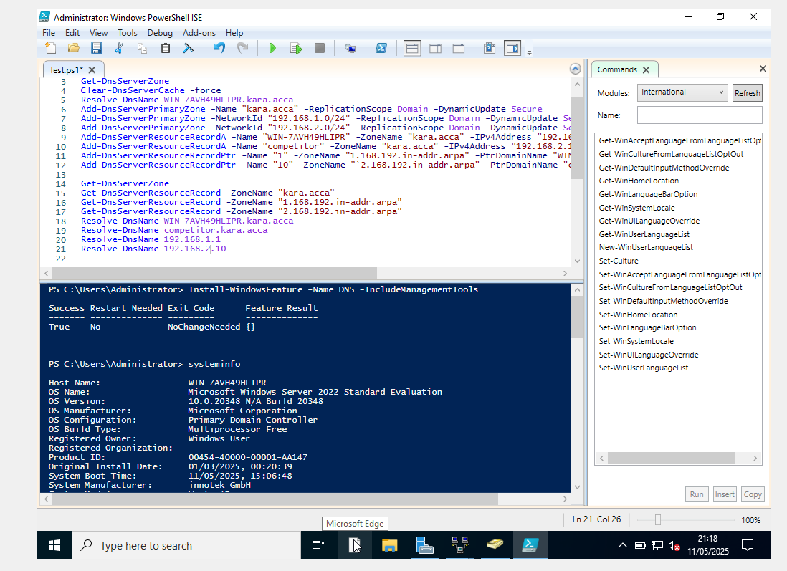

1.6. Create user accounts for yourname.acca domain with all the parameters defined in the users_list_updated.xlsx document. This document will be shared by your lecturer. You must use first letter from first name with a dot and last name as SAM Account Name. Eg: First Name: Nitheesh Last Name: Kaliyamurthy. → n.kaliyamurthy.

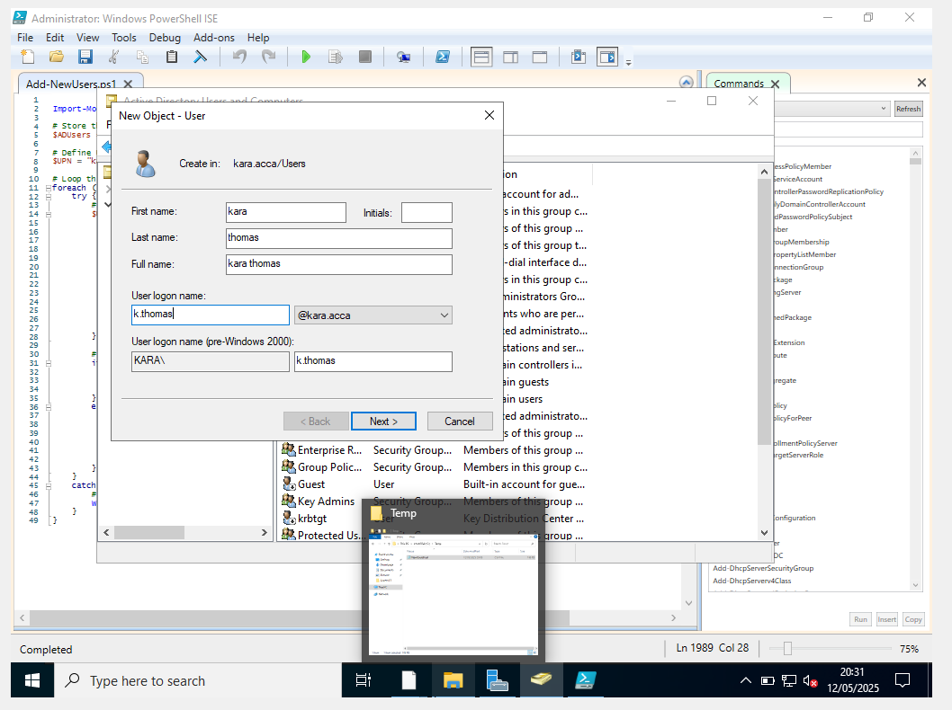
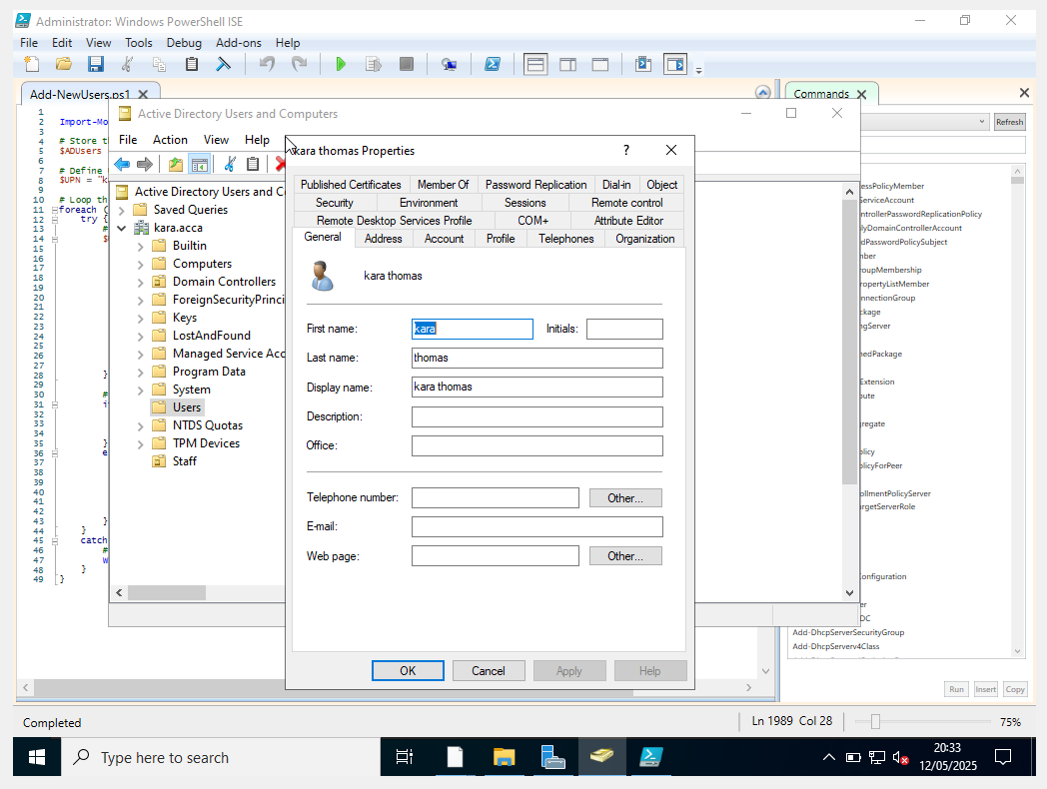

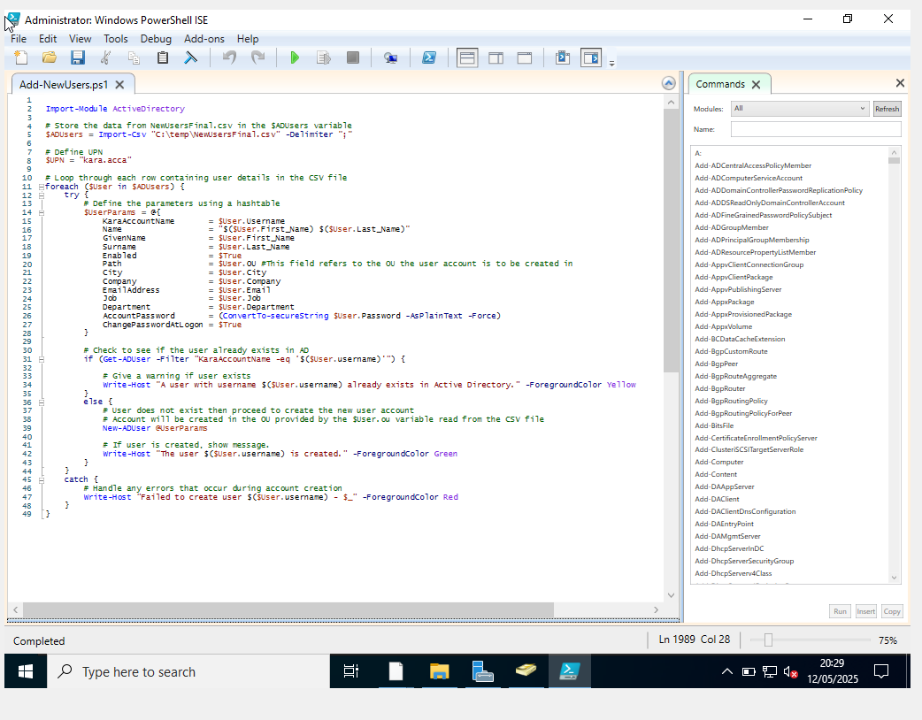

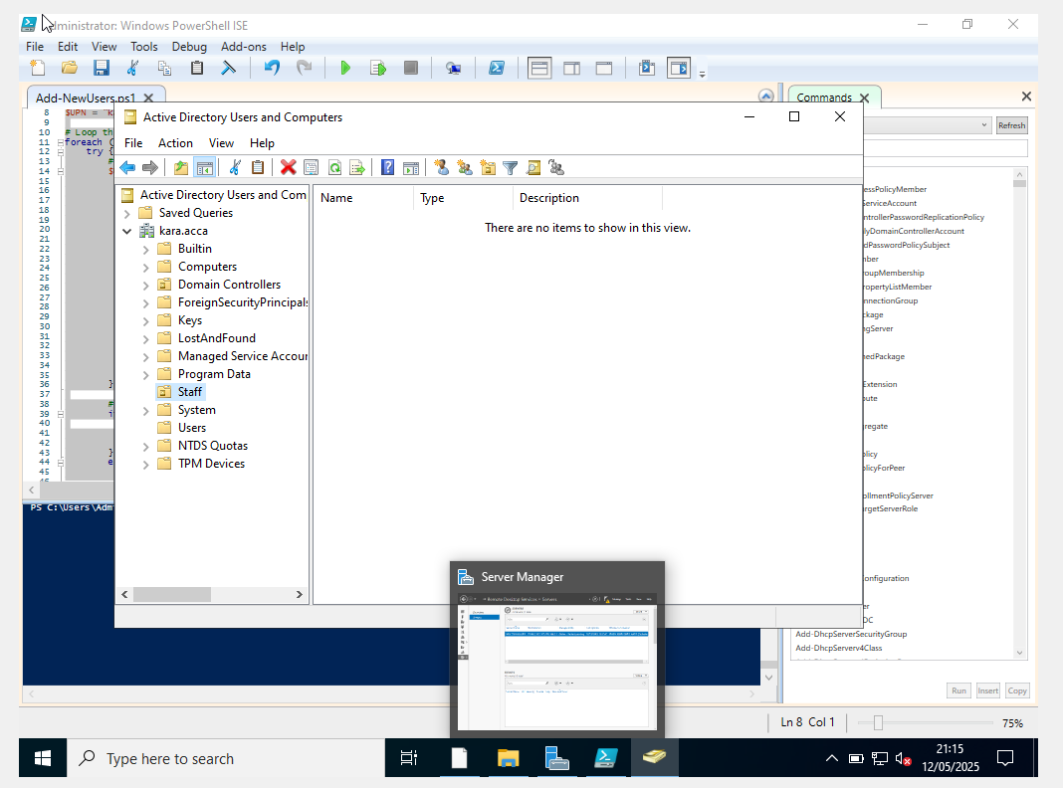

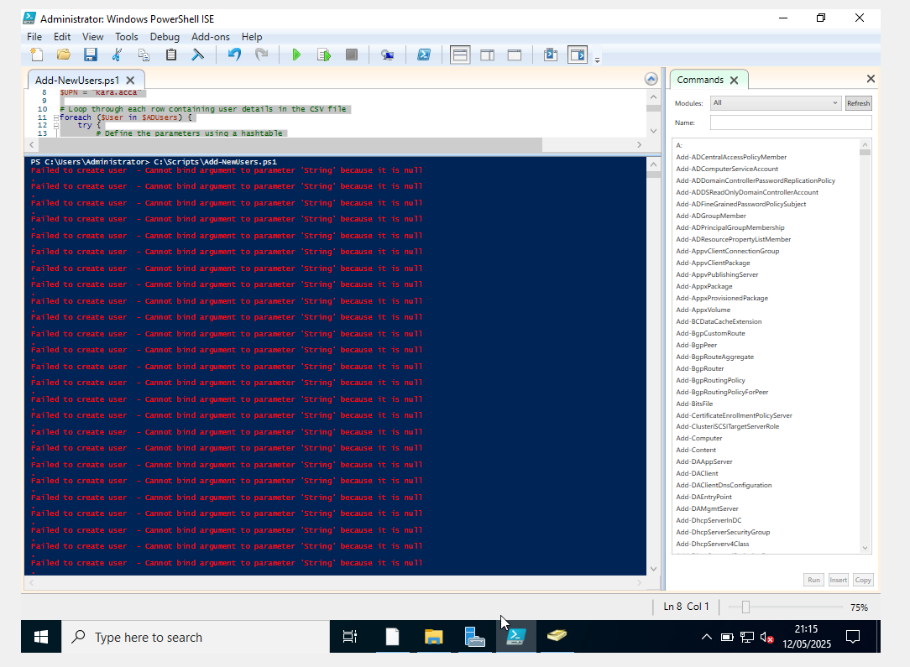

Users from the users_list_updated.csvfile cannot be added to the staff OU due to an unknown error.

1.7. Mount second disk drive to D:\SwanseaFiles.
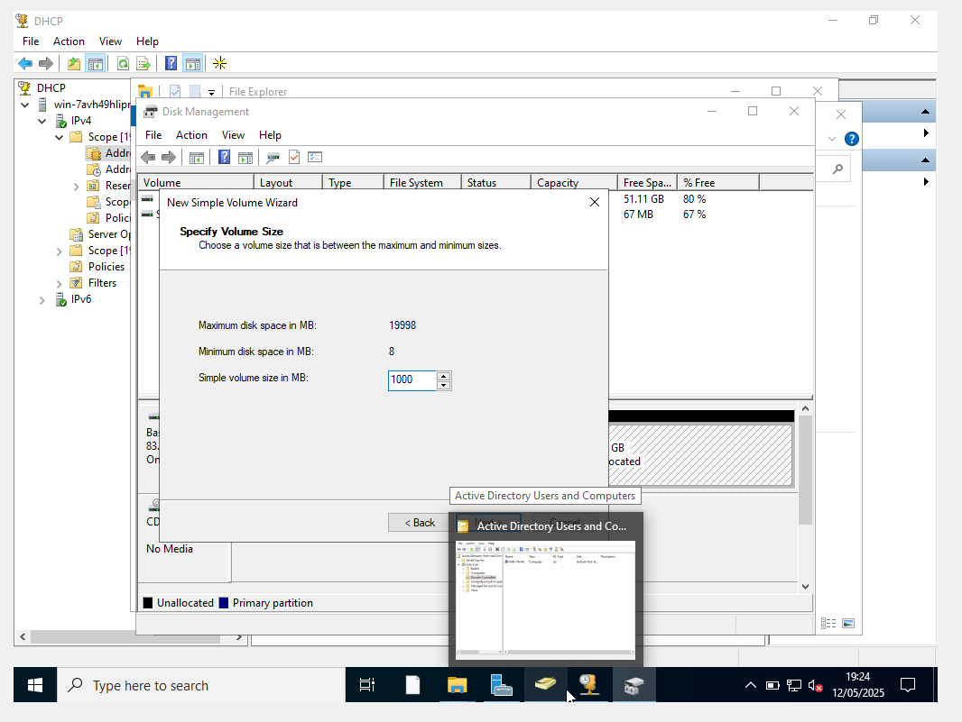
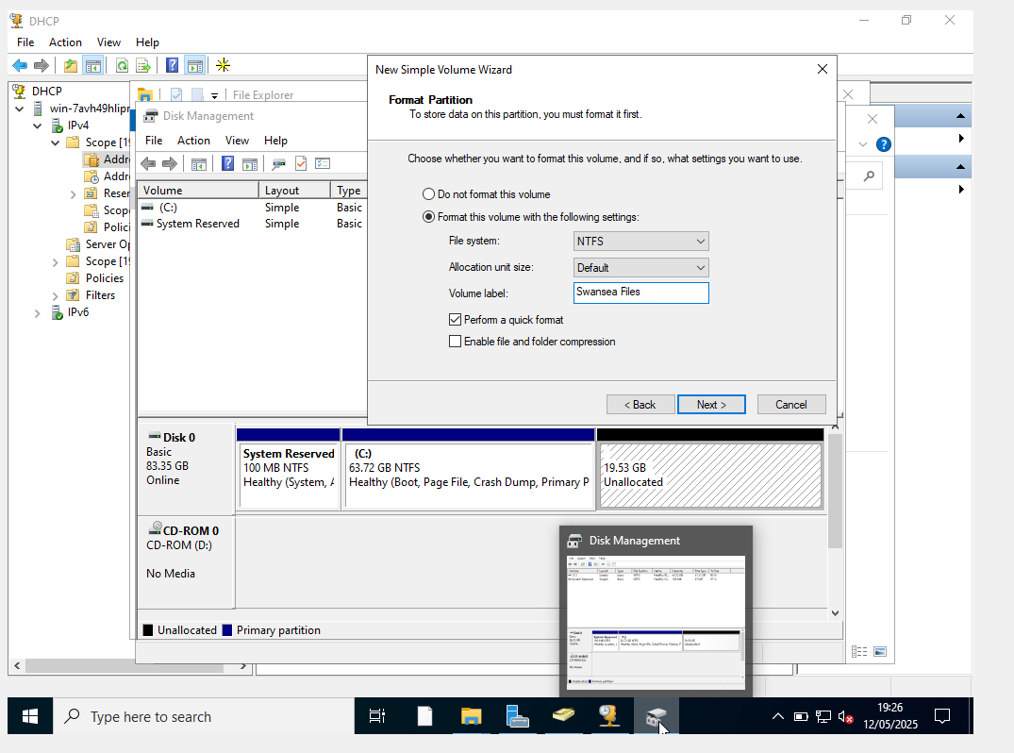
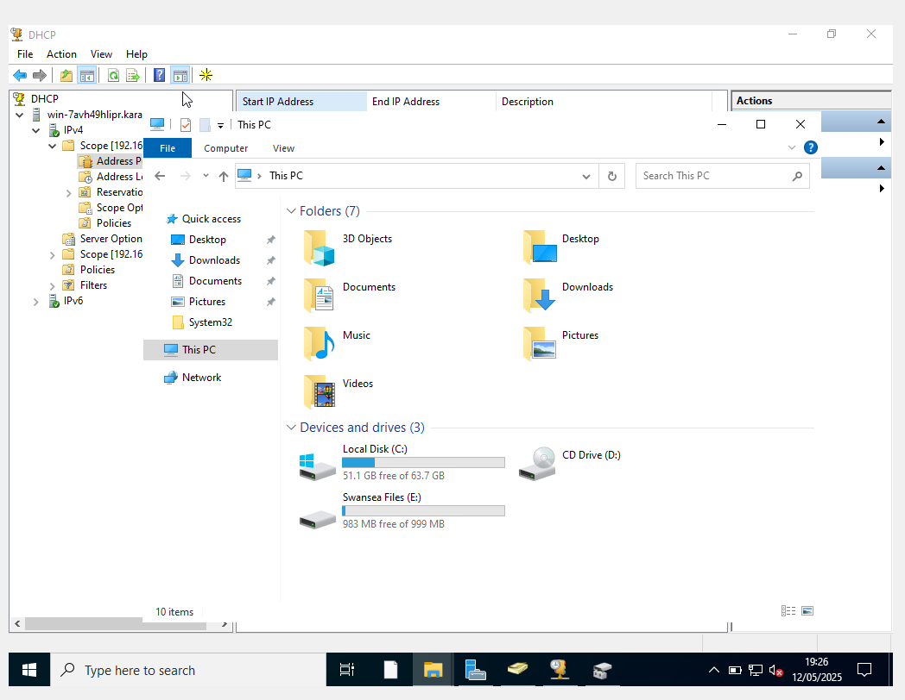

1.8. Configure DHCP Services. The range is 172.16.1.10 – 172.16.1.20. Determine other DHCP options as per the infrastructure.
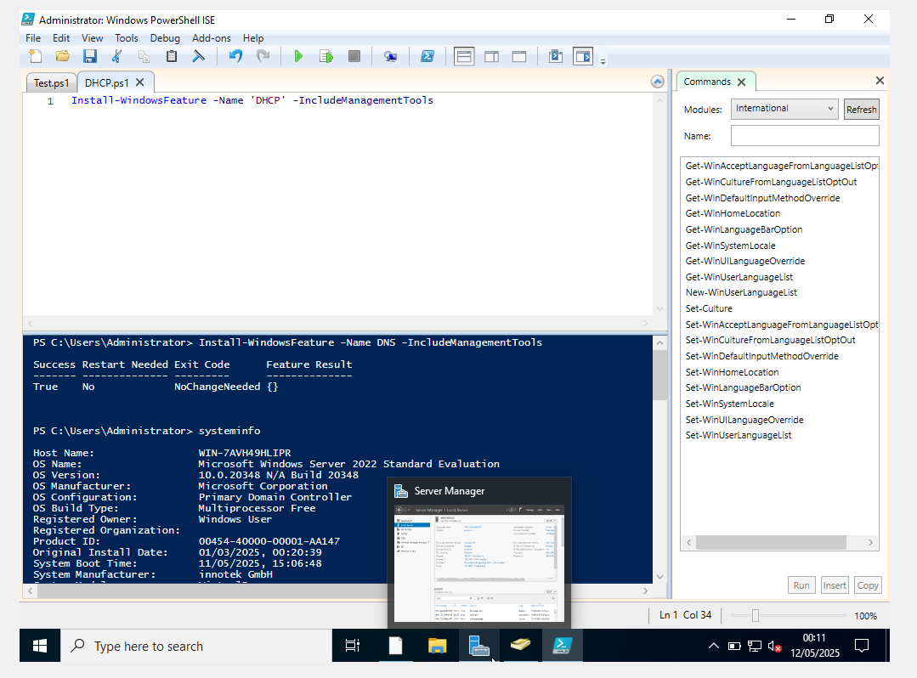
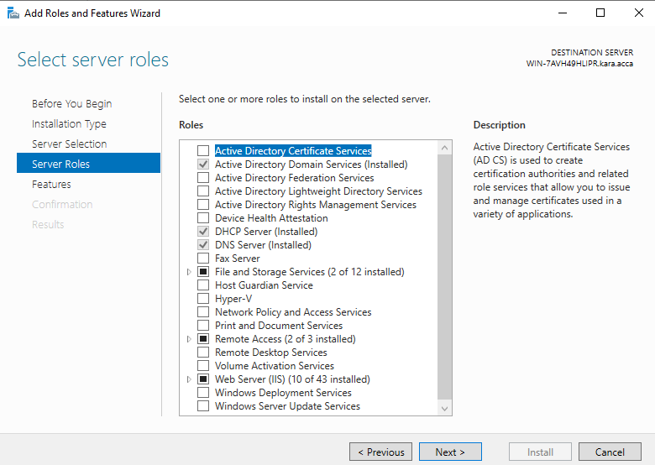

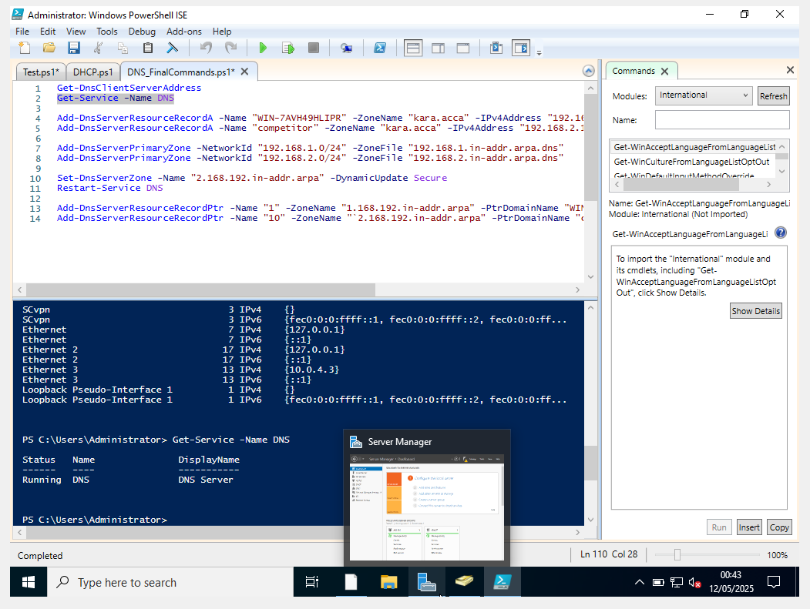
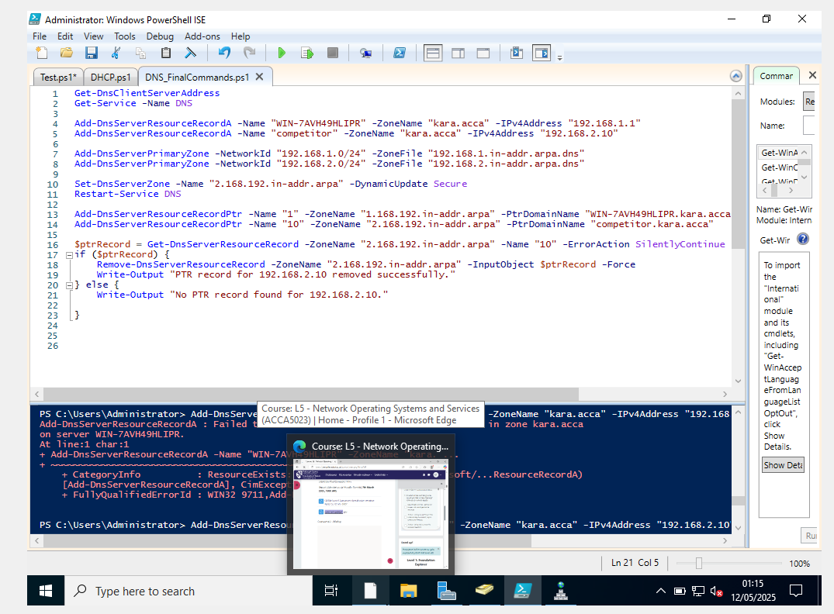
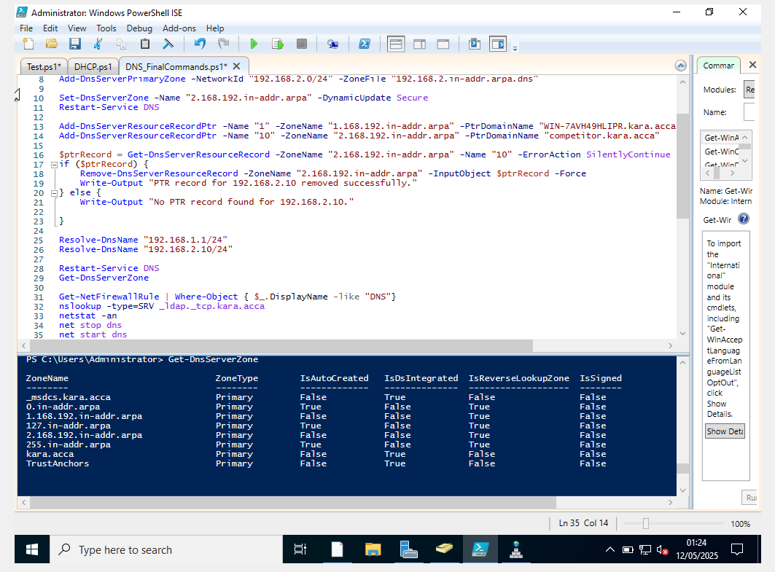
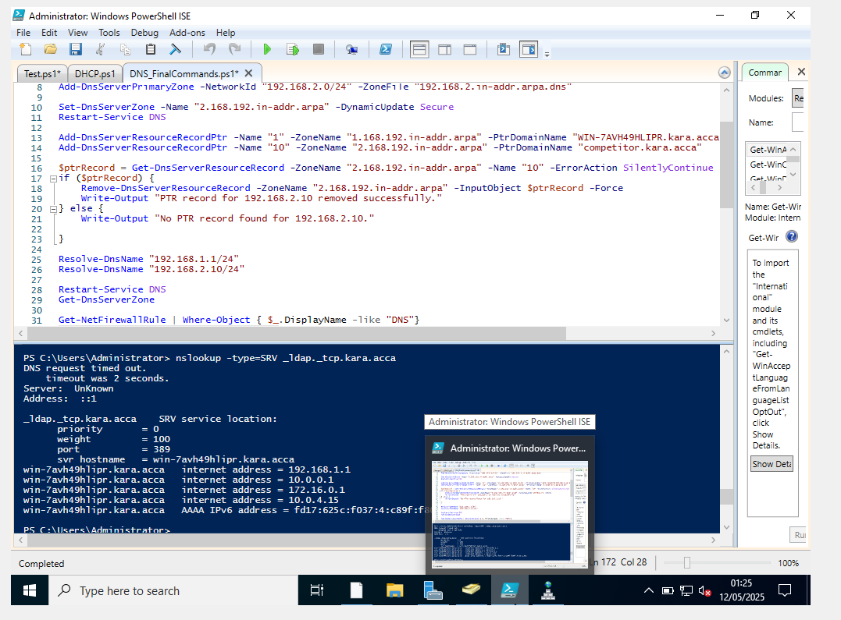
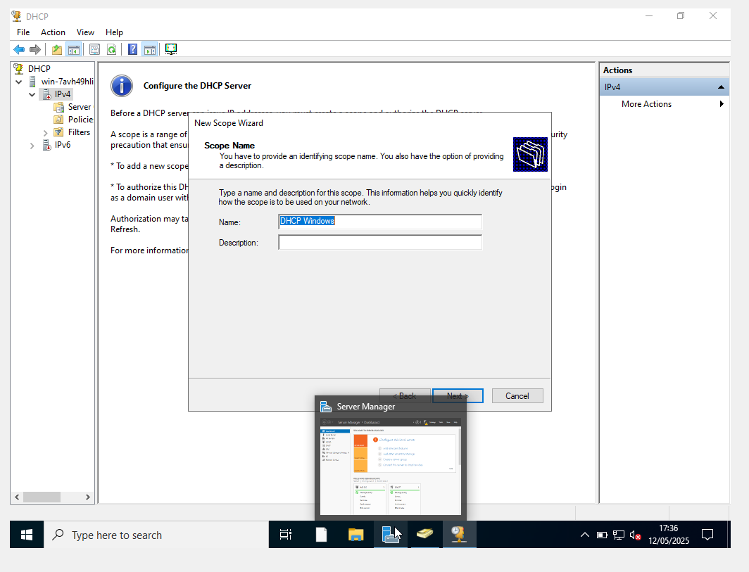

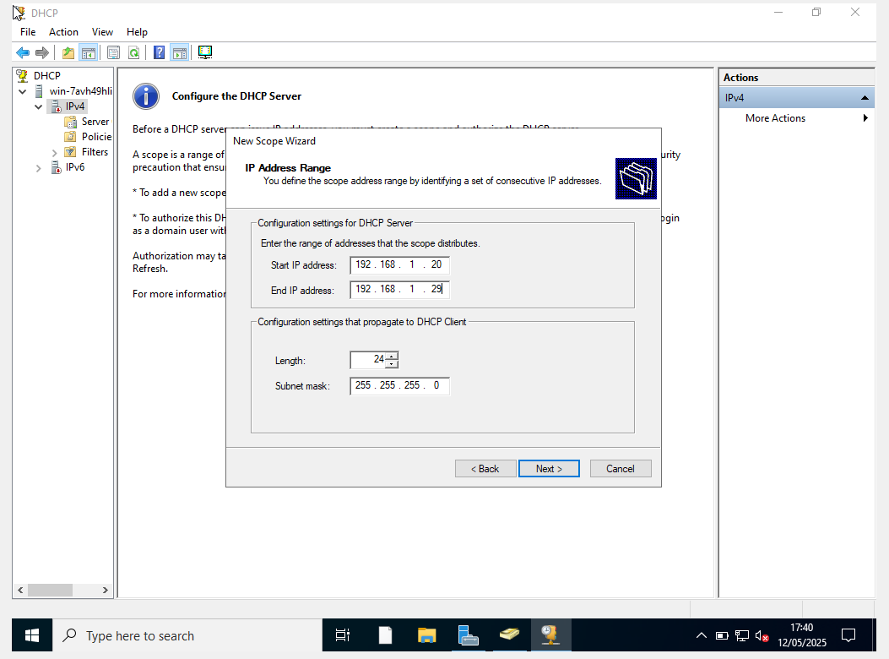
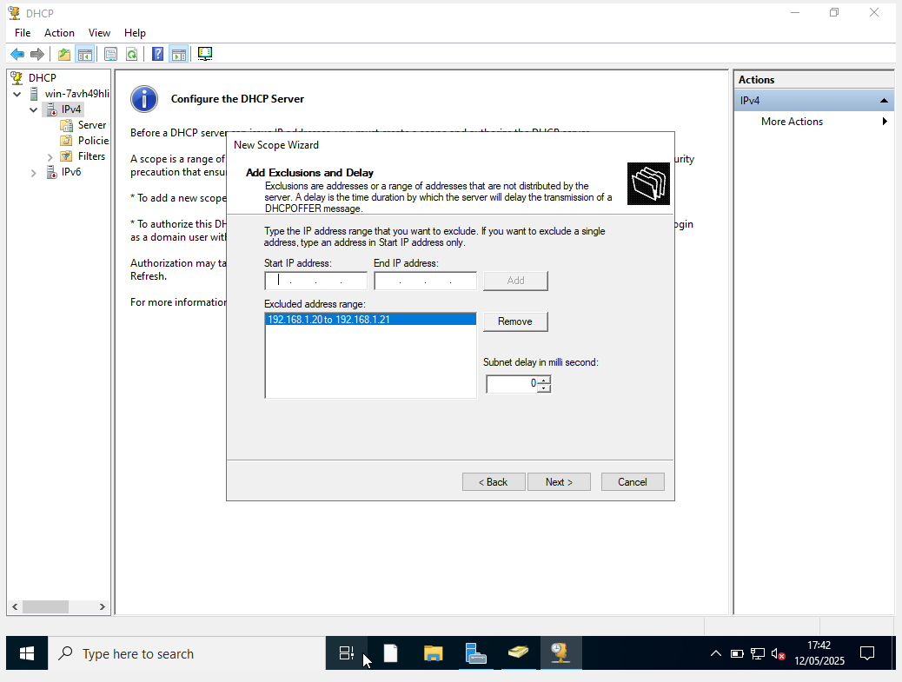
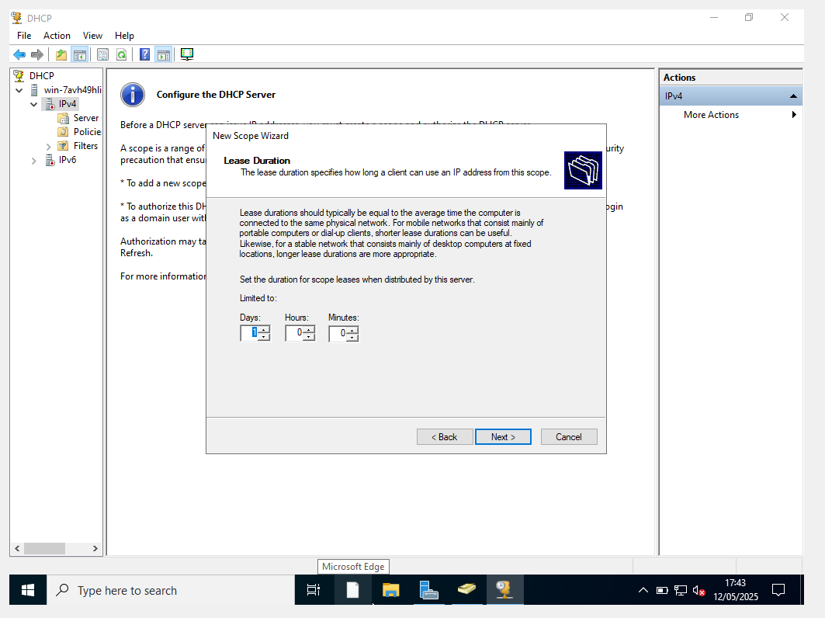

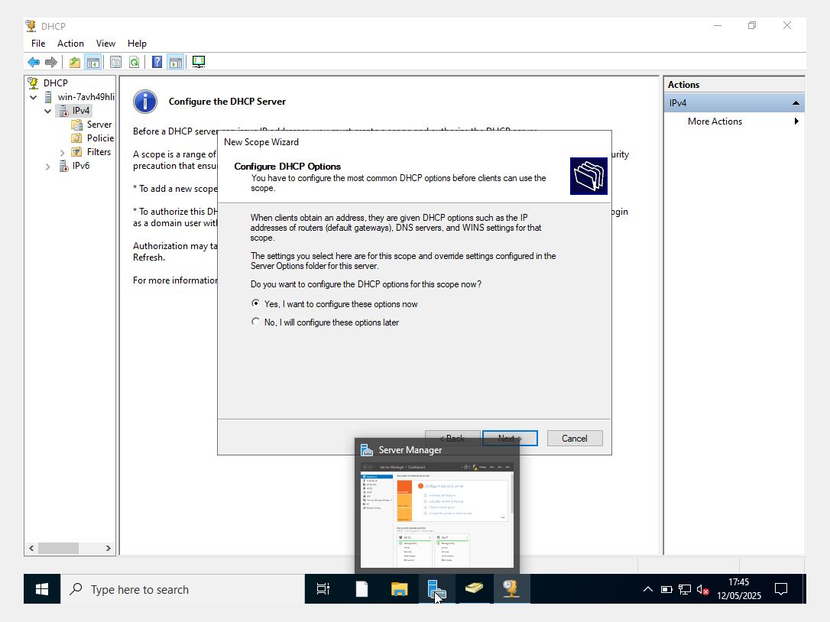

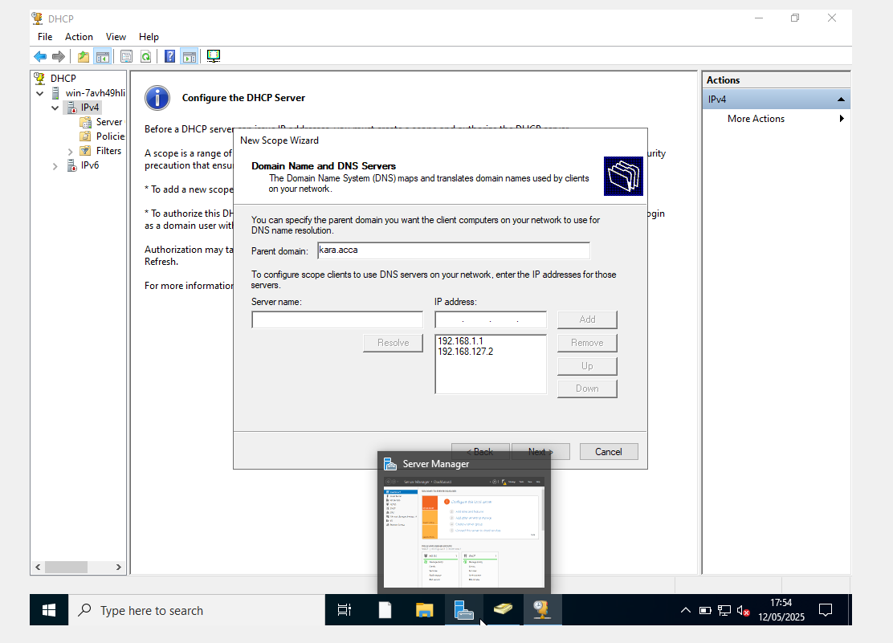

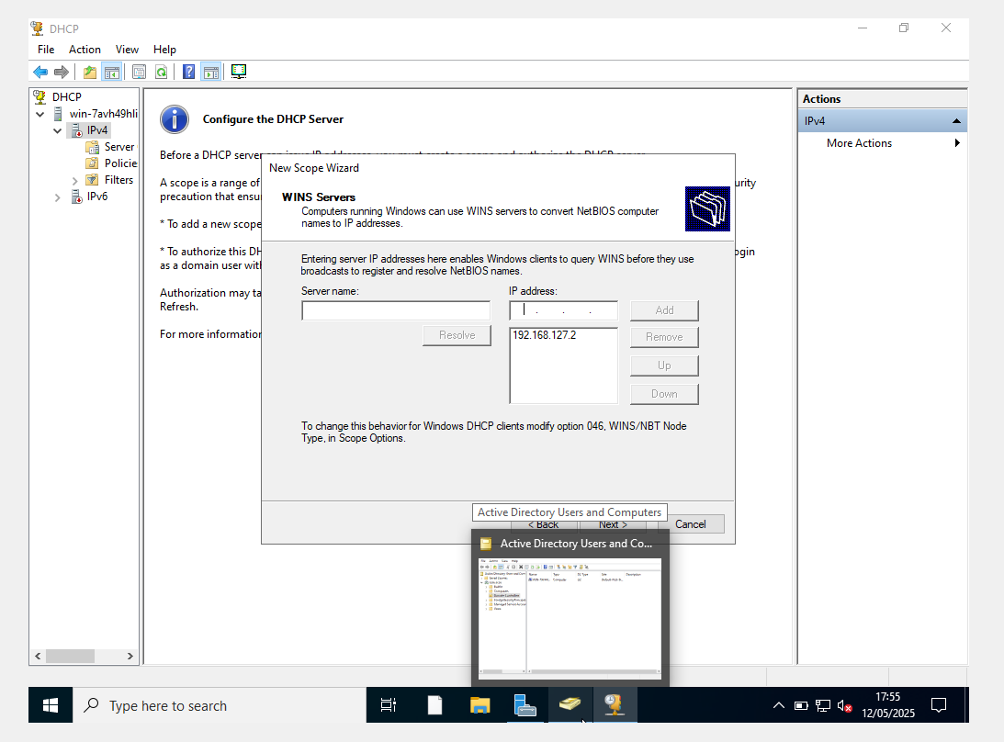
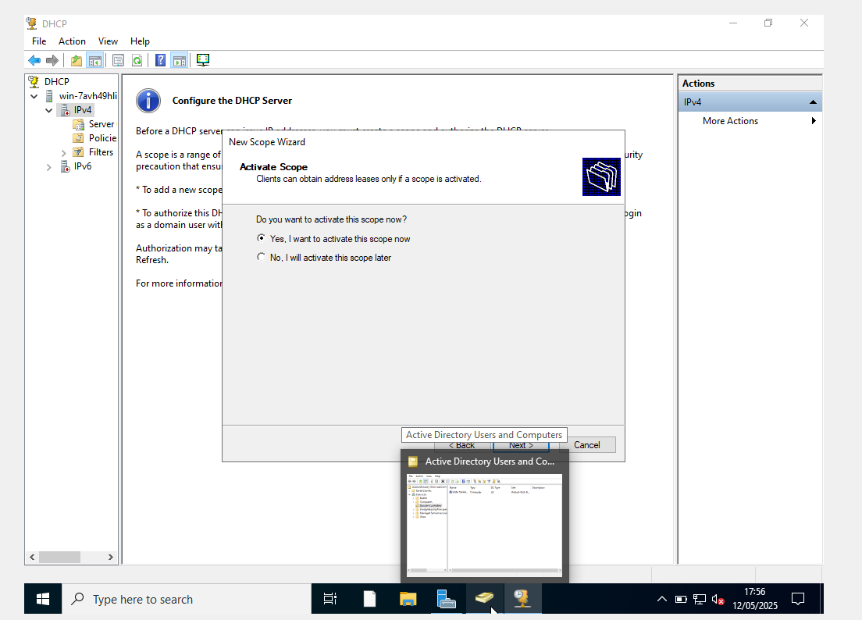
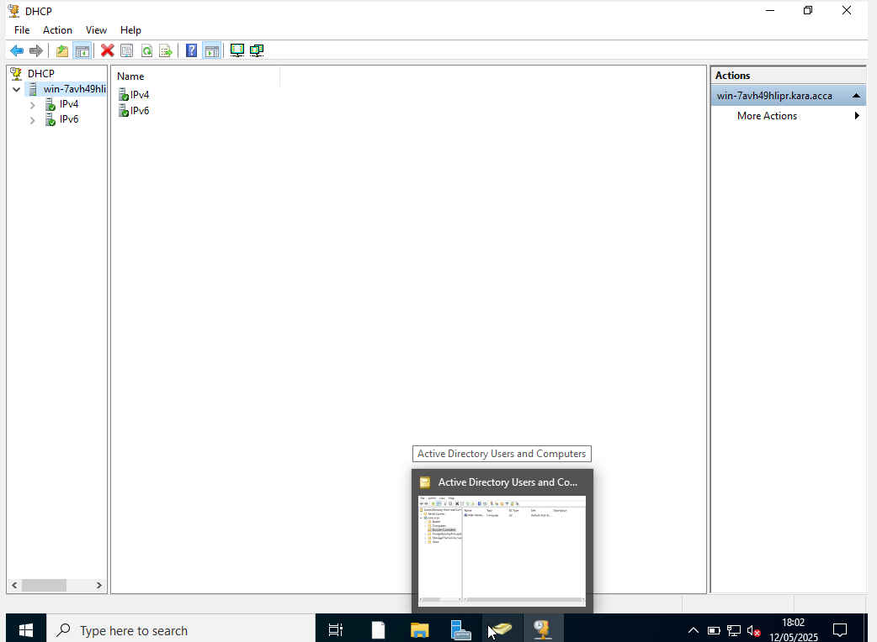

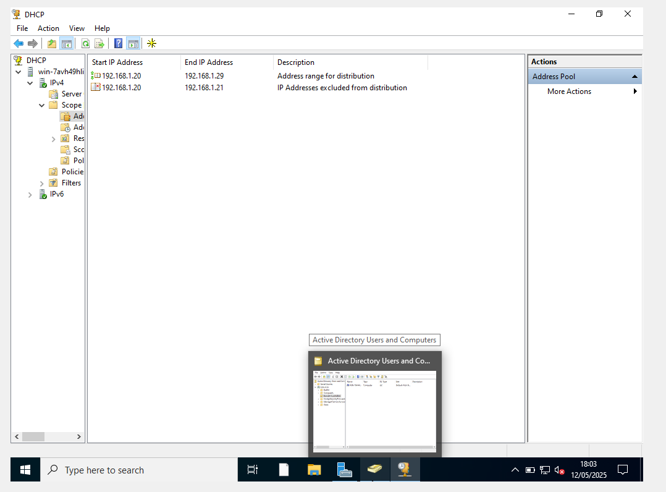

1.9. Join the ClientS1 to yourname.acca domain.
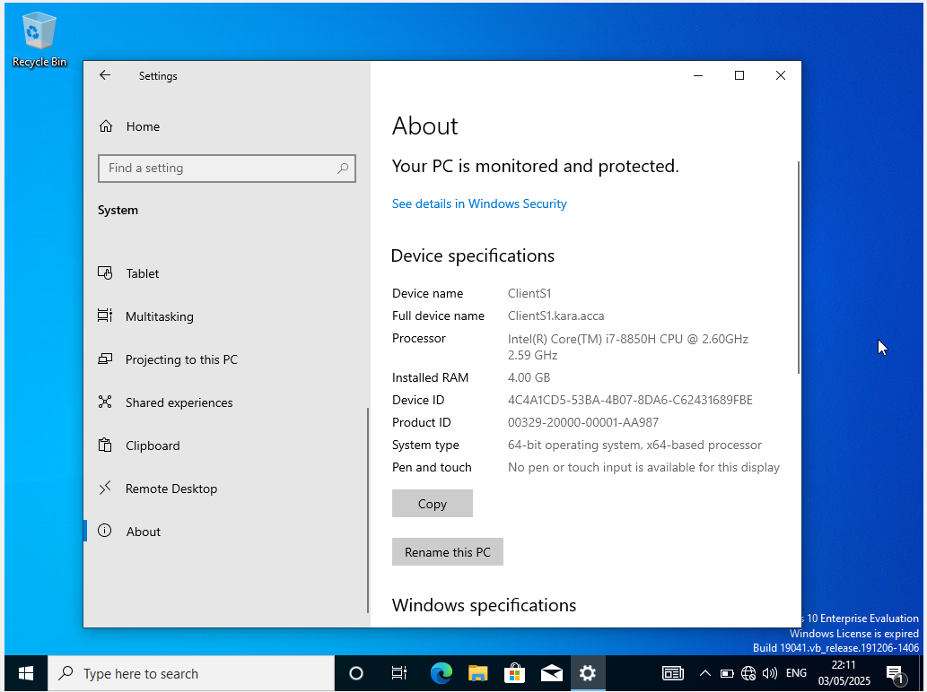

1.10. Assign ClientS1 with DHCP IP Address.
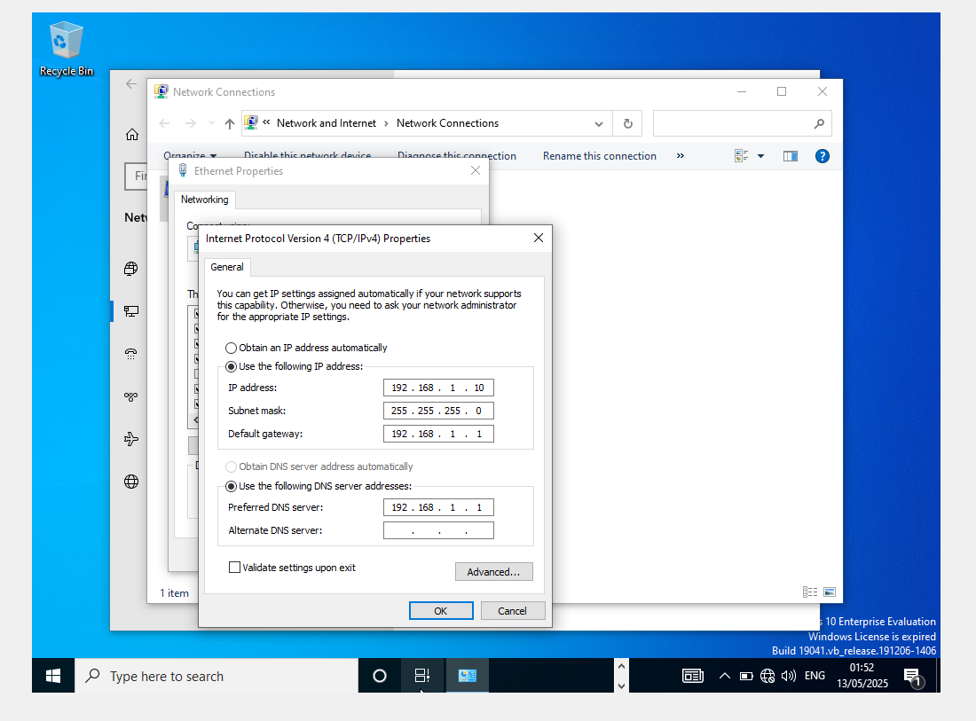
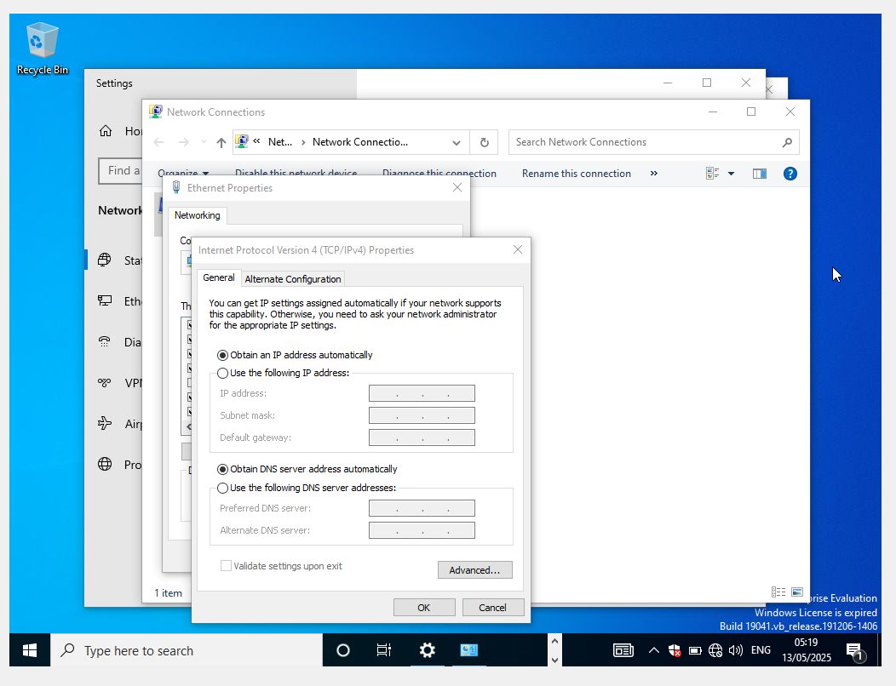
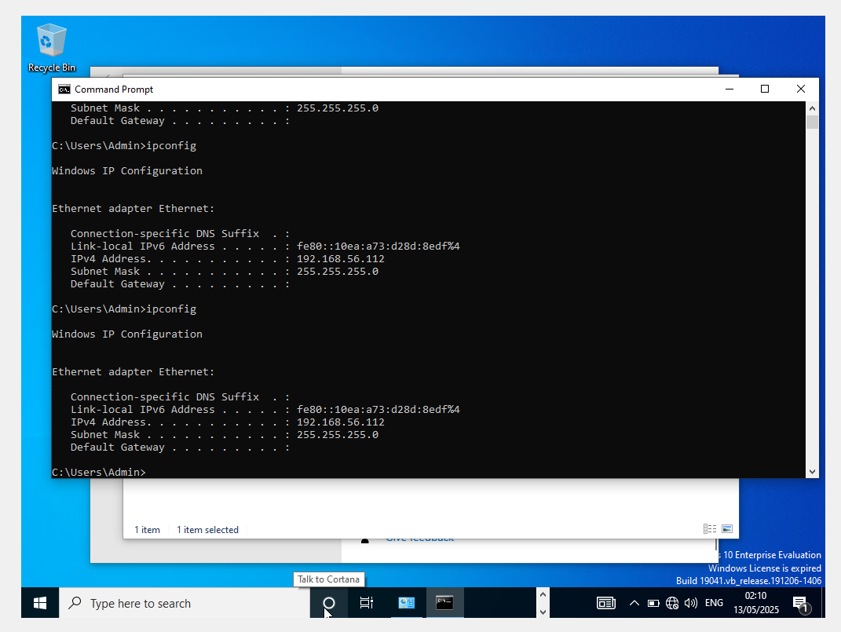

2. In Cardiff Network,

2.1. Install Routing and Remote access Service (equivalent) and modify firewall rules to allow ICMP Traffic.
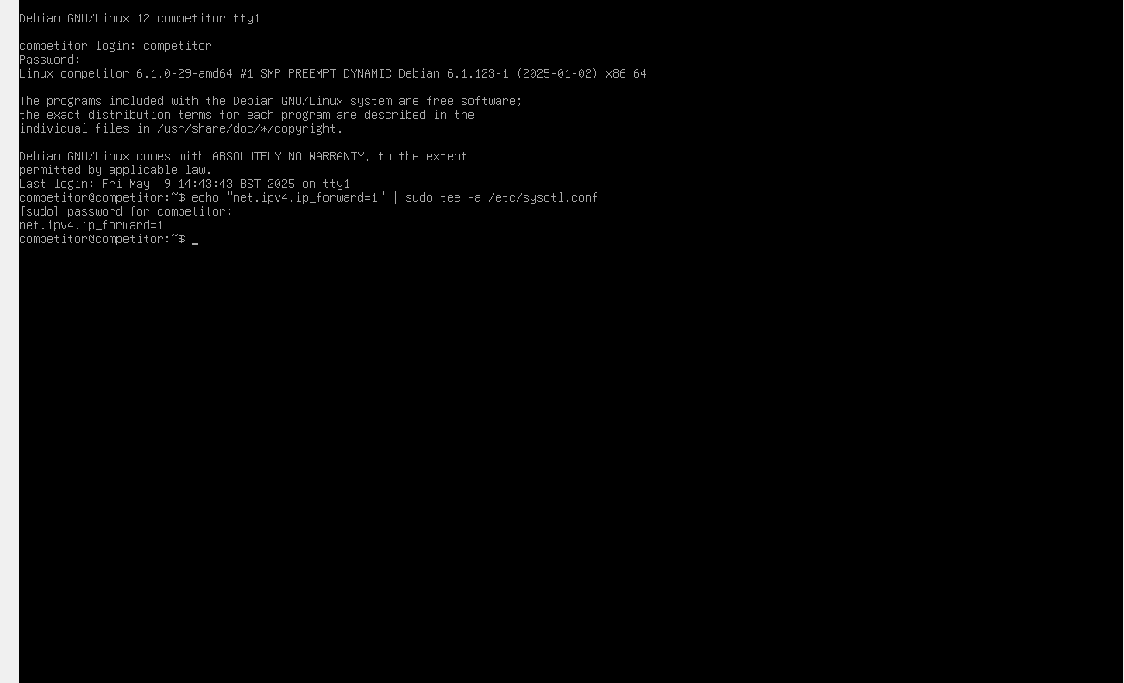
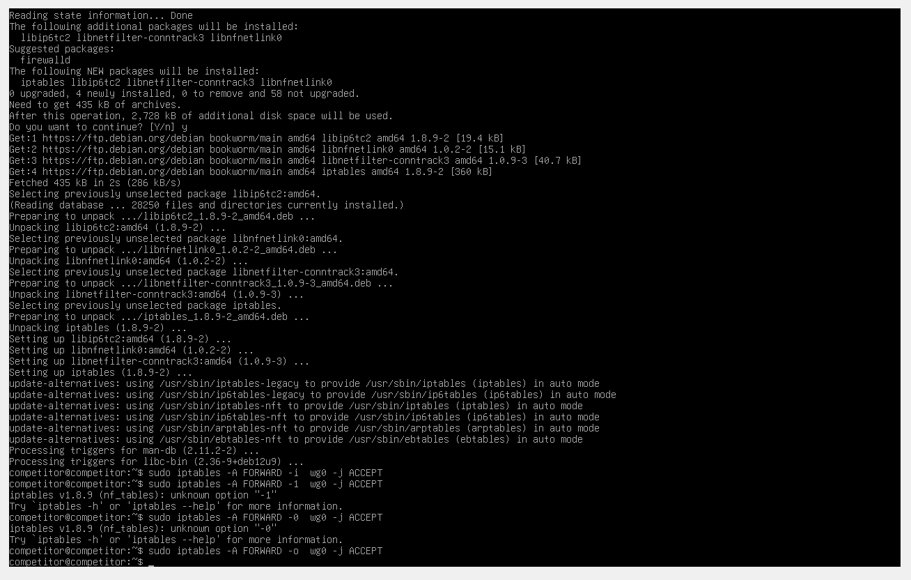
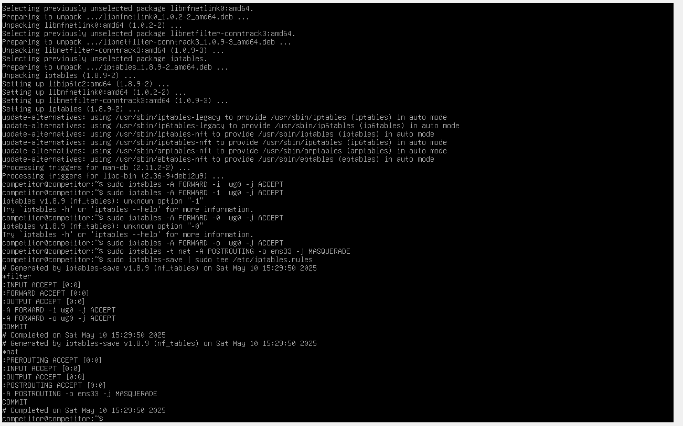

2.2. Configure Site-to-Site VPN to Swansea Network. Set the connection type to “persistent connection”.

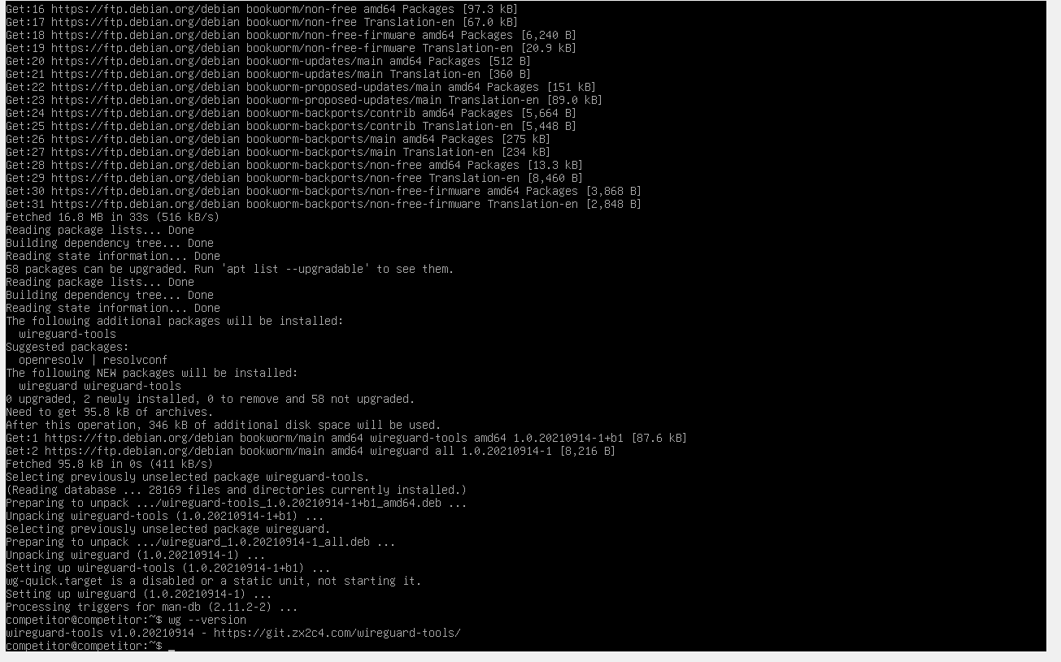
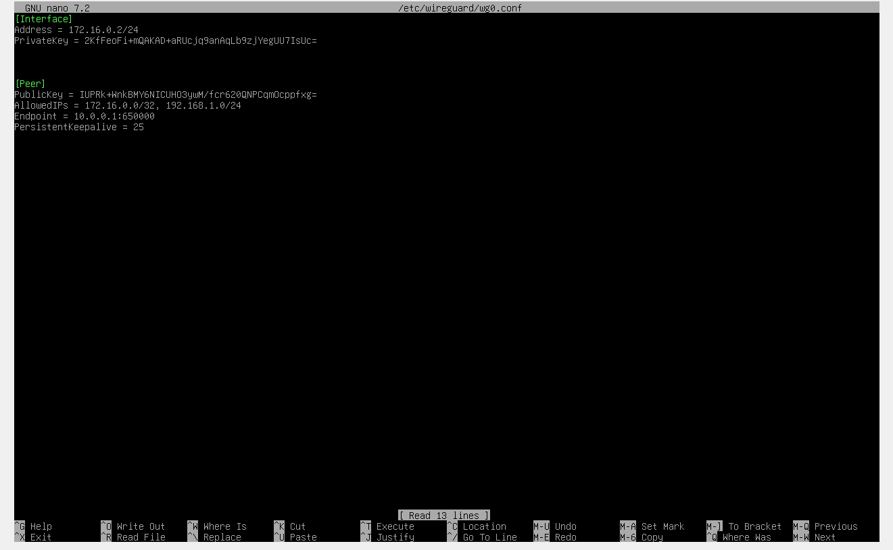
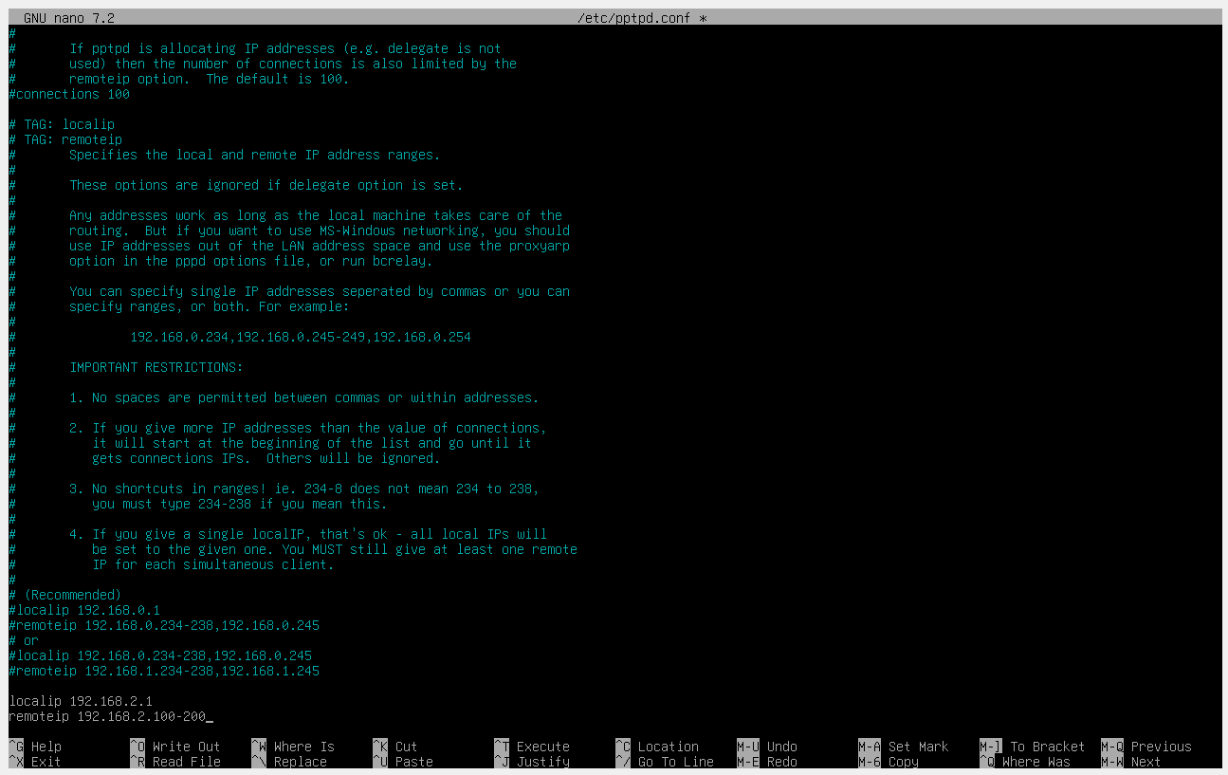
/etc/pptpd.conf

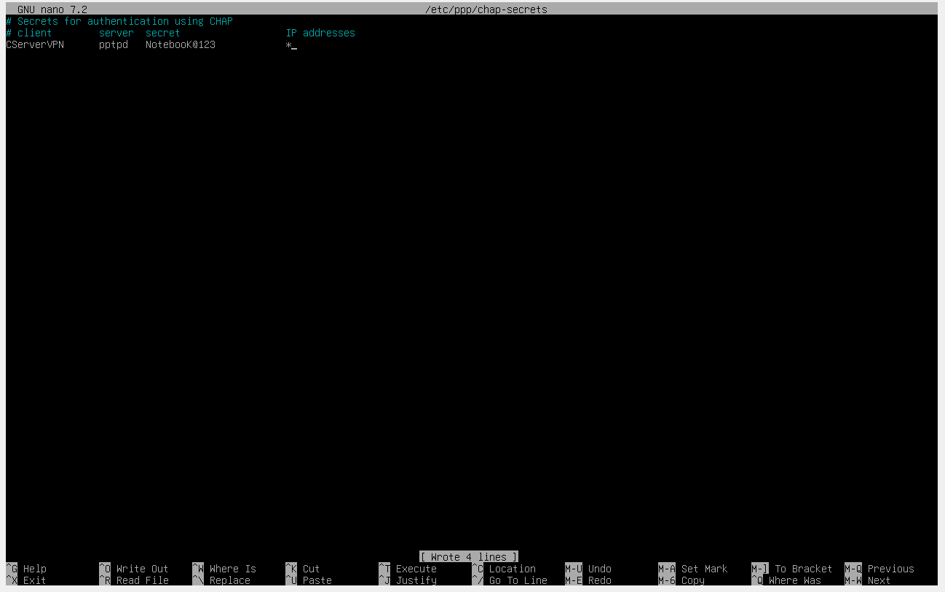
/etc/ppp/chap-secrets

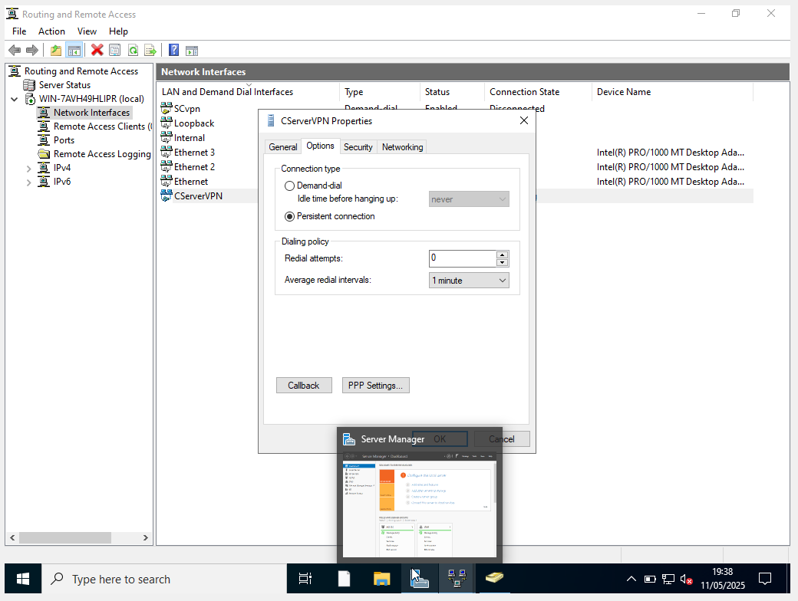

2.3. Join devices in this network to the yourname.acca domain.
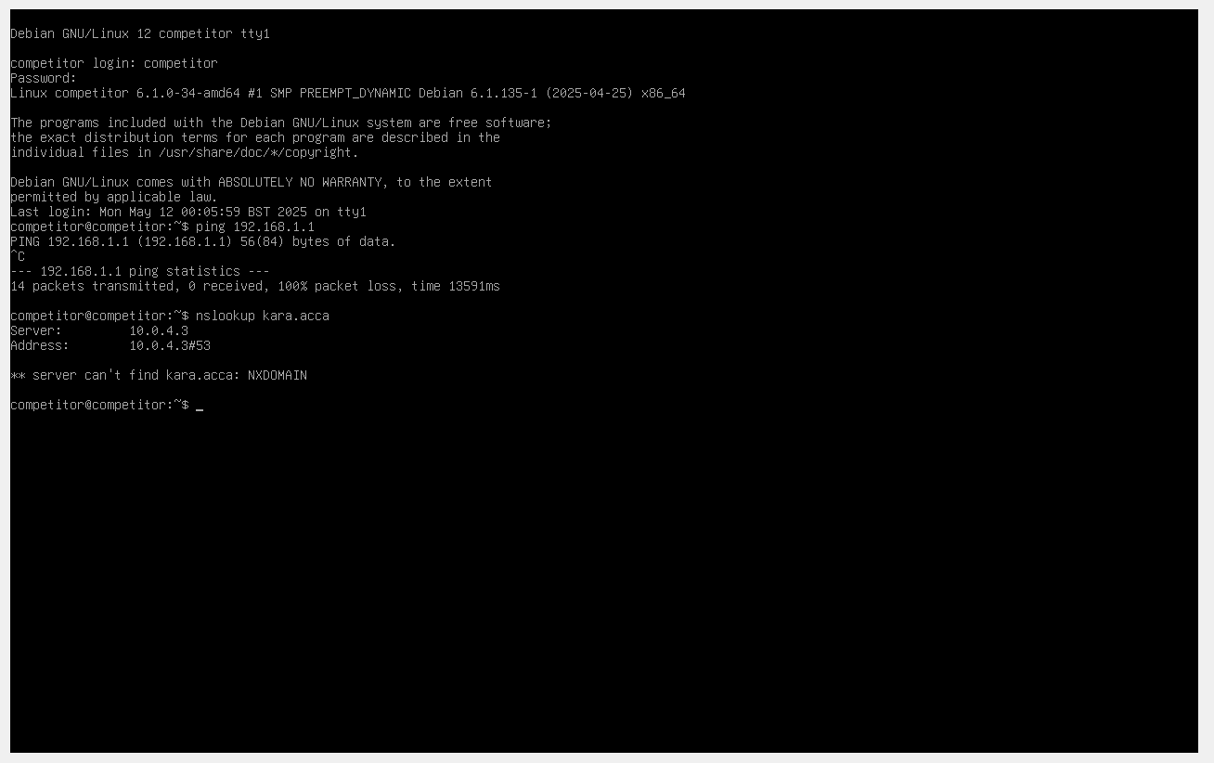
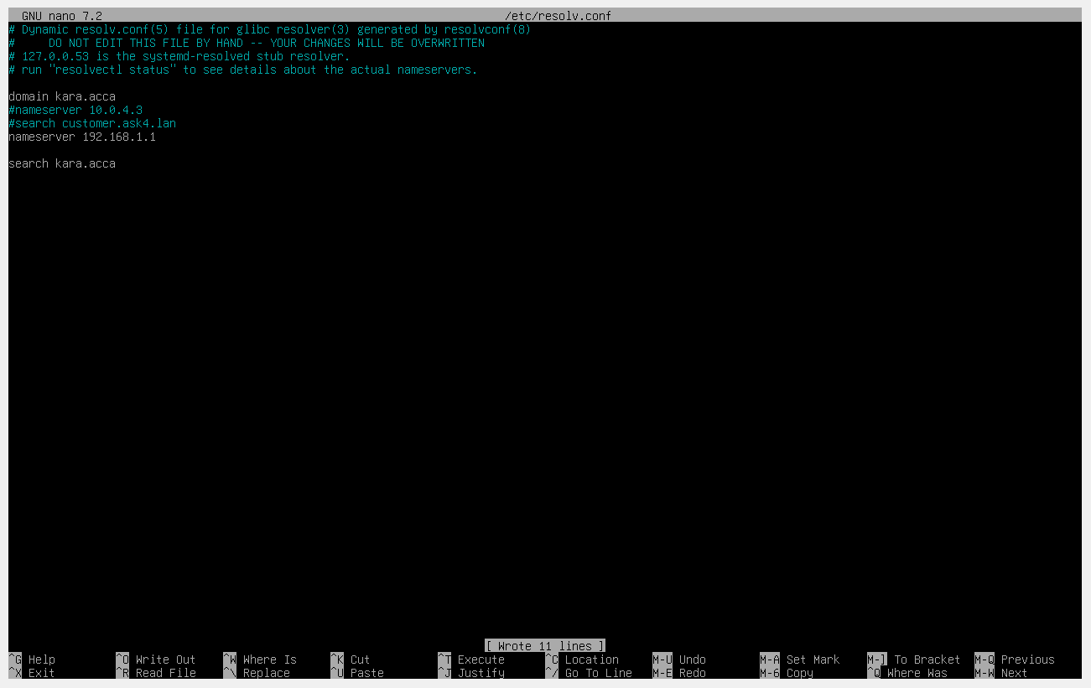
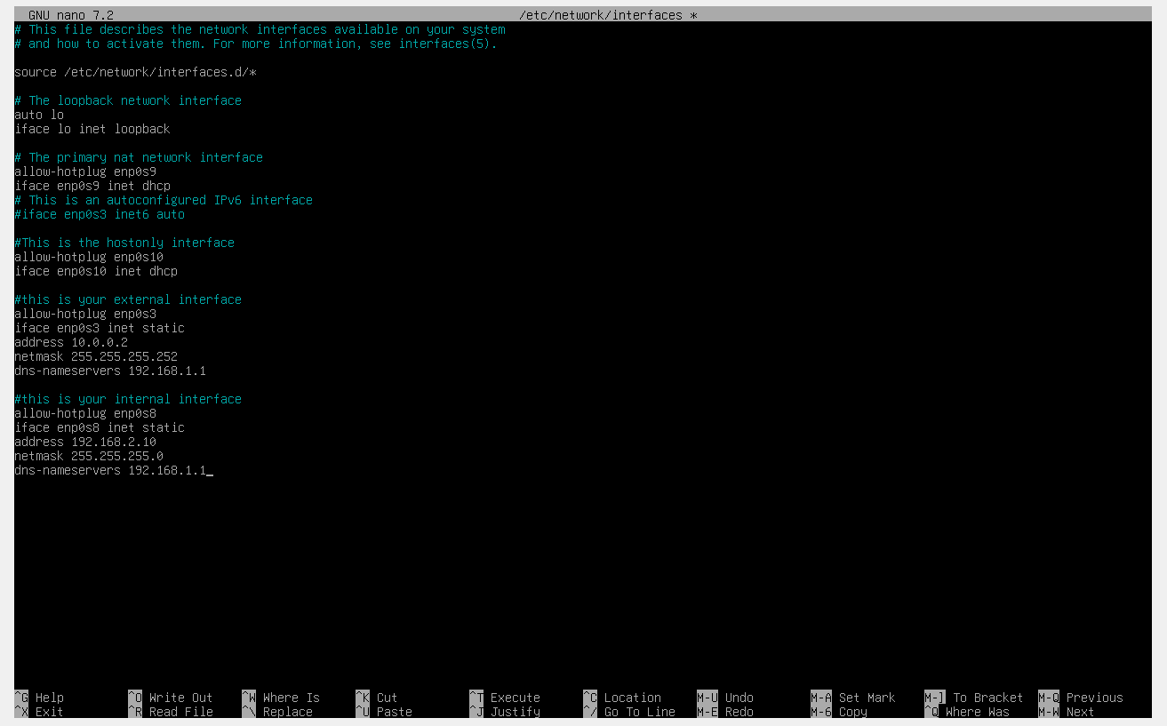

2.4. Configure DHCP Services. The range is 10.1.1.10 – 10.1.1.20. Determine other DHCP options as per the infrastructure.

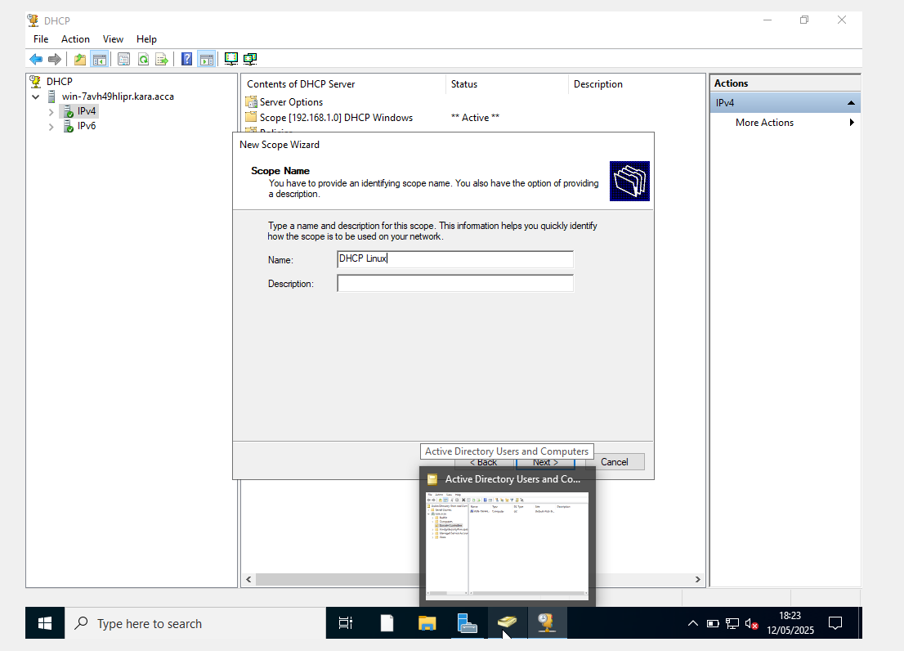

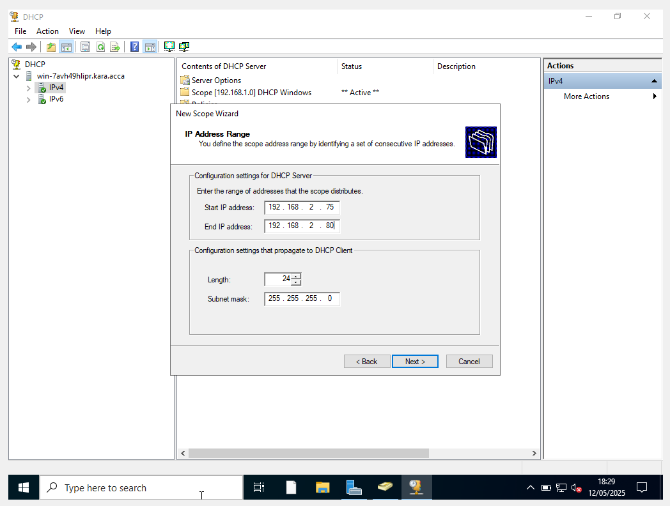
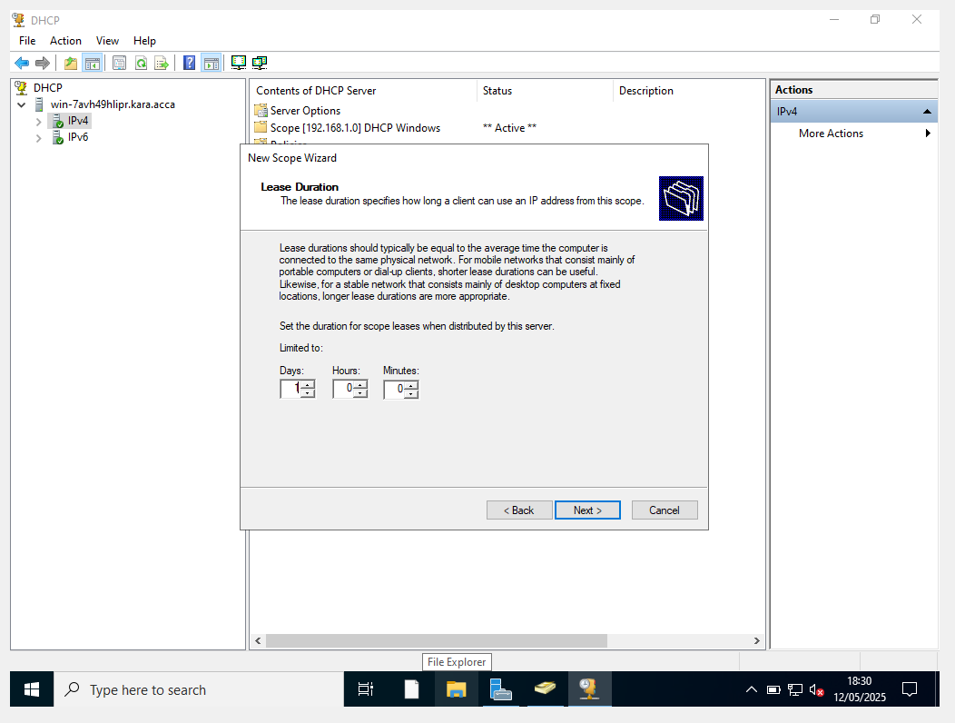
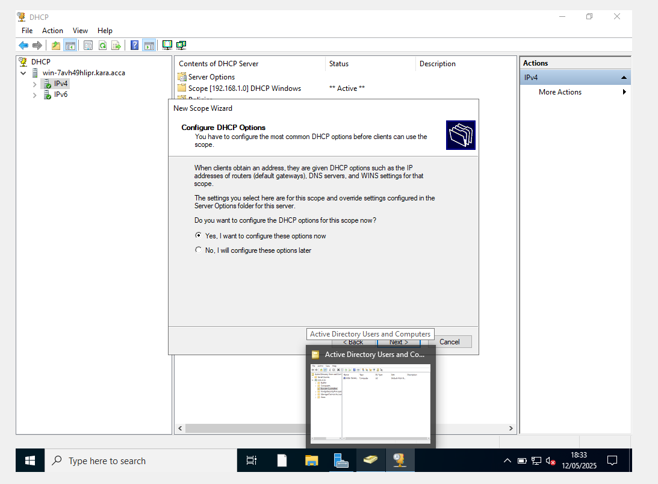
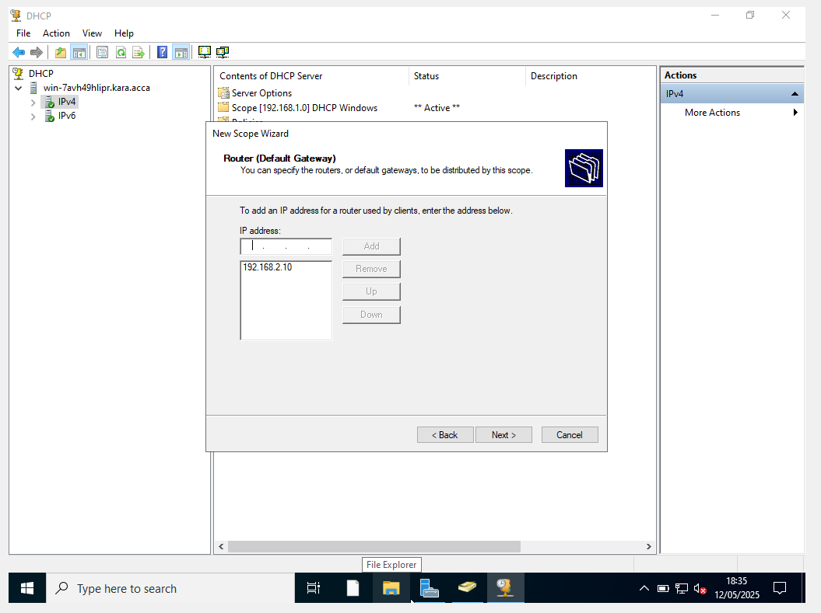

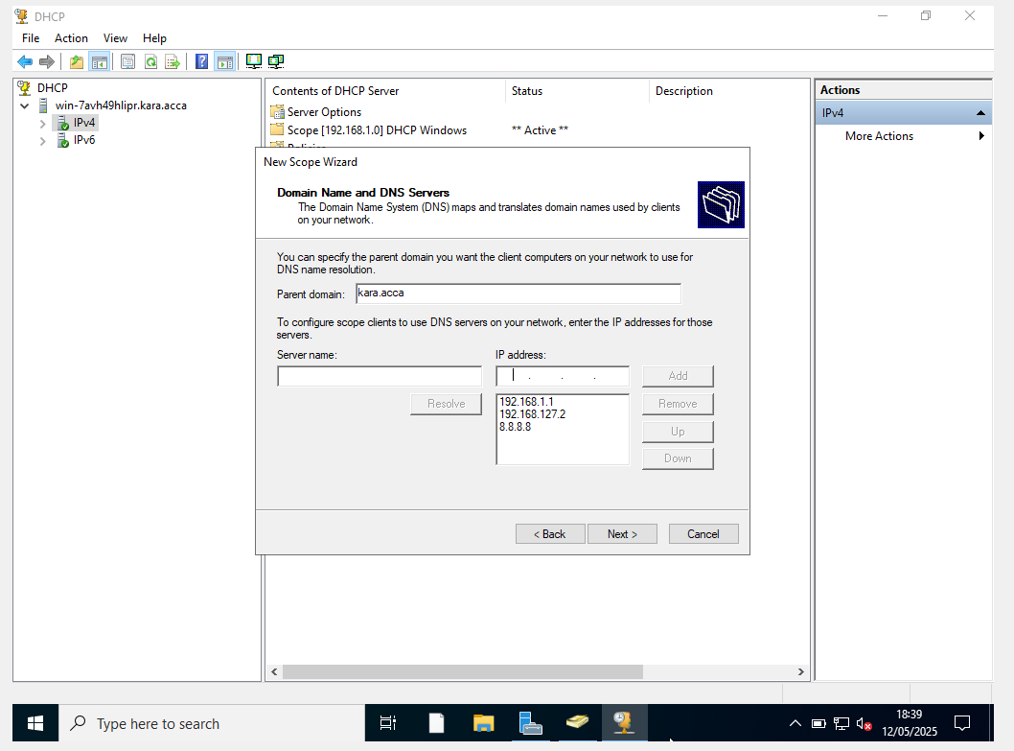

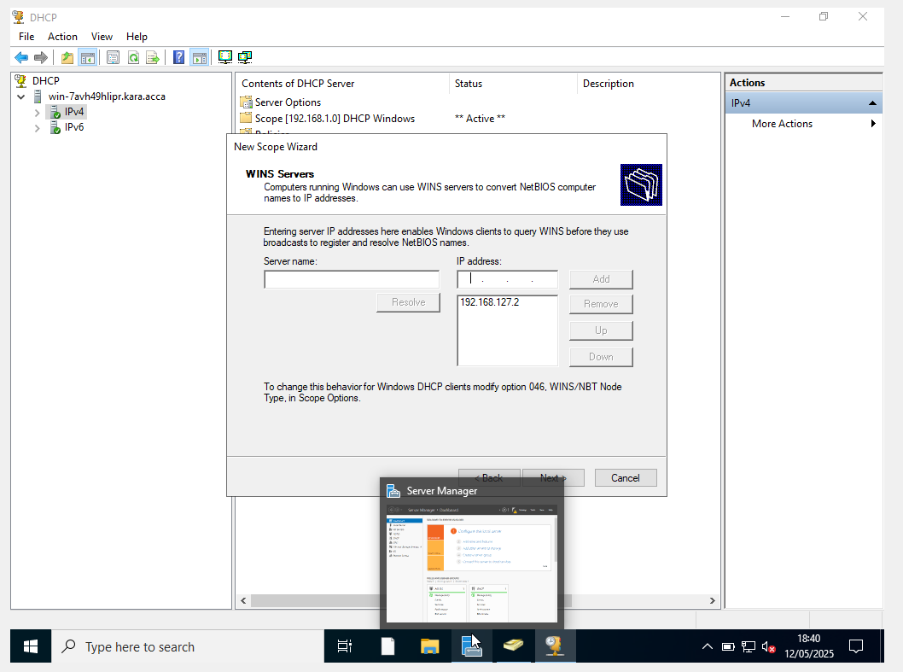
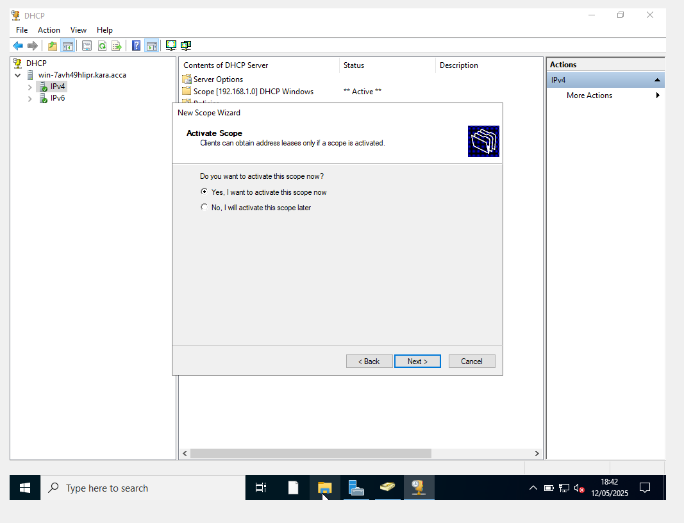
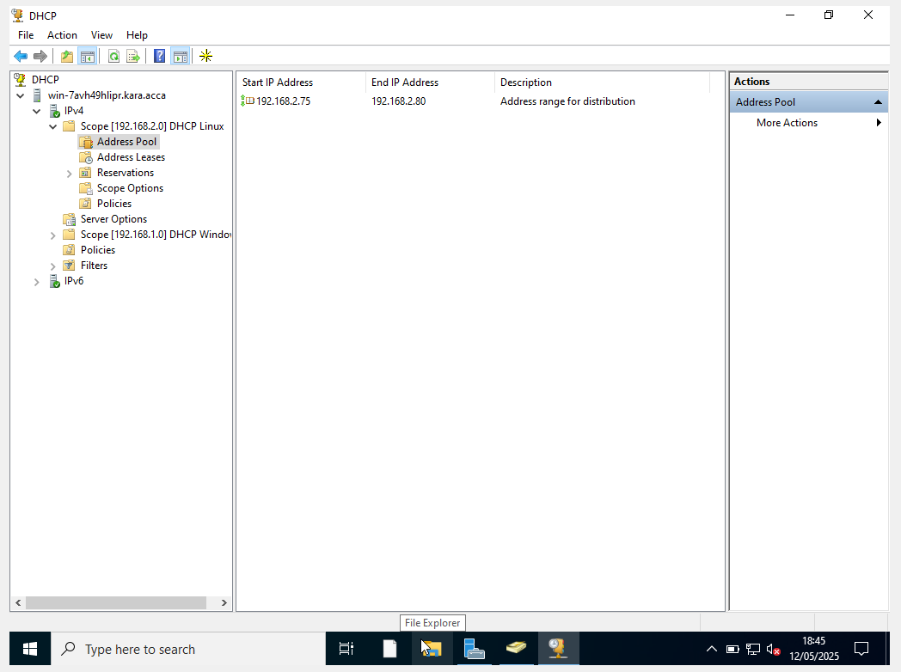

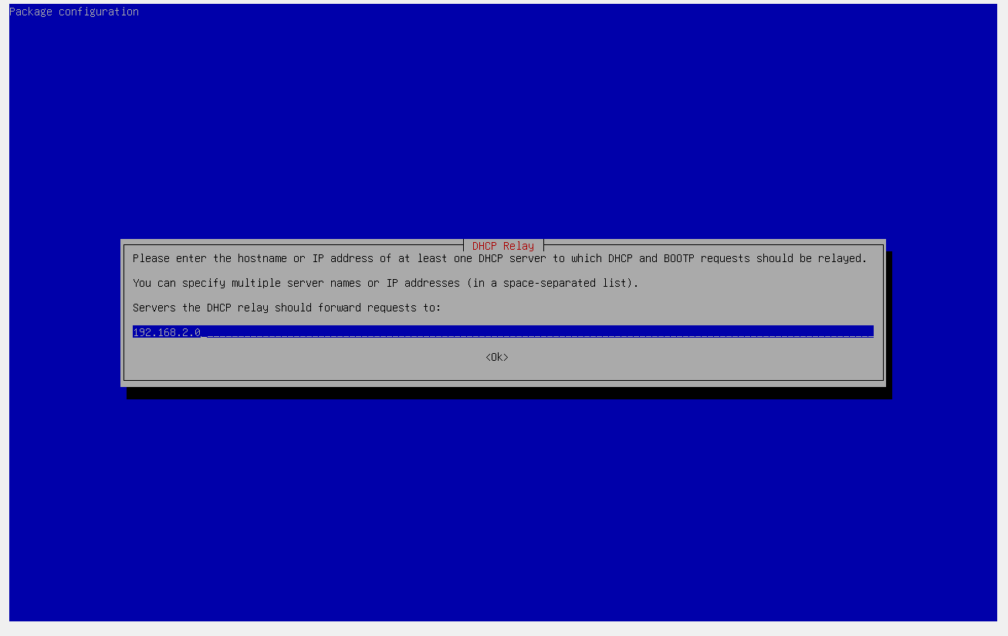
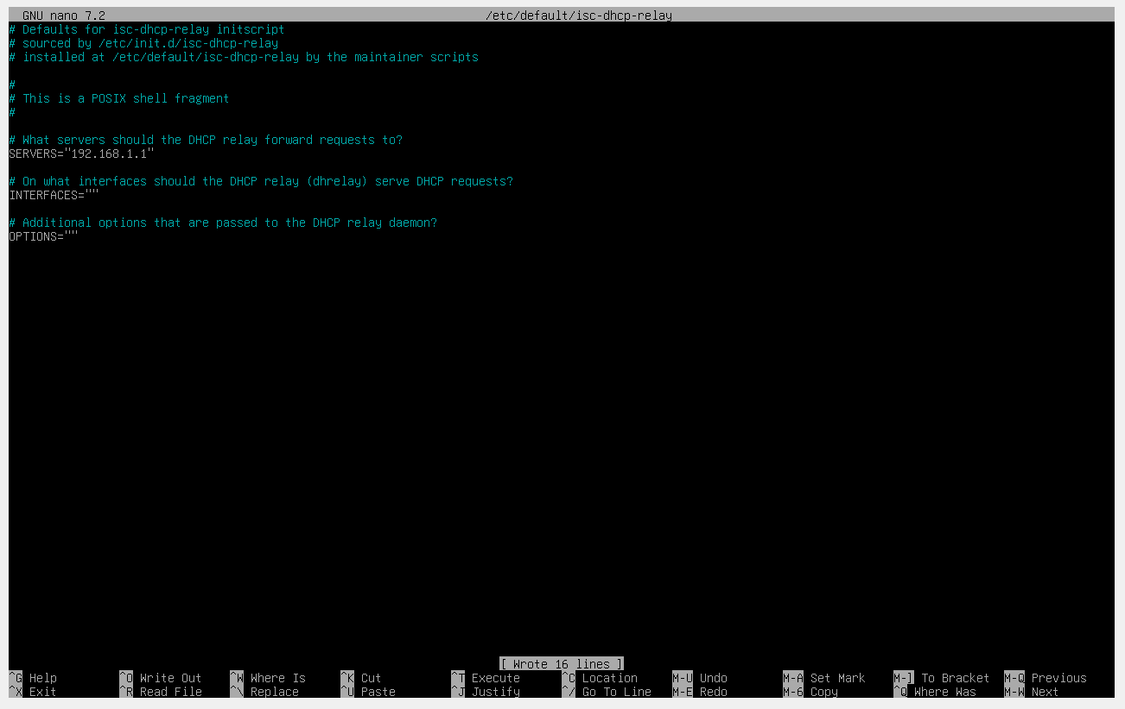
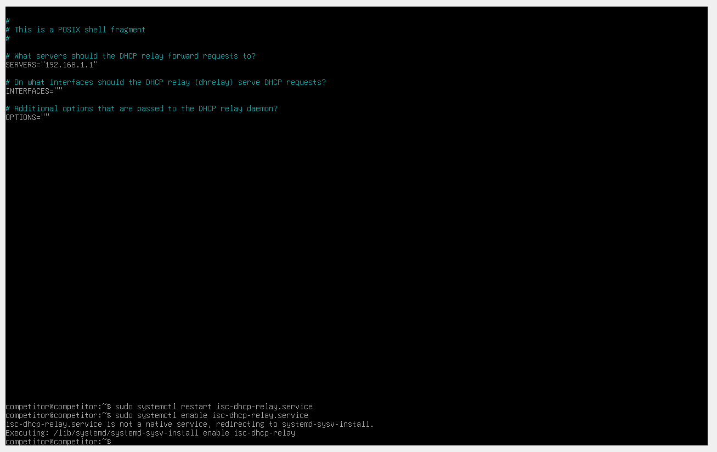
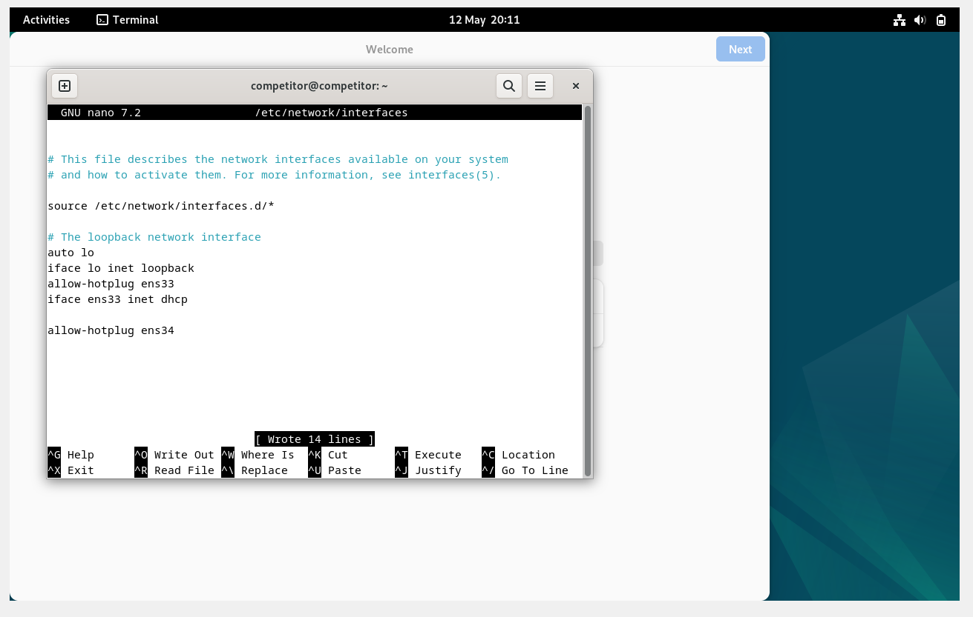

6. Remote Desktop Services: Configure remote access for S-DC from any other machines in the network. Make sure that the Remote Desktop Services login page should be accessed via https://rds.yourname.acca and necessary certificates are signed.


