Synthesize a Solution to a Potential Real-life Scenario
Jacob Moseley
BSc Software Engineering
University of Wales Trinity Saint David
Swansea, United Kingdom
2317034@student.uwtsd.ac.uk
Abstract - This report presents a comprehensive cybersecurity strategy for FinSecure Ltd, a financial services provider facing a range of both internal and external threats. Key vulnerabilities include threats form phishing attacks, the misuse of personal devices and malicious insiders. In response, the report proposes security policies aligned with gloabally recognised standards such as ISO 27001, NIST, and GDPR, which are furher supported by targeted mitigation methods. A structured incident response plan and continuous monitoring system are also outlined, alongside a staff training programme to reduce human error. Together, these measures offer a layered, organisation-wide approach with the aim of improving FinSecure’s cybersecurity and safeguarding in regard to sensitive financial, company and client data.
I. INTRODUCTION
In the digital age cyber security has emerged as a major concern for businesses worldwide, particularly in the financial sector where the protection of sensitive information is of utmost importance. With the growth of remote work and online connectivity, organizations are under increasing pressure to secure their networks and digital assets from increasingly sophisticated cyber-threats. FinSecure LTD (FSL), a financial services provider, has recently experienced a series of incidents, ranging from phishing attacks to unauthorized access attempts on its network, exposing threats within FSL’s security policy.
This report aims to develop a comprehensive cybersecurity solution for FinSecure LTD, addressing both internal and external threats. By first identifying the key threats facing the organization, followed by the proposal of robust security policies, this report outlines a multilayered approach to safeguarding FSLs infrastructure. These policies are supported by mitigation techniques designed to reduce vulnerabilities within their network and reduce the risk of further breaches and incidents. In addition, this report shall also outline an employee training and awareness program, ensuring staff are equipped with the skills necessary to recognize, prevent, and appropriately address potential cyber threats.
II. IDENTIFICATION OF THREATS
As a financial services provider, FinSecure LTD is a prime target for a wide range of cyber security threats. These threats can be classified as both internal and external, each posing significant risks to sensitive data.
A. Internal Threats
Internal threats arise from within an organisation and may be intentional or unintentional. Examples include employees falling victim to phishing emails scams, using weak passwords or accessing sensitive data from unsecure and unauthorized devices and software. Cloud infrastructure is also a point of interest for hackers, where misconfigured permissions can be an entrance for those with the wrong intentions [1]. A more intentional example would be an employee with malicious intent using their position in an attempt to steal or damage data.
B. External Threats
External threats originate from outside of an organisation and tend to be more complex in nature. These attacks can range from forms of social engineering such as phishing campaigns and impersonation to more sophisticated attacks using software bugs, malware. The loss of and corruption of sensitive data is not the only threat faced by FSL. Cyber criminals may also aim to disrupt FSLs operations through Distributed Denial of Service (DDoS) attacks, using large botnets with the aim of overwhelming their network [2].

C. Threat Overview
To provide a clear overview of the risks faced by FinSecure LTD, threats have been grouped into three key threat domains. Each domain is vulnerable to specific internal and external threats as show in Figure 1.
Threat Domain | Internal Threats | External Threats
Individuals | - Employees falling for phishing scams  - Weak passwords  - Malicious insiders | - Phishing campaigns  - Social Engineering tactics such as impersonation
Devices and Networks | - Use of unauthorised devices to access FSL infrastructure | - DDoS attacks on the network
Cloud Infrastructure | - Accessing sensitive cloud data via unsecure connections  - Misconfigured cloud permissions
Software | - Use of unverified software | - Exploitation of software bugs  - Malware making its way into the network
[Figure 1]
These classifications shall serve as the foundation for the development of FinSecure LTD’s cyber security policies, mitigation methods and staff training programs. Each domain shall be addressed in order to provide an organization wide, layered approach to cyber security.
III. SECURITY POLICIES
In regard to cyber security, a security policy generally refers to a set of guidelines and procedures designed to protect an organizations digital assets and data from cyber threats [3]. These policies form internationally recognised standards such as ISO 27001, NIST and GDPR. Implementing these policies is essential in order to mitigate both internal and external threats, as identified in the previous section.
A. Access Control Policy
Access control is a security mechanism that regulates who or what can view or use resources in a computing environment and is essential to an organisation like FSL where the security of data is paramount. This is achieved through a process of verifying users, determining appropriate access levels and restricting unauthorized access to sensitive data [4] as outlined in ISO 27001 Annex A.9.4.1. In accordance with Annex A.9.4.2, FSL should also look to implement security measures such as multi-factor authentication to add an extra layer of security in the event an employee’s password is compromised. Furthermore, following Annex A.9.4.3, the use of a password management system should be adopted to ensure strong password creation and practices [5].
B. Data Protection Policy
To comply with GDPR Articles 5 and 32 as well as ISO 27001 Annex A.8, FinSecure must establish robust procedures aimed at protecting both the personal and financial data of clients and the organisation itself [6]. This means taking steps to ensure that data is encrypted while at rest and in transit, limiting access to data on a need-to-know basis and securely disposing of outdated records in line with A.8.3.2 [7].
C. Incident Response Policy
Following ISO 27001 Annex A.16 and NIST SP 800-61, this policy outlines procedures for identifying, reporting, and responding to cybersecurity incidents. Within accordance to A16.1.2, in the event of an incident, staff within the FSL must be trained to report suspected breaches immediately. A response team should be put in place in order to contain and resolve incidents effectively, with logs available for post-incident analysis with the aim of preventing incidents of a similar nature as stated within Annex A.16.1.6 [8].

D. Device Usage Policy
Based on ISO 27001 Annex A.6.2.1, this policy regulates access to FSLs network from personal devices. This policy involves applying strict restrictions on the types of software that can be installed on devices, as well as ensuring that devices can be wiped remotely in the event of a loss and making sure employees are aware that personal devices can only be used if they meet the security requirements of FinSecure LTD. Employees should also be informed of the dangers of using mobile devices in public, such as connecting to ‘free’ Wi-Fi that could compromise data, as well as less technical risks like uninvited observers viewing their screen [9].
These policies form FinSecure LTD’s cyber security strategies and form the groundwork for the following targeted mitigation and training initiatives.
IV. MITIGATION METHODS
Mitigation measures translate FinSecure LTD’s security policies into an effective defence against cybercrime. Each measure below targets a specific risk, ensuring safeguards are in place for a wide range of threats.
A. Access Control Mitigation
To combat against insider misuse and unauthorised access, FSL should look to implement role-based access control (RBAC) in order to restrict the network access of employees based on their role [10]. The implementation of RBAC would both improve data security and enhance compliance with data protection regulations [11]. The addition of phishing resistant multi-factor authentication (MFA) such as passkeys, where credentials are tied to genuine websites and cannot be used elsewhere, would also add a strong barrier against credential theft via methods such as phishing [12]. Furthermore, deploying a password manager ensures staff generate and store complex passwords securely, reducing brute-force and reuse risks.
B. Data Protection Mitigation
In order to protect against data theft or leakage, outdated records and storage devices should be both wiped and destroyed. By limiting access to data through RBAC, potential breaches can also be contained within smaller areas in the event of insider misuse or unauthorised access to the network. Data should also be encrypted through methods such as the Advanced Encryption Standard (AES) which can range from a 128-bit form to keys as large as 256 bits for more heavy-duty encryption purposes, perfect for an organisation such as FSL where large amounts of sensitive data are held [13].
C. Incident Response Mitigation
To respond effectively to cyber incidents, FSL should aim to implement a Security Information and Event Management (SIEM) system that can be used to log events within a network, such as failed logins and unfamiliar IP addresses, and use this data to detect signs of an attack, threat or breach [14]. These logs can be used in post incident reviews in order to refine procedures and avoid repeat incidents.
D. Device Mitigation
To prevent threats stemming from personal devices, FinSecure FSL should ensure that all devices that connect to their network meet strict security requirements. These requirements include ensuring employees are aware of what software can be installed on devices that connect to FSL’s network. These devices must include the ability to be wiped in the event they are lost or stolen. These measures also ensure that former employees don’t have access to sensitive information in the event that they leave the organization [15]. Further steps could be taken to only allow employees to access FSL’s network from company devices, such as work phones that have been configured with software such as antiviruses and activity loggers.
These measures collectively ensure FinSecure LTD’s policies translate into real-world protection.
V. MONITORING AND RESPONSE
Effective cybersecurity requiremes not only strong policies and mitigation methods, but also continuous monitoring and the ability to respond with haste in the event of an incident. In order to protect both its network and sensitive information, FinSecure LTD’s must implement an effective monitoring and incident response system in order to detect abnormalities, minimise damage and prevent reoccurrences.

A. Monitoring Tools and Techniques
As mentioned in the previous section, FSL should deploy a Security Information and Event Management (SIEM) system to collect and analyse data within their network. This includes events from firewalls, servers and user activity which allow FSL to identify threats before they escalate.
B. Incident Response Plan
An incident response plan informs IT and cybersecurity professionals of the steps to take in the event of a breach or leak of sensitive information. Below are six steps that FinSecure LTD should look to implement in order to prevent, defend and learn from cyber security incidents within the organisation [16].
- Prepare - Develop policies, assign response roles, and train staff to ensure FSL is ready to handle security incidents. Organise simulations in order to further prepare employees.
- Identify - Detect and confirm potential security events using monitoring tools, logs, and alerts through tools such as SIEM.
- Contain - Take immediate steps to isolate affected systems and prevent further damage. This may include taking systems offline, blocking malicious activity and creating both a long- and short-term strategy.
- Eradicate - Remove malicious software, patch vulnerabilities, and update systems to eliminate the root cause. Perform thorough checks to ensure no threats remain.
- Recover - Restore affected systems back to normal operation after verifying they are secure. Monitor systems closely during and after recovery to prevent recurrence.
- Lessons Learned - Conduct a post-incident review to evaluate the response and identify areas for improvement. Use findings to strengthen future incident response procedures.
This process should be visually mapped and communicated to all relevant staff. See Figure 2 for a simplified incident response flowchart.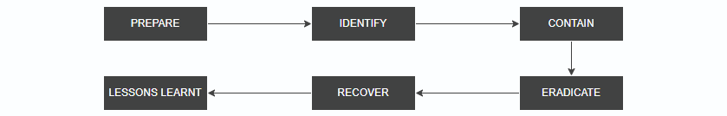[Figure 2]
C. Accountability and Logging
All actions during an incident should be logged and timestamped to support investigation, reporting and compliance with ISO 27001 Annex A.16 [8]. Regular internal penetration testing should be scheduled in order to test the effectiveness of the monitoring and response plan and process.
VI. TRAINING AND AWARENESS
An effective cybersecurity strategy relies not only on technical controls, but also the awareness of threats within employees of FinSecure LTD. As highlighted throughout this report, many of the risks faced by FSL such as phishing and the misuse of devices stem from human error. In order to combat this, implementing a structured training and awareness programme is critical for ensuring compliance with security policies and reducing internal threats.
In line with ISO 27001 Annex A.7.2.2, FSL should develop a programme with the aim of educating all employees about their responsibilities in maintaining cybersecurity. This programme should be introduced during onboarding and reinforced through regular training sessions and assessments [17].
These training sessions should cover topics such as:
- Identifying phishing emails and social engineering tactics
- Secure password practices and MFA usage
- Proper handling of sensitive data
- Safe use of personal devices and software
- Incident reporting procedures
Interactive methods such as simulated phishing campaigns and online lectures can help to reinforce these principles. Managers and IT administrators should receive more in-depth training regarding areas such as incident response and system monitoring in order to reinforce these principles within their team members.
Ultimately, fostering a security-conscious culture within FinSecure is key to the long-term success of its cybersecurity measures. By equipping employees with the correct knowledge and mindset, the organisation can greatly reduce its vulnerability to both internal and external threats.
VII. CONCLUSION
In today’s digital landscape, cybersecurity is essential for safeguarding sensitive data, particularly within the financial sector where the risks and consequences of breaches, data loss, and operational disruption are high. This report has explored the challenges facing FinSecure Ltd, including both internal and external threats such as phishing attacks, unauthorised device usage, and malware.
To address these challenges, a set of structured security policies were proposed, grounded in internationally recognised standards including ISO 27001, NIST, and GDPR. These policies were supported by targeted mitigation techniques to reduce technical vulnerabilities and limit exposure across FinSecure LTD’s network. A comprehensive monitoring and response plan was also outlined, providing a framework for detecting incidents early and responding in an efficient manner. Finally, the importance of employee training and awareness was highlighted, recognising that even the strongest technical defences can be undermined by human error. By adopting this layer approach, FinSecure LTD can minimise the threat and impact of cyber incidents, protecting both client and company data in an increasingly hostile digital environment.

VIII. REFERENCES
[1] E. Gibbons, “What Are Internal Threats in Cyber Security?,” Aspire Technology Solutions, Sep. 02, 2022. https://www.aspirets.com/blog/what-are-internal-threats-cyber-security/ (Accessed 05/05/2025)
[2] WithSecure, “External and Internal Threats | WithSecure,” www.withsecure.com, Apr. 24, 2023. https://www.withsecure.com/en/expertise/blog-posts/external-and-internal-threats (Accessed 06/05/2025)
‌[3] Jennifer L. Bayuk, Jason Healey, Paul Rohmeyer, Marcus H. Sachs, Jeffrey Schmidt, Joseph Weiss, “Cyber Security Policy Guidebook,” John Wiley & Sons, 2012. https://books.google.co.uk/books?id=E08UPzu42xoC&dq=what+are+cyber+security+policies&lr=&source=gbs_navlinks_s (Accessed 07/05/2025)
[4] B. Lutkevich, “What is Access Control?,” TechTarget, Jul. 2022. https://www.techtarget.com/searchsecurity/definition/access-control (Accessed 09/05/2025)
‌[5] M. Edwards, “Annex A.9 – Access control,” ISMS.online, Jun. 27, 2018. https://www.isms.online/iso-27001/annex-a-9-access-control/ (Accessed 09/05/2025)
‌[6] ChatGPT. (GPT-4o). OpenAI https://chat.openai.com/chat (Accessed 09/05/2025)
[7] “ISO 27001 Controls: Annex A.8 Asset Management,” ISO Templates and Documents Download, Jan. 20, 2023. https://iso-docs.com/blogs/iso-27001-standard/iso-27001-controls-annex-a-8-asset-management (Accessed 09/05/2025)
‌[8] M. Edwards, “ISO 27001 Annex A.16 - Information Security Incident Management,” ISMS.online, Dec. 14, 2023. https://www.isms.online/iso-27001/annex-a-16-information-security-incident-management/ (Accessed 09/05/2025)
‌[9] “ISO 27001:2022 Annex A 8.25 – Secure Development Life Cycle,” ISMS.online, 2022. https://www.isms.online/iso-27001/annex-a/8-25-secure-development-life-cycle-2022/ (Accessed 10/05/2025)
‌[10] E. Zhang, “What Is Role-Based Access Control (RBAC)? Examples, Benefits, and More,” Digital Guardian, Aug. 20, 2018. https://www.digitalguardian.com/blog/what-role-based-access-control-rbac-examples-benefits-and-more (Accessed 11/05/2025)
‌[11] B. Herzberg, “4 Benefits of Role-Based Access Control (RBAC) and How to Implement It,” DATAVERSITY, Oct. 16, 2023. https://www.dataversity.net/4-benefits-of-role-based-access-control-rbac-and-how-to-implement-it/ (Accessed 11/05/2025)
‌[12] ChatGPT. (GPT-4o). OpenAI https://chat.openai.com/chat (Accessed 11/05/2025)
[13] Arcserve, “5 common encryption algorithms and the unbreakables of the future,” Arcserve, Sep. 19, 2023. https://www.arcserve.com/blog/5-common-encryption-algorithms-and-unbreakables-future (Accessed 11/05/2025)
‌[14] Microsoft, “What is SIEM? | Microsoft Security,” www.microsoft.com, 2024. https://www.microsoft.com/en-gb/security/business/security-101/what-is-siem (Accessed 14/05/2025)
‌[15] S. Blanchard, “Managing how employees use their own devices for work,” Data Protection Network, Nov. 15, 2023. https://dpnetwork.org.uk/tackling-byod-security-risks/ (Accessed 14/05/2025)
‌[16] A. Uberoi, “What are the 6 Phases in a Cyber Incident Response Plan?,” www.cm-alliance.com, May 06, 2021. https://www.cm-alliance.com/cybersecurity-blog/what-are-the-6-phases-in-a-cyber-incident-response-plan (Accessed 15/05/2025)
[17] isms.online, “Annex A.7 Human resource security,” ISMS.online, Jun. 27, 2018. https://www.isms.online/iso-27001/annex-a-7-human-resource-security/ (Accessed 15/05/2025)
‌

‌

Appendix: Summary Presentation

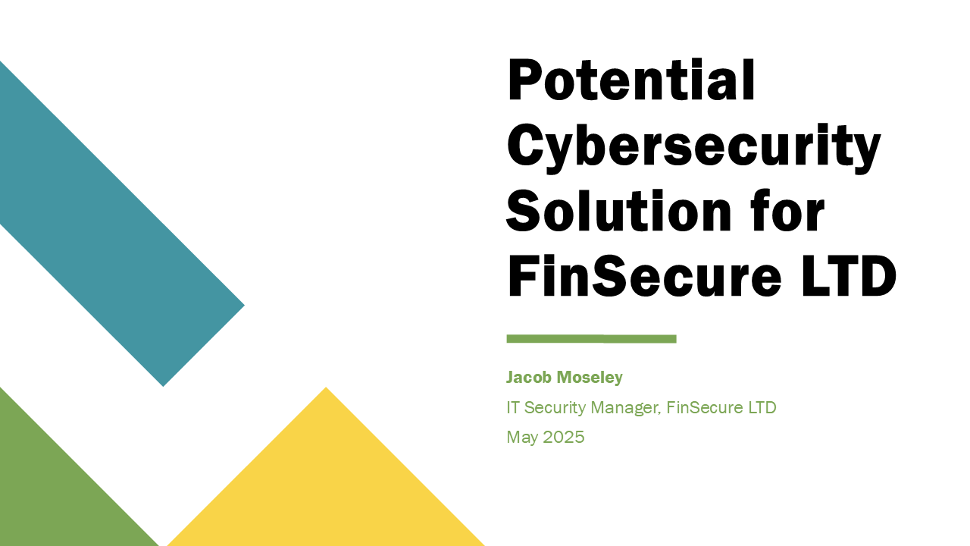 [Figure 1]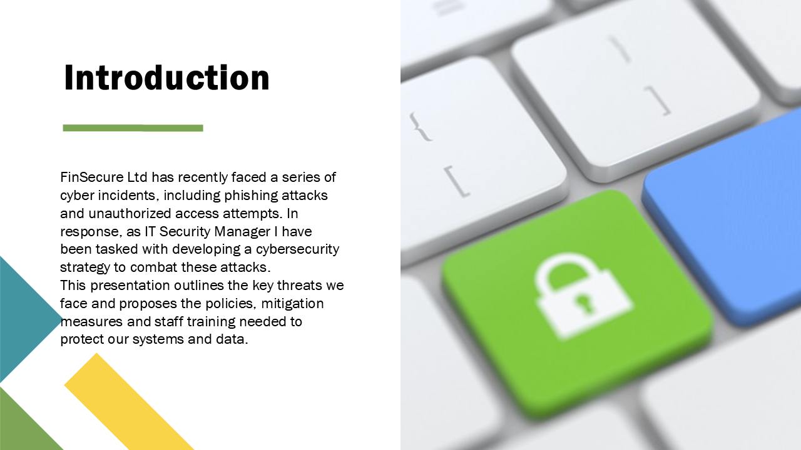 [Figure 2]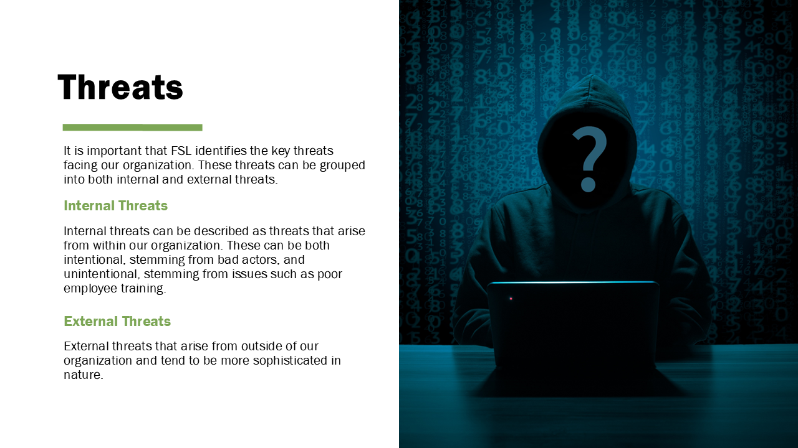 [Figure 3]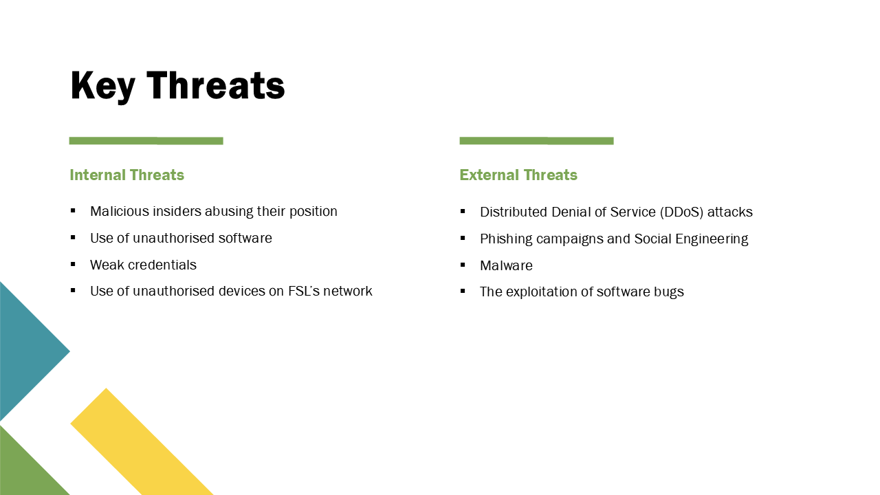 [Figure 4] [Figure 5]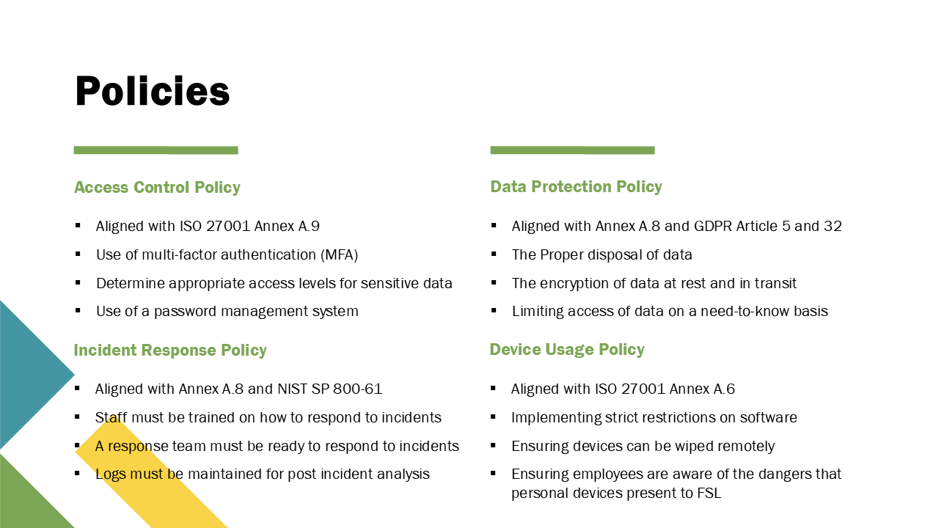 [Figure 6]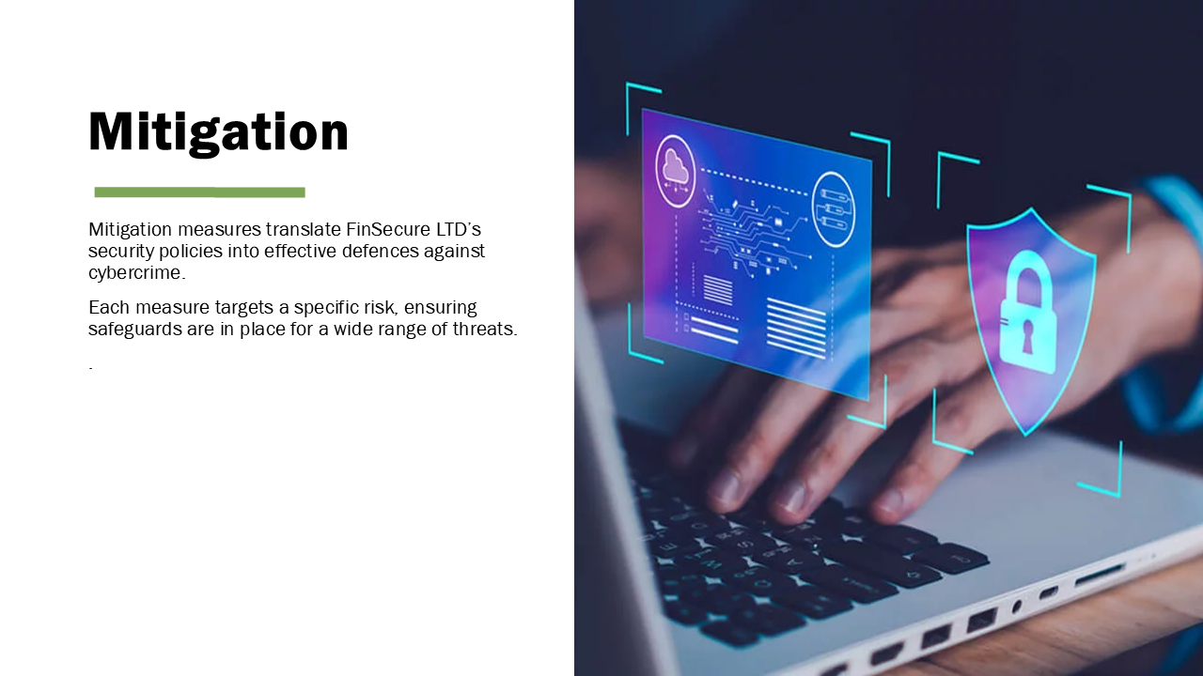 [Figure 7]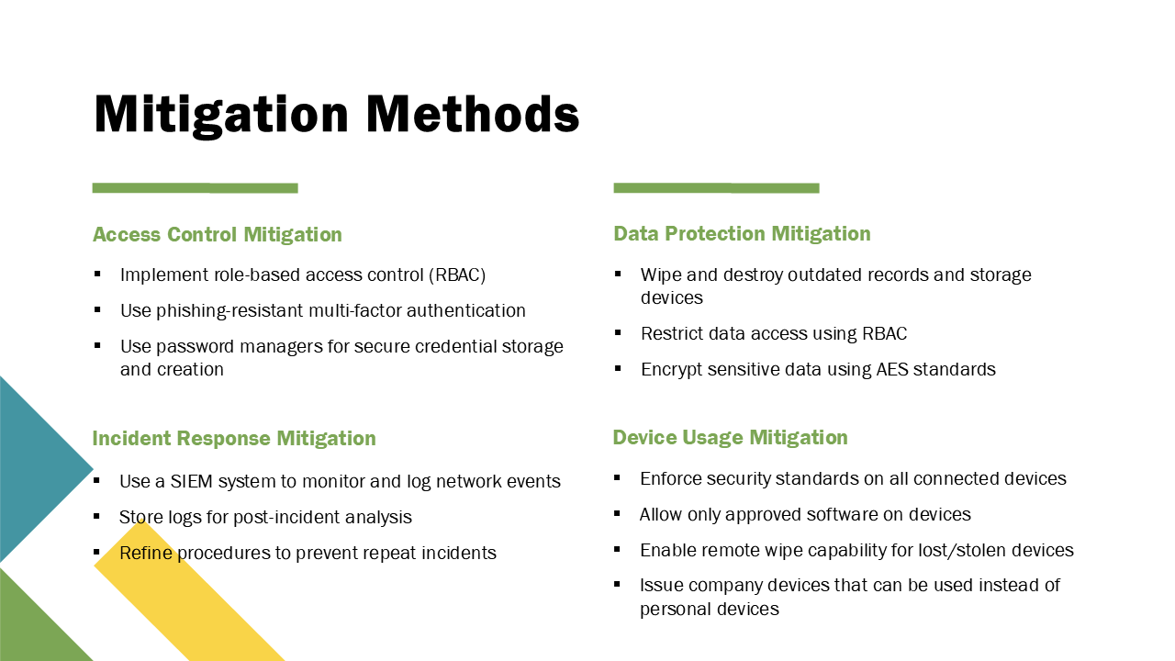 [Figure 8]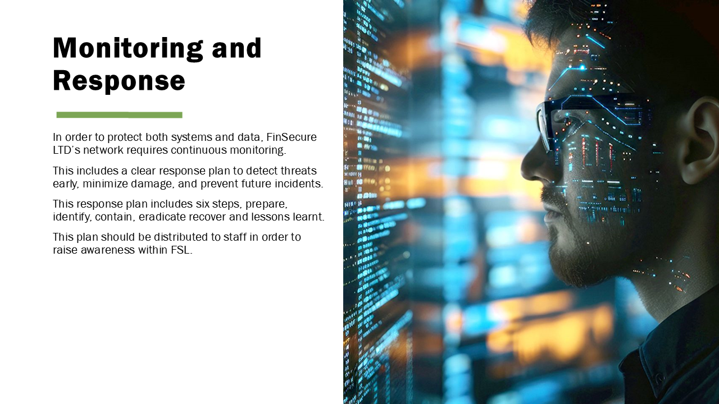 [Figure 9]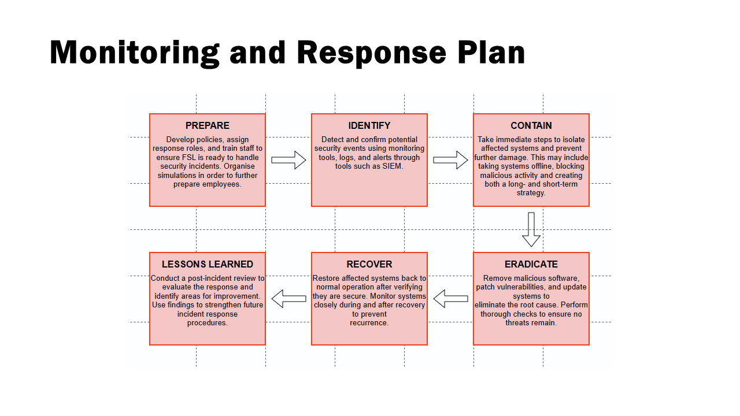 [Figure 10]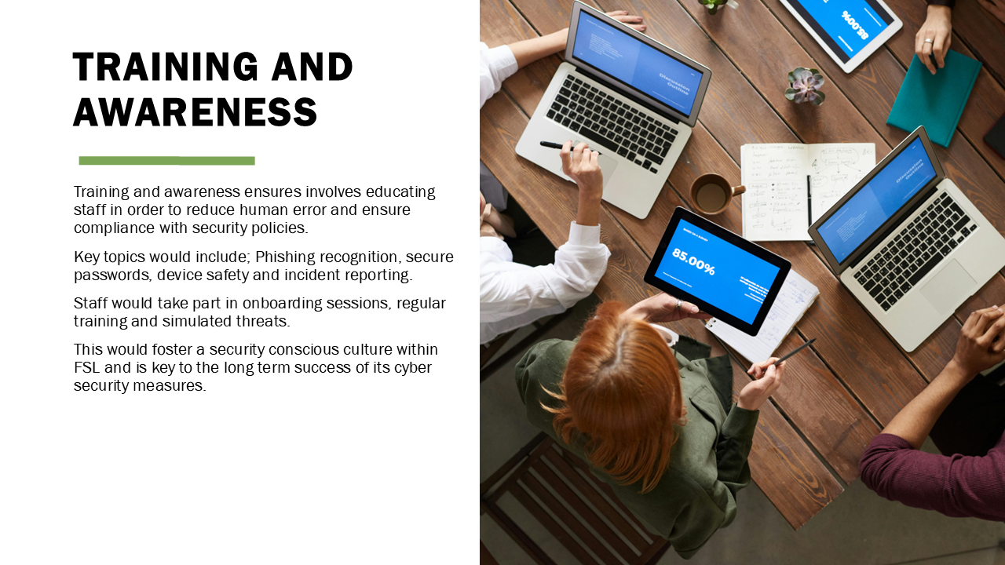 [Figure 11]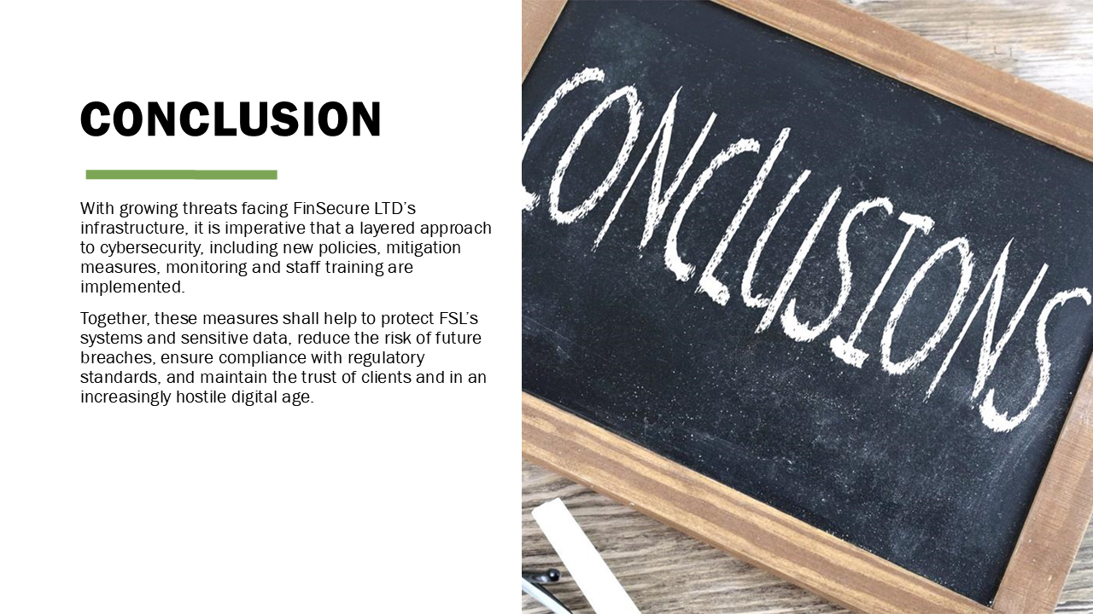 [Figure 12]

[Figure 13]

