

Assignment Title: Reflective Blogs
Module name: Managing Projects in the Organisation (BMSW5009_SWAN)
Student name: Marian Mihai Luca (1712434)
Lecturer Name: Giulia Chifari
Submission date: Friday 19th of June 2026

Word count: 1087
Blog 1: Project Introduction and Team Role Reflection
I am Marian and as part of the Managing Projects in Organisations module, I have been working with Sanda, Catalina and Daniel on a Mental Health Awareness Campaign. Our project sponsor is our module lecturer, Giulia Chifari, who supported us from the beginning. The aim of the project was to raise awareness of mental health issues among students at UWTSD and to collect voluntary donations for Mind, which is a well-known UK mental health charity.
My responsibility was ordering the personalised t-shirts for the team and support with planning decisions and general organisation throughout. When I did the Belbin Team Role assessment, my result was Coordinator, which means someone who helps the team stay focused and work towards a shared goal (Belbin, 2010).
My Coordinator role meant making sure early meetings did not lose focus and that everyone had a chance to speak before roles were decided. I think without that structure we would have taken longer to get started.
Looking back, I think the Belbin model helped me understand my natural way of working in a group, but I also noticed that my role was not always the same throughout the project. So, I agree with Fisher, Hunter and Macrosson (2001) that people do not always stay in just one role.
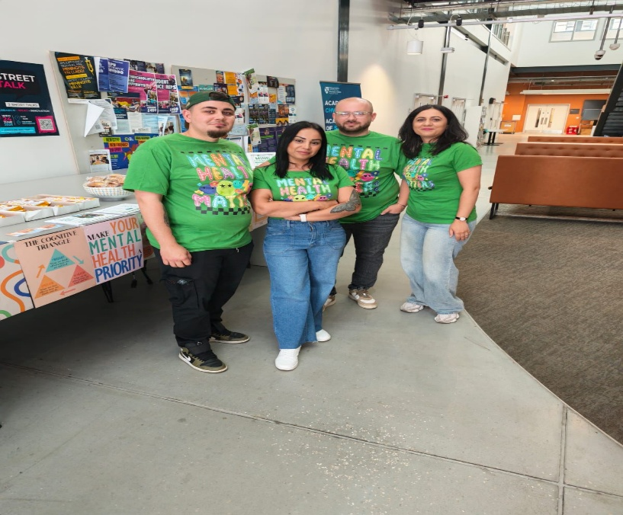

Blog 2: Project Initiation and Scope
After agreeing on our project, the next step was to make it structured and realistic. Our main aim was to raise awareness of mental health among students at UWTSD and to raise donations for Mind charity. We identified our key deliverables as the personalised t-shirts, promotional flyers, a social media campaign, refreshments for attendees and the live awareness event on 16th of June 2026. Having these deliverables clear from the beginning helped everyone understand what we were working towards and who was responsible for what (Kerzner, 2022).
We agreed the campaign would stay focused on the UWTSD campus and would not include any activities outside the university. Clegg, Skyttermoen and Vaagaasar (2020) explain that defining scope clearly at the beginning is one of the most important steps in keeping a project on track.
The Iron Triangle felt real when we lost time due to late approval. I felt worried the quality of the campaign would suffer, but we managed. It showed me that time, cost and quality really do affect each other and the group agreed to move the presentation one week ahead.
Heagney (2016) says the Iron Triangle is about finding the right balance between time, cost and quality, and I think this situation showed exactly what that means in real life.

Blog 3: Stakeholder Analysis and Communication
We identified our key stakeholders as students, the Student Wellbeing Team, the university operations team, Mind charity, university staff and our own project team. Freeman (1984) defines a stakeholder as any person or group who can affect or be affected by what an organisation does. To help us prioritise, we used the Power-Interest Grid. This showed us that the Student Wellbeing Team was high in both power and interest, so they needed careful management and regular communication. Students were high in interest but lower in power, meaning our job was mainly to keep them informed and engaged.
One challenge we faced was not identifying the university operations team early enough. We needed their approval before the event could go ahead, and this caused us to reschedule, which created pressure. Project Management Institute (2021) highlights that missing key approval stakeholders early is one of the most common causes of project delays. For internal communication we used WhatsApp.
I felt frustrated with myself when this happened. I think one simple question at the start, “Who needs to give permission for this event?” would have saved the whole group a lot of stress.
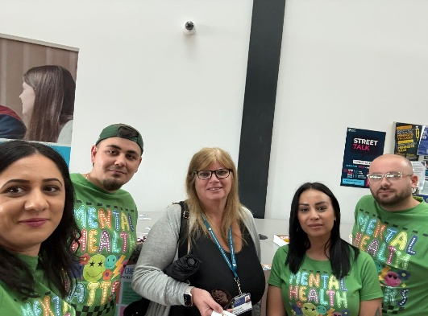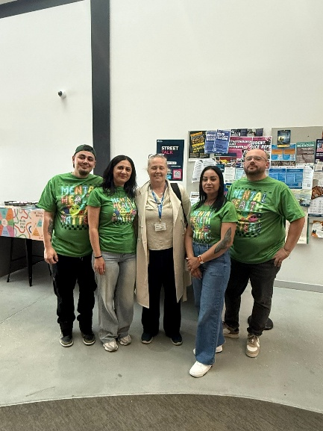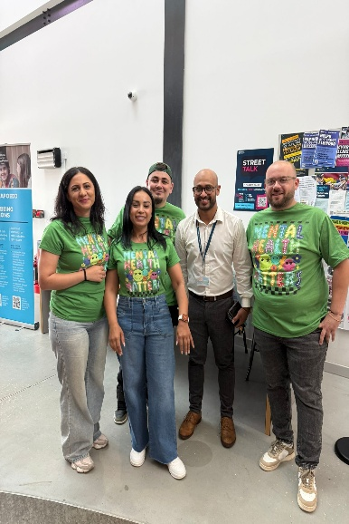

Blog 4: Work Breakdown Structure and Gantt Chart
Before this module I had never used a Work Breakdown Structure or a Gantt Chart in practice. Working on the Mental Health Awareness Campaign showed me exactly why project managers rely on these tools.
The WBS helped us break the whole project down into smaller, specific tasks such as ordering T-shirts, designing flyers, purchasing refreshments and preparing the presentation. Before we did this it felt like there was a lot to do but it was hard to know where to start. Heagney (2016) explains that breaking a project into smaller work packages makes it easier to assign responsibilities and track progress, and I found this to be very true.
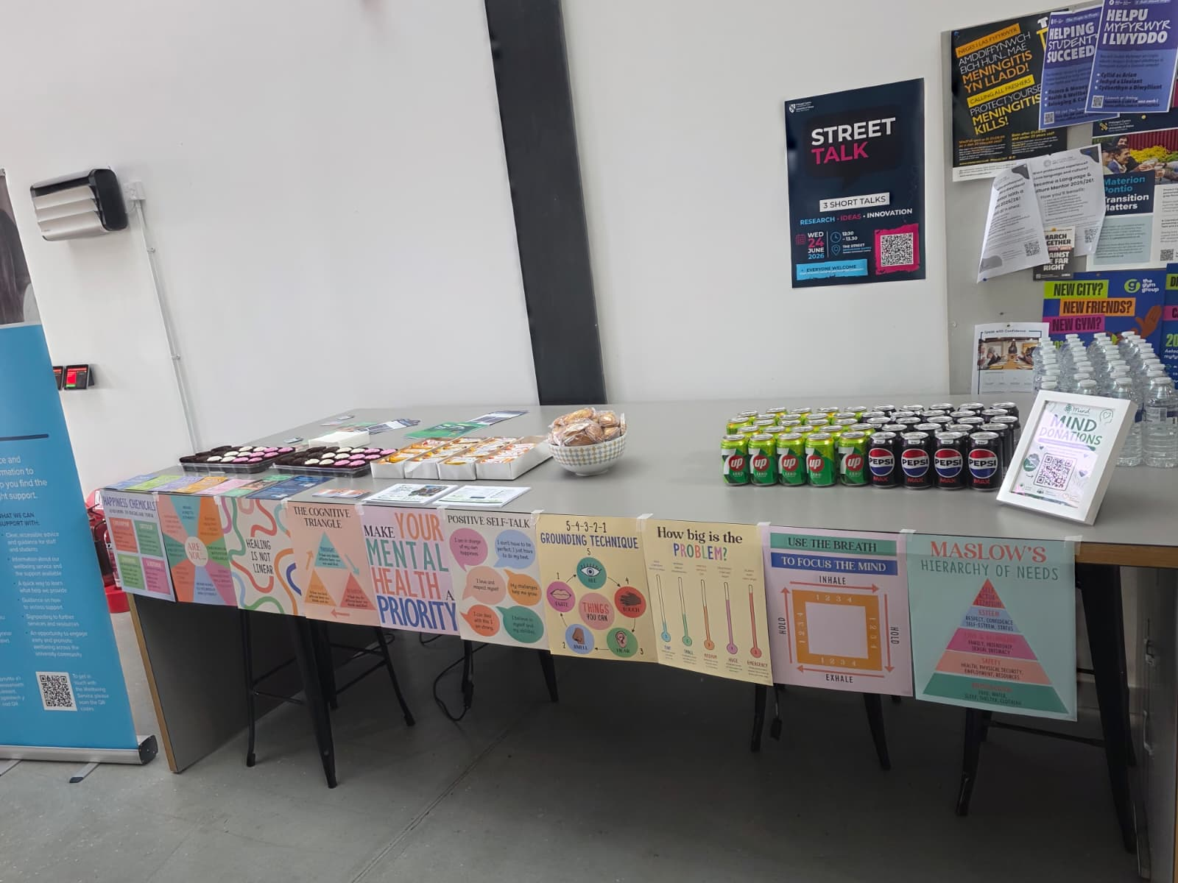
The Gantt Chart then helped us put the tasks into a visual timeline. For me personally, the Gantt Chart was the more useful tool. It gave a clear picture of what needed to happen and when. When we had to reschedule the event because of the late operations approval, the Gantt Chart helped us to adjust quickly.
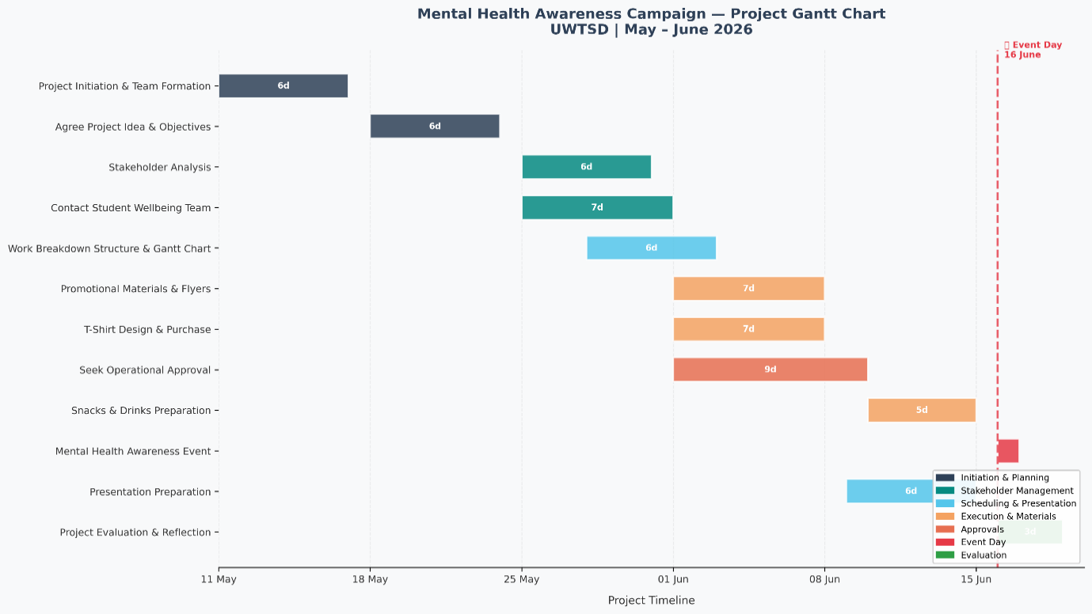
Clegg, Skyttermoen and Vaagaasar (2020) argue that visual scheduling tools are especially valuable when projects face unexpected changes.
I learned that these tools only work if you keep updating them, which is something I will do better in future projects (Wysocki, 2014).

Blog 5: Critical Self-Evaluation and Self-Development Plan
Looking back at the project, I feel proud of what the group achieved. The event went well, students engaged with the materials, everyone enjoyed the refreshments and the feedback from lecturers was positive. But I also think it is important to be honest about what I could have done better.
One of my main strengths was reliability. I made sure the T-shirts were ordered on time, contributed to planning discussions and stayed organised throughout. Heagney (2016) argues that personal accountability is one of the most valuable qualities in a project team member and I tried to demonstrate this throughout.
My lesson was around stakeholder identification. Not recognising the operations team as a key stakeholder early enough meant we had to reschedule the whole event, which was stressful for everyone.
Meredith and Mantel (2009) explain that poor stakeholder identification in the early stages is one of the most common causes of unexpected project delays.
Using Gibbs (1988) as a guide, I have identified three personal goals. Within three months, I will practise building a stakeholder map with a focus on approval stakeholders. Within six months, I will learn how to create a basic risk register. In my next group project, I also want to take a more visible role rather than staying in the background, because I think I can contribute more if I am more confident about speaking up.
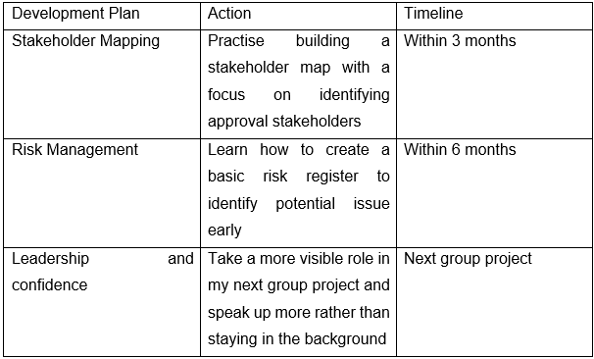
Reference list
- Belbin, R.M. (2010) Management Teams: Why They Succeed or Fail. 3rd edn. Oxford: Butterworth-Heinemann.
- Clegg, S.R., Skyttermoen, T. and Vaagaasar, A.L. (2020) Project Management: A Value Creation Approach. London: Sage.
- Fisher, S.G., Hunter, T.A. and Macrosson, W.D.K. (2001) 'A validation study of Belbin team roles', European Journal of Work and Organizational Psychology, 10(2), pp. 121–144.
- Freeman, R.E. (1984) Strategic Management: A Stakeholder Approach. Boston: Pitman.
- Gibbs, G. (1988) Learning by Doing: A Guide to Teaching and Learning Methods. Oxford: Oxford Polytechnic.
- Heagney, J. (2016) Fundamentals of Project Management. 5th edn. New York: AMACOM American Management Association.
- Kerzner, H. (2022) Project Management: A Systems Approach to Planning, Scheduling, and Controlling. 13th edn. Hoboken, NJ: Wiley.
- Meredith, J. and Mantel, S. (2009) Project Management: A Managerial Approach. Asia: John Wiley and Sons.
- Project Management Institute (2021) A Guide to the Project Management Body of Knowledge (PMBOK Guide). 7th edn. Newtown Square, PA: Project Management Institute.
- Reiss, G. (2015) Project Management Demystified. London: Routledge.
- Wysocki, R.K. (2014) Effective Project Management: Traditional, Agile, Extreme. 7th edn. Indianapolis: Wiley.

