Natalie Barcham

1811447

BA HONS Surface Pattern Design

Word count- 2,202

Julia Lockheart/ Gwenllian Beynon

My exhibition will be political and very topical to today’s existential. The continuation of
habitat destruction killing the animals we share this world with. According to World Wildlife
Foundation ‘sea levels are rising, and oceans are becoming warmer. Longer, more intense
droughts threaten crops, wildlife and freshwater supplies”, and because of this it
“threatens polar bears in the Arctic to marine turtles off the coast of Africa, our planet’s
diversity of life is at risk from the changing climate”. Effects of climate change (WWF, 2019).
And sadly, according to these statistics and organisation, WWF suggest that humans’ actions
have indicating factors for the reason of this frightening decline of habitat loss.

My object will be a curation of animal sculptures made by school children to highlight and
demonstrate man’s disturbance of nature, and the devastating reality of deforestation,
harmful greenhouse gasses, and the changes in the sea level. Humans continue to destroy
habitats and are the main cause of global warming already being the main for causing the
“annihilation of 83% of all wild mammals and half of all plants”. (McCarthy, Sanchez, Sepehr,
2018). Statistically these facts are frightening and a concern for the planet as the
temperature continues to rise.

By illustrating this in a metaphoric way of having innocent, childlike sculptures created by
children to create an atmosphere of deeper sadness and irony as if humans carry on there
will not be a positive future for mankind. David Attenborough renowned naturalist and
broadcaster identifies the frightening facts and reality of climate change in a recent BBC one
documentary. He makes a point ‘if we have not taken dramatic action within the next decade
we could face irreversible damage to the natural world and collapse of our society. He also
believes “if we better understand the threats that we face it is likely we can avoid such a
catastrophic future”. Climate Change (BBCNEWS,2019). Therefore, if we all listen and take
on board the hard facts of this worldwide problem then we all can have a great impact on
helping rebuild our planet.

I will include animals such as the Black rhino, Orangutan, turtles etc, and they will be made
the focal point of the exhibition and all sculptures will be made from recycled materials,
supporting sustainable art. I will have a more morbid side inside my exhibition space, a large
digital clock with timers sets beside each endangered animal sculpture displaying the
number of species there were counting down quickly to how many there are now. The digital
clocks will make a strong beep, to make them hard to ignore. This creates a dramatic sense of
urgency and calling to the people inside the exhibition space. This notion of time will be a key
element of this exhibition, artist Anna Frants also explores the concept of time but
demonstrates it in a more abstract way by creating a sensory exhibition, full of interactive
installation shadows. Frants creates a “coming to life” environment full of visuals and
acoustics, the effect of this keeps the spectator and partaker involved. Time becomes the
visual and how the participant may have a personal perception of it. The exhibitions aim is to
show that “time is a definitely subjective dimension” in Silvia Bertoletti’s opinion.
(Bertoletti, 2012). But also has some urgency about it, needing to act fast as humanity itself
has a huge metaphoric timer above their heads until the planet will deteriorate for good,
beyond mending.

Artist and activist Eliasson Olafur and geologist Minik Rosing also take on an artistic approach to raising concern of our earth’s climate change with an outdoor exhibition. The installation named the ‘Ice Watch’, is a circle of icebergs with a circumference of twenty metres, is an installed at the Place du Pantheon during the week of Climate Change Conference taken place in Paris. We both adopt a similar approach in wanting to have an impact on people to identify that we as humans are the issue. Although man does not so much destroy the earth or nature as takes the space that nature we know for his/her own activities. Going back to this notion of the idea of space is highly symbolic in determining how we act and behave around others/how we feel ourselves in this space, the historic meaning and societal perspectives.

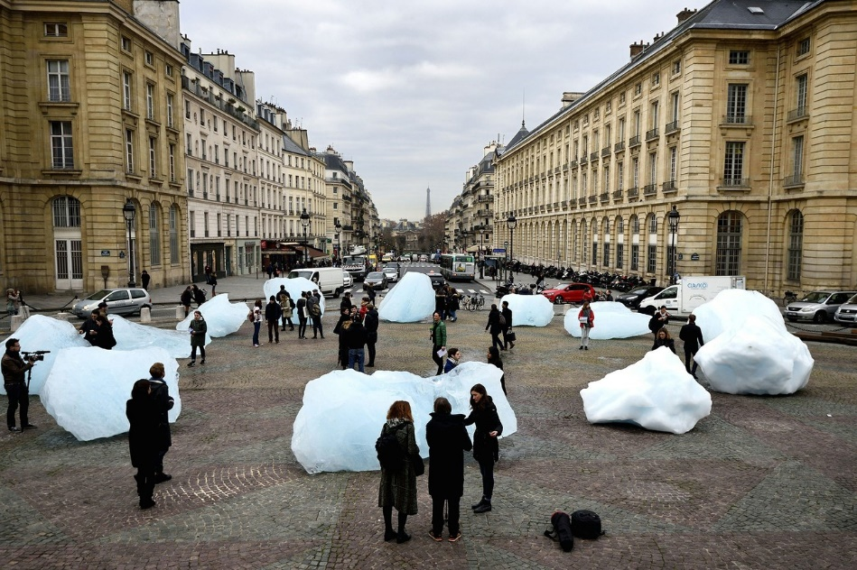
Figure 1. The artist who is bringing icebergs to Paris, (Feferberg,2015)

Eliasson’s suggests that his “kids are more elaborately agile in the digital mode. My generation experienced a time of innocence, but children now have never known a time without the challenge of climate change. They know what everything. But they do not know what it feels like. Public space in which things happen is vitally important now” (Zarin, 2015). Today’s generation of children are exposed to more truths about the world from a younger age because of how easily accessible social media is, being more aware of today’s existential.

In the Poetics of Space, Bachelard refers to the idea of “topoanalysis” which refers to the systematic psychological study of sites of our intimate lives. He writes ‘when all we know is a sequence of fixations in the spaces of the being’s stability- a being who does not want to melt away, and who, even in the past, when he sets out in search of things past, wants to “suspend” its flight. In its countless alveoli space contains compressed time’. Bachelard,(1958). Alveoli is the medical term for Part of the respiratory system, these tiny alveoli have a key role in the movement of oxygen and carbon dioxide. Alveoli(nrpt, 2000-2019). There is an increase of respiratory diseases found in children as they are exposed to environmental factors which are likely to cause illnesses such as asthma and bronchitis. There are dangerous chemicals polluting the air such as industrial emissions, vehicle exhausts, and the constant use of gasoline in leading to the rise of greenhouse gases causing the green house effect to the planet. The greenhouse like effect is highlighted in my choice of exhibition space, a stuffy, uncomfortable space to be in. According to an American study conducted by South Carolina University there is a link between children that are more exposed to vehicle exhausts are more likely to ‘nine times higher in children, who lived within seventy-five metres of a busy road’, compared to children who were not. The study shows that by keeping children away from environmental factors such as these harmful gases by taking steps to becoming greener by e.g. walking to school, taking the train or by simply living away from a major road that you can help reduce these respiratory problems in young children. NHS Directory. (2007)
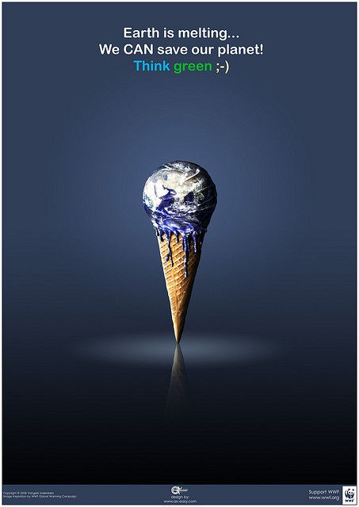
Figure 2.
Ice Cream Campaign (WWF,2005)

The space will be light (white) almost clinical feeling like a dental surgery, a large room in a gallery full of mirrors. The space itself will be made to be exhibited at a global scale, this white large box like space is portable, and adaptable thus being able to make and taken down easily for transport. It can be moved from country to county.

There will be at least one made the mirrors are for the viewers to have a true representation that it is themselves that can help change the rapid destruction of the earth we live in. My exhibition will be transported by train as it’s considered one of the more economically friendly forms of transport and travelling for medium to long journeys. According to 3 minutes’ stop by “comparing rail with road and air transport makes it possible to demonstrate that the train is much more sustainable, whether in terms of CO2 emissions, energy consumption, use of space, or noise levels”. 3 minutes’ stop everything about the world of trains (Alstom presents, 2019). As statistics show travelling by train may only generate “15g of CO₂ per kilometre compared with about 100g for flying”, (Orange, 2019). As the teenage activist Greta Thunberg travelled around Europe by train instead of flying by plane to bring forward the “flight-shame” movement in Sweden.

The viewers will see themselves in the mirrors, they will not be able to escape them, identifying man with themselves enabling them to escape from themselves. Novelist and poet John Berger wrote that “the way we see things is affected by what we know or what we believe in. Seeing comes before words. The child looks and recognizes before it can speak.” (Berger,1972). If adults were to set a better example of how act appropriately in terms of being more energy efficient and speaking up about the catastrophic state the planet is in currently, then children would be socialised to behave and act in the same way.

Social theorist Michael Foucault theory on rotating mirrors suggests how light can pass through half transparent plates of glass and is reflected from the rotating mirror. Foucault suggests that light that is reflected can then be focused through the lens onto an incurvate mirror, which is then returned the light to the rotating mirror. He then goes onto saying that “If the rotating mirror is stationary, light is reflected to the semi-transparent plate of glass, from which it is reflected to the observer”. Somerfield,B (2013). The idea of having mirrors in my exhibition space follows this similar theory, you will always have to face these mirrors, they are not escapable, nor can you walk away from it as you will always see your own accurate reflection. I want the spectator to view these mirrored reflections as a positive idea, to make change and to act, as they as individuals metaphorically have the planet in their hands.

Mirrors will be placed on the ceiling, and around the side walls of the exhibition room. The mirrors will show the animals surrounding them, highlighting a deeper sense of sadness. The effect this will have on viewers will create a confining atmosphere. As the “artwork will not be finished; no art is finished until the spectator”. (Duchamp,1917). This quotation from Duchamp plays an integral part in the meaning of my imagined exhibition as it may suggest that metaphorically humanity cannot rest until he comes together in helping rebuild the planet we all share, for the sake of our children’s future.

Figure 3. Map of exhibition
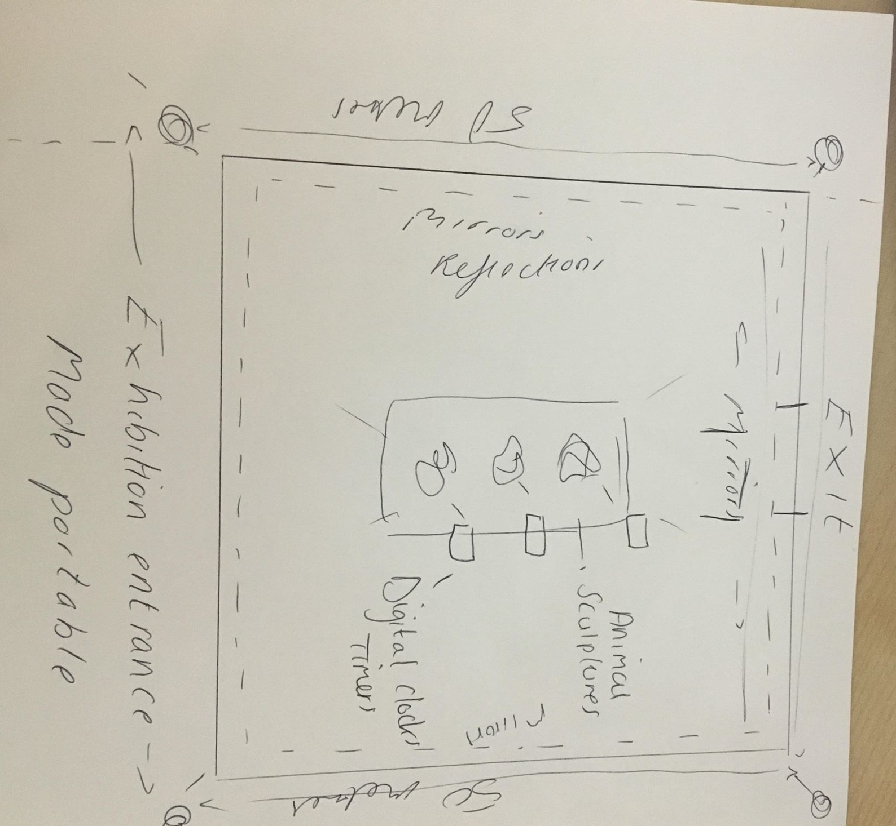

Michael Foucault writes in the Archaeology of Knowledge that “the great problem presented by such historical analyses is not how communities are established, how a single pattern is formed and preserved, how for many different, successive minds there is a single horizon, and what substructure is implied by the interplay of transmissions, disappearances and repetitions”. The way patterns are repeated can have both positive and negatives actions conveyed through humanity, as it takes a single person to speak out and demonstrate that because a pattern is repeat it doesn’t necessarily mean it’s right for us. The point I’m trying to make is that by breaking down destructive repetitions from the past such as continuing to carry on breaking down the o-zone and burning greenhouse gases through huge industrial scale and polluting our seas. These patterns can be changed, through the means of education, making both children and adults more educated in making better choices for their futures.

The exhibition itself will be free entry and open 24/7 to the public making it assessable for anyone to enter and to not contribute to consumerism culture. There will be a level of trust here, respect to be given to the creators of the exhibition and to the public to take care of the space and not to abuse the trust. Overall, I want my curation of objects inside my portable exhibition to really dig deep and create even more of a social awareness of climate change as we are nearly geologically approaching the point of no returns.

I want the exhibition to help the earth become a much more environmentally friendly place for our future and for the future of our children. With Greta travelling Europe by train with her father they were both able to save around “400kg of carbon dioxide by not flying which works out to be around a tenth of the average Swede’s total annual carbon emissions.” (The Guardian, 2019). These facts show that I will be practicing what I preach by transporting my portable exhibition through the means of trains releasing less dangerous gases into the air calling attention the better benefits trains have on the environment.

My imagined exhibition space and the curation of objects it beholds demonstrates theoretical perspectives of climate change which explores notions of a unique curation of objects inside a tense space. The ideas of creating a political exhibition bringing up very topical themes to today’s panic is effective, it keeps the ball rolling with activist approaches to raising alarms and a call for action. The curation of objects inside my exhibition will all be authentic and unique to one another found in the other exhibition spaces found across the globe as different countries will have their own method in making, showing cultural diversity. The only issue is that for many countries many workers may rely on working for companies that support poaching, or deforestation business to feed their families, therefore not making a judgemental space but a space for awareness.

References

Alstom presents (2019) 3 minutes’ stop about the world of trains. Available at: https://3minutesstop.alstom.com/infographie/train-environmentally-friendly-mode-transport/ (Accessed: 5th May 2019).

Bachelard,G.(1958) The Poetics of Space. Presses Univeritaires de France. Beacon Press.

BBC NEWS (2019) Sir David Attenborough presents Climate Change- The Facts. Available at https://www.bbc.co.uk/news/av/uk-47972979/sir-david-attenborough-presents-climate-change-the-facts (Accessed 26 April 2019).

Berger,J.(1972). Ways of Seeing. London: Penguin books Ltd.

Bertoletti, S (2012) ‘The Time Keeper: 3 Artists explore about the concept of time’, Digital meets Art, 8th August. Available at: https://www.digitalmeetsculture.net/article/the-time-keeper-3-artists-explore-about-the-concept-of-time/ (Accessed 5th May 2019).

Foucault,F.(1969 ) The Archaeology of knowledge, France: Pantheon Books, New York.

National Register of Personal Trainers (2000-2019) Alveoli. Available at: https://nrpt.co.uk/training/body/respiratory/alveoli.htm (Accessed 26 April 2019).

NHS DIRECTORY. (2007) ‘Living near a busy road can increase risk of asthma in children’ Available at: https://www.nhs.uk/news/lifestyle-and-exercise/living-near-a-busy-road-can-increase-risk-of-asthma-in-children/ (Accessed: 5th May 2019).

Orange,R.(2019) ‘Greta Thunberg’s train journey through Europe highlights no-fly movement’, The Guardian, 26th April. Available at: https://www.theguardian.com/environment/2019/apr/26/greta-thunberg-train-journey-through-europe-flygskam-no-fly (Accessed 5th May 2019).

Somerfield,B. (2013) ‘History of the speed of light experiment’, Cosmology and the zero point energy. Available at: http://setterfield.org/cx4.html (Accessed 5th May 2019).

Worldwildlife (2019) Effects of Climate Change. Available at: https://www.worldwildlife.org/threats/effects-of-climate-change (Accessed:26 April 2019).

WWF.(2005) Available at: https://www.adforum.com/creative-work/ad/player/49872/ice-cream/wwf (Accessed 26th April 2019).

Zarin,C.(2015) ‘The Artist who is bringing icebergs to Paris’, The New Yorker, 5 December. Available at https://www.newyorker.com/culture/culture-desk/the-artist-who-is-bringing-icebergs-to-paris (Accessed 26 April 2019).

Bibliography

Alstom presents (2019) 3 minutes’ stop about the world of trains. Available at: https://3minutesstop.alstom.com/infographie/train-environmentally-friendly-mode-transport/ (Accessed: 5th May 2019).

Bachelard,G.(1958) The Poetics of Space. Presses Univeritaires de France. Beacon Press.

BBC NEWS (2019) Greta Thunberg: Teen Activist says UK is irresponsible on climate. Available at: https://www.bbc.co.uk/news/uk-48017083 (Accessed: 4th May 2019).

BBC NEWS (2019) Sir David Attenborough presents Climate Change- The Facts. Available at https://www.bbc.co.uk/news/av/uk-47972979/sir-david-attenborough-presents-climate-change-the-facts (Accessed 26 April 2019).

Berger,J.(1972). Ways of Seeing. London: Penguin books Ltd.

Bertoletti, S (2012) ‘The Time Keeper: 3 Artists explore about the concept of time’, Digital meets Art, 8th August. Available at: https://www.digitalmeetsculture.net/article/the-time-keeper-3-artists-explore-about-the-concept-of-time/ (Accessed 5th May 2019).

Foucault,F.(1969 ) The Archaeology of knowledge, France: Pantheon Books, New York.

Feferberg,K. (2015) Available at: https://www.newyorker.com/culture/culture-desk/the-artist-who-is-bringing-icebergs-to-paris (Accessed 26 April 2019).

Frants, A and MediaLab C. (2012) Shadows. Available at: http://www.annafrants.net/home_30.html (Accessed: 5th May 2019)

Mackenzie,J.(2016) Air Pollution: Everything you need to know. Available at https://www.nrdc.org/stories/air-pollution-everything-you-need-know (Accessed: May 5th 2016).

McCarthy, J, Sanchez, E, Sepehr, J. (2018)’Humanity has killed 83% of all wild mammals and half of all plants’. Global Citizen, 22nd May. Available at: https://www.globalcitizen.org/en/content/humans-destroyed-83-of-wildlife-report/ (Accessed 4th May 2019).

McGraphy,M.(2018) ‘What is Climate Change’, BBC, 3rd December, Available at: https://www.bbc.co.uk/news/science-environment-24021772 (Accessed 4th May 2019).

National Register of Personal Trainers (2000-2019) Alveoli. Available at: https://nrpt.co.uk/training/body/respiratory/alveoli.htm (Accessed 26 April 2019).

NHS DIRECTORY. (2007) ‘Living near a busy road can increase risk of asthma in children’ Available at: https://www.nhs.uk/news/lifestyle-and-exercise/living-near-a-busy-road-can-increase-risk-of-asthma-in-children/ (Accessed: 5th May 2019).

Somerfield,B. (2013) ‘History of the speed of light experiment’, Cosmology and the zero point energy. Available at: http://setterfield.org/cx4.html (Accessed 5th May 2019).

Worldwildlife (2019) Effects of Climate Change. Available at: https://www.worldwildlife.org/threats/effects-of-climate-change (Accessed:26 April 2019)

Worldwildlife (2016) Species Directory. Available at: https://www.worldwildlife.org/species/directory?direction=desc&sort=extinction_status (Accessed: 4th May 2019).

WWF(2005) Available at: https://www.adforum.com/creative-work/ad/player/49872/ice-cream/wwf (Accessed 26th April 2019).

Zarin,C.(2015) ‘The Artist who is bringing icebergs to Paris’, The New Yorker, 5 December. Available at: https://www.newyorker.com/culture/culture-desk/the-artist-who-is-bringing-icebergs-to-paris (Accessed 26th April 2019).

