Marketing Plan & Presentation Slide
Submission Date:
Student ID Number: 2234363
Module Code: ‘BMIH4005’
Name: Amirul Islam
Module Title: Marketing Essential
Lecturer’s Name: Scott James

Table of Contents
Introduction 3
Situation Analysis 3
Objectives 6
Strategy 7
Tactics 8
Action (Gantt Chart) 9
Control 10
Conclusion 10
Reference List 11

Introduction
Hilton Hotel is one of the renowned international hospitality companies located in the USA. In this assignment, a marketing plan will be prepared for the Holiday Inn Company. The purpose of this marketing plan is to identify growth opportunities for Hilton Hotel. Through the use of the Ansoff’s Matrix, Bowman's strategy clock, and KPI's matrix the marking plan will be prepared.

Situation Analysis
Company
In order to evaluate the management and environment of the concerned hotel, a SWOT analysis is provided in this study. Through this analysis, different opportunities and threats regarding the strengths and weaknesses of Hilton Hotel are estimated.
Strengths  - A very popular global brand (Bowie et al., 2017).  - Satisfied manpower.  - A wide range of customer base. | Weaknesses  - Inaccessible number of employees.  - Negative feedback from stakeholders.  - Data breach.
Opportunities  - Keeps an eye on social media marketing.  - Entering developing nations.  - Providing country-based seasonal offers. | Threats  - Highly competitive marketplace.  - Increase of operational costs.  - Lack of demand during the pandemic.
Customers: STP
Segmentation
The geographic segmentation strategy of Hilton Hotel primarily aims to build hotels in popular locations along with targeting customer segmentation (Kotler et al., 2020). Moreover, it targets customer segments that represent professionals of senior and middle age with a high income. Actually, the main customers of the hotel belong to the upper-class society.
Targeting
Hilton Hotel mainly targets elderly persons as well as mid-aged guests (Chaffey and Ellis- Chadwick, 2019). Furthermore, the people who have a high level of income are mostly targeted by the aforementioned hotel company. The loyal customers of the hotel are able to experience various types of advanced facilities in this tavern.
Customer Profile
Name | Daniel
Age | 40 years
Income | 100000 Pounds
Location | Las Vegas
Hobbies | Trekking, Travelling
Visit | Weekends
Competitor
Hilton has healthy competition with so many popular hotel chains in the USA hospitality sector. Among them, Loews Hotels, Hyatt, and IHG are the main ones. Unlike the above-mentioned hospitality providers, Hilton Hotel is required to provide effective personalised service and quality product to its guests. This change in provision may help the hotel to boost the growth.
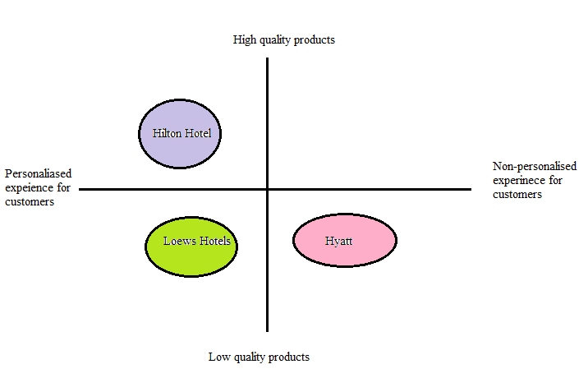
Figure 1: Perceptual Positioning Map
(Source: Self-Created)
Bowman’s strategy clock
According to Bowman's strategy clock, it can be said that the aforesaid hotel is able to achieve immense success by maintaining some factors (Styles et al., 2020). It includes risky high margins, focused differentiation, monopoly pricing, diversification, hybrid, added value, loss of share, and low price.
Collaborators
Being collaborated with BuzzFeed, Hilton is bringing a notable transformation in travel content. In addition, it contains several brands across various market segments (Jobber and Ellis-Chadwick, 2020). It also makes collaboration with Microsoft for helping the employees to enhance productivity and adopt tools of corporate social media.
Climate
Factors | Impacts
Political | Effective and stable political conditions.
Economic | The revenue of the hotel impacts the US economy.
Social | The lifestyle of regional people is affected by hotel activities.
Technological | Adopts various advanced technologies to provide better facilities.
Legal | Implying various laws regarding recruitment and hospitality activities, it develops its services.
Environmental | Effective protections are undertaken against environmental threats.
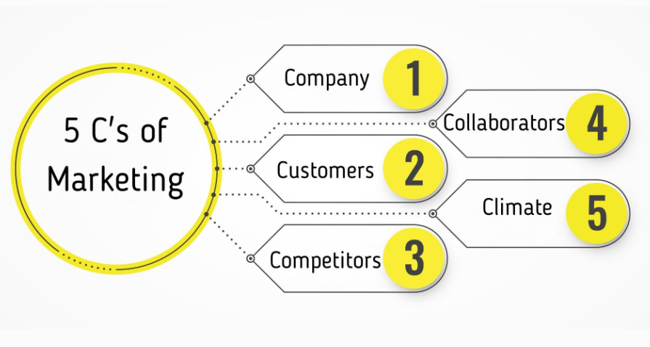
Figure 2: 5 Cs in marketing.
(Source: Jobber and Ellis-Chadwick, 2020)
Marketing Mix
Factors | Operations
Product | - ‘Hilton Honours Programme’  - Silver, Blue, Gold, and Diamond membership.
Price | - Price for additional facilities.  - Premium pricing strategy.
Place | - 103 nations.  - Entering developing countries.
Promotion | - Collaboration with companies.  - Digital marketing.

Objectives
Specific | Measurable | Achievable | Relevant | Time-bound
To improve the interaction experience of the customers. | This objective is measurable by expanding the offers and discounts for the customers. | This objective is attainable through integrating Artificial Intelligence chatbots into the website (Housden, 2008). | This objective is relevant to improve the economic performance of the Hilton Hotel. | 7 months.
To improve the earnings of the hotels. | This objective is measurable by contributing more to the progressive technologies like Artificial Intelligence chatbots. | This objective is attainable by proposing trustworthiness programs for the customers. | This objective is relevant to form the plan for marketing successfully. | 6 months.

Strategy
In the context of explaining the new value proposition of the American hotel company Holiday Inn, the Ansoff Matrix will be used (Zhang, 2021). At present the company needs to be focused on market penetration. So, it is very clear that the company needs to implement relevant strategies to design its products and services more attractively in order to increase sales in the existing market (Ghauri, 2014). Possible impacts of effective market penetration are described below.
- Effective market penetration can be ensured by making the products and services of the Hilton Hotel more attractive and demandable for the customers (Bagheri et al., 2020).
- On the other side, the company will be able to generate more revenue from the existing markets for ensuring effective market development.
- Following current market trends will be one of the most relevant steps or initiatives for this company to start product development.
- Market penetration will allow the company to offer the diversity of products and services for the customers.
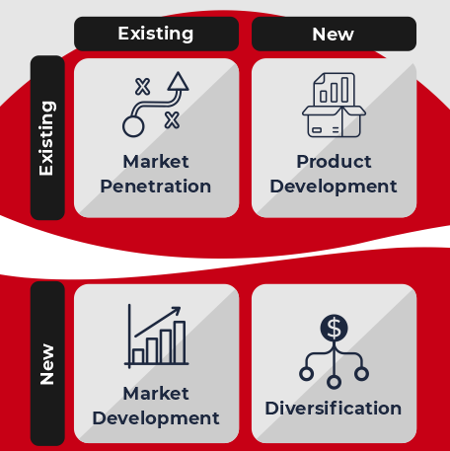
Figure 3: The Ansoff Matrix
(Source: Zhang, 2021)

Tactics
Factors | Strategy
Reach | Increasing website visits, building the consciousness of a brand.
Act | Supporting interactions in social media and on websites to develop leads.
Convert | Achievement of sales either offline or online.
Engage | Growing a deep-rooted relationship with the buyers of first-time to build the loyalty of the customers (Dewnarain et al., 2021).
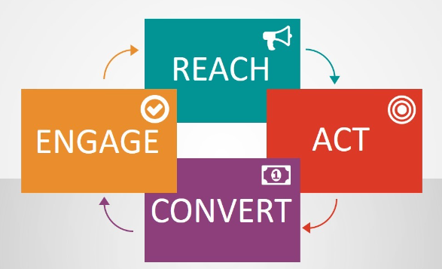
Figure 4: RACE Framework
(Source: Dewnarain et al., 2021)
Usages of New communication strategy
The new digital communication could be handled by email marketing and different types of social media. Anyhow, the advanced Artificial Intelligence chatbots could be used in the website which helps the customers to communicate easily and quickly sort out their queries (Canhoto and Wei, 2021). Alternatively, the technology of Artificial Intelligence can be joined in the website, which might help the organisation to provide the proper suggestions regarding the services depending on the browsing history and previous booking of the visitors.
The current communication process of the Hilton Hotel
In the matter of the present system of communication of the Hilton Hotel, it has been noted that the organisation has mainly focused on traditional methods, like newspapers, print media, flyers, and magazines (Hilton, 2023). Moreover, the overconfidence in the traditional methods of communication has required extending a vast number of clients. The organisation is required to conduct proper brand promotions and advertisements in front of a huge amount of people. Following the issue, the strategy of digital marketing will be established for Hilton Hotel using email marketing and different platforms of social media (Monshi, 2020). Through using email marketing and digital marketing, the issues of the expanding operational price could also be preserved for Hilton Hotel in the market properly.

Action (Gantt Chart)
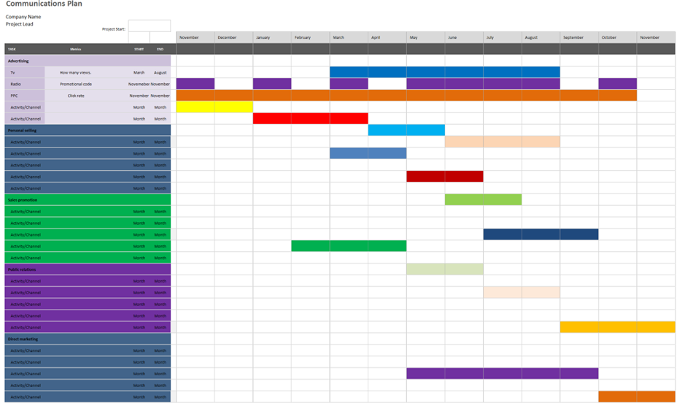In the above-mentioned Gantt Chart, each and every detail of surveying the services of the Hilton Hotel. The number of TV advertisements regarding the Hilton Hotel viewed on TV will be counted from the month of March to August. Radio promotional codes will be researched in the month of November. Apart from that, the personal selling operations of this company will be observed from February to September. Therefore, research will be done to understand the relationship of the company with the customer along with finding the customer satisfaction rate. Finally, the direct operations of Hotel Holt will be observed very carefully.

Control
Through the use of KPIs, a quantifiable success rate of the company Hilton Hotel will be measured (Smith and Zook, 2020). Measurement of the strategies to become more successful in the markets will be very helpful for the company to become more efficient in achieving its ultimate target.
- Focusing more on digital marketing and social media marketing within 4 months.
- Increasing efficiency in researching current market trends to increase brand value in 1 month.
- Enhancement of customer service by 20% within 6 months.
- Being efficient in implementing new innovations in the company functions (Clow and Baack, 2013).
- Increment in the rate of revenue generation by 10% within 4 months.

Conclusion
From the above discussion, it can be concluded that the Hilton Hotel has multiple chances in the context of increasing organisational value along with being more successful. The company only needs to take care of little strategies such as focusing on market trends or starting social media marketing to meet with more growth options.

Reference List
Bagheri, M., Baum, T., Ebrahimi, A. and Abbasi, A., (2020). Talent management in the tourism and hospitality industry: evidence from Iran. Anatolia, 31(1), pp.88-98. Available at: https://strathprints.strath.ac.uk/71014/1/Bagheri_etal_Anatolia_2019_Talent_management_and_the_Tourism_and_Hospitality_industry.pdf
Bowie, D., Buttle, F., Brookes, M. and Mariussen, A., (2017). Hospitality Marketing. 3 rd ed, Routledge, London
Canhoto, A.I. and Wei, L., (2021). Stakeholders of the world, unite!: Hospitality in the time of COVID-19. International Journal of Hospitality Management, 95, p.102922. Available at: https://www.researchgate.net/profile/Ana-Canhoto/publication/350433470_Stakeholders_of_the_World_Unite_Hospitality_in_the_time_of_COVID-19/links/60708f814585150fe997f42a/Stakeholders-of-the-World-Unite-Hospitality-in-the-time-of-COVID-19.pdf
Chaffey, D and Ellis- Chadwick, F., (2019). Digital Marketing. 7 th ed, Pearsons, London.
Clow, K. and Baack, D., (2013). Integrated Advertising, Promotion and Marketing Communications. 6 th ed, Pearson, London
Dewnarain, S., Ramkissoon, H. and Mavondo, F., (2021). Social customer relationship management: a customer perspective. Journal of Hospitality Marketing & Management, 30(6), pp.673-698. Available at: https://repository.derby.ac.uk/download/36a28483fdefd2f9e0ad6af633c3f64304d7dd9bf52d6657ec2a531f665d7a46/346319/paper%20%28accepted%20version%29.pdf
Ghauri, P. N., (2014). International Marketing, 4 th Ed, McGraw Hill, London
Hilton, (2023). Hotels by Hilton - Book the Best Rates Across All Brands. [online] Hilton. Available at: https://www.hilton.com/en/.
Housden, M., (2008). Marketing Research &amp; Information, Butterworth Heinemann, Oxford.
Jobber, D. and Ellis-Chadwick, F., (2020). Principles and practice of marketing. 9th ed. London
Kotler, P., Armstrong, G., Harris, L. and He, H., (2020). Principles of marketing. 8 th European ed,
Monshi, O., (2020). Exploring challenges in implementing customer relationship management (CRM) for customer brand engagement (CBE) in the hospitality industry: A developing country perspective. Journal of International Business and Management, 3(4), pp.1-10. Available at: https://rpajournals.com/wp-content/uploads/2020/09/JIBM-2020-04-109.pdf
Smith, P. R. and Zook, Z. E., (2020). Marketing Communications. 7 th ed, Kogan Page, London
Styles, D., Yesufu, J., Williams, P., Bowman, M. and Luyckx, K., (2020). Identifying the Sustainable Niche for Anaerobic Digestion in a Low Carbon Future. Available at: https://feedbackglobal.org/wp-content/uploads/2020/08/Styles-et-al-2020-Identifying-the-Sustainable-Niche-for-Anaerobic-Digestion-in-a-Low-Carbon-Future.pdf
Zhang, Z., (2021). The Strategic Brand Plan of Scandic Hotel, Scandic Life in Helsinki-A Smart Self-service Hotel, an Intelligent Lifestyle Sharing. Available at: https://www.theseus.fi/bitstream/handle/10024/684525/The%20Strategic%20Brand%20Plan%20of%20Scandic%20Hotel%2C%20Scandic%20Life%20in%20Helsinki-%20A%20Smart%20Self-service%20Hotel%2C%20an%20Intelligent%20Lifestyle%20Sharing.pdf?sequence=2

Appendices





