NARCISA DANIELA TRIFANOV (1812758)
university of wales trinity saint david
problem solving and decision making

December 11, 2020

Executive Summary

This report evaluated the current problem that is causing the decline of Royal Mail, the customer complaints. While investigating, it was discovered that the root cause is actually represented by the poor customer service given by the employees. Using SWOT and PESTLE, it was easy to identify the strengths of Royal Mail and the opportunities that the company has, which both could help to solve the main issue and to stop the company’s decline. It was clear that Royal Mail has some strengths that are not highlighted as they should, for example the number of staff or the low level of debt. At the same time, using those strengths, opportunities were found, such as using the low level of debt to invest in employees training. The action plan proposed is taken from the opportunities and it shows a high level of success, only by following a few steps like efficiently training the employees of Royal Mail.

Table of Contents

Executive Summary 1
Introduction 3
Findings 3
About Royal Mail 3
Nature 3
Scope 5
Impact 5
SWOT Analysis 6
PESTLE Analysis 7
Conclusion 8
Options 8
Action Plan 9
Monitor 9
Review 9
Communication 10
Appendices 10
References 14

Introduction
The report was requested by the lecturer Laura James for the course Problem Solving and Decision Making at University of Wales Trinity Saint David. The report was requested on 23rd of November 2020 and it is due to submission on 11th of December 2020. The person who compiled this report is Narcisa Daniela Trifanov, with Student Number 1812758.
The purpose of this report is to investigate the problems faced by Royal Mail by using tools such as SWOT and PESTLE to determine the cause of the problem and identify potential solutions. The potential solutions will be inserted in an Action Plan which will be used to solve the main problem of Royal Mail.
The research methods used for the evaluation of Royal Mail are journals, articles, and reports.

Findings

About Royal Mail
Royal Mail has a history of over 500 years, in which it developed two main divisions: UKPIL and GLS. UKPIL is the acronym from UK Parcels, International & Letters, while GLS represents General Logistics Systems. Royal Mail Group is focusing on delivering letters and parcels in 43 countries, and in 2019 had 159000 employees (Craft, 2020), with considerable level of recruitment of temporary staff during seasonal periods (The Guardian, 2020). While the group was a publicly owned company, it was decided to become private in 2014, but it was undervalued (Jenkins, 2014). There are different opinions regarding the privatization of Royal Mail, one considering that it will make the company being focused on the profit, while others considering that the company will adapt to the necessities nowadays by being modernized (MarketLine, 2013). No matter which side was right, because the true problem of Royal Mail is represented by the increasing number of complaints from customers.

Nature
The nature of the problem is that Royal Mail is constantly failing to satisfy its customers, and this is shown by the increasing number of complaints each year (Statista, 2020) and the increasing number of compensations payouts due to the complaints (Dawson, 2019). The figures below are showing the numbers of complaints and the compensations payouts, being also a parallel between the years.

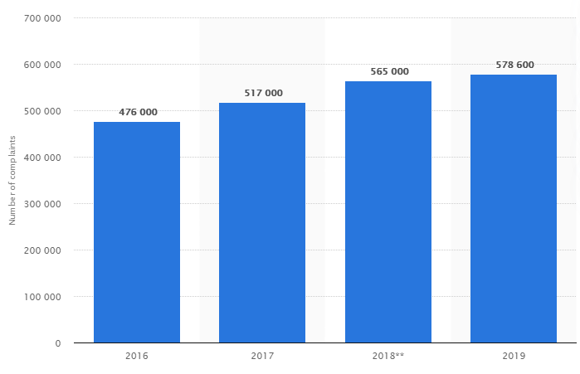
Figure 1. Complaints against Royal Mail 2016-2019
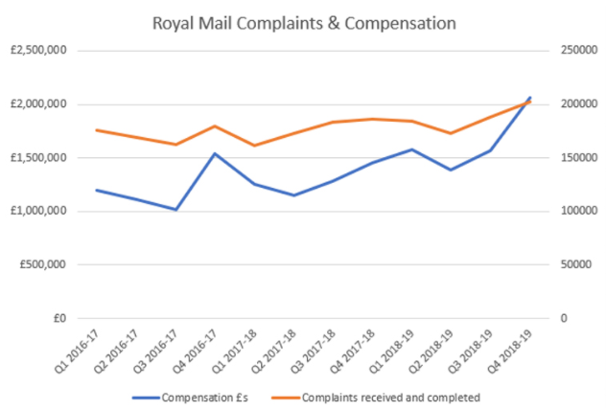
Figure 2. Compensations paid by Royal Mail

The reasons behind the complaints can be found in the figure below:
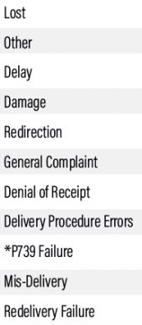

Scope
There are many factors that contribute to the customer’s complaints, as it can be seen in the list above, but the most important factor is regarding the poor customer service, represented by the loss of products, delays, damages of products or denial of receipt. All these actions have consequences for the customers of Royal Mail, because the packages or letters could be really important, and losing them or damage them can put the customer in a difficult position. At the same time, the image of Royal Mail is affected, because an unhappy customer will be more likely to publicly complain, in this way making other customers to avoid using the services of Royal Mail.

Impact
The customers have been impacted with the loss of their packages and the consequences that it might have, but also with the damaged packages, which also has its implications, over charging, and overall a poor customer service that it might have different outcomes for every customer. On the other side, Royal Mail was affected financially, because it has to pay exquisite amounts of money to the customers that were not satisfied. Moreover, because Royal Mail failed to deliver many packages and overcharged the customer, the group also had to pay £1.6 million worth of fines to the Ofcom in 2020 (The Guardian, 2020).

SWOT Analysis
The Swot Analysis can be found in Appendices 1, and it clearly shows areas that need improvement, which, once improved, will solve the main issue of Royal Mail, the increasing number of customer complaints.
The strongest points of Royal Mail are the huge number of staff, the low amount of debt and the multiple services that it offers. Those strengths can be used in many ways to solve Royal Mail’s problem. The huge number of staff can be used more effectively, for example, making them more organized and more customer focused. The employees can go through training about customer service, they can be organized more using different strategies such as Belbin’s Team Roles (Belbin, 2020). At the same time, the low amount of debt (MarketLine, 2020) means that the company can use more money to invest in staff and customer service. Moreover, the fact that Royal Mail offers multiple services means that it can have a large target, and everyone can use its services.
The weaknesses of Royal Mail are poor customer service, poor organization and time management, and weak automation. The poor customer service is the represented by customer’s complaints that are constantly rising, and it is also the main reason of why the customers complain. The poor organization and time management is represented by the delays in deliveries, which led to a high fine from Ofcom. The weak automation is also the cause of delays. These weaknesses can be easily corrected using the strengths of Royal Mail. For example, the low amount of debt can be smartly used to improve the automation and to train the staff in organization and time management.
There are also loth of opportunities for Royal Mail to solve the customer’s complaints issue. For example, Royal Mail can hire more skilled staff, with time management and communication skills. At the same time, since Social Media is more popular, Royal Mail can use it more to engage with the customers and ask for constant feedback. Another opportunity for Royal Mail is represented by e-commerce and the fact that people are starting to use it more. This can bring extra customers and extra profit, as well as extra changes to make a good impression. Another opportunity that can be used to increase the customer satisfaction is the sustainability, by avoiding waste and encourage the recycle.
On the other side, there are also a few threats for Royal Mail. The main one is the customer’s complaints, because even if it is the problem of Royal Mail, by not solving it, it will only increase and provoke more damage to the company and its image. At the same, this threat is leading to another, having more fines from Ofcom. Lastly, another threat for Royal Mail is represented by the competition, because if Royal Mail’s customers are not satisfied with its services, they will look into new companies to work with.

PESTLE Analysis
All the elements of the PESTLE Analysis have an impact on the Royal Mail and its problem regarding customers’ complaints.
Politically, the factors that have the biggest impact on Royal Mail are the changing policies and political movements. The changing policies of operating as a postal company will directly impact Royal Mail and its competitors, and all of them must comply to them (Royal Mail, 2019). The political movements are a huge opportunity for Royal Mail to be closer to its customers and show support, as it did in 2020 in Black Lives Matter movement, when it revealed black mailboxes (The Indian Express, 2020).
Economically, the most important factors are inflation and labor conditions. The inflation can make Royal Mail increase or decrease its prices. Currently, Royal Mail decided to increase the price of first-class stamp from 9p to 85p (The Guardian, 2020). The labor conditions can make Royal Mail to hire more skilled staff or to provide more training to the actual staff, and even increasing the wages. This will benefit Royal Mail because it will increase the customer service.
Socially, the factors that impacts Royal Mail are diversity and spending behavior. The diversity is a factor that is valuated at Royal Mail, which prides to be an inclusive employer, by supporting diversity, gender diversity, and employees with disabilities (Sustain Case, 2016). This is helping with the brand image. The spending behavior factor can be useful to Royal Mail because it gives the opportunity to acknowledge the customer’s needs, and also to make plans to satisfy those needs.
Technologically, the factors are innovation and social media. The innovation is a necessity for Royal Mail, who must adapt to the new technologies. An example of innovation for Royal Mail is represented by the Digital Stamp (Royal Mail, 2018). The social media represent a tool that can be used in favor of Royal Mail, by having interactions with customers in real time, gather feedback and create a bond between the company and its customers.
Legally, the factors are data and employee protection. The data protection is represented by the GDPR, and Royal Mail must comply, as well as all the organizations of the world. The employee protection is mainly represented by equality, discrimination acts being forbidden.
Regarding to the environmental element, the factors are recycling and renewables. The recycling can be used by Royal Mail to promote sustainability, which will also bring customer satisfaction. The renewables can be used in the same way, with the mention that those will represent a smart investment.

Conclusion
The two analyses that were conducting on Royal Mail made clear that there are lots of opportunities that the company can use to solve the increasing number of customer complaints, which affects the customers, as well as the company and the image that took 500 years to build.
Firstly, it is safe to say that the root cause of customer’s dissatisfaction is the poor customer service, manifested by, for example, the loss, damage and delays or deliveries, which also has its root cause in poor organization of employees.
Secondly, the strengths that Royal Mail has, such as a great number of staff and low debt, can be smartly used to educate and invest more in employees, which will increase the customer satisfaction and solve the main problem of Royal Mail.
Moreover, from the PESTLE Analysis resulted that are lots of opportunities for Royal Mail to reduce the number of complaints. The most noticeable opportunities are the diversity, sustainability, the involvement in political movements and social media. All these can increase the bond between Royal Mail and its customers, making the customers thinking twice before submitting a complaint.
The strengths alongside opportunities are the start point of solving the problem of Royal Mail and, by using them correctly, the company will succeed to solve it.

Options
Based on all the information available at this point, it is important to say that Royal Mail’s problem with the customers’ complaints has its root inside the company, because the company is practicing ineffective team work, since the customers’ are complaining about the service in general.
A few options that the CEO might have are:
- invest in staff training
- create effective teams, not groups
- analyze the customers needs and find ways to satisfy them.
Those options will help to improve the quality of the services offered by Royal Mail, will make the customers satisfied and will increase profitability.

Action Plan
As it is shown in the Appendices, the decision is to focus more on customer service to reduce the number of complaints and increase profitability, by training the staff. This is the main solution to the problem that Royal Mail is currently facing and by following it, Royal Mail can have may benefits.

Monitor
The resources needed for this Action Plan are money, employees, and trainers. The money is essential because without them, the trainings for the staff and the investigation regarding the customer needs cannot take place. The employees play a huge role in this action plan because they are the ones who interact with customers the most and they need to give their best customers service. This is the reason why it is important that the employees are trained. The final resource needed are trainers, which must be carefully chosen so that they help to build effective teams.
The key indicators for the success of this action plan are represented by reduced number of complaints, increase of profit and productivity. The reduced number of complaints is the best way to tell if the action plan is succeeding, and it can be monitored monthly. At the same time, if the number of complaints will be reduced, the profit will increase because there will be lower compensations to pay. At the same time, those indicators are connected with the increase of productivity, because this is the first step in the success of the Action Plan.
The targets, which are smart, are represented below and by touching them it will be clear that the implemented decision is working:
1. To reduce the number of complaints for the first time in 10 years by at least 20% by the end of the year.
2. To increase the profit by paying less compensation due to the decrease of complaints by the end of the year.
3. To train the training with 50% for staff, focusing on creating effective teams using the Belbin’s theory by the end of the year.
All the targets achieved or not will be communicated by the company at the end of the financial year. At that point, it will be clear to see what worked and what now, and the reasons behind that.

Review
At the end of the financial year, after the decision was implemented, it will be the perfect opportunity to analyze the results, by asking the following questions:
- The number of complaints is decreasing?
- The amount of compensation paid is decreasing?
- Has all the staff completed the mandatory training?
- The productivity is increasing?
- Is the company gaining new customers?
- What was done wrong?
- What was done right?
These questions are important to determine the success of the action plan, the areas of improvement and new opportunities.

Communication
There are two types of communication available: internal and external. Internally, the decision will be communicated to the employees, management, and trainers, because it is important that they know that trainings will start to begin, so that they can also organize the work. Eternally, the decision will be communicated to the shareholders, because they need to make the investment and to the customers, so that they can know that there are steps taking to provide them the best services.

Appendices

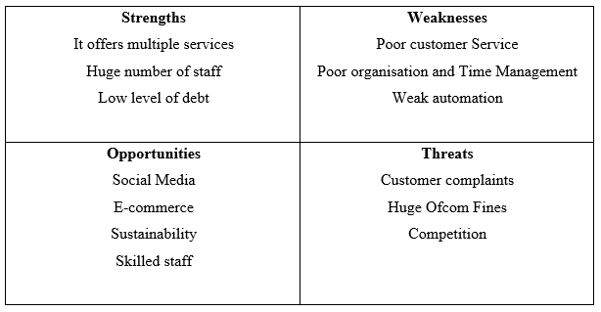

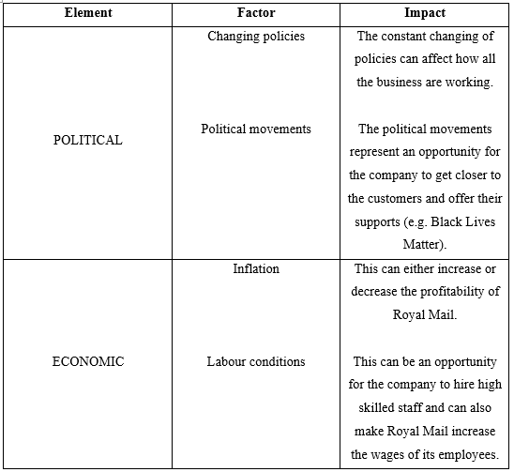
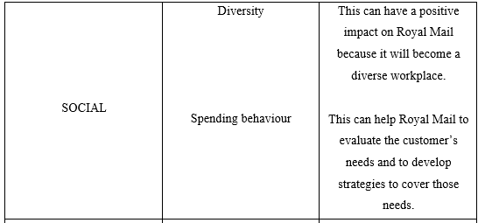

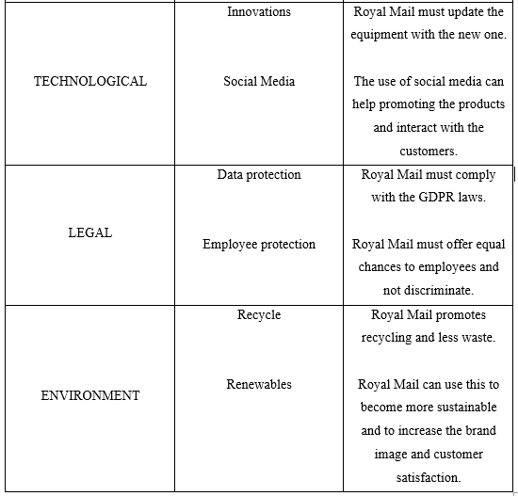

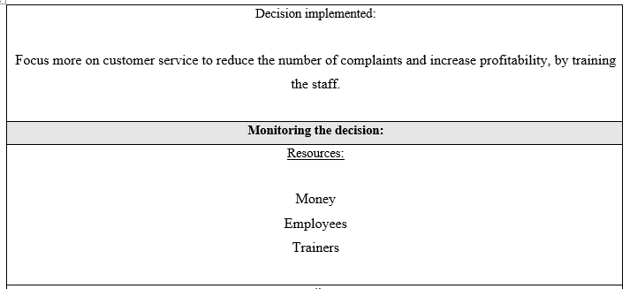

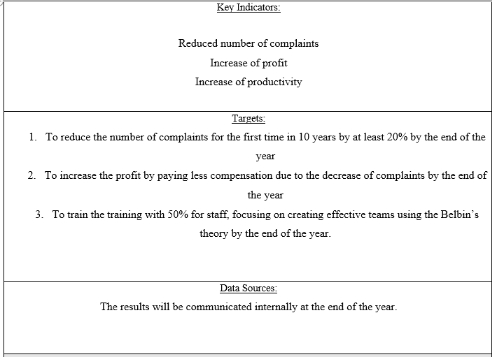
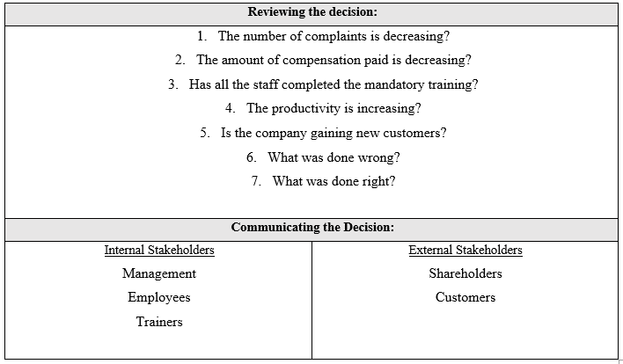

References
- Belbin (2020) The Nine Belbin Team Roles. Available at: https://www.belbin.com/about/belbin-team-roles/ (Accessed: 7 December 2020).
- Craft (2020) Royal Mail. Available at: https://craft.co/royal-mail (Accessed: 7 December 2020).
- Dawson, C. (2019) Record £2 million Royal Mail Compensation Payouts in last quarter. Available at: https://tamebay.com/2019/05/record-2-million-royal-mail-compensation-payouts.html (Accessed: 7 December 2020).
- Haven, B. (2018) The amount of compensation paid out to Royal Mail customers in 2017/18 has been revealed. Available at: http://www.businessmole.com/royal-mail-compensation/ (Accessed: 7 December 2020).
- Jenkins, S. (2014) There was only one loser in this Royal Mail privatisation: the taxpayer. Available at: https://www.theguardian.com/commentisfree/2014/apr/01/royal-mail-privatisation-taxpayer-loser (Accessed: 7 December 2020).
- MarketLine (2013) The UK postal service succumbs to the privatization trend. pp 8.
- Royal Mail (2018) Royal Mail Retail Digital Stamp Design Specification. Available at: https://www.royalmailtechnical.com/rmt_docs/QA_Stamp_Indicia/Retail_Digital_Stamp_Design_Specification_v1.0_20181107.pdf (Accessed: 7 December 2020).
- Royal Mail (2019) Royal Mail’s response to Statement of Strategic Priorities for telecommunications, the management of radio spectrum and postal services. Available at: https://assets.publishing.service.gov.uk/government/uploads/system/uploads/attachment_data/file/818077/RM_Response_to_DCMS_SSP_Consultation_.PDF (Accessed: 7 December 2020).
- Statista (2020) Number of customer complaints against the Royal Mail 2016-2019*. Available at: https://www.statista.com/statistics/1006890/royal-mail-customer-complaints/ (Accessed: 7 December 2020).
- Sustain Case (2016) Case study: How Royal Mail supports diversity and equal opportunity in its workforce. Available at: https://sustaincase.com/case-study-how-royal-mail-ensures-occupational-health-and-safety-3/ (Accessed: 7 December 2020).
- The Guardian (2020) Royal Mail fined £1.6m for late deliveries and stamp overcharging. Available at: https://www.theguardian.com/business/2020/jul/10/royal-mail-fined-for-late-deliveries-and-stamp-overcharging-ofcom (Accessed: 7 December 2020).
- The Guardian (2020) Royal Mail raising price of first-class stamp to 85p. Available at: https://www.theguardian.com/business/2020/dec/01/royal-mail-raising-price-of-first-class-stamp-to-85p (Accessed: 7 December 2020).
- The Guardian (2020) Royal Mail to hire record number of Christmas temps. Available at: https://www.theguardian.com/business/2020/oct/25/royal-mail-to-hire-record-number-of-christmas-temps (Accessed: 7 December 2020).
- The Indian Express (2020) Britain’s Royal Mail unveils black mailboxes to celebrate Black History month. Available at: https://indianexpress.com/article/trending/trending-globally/black-mailboxes-royal-mail-post-services-brutish-black-history-month-6666514/ (Accessed: 7 December 2020).

