[Alin Valentin Raducan] [2522566] CertHE Computing Skills for Workplace Module Code: ACCA4026 Lecturers: Martin Svejda, Osman Elgawi University Name: University of Wales Trinity Saint David Campus: [Birmingham] Date of Submission: 25/03/26

1.
In a modern digital world, e-commerce website creators have become essential tools for business operations. These software solutions allow organisations to make and manage online storefronts without needing advanced coding knowledge. By using these platforms, a business can greatly enhance its productivity and reach a global customer base. This section will explore two contemporary solutions, [Shopify] and [Wix], analysing their key features and how they support day-to-day business functions.

Shopify is an e-commerce software widely used around the world; it is designed to help manage businesses and their retail operations more effectively. A key feature of this platform is how it handles inventory in real time [1]. Instead of a worker having to sit there and count boxes for hours, the system just does it automatically. This is a huge boost for productivity because it frees up staff to do more important jobs, it also makes workflow better since you aren’t accidentally selling stuff that is out of stock [1]. It reduces the human error, so the business growth increases, for example imagine a small boutique that sells both in a physical shop and online. Without this real-time sync, they might sell the last pair of shoes to a customer in-store at the exact same time someone buys them online. Shopify prevents this ‘double selling’ nightmare by updating the digital shelf the second the barcode is scanned at the till. It basically turns the stockroom into a smart environment where the owner doesn’t have to guess what’s left, which is a massive stress reliever for any busy retailer

On the other hand, Wix is a versatile website builder that’s usually the go-to for smaller businesses that want a professional-looking site without having to write the code. One of the best things about it is that it's an all-in-one business dashboard, where you can handle everything from SEO to your customers list in one spot [2]. This is a huge boost for productivity because it lets an owner get their shop up and running quickly on their own, instead of waiting for weeks for a developer to do it. Plus, as tech platform “Enzuzo” points out, Wix has a massive library of app integrations that keep the daily workflow smooth. It handles the boring stuff, like automating booking calendars and marketing emails so you aren’t stuck constantly jumping between different tools all day [2]. A great example of this would be a yoga studio. Instead of spending hours on the phone, they can use the wix booking app to let clients see their live schedule and pay upfront. Because this connects directly to the site’s dashboard, the owner wakes up to a prefilled calendar and the money already in their account. It changes the workflow from ‘chasing leads’ to ‘delivering services,’ which is exactly how these modern tools help a one-person business feel like a much larger operation [2].

2a.
Mind mapping is a visual information management tool used to capture, develop, and share ideas in a non-linear format. It begins with a central "nucleus"—the primary subject or problem—from which related concepts radiate outward as branches and sub-branches. Unlike traditional linear notetaking, which can be rigid and restrictive, mind mapping utilizes a combination of keywords, symbols, color-coding, and spatial arrangements to mirror the brain’s natural associative thinking patterns.
According to the Engineering Management Institute, mind mapping represents a "productivity revolution" because it significantly reduces cognitive load [3]. In complex professional environments, the human brain can become overwhelmed by dense blocks of text; mind mapping bypasses this by allowing users to visualize both the "big picture" and granular details simultaneously [3]. By offloading complex hierarchies into a visual map, professionals can free up mental bandwidth for higher-level analysis and more creative problem-solving.
In modern business operations, the benefits of this technique extend beyond simple brainstorming. Business.com highlights that one of the primary professional advantages is "information chunking" [4]. This process helps teams break down massive, multifaceted projects into small, digestible, and actionable steps [4]. Key operational benefits include:
- Strategic Clarity: Identifying hidden dependencies between different departments, such as how a delay in R&D testing impacts the marketing launch timeline [3].
- Enhanced Memory and Retention: The use of visual cues and spatial orientation triggers better long-term recall compared to standard monochromatic lists [4].
- Collaboration: Mind maps serve as a "living document" during meetings, ensuring that all stakeholders maintain a shared mental model of organizational goals [4].

Beyond individual productivity, mind mapping functions as a critical framework for risk management and operational planning. In a business environment, the technique allows for scenario mapping, where leaders can visualize the potential ripple effects of a single decision across various departments. For example, a mind map entered on new product launch can breach into supply chain logistics, legal compliance, and customer support requirements simultaneously. This visual hierarchy ensures that no silent operational requirement is overlooked, which is a common failure of linear checklists.
The effectiveness of mind mapping in modern operations is significantly by digital software solutions. Unlike paper-based maps, contemporary applications allow for the attachment of live data, hyperlinks to internal documents, and real-time collaboration among remote teams. This digital transition supports transferable skills by ensuring information is communicated accurately and reliably within a managed environment. By using software to chunk information, professionals can transition seamlessly from broad brainstorming session to a structured project management workflow.

2b. Mind map
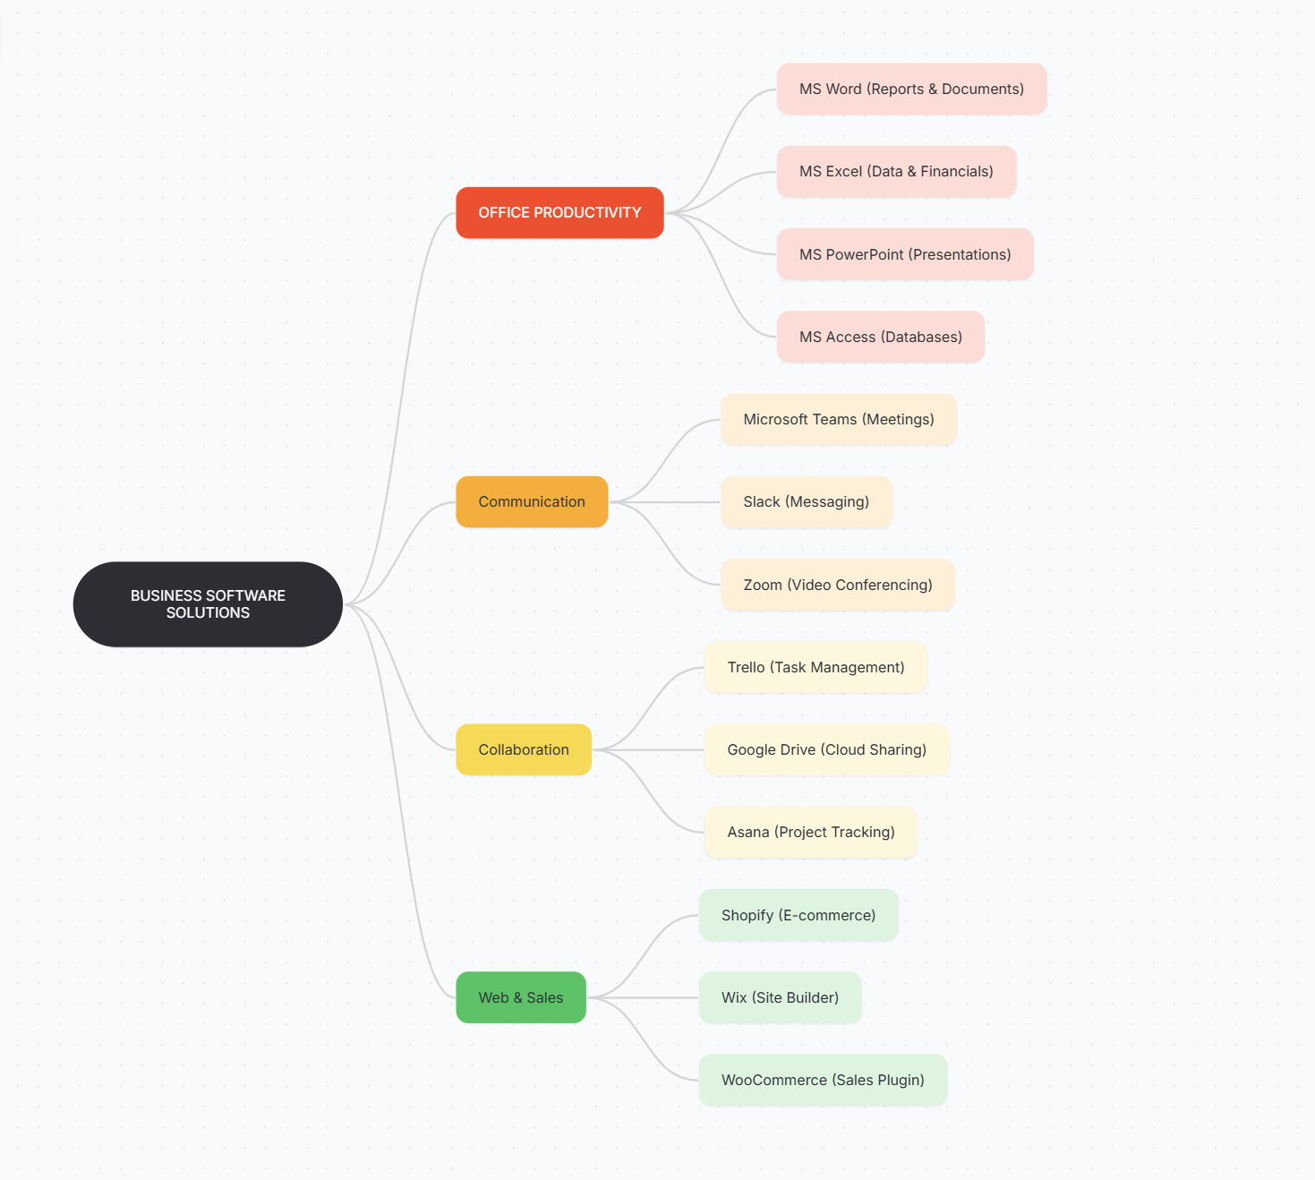
Figure 1: Mind map of contemporary software solutions for business operations.

3a.
Microsoft Word remains the industry standard for word processing, providing a foundational tool for business communication [5]. Its major features extend far beyond simple text entry; it offers comprehensive tools for formatting, which are essential for creating professional reports, contracts, and internal memos. Features such as integrated spell-check, grammar suggestions, and a built-in thesaurus help ensure that business communications uphold a high standard of professionalism [5]. Moreover, the capability to incorporate external media such as images, Excel data tables, and analytical charts enables users to craft visually appealing documents that convey complex information effectively.

One of the key advantages of Word is its intuitive interface, which adheres to the well-known ribbon design, making it user-friendly for employees with diverse technical abilities [5]. Its compatibility is another significant benefit; the ability to export documents to PDF guarantees that they can be shared across various platforms without compromising their formatting. For businesses aiming to enhance efficiency, the vast collection of pre-designed templates for invoices and business plans greatly simplifies the document creation process. Nevertheless, Word does have its setbacks. Advanced formatting options, such as section breaks or intricate indexing, can often pose a considerable challenge for inexperienced users [5]. Furthermore, for a small enterprise, the expense of an Office 365 subscription may represent a financial strain when compared to free alternatives.

In the context of business strategy and marketing, Microsoft's PowerPoint serves as an essential tool for visual storytelling [6]. Its main characteristic is a slide-based framework that facilitates the development of tailored presentations, utilising transitions and animations to highlight significant points. In addition to text, PowerPoint excels in multimedia integration, enabling users to incorporate audio clips, high-definition videos, and live web links [6]. This results in a multi-sensory experience that aids in maintaining the audience’s focus during lengthy meetings or sales presentations. The advantages of utilising PowerPoint encompass its adaptability in presentation delivery; slides can be shared digitally or displayed on a large screen [6]. The design ideas feature employs AI to recommend professional layouts, ensuring that even those without a background in graphic design can create high-quality slides. However, a prevalent drawback is the “death by PowerPoint” phenomenon, where excessive use of animations can divert the audience’s attention from the core message [6]. Effectively balancing visual appeal with informative content requires a specific set of design skills.

Microsoft Excel is arguably the most robust tool within the office suite for managing data and conducting financial analyses [7]. Its key features encompass a grid-based spreadsheet system that can manage extensive datasets through the use of advanced formulas, pivot tables, and VLOOKUP functions. For business, this translates to the capability of converting raw data into actionable insights via visualisation tools such as heat maps and intricate charts [7]. The foremost advantage of Excel is its role in facilitating informed decision-making. It is extensively utilised across various sectors for budgeting, financial forecasting, and inventory management [7]. The automation capabilities provided by Macros enable businesses to streamline repetitive tasks, significantly enhancing productivity. Nevertheless, a drawback of Excel is its complexity; mastering functions such as nested IF statements of Pivot Table necessitates considerable training [7]. Additionally, since data is input manually, Excel is susceptible to human error; even a single misplaced decimal point in a formula can result in substantial financial miscalculations.

Figure 2
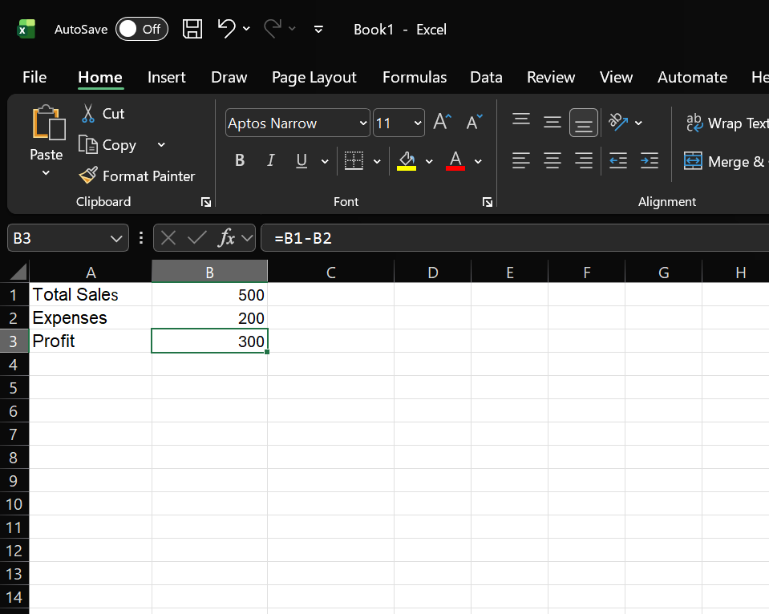

Figure 3
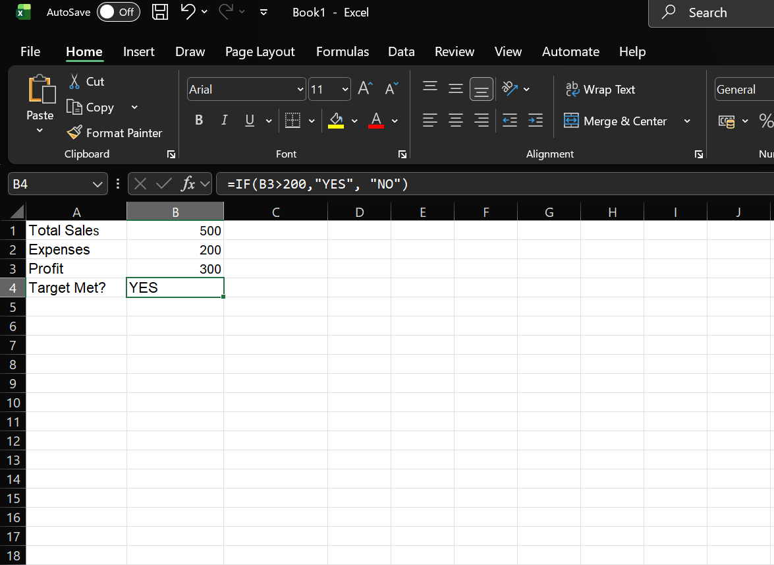

While Excel excels in performing calculations, Microsoft Access is specifically tailored for the organised storage and retrieval of extensive data sets [8]. As a relational database management system, its primary feature is the capability to connect various tables of data, such as associating a customer table with an orders table, thereby ensuring data integrity [8]. Access empowers users to create customised data-entry forms and automated reports without requiring extensive programming expertise. The advantages of Access lie in its querying efficiency. Users can swiftly shift through thousands of records to locate specific details, such as sales trends over time [8]. It accommodates multi-user access, enabling multiple team members to update the database concurrently. Nevertheless, its scalability presents a recognised limitation. As a business evolves into a larger enterprise, access may experience performance issues, ultimately necessitating a transition to more powerful systems like SQL Server [8]. Furthermore, establishing a database correctly necessitates a grasp of database design principles to avoid data redundancy.
In conclusion, the Microsoft Office suite offers a comprehensive and interconnected array of digital tools specifically designed to meet the diverse and changing needs of businesses [9]. While Microsoft Word and PowerPoint primarily emphasise qualitative aspects of business, such as effective communication, documentation, and compiling visual storytelling. Excel and Access deliver the crucial quantitative, analytical and organisational framework essential for effective data management. For a contemporary business to function at optimal efficiency, a fundamental proficiency in all four applications is imperative for daily operations. Each software solution addresses a distinct aspect of corporate productivity: Word guarantees professional clarity, PowerPoint enhances engagement, Excel fosters data-driven decision-making, and Access upholds the integrity of complex information systems. Despite the initial financial.

3b.
As illustrated in Figure 1, I performed a primary practical test using Microsoft Excel to showcase the application’s fundamental ability to manage financial data through automated calculations. In this instance, I created a simple business profit-and-loss summary. I input raw data for “Total sales” (500) and “Expenses” (200) into cells B1 and B2, respectively. The aim of this test was to eliminate manual calculations, which are susceptible to human error, and instead leverage Excel’s dynamic cell referencing system. I applied the formula=B1-B2 in cell B3 to calculate the “Profit”. This particular test underscores a significant advantage for contemporary business operations: the “automatic update” feature. In a practical setting, in B3, the update would occur immediately without any further user action. This alleviates the cognitive burden on staff and guarantees that financial reporting remains precise and current. By capturing the formula bar in the screenshot, I have provided proof of the logical framework behind the data, demonstrating that the software is utilised as a calculation engine rather than merely a digital spreadsheet. This foundational skill is crucial for any business professional responsible for budgeting or inventory management, as it facilitates the swift scaling of data without heightening the risk of mathematical errors. Furthermore, this test demonstrates the importance of “cell Auditing.” In a professional business setting, transparency is key. Because the formula bar clearly shows that B3 is the result of B1 minus B2, any other staff member or auditor can verify where the profit figure came from. This creates a “trail of logic” that is impossible to achieve with a standard handheld calculator. It also allows for “Template Creation,” where a business can set up this structure once and reuse it every month just by changing the input numbers, significantly boosting administrative productivity.

In Figure 2, I have broadened the scope of practical testing to encompass more advanced logical functions, particularly the IF statement. The objective of this test was to illustrate how Excel can function as a sophisticated decision-support tool rather than merely a basic calculator. In numerous fast-paced business environments, managers require immediate knowledge of whether a specific Key Performance Indicator (KPI) or financial target has been achieved. Rather than relying on a human to analyse the figures and make a subjective assessment, I programmed the software to conduct this analysis automatically based on established business rules. I input the formula =IF(B3>200, "YES", "NO") into cell B4. This formula directs Excel to examine the profit calculated in the preceding test and compare it against a target threshold of 200. Given that the profit was 300, the software accurately returned the value "YES". This test serves as a practical demonstration of how automation can be integrated into everyday business workflows. For instance, a procurement manager might utilize a similar formula to indicate "REORDER" if stock levels drop below a certain threshold, or an HR manager could apply it to determine if an employee has met their sales bonus criteria based on monthly performance metrics. The importance of this test resides in its capacity to manage "Binary Logic"—transforming raw numbers into clear, actionable terms. This eliminates ambiguity from business reporting. By documenting this process, I have demonstrated my ability to progress beyond simple data entry into the domain of basic data programming. This fulfils the "Practical Testing" requirement of the assignment by evidencing that the software has been set up to execute a specific business function. It also underscores the "Scalability" of Excel; although I only tested one row of data, this same logic could be "dragged down" to assess thousands of rows of data in mere seconds, a task that would require a human employee days to accomplish manually.
The outcomes of these evaluations validate that Microsoft Excel transcends being merely a tool for number storage; it functions as a relational framework where data points engage with each other to deliver business intelligence. Throughout the evaluation process, it became evident that the foremost benefit of utilizing such a tool is Data Integrity. When formulas are applied correctly, the likelihood of 'fat-finger' errors (inputting an incorrect number into a calculator) is considerably diminished, as the user interacts solely with the raw data inputs, while the software manages the intricate logic. Nevertheless, the evaluation also underscored the significance of Formula Transparency. As illustrated in the screenshots, the 'Formula Bar' constitutes the most crucial aspect of the interface, as it discloses the logic employed to derive the answer. For a business to thrive, its spreadsheets must be 'auditable,' implying that another individual should be able to click on a cell and comprehend precisely how a number was computed. These evaluations demonstrate that I can create a transparent, logical, and automated spreadsheet that adheres to the professional standards necessary for the contemporary workplace. By incorporating these features, businesses can shift from reactive data management to proactive strategic planning. The capability to establish 'Rules' through IF statements enable the software to function as a preliminary analyst, promptly notifying the business of successes or failures. This practical utilisation of Excel features directly reinforces the theoretical analysis, affirming that the Microsoft Office suite is a vital element of professional information systems.
In summary, the practical evaluations carried out in Microsoft Excel illustrate that this software is an essential tool for ensuring data precision and operational effectiveness within an organization. Transitioning from manual computations to automated formulas, such as basic subtraction and the "IF" logical function, allows a business to considerably minimize the likelihood of human error. This aspect is especially crucial in financial departments, where even a minor error can result in significant financial losses. Furthermore, these evaluations confirm that the Microsoft Office suite is built for scalability. Although the instances presented in this portfolio were on a small scale, the same principles and formulas can be utilized for thousands of data rows, enabling a growing enterprise to handle its information without the necessity of hiring additional personnel for data entry. Ultimately, the capability to convert raw data into straightforward "YES/NO" decisions indicates that these tools serve not merely as storage solutions but as integral components of a company’s decision-making framework. By successfully completing these evaluations, I have showcased the technical expertise necessary for effectively managing business data.

4a.
1. High-Definition Audio and Video Architecture
The primary feature of Zoom is its proprietary transport protocol, which optimizes high-definition (HD) video and audio even in fluctuating network conditions. Unlike traditional peer-to-peer services, Zoom utilizes a multi-layering video coding (SVC) technology. This allows the system to adjust the resolution and frame rate of the stream based on the hardware and bandwidth of each individual participant [10]. This ensures that a user on a high-speed fibre connection and a user on a mobile 4G network can coexist in the same meeting without the weaker connection degrading the quality for everyone else.
2. Advanced Collaboration and Screen Sharing
Beyond basic video, Zoom’s suite of collaboration tools is designed for synchronous professional workflows. The Screen Sharing feature is highly granular, allowing users to share their entire desktop, a single application window, or even a specific portion of the screen.
- Co-annotation: This feature allows multiple users to draw, type, and highlight on a shared screen simultaneously.
- Remote Control: In technical support or collaborative coding scenarios, one participant can request permission to control another's mouse and keyboard.
- Breakout Rooms: For educational or corporate training environments, Zoom supports the creation of up to 50 separate sessions within a single meeting. This allows for small-group discussions that the host can move between seamlessly [11].

Figure 4
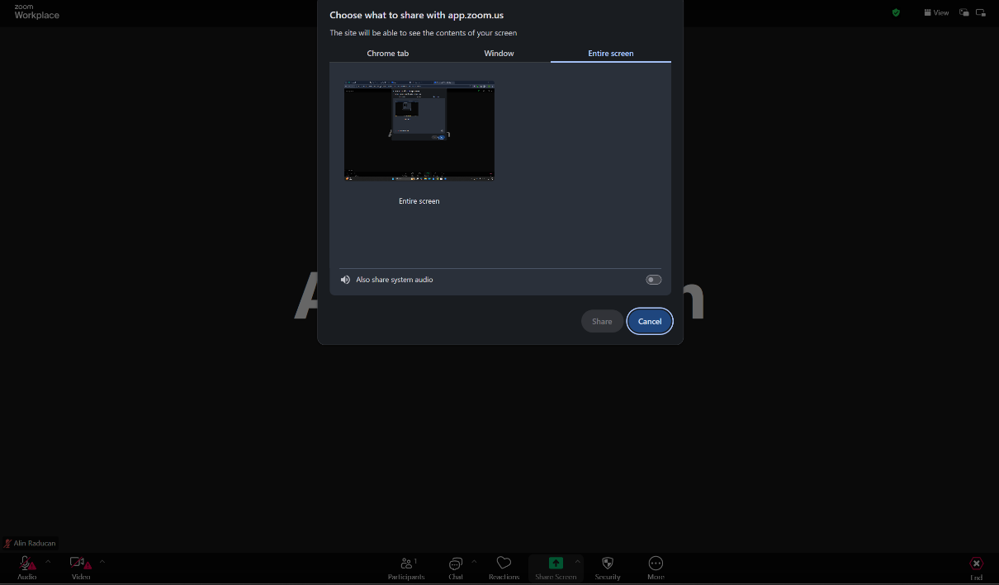
Figure 5
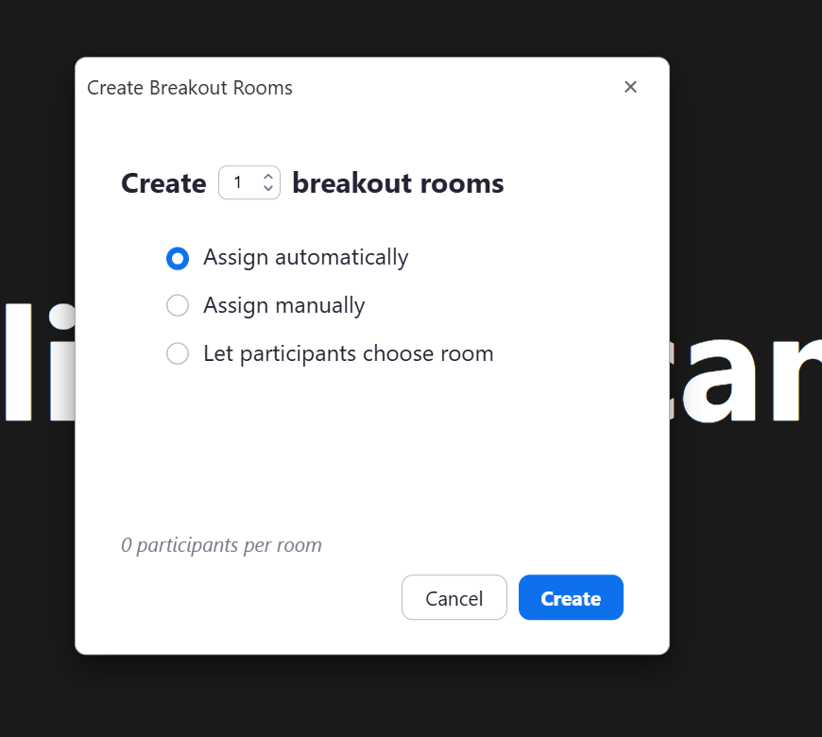
3. AI-Driven Productivity: The Zoom AI Companion
As the platform transitioned into a "Workplace" solution, the integration of generative AI became a cornerstone feature. The Zoom AI Companion utilizes large language models to assist users in real-time. This includes:
- Meeting Summaries: Automatically generating structured notes and action items from a recorded session, which are then emailed to participants.
- Smart Recording: Using AI to divide cloud recordings into distinct chapters based on the topics discussed, making it easier for absent team members to find relevant information [10].
- Real-Time Querying: Users who join a meeting late can ask the AI Companion private questions about what they missed without interrupting the flow of the conversation.
Figure 6
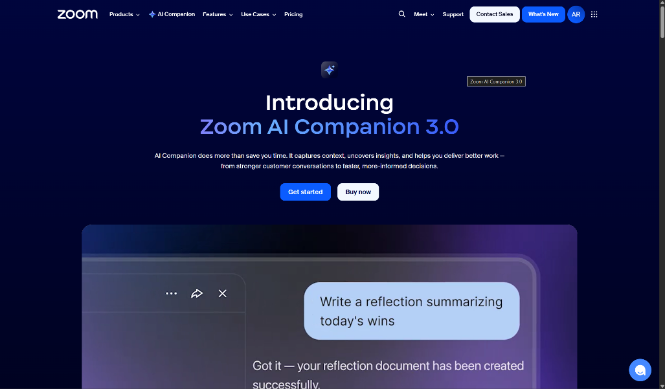

4. Security Framework and Encryption
In response to early security concerns, Zoom implemented a "security-first" architecture. The most significant feature is End-to-End Encryption (E2EE). When enabled, the cryptographic keys are generated on the participants' devices rather than Zoom’s servers, ensuring that no third party—including Zoom itself—can monitor the data [12]. Supplemental security features include:
- Waiting Rooms: A virtual staging area that prevents uninvited guests from entering until the host manually admits them.
- Personal Meeting ID (PMI) Disabling: To prevent "Zoom-bombing," the system encourages the use of unique, one-time meeting IDs for every session [11].

Figure 7


5. Integration and Extensibility
Zoom’s ecosystem is defined by its interoperability. The Zoom App Marketplace allows for integrations with hundreds of third-party services like Slack, Microsoft Outlook, and Google Calendar. This allows users to schedule and launch meetings directly from their existing workflow tools. Furthermore, Zoom’s API and SDKs enable developers to embed Zoom’s video functionality directly into custom-built healthcare, legal, or educational applications [10].

4b.
1.
The most significant advancement in Teams is the integration of Microsoft 365 Copilot, which acts as a real-time analytical engine. Copilot does not merely transcribe meetings; it performs "semantic indexing" of conversations to identify intent and sentiment [13]. During live sessions, the Intelligent Recap feature automatically generates structured notes, categorizing mentions of specific stakeholders and deadlines. This reduces the cognitive load on participants, allowing them to focus on the dialogue rather than documentation. Furthermore, Copilot assists in "message composition," helping users adjust the tone and clarity of their chats based on the recipient's organizational hierarchy and past interactions [13], [14].

Figure 8
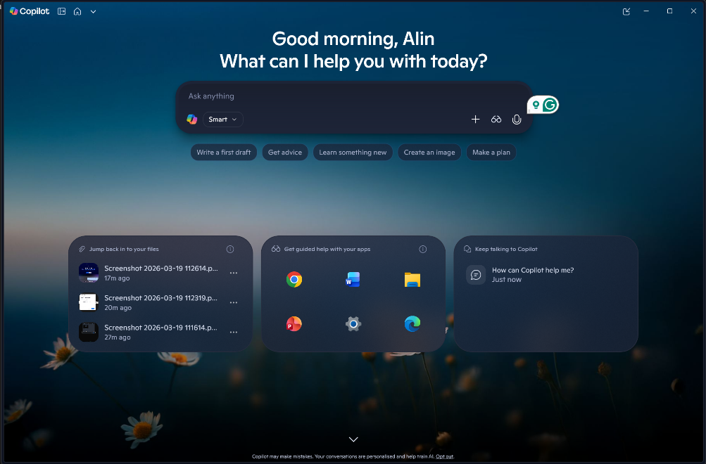

2.As organizations have stabilized into hybrid models, Teams has introduced features to bridge the gap between physical and digital spaces. Front Row and Together Mode use AI to segment participants from their backgrounds and place them in a shared virtual environment, which has been shown to reduce "Zoom fatigue" by mimicking natural spatial awareness [14].

Technologically, the platform now supports Multi-stream IntelliFrame. This feature allows in-room cameras to identify individual faces in a conference room and provide them with their own dedicated video tile in the gallery. This ensures that remote participants can see the facial expressions of everyone in the room clearly, promoting "meeting equity" where every participant has an equal visual presence regardless of their location [15].

3. Teams has evolved into a "platform-as-a-service" (PaaS) model where third-party applications are embedded directly into the chat and channel interface. This eliminates "context switching"—the productivity loss associated with toggling between different software applications [14].

Additionally, the introduction of Microsoft Mesh allows for immersive 3D workspaces within Teams. Users can join meetings as avatars in spatial environments, which is particularly useful for virtual social gatherings, onboarding, or complex 3D design reviews [13]. This spatial audio and visual depth provide a level of immersion that traditional 2D video cannot replicate, making digital interaction feel more human-centric.
Figure 9
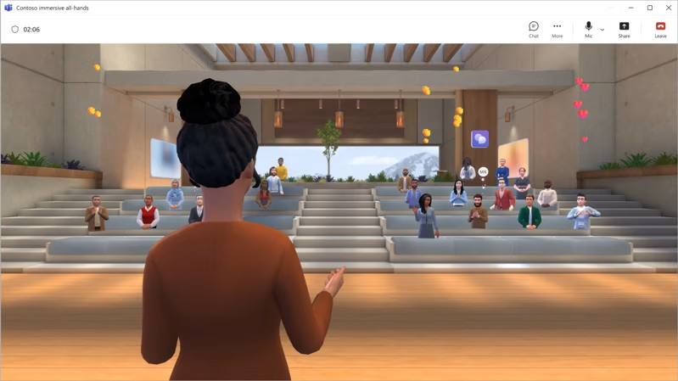

4.Security remains a cornerstone of the Teams architecture. The platform utilizes Advanced Threat Protection (ATP) to scan attachments and links in real-time. In the 2026 environment, Teams has implemented "Zero Trust" communication barriers, which automatically prevent sensitive data (like credit card numbers or internal code) from being shared with external guest users unless specific encrypted channels are used [15]. Furthermore, Shared Channels (via Microsoft Teams Connect) allow multiple organizations to work in a single space without the need for tenant-switching, maintaining a strict security boundary while fostering seamless B2B collaboration [13].

References
[1] M. Keenan,” Real-time inventory Management Benefits and How To”
Shopify UK, Jan. 27, 2025. Accessed: Feb. 24, 2026. [Online]. Available: https://www.shopify.com/uk/retail/real-time-inventory-management-benefits-and-how-to-2025

[2] P. Harris, “Pros and Cons of Using Wix” Enzuzo blog Feb. 9, 2025.
Accessed: Feb. 24, 2026. [online] Available: https://www.enzuzo.com/blog/pros-and-cons-of-using-wix

[3] M. Douglas, “How mind mapping can revolutionize your productivity”
Engineering Management institute Feb. 14, 2024. Accessed: Feb. 25, 2026. [Online] Available: https://engineeringmanagementinstitute.org/mind-mapping-revolutionize-productivity/

[4] S. Peek, “The Benefits of Mind Mapping for Busy Professionals” Business.com Jan. 12, 2026. Accessed: Feb. 25, 2026. [Online] Available: https://www.business.com/articles/benefits-of-mind-mapping-for-professionals/

[5] M. N. H. S. R. Crandall, “An overview of Microsoft Word,” IEEE Technology and Society Magazine, vol. 32, no. pp. 37-41, 2013.

[6] L. R. K. Gonzalez, “Utilizing Microsoft PowerPoint in Business,” IEEE Transactions on Professional Communication, vol. 48, no. 1, pp. 102-110, 2005.

[7] T. H. M. Flanagan, “Data management in Microsoft Excel, “ IEEE Software, vol. 25, no 1, pp. 82-86, 2008

[8] P. D. Smith, “Microsoft Access in enterprise database applications, “ IEEE Computer Applications in Power, vol. 14, no. 3, pp. 41-47, 2001.

[9] B. Magoutas, D. Apostolou, and G. Mentzas, “An Event-Driven Framework for Business Awarness Management,” 2020. [Online]. Available: https://arxiv.org/pdf/2012.02615v1

[10] PeopleLink Video Conferencing, "The Ultimate Guide to Video Conferencing: The Digital Age of Communication," PeopleLinkVC.com, 2026. [Online]. Available: https://www.peoplelinkvc.com/the-ultimate-guide-to-video-conferencing/. [Accessed: Mar. 19, 2026].
[11] IT Services University of York, "New Zoom features: AI Companion," York.ac.uk, Jan. 9, 2026. [Online]. Available: https://www.york.ac.uk/it-services/about/news/2026/new-zoom-features-ai-companion/. [Accessed: Mar. 19, 2026].
[12] Y. Dodis, D. Jost, B. Kesavan, and A. Marcedone, "Comprehensive Security Evaluation on End-to-End Encryption of Zoom," IEICE Transactions on Information and Systems, vol. E108.D, no. 12, pp. 2024–2030, Dec. 2025.

[13] M. Teltek, “Microsoft Teams in 2026: What’s New, What’s Changing, and What Businesses Must Prepare For,” Teltek Systems Blog, Dec. 29, 2025. [Online]. Available: https://myteltek.com/blog/2025/12/microsoft-teams-in-2026-whats-new-whats-changing-and-what-businesses-must-prepare-for/. [Accessed: Mar. 19, 2026].
[14] S. Business Cloud, “New Microsoft Teams Features in 2026 Explained,” SMS Business Cloud News, Jan. 13, 2026. [Online]. Available: https://smsbusinesscloud.com/news/new-microsoft-teams-features-in-2026-explained/. [Accessed: Mar. 19, 2026].
[15] Microsoft, “What’s New in Microsoft Teams | February 2026,” Microsoft Tech Community, Feb. 2026. [Online]. Available: https://techcommunity.microsoft.com/blog/microsoftteamsblog/what%E2%80%99s-new-in-microsoft-teams--february-2026/4497206. [Accessed: Mar. 19, 2026].

