Mohammed Azar
1818591
Module Lecturer: Anita Nan
This is a report analysing some academic and employability skills for Anita Nan
Academic and employability skills
BMSW4001

Contents
Introduction 2
Time management 2
Team working 3
Active listening 4
Conclusion 6
References 6

Introduction

This report aims to focus and analyse some academic and employability skills such as time management, teamworking and active listening skills. It also aims to analyse how good I am at these skills and what I can do to improve them. The report will also be looking at why these skills are important in the workplace, when studying and everyday life.

Time management

Time management is defined as having the ability to use your time effectively and productively, mainly at work or when studying.
We cannot change time; we cannot increase or decrease it. Time is everywhere and we all have the same amount of it, 24 hours in one day. However, what makes us who we are is how we choose to use that time (Chidiac, 2019).

Students with good time management are more likely to pass any courses they are taking. Failing to manage your time efficiently will make it almost impossible to pass your course (Morgan, 2017).

Time management in the workplace is also very important. People who can manage their time well can get a lot more done in less time which would leave them more time for trainings and other learning opportunities.

Bad time management could lead to stress because of not meeting deadlines or getting things done in time or at all. It could give a person a bad reputation amongst colleagues if you they constantly late to meetings or if them not getting things done is affecting others or the team’s targets.

People who want to get better at managing their time can do so by keep a log of everything they do in a day or a week and then analyse their findings to see where they waste most of their time. Once they have identified the problem times, they can then make changes to reduce or cut out the things they do that waste the most amount of time and replace those times with things that are more productive and beneficial to them.

Keeping a diary and making ‘to do’ lists are also good ways of getting better at managing your time. People who make to do lists can then use methods such as the Eisenhower method or Pareto’s 80-20 rule to prioritise which of the tasks on their to do list is most urgent/important, which tasks are not so important/urgent and which tasks are most time consuming.

My ability to manage my time effectively and efficiently before doing this course was not very good. I had been told and advised by previous managers that it is important for me to learn how to manage my time better. They would give me ideas such as keeping a ‘to do’ list of the tasks I needed to complete on a day at work at the start of the day and that I should give myself a realistic amount of time to do each one. They also advised me to keep up with my online diary. Over the years I have got better at this but after this case study I have learnt even more about the importance of good time management and methods that can help be better at it.

I will now complete a to do list the night before rather than in the mornings and it will be for both the tasks I need to do at work and outside of work for example studying. I will keep a personal diary as well as a work diary and I will use both the Eisenhower method and Pareto’s 80/20 rule to prioritize them by urgency, importance and size.

Team working

Team working is when a group of people work and use their individual skills together to achieve a common goal, target or outcome.

When recruiting new staff, organisations may look at a person’s ability to work as part of a team and their ability to get along with others. Many workplaces now use the TEAM moto (Together Everyone Achieves More) as part of their team building days and trainings. By working together, putting each other’s experiences, skills and knowledge towards a common goal they can all achieve a lot more than what they would by themselves.

Teamwork requires each member of the team to work hard, take responsibility, demonstrate good communication and good active listening. It also requires them to demonstrate that they can work together with the other people in their team to achieve a common goal; build relationships and trust with them; contribute and respect that other members of the team may have different opinions, ideas, or ways of working to them.

According to (Morgan, 2017) teams that are too large can become ‘dysfunctional’ because of arranging meeting times and difficulty communicating etc. He recommends that teams should be of about five to seven and that those five or seven people should be carefully chosen so that they all bring something different to the team as oppose to all having the same skills. He goes on to say that they should set clear goals that they are all ‘committed’ to achieving and that they should all agree on how they will go about achieving them. Teams should pull together when things don’t go to plan and each member should help and support the other in order to create a strong bond and team spirit.

Research shows that a team’s success can depend on the way it is put together. William M, Marston’s DISC personality profiling and Meredith Belbin’s Team Role Theory are two models that are often spoken about when it comes to putting a team together (Morgan, 2017).

DISC personality profiling assesses a person’s personality traits against four main areas. Dominance, Influence, Steadiness and conscientiousness. It is used to determine a person’s behaviour and personality in a team by carrying out a personality questionnaire.

In 1970 Beblin and others (Belbin, 1981) carried out research in the form of simulations and questionnaires to identify nine team roles. They found that the more these roles were reflected in a team, the better the team did (Morgan, 2017).
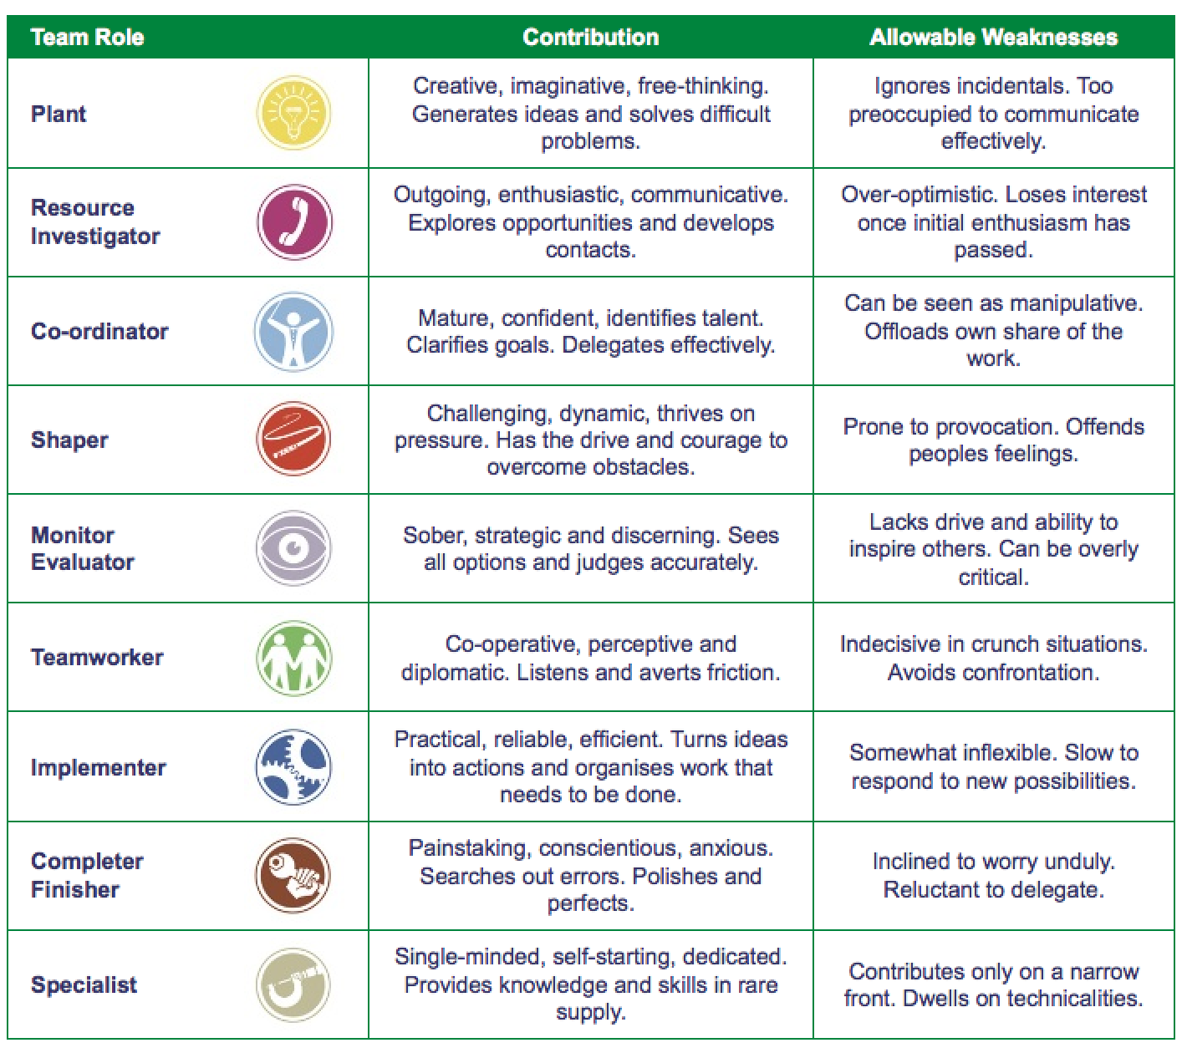

Team development and team cohesion are also an important part of having a successful team. As well as trainings and team building days, it is good for teams to do informal things together such as going for a meal. Identifying a common enemy can create good team cohesion. "A team that has a common enemy to fight against can focus its energy more effectively” (Morgan, 2017).

My teamwork skills are good, but I have learnt a lot from the research carried out for this report for me to improve and become even better. I also feel what I have learnt will help me be a better team leader. I have very good communication skills and am very good at actively listening to others. I feel I have a lot of experience of working with people of all different ages, backgrounds abilities and personalities which and I am good at defusing conflicts and decision making. I am reliable and would bring a variety of skills to a team.

Active listening

Active listening is when a person listens motivates themselves to use all of their senses to maximize concentration, attention and focus on what is being communicated.

According to Hoppe, M.H. (2006) “Active listening is a person’s willingness and ability to hear and understand”.
Listening is a vital skill and not having this skill could have a major impact on your life, your career and your relationship with others.
In order to engage in good active listening, a person must make a conscious effort to want to listen and understand. Motivating themselves to want to learn, understand and obtain the information that the speaker is sharing. “Listening involves paying attention to multiple channels, not only the oral channel” (Wilson, 2013).

Some key things to keep in mind are:

- To pay attention
Give the speaker your undivided attention and don’t let anything that is going on around you to distract you. Look directly at the speaker and be aware of their body language.

- To show that you are listening
Lean forward slightly or sit upright making sure your posture is open to show the speaker you are interested in what they are saying. Use facial expressions and encourage the speaker to give you more information by occasionally nodding or giving verbal prompts such as “mm hmm” or “uh huh”.

- To provide feedback
A good way to show the speaker you are listening is by asking questions about what was said or summarizing what they have said and paraphrasing it back to them.

- Don’t be Judgemental
Don’t be thinking of counter arguments in your head whilst they are speaking and don’t interrupt the speaker with any as this may frustrate the speaker and lead to them not sharing anymore and limit your understanding of the message. Only ask questions that are relevant, that will encourage the speaker to give more information and wait till the speaker has finished making a point before asking.

- Respond appropriately
It is always good to be open and honest when responding but remember to be respectful and consider how it will make the speaker feel.

Active Listening will help a person in all walks of life. A student that is studying at university or doing a course or learning would benefit from active listening as it could help them retain information better, focus more on what a lecturer is teaching them or help them in group assignments. Listening actively outside of work or learning would also help a person have better relationships with their partner, family and friends. People like to know and feel like they are being listened to and giving your undivided attention to people especially friends and family could earn a person more respect, admiration or appreciation.

Active listening also helps people in the workplace. For example, if a person is working in retail, they can use active listening with an unhappy customer to defuse a situation by showing the customer that they are listening, showing empathy, showing that they understand and responding well by using the information gained or if a person is working with children or the elderly who may not always speak clearly, they can use active listening to identify their needs using body language, facial expressions etc.

I was taught about active listening about twelve years ago and have been using it and trying to improve it ever since. I have worked with children with disabilities for the past 15 years and listening actively has helped me a lot when understanding and identifying young people’s needs especially if they are non-verbal or have limited speech. I must use all my senses to listen and try to understand what it is they are trying to communicate or to encourage them to communicate. I make sure my phone is off so that I cannot be distracted, and I try to limit distractions in the environment in which I am working wherever I can. I try to make sure my body language is open and have awareness of my positioning is side on to make them feel comfortable and relaxed to communicate.

Summarizing

To summarise something is to take the key points from it and link them together to create a short summary.

Paraphrasing

Paraphrasing is a someone takes something someone has said or wrote and puts it into their own words. To avoid plagiarism the words and structure must be change. This can be done by changing the word class, use of synonyms and changing the order of the sentences.

Conclusion

This report analysed a few academic and employability skills which I have acquired such as active listening, team working and time management. It highlights the importance and benefits of these skills at work, when studying and in everyday life. Managing your time better can help you get more done in less time and help you meet targets and deadlines as well as building a reputation with colleagues and managers for being reliable. Working well in a team can help you achieve more than what you can achieve alone and listening actively in your daily life whether at work, at university, with friends or at home can help you build better relationships, retain information better and respond better.

References
Chidiac, S. (2019) The 10 unbreakable rules of time management. Dubai: Chidiacbooks.com.
Hoppe, M. H. (2011) Active listening improve your ability to listen and lead. North Carolina: Centre for creative leadership.
Morgan, P. (2019) The business student's guide to study and empoyability. California: SAGE.
Wilson, M. and Rost, J.J. (2013) Research and resource in language teaching active listening. New York: Routledge.
Mound, A. (2017) Certificate in higher education: skills for the workplace student yearbook. London: Sage Publications Ltd.
Belbin, R.M. (1981) Management teams: why they succeed or fail. London: Heinemann.

In Class Exercises



