

Tittle: New Performance Management for SainCo

Student name: Akashdeep singh
Student ID : 2239847
Programme : MBA Human Resource Management
Module Name- Managing Performance
Module code : LCMB7013
Lecturer name: Hong Nguyen
Date: 2 May 2024

Table of Contents
1. Introduction 3
SainCo understands that being in the retail business for a long time requires modernizing performance management practices while ensuring their adequate implementation and compliance. This paper explores the concept of performance management, identifies critical issues relating to the currently used approach, and suggests a new vision that fits the company’s goals and the desired level of employee involvement. 3
2. Performance Management: A Continuous Process 3
3. Organisational and Employee Concerns with Current Approach: 12
4. Employee Engagement and Employee Involvement: Driving Performance at SainCo 18
5. Recommendations 21
6. Conclusion 25
References 26

1. Introduction

SainCo understands that being in the retail business for a long time requires modernizing performance management practices while ensuring their adequate implementation and compliance. This paper explores the concept of performance management, identifies critical issues relating to the currently used approach, and suggests a new vision that fits the company’s goals and the desired level of employee involvement.

2. Performance Management: A Continuous Process
The level of success that SainCo achieves is directly linked to the performance of its different employees. For SainCo to attain optimal performance and keep its competitive market position, the company needs to have a performance management system that is thorough and goes beyond yearly reviews. The management of performance is a continual activity that guarantees that individual goals are by the overall strategic direction of the business. It also helps to foster the growth of the culture of the organization. In the following section, we will delve into the key components that serve as the foundation of a modern performance management system. Our focus will be on the most important aspects that contribute to the success of the company as well as the level of engagement that workers have in their work.
2.1 The Continuous Cycle: Development and Appraisal
Performance management is a nonstop procedure and it is not limited to a single occurrence, but rather to a broader series of activities that include, goal-setting, continuous input, ability expansion, and the target accomplishment of the company. It is intended to make sure that the objectives of the organization are attained. This process is made up of two major and overlapping rounds.
Component | Description
Performance Management | A continuous process focused on setting clear goals, providing ongoing feedback, and developing employee skills to achieve organizational objectives (Camilleri, 2021).
Performance Development | Focuses on setting goals collaboratively, providing regular feedback and coaching, and identifying training opportunities for skill development. It aligns individual goals with the organization's strategic direction.

2.1.1 Performance Development:
The performance development itself centers on the performance development process. The critical part of the endeavor is the creation of an encouraging environment that will allow the management and the workers to partner in goal-setting, spot opportunities for improvement, and offer ongoing support.
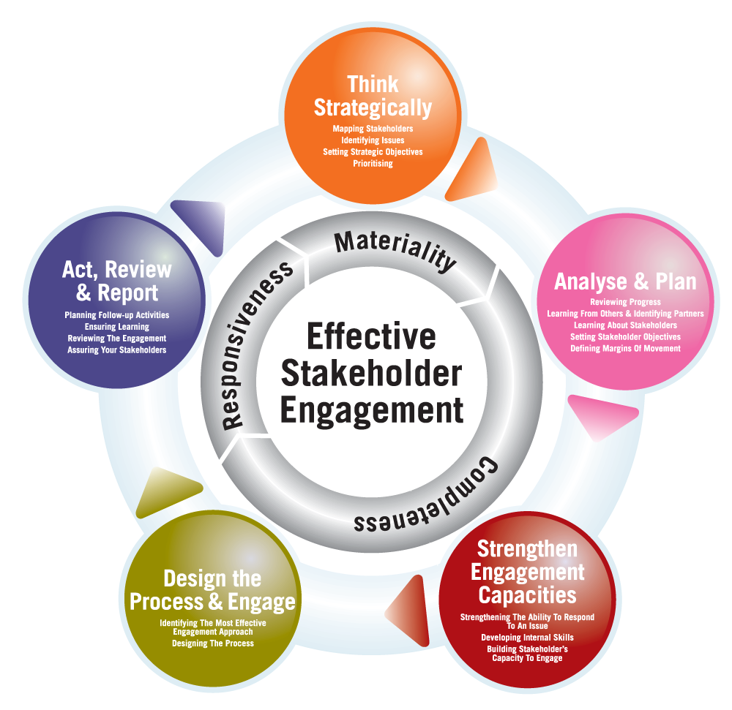
Figure 1: Performance Development
(Source: Hristov et al., 2021 )
The components of performance development are:
Element | Description
Goal Setting | * Collaborative Approach: Employees and managers work together to define SMART goals (Specific, Measurable, Achievable, Relevant, and Time-bound). This fosters ownership and engagement (Hristov et al., 2021 ).
 | * Alignment with Strategy: Goals are aligned with the organization's strategic direction, helping employees see how their contributions impact the bigger picture.
 | * Flexibility and Review: Goals are reviewed and adjusted as circumstances change to ensure continued relevance and alignment.
Regular Feedback | * Continuous Process: Regular feedback conversations occur throughout the year to support ongoing development (Hristov et al., 2021 ).
 | * Formative and Developmental: Feedback provides a balance of positive reinforcement and constructive criticism, focusing on both strengths and areas for improvement. It offers guidance for growth.
 | * Two-Way Communication: Feedback conversations are a two-way street, allowing employees to ask questions, clarify expectations, and provide feedback to their managers.
Coaching and Development | * Identify Needs: Through ongoing feedback and discussions, managers identify skill gaps or areas where employees require additional support.
 | * Development Opportunities: Providing access to training programs, mentoring, or other development opportunities equips employees with the skills and knowledge needed to achieve their goals and excel in their roles.
 | * Individualized Approach: Development plans are tailored to individual needs and career aspirations, ensuring employees acquire the specific skills necessary for their success.

- Goal Setting:
  - Collaborative approach: the employees and their managers work together to set goals, and instead of them being exclusive, they are inclusive in terms of being SMART- Specific, Measurable, Achievable, Relevant, and Time-bound. This approach makes it easier for the employees to own the goals set and hence results in better engagement and motivation.
  - The third approach is in terms of alignment with the organization’s strategy. Goals should be well defined to impact the strategic path of the organization, as the understanding of the contribution of the individual to the bigger picture is a key foundation to be motivated.
  - Flexibility and review: goals should not be fixed on the employees, but new circumstances and performance should allow for new ideas to be used.
- Regular Feedback:
  - Continuous Process; just as described above, performance management is not a review activity on an annual basis. Regular feedback conversations need to happen throughout the year to ensure an employee’s continuous development.
  - Formative and Developmental: feedback needs to be positive and formative. It should identify performance strengths and areas for growth and develop guidance on the latter (Hristov et al., 2021 ).
  - Two-Way Communication: weekly feedback conversations or meetings are a two-way street.
- Coaching and Development:
  - Identify Needs. Regular feedback and conversations with employees will help managers disclose skill gaps or where workers need extra help or support.
  - Development Opportunities. Increased access to training courses, mentors, and other education opportunities enables employees to acquire the right skills and knowledge to achieve their personal and professional objectives.
  - An Individual Approach. Schemes must be personalized to fit employees’ needs while also being declared in terms of career ambitions. This means workers would need to obtain individual skills.
2.1.2 Performance Appraisal: Evaluating Progress and Making Decisions
Performance appraisal is a formal evaluation of employee performance against predetermined goals. It provides an opportunity to:
- Assess progress — appraisals give a chance to review how far goals have been met and what areas require adjustment; they are also an occasion to recognize and celebrate achieved success.
- * Identify strengths and weaknesses — it is only by analyzing performance that one can capitalize on the former and pinpoint the latter to concentrate one’s development efforts.
- * Future decisions — appraisals help to decide about the employee’s possible promotion, compensation changes, and development requirements along with updating future goals and plans for development to map the way forward (Enyinna, 2024).
2.2 Theories Supporting Modern Performance Management
Modern performance management practices are underpinned by two key psychological theories:
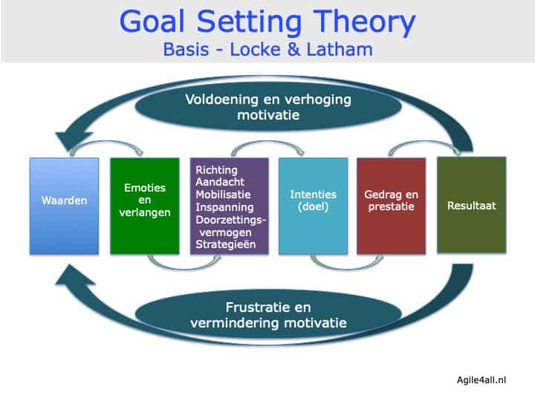
Figure 2: Goal-Setting Theory
(Source: Enyinna, 2024)
Goal-Setting Theory (Locke & Latham): According to this notion, increased performance may be achieved by setting objectives that are precise, difficult, and within one's reach. Employees are more likely to feel committed to reaching their objectives when they are allowed to participate in the process of creating those goals. The process of defining goals along with others not only enhances the chance of achievement but also promotes a sense of ownership.
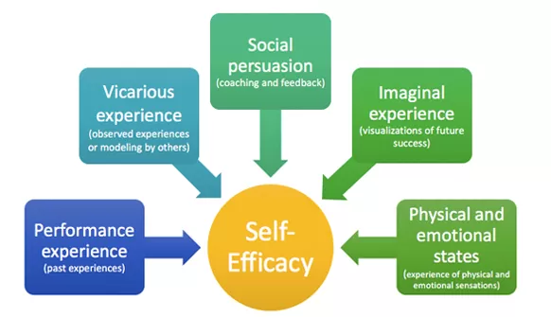
Figure 3: Self-Efficacy Theory
(Source: Garengo et al., 2021)
Self-Efficacy Theory (Bandura): The necessity of self-belief in the process of achieving one's goals is emphasized by this concept, which lays focus on the importance of self-belief. Increasing an employee's self-efficacy, which can be defined as their belief in their ability to achieve success, may be achieved by providing them with opportunities for growth, coaching, and regular feedback (Garengo et al., 2021). The possibility of an employee putting in the effort necessary to reach their goals is raised when that individual has confidence in themselves.
By incorporating these theories, modern performance management systems encourage employee engagement and empower individuals to reach their full potential.
2.3 The Benefits of a Continuous Approach
A continuous performance management system offers numerous benefits for both SainCo and its employees:
- Greater Performance: when employees have clear goals, regular feedback, coaching, and development opportunities, both individuals and the larger organization perform better.
- Higher Engagement: when setting goals and keeping employees informed and involved becomes a priority, the level of ownership and engagement increases. Those factors in turn drive motivation, effort, and commitment.
- More Development: identifying development opportunities and skill needs allows organizations to scale up high developments on their investments as they work with a highly capable and adaptable population(Garengo et al., 2021).
- Increased Alignment: when everyone’s goals are tied to the business strategy, the entire organization moves in the same direction, leading to a strategic and concentrated effort.
- Higher Retention: when workers feel appreciated and that their employers are working to assist them, they are more likely to remain with the firm.
- Improved Decision-Making: with well-defined goals, regular feedback, and guidance, performance-related data can guide decisions regarding promotions, compensation, and development opportunities.
2.4 Building a Culture of Feedback
One needs to develop a culture of feedback, which is a crucial part of the system for effective performance management in a continuous manner. It is only possible to do this by creating a climate in which managers and employees experience no discomfort about giving and getting feedback regularly. Here are some strategies to achieve this:
- Normalize Feedback: Establishing the culture of expecting feedback to be a part of everyday discussions and development sessions is one way to get everyone used to the idea of being assessed regularly.
- Focus on Growth: Make sure feedback is actionable and formulated positively to help employees meet new goals. Diplomacy without examples and steps for improvement is a big disadvantage and a waste of time (Díez et al., 2020).
- Two-way Communication: Finally, get used to the idea that your employees should feel free to give feedback to their managers as well. Psychological Safety: Show your employees that you appreciate such feedback.Django and active listening, even if it may seem critical.
2.5 Conclusion
Given that if SainCo develops a continuous performance management system that is centered on employee participation, feedback, and progress, then the company will be in a position to realize its full potential and actualize its full potential. People are authorized to do their best, a culture of learning and growth is cultivated, one’s personal goals align with the direction of the organization, and lastly, people make their individual goals align with an organization’s direction. SainCo attains enhanced performance, a happier workforce, and a market-dependent edge directly from there.

3. Organisational and Employee Concerns with Current Approach:
SainCo's current performance management system, built upon a traditional, autocratic management style, presents several concerns that hinder employee engagement, growth, and ultimately, organizational success. This section delves into these concerns, highlighting how they negatively impact various aspects crucial for effective performance management, including business strategy, commitment, improvement flexibility, and quality.
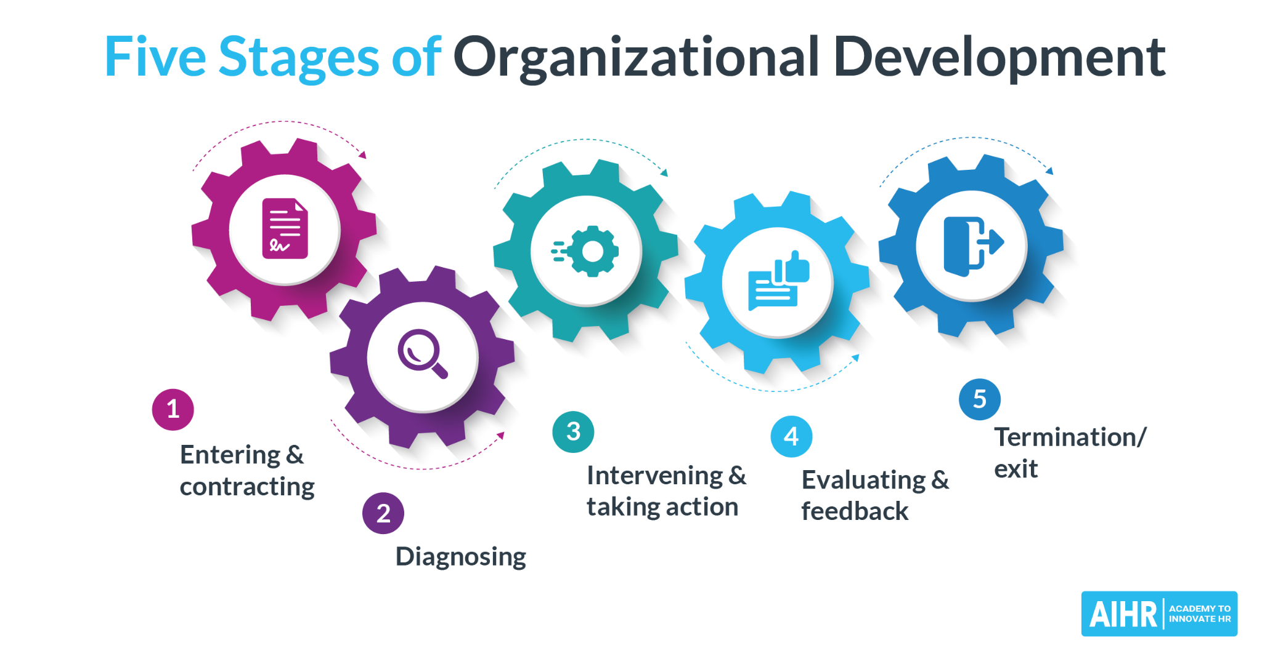
Figure 4: Employee Engagement
(Source: Garengo et al., 2021)
3.1 Lack of Employee Engagement: A Demotivating Disconnect SainCo's autocratic approach fosters a culture of disenfranchisement, leading to a lack of employee engagement with the performance management process. This disconnect manifests in several ways:
- Disempowered Goal Setting: Management sets targets in a primary form of indecency as dedication is stifled. Management is circumnavigating individual abilities, hopes, and insights. Employees often view such targets as unachievable or irrelevant and fail to root for their real success.
- Perceived punitive appraisals: Performance assessments, especially in terms of penalties or predilection, establish the stage for employees to be sarcastic and defensive. It erodes the relationship between themselves, reducing truthful contact and introspection. This is a developmental roadblock (Endalamaw et al., 2024).
- Reduced innovation and initiative: Employees who are assured of the current painless feelings do not resonate with the customers. No one wants to make the necessary sacrifices or inspire them to make critical decisions.
Business Strategy Impact:
- If they do not have the chance to give input, they follow that the objectives do not align with their talents and expertise. Thus, the lack of this gap makes it more difficult to attain the company’s objectives (Goshie et al., 2022).
- They are less creative and less motivated if workers are not actively engaged in their work than if they are. It has an impact on the performance of the organization as well as its ability to meet its strategic objectives.
Commitment Impact:
Poor morale is likely to rise to the extent that participation and appreciation decrease, and this can foster an environment where subversion, violence, or other misconduct take hold. This would inevitably raise the volume of workers who get up and quit, making it even more difficult for the firm to recruit and retain the most qualified employees.
3.2 Focus on Appraisals Over Development: Missing Opportunities for Growth
First and then, SainCo’s top-heavy focus on the annual appraisal reduces the organizational emphasis on development. More specifically, a gap separates the appraisal of performance and the provision of the same to ensure continuous growth. More so due to:
By focusing development alone on determining the appraisal need, SainCo loses a host of the terrain where one would always capitalize on the offering of feedback and skill attraction. As a result, Without consistent feedback, coaching, and even regular access to formal training exposure, the employee’s skills become outdated and hence become irrelevant In the absence of a regular skills cap, the employee’s performance would naturally be affected. In some situations then, SainCo’s talented employees languish without adequate developmental support from the organization. They never realize their full potential. Thus, .Such limits the talent pool and, therefore, the talent spend line makes innovation sluggish as well as adaptability.
Improvement Flexibility Impact:
1. Limited Learning: When there is no culture of constant learning and development, and employees are not accustomed to curious learning, they are less likely to accept new concepts and develop a change. Any employer-specific desires – which implies losing a substantial competitive appetite.
2. Slow Response to Challenges: It’s clear that when employees have fewer development opportunities they are less adaptable, but this also implies the organization’s ability to handle challenges poorly.
Quality Impact:
Inconsistency in Performance: Without ongoing feedback and coaching, performance inconsistencies can occur. This can negatively impact the quality of work delivered.
Missed Opportunities for Improvement: Without regular opportunities to identify and address performance gaps, quality issues may persist (Cabrera et al., 2020).
3.3 Limited Feedback: A Barrier to Progress
The existing system of feedback at SainCo, evidenced by rare and mostly one-way communication, undermines the progress of employees. Firstly, respondents may lack a sense of direction and may not know where their performance is located and where they want to move forward. As a result, motivation may be limited, and the ability to seek growth will be lost. Secondly, with infrequent feedback, it becomes more difficult to understand their mistakes and examples to correct them. The danger of not correcting the trajectory of lightning kills is meeting the line itself. Lack of Opportunity for course correction. Finally, when feedback is lacking, it hinders the ability to communicate openly. Distrust between employees and management can exist, and the communication process is closed. No trust to experience civil aviation. Limited Trust and Openness.
Improvement Flexibility Impact:
Missed Opportunities for Learning: As limited feedback is offered, employees miss chances to learn from doing wrong and not doing the right things repeatedly. They are also limited to learn and grow from the wrong perspectives. Therefore, they cannot adapt and change their poor performance.
Quality Impact:
Inconsistent Quality: Without regular feedback, employees may not be aware of how their performance impacts the overall quality of work delivered. This inconsistency can negatively affect customer satisfaction and brand reputation.
3.4 Unstructured Goals: Lack of Clarity and Focus
Goals Setting: the way SainCo sets goals at the moment is a big barrier. Clear or properly defined goals can have the following negative consequences: Misdirected effort; goals that are not structured prevent the SainCo staff from channeling their effort and energy properly and in the right direction. Goals that are not specific cause ambiguity when it comes to the possibilities of achieving organizational objectives (Ballard et al., 2020). Many employees do not understand what is expected of them, and they do things that are not contributing to organizational goals. Demotivation and frustration. Poorly defined or not achievable goals are a cause of frustration and demotivation for employees. As a result, employees will not be able to work effectively and make the most of their capabilities. Lack of cleanly measurable goals; if goals are not specific, it is difficult to measure progress and understanding for an individual. Such a poor level of measurement leads to a lack of accountability for effort and effective management.
Improvement Flexibility Impact:
it is evident in several ways. This includes Misaligned Efforts, which refer to the lack of clear goals resulting in employee efforts not being aligned with the strategic requirements. This may result in the organization failing to achieve the desired objective. Secondly, Missed Opportunities where an organization’s unfocused goals may eliminate critical strategic objectives. This can result in a reduction in the opportunities for growth and innovation. The second impact is on Improvement Flexibility, where the following two effects of unclear goals can be used. The first is Resistance to Change, which implies that ambiguous goals cause uncertainty and thus resistance to change.
Quality Impact:
Employees can be reluctant to change their approach or try something new if they are uncertain how their contributions contribute to the goal. Difficulty Adapting to Challenges: Unclear goals also complicate the identification and resolution of challenges that thwart progress. This can prevent an organization from being agile with market changes.
3.5 The Vicious Cycle: How These Concerns Reinforce Each Other
The concerns identified above are not isolated issues; they reinforce each other, creating a vicious cycle that hinders overall performance. Here's how these concerns contribute to a negative cycle:
- Uninterested workers: Employees’ lack of engagement and commitment do not lead to feedback, causing the problem of goal setting.
- Assessment over goal: year-end evaluations do not concentrate on regular development and delivery as frequently as possible to learn new skills, limiting those abilities' prospects.
- Regular feedback: urges staff to give up their collection fund contributions limiting the most popular staff decisions from becoming involved and causing the problem. Disorganized Goals: fuzzy targets cause feelings of disgust and withdrawal, making it difficult to follow feedback. • Regular review can help determine when modification or reform is required.
Impact: SainCo-. The above discussion shows that the fallout from the company’s current approach to performance management includes poor employee output, high turnover rates, limited innovation, consistency in performance and quality, and a poor customer experience. The foregoing indicates the impacted areas of the organization.
Need for change: Again, upon reflecting on the above challenges, it is clear that SainCo needs to upgrade its method of performance management. Thus, identifying a system focused on development, feedback, and employee satisfaction will enable SainCo to extract value and accomplish its intended goal.
3.6 Recommendations for a Modern Performance Management Approach at SainCo
The performance management system at SainCo requires a modern approach that places employees first. Key suggestions entail developing a feedback culture, concentrating on development, encouraging straightforward communication, and establishing psychological security (Portugal et al., 2023). Using the SMART Framework to set objectives together, Development and coaching on a constant level, Developmental performance evaluations are held, and Technology is an enabler. This strategic approach would enhance skills shortages, provide further opportunities for growth, and be consistent with strategic goals. Additionally, technology would make it simple to set objectives and acquire learning hours on demand. Table of Recommendations for a Modern Performance Management Approach at SainCo:
Aspect | Description
Building a Culture of Feedback | * Normalize Feedback: Embed regular feedback into the organizational culture. * Focus on Growth: Ensure feedback is constructive and focused on improvement. * Two-Way Communication: Encourage open communication with feedback from both managers and employees. * Psychological Safety: Create a safe space for honest feedback through appreciation and open communication.
Collaborative Goal Setting | * SMART Goals: Implement a framework for collaborative SMART goal setting. * Alignment with Strategy: Ensure goals are aligned with the organization's strategic direction. * Flexibility and Review: Schedule regular check-ins to review progress and adjust goals as needed (Key et al., 2023).
Continuous Development and Coaching | * Skills Gap Identification: Utilize ongoing discussions to identify skill gaps. * Development Opportunities: Provide access to training, mentoring, or development opportunities tailored to individual needs. * Coaching and Support: Managers act as coaches, providing ongoing guidance and support.
Performance Appraisals for Development | * Shift the Focus: Appraisals should be for development planning, not just evaluation. * Data-Driven Discussions: Base appraisals on clear goals, regular feedback, and documented performance. * Future-Oriented: Use appraisals to discuss future goals, development needs, and career aspirations.
Technology as an Enabler | * Performance Management Software: Utilize technology to streamline goal setting, track progress, and facilitate feedback conversations. * Learning Management Systems: Utilize online platforms to provide flexible and accessible training opportunities.

4. Employee Engagement and Employee Involvement: Driving Performance at SainCo
4.1 The Power of Employee Engagement and Involvement
Definitionally, employee engagement is the degree to which an employee wants to give his or her best at work and the various demonstrations of association with the organization one is employed. Therefore, engaged workers are more likely to be at their jobs but also committed to the work they are doing and invested in the success of the businesses. In contrast, involvement can be defined as the degree to which the employees take part in the decision-making process, solving problems, or their growth. The two concepts are related to each other and necessary for the achievement of high-performance results.
Benefits of Engagement and Involvement for SainCo:
• Better Performance: Greater involvement and ownership of employees results in better work output in quality and excellence.
• More Innovation and creativity: Employee empowerment brings forward ideas and innovation since it allows for decision-making in the workplace (Ulfert-Blank et al., 2022).
• Higher Productivity: Since empowerment leads to focus, motivation, and efficiency, one can expect more work done by the same number of employees.
• Reduces absenteeism and turnover: since employees feel valued and supported, they are more satisfied with their work and do not have to look for opportunities elsewhere. It results in fewer absentees and reduces employee turnover.
• Broader customer satisfaction: relative: Involved employees give better customer service. Positive attitude and commitment to their work environment translate into a good customer experience.
4.2 Performance Management: Fostering Engagement and Involvement
In this way, the practices embedded in the performance management system create a huge impact and affect employee engagement and involvement. The more performance management is focused on development, feedback, and involvement, the more positive and results-oriented work environment is developed (Graham, 2022). The aspects of performance management that are offered include: . . • Collaborative goal setting that allows employees to take responsibility and feel more involved; . • Individual goal alignment with the company’s strategic direction, which increases motivation; • Regular and valuable feedback that may serve as a coaching process; • development opportunities, such as training or mentoring; • Recognition and rewards for positive behaviors; • Autonomy and control over the task, which contributes to employee involvement.
4.3 Theories Supporting Engagement and Involvement
Two key theories provide valuable insights into the relationship between employee engagement, involvement, and performance management:
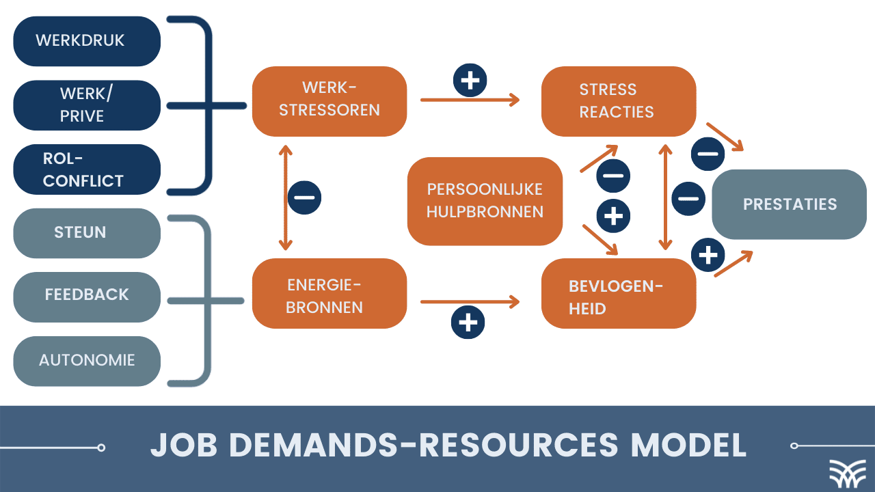
Figure 5: Job Demands-Resources Model
(Source: Shorey and Lopez, 2021)
Job Demands-Resources Model: Schaufeli and Bakker propose that the work-life balance of job demands and job resources is vital for employee well-being and performance (Shorey and Lopez, 2021). When employees have the right job resources to meet job demands – such as additional training, the ability to be autonomous, and supportive management – they are more likely to be engaged and perform better. About performance management, which can be considered as a type of job demand, setting goals that are collaboratively done, giving employees job resources, channeling work-related information, and providing feedback are job resources that help employees manage job demands better, which leads to overall employee engagement.

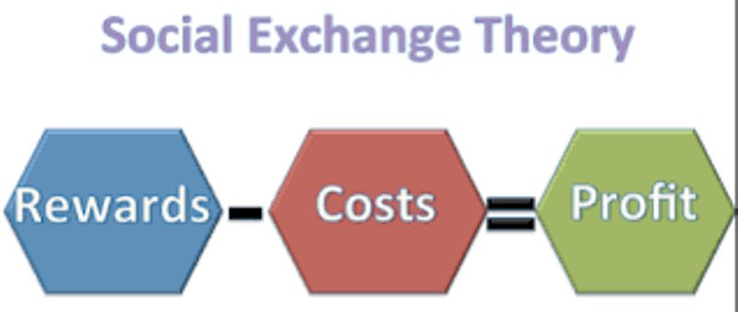
Figure 6: Social Exchange Theory
(Source: Shorey and Lopez, 2021)

Social Exchange Theory: This theory is built on the requirement for reciprocation in the business between the employer and the employee while creating a sense of affiliation. The employees commit their time and loyalty to the organization on the condition that they will be compensated and recognized for their input (Fryer et al., 2023). When the organization invests in employees by facilitating effective performance management, it sets reciprocity in motion. This implies that the employees will work harder to display their commitment to the organization. As effectively provided in performance management, such employees will attain more to involvement, feedback, and developmental opportunities leading to greater engagement, thus enhancing their performance level.
4.4 Integrating Engagement and Involvement into SainCo's Performance Management System
SainCo can leverage the power of engagement and involvement by integrating them into its performance management system:
Collaborative Goal Setting: Move beyond top-down goal setting. Involve employees in defining their goals, and fostering ownership and engagement.
Regular Feedback and Check-Ins: Provide ongoing feedback through informal conversations and structured check
Conclusion: Building a High-Performance Culture at SainCo
By embracing a modern performance management approach that emphasizes continuous development, feedback, employee engagement, and involvement, SainCo can unlock its full potential and achieve its strategic objectives. This shift will create a culture of growth, empowerment, and mutual trust, leading to a more motivated, productive, and innovative workforce.

5. Recommendations
To address the concerns raised with SainCo's current performance management system and integrate international, environmental, ethical, and sustainability considerations, a multi-pronged approach is recommended. Here are specific short-term and long-term recommendations:
Short-Term Recommendations:
- For Managers: Provide Managers Training that offers the skills required to coach, feedback, and set goals collaboratively. The training should include the following: coaching techniques, which enhance the managers with the power to guide their employees through what they require and support them to make it happen, thereby enhancing the growth mindset. The managers should also be trained on feedback to facilitate such negative yet constructive feedback that is retained, precise, and growth-focused. The training should also include developing managers with the power to ensure collaborative creation (Gordon et al., 2023). This helps in making sure the realistic, mobilizing, inspiring, challenging, and measurable goal setting is done. The goals should also be strategically informed of the individual strengths, international goals, environmental considerations, and ethical and sustainability considerations.
- 360-Degree Feedback: Implement a 360-degree feedback system where employees receive feedback from a variety of sources, including colleagues, managers, and potentially even customers (depending on the role). This provides a more comprehensive view of performance, fosters self-reflection, and allows for a well-rounded assessment that incorporates international perspectives and ethical considerations.
  - Performances Management Software: implementing technology to support administrative processes can reduce the associated time-consuming responsibilities and support an open, interactive environment for communications. Some features to explore include Goal setting and monitoring. The software can simplify the process of setting objectives and tracking performance over the year and compliance with international standards and sustainability practices. Feedback conversations (Hebdon et al., 2021). Systems that make frequent feedback an easy, two-way process that can be managed separately from the performance process can support development all year round.Performance data management. Expenses management software can support the the measurement of key performance metrics and analysis of the data collected, supporting an evidence-based approach to decision-making, while ensuring international compliance.
Long-Term Recommendations:
- Culture Shift: Change the cultural environment from an autocratic viewpoint to a more collaborative and empowering approach. This approach can be instrumental in convincing employees that the organization values their contribution. Furthermore, it can be conducive to consultation, rather than coercion. It also makes employees focus on performance outcomes and work hand in hand with management. It could help Egypt avoid autocratic and overbearing practices. Culture of open communication. Promotes honest and open communication among all staff levels. Egypt may even work to develop and maintain an open and transparent work environment. Furthermore, it creates a foundation for trust. It makes it easy for employees to express concerns and pass on lessons, which could be international best practices (Díaz-Mujica et al., 2022). Culture of employee involvement – this culture is instrumental when employees are empowered to solve problems. Furthermore, it makes people feel like they are queries of processes. It, in turn, helps to bring international standards to Egypt and promote compliance and long-term sustainability. From a cultural strategy viewpoint, therefore, SainCo could invest in the workplace with collaborative and empowering cash and employee participation.
- Review of the performance management process: The organization needs to take adequate feedback from its employees and managers alike. One may focus on the following areas: o Performance management should be aligned with international standards and relevant industry benchmarks. o Review the process for ethical considerations, i.e., if the process is conducted in a fair, transparent, and ethical way. o Sustainability context” attempts to incorporate the sustainability concept into the performance management framework (Shapiro et al., 2021). Thus, one can integrate consideration of sustainability, i.e., do the goals related to environmental responsibility, conservation of the resources available, and of social impact, including setting performance goals sufficiently high to ensure sustainability efforts. Thus, a proper review of the process incorporating feedback can formulate a well-accepted performance management system across the globe, process ethically correct, and push goals towards sustainability ethos.
- Link back to 1st recommendation: Link performance – Ensure that performance goals are connected to ways to further one’s development (Alanoglu et al., 2022). In this way, when performance evaluations are made and the connection to self-improvement, career opportunities, and ability to further the international best practices and sustainability SainCo’s workers already possess is another way the performance correlates with development. This implies that, through this particular recommendation, placing this condition allows linking the workforce’s personal development further influences. Altogether, SainCo can thus invigorate a continuously learning and growing workforce, which in turn bolsters its competitiveness, innovativeness, level of international criteria compliance and adherence to ethical and environmentally responsible conduct.
Recommendations for a Modern Performance Management System at SainCo
Focus | Recommendation | Description
Short-Term | Training for Managers | * Equip managers with skills for coaching, providing feedback, and setting goals collaboratively. * Training covers coaching techniques, effective feedback, and collaborative goal setting.
 | 360-Degree Feedback | Implement a system where employees receive feedback from colleagues, managers, and potential customers (Baluszek et al., 2023).
 | Performance Management Software | Utilize technology to streamline processes, facilitate communication, and encourage ongoing dialogue.
Long-Term | Culture Shift | Gradually move towards a more collaborative and empowering management style.
 | Performance Management Process Review | Conduct a comprehensive review of the existing process, gathering feedback from employees and managers.
 | Performance and Development Link | Align performance goals with individual development plans (Hussain et al., 2021).
 | Recognition and Rewards | Implement a system that acknowledges and celebrates achievements beyond just annual appraisals.

6. Conclusion
SainCo has the potential to drive its business by shifting from a traditional appraisal-based system to a continuous performance management system centered on employee development and career advancement. A contemporary, collaborative, feedback-oriented, and development-centered performance management system will strengthen employees, help them stay focused on the firm’s long-term objectives, and keep SainCo on track for long-term success.

References
Alanoglu, M., 2022. The role of instructional leadership in increasing teacher self-efficacy: A meta-analytic review. Asia Pacific Education Review, 23(2), pp.233-244.
Ballard, M., Bancroft, E., Nesbit, J., Johnson, A., Holeman, I., Foth, J., Rogers, D., Yang, J., Nardella, J., Olsen, H. and Raghavan, M., 2020. Prioritising the role of community health workers in the COVID-19 response. BMJ global health, 5(6), p.e002550.
Baluszek, J.B., Brønnick, K.K. and Wiig, S., 2023. The relations between resilience and self-efficacy among healthcare practitioners in context of the COVID-19 pandemic–a rapid review. International Journal of Health Governance, 28(2), pp.152-164.
Cabrera, V.E., Barrientos-Blanco, J.A., Delgado, H. and Fadul-Pacheco, L., 2020. Symposium review: Real-time continuous decision-making using big data on dairy farms. Journal of dairy science, 103(4), pp.3856-3866.
Camilleri, M.A., 2021. Using the balanced scorecard as a performance management tool in higher education. Management in Education, 35(1), pp.10-21.
Díaz-Mujica, A., Sáez-Delgado, F., Cobo-Rendón, R., Del Valle, M., López-Angulo, Y. and Pérez-Villalobos, M.V., 2022. Systematic review for the definition and measurement of self-efficacy in university students. Interdisciplinaria, 39(2), pp.37-54.
Díez, F., Villa, A., López, A.L. and Iraurgi, I., 2020. Impact of quality management systems in the performance of educational centers: educational policies and management processes. Heliyon, 6(4).
Endalamaw, A., Khatri, R.B., Mengistu, T.S., Erku, D., Wolka, E., Zewdie, A. and Assefa, Y., 2024. A scoping review of continuous quality improvement in the healthcare system: conceptualization, models and tools, barriers and facilitators, and impact. BMC Health Services Research, 24(1), pp.1-14.
Enyinna, U.K., 2024. Aligning total quality management, continuous improvement for process performance: An empirical review. Journal of Commerce, Management, and Tourism Studies, 3(1), pp.1-12.
Fryer, L.K. and Leenknecht, M.J., 2023. Toward an organising theoretical model for teacher clarity, feedback and self-efficacy in the classroom. Educational Psychology Review, 35(3), p.68.
Garengo, P., Sardi, A. and Nudurupati, S.S., 2021. Human resource management (HRM) in the performance measurement and management (PMM) domain: a bibliometric review. International Journal of Productivity and Performance Management, 71(7), pp.3056-3077.
Gordon, D., Blundell, C., Mills, R. and Bourke, T., 2023. Teacher self-efficacy and reform: A systematic literature review. The Australian Educational Researcher, 50(3), pp.801-821.
Goshie, R.W., Muttee, D. and Mutwiri, C., 2022. Acquisition of Online Competences of Librarians through the continuous staff Development programs for improved Job performance in Academic Libraries in Nigeria: A Review of Concepts and Challenges.
Graham, S., 2022. Self-efficacy and language learning–what it is and what it isn't. The Language Learning Journal, 50(2), pp.186-207.
Hebdon, M.C.T., Coombs, L.A., Reed, P., Crane, T.E. and Badger, T.A., 2021. Self-efficacy in caregivers of adults diagnosed with cancer: An integrative review. European Journal of Oncology Nursing, 52, p.101933.
Hristov, I., Appolloni, A., Chirico, A. and Cheng, W., 2021. The role of the environmental dimension in the performance management system: A systematic review and conceptual framework. Journal of Cleaner Production, 293, p.126075.
Hussain, A., Mkpojiogu, E.O. and Ezekwudo, C.C., 2021. Improving the academic self-efficacy of students using mobile educational apps in virtual learning: A review. International Journal of Interactive Mobile Technologies, 15(6).
Key, K.N., Hu, P.T., Choi, I. and Schroeder, D.J., 2023. Safety culture assessment and continuous improvement in aviation: A literature review. Aviation Safety Office of Aerospace Medicine, report DOT/FAA/AM-23/13, Washington, DC.
Portugal, D., Faria, J.N., Belk, M., Martins, P., Constantinides, A., Pietron, A., Pitsillides, A., Avouris, N. and Fidas, C.A., 2023. Continuous user identification in distance learning: a recent technology perspective. Smart Learning Environments, 10(1), p.38.
Shapiro, C.J., Watson MacDonell, K. and Moran, M., 2021. Provider self-efficacy in delivering evidence-based psychosocial interventions: A scoping review. Implementation Research and Practice, 2, p.2633489520988258.
Shorey, S. and Lopez, V., 2021. Self-Efficacy in a nursing context. Health promotion in health care–Vital theories and research, pp.145-158.
Ulfert-Blank, A.S. and Schmidt, I., 2022. Assessing digital self-efficacy: Review and scale development. Computers & Education, 191, p.104626.

