ACADEMIC AND EMPLOYABILITY SKILLS

Student Name: Radu Micu
Student Id: 1915963
Table of Contents

Introduction 4
Section 1 4
Section 2: Evaluation of the skills 8
Section 3: Action plan 14
Section 4: Application 17
Section 5: Conclusion and evaluation 20
References 25
Section 6: Appendices 27
Appendix 1: Crypto wall report 27
Appendix 2: Test Questionnaires 29

Executive Summary
In this report, a discussion has been done on essential academic employability skills. Based on personal perception a presentation has been prepared that constitutes personal strength and weaknesses. In order to align the result with scientific measurement; an online test has been performed that has analysed core strength and weaknesses. A comparison of both self-overview and test results has been done here. Based on a common understanding of data privacy, different types of back-up options have been analysed in light of disasters. An e-portfolio and Linkedin profile has been created for demonstrating professional skills. An action plan has been prepared that can improve personal skill sets as well.

Introduction
Academic and employability skills of an individual are closely related to each other. Transferable skills refer to a set of essential skills that help an individual to progress through training, education and employment. Also, employability is a specific set of skills, personal attributes and knowledge that make an individual more employable in comparison with others. Several higher education institutions throughout the world use different types of examination methods to improve the employability skills of an individual student. In this report, I am going to be reflecting on my employability and my career skills that I have developed during my study of the Academic and employability skills module.

Section 1
Personal overview
I am a student of BSc cloud computing and as an essential part of my professional needs, I have taken part in the academic and employability skill assignment. I have an aim to excel in my professional field, therefore, I am well about my core competencies. I am continuing my studies from the University of Wales and in this presentation, I am going to focus on my core strengths and weaknesses.
Strengths
I am very much a positive person who loves to take risks. I understand that effective teamwork is necessary for the professional field. I try to be reliable to my team members and I believe effective communication is the secret of success of a team. I am focused on my aim and try to focus on the visions. I schedule my activities at the onset and try to meet the deadlines. Increased level of curiosity, the urge of implementing innovation and the ability to keep professional commitments are my core strengths that may help in my future professional career as well as in higher studies.
Weaknesses
With a lot of core competencies, I have certain weaknesses which I have to improve for overall enhancement of my higher education and employability skills. I sometimes get detached from the purpose of activity due to intrinsic involvement in other activities. Strong focus on purpose is important to achieve the aim. Sometimes I lack self-determination due to lack of resources or by experiencing difficulties. I generally focus on the future outcomes but due to patience issues, I lack to recognize the handful of resources that I have. Resourcefulness is essential to achieve the desired success.
Self-understanding
In a nutshell, I can conclude that I am a mixed personality who has certain essential employability and HE skills like effective communication approach, problem-solving, making notes, and strong presentation skills. However, due to lack of my patience, I lack in planning with the handful of resources that I have. Sometimes my desires and the way that I have finalized to attain the desires do not align. I have to work on my weaknesses to enhance my overall skill set.

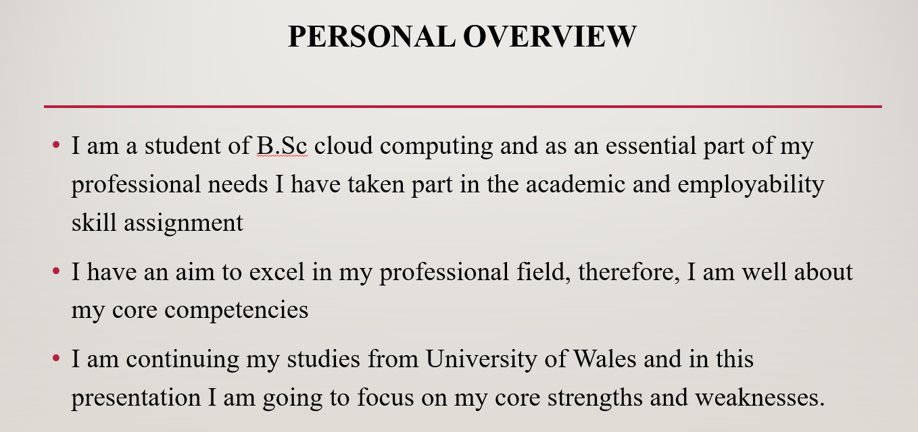
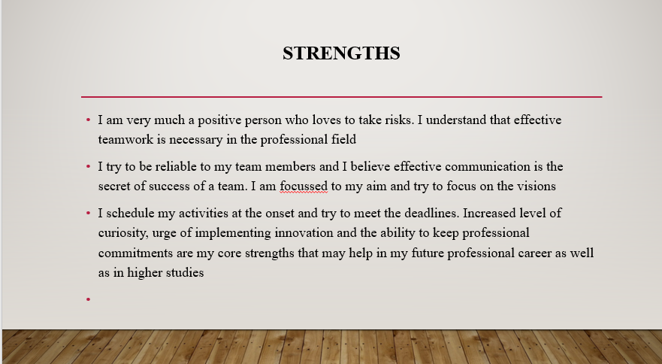
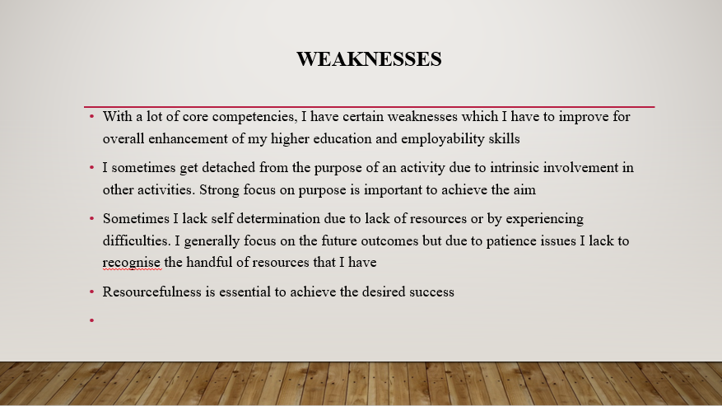
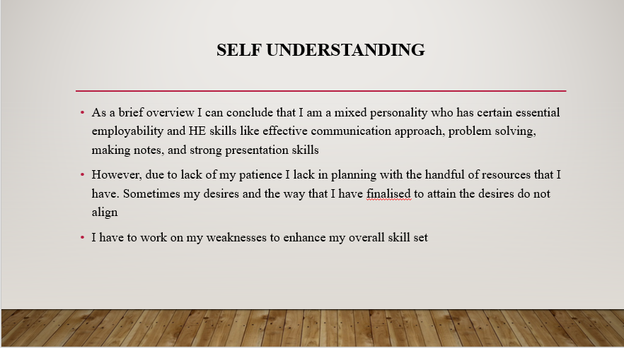
Figure: Screenshots from the presentation

Key learning points
While preparing the presentation I have learnt that understanding the importance of a specific subject is important. The essential things that I have learnt while preparing the presentation are as follows;
- Focusing and evaluating my core strengths and weaknesses
- Only summarizing the key points in the presentation to provide a resourceful essence of a vast evaluation
- My presentation skills have been improved; I have learnt to prepare an attractive presentation that can gain the attraction of the listeners

Section 2: Evaluation of the skills
Higher education (HE) learning
Some essential skills are required for being successful in the HE learning process which are as follows;
- Quick response and a habit to ask questions: Several teachers like in this case ask the students to prepare presentations to improve their demonstration skills. The question-answer session that is conducted after a presentation improves the listening skill of the students as well as improve the efficiency of the students to deal with difficult questions.
- Understanding the inferred meaning of the texts: Not only theoretical papers but using short videos and presentations help a student to improve his/understanding of a specific test (Aasheim et al. 2019) [1].
- Writing down important notes: In the HE learning process students have to take prompt notes on the essential information in their language. This skill helps in the self-understanding of the study materials.
- Argumentative skill: Production of coherent and justified arguments is a necessary skill of higher education. The students can present their arguments to the peers and demonstrate how logical their arguments are.
- Comprehension: Only developing an idea from a text is not enough for higher education students rather providing evidence in support of the idea is also equally important. As mentioned by Germaine et al. 2016 [6], developing and arranging evidence to back up one's own idea is another important skill of higher learning.
Employability
The essential employability skills are as follows;
- Communication: Careful listening and understanding the perception of others are required in professional fields. Positive negotiation, presenting your own view clearly and proper sharing of information are essential communication skills for improving employability standards (Aldowah et al. 2019) [2].
- Teamwork: In the professional field each individual has to work with an organisational team. Proper understanding of the core strengths and weaknesses of team members help to improve the performance of the team.
- Problem solving: Professional fields are indulged with a number of problems that need practical solutions. Through effective communication with the team members solutions for problems can be achieved (Boahin, 2018) [4].
- Self-management: In order to get desired outcomes, finalisation of future goals are important. Recognising responsibilities and performing the tasks accordingly are important.
- Planning and organising: Clear understanding of both long term and short-term goals are essential. Based on the timespan of the set goals, activity planning has to be done which is an essential employability skill (Barjetesh et al. 2018) [3].
- Technological skills: In the era of the twenty-first century, application of technological innovations is considered one of key employability skills of individuals.
Self-evaluation exercise
In order to align my own assumptions with scientific standards, I have taken part in an online based self-evaluation test.
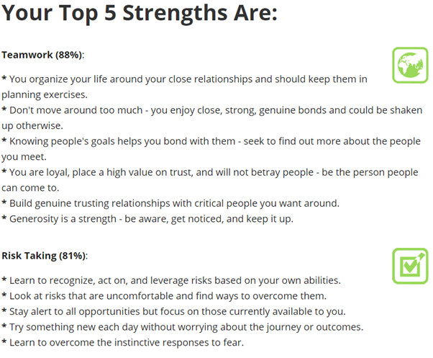
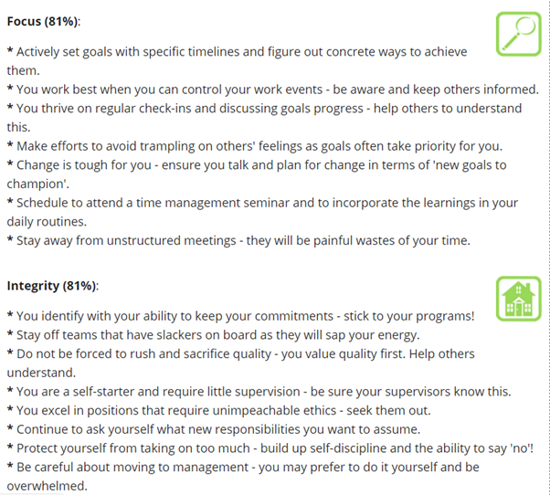
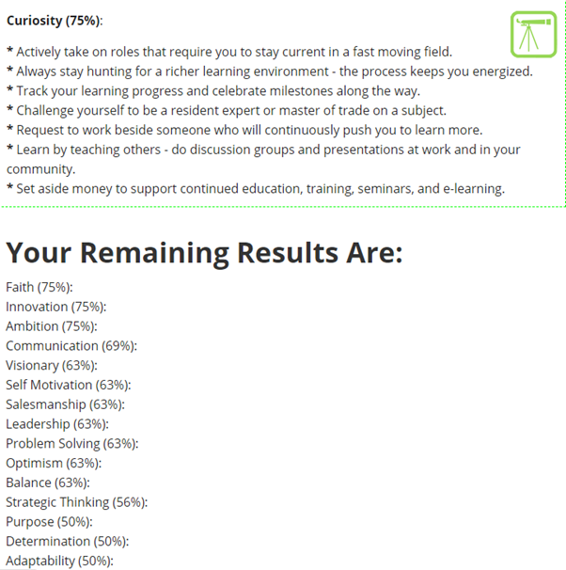
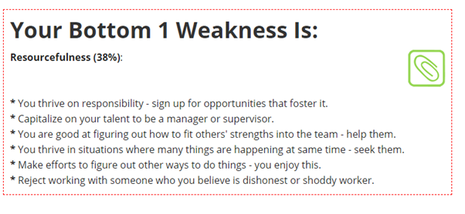
Figure 2: Results of the online self-assessment examination
(Source: Richardstep.com, 2020 [9])
Contrast of primary perception and test results
My primary perception about myself more or less aligns with the outcomes of the online test results. The online test has conferred me as an effective team member as well as a reliable person that I have already mentioned in the previous overview. The test has graded me 81% in the risk-taking abilities. Personally, I have also reflected that I like to face challenges as it can test my leadership skills in hard situations. I always set my visions to prepare myself for any activity. According to the online test I am graded as 81% focused to my activities. I feel myself to be severely curious for several reasons and the online test has also acknowledged me as a curious person as well.
However certain personal perceptions of me have not aligned with the result of the test. I have rated myself with high grades in strategic thinking but the test has reflected that my strategic thinking skills have to be improved and rated it with 56%. In contrast the test aligns with my perception that sometimes getting de-focused from actual aim reduces the chances of attaining goals. Similarly, the test result reflects that I lack in planning with the resources I presently have. The test has graded my resourcefulness as 38%.
Therefore, aligning my personal understanding and the test result, it can be said that I am a good team member with a reliable approach and strong leadership skills. Therefore, the career of manager or some kind of organizational leaders suit myself.

Section 3: Action plan
In order to improve my higher educational and employability skills I have pointed out certain short term and long-term goals that may lead me towards future success.
Short term goals
- Improving presentation skills further
- Being more comprehensive while presenting evidences for own ideas
- Improving my argumentative skill with proper usage of academic knowledge in need
- I need to chalk out the key notes from a vast lecture for future application
Long term goals
- Improving my planning skills through effective usage of essential resources
- I have to improve my leadership skills to lead a team in the professional field
- Mainly I have to work on my analytical abilities to achieve the goals and it is also important to improve my employability as well as higher education skills

Academic and professional skills | Improvement strategy | Time period | KPI
Argumentative skills | - Placement of current evidences while framing arguments  - Strong basic knowledge about the topic of argument (Burke et al. 2018) [5] | 3 months | - Strong argumentative skills while playing own viewpoint
Taking essential notes | - Focusing on the main points of a discussion or a lesson  - Taking quick notes of essential points | 2 months | - Core essence of a lesson or discussion is going to be understood properly
Development of planning skills | - Gaining knowledge about the available resources that I have  - Trying to prepare plans as per the presently available resources | 1 year | - Effective planning is going to help me in my future achievements
Improving leadership skills | - Understanding the strength and weaknesses of the team members  - Increasing reliability and leadership approach to lead a team from the front | 3 years | - Achieving successful outcome from teamwork
Table 1: Action plan for professional and academic skill development

Section 4: Application
Backup strategy
While preparing for any project or doing any organizational work, preparing the backup of essential dataset is important. In the 21st century, the majority of the valuable data are stored in cloud-based storage systems. Losing a robust amount of data for malware activities cannot be compensated while doing any kind of academic project or organizational work.
As mentioned by Preston, (2019) [8], data loss occurs due to sudden attack of malware viruses. System corruption, mistaken operation and infection of ransomware are some of the instances that are responsible for sudden data loss. Three common types of data backup procedures are as follows;
Full backup
Complete and basic types of backup operations are termed as complete backup operation. In this case the whole record of the virtual data including settings, applications, files, folders have to be stored in hard devices like HDD, SSD and hard drives. In case of choosing a whole backup option all the files and folders of a system pass through subsequent backup operation and redundant copies are made. After completion of a whole curse work or project, full back up can be done in a storage device like pen drive or another system (Tan et al. 2018) [10].
Incremental backup
Incremental backup options only safeguard the data that have been newly added since the last backup. A part of the whole data can be kept as a backup option in other devices as well. Incremental backup is useful when the project is still in an ongoing mode.
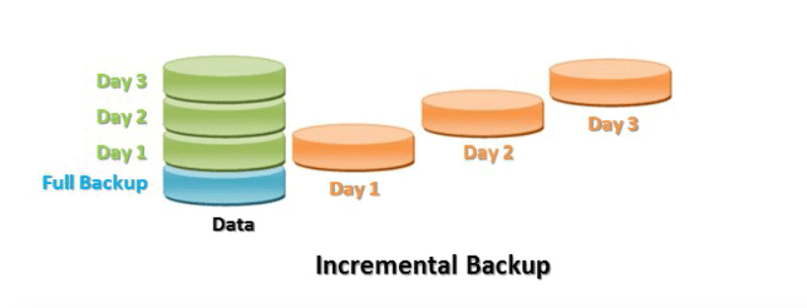
Figure 3: Incremental backup option
(Source: Xu et al. 2018, [13])
Differential backup
Differential backup only makes the backup of the files that have been changed since the last full backup. Therefore, it adds the newly changed data to the previously existing data. Likewise, the incremental data, it also backs up the changed or modified data only.
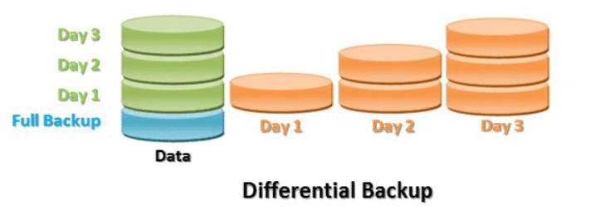
Figure 4: Differential backup
(Source: Wu et al. 2018, [12])
From the strategy of storing data in three different places, it can be said that malware can attack one device or one storage system. Differential backup helps to protect a valuable data source from possible attacks.
Possible disaster scenarios
- Failure of hard drive: Extreme load on the hard drive or running an old server may lead to a situation when the entire server gets collapsed. Due to the collapse of the hard drive the robust data set that is available in the drive may be lost causing huge loss. Back up in other devices can safeguard the data from this scenario.
- Computer viruses: Viruses like crypto wall are a serious threat to the stored system data. These are designed ransomwares that are used for stealing essential information from a system.
- Manual error: Accidentally an individual can delete important data in course of actions. Therefore, keeping the backups are essential to safeguard the valuable data from manual error. The chances of manual error are increased among the early professionals as well as students.
- Natural disasters: Natural disasters can hamper the information technology infrastructure of an organization. Due to the natural disasters the complete dataset of an organization can be lost. Only back up of the valuable dataset in different lacs can safeguard from this risk (Tan et al. 2018) [10].
Crypto wall virus attack
Crypto wall belongs to a ransomware family that infiltrates into the computer system through accession of suspicious links and hides itself from victims. In the exercise class I have performed a demonstration of the Crypto wall virus attack. This is a Trojan horse virus which encrypts the information files in a jeopardized computer and asks for paying bitcoins to decrypt the essential files. In order to remove Crypto walls, the software has to be dated regularly while virus protection software like Comodo has to be installed to safeguard the machine from Crypto wall virus (Tang et al. 2018) [11].
Time management
From the time management lectures and video tutorials the key aspects of time management are:
- Eliminating instances of unnecessary time allocation
- Planning prior the onset of the activities
- Improvement of multitasking skills
- Proper allocation of time and finalization of the deadlines
- Reduction of the interruptions (Barjesteh et al. 2018) []
In order to enhance my personal productivity, I am going to take certain steps which include;
- Proper scheduling of activities prior jumping towards any act
- Taking control of the situations
- Finalisation of deadlines so I can put much effort to complete the work within time
- Improvement of my listening and analytical skills to address the importance of a particular situation
- Providing adequate time of relaxation to self for reducing stress

Section 5:Conclusion and evaluation
Screenshots
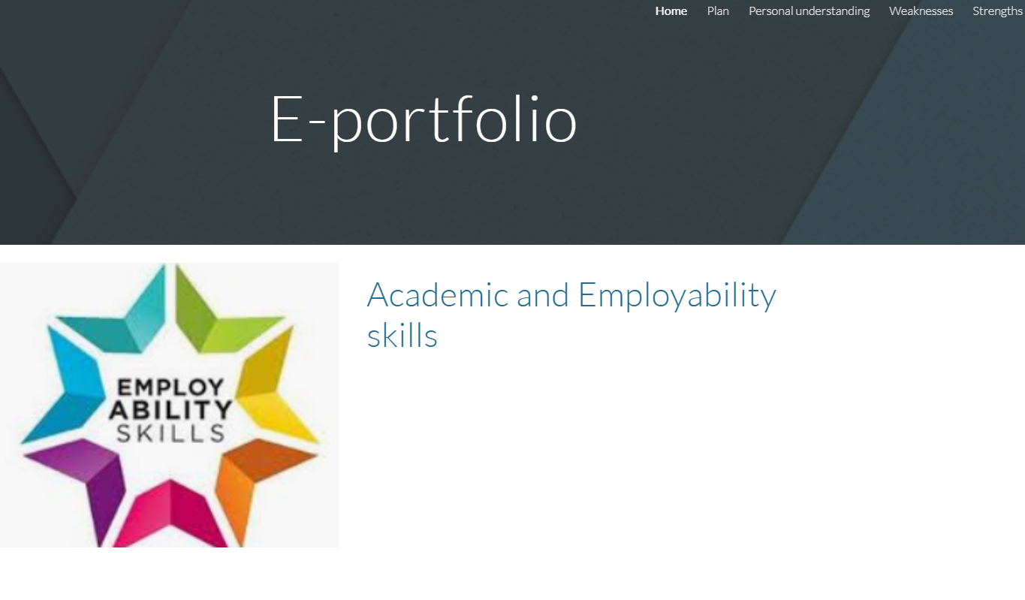
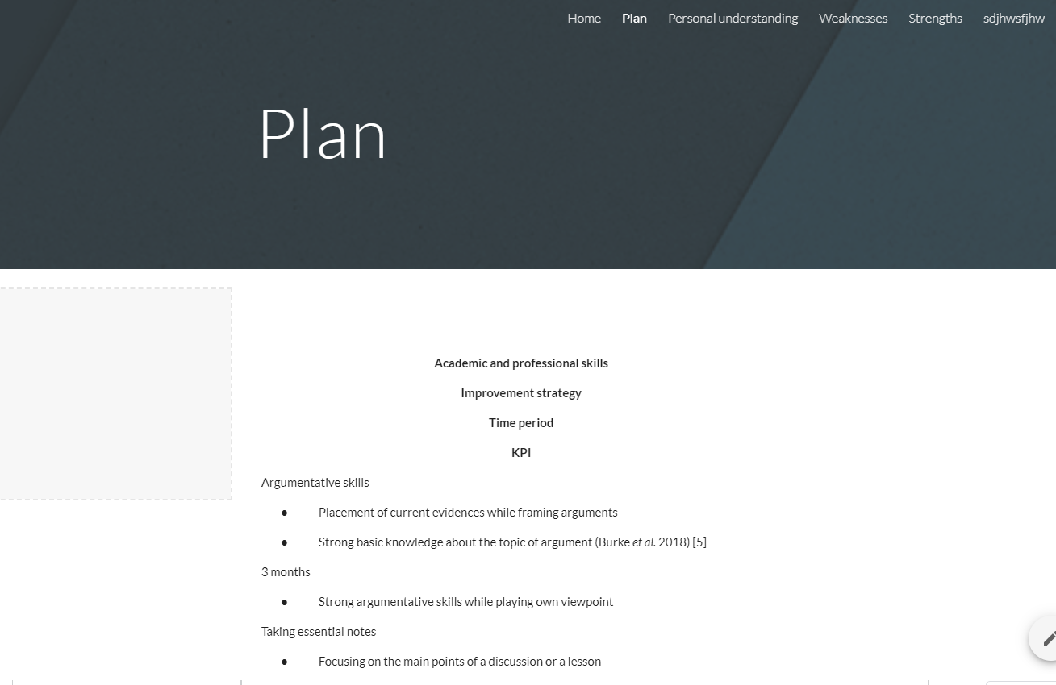
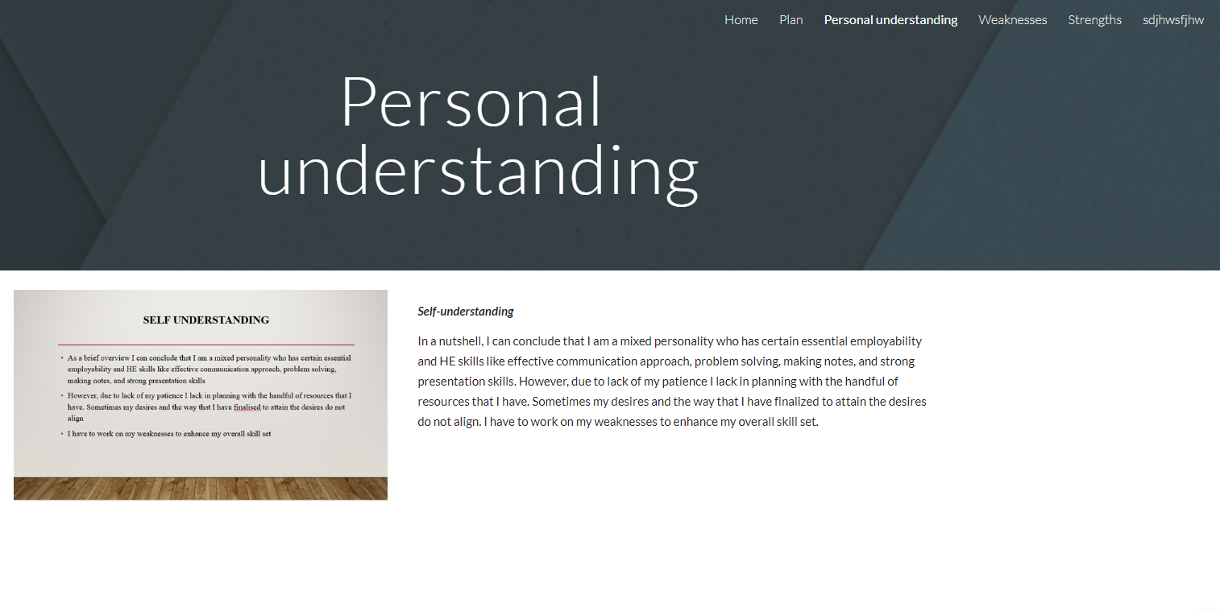
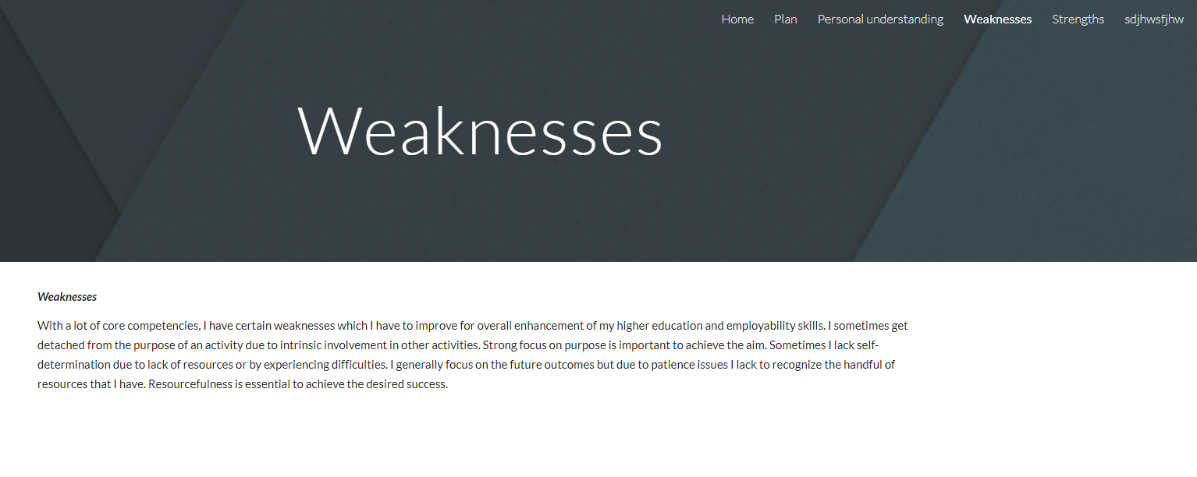
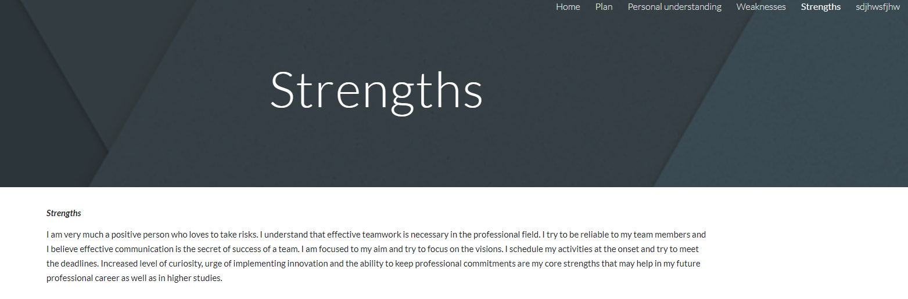
Figure 5: E-portf0lio
(Source: https://sites.google.com/view/portme2/strengths)
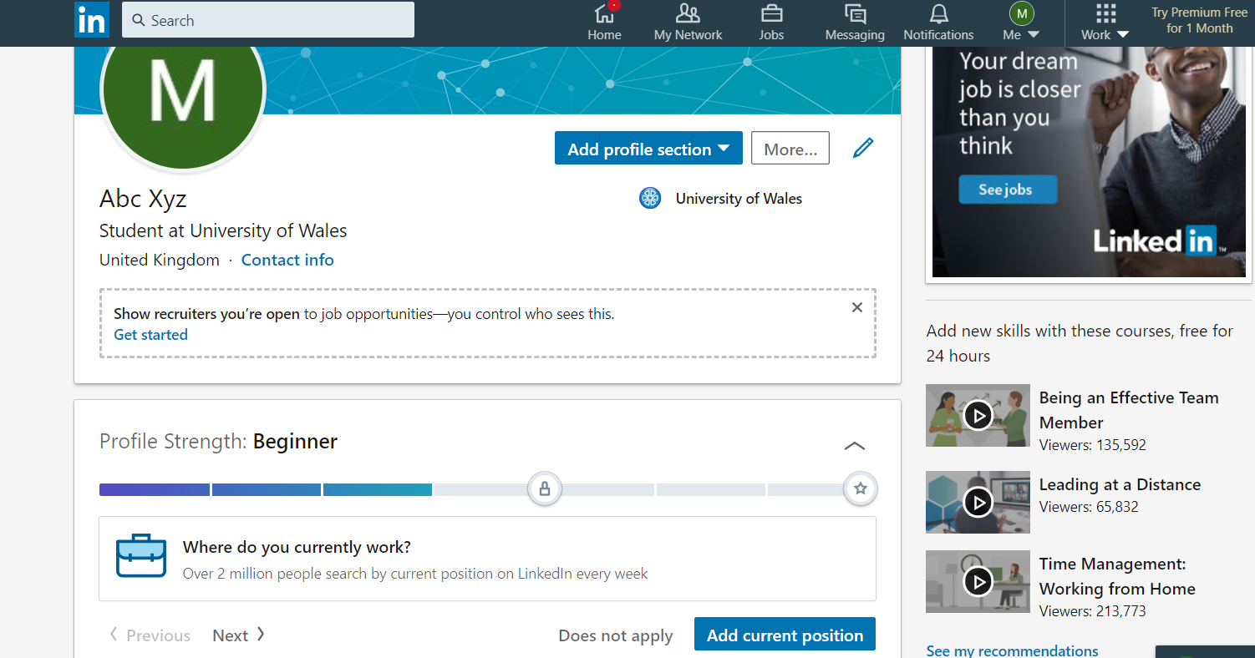
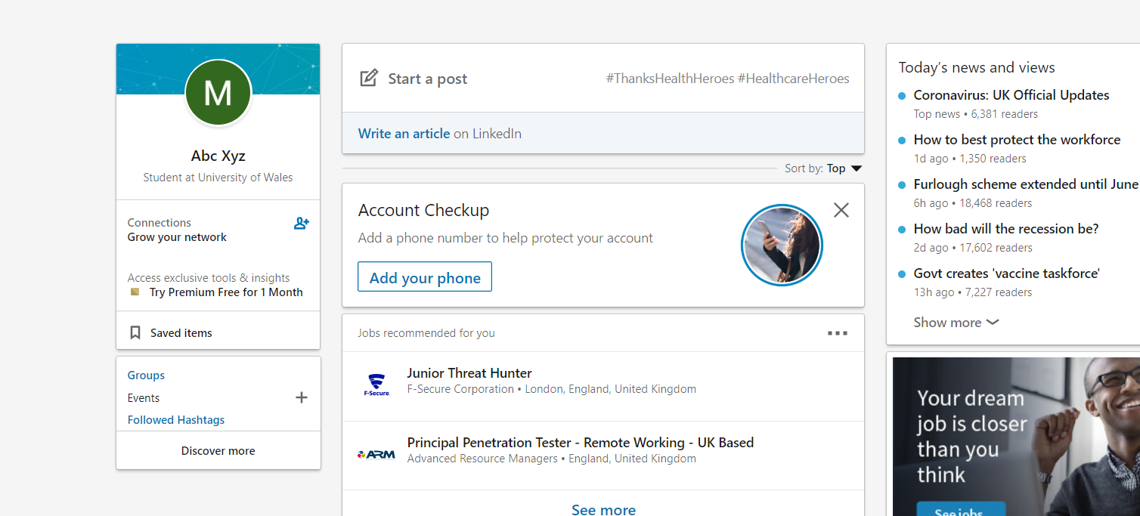
Figure 6: Linked in profile
(Source: https://www.linkedin.com/in/abc-xyz-6576001a7/)
Conclusion
This assignment has fully focused on the essential academic and employability skills that are essential for both higher education as well as professional field. An online test has been attempted that has helped to scientifically find out core strength and weaknesses. In order to improve core competencies proper identification of the personal competencies are important. Based on the disaster scenario of data backup, an effective account has been prepared that sheds light on decision making skills. An action plan for improvement of skill sets as well as for time management has been prepared here.
Recommendations
In order to improve skill sets, more study on academic and employability skills are required. Additionally, practical application of the learnings is important in the core study area of an individual. Effective execution of the skill development action plan and time management steps can help to improve personal as well as academic skills of an individual.

References
[1] Aasheim, C., Shropshire, J., Li, L., & Kadlec, C. (2019). Knowledge and skill requirements for entry-level IT workers: A longitudinal study. Journal of Information Systems Education, 23(2), 8.
[2] Aldowah, H., Al-Samarraie, H., &Fauzy, W. M. (2019). Educational data mining and learning analytics for 21st century higher education: A review and synthesis. Telematics and Informatics, 37, 13-49.
[3] Barjesteh, H., Asadpour, S. A., &Manochehrzadeh, M. (2018). The Relationship between Iranian EFL Teachers’ Creativity and Time Management Skills. International Journal of Applied Linguistics and English Literature, 7(2), 207-213.
[4] Boahin, P. (2018). The changing nature of work and employability skills development in Higher Education Institutions in Ghana. Eur. J. Educ. Dev. Psychol, 6(3), 21-32.
[5] Burke, C. S., Priest, H. A., Salas, E., Sims, D., & Mayer, K. (2018). Stress and teams: How stress affects decision making at the team level. In Performance under stress (pp. 197-224). Boca Raton: CRC Press.
[6] Germaine, R., Richards, J., Koeller, M., & Schubert-Irastorza, C. (2016). Purposeful Use of 21st Century Skills in Higher Education. Journal of Research in Innovative Teaching, 9(1).
[7] Linkedin.com (2020). Profile. Retrieved on: 10th April, 2020. From: https://www.linkedin.com/in/abc-xyz-6576001a7/
[8] Preston, W. C. (2019). Protecting data in an age of cloud and virtualisation. Computer Fraud & Security, 2019(3), 14-15.
[9] Richardstep.com (2020). Free aptitude test for strengths and weaknesses. Retrieved on: 8th April 2020. From: https://richardstep.com/rswatest/strengthstest_results.php
[10] Tan, C. B., Hijazi, M. H. A., Lim, Y., &Gani, A. (2018). A survey on Proof of Retrievability for cloud data integrity and availability: Cloud storage state-of-the-art, issues, solutions and future trends. Journal of Network and Computer Applications, 110, 75-86.
[11] Tang, K. N. (2018). The importance of soft skills acquisition by teachers in higher education institutions. Kasetsart Journal of Social Sciences.
[12] Wu, H., Wang, C., Fu, Y., Sakr, S., Lu, K., & Zhu, L. (2018). A differentiated caching mechanism to enable primary storage deduplication in clouds. IEEE Transactions on Parallel and Distributed Systems, 29(6), 1202-1216.
[13] Xu, F., Wang, Y., & Ma, X. (2018). Incremental encoding for erasure-coded cross-datacenters cloud storage. Future Generation Computer Systems, 87, 527-537.

Section 6: Appendices

Appendix 1: Crypto wall report
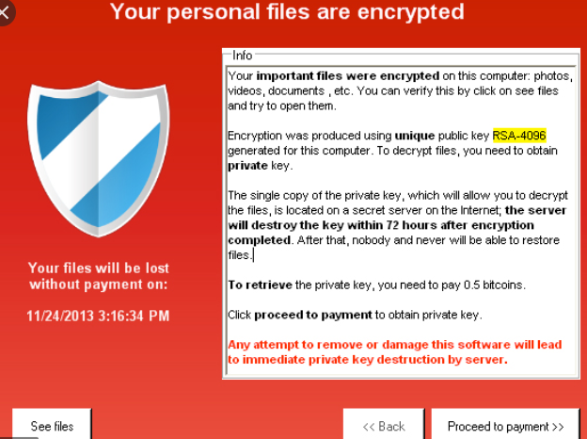
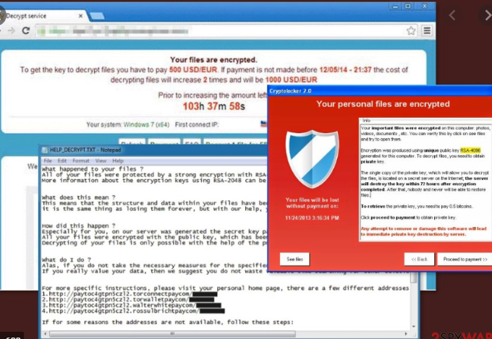
Figure 1: Crypto wall virus attack and removal
Report
Type of attack: Project files of the student system
Problem: Encrypted personal files and demanded bitcoins to decrypt
Solution: Comodo antivirus installation

Appendix 2: Test Questionnaires


