In the name of Allah (SWT), the most Gracious, the most Merciful.

QUESTIONNAIRE REPORT
Questionnaire Report

June 26, 2020

BMSK4003
Mr Soyful Islam Miah
1709512
University of Wales Trinity Saint David
Lecturer: Christian Felices

Analysis

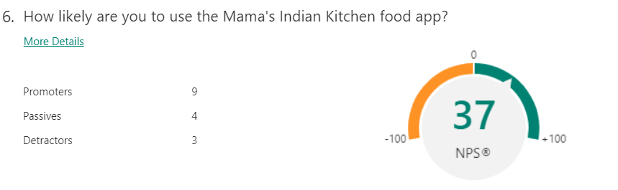
By analysing this data, I have found that most consumers are highly likely to use our personal food app. This would be a good investment as now from the gathered data we have concluded that most consumers will download our app for uses of ordering their meal. Having the Mama’s Indian kitchen food App would benefit the business as consumers are more likely to use our services on a regular basis as it is time effective and gives them a direct access to our service instead of going on to different platforms such as Just-eat and Google search. By having the app on display on their device customers will be more likely to use the App more frequently. According to Srivastava, S. (2018) From a recent survey that was carried out states that approximately 1,500 mobile phone users, 81% of consumers reported that they would search for any food business using an app. On the other hand, there was a 92% consumer that would complete this task using the mobile web.

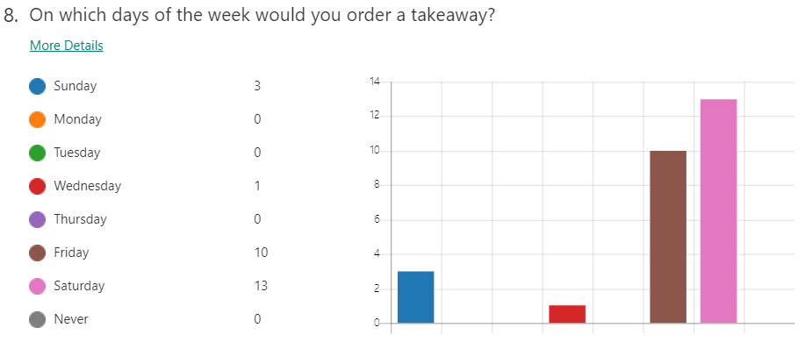

My findings from the data that I have analysed gives me a clear result of which days of the week I would be busier to which days that will be quiet. I have found that food preparation will have to be taken into consideration on my busy days of the week. Service and quality from Friday to Sunday must be high as many consumers will use their experience to judge our establishment. More stock will be needed in advance and that extra staff will have to be employed such as packers and delivery drivers. This data has also indicated to me that my week days need a boost and I will need to advertise a promotional offer to bring in the consumers on the less busy days of the week as my revenue would be lower from Monday to Thursdays. I would need to prepare my food on a Thursday, but this also means extra staff unless I prepare my ingredients and products before business opening hours on a Thursday. This will reduce overheads.
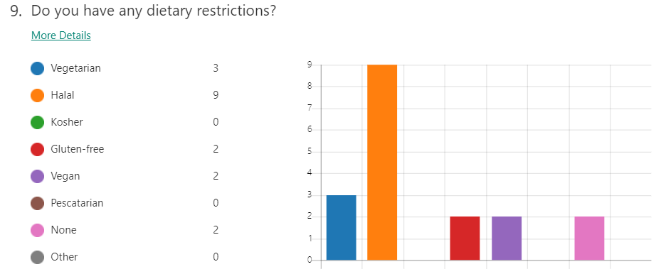
According to the data on Dietary restrictions. We have found that there is a high demand for Halal meat. I will be introducing Halal poultry on to the menu and reaching out to the vast members of the Muslim community who are in the surrounding areas of the establishment. I will need to research and approach local butchers and suppliers with a high quality of Halal meat and find a supplier that is cost effective with their prices. Vegetarianism also scored quite highly this has been introduced to the menu in our second establishment, which has proven to be highly popular and we would like to build on the success of this in our third establishment. According to Quach, G. (2019) most customers would choose to abstain from eating Halal meat, it may be that a business chooses to cater for the Halal consumers, but is not solely focused on Halal and would have alternatives for the non Halal meat eaters. You can decide upon selling Halal meat products by the results on your demographics of your local area
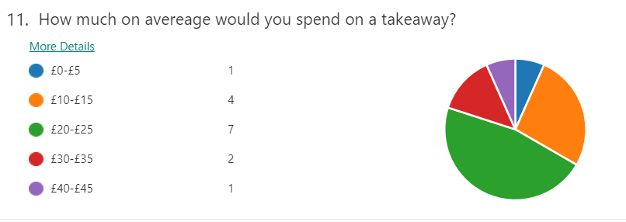
From the results I have found consumers to spend the maximum amount of £25 on a meal. I will be researching surrounding Indian cuisines and gathering information on their pricing to decrease the amount I charge on my menu. As we are approaching a deep recession and job losses may be on the increase. I feel that it would be fair to lower my prices. This is will also help me attract more customers as many members of the public will be eating in to as opposed to dinning out which is more cost effective as most bills include the cost of alcoholic drinks. Finding many businesses have reached their limit of closure, it is crucial our establishment survives. I can reach out to further consumers with a low-cost effective menu as many tend to order food when socializing with friends and family at a home gathering where prices are discussed amongst individuals. Having a healthy price will also bring recommendations from friends and family. The one thing that I will have to investigate would be the prices of my suppliers. From my knowledge many will decrease their prices as they want to stay in business and hold on to their consumers. Economy growth can only increase by making a less amount of profit and then increase profit after the economy is stable.

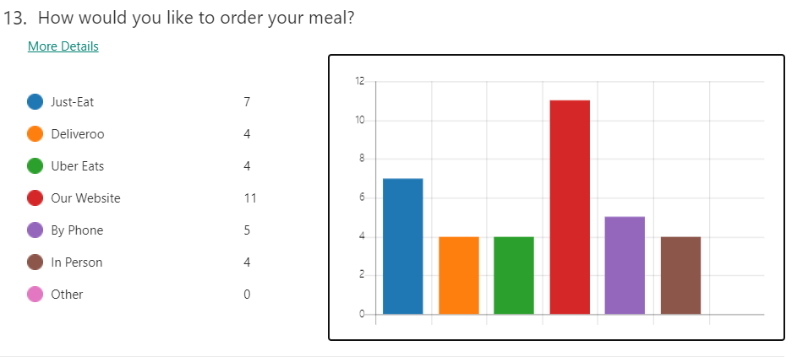
The data indicates that most consumers will use the platform of Just-eat and our website. I will take steps to invest in an e-commerce website. Finding that just-eat as a middle person charges the business a fee and charges the consumer a fee is something that I think is a loss for myself and consumers. This is not to say that the Just-eat service should be removed as there is a lot of revenue in this source. Having a website saves more time for the consumer and brings them directly to us, where as if a consumer uses the platform of Just eat they are more likely to choose a different establishment and are more than likely to choose a different cuisine. If I can direct the consumers to our website where offers and promotional information is stated, we are more likely to build interest in the consumers on other products that we offer. Saving money will be key for the public due to the deepening recession. According to Volpe, M. (2016) Having a website service for a food establishment will help you to promote the business and can give a consumer an insight of what the quality that they can expect whether it's ambiance or excellent food.

Summary

In this report I have collected relevant data which has been analysed for the purpose of business research. Analysing this data has given me a clear understanding of which areas that will need to be addressed. The food application is a tool that is frequently used by businesses as we have moved into the 21 century, we have seen a growing number of apps and technology being used by the public. The report has shown a clear result of the days of the week that need to be focused upon as well as finding that there is a high demand for Halal meat. Approaching a deep recession, the consumers are more likely to save money and look for services which are cost effective, by using our website this can help consumers focus on promotions and to save money.

Reference List

Srivastava, S. (2018) Why Restaurant Need Well-Executed Mobile App. Available at: https://appinventiv.com/blog/why-restaurant-need-well-executed-mobile-app/ [Accessed- 26/06/2020]

Volpe, M. (2016) The Importance of Restaurant Websites from a Business and Design Perspective. Available at: https://9fold.me/importance-restaurant-websites-business-design-perspective/#:~:text=One%20of%20the%20reasons%20it's,what%20a%20customer%20is%20expecting.&text=Having%20a%20website%20for%20your,it's%20ambiance%20or%20excellent%20food. [Accessed – 26/06/2020]

Quach, G. (2019) How do I make my restaurant Halal-friendly? Available at: https://storekit.com/advice/how-do-i-make-my-restaurant-halal-friendly/ [Accessed- 26/06/2020]

