Student Name: Ffion Lavington
P Number: 2204160
Programme of Study: BA Graphic Design (Contextual Practices)
Module: ADAD4019 Ways of Perceiving
Word Count: 1002

The Art of Body Positivity

I will be curating an exhibition based on body positivity. The name of the exhibition will be The Art of Body Positivity. Curation is the act of selection and organising pieces of artistic work to be used in a presentation, such as a show or and exhibition. Being a teenage girl who has grown up in the rising social media world, I’ve seen how it takes advantage of young girls and make them think negatively of their body’s by always promoting small petite bodies all over social media. This exhibition will be to show how we shouldn’t give into society’s stereotypes on the body and how we should look. The exhibition will consist of artworks made using different techniques and styles as well as including positive words of affirmation. As someone who did suffer from a negative opinion on their body for some time, this content for the exhibition has a personal link to me. “The historical context of body image research is reviewed in addition to the contemporary importance of understanding body image given rising concerns about adolescents’ vulnerability to both obesity and eating disorders” (Markey and Gillen, 2016). The exhibition will take place during the winter months as that is the time of year when women start to wear shots and crop tops which further some women’s insecurities, most women will avoid wearing shorts and crop tops to be more comfortable as it will force them to show more skin.
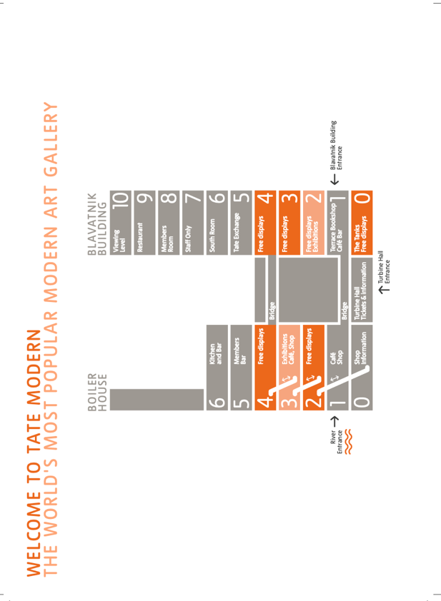
I chose the Tate Modern Museum because of its immense popularity with local people and tourists. The importance of location and its popularity will heavily influence the amount of people and foot traffic this exhibition will attract. The exhibition will start in the free display rooms, specifically started in right side room 2. The exhibition will then progress up the right side of the building in to rooms 3 and 4. The reason for picking these rooms is that they are one of the firsts room people will see and go to when entering the building therefore ensuring that people will see the pieces of artwork. Each room will consist of one to two pieces of artwork on one or more sides of the room, depending on the artwork’s significance. The use of lighting in these spaces will be key, as each piece of artwork will have a spot light above it highlighting and making the piece standout. Also, the whole rooms lighting will be dimmed slighting further making the spotlight standout.
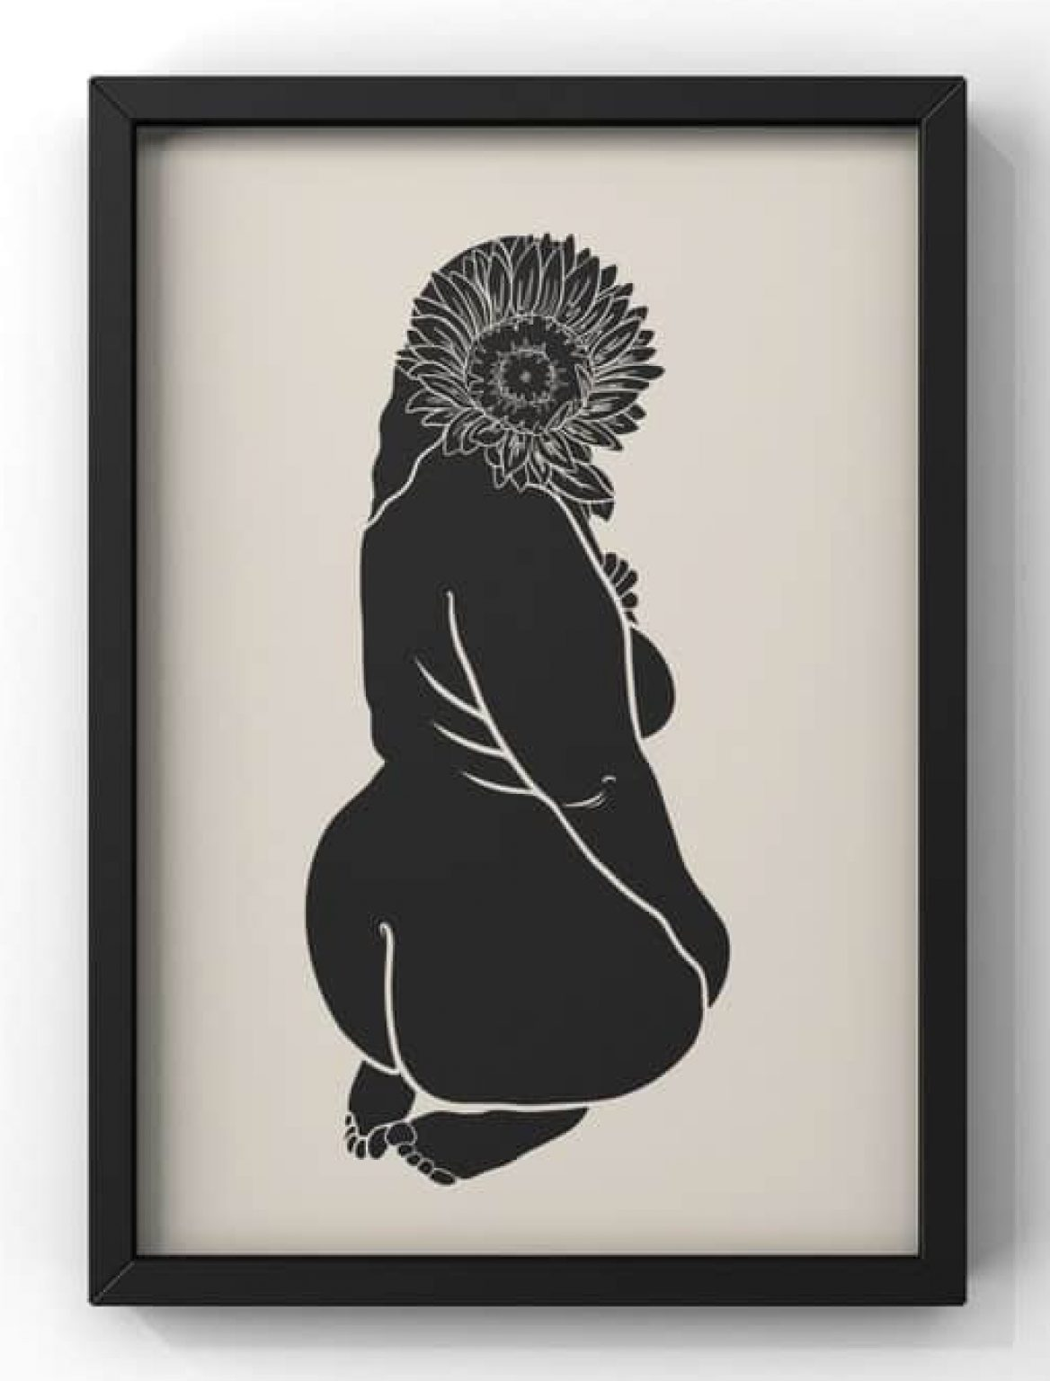
Fig. 1, Body Positivity, 2022

This piece of digitally created art was created by Jude, also known as Bewilderedesigns on Instagram, sells her art on Esty and creates custom work for her customers. She is a freelance artists based in the United Kingdom and is also a teacher. This piece was part of her Body Positivity collection and was created around the start of 2022. The position of the flower over the head helps me link to how “negative body image has historically gained more attention because of its association with psychiatric disorders” (Markey and Gillen, 2016). Some women who consider themselves ‘obese’ from online influences seek surgery to help them “however, when it comes to reconstructive surgery performed to improve changes in appearance, either following congenital or acquired differences, illness or injury, health insurance providers may continue to deny coverage because they classify such procedures as cosmetic in nature and not medically necessary” (Rumsey and Harcourt, 2012). Jude creates her art to help empower women who have a negative opinion on their bodies and to help them see the beauty in what they consider something negative. The artist rejects society’s influence for perfect thin bodies through her use of creating art that depicts curvier women, highlight their beauty.

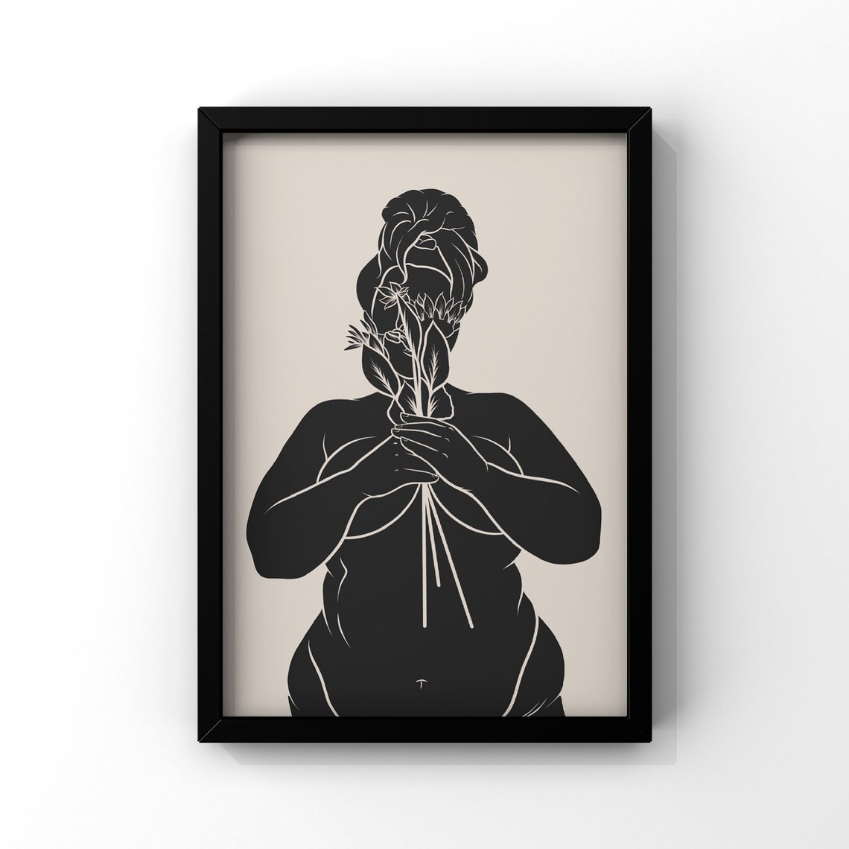
Fig. 2, Body Positivity, 2021

Jude continues this collection of digitally created work, with this piece also named Body Positivity which had been created one year prior to her other work. This piece was also created in England where she resides as a freelance artist created custom work for her customers. This piece fits perfectly into the exhibition with its link to how the meaning behind the image is to promote do specific body shape and size is the correct one, or how only one body shape is acceptable and being bigger is frowned upon. For years it’s been taught that being skinny and petite is the only way you be seen as attractive as “since the 1960s, a slim or thin body has been a key signifier of ‘femininity’ in Western cultures” (Rumsey and Harcourt, 2012). When most women are faced with are part of their body’s which they don’t like they turn to surgically altering their body’s permanently as “cosmetic surgery stands, for many theorists and social critics, as the ultimate invasion of the human body for the sake of physical beauty. It epitomizes the astounding lengths to which contemporary women will go to obtain bodies that meet current ideals of attractiveness.” (Gimlin, 2001).

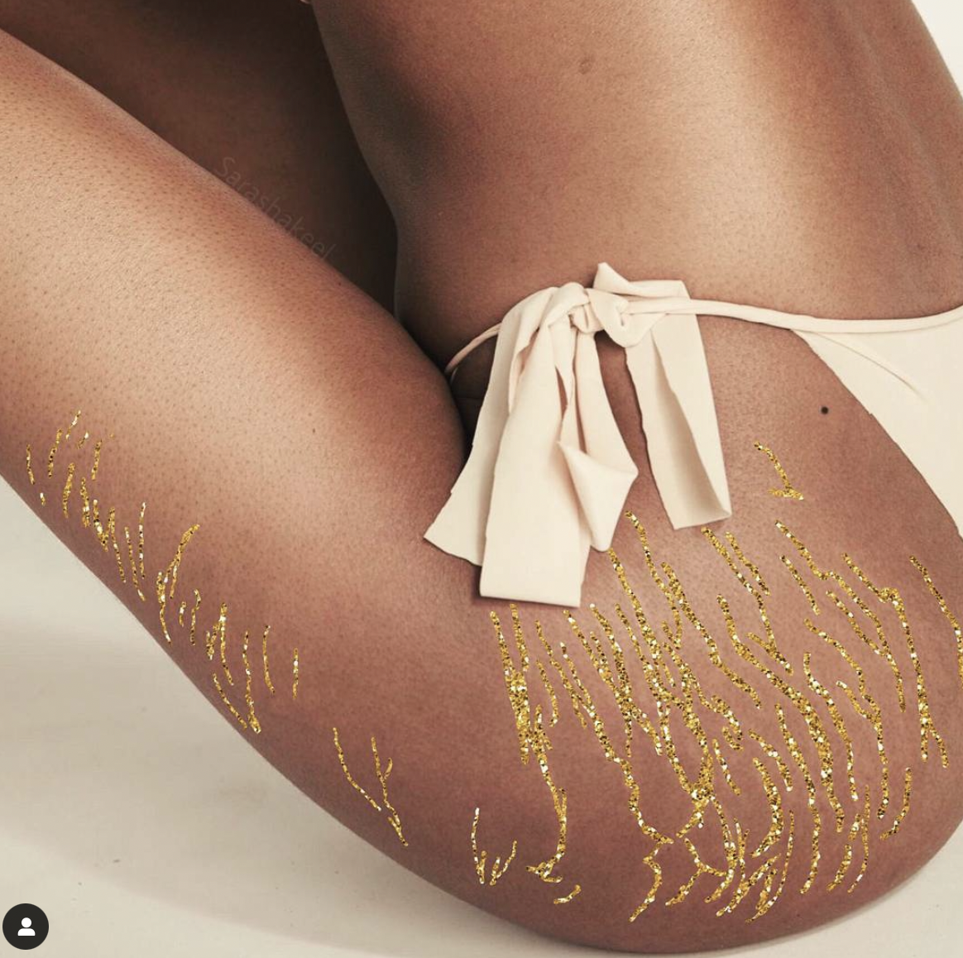
Fig. 3, GlitterMarks, 2017
The artist Sara Shakeel is known for her work of digitally adding glitter to images using photoshop. Adding glitter to images where women are showing their stretch marks helped her gain more recognition for her work, especially with young women who were struggling to see the beauty in their stretch marks. This piece was created in 2017 and posted online to Instagram, where Shakeel shows all of her work. This piece fits in with the topic of the exhibition as it once again highlights an aspect of the human body which a high percentage of women are insecure about. In an article where a woman was interviewed about her lifestyle to stay fit and how she’s still disappointed she stated that “she eats no meat, very little oil or fat, and no sweets, and she drinks very little alcohol. Despite her rigorous body work routine, Jennifer’s legs have remained a disappointment to her. Rather than lean and muscular, they look, by her account, thick and shapeless— particularly around her lower thighs and knees.” (Gimlin, 2001). She later goes on to say that she had decided to have liposuction on her legs to make them look more pleasing. This society’s opinion on the women’s body is forcing women to have such a negative opinion on their bodies to have to surgically change them, risking their lives.

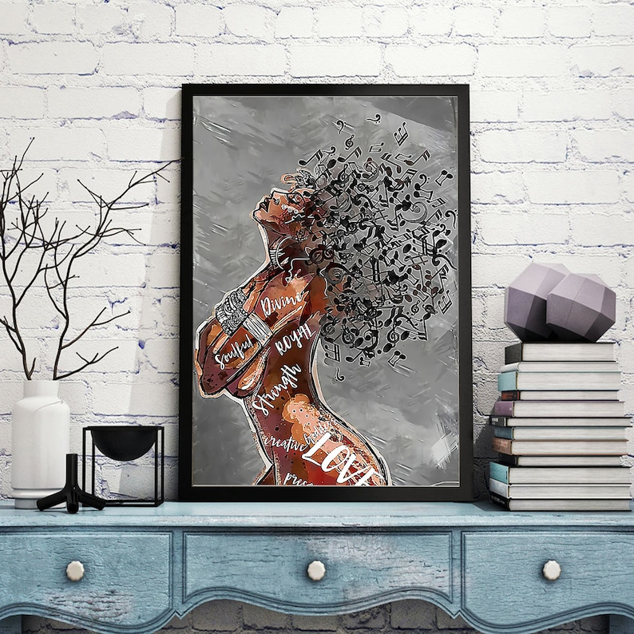
Fig. 4, Black Queen, 2021

This piece was created by an artist named Jessica, she promotes her work and sells it on Etsy on her shop named Wendieiera. It is unknown where the artist created this piece and where it was released as the only place promotes and shows her work is on Etsy. This piece shows how words can affect someone and their opinions of themselves as “one only needs to pick up a newspaper, turn on the television, or glance at the magazines in the checkout line at the grocery store to be reminded of our cultural obsession with the appearance of our bodies” (Markey and Gillen, 2016). So many young women are under the stress of making sure their bodies conform to societies beauty standards and “advice on how to improve one’s physical appearances abounds – from how to lose weight to how to surgically alter one’s appearance.” (Markey and Gillen, 2016). With body image standards changing over the years from have the expectations for being ridiculously skinny, heroin chic, to being told that the new beauty standard being that you should have an exaggerated hourglass figure. This beauty standard is forced on young girls through influencers on social media promoting this beauty standard and “although strategies for surgically altering the body’s appearance have been available for centuries, the practice has only recently become a mass phenomenon” (Gimlin, 2001). This piece of work fits in with my exhibition with its like to beauty standards with the words of affirmation written all over the women’s body.

To conclude, I believe that I have been able to show the topic of my exhibition clearly through the pieces of artwork I have selected. Each piece is unique in the way that each artwork possesses different aspects of the saying ‘Body Positivity’. With each artwork either conveying the topic through mental health aspects or through the use of different medias. I also believe with the artworks either being created digitally or by hand makes the pieces more impactful, with each artwork highlighting different body parts women could feel insecure about. I highlighted ones I thought were most common which was stretch marks and body size.

Bibliography

Daniels, E. and Gillen, A and Markey, C. (2018) Body Positive. Cambridge: Cambridge University Press.

Gimlin, D. (2001) Body Work Beauty and Self-Image in American culture. California: University of California Press

Markey, C and Gillen, M. (2016) Body Image. Available at: https://www.researchgate.net/publication/311962736_Body_Image (Accessed: 23 April 2023)

Maykel, C and Bray, M. (2020) Promoting Mind-Body Health in Schools; Interventions for Mental Health Professions. American Psychological Association.

Rumsey, N and Harcourt, D. (2012) Oxford Handbook of the Psychology of Appearance. Oxford: Oxford University Press.

List of Figures:
Figure 1: Body Positivity, 2022. Accessed: https://www.instagram.com/p/CXrp2FZNO33/ (Accessed: 23 April, 2023)

Figure 2: Body Positivity, 2021. Accessed: https://www.instagram.com/p/CQQ3UU7pDaL/ (Accessed: 23 April, 2023)

Figure 3: Sara Shakeel GlitterMarks, 2017. Accessed: https://www.instagram.com/p/Bawcp9enZDq/?hl=en (Accessed: 23 April, 2023)

Figure 4: Black Queen, 2021. Accessed: https://www.etsy.com/uk/listing/1414206848/black-queen-music-afro-girl-poster-music?click_key=8b5aa8825bb9df0e4c9396a0f70d7ae7e74a2aef%3A1414206848&click_sum=d35e424f&ref=shop_home_active_38&pro=1 (Accessed: 26 April, 2023)

