Marketing plan written for

Old Edwards Inn and spa __________________________________

Student Name

Abul Imran
__________________________________________________

Student ID number

2110029
___________________

Marketing Essentials BMIH4005

Lecturer

Neil Dyer
________________________________

This assignment will focus on Old Edwards Inn and Spa. This hotel is located within the St Highlands in the USA.It is important to consider that a business is able to influence a consumer perception on a brand or image by the use of the marketing mix. ( Proctor, T 2008). The product strategy of Old Edwards Inn and Spa can be recognised in adherence to the high quality service accompanied by its luxurious room in conjunction with its historic European style spa has proven to be a successful strategy to attract high level of consumers. The hotel thrives through its ability to provide premium leisure facilities such as a golf course and elegant fine dine offerings. (Trip advisor 2020).

The hotel offers a varied guest rooms , suites ,each room is unique and embodied with antiquarks and Italian bedding. There are approximately 84 rooms. In cohesion to the pandemic, modified restrictions have been implemented due to the focus on the safety and well being of their guests such as reservations must be made before entering the restaurant to ensure social distancing. In parallel with legal restriction the use of amenities has been modified. Which the hotel have furnished additional outdoor spaces to ensure relaxation whilst practicing social distancing. For improvement to COVID safety the hotel may decide to ensure that each person has ensured a temperature check by a hand free digital thermometer and if an individual reaches a concerning temperature they should be offered a guest room to isolate. Therefore they are not putting others in to danger. Which also ensure a more comprehensive method to ensure COVID safety. ( Ferguson 2021)

Old Edwards uses a price skimming strategy by utilising high pricing strategies in relation to the service and product offered. (Blythe, J., 2012.) This increases perception value of the hotel due to the exclusivity and uniqueness that is offered. The hotel may increase there added luxury value to continue to maintain prestigious pricing by all inclusive packaging deals which include fine dining and spa treatment of the consumer choice. This can increase the magnitude of the added luxury value. This may also include providing a complimentary gift such as robes and slippers or food basket.

Old Edward inn is located amongst the beauty of the Blue ridge mountains and cascades over several aches of land .The website captures the exclusivity of the hotel by using a variety of scenographic images surrounded by by forests , rivers trails and waterfalls to provide exclusive segment.This is facilitated by their app which provides a map view of the hotel. ( Old Edwards Inn and Spa 2021)

Common promotion strategy employed by the company is the varied packages offered such as winter all inclusive which offers deluxe accommodations for one night including breakfast for two at Madisons Restaurant and lunch at the food and beverage outlet. The company websites is frequently used for advertising products and services by the hotel. Old Edwards have used social media platforms such as Instagram to promote their business this is a comprehensive method to maximise and reach a wide customer base as social media is accessible to all consumer types which can maximise the company’s bookings. To capture the attention of new consumers and increase awareness of the brand, Old Edwards may want to consider using celebrity endorsement. This is an effective method in which the business will be able to enhance credibility and boost sale revenue. (Old Edwards 2021)

A swot analysis is a strategic planning technique which provides a a company to do a situational analysis. Old Edwards strengths that have been identified by consumers is the beautiful scenery and well appointed rooms. This was recognised in trip advisor by consumers in which the amenities such as variety of dining venues , spa and lounges, golf course had added to their luxurious experience.

The Hotel must address the weaknesses that have been identified for example many consumers have complained regarding the cleanliness of the room. Numerous complaints have been made regarding the customer service.In which they claimed staff were rude and were unable to provide a high standard of customer service that was expect. consumers had also faced difficulties in relation to the booking service in which consumers were unable to gain contract through the phones even after calling multiple time. ( Trip Advisor 2021)

Old Edwards may address these weakness which can facilitate opportunities to help enhance the experience of consumers. In relation to the negative experience encountered by consumers in conjunction with the poor service provided by the staff, this may illustrate to the business that staff may need training. This ensures each staff member is able to provide a high quality of service which can enhance the customer experience. This will lead to positive reviews on websites such as trip advisors which can promote the business. This can also be done by word of mouth in which this will attract new customers to stimulate a growth in revenue.( Van DWL 2006)

The threat of pandemic can pose a threat to Old Edwards as due Covid-19 had a severe affect on the hospitality industry due to social distancing and lock downs. Which significantly reduced demand for the business as this can lead to Old Edwards limiting their operations . The hotel may address this threat by diverting their attention to the health and safety of the consumers. For example new measures can be introduced such as prioritising house keeping and introducing frequent cleaning schedules which will be able to guarantee cleanliness and sanitation to help protect staff and consumers.( Mauguin 2020)

By segmenting customers , Old Edwards Inn is able to help the business meet the customers expectations. One way Old Edwards Inn may segment their target audience by targeting couples and families as when researching many consumers have attended the hotel as a couple or with their families. The hotel may be able to increase competitiveness by focusing on these two target audience for example the hotel may introduce a couples only package which may include a bouquet of flowers on arrive , in door dining experience with a complimentary Champaign. This will allow to stand out from competitors as this will increase customer satisfaction. ( Xotels 2020)

It can be inferred that Old Edwards Inn have used Instagram marketing to help connect with a wider range of audience this helps the business position their business visually. For example the hotel uses hashtags on their post which allow the business to help connect users to similar post and help the business to target their audience. This will allow the hotel to promote their business to help consumers to identify the services offered. However, when analysing Old Edwards inn twitter page it can be inferred that the social media account has been inactive since 2019. One recommendation that can be purported is that staying active on platforms such as twitter will allow consumers to share their experience with others and share constructive feedback. For example Hotels such as Hilton use this platform to highlight offers available , publish news blogs and share pictures which will allow consumers to gain valuable aspect into the business. (Old Edwards 2019)

Moreover, when analysing how Old Edwards optimise their search engine , when searching ‘ hotels in Highlands in North Carolina’ it can be highlighted that the hotel is within the first three hotels suggestion that is when. This is a positive aspect which will help gather more potential customers as it is top ranked and will help gain more visibility online. ( McGarth 2019)

To conclude, Old Edwards should implement these recommendations into the marketing strategies as the recommendations are in conjunction with modern society. For example one recommendation included using social media platforms to increase brand awareness is very beneficial to the business as social media is widely used by consumers all around the world and is able to target wide range of audience by engaging in platforms such as instagram the business is able to promote their business to wider scale. In cohesion to this by using celebrity endorsement to promote the business this will increase visibility online for the customer and will increase the visibility to a wide base of consumer. This is a quick method to help optimise bookings and help the business grow competitively to help increase their market share in the hotel sector.

Bibliography

Blythe, J., 2012. Pricing and price policy, London: Henry Stewart Talks.

Ferguson, A 2021, Luxury Product Marketing: How to Determine Pricing Strategy?. Available at : https://www.annetteandco.co.uk/luxury-product-marketing/ (Accessed 10 December 2021)

Old Edwards Inn and Spa (2021) Old Edwards Hospitality Group. Available at : https://www.oldedwardshospitality.com (Accessed 10 December 2021)
Old Edwards Inn and Spa 2021. [ Instagram] [ Accessed 10 December ] Available from https://www.google.co.uk/url?sa=t&rct=j&q=&esrc=s&source=web&cd=&ved=2ahUKEwia0c6I7dn0AhWCZMAKHQWoBRgQFnoECAMQAQ&url=https%3A%2F%2Fwww.instagram.com%2Foldedwardsevents%2F%3Fhl%3Den&usg=AOvVaw2gQfGqwFC_dd22XxTrbXRt

Old Edwards Inn and Spa 2019. [ Twitter] [Accessed 10 December] Available from https://twitter.com/oldedwardsinn

Proctor, T 2008, Strategic Marketing : An Introduction, Taylor & Francis Group, Florence

Mauguin M 2020, Covid- 19: The great hospitality rest. Available from https://hospitalityinsights.ehl.edu/great-hospitality-reset ( Accessed 10 December 2021)

McGrath M 2019. The Importance of Search Engine Optimization (SEO) [ Acessed 10 December ] https://alterendeavors.com/search-engine-optimization-seo-importance/

Tripadvisor, (2021) Old Edwards Inn and spa. Available at : https://www.tripadvisor.co.uk/Hotel_Review-g49215-d554653-Reviews-Old_Edwards_Inn_and_Spa-Highlands_North_Carolina.html (Accessed 10 December 2021)

Tripadvisor ,(2020) Old Edwards Inn and Spa. Available at: https://www.relaischateaux.com/gb/united-states/old-edwards-inn-and-spa-highlands (Accessed 10 December 2021)

Van, DWL 2006, Human Resource Management for Events : Managing the Event Workforce, Routledge, Jordan Hill.

X hotels 2020, hotel market Segmentation 2020 https://www.xotels.com/en/revenue-management/revenue-management-book/hotel-market-segmentation [ Accessed 10 Dec,ever 201}

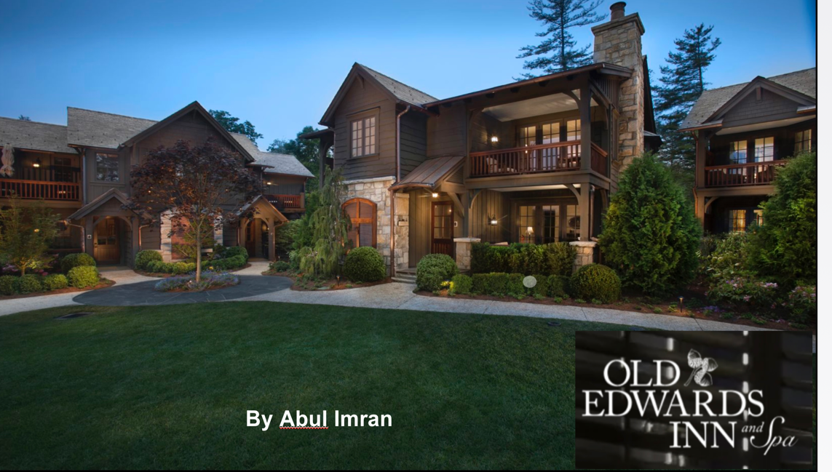
My presentation



