

Data analysis and Visualisation

ASSIGNMENT 2

Koushik Modak, Data analysis and Visualisation | 6.05.2022
Tünde Debreczeni (2115195)

Contents
Data analysis and Visualisation 1
Analysing the presented data 3
1 Introduction 3
2 Description of the data 3
3 Visualization of the data set 4
4 Analysis 5
4.1 Hypothesis testing 5
4.2 T-testing 5
5 Outliers in the data set 8
6 Factors affecting Hypotheses testing 9
7 Results 9
Conclusion 10
Bibliography 11

Analysing the presented data

1 Introduction

In this task I have a table which displays class test results mark out of 20 of 40 years 5 school children who are learning mathematical concepts in the local primary school an online learning company has given the school and learning app for free of charge. The company wishes to Analyse the use of the app as a learning tool, based on the findings they can decide whether they should proceed with the development of the app or not.
Results are given in a data set, the results show achievements of the children when using traditional materials, the second set shows the result achieved when the children use the new online app which helped with their studies.
My my task is to analyse the data providing on the recommendation to the company as to whether the app is a success or not.

2 Description of the data

The data represented are the grades display before using the app and after using the app by the students which is arranged in a table of data given in excel, it's represented in two columns, are the observations, and the data shown in them are the variables. [1]The data displayed is numerical. We can identify two categories of data. The first column displays degrades before the app was used, the second column shows the grades after the students used the app.
We have two sets of data to analyse and compare, to find out if the app helped the students to upgrade their studies. The data is the level of the measurement, in our case is interval ratio data, in our case is represented with whole numbers. [2] Looking at the data set without any analyzation, in the second column we can see a tendency of higher grades after the app was used.

3 Visualization of the data set

Based on the data set, presented in excel I created a chart for the better understanding of the data set. Based on the chart we can see that the data presents deviations between the two samples. The sample is the collective of 40 students, first variable is the test scores when the students didn’t used the new app for studying. the second variable present the test scores after the studying app was used.
The chart shows us the difference is and the similarities between the two variables, we can see a trend line presenting the test scores after the app was used. The two variables are very similar to each other.

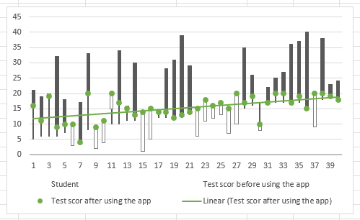

4 Analysis

Our objective is to find out if the studying app helps the students to have better grades, then before they used one. This is our problem statement. We will find a hypothesis upon we will test the data set. What is the goal, to see if the app helps the students in learning, because if it does then the software can be develop, the developers don't know yet if it suits the purpose or not? We will use quantitative data analysis, to measure the differences between the two-sample given. We try to set relationships between variables. [3]And we will test hypothesis scientifically rigorous way. For example, the impact of the learning app on the students, that that cannot be reduced to numbers. The population is in this in this case are the 40 students, the samples are, the two data set, first data set with the grades of the students who didn't use the app, the second sample is the data set with the greats off the students who used the studying app.
With the help of statistical hypothesis, we can analyse the data set, and we can determine if the learning app it helped the students achieving higher degrees or not.
4.1 Hypothesis testing
Is a key feature in inferential statistics. It is based on the idea that we can tell things about a population from a sample taken from it. Hypothesis testing can be explained in five steps: Hypotheses, Significance, Sample, P value, Decision.
Hypotheses is based on the premise that you cannot prove something to be true, but you can disprove something by finding an exception you decide what you’re trying to provide evidence for. [4] Then we have to set up the alternative hypothesis, H1 the opposite is the null hypothesis, H0 and find evidence to disprove that it can be said. We have to decide Which hypothesis we will use, the 0 hypothesis, H0 or the alternative hypothesis H1.
0 Hypothesis in this case is that is no different between the students’ grades before and after using the app.
H0= there is no difference between the grades after using the studying app.
The alternative hypothesis in this case is that there is difference between the grades after using the studying app.
H1= there is a difference between the grades after using the studying app.

4.2 T-testing

For proving our hypothesis, we are using different statistical tests, in this situation we will use T -testing to prove that the two samples provided are not similar. To prove that there is a difference between the two samples, so the 0 Hypothesis will be rejected, and we could assume there is a difference between the samples. Then we can provide evidence that's the learning app has influence on the students’ grades.

H0: μ1=μ2

The calculation for the T test is made in excel spreadsheets, with the help of data analysing toolkit. On the T test chart, We will find statistically important values calculated precisely, Comparing these values we can perform a one tail and a two tail test. We will provide the P value for each T test.

A P value is a probability that is what the P stands for, it is the difference in a sample, evidence of difference in the population. [4] [5]The P value tells us the probability that we would get the sample results by chance, if there is no effect in the population. The smaller the sample is from the population, as in our case the 40 students, the easier we can calculate the mean and standard deviation of the sample will be different.

Now we are introducing the first T-test chart.

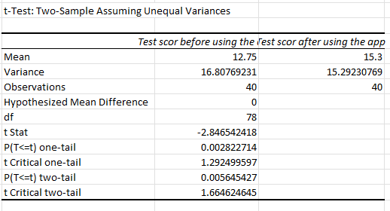
The level of significance we used in this T -test was 0.10 or P value
α = 0.10

The test will provide a single obtained value, T obt. The larger of the value of t obt is likely it will present statistically significant difference between the two variables.
T critical presents the value of the one tail test.
Comparing the T crit with the T obt we can find out if the probability at is a statistically significant difference appeared by chance.

In this test we can see that the T stat is -2.846 and the T crit one tail is 1.292.
From this results that with the help of the one tail test, we can demonstrate that T stat is not larger than the T crit , so there is no significant difference between the two variables. Based on these facts we cannot reject the 0 Hypothesis. The two variables don't have the same value.
We will do the two tailed test as well, T critical two tail is 1.664 the T stat is -2.846.
We are in the same position we cannot reject the 0 Hypothesis.
Conclusion is that the difference is minimal, in both variants and there is no not enough evidence to sustain that hypothesis.

Now we are introducing the second T test, with the P value of 0.25.

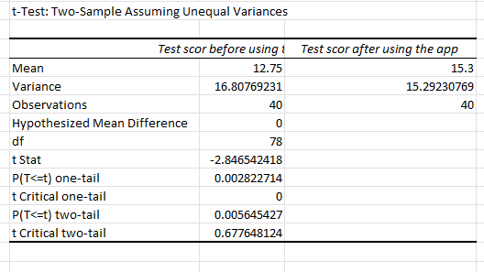
α = 0.25
We will perform a one tail test, T stat is -2846, and T critical one tail is 0. In this analysis the t stat is not bigger than the T crit one tail, this means that cannot reject 0 Hypothesis.
We will do another test, the two tailed test. T stat is -2846 and the T crit two tail is 0.6477. Comparing these two values We can't reject the 0 Hypothesis.

Third T-Test, P value =0.01
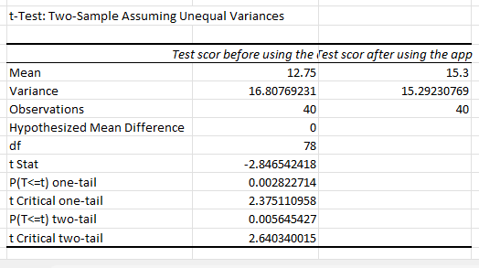

We do a one tail test; T stat is -2846 which will be compared with the value of T crit one tail:2.375. The 0 hypothesis cannot be rejected,
Two tail tests performed based on the T test chart. The T stat -2846 is compared with T crit two tail 2.640 and does not give us o positive result for rejecting the 0 Hypothesis. If the value of the T stat would be much higher than the T crit we could reject the 0 Hypothesis.

5 Outliers in the data set

Outlier is an extremely low or high value in a data set, we can identify an outlier if it is greater than Q3+1.5 (IQR) inner curtail range, and Q1 -1.5(IQR).
In our case we have the two Mean values from the two data samples.
Q1=12.75 - Q2=15.3 = -2.55(IQR)

12.75 +1.5(-2.55) =16.575 =extremely high value
15.3-1.5(-2.55) =11.475 = extremely low value
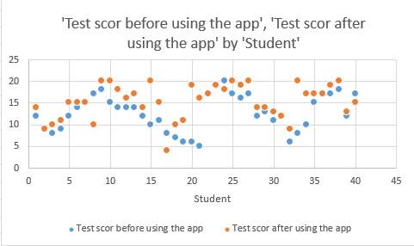

This this graph is representing all the values from the two samples from the data set, the test scores before the learning app was used, and test scores of the students after they used to study app. We can see differences, but similarities as well. This scatter plot points out the aberration values found in this data set; this represents the extreme values of outliers The two variables are shown with different colours so we can see clearly if we can find some relationship between them. Can we find a linear relationship, between the variables on the different axes, is it a positive or is it a negative relationship, or we can find outliers? The scatter plot presents a positive weak linear relationship, between the values.

6 Factors affecting Hypotheses testing

Statistical hypothesis testing can be affected by the significant value which is given by the examiner. Usually, the significant value is decided to see variate results, off the variables, so the result can be compared, and reject or sustain a hypothesis.
Other factor that can affect the hypothesis testing is the variability of the population, in our case we had a sample from the results of 40 students who used a studying app. the population was singular, it was the sum of the 40 students, and their results after exams.
Other factor that can affect the hypothesis testing is the test we use to get the results, each data set is different, so we must use the proper test.
Other factors that can affect our hypothesis testing is, the hypertensive itself, is it a simple hypothesis, or a complex one, directional one, or nondirectional, is it the 0 hypotheses.

7 Results

We got those data set, with the two variables, two columns in the access spreadsheet, and our task was to demonstrate, that's the learning app have the students to have better results after usage. We used tree testing methods, to try to demonstrate better learning app help the students. [5] Unfortunately, we couldn't demonstrate, because the results are two similar, and we kid couldn't prove the 0 Hypotheses.
The samples are similar, but we found aberrant values as well, which cannot give us concrete results.
The probability statement could be that this learning app is helping the students to be more prepared for the exams. From the data visualisation we can define, the probable differences between the two variables presented. We cannot conclude on the statement that the learning app is helping the students for preparing for the exams and getting better grades.

Conclusion

The learning app is a useful tool, but it's not guaranteed that it helps the students to learn more effectively. We encourage the software developing company, to carry on developing this studying app, and ma maybe provide us later with another sample, from another population then maybe the results will be more precise.

Bibliography

[1] | E. F. F. H. Sy-Miin Chow, Statistical Methods for Modeling Human Dynamics, New York, 2009.
[2] | J. H. Kranzler, Statistics for the terrified, Lanham, Maryland : Rowman & Littlefield, 2018.
[3] | “Advances in statistical analysis.,” Advances in statistical analysis., no. Springer-Verlag, 2007.
[4] | i. b. American Statistical Association, “Statistical analysis and data mining.,” Statistical analysis and data mining., no. 1932-1872, 2008.
[5]

