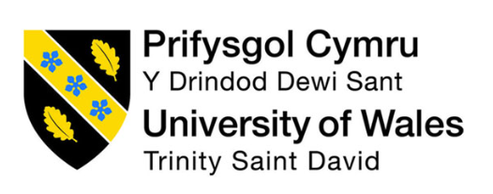

An Analysis of a critical organisational change at a UK Steel Works

Gavin Williams
1503534

Acknowledgements:
I want to thank Sophie Rapsey, BSc, MSc, for her knowledge and academic tutoring during my first analysis project. With guidance, structure and support, she has taught me a lot about scientific research, specifically quantitative and qualitative research methods.

Abstract:
The purpose of this research project is to investigate how an engineering company led a successful merger between departments. The topics aim to discuss how the implementation was managed using change-structured techniques and the problems it can create if not considered. The author, to accomplish this, conducted a quantitative questionnaire to gain general knowledge and insights to understand how employees felt during the merger and used this research to combat the effect of resistance and why the difference between dialogue and no dialogue stems from a significant gap within the dynamic of an organisation. The research, shows where leadership styles and individuals should be recognised and used when an organisational change is initiated. The findings of gathered information proved crucial to how leadership styles and change management structures impact organisational change. The information gathered also shows that dynamic conversation can have several impacts on the organisation and the individual. To conclude, this research project dives into already proven change management structures and highlights critical, impactful decision-making. By understanding the individual and management of change, companies can have a much more effective course of action with a greater chance for success.

Table of Contents:
Acknowledgements: 2
Abstract: 3
List of figures: 5
Introduction 6
Research/literature review 7
Methodology 10
Gantt Chart 11
Change Management 13
Quantitative analysis results 17
Conclusion 19
References 21
Appendices: 25

List of figures:
Figure 1: First projected Gantt chart
Figure 2: Updated and revised Gantt chart
Figure 3, Energy one Project timeline.
Figure 4: Lewin’s change management model
Figure 5: Kotters’ 8-step change model
Figure 6: Leadership styles (Doyle, 2016)
Figure 7: Questionnaire results.
Figure 8: Questionnaire

Introduction
This report will analyse the organisational change implemented within Tata Steel, Port Talbot (UK), which occurred between October 2022 and February 2023. Tata Steel, Port Talbot consists of individual departments which are critical to the steel-making process. The departments, in turn, have their own vital responsibilities, roles and budgets (Tata Steel Europe Limites, 2023). As part of the change, the Energy Department was separated into two different departments, Generation and Utilities. As part of the merger, these departments were put together however, their budgets and workforce continued to be managed separately. The Generation department is renowned as Tata Steels’ “Power Plant”. The power plant consists of extremely high-pressure steam boilers, which in turn power the steam-driven turbines and alternators, producing electricity. This electricity supplies the rest of the steelworks. The Utilities workforce is in charge of the supply of steam across the site; however not limited to steam. They also look after water, gas and oil, which many, if not all, supply every department across the Tata Steels site use.
As Lewin (2019) highlights, there are many factors to implementing effective organisational change that reduces the risk of the change to the company. Lewin (2019) notes how the change itself must be driven by data, for example, profitability for the company or in response to a financial crisis. Therefore, it is essential to understand the motives driving the organisational change to assess whether it is a good step for the company. Once the change has taken place, as Hayes (2022) notes, change management methods are critical in practical implementation. Therefore, this project will explore these to assess the effectiveness of the change methods used within the Tata Steel Energy department.
Highlighting critical positive and negative management change procedures appears necessary for the need to learn from experience, a crucial element of project management (Adams & Blair, 2019). Some motivators for the change could be linked to the ongoing political issues surrounding cheap steel imports, which have been at an all-time high since 2021. The UK government implemented trade sanctions that warranted only steel in the EU could be bought and sold, thus eliminating the cheap trade from foreign states (Hutton, 2023). This creates a rise in price for not only steel costs but imports or raw materials also. In addition, the cost of natural gas and electricity has increased dramatically, and the push for a more carbon-neutral process has put Tata in a very hostile position with the rising cost of steel and its operations. The company and many other businesses in the EU are forced to find cost-saving measures. In addition, the parent company Tata Steel (India) has been reducing the financial backing it provides to the UK and EU plants. With many change theories postulating that poorly implemented organisational change can have the opposite intended effect, it is essential to identify which change management methods would support the original motives behind this change.

Research/literature review

In consideration of the literature, it appears that the broad area of specific change management has a wide variety of factors to be considered (Lines et al., 2015). Such factors are regarding general change management methods that are not specific to engineering. For instance, Jabri and Jabri (2022) highlight potential gender differences in the processing and implementation of change. Although, the research on change management appears heavily researched on the male population rather than female. This could be attributed to the inequalities present in leadership roles, which the sample research relies on. This bias in the research does not appear to affect the current project as all employees involved in the change at Tata Steel Port Talbot were male, including the management implementing the change. Therefore the research seems applicable to the sample.
Yue, Men and Ferguson (2019) discuss the strength of positive leadership in any area of change, which can significantly influence employee acceptance of the change. Employees tend to react better to proactive individual discussions rather than being told or hearing rumours (Reunanen & Kaitonen, 2019). Therefore, it might be suggested that one-to-one meetings or holding regular update meetings with all employees affected by the change would reduce the negative impact of rumours. Doaei, Eslami & Gholami (2021) indeed highlight this negative impact on workforce productivity and workplace culture. Although this research is not specific to the engineering industry, Akella & Lewis (2019) advise that the impact of rumours is applicable across organisational contexts.
In addition, mental and physical health are also factors linked to whether the change implemented has a positive or negative outcome. However, the majority of people who work at Tata Steel, Port Talbot, are generally in good physical health due to the conditions and nature of the job. All employees undergo a medical check yearly. However, the understanding of mental health in this industry is limited. These differential influencing factors appear to reduce the negative impact of change if the leadership style is authentic, open and considerate. Some research suggests Lewin’s change management model can be used to facilitate this type of leadership, despite it being an old model. Burnes and Bargal (2017) argue the relevance of this model to organisations in today’s climate. However, this model is not without criticism (Bakari, Hunjra & Niazi, 2017).
The majority of research stems from Kurt Lewin’s change management model, which was the foundation for other models such as but not limited to Kotter’s 8-step change model, McKinsey’s 7-step model, ADKAR Change management model and Bridges’ transition model. Errida and Lotfi (2021) go into depth using a comparative case study to discuss the most favourable methods. However, Mckinsey’s 7-step model is deemed somewhat complex (Chia, 2018). The 7-step model also offers a particular methodology to change management by focusing on tasks and problems efficiently. It also highlights the importance of the involvement of employees and a clear communication strategy; the only issue is that this is more group based and not focused on key individuals. One of its key factors is looking back and reviewing each and every process on multiple occasions, which builds it to be a high sort after change management method (Kadenic & Tambo, 2023). The ADKAR model consists of a change management model that focuses on individual, organisational change. ADKAR is an abbreviation for five words that make up; Awareness, Desire, Knowledge, Ability and Reinforcement. The ADKAR model provides a clear framework for the individual, which follows a specific order to help the supervisor identify relevant information, support and resources needed for the organisation to reach their intended goal (Keeslar, 2022).
Kurt Lewin’s change management model (1946) was often said to be too simplistic; he targeted groups rather than individuals as often, change happens in environments of social activities and social groups rather than solo, providing a rational thought of process management for teams. For this (Crosby, 2020). However, this oversimplification led many organisations and critics to shut the theory down as outdated, not considering individual characteristics that influence group dynamics. Lewin’s theory comes across as simple as it follows a 3-step pattern, unfreeze-change-freeze. Hussain et al. (2018) state that in today’s global economy and with the vast amounts of technological improvements since Lewin’s (1946) method came out, it does not simulate this era’s difficulties. Therefore, a new model should be used to outline today’s culture and politics. On the other hand, many still use the 3 step model proactively on a day-to-day method. Rosenbaum, More and Steane’s (2018) research suggested that Lewin’s model is everything of an outline to change management and that it is a process of planned organisation change. Like many majorities believe that rather than trying to create a new framework between managers and employers to oversee a new change method, research still suggests that many still use the change management model as a standard approach (Pallapu, 2022), a surprisingly big downfall of Lewins’ model is that it does not and cannot adapt or be adapted. The simplistic nature was that it could be used by many targeted groups and applied across different sectors. As Kurt Lewin was a qualified Doctor of Psychology, it may have been his work mission to understand people’s behaviours, beliefs and thought processes before adequately adapting to the change process (Papanek, 1973). However, understanding of human behaviour has evolved drastically since then. However, much of the research to date supports his theory as an excellent application to planned, structured change (Pallapu, 2022). It could be helpful to personalise his model to the organisational change context.
Kotter’s (1995) 8-step change process is also known as the Integrative model of organisational dynamics. It is a world-renowned change management model which is widely used in organisations. However, upon research Pollack and Pollack (2014) state that there is a lack of academic research on where this process has been implemented. This process has eight easy step-by-step processes allowing the organisation to choose its intended audience. Whereas most change models lead from the top-down approach, Kotters’ 8-step process allows individuals from all parts of the organisation to have input at certain stages (Hayes, 2022). – very good. Kotters’ 8-stage process has multiple implementations where short, medium and long-term effects can show different results in the organisation’s results. One of the main reasons this model is still used today is due to Kotter’s ability to advance and adapt his original change management process. He explores different dynamics between companies and has adapted to suit multiple organisations; his process has been easily adaptable to fit companies over the last 20 years (Kotter, 2012; 2014). One of the primary functions of the model, which contributes to many steps, is communication; the adaptable framework means that companies can tailor it to whatever they would like. The focus is mainly on communication, building a sense of worth even as an employee and allowing employees to have a voice in the step process, which helps the short-term theory goal (Bakari, Hunjra, & Niazi, 2017). Rather than making a change out of the blue, the model focuses on building the change within the organisation before implementing it and developing it into a coalition-led change.
Considering the research, it is hypothesised that both models must be kept up to date in today’s ever so advancing global, political, and economic market. The growing markets present new challenges for change processes (Hanelt, Bohnsack, Marz and Antunes Marante, 2021). AI technology is taking jobs with twenty-four-hour processes and minimal downtime, and the cost of living affects the price rise in energy, be that electricity or natural gas. Due to the relevance and wealth of research for Lewin’s (2019) and Kotters’ models, this project will use these as the basis for the research and analysis.

Methodology
The methodology undertaken for this analysis will be a quantitative questionnaire design with some qualitative data to gain a broader range of knowledge. This has enabled the author to find out people’s opinions, perspectives and experiences to help further the research and analysis undertaken for the project. The primary data was collected through face-to-face interviews and online questions. The author created the questionnaire due to the specific nature of the questions that had to be asked and were deemed necessary and relevant. Questionnaires were printed out with a tick box style answer (see Appendix A) and handed out. Those given the questionnaires returned them the same day. This was to reduce the bias of discussing the answers with others on the team to achieve individual feedback. By doing this, the author also gathered the relevant information quicker. However, by doing that, the author is aware that by asking the same questions towards a directed audience, they will more likely have biased answers. However, asking more open questions will leave a broader opening for greater depth and a personal touch with fewer answers. The questions were open-ended. However, some were multiple-choice, so it. The aim of this project is to research the methods of change management used and to critically discuss how Tata Steel implemented the organisational change and how it was managed. It also explores other change management methods and critical leadership skills that might have been present or lacking. By doing this, it will evaluate how the Energy department adapted and overcame obstacles and, in addition, pinpoints successes. By using the quantitative methodology as a collective, it is hoped to gain a better statistical analysis and test results rather than a qualitative questionnaire as it is less structured with no means of graphs and or surveys. A qualitative collection would have limited the ability to create charts to understand the data.
This questionnaire was given to fifteen TATA STEEL Energy department employees, a mixture of the two department’s generation and utilities. The employees were also a mixture of operational and craftsmen. They were all male, and their age ranged between twenty-two to fifty. All men had a range of working years for the company, between 3-22 years of experience.

Gantt Chart
This Gantt chart states the timeline of the research and planning undertaken; the Gantt chart consists of a few milestones undertaken for the project research. It illustrates the timeline at hand and gives a clear schedule for the proposal. This highlights the timelines and deadlines of the research and project that must be adhered to. It is also allows the reader to visually see the overlapping of the activities to see what is working well and keep up to date records of this.
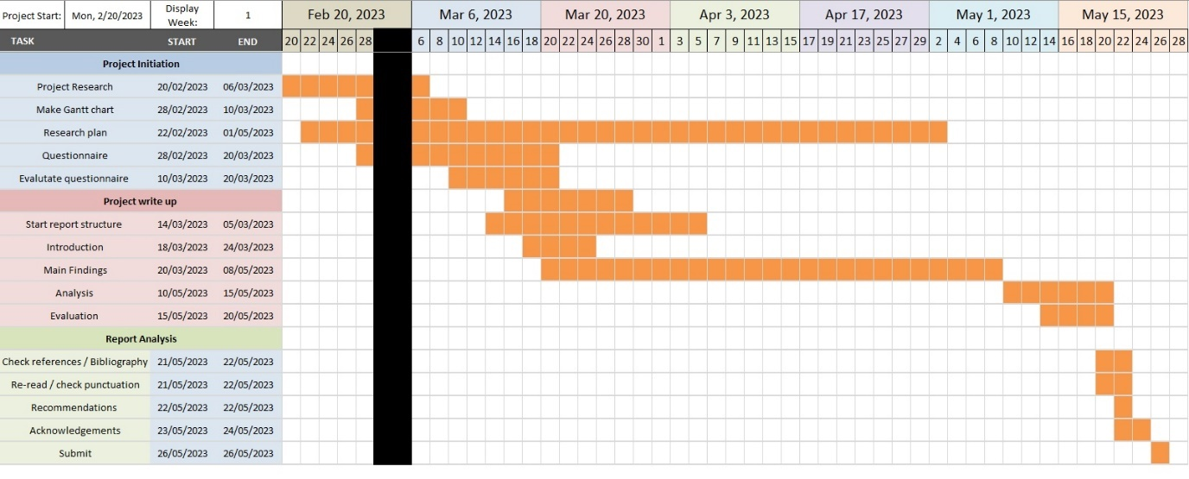
Figure 1: First projected Gantt chart.
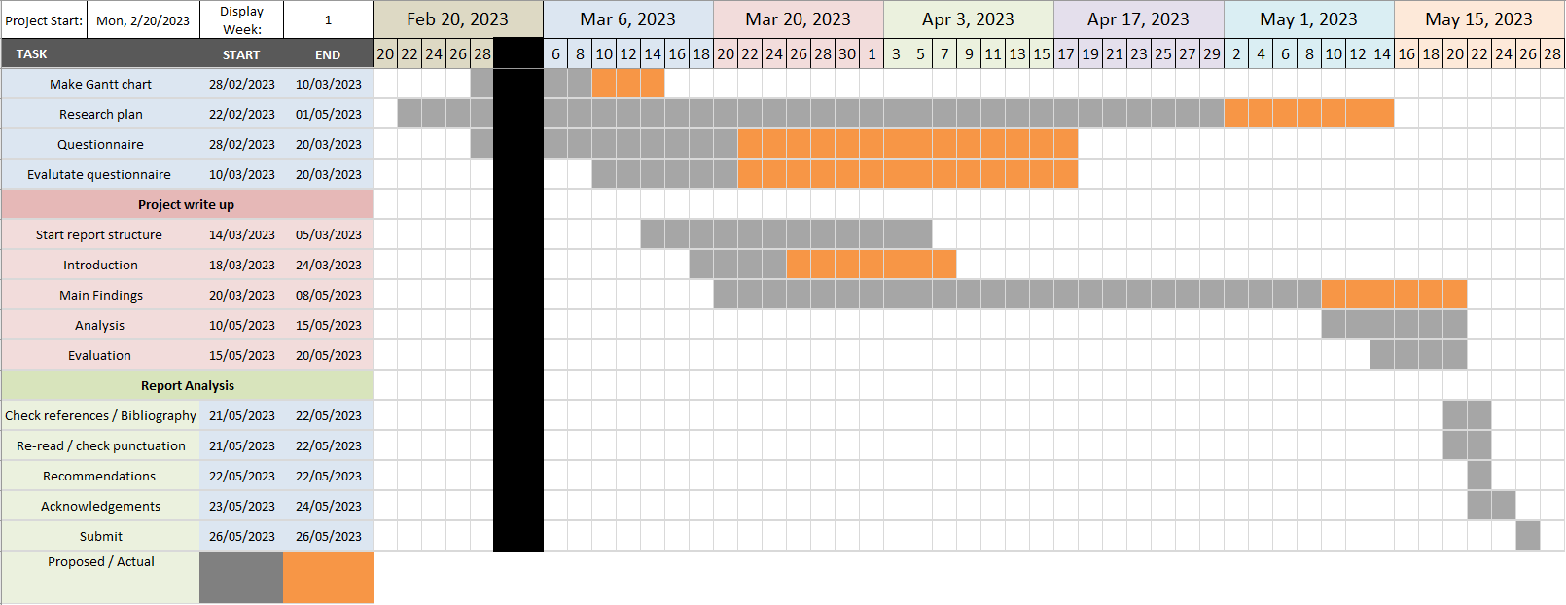
Figure 2, a revised Gantt chart highlighting the actual and proposal time.
A revised Gantt chart was needed to review the progress recorded for the timeline of the project; this is due to needing to allocate more time to certain parts of the project. Under different circumstances, projects can sometimes be pushed back or moved forwards depending on the organisation. Gantt charts are essential in project management to allow for over or under-estimation. They are helpful for the allocation of timeslots, and resources and keeping up-to-date with tasks.

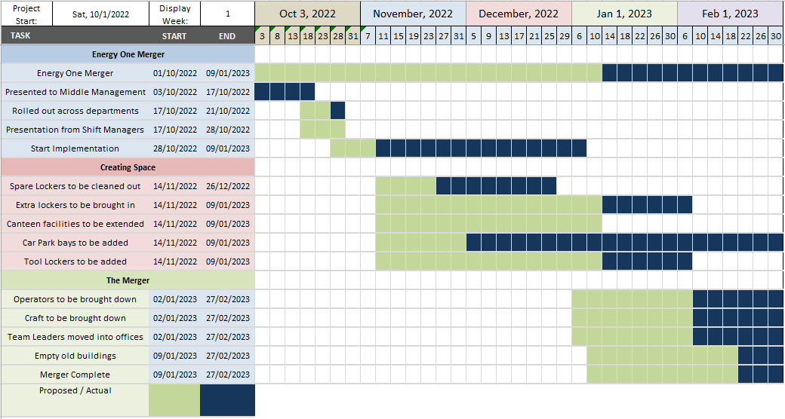
Figure 3, Energy One Project timeline.
The Energy One Project Gantt chart consists of multiple periodic mistakes. Within the Gantt, it is noticed how the proposed time scales run a great deal past their expected date of completion. The main goals for the merger greatly overran or are still ongoing. When looking at the Gantt we can noticeably see that the Project was pushed back for over a month period. From the Gantt we also can see those facilities for the employees moving to the new area required clothes and tool lockers along with new parking spaces. These facilities were either pushed back or did not arrive at their proposed date. This would play a heavy role as companies must provide adequate facilities for employees (Managing for Health and Safety, 2013).

Change Management

The management at Tata Steel’s Energy department was given the considerable task of undertaking a merger between the Utilities and Generation departments within a five-month time scale between the months of October 2022 to February 2023. Given the short time scale for such a significant task, enormous pressure must have been imposed on senior management. Avdeeva, Golovina and Polyanin (2021) state that longer periods for decision-making and long-term goals are considered more valuable and more suitable as there is a framework appointed to outline specific criteria for planning and development within an organisation. However, Cignitas, Torrents Arévalo and Vilajosana Crusells (2022) state that for any positive outcome for any strategy-based organisational change, a positive balance between management and employees can also lead to a successful outcome no matter what circumstances are thrown at them. The merger consisted of day and shift teams based in the Utilities department to be moved to the generation department. The logistical change sparked many questions from employees and middle managers such as Shift Managers, Team Leaders and Leading Hands. The difference would see middle management, electrical and mechanical craft, and other operational team members, re-positioned. It is believed that there was no formal communication between senior management and employees for the merger, which was dictated by senior to middle management and passed down. Therefore, this management of change structure would be deemed a top-down approach (Tsai & Beverton, 2007).
When implementing an organisational change, first acknowledging the original organisational chart to understand who the key leadership figures are is essential. If the leadership shows evidence of characteristics that can offer a clear vision, they can maintain and inevitably sustain the momentum of the change. This can then make more sense to employees. Also, the business shall gain more influence and support from everyone around. Providing a cognitive map for the employees to follow helps identify transparency between management and employees (Hughes, 2016). Suchman et al. (2011), also believe this is the case. Maintaining a healthy relationship between management and employees helps bridge the gap or perspectives they might have. For most managers, their role is spent looking after the company’s vision, whether this is quarterly budgets, sustainability issues, individual goals and improving efficiency.
Kurt Lewin (1946) initiates the change management model process by allowing different factors to be factored in at the initial unfreeze stage and the middle, Change stage. This can allow for any weaknesses to be pointed out and dealt with before implementation.
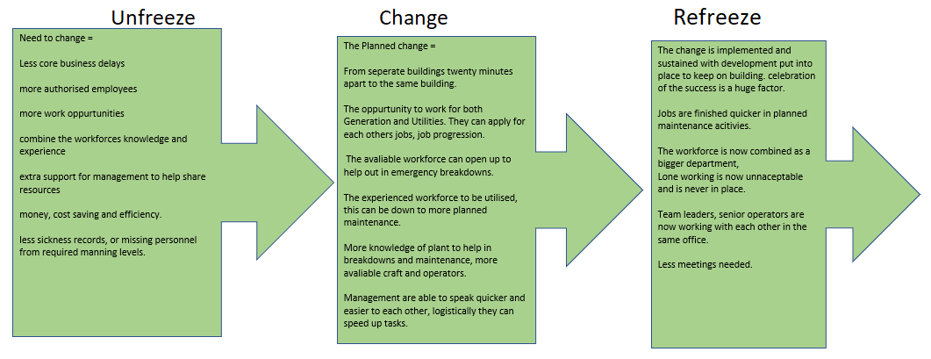 Figure 4: Lewin’s change management model
In the case of Tata Steel’s merger project, management is believed to have not communicated very well with the employees. By using a quantitative questionnaire, the author was able to gain knowledge and understanding of how the merger was perceived by management and employees. When the merger was broadcasted to middle management in October 2022, they then proceeded to tell employees about the changes being implemented. This would consist of logistical movements from the Utilutility department to Generation. The departments had been split for the previous twenty-plus years. Employees had queried that there was not enough space for the other employees. There were also questions about job changes, shift changes, employee structure, increased workload, and job losses (Karatepe, Rezapouraghdam & Hassannia, 2020) state that these are common questions when it comes to any work change. Research suggests this was primarily a top-down approach adopted by Kurt Lewin’s theory (Burnes, 2020). One of the issues with using a top-down approach is that employees struggle to feel a part of the organisation as they have no choice or ruling in the matter. Lewin’s change management model of the unfreeze-refreeze method gives employees a voice and the option to act on the change (Memon, Shah & Khoso, 2020). Employees starting on a negative can lead to a less productive workforce and a majority with a negative mindset. Resistance from the employees is a significant factor in organisational change. This stems from a fear factor of the unknown. Change enhances uncertainty of job loss, job satisfaction, and increased workload. Fear of the unknown can also lead to mental health factors of people stepping out of their comfort zone. Organisational change outlines individuals potentially becoming creative, going above their regular positions and daily activities, and possibly competing for their job as they can become unfamiliar with new surroundings (Baquero, 2022). Organisation change is stemmed from communication from start to finish. This can negate negative comments and steer employees and others on a clear path to stop resistance and fear from rising in the ranks. However, once instilled and management is made aware of the resistance, they need to address this by providing support and a clear and targeted vision of which the coalition can be a part. When addressing the resistance and answering the negative surroundings, this is the removal of all barriers and a goal they can build on, thus using the step-model process (Cohen & McWilliams, 2021).

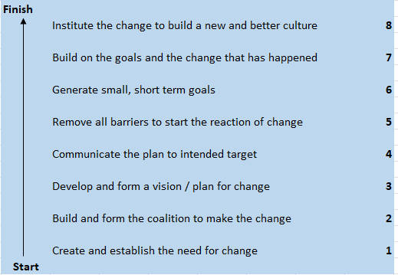
Figure 5, Kotters’ 8-step change model
When change management models are focused on and addressed, they can effectively highlight what the organisation is doing. It can also be used to see what factors have been missed. The author learnt that the change was sprung on employees during the organisation change process. During the initial communication phase, scepticism had set in; questions were set upon managers who had no clear answers for employees at that initial time, with the promise of coming back and answering them before the merger was set. Maylett and Wride. (2017) assert that retention of employees is critical and must be kept to an engaging level to have sustainable performance levels throughout a change, rather than having a decline in performance and initiative. It was found that the management had held out against the employees yet the questions they posed mainly were logistical questions that would pose a problem for the employees themselves who wanted a solution. Whilst the usual response was “we shall get back to you” the employees heard nothing back. Even with a top-down approach, there has to be a solidified plan that has or can be changed upon any snags found. A perfect plan is never made up of just senior management, it is found that employee’s knowledge and experience are usually the crucial part in a puzzle as they are the ones who often run the plant (Di Fabio & Kenny, 2019). Not the senior management who of course runs the business. With a combination of the two, Lewin’s’ and Kotter’s models are exceptional in pointing out characteristics within organisations that must be present.

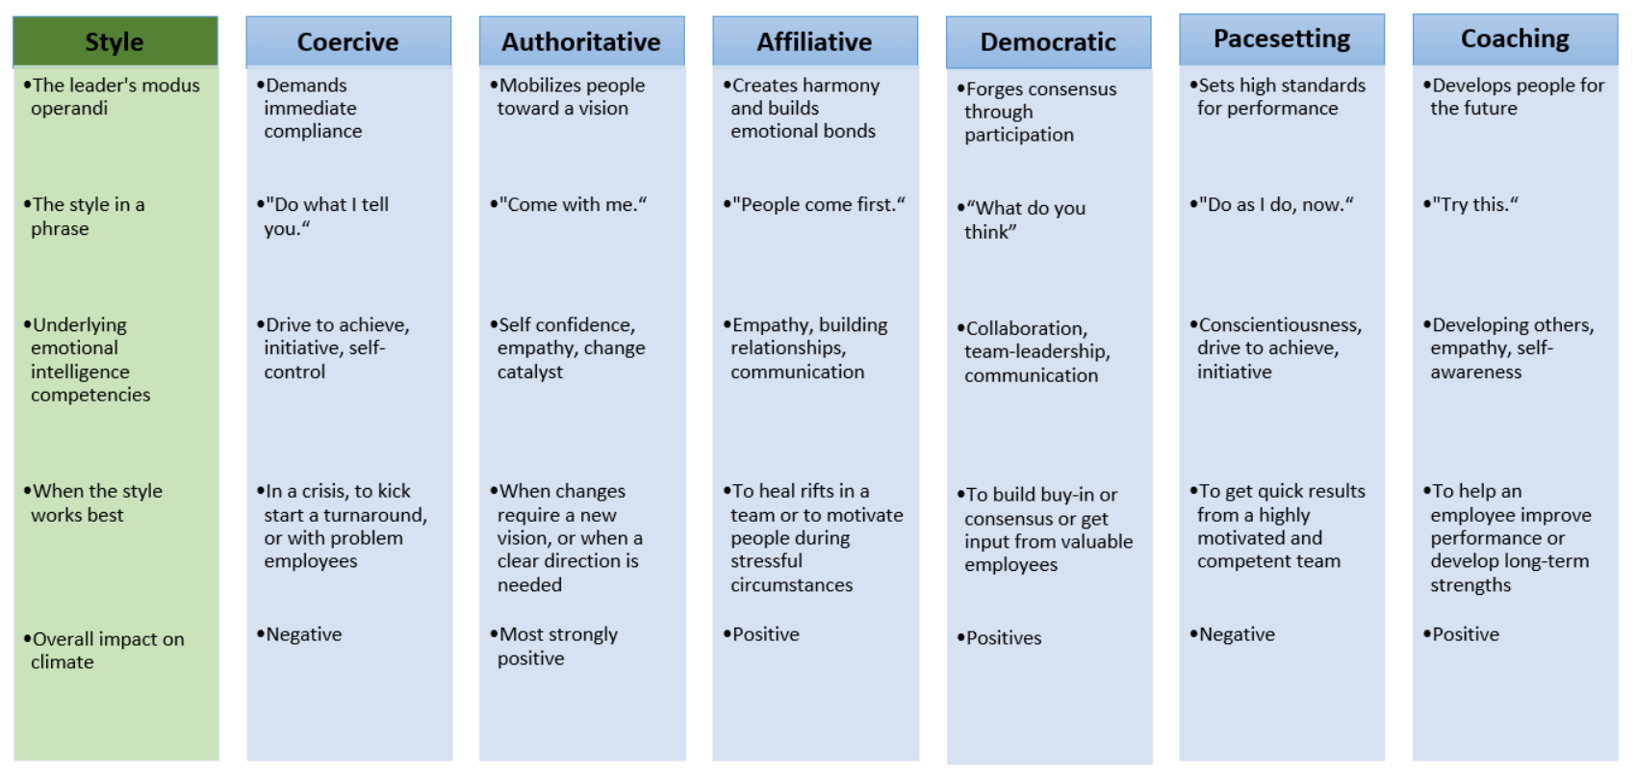
Figure 6, Leadership styles (Doyle, 2016)
Leadership characteristics stand out in change, and research suggests individuals will usually follow someone who has a positive relationship with them. Someone with a more affiliative or democratic are usually this type, someone with whom the majority can associate on the other hand sometimes management needs to remain strong, and for core business results they need and must provide solutions in short or long-term goals these would then be titled coercive or authoritative (Fries, Kammerlander and Leitterstorf, 2021). It is also worth noting that when individuals anticipate that a change benefits them or others, they may be more highly motivated and can support the possibility of a change (Zboja, Jackson, Grimes-Rose, 2020).

Quantitative analysis results

Figure 7, Questionnaire results.

The quantitative results give us an insight into how individuals feel about the merger for the Energy department. The results show a confused workforce struggling to understand why their jobs were merging. The Energy departments had run separately for years, and results suggest employees would have liked to keep it that way. The merger outlined to cut over-time and job losses with also a focus on decreasing work sicknesses.
The questionnaire consisted of open-ended questions defined by the author, this included fifteen participants from TATA STEEL’S Energy department. It was a mixture of job roles, so this would have different perspectives on the questionnaire. Overall the questionnaire seems to have a negative output on the perspectives of the individuals who participated.
When considering the first question (bottom for reference) There is a majority of fifteen answers of Yes, to 0 answers of No. We know this is not a negative factor from the change management research. Management has a duty of care and responsibility for employees and the company. Therefore for them to instigate an organisational change is well within their roles and responsibilities. Step 1 of Kotter’s 8-step plan explains that there must be an urge or need to create and establish a change.

Question 2 explains that this is where the negative statements start to appear. The amount of those completing the questionnaire felt the old system was effective and efficient. If management had asked these questions before applying the change, they could have shared their reasons for the change as it did not seem to make sense to employees. It is known that that lack of communication and understanding is a pivotal contributor to resistance. Out of the fifteen individuals asked, five considered that senior management had thought about the resistance that would be upcoming, and as the data shows they also believed that some measures were put in place to manage this as well.
It is clear from the data that most individuals are believed to have thought about productiveness and well-being since the merger was announced and believed that levels had dropped after October 2022. All research in the literature points to the management of change processes. Without employee recognition, incentives, or opinions of the change, it is believed that certain employees and middle management can become distant and resent the change. Further research suggests that direct contact between management and employees directly links to a positive outlook and beliefs on change (Rafferty & Minbashian 2018).
Through the questions, it is noticed that the perception of the merger is mainly thought to have been driven by cost-saving and efficiency plans from senior management and above. Although the questionnaire does not state otherwise, and it is noted that this was at a time of financial crisis within the sector (Jolly, 2021). TATA has a long-term and short-term goal list. It is believed that the drive to become a self-sustainable company is leading them to create change and cut costs where necessary.
The final questions outline a response to workload, effectiveness, and efficiency before and after the organisation’s change. The coalition from employees is that they would prefer to have their old system in place. There are many links to resistance, with familiarity with the job being one of them; fear of the unknown regarding the change can lead employees to worry (Hayes, 2022). Day-to-day jobs could be subjected to a change of process and performance, which also gives employees or any individual a feeling of fear. A cultural shift could also play a significant factor, as research suggests that the majority of a group will always stick together. This is more likely a sense of pressure perceived by individuals who can project onto others. Good leadership and an outspoken voice of reason can help employees feel that they are being led down the correct work path and have a sense of control in the new system. Clear support from management can benefit and highlight the individual’s strengths and weaknesses moving forward with an organisational change (Cohen & McWilliams, 2021).

Conclusion
During the research project, it is perceived that TATA STEEL’s Energy Department did not adopt any change management structure recommended. A Top-down approach was noticeably used by higher management, which led to an unhealthy organisation change with much resistance met by employees. With an adaptation of Lewin’s “unfreeze, change, refreeze” model, it is clear that this could have helped manage resistance with very little change to a top-down approach still being used. A bottom-up approach cannot also be considered regarding the facts and challenges presented by the organisation. Suppose Kotters change management model had been more heavily emphasised. In that case, it is also believed that this would have held more of a structure to the change and led to a smoother transition without a setback from January to February 2023. Both models focus on creating the change, making a change and then emphasising it. There are clear paths and frameworks for either that are needed in today’s society, as job security is at the forefront of the fear factor.
Highlighting a key leadership figure which is apparent in this situation, there was not. This would have allowed employees to communicate with senior management and could have influenced individuals’ motivation for the merger. Even with a clear motive and a process set out by senior management for addressing a cost-saving merger for the Energy Department, a framework for the organisational change was not present for employees. In conclusion, it would be the organisation’s best interest to follow a change management structure when any change management is necessary. This would help organise an approach to the change and manage any resistance that may follow. A top-down approach could be considered outdated, and using a hybrid model of any change management theory could potentially have a greater chance of success when implemented correctly.
Organisations that can review and not overlook such change would receive vital feedback and allow for alteration as and when needed, allowing continued cultural growth. Training and development for employees was also another factor rarely mentioned. With the merger happening and operational and craft positions combining, there was no communication about how and when this would occur. The understanding was that no job progression or job share was being issued. However, overall, it was to ensure that in case of any sickness periods, these positions would now be covered by other personnel. To conclude, the analysis of the management of change does not speak of any reward or celebration of success for employees or middle management. This change was brought on by senior management as it was thought to be a cost-saving exercise at the employees’ expense, under no circumstance during the merger was there any clear reward or incentive for individuals.
In reflection on this research project, I have learnt a lot from change management concerning positive and negative impacts within an organisation. The positive outcomes are that of a merger that was accomplished with authoritarian leadership and an authoritarian overview, then again, the negative side to this was that it formed quite a high resistance among employees. To combat this, management had to yield to tasks that they thought they would have gotten away with, about tool lockers and clothes lockers. Although the merger was only delayed by a month, I would say that overall the outcome was negative. The results from an employee’s perspective can only be analysed through the questionnaire results, to which the majority answered that the old system was more effective. Also, by using this information, the author acknowledges that more qualitative questions could be asked to continue the employee’s reflections and managers. This potentially would have yielded further and more detailed information. The questionnaire could also have been more tailored to senior management regarding questions surrounding cost, efficiency and sustainability. From the results of the Energy One merger, a more open dialogue between senior management and employees could have avoided the delay in the process. In response to this it would have saved the company financially, also regarding the month’s delay. this would have prolonged operator and craft tasks surrounding work. With production low due to workforce resistance, it can be estimated that this also cost the company.

References

Ali, B.J. and Anwar, G. (2021). The Mediation Role of Change Management in Employee Development. International Journal of English Literature and Social Sciences, 6(2), pp.361-374.
Adams, R.V. and Blair, E. (2019). ‘Impact of time management behaviours on undergraduate engineering students’ performance’, SAGE Open, 9(1), pp. 1–11. doi:10.1177/2158244018824506.
Avdeeva, I., Golovina, T. & Polyanin, A. (2021). ‘Change management strategy for the activities of Business Organizations’, SHS Web of Conferences, 90, p. 01003. doi:10.1051/shsconf/20219001003.
Bakari, H., Hunjra, A.I. and Niazi, G.S. (2017). ‘How does authentic leadership influence plan organizational change? the role of employees’ perceptions: Integration of theory of planned behavior and Lewin’s three step model’, Journal of Change Management, 17(2), pp. 155–187. doi:10.1080/14697017.2017.1299370.
Baquero, A. (2022). ‘Job insecurity and intention to quit: The role of psychological distress and resistance to change in the UAE Hotel Industry’, International Journal of Environmental Research and Public Health, 19(20), p. 13629. doi:10.3390/ijerph192013629.
Bougie, R. and Sekaran, U. (2020). Research methods for business a skill-building approach. Eighth. Hoboken, NJ: Wiley.
Burnes, B. (2020). The origins of Lewin’s three-step model of change. The Journal of Applied Behavioural Science, 56(1), pp.32-59.
Cameron, E., Green, M. and Davies, M. (2020). Making sense of change management : a complete guide to the models, tools and techniques of organizational change. Fifth edition. London ;: Kogan Page.
Chia, A. (2018). ‘Distilling the essence of the mckinsey way: The problem-solving cycle’, Management Teaching Review, 4(4), pp. 355–370. doi:10.1177/2379298118779325.
Cignitas, C.P., Torrents Arévalo, J.A. and Vilajosana Crusells, J. (2022). Positive management and the balanced scorecard: A successful organisational strategy, Journal of Positive School Psychology. Available at: https://upcommons.upc.edu/handle/2117/367242 (Accessed: 4 April 2023).
Crosby, G. (2020). Planned Change: Why Kurt Lewin's Social Science is Still Best Practice for Business Results, Change Management, and Human Progress. First edition. United Kingdom: Taylor & Francis.
Cohen, M.B. and McWilliams, J. (2021). Coch, Lester, and John RP French Jr.: Overcoming Resistance to Change. In The Palgrave Handbook of Organizational Change Thinkers (pp. 395-405). Cham: Springer International Publishing.
Di Fabio, A. and Kenny, M.E. (2019). Resources for enhancing employee and organizational well-being beyond personality traits: The promise of Emotional Intelligence and Positive Relational Management. Personality and Individual Differences, 151, p.109278
Doyle, P. (2016) 6 leadership styles in Project Management, BrightWork.com. Available at: https://www.brightwork.com/blog/project-leadership-and-its-6-different-styles (Accessed: 06 March 2023).
Errida, A. and Lotfi, B. (2021). The determinants of organizational change management success: Literature review and case study. International Journal of Engineering Business Management, 13, p.18479790211016273.
Fries, A., Kammerlander, N. and Leitterstorf, M., (2021). Leadership styles and leadership behaviors in family firms: A systematic literature review. Journal of Family Business Strategy, 12(1), p.100374.
Goffin, K. and Mitchell, R. (2021). Innovation management: Effective strategy and implementation. Third. London: Bloomsbury Academic.
Hanelt, A., Bohnsack, R., Marz, D. and Antunes Marante, C. (2021). A systematic review of the literature on digital transformation: Insights and implications for strategy and organizational change. Journal of Management Studies, 58(5), pp.1159-1197.
Hayes, J. (2022). Theory and practice of Change Management. Sixth. London, UK: RED GLOBE PRESS.
Hughes, M. (2016). ‘Leading changes: Why transformation explanations fail’, Leadership, 12(4), pp. 449–469. doi:10.1177/1742715015571393.
Hutton, G. (2023). UK Steel Safeguards - House of Commons Library, UK steel safeguards. Research Briefing. Available at: https://commonslibrary.parliament.uk/research-briefings/cbp-9596/ (Accessed: April 24, 2023).
Hussain, Syed., Lei, Shen., Akram, Tayyaba., Haider, J.M., Hussain, H.S., Ali, Muhammad. (2018). “Kurt Lewin's change model: A critical review of the role of leadership and employee involvement in organizational change,” Journal of Innovation & Knowledge, 3(3), pp. 123–127. Available at: https://doi.org/10.1016/j.jik.2016.07.002.
Jolly, J. (2021). Port Talbot Steelworks owner reports £347m loss despite £1bn funding, The Guardian.
Kadenic, M.D. and Tambo, T. (2023). Resilience of operating models: exploring the potential of agile project management as enabler. International Journal of Managing Projects in Business, 16(3), pp.521-542.
Karatepe, O.M., Rezapouraghdam, H. and Hassannia, R. (2020). Job insecurity, work engagement and their effects on hotel employees’ non-green and nonattendance behaviours. International Journal of Hospitality Management, 87, p.102472.
Keeslar, A. (2022). Prosci ADKAR Model of Change, Study.com | Take Online Courses. Earn College Credit. Research Schools, Degrees & Careers. Available at: https://study.com/academy/lesson/the-prosci-adkar-model-of-change-definition-process.html#:~:text=Because%20the%20ADKAR%20process%20is,through%20to%20the%20final%20goal. (Accessed: 20 April 2023).
Kotter, J.P. (2012). Leading change. Boston, Massachusetts: Harvard Business Review Press.
Kotter, J.P. (2014). Accelerate! Boston: Harvard Business Review Press.
Lewin, K. (1946). Force field analysis. The 1973 annual handbook for group facilitators, 111, p.13.
Lines, B.C., Sullivan, K.T., Smithwick, J.B. and Mischung, J. (2015). Overcoming resistance to change in engineering and construction: Change management factors for owner organizations. International Journal of Project Management, 33(5), pp.1170-1179.
Managing for Health and Safety (2013). Merseyside: HSE Books.
Maylett, T., & Wride, M. (2017). The employee experience: How to attract talent, retain top performers, and drive results. John Wiley & Sons.
Memon, F.A., Shah, S. and Khoso, I.U. (2020). Role of leadership communication in creating change readiness: revisiting Kurt Lewin's Model in telecommunication sector of Pakistan. Indian Journal of Science and Technology, 13(26), pp.2625-2632.
Pallapu, A.V. (2022). Assessment of Change Management and development; in perspective ... Available at: https://www.researchgate.net/publication/360345157_Assessment_of_Change_Management_and_Development_in_Perspective_of_Sustainable_Development (Accessed: 21 April 2023).
Papanek, M.L. (1973). “Kurt Lewin and his contributions to modern management theory.,” Academy of Management Proceedings, 1973(1), pp. 317–322. Available at: https://doi.org/10.5465/ambpp.1973.4981410.
Phillips, J. and Klein, J.D. (2022). “Change management: From theory to practice,” TechTrends, 67(1), pp. 189–197. Available at: https://doi.org/10.1007/s11528-022-00775-0.
Pollack, J. and Pollack, R. (2014). “Using Kotter’s eight stage process to manage an organisational change program: Presentation and practice,” Systemic Practice and Action Research, 28(1), pp. 51–66. Available at: https://doi.org/10.1007/s11213-014-9317-0.
Rafferty, A.E. and Minbashian, A. (2018). ‘Cognitive beliefs and positive emotions about change: Relationships with employee change readiness and change-supportive behaviors’, Human Relations, 72(10), pp. 1623–1650. doi:10.1177/0018726718809154.
Reunanen, T. and Kaitonen, J. (2019). Different roles in leadership styles in modern organization, SpringerLink. Available at: https://link.springer.com/chapter/10.1007/978-3-319-42070-7_24 (Accessed: 23 April 2023).
Rosenbaum, D., More, E. and Steane, P. (2018). “Planned Organisational Change Management,” Journal of Organizational Change Management, 31(2), pp. 286–303. Available at: https://doi.org/10.1108/jocm-06-2015-0089.
Suchman, A.L., Sluyter, D.J. and Williamson, P.R. eds. (2011). Leading change in healthcare: transforming organisations using complexity, positive psychology and relationship-centered care. Radcliffe Publishing.
Tata Steel Europe Limited (2023). Sustainability performance at our sites. Tata Steel in Europe. Available at: https://www.tatasteeleurope.com/construction/sustainability/performance-at-our-sites/port-talbot (Accessed: 13 April 2023).
Tsai, Y. & Beverton, S. (2007). Top‐down management: An effective tool in higher education?, International Journal of Educational Management. Available at: https://www.emerald.com/insight/content/doi/10.1108/09513540710716786/full/html (Accessed: 25 April 2023).
Swanson, D.J. & Creed, A.S. (2013). Sharpening the focus of force field analysis, Taylor & Francis Online. Taylor & Francis. Available at: https://www.tandfonline.com/doi/abs/10.1080/14697017.2013.788052 (Accessed: May 4, 2023).
Yue, C.A., Men, L.R. & Ferguson, M.A. (2019). ‘Bridging transformational leadership, Transparent Communication, and employee openness to change: The mediating role of trust’, Public Relations Review, 45(3), p. 101779. doi:10.1016/j.pubrev.2019.04.012.
Zboja, J.J., Jackson, R.W. & Grimes-Rose, M. (2020). An expectancy theory perspective of volunteerism: The roles of powerlessness, attitude toward charitable organisations, and attitude toward helping others - International Review on public and nonprofit marketing, SpringerLink. Available at: https://link.springer.com/article/10.1007/s12208-020-00260-5 (Accessed: 09 April 2023).

Appendices:
Appendix A,
This questionnaire was given to fifteen employees at TATA STEEL Energy department, a mixture of the two departments generation and utilities.

Questionnaire
- Was the merger for the Energy departments initiated by higher management only?
Yes No

- Was potential resistance from the workforce considered before applying the change?

Yes No

- Were measures put in place to manage the resistance before issues were raised by the workforce?

Yes No

- Did the change have a negative effect on the productivity and well-being of workers initially?

Yes No

- Was the change put in place for cutting financial costs for the company?

Yes No

- Do you feel as a workforce that you had any benefits from the merger?

Yes No
- Do you feel like this affects employees’ workloads and responsibilities by merging departments?

Yes No

- Do you feel the old system was effective and efficient prior to the change?

Yes No
- Do you feel the new system is a more effective and efficient post to the change?

Yes No
Figure 8, Questionnaire.

