A hotel placement research project on understaffing in Mariott Hotels in Leicester
BMIH6006, BMIH6008
Student Name: Rukshana Begum
Student Number: 2120527
Lecturer Name: Ernest Balutie Wavei

Table of Contents
Introduction 4
Background of the study 4
Aim of the study 5
Objectives of the study 5
Research questions 5
Literature review 6
Understaffing in human resource management 6
Causes of understaffing 6
Impact of understaffing 7
Strategies to overcome understaffing 8
Methods 10
Research philosophy 10
Research method 10
Data collection method 10
Data analysis 11
Ethical consideration 11
Limitation 11
Case study overview and findings 12
Overview of Marriot international 12
SWOT analysis 13
PESTEL analysis of Marriott 15
Competitor analysis 17
Discussion 20
Quantitative analysis 20
Qualitative analysis 28
Conclusion and recommendations 31
Conclusion 31
Recommendation 32
References 34
Appendix 39

Introduction

Background of the study
Shen et al. (2019) stated that organisations faces understaffing in business operation while these recruit less employees compared to required number. In line with this, Hudson and Shen et al. (2018) cited that understaffing is a situation where there are found not enough employees to deploy for handling workload. Hudson and Shen (2015) described understaffing as workforce challenge for the management of an organisation. From the analysis of Ogumeyo and Ekeh (2023), it is stated that different organisations experience understaffing situation due to sudden increase in workload, improper workforce planning, etc. The human resource management of an organisation is highly responsible for understaffing challenge where it needs to effective steps and strategies for overcoming the challenge. Pandey, Gajjar and Shah (2021) claimed that understaffing can lead to poor organisational performance, decreased operational efficiency, financial challenges. In another context, Amadhila (2022) reported that an organisation can experience reduction in employer brand image due to the understaffing situation where this leads to reduced productivity. According to MacKenzie Jr (2018), organisations in the tourism and hospitality industry face increase in customer dissatisfaction due to poor and delayed customer service because of understaffing challenge. In the human resource management practice, an organisation needs to design its proper workforce planning for performing workload and business operations where improper workforce design and adaptation results in understaffing to cause reduced performance. In the context of hospitality industry, the management of human resource needs to ensure effective and prompt customer service to guests and visitors where challenge of understaffing can create disaster to customer satisfaction and service operation. Wei et al. (2024) cited that organisations need to assess risk of understaffing, potential causes where this assessment can guide in the right track of adopting effective strategies to resolve such issues. However, the researcher has assessed the importance of this issue and selected understaffing as research issue for the hotel placement research project. The issue of identifying causes of understaffing, its impact and strategies to resolve this for enhancing organisational performance has been selected for this project where the context of Mariott international hotel in Leicester has been focused to achieve research aim.

Aim of the study
The aim of this study is to analyse the understaffing issue of Mariott Hotels in Leicester where the researcher wants to explore cause behind such incident and strategies adopted by management to overcome the challenge.

Objectives of the study
The researcher has devised some objectives that are to be achieved with the completion of this study where the objectives are mentioned below:
- To analyse understaffing issue and causes of understaffing of human resource management in an organisation of tourism and hospitality industry
- To identify strategies adopted by the HR management in resolving challenge of understaffing in organisations of tourism and hospitality industry
- To analyse causes and impact of understaffing on organisational performance of Mariott Leicester hotel
- To analyse the strategies taken by HRM of Mariott Leicester hotel to resolve understaffing

Research questions
The questions of this research are highlighted below:
- How is understaffing and its causes explained in the context of human resource management?
- How does HR management address and resolve understaffing to overcome challenge of understaffing in organisations of tourism and hospitality industry?
- How does understaffing impact on organisational performance of Mariott Leicester hotel?
- What are the strategies taken by HRM of Mariott Leicester hotel in resolving challenges of understaffing?

Literature review

Understaffing in human resource management
Ogumeyo and Ekeh (2023) reported that understaffing in organisations is a common issue where a few employees are available for performing tasks or workload. On the other hand, Pandey, Gajjar and Shah (2021) cited that an organisation faces understaffing while it recruits fewer employees than requirement for daily activities of the organisation. The improper workforce planning has been a key reason of understaffing and this leads to lower productivity and performance. In this context, Mani, Kesavan and Swaminathan (2015) discussed that human resource managers need to assign more work and hours to perform responsibilities while experiencing understaffing in workplace. According to Mutua (2019), there are found signs of understaffing such as consistent overtime, high employee turnover, low morale, in workplace that these create to the existence of understaffing. Increase in customer complaints is another sign of understaffing where a few employees in workplace create dissatisfaction of customer. From the analysis of Baum (2018), understaffing is cost reduction situation for employers but employees have to experience stress, overtime, increased projects, etc. in the workplace. Hudson and Shen (2015) stated that the management of an organisation needs to address understaffing properly for avoiding cascade of problems and maintaining organisational performance. In line with this, Pandey, Gajjar and Shah (2021) cited that proper assessment and management of understaffing is highly significant for an organisation in developing a desirable work environment, customer satisfaction, productive workforce and employer branding.

Causes of understaffing
According to Belias et al. (2017), poor workforce planning can cause to understaffing where human resource managers fails in assessing and recruiting required number of employees for the employees. An organisation needs to develop a workforce planning model to ensure availability of employees in the workplace for performing designed tasks and activities to achieve goals. On the other hand, Abdiyev and Alimardonov (2022) reported that general shortage of employees can also lead to understaffing. From the analysis of Baum (2016), dissatisfaction among employees create high employee turnover that becomes a good reason of understaffing. In the situation of understaffing, business leaders have to assign more tasks and overtime to the employees for attaining desired business goals. Stone et al. (2024) cited that organisations may face understaffing from the seasonal fluctuation or turnover among the employees due to their career selection and switch. In another context, DeCenzo, Robbins and Verhulst (2016) argued that employee absenteeism can be a reason to understaffing where a burden of those absent minded employees goes to other employees. The positive business growth can become a cause to understaffing where the business leaders struggle to find available employees to manage extra work pressure due to business growth. MacKenzie Jr (2018) described that inefficiency of human resource department in determining the right period of recruitment and workforce management is another crucial cause to understaffing. Sometimes, business find difficulty in selecting right and qualified employees for a job post where vacancies exist for a long period. In this context, Ogumeyo and Ekeh (2023) human resource management of an organisation needs to be dynamic and adaptive to changing situation for planning right recruitment process and schedule to select employees for available vacant post in the workplace. The different reasons of understaffing have to be assessed in different ways for understanding gap of decision makers in finding out the challenge leading to poor organisational performance.

Impact of understaffing
An organisation with understaffing experiences poor operational performance where required number of employees are absent to perform total workload. Dessler (2020) reported that over workload falls on existing employees who feel cynicism and dissatisfaction while working overtime consistently. On the other hand, Stone et al. (2015) stated that organisations can reduce operational cost with understaffing where this issue is considered benefits for business leaders. From the analysis of Boxall and Purcell (2022), increased burnout has been a key challenge from the issue where the employees performing overtime becomes exhausted and dissatisfied to the organisation. This understaffing issue creates over expectation on employees among managers where the employees lose morale while underperforming in workplace cant met expectation. Weiss and Hoegl (2016) reported that businesses may incur over cost and poor financial performance due to lack of required employees in workplace to perform responsibilities. In line with this, AlAli (2020) stated that organisations may lose employer brand image due to the understaffing where employees share negative impression and views on the job experience. The analysis of De Moortel et al. (2018) reports that an organisation experiences decreased productivity and efficiency among employees who are performing for the organisation. The increased workload on available employees who find difficulty of maintaining over workload resulting in reduced productivity. From the discussion of Heyes and Tomlinson (2021), it is found that organisations in hospitality industry can’t provide quick response to customers where the longer response time is the result of understaffing. In another context, Otterbach et al. (2021) stated that reduced quality of customer service is result of the issue where employees with overload can’t maintain quality of delivered service to customers. Dvouletý (2023) emphasised on employee health condition that degrades because of extra work pressure, stress, overtime, etc. In line with this, this can be stated that employee absenteeism is increased from the understaffing where employees can’t adapt with workload situation and performance. Amadhila (2022) reported that an organisations faces increased turnout rate where employees resign job in search of suitable work environment.

Strategies to overcome understaffing
An organisation needs to adopt effective strategies for combating challenge of understaffing where there are found different strategies to find out desirable solution. Ekwoaba, Ikeije and Ufoma (2015) cited that assessing needs of staffing for the organisation where proper assessment supports in recruiting right number of the employees for the available job role. On the other hand, Mukherjee and Yadav (2020) reported that strategic recruitment plan is necessary for the arrangement of human resource management. The management of an organisation has to find out right number of employees requirement for performing business activities. According to Heneman, Judge and Kammeyer-Mueller (2019), workforce planning is a crucial strategy for overcoming understaffing challenge where this planning assists in assessing staffing needs for the organisation and potential gaps in workplace. On the other hand, Mutua (2019) reported that high rate of employee dissatisfaction can be cause to understaffing where mismanagement and poor employee relationship are responsible for such an issue. In response to this, business leaders need to develop proper employee relationship for the management of employee mental health. In this context, Snell and Morris (2019) cited that managers of human resource management needs to organise effective employee relation strategy for understanding their views, feedback and growth orientation. In line with this, Cascio (2015) discussed that employee retention strategy can be an effective tool for reducing understaffing issue in an organisation. Tucker (2022) argued that retention strategy is effective for retaining skilled and talented employees where this isn’t found appropriate for controlling understaffing challenge. Employers experience shortage of employees due to the improper human resource policy and recruitment strategy where they need to design impactful human resource strategy for the management of workforce. Nasirian et al. (2022) reported that over worked employee can increase employee turnover rate and this needs to be monitored properly with the purpose of reducing challenge of understaffing. In this way, employers have to assess workforce capacity and performance where this can find the solution of reducing workload and proper distribution. According to Jackson, Schuler and Werner (2018), workload management is to be performed properly for the reduction of understaffing in organisation where managers can distribute equal and optimum workload to available employees. The implication of staffing theory can be a possible effective solution to the management of understaffing challenge. In this context, Sparkman (2018) discussed that staffing theory needs to be implemented in the workforce management where this theory guides in designing human requirement and process of recruitment of desired number of employees. On the other hand, Mello (2015) cited that organisational theory can be practised at workplace with the purpose of managing organisational activities, staffing, human resource policy and performance. Mukherjee and Yadav (2020) argued that frequent rise in employee turnover due to seasonal fluctuation, poor organisational performance, dissatisfaction, crisis movement, strict leadership, burnout, etc. can cause sudden understaffing that cis found difficult for organisation to manage the situation.

Methods

Research philosophy
A research philosophy sets ideology of a specific research project where it establishes research framework. The types of research philosophy are epistemology, positivism, doxology, interpretivism, etc. which are different from one another in terms of scope, application, nature, orientation, etc. (Gupta and Gupta, 2022). From these philosophies, the researcher selected positivism philosophy for developing structure of this study where this was used in setting up research method, data type, collection method, analysis process, result preparation, etc. (Pandey and Pandey, 2015). This method was found structured and it supported the purpose of applying mixed method to conduct this research project.

Research method
Researchers use either quantitative method or qualitative method for conducting a research project where the data collected from these method are numeric and non-numeric respectively. A researcher can design numeric analysis using the quantitative method where primary data are collected and analysed using statistical tools (Flick, 2015).
For accomplishing the purpose of this study, the researcher applied a mixed method that include both quantitative and qualitative research method (Gupta and Gupta, 2022). This method was found effective as it supported in reducing discrepancy of data analysis and result. In addition, it presented scope of increased validity and quality of research result.

Data collection method
From the two data collection method namely primary and secondary data collection method, the researcher applied both to comply with mixed research method. The primary data collection method was used for collecting data from respondents who were 20 in number. Using a non-probability convenience sampling technique, the researcher selected 20 respondents who comprise of employees, HR managers, professionals and customers of hospitality sector (Mukherjee, 2019). Secondary data were collected from different secondary sources where relatability and authenticity of data were ensured while collecting those non-numeric data from secondary sources (Flick, 2015).

Data analysis
After collecting primary data from survey of 20 respondents, the researcher analysed those using statistical tools such as charts, graphs, statistics, etc. From the analysis, the result was presented in a quantifiable form for better understanding of audience. The researcher also provided discussion and analysis on the result and findings from the quantitative analysis of primary data. In another context, the researcher collected secondary data from sources such as books, articles, newspaper, websites, publications, etc. that were analysed according to findings of those study (Mishra and Alok, 2022). Besides, the researcher added information and findings from personal observation, intelligence, knowledge, etc. to enrich quality.

Ethical consideration
In this project journey, the researcher maintained proper ethical consideration such as anonymity, voluntary participation, no harm, data protection, informed consent, potential for harm, data falsification, etc. The researcher ensured anonymity of the respondents in the data collection process where they were surveyed with a questionnaire (Mishra and Alok, 2022). In addition, respondents were provided with informed consent form for seeking their consent to ensure voluntary participation. Throughout the research process, the researcher maintained no harm policy where all possible potential for harm was controlled consciously to protect participants and others (Devi, 2017). With the implementation of data protection act, the researcher ensured confidentiality of personal data from respondents who were surveyed in the project. In another context, the research ensured protection of data falsification, manipulation and misinterpretation while analysing data collected from secondary sources while conducting qualitative analysis of this research project (Kumari et al.,2023).

Limitation
While conducting this study, the research faced challenges from time constraints, resource limitation and effort. This was found difficult to complete the study within a limited time duration but the researcher managed the work through proper planning and segmentation of work. More resources for this study would increase value and quality where the researcher couldn’t access to much resources for this project. In addition, the researcher had to complete this analysis with a small sample and data analysis. All of these limitations were managed efficiently by the researcher to complete the research project.

Case study overview and findings

Overview of Marriot international
The Marriott in Leicester is a chain of American multinational hospitality company Marriott international Inc. that was established in Maryland in 1927 (Marriott, 2025). Entrepreneurs, Alice Marriott and Willard Marriott, initiated this hotel with the dream of developing a renowned hotel chain in the world (Marriott, 2025). This hotel has become a recognised brand in the hospitality industry with its 608 locations around the world. In the year 2024, the management of this hotel could secure a revenue of $6.44 billion for the second quarter where this indicates a 6% increase in a year (Marriott, 2025). In addition, the hotel achieved a net income of $772 million in the income year 2024 and this indicates good financial health of this organization (Statista, 2025). This organisation operates about 582 hotels and resorts with 205,053 rooms in more than 144 countries (Statista, 2025). Moreover, Marriott has developed 36 brands for the business operation leveraging its brand value and resources to expand market. The success of Marriott has been achieved with the support and productivity of its employees who are 418,000 individuals in number across the world (Reuters, 2025). This large number of employees have been performing efficiently in different locations to uphold brand value, to provide superior customer service and to increase organisational performance. From the analysis of Reuters (2025), it is found that this organisation achieved a revenue of 3-4% on per available room and it has changing this statistics with this productive performance. In addition, the organisation has been capable of signings about 75% new rooms for the business expansion (Statista, 2025). Thus, it has achieved the title of brand leadership in the hospitality industry where this achievement was supported by its extensive portfolio, global presence, productive workforce, performance and effective planning. Marriott international has achieved a market share of 20.4% in 2024 in the tourism and hospitality industry over its competitors (The Conversation, 2025). The overall revenue of this company is 23.7bn USD over its sales of 24.07bn USD where the total market size of hospitality industry is 4770bn USD (Statista, 2025).
SWOT analysis
A SWOT analysis has been prepared below for Marriott International where the researcher has described strengths, weakness, threats and opportunities.
Strengths
Marriott international has achieved a market share of 20.4% in 2024 in the tourism and hospitality industry over its competitors where this has been a great strengths for this organisation (The Conversation, 2025). Moreover, it has achieved a 9361 properties in more than 144 countries and this has created the title of strong brand and the largest hotel chain in the world (Marriott, 2025). In another context, it has established 36 brands to develop a strong brand portfolio where those brands include Westin, The Ritz-Carlton, Sheraton, etc. (Marriott, 2025). With all these brands, the organisation has become capable of reaching to a large number of customer base ranging from budget customer to luxury customers. The overall revenue of this company is 23.7bn USD over its sales of 24.07bn USD where the total market size of hospitality industry is 4770bn USD (Statista, 2025). This financial performance has created a strong financial position and strength of Marriott. The management of hits hotel chain has established a strong loyalty program with Marriott Bonvoy where it has enrolled over 180 million members to enhance brand loyalty and customer satisfaction (The Conversation, 2025). A great strength of this hotel is technology and innovation where this company has implemented AI driven customer service, IoT, hotel management technology, smart hotel rooms, digital operation, etc. to enhance customer expernce. In another context, it has created a pipeline of more 559,000 new rooms and 75% signing of new rooms’ acquisition that indicates a prosperous growth and market expansion of Marriott international (Marriott, 2025).
Weakness
Overreliance on US market for revenue generation has been a major weakness of this hotel that generates maximum of its profit revenue from this specific market. It is also found that this hotel incurs high operating cost in different form such as labour, maintenance, real estate, offering of luxury service, luxury accommodation for guests, etc. (The Guardian, 2025). As the company has established digital service and technology for extending its service, it may cause to cybersecurity issue. In 2018, the company faced a cybersecurity breach issues of 500 million guests resulting in data protection failure, reduced damage of trust and brand image (The Guardian, 2025). In another context, this company fails in owning properties and hotels in different location where it performs franchisee contract leading to weak control over brand, quality and performance. There has been found a big weakness for Marriott in staffing challenge while managing a large number of employees over 418,000, understaffing, turnover, reduced productivity, performance, etc. (Reuters, 2025).
Opportunities
The expansion opportunities of this brand has been a great opportunities for the business where it can expand its market in emerging markets such as Asia, Africa, Middle east, etc. (Reuters, 2025). Adapting to the rising issue of sustainability can be leveraged in the business where the management can implement sustainability and ESG initiatives for developing eco-hotel service, reduction of carbon emission, attaining energy efficiency, etc. Technology creates opportunity of Marriot that can increase its adoption of technologies. By implementing AI in business management, customer experience, service bots, personalised offering, IoT, integrated technology in business process, the organisation can enhance its service quality, customer experience and brand value (The Guardian, 2025). New service offering by this organisation can be an effective option of business expansion where leisure travel, workcation, corporate travel, sports tourism, etc. can be utilised properly to cash trend and market value. Moreover, this company utilise the opportunity of acquiring regional brand and merging with suppliers, strategic partners, technology developers, etc. (The Guardian, 2025).
Threats
Increasing intense competition in the industry has been threat for the organisation where it faces competition from large brands such as Accor, Airbnb, Hyatt, Hilton, etc. These competitors are breathing behind Marriott in terms of market share, performance and customer share (The Conversation, 2025). Economic downturn is another risk for this hotel where inflation, interest rate, recession, etc. create negative impact on revenue and financial performance of Marriott. Its global presence can cause to risk regarding political tension, wars, conflict, ban, operational regulations, etc. In another context, the organisation may face challenge from regulations of countries such as environmental issue, labour, data protection, regulation, business operation, etc. (The Conversation, 2025). It needs to be aware of cybersecurity due to the rising technological integration and adoption of tools in the business process and operational functions.

PESTEL analysis of Marriott
Political
Government regulation is a key force of political environment as this organisation has been operating in more than 144 countries. Issues such as taxation, laws, regulations, political tension, etc. create effect on the business operation of this hotel. In another context, geopolitical risks can erupt form the environment where travel restrictions, wars, foreign currency, inflation, trade ward, etc. are the common geopolitical issues for this organisation (Daniels, Radebaugh and Sullivan, 2019). For example, COVID-19 pandemic created huge economic and performance impact on the operation of Marriott Hotel. This organisation may face tension and crisis from labour laws issue, working hour, employment, regulations, business restriction, tariff policy, etc. of different countries (David and Jane, 2019).
Economic
An organisation like Marriot need to manage challenge from inflation, exchange rate fluctuation, interest rate, recession etc. while operating its business in different country. The change in foreign exchange rate can change operational cost while purchasing raw materials and providing services to guests (Wild and Wild, 2019). On the other hand, the management of this organisation can utilise trends in the industry where those include workation, corporate travel, sports tourism, business, cultural tourism, etc. An effective planning on the trends of hospitality can lead to increased sales and revenue growth. In another context, a change in disposable income can create impact on sales of this organisation where a rise in income may create high demand (Ebert and Griffin, 2020).
Social factor
The management need to observe change in customer preferences in Leicester while operating business where changes in preference need to be addressed properly in the service offering and business management. This should leverage tourism trends such as workcation, sports tourism, business travel, etc. where these services can meet increased demand among customers (Ebert and Griffin, 2020). It is identified that people in this location has raised demand of sustainability issues where they want Marriott to increase sustainability practice. Responding to this, it can adopt strategies of sustainability, eco-friendly, carbon free service, green supply chain, etc. (Edgell Sr, 2019). An extra care and respect should be provided to aging population of this region where it can offer new service for those people of Leicester (Higgins-Desbiolles, 2018). An extensive focus on health and safety of customers and employees can add value to the brand image where this service needs to be added in different aspects of service delivery.
Technology
Changes in the industry with the revolution of technology have offered opportunities for Marriott that can integrated artificial intelligence, automation, etc. for enhanced customer service. The application of mobile technology such as digital room keys, kiosk, mobile check in, mobile app, etc. has created great option for the organisation (Ali, Rasoolimanesh and Cobanoglu, 2020). In line with this, big data analytics can be utilised effectively to manage business operation, to develop business planning and to design strategies for market operation, marketing and others. The management should ensure cybersecurity for managing risks where the data management system, security, system maintenance, etc. have to be maintained properly. Technologies such as IoT, smart rooms, kiosk, etc. have enhanced customer service and experience to increase brand value and sales (Ratna et al., 2024).
Environment
The management of Marriot has to focus on environmental issues for adapting with market change where issues such as sustainability, carbon reduction are to be responded properly by this organisation (Aragon-Correa, Martin-Tapia and de la Torre-Ruiz, 2015). In response, this hotel chain has initiated a plan of attaining 30% carbon reduction within a period of 2030 in accommodation with the visionary policy by the government of the UK (The guardian, 2025). It has implemented green procurement with LEED certified buildings, emerging efficiency, renewable energy, technology, etc. to attain sustainability (Marriott, 2025). In another context, Mariott has been working on waste reduction through strategy, programs, using eco-friendly materials, recycling, etc.
Legal factor
While operating business in another country, the management of Marriott will face regulations on employment laws such as employee protection, minimum wage, health & safety, anti-discrimination, workplace, etc. that are to be complied with properly to maintain business operation (Daniels, Radebaugh and Sullivan, 2019). Data protection laws such as GDPR, data privacy act, are to be implemented in the performance of business. As the organisation operates franchise and licensing, the regulations available for these contract are to be complied for effective business operation in overseas. Laws and regulations related to cybersecurity, digital business, etc. are also found available in the business environment. In another context, legal issues on labour disputes, disagreement, violation of act, data breach, environmental regulation, tax policy, etc. are to be followed properly in the way to run business functionality (Prajogo, 2016).

Competitor analysis
Leicester Marriott
This is a 4-star hotel in Leicester where it has found an optimum location near Junction 21 and Fosse shopping Park. The location of this hotel has been attractive for travellers, guests, corporate and business events. With a number of 227 modern rooms, fitness centre, conference room, attractive kitchen, Marriott offers extensive service to its customers (Marriott, 2025). Moreover, Marriott Bonvoy loyalty program has created great attraction in addition to the existing service program of this hotel.
Key competitors
There are found some key competitors of this hotel where they include Hilton Leicester, Holiday Inn, the Belmont Hotel, Novotel Leicester, etc. A brief discussion of these competitors is described below:
Hilton Leicester: It is also a 4-star hotel located near M1 and Fosse Park where it offers services with 179 rooms, indoor swimming pool, gym and other services. The target customer of this hotel include leisure guests, business travellers, corporate events, etc. and it also offers Hilton Honour as loyalty program (Reuters, 2025).
Holiday Inn Leicester: The location of this 4-star hotel is city centre and it has 194 rooms for the guests. Its restaurant, parking facilities attract customers and it maintains loyalty program with IHG one rewards. The target customers include business travellers, tourists, etc. (The guardian, 2025).
Novotel Leicester: This hotel is a sub-brand of Accor group and it locates in city centre. With 154 rooms and other facilities, it offers customers such as business guest, leisure guests, travellers, and event, etc. (The guardian, 2025). Besides its loyalty program Accor Live Limitless, it offers trendy and modern services to attract customers.
The Belmont Hotel: A brand of Boutique that is 4-star hotel located near Victoria Park. This hotel has 74 boutique style rooms that are small in number offering services. The attraction for this hotel is personalised service, boutique room décor for the customers from university, couples and tourists.
Analysis of the competitors
Over competitors, Marriott Leicester possesses large meeting rooms, more rooms, facilities, technology, corporate customer base, etc. where it doesn’t have any swimming pool. Its large market share and strong brand image has created leading position in the competitive market. This hotel is desirable host for business travellers, large events, leisure tourists, etc. who prefer this over others (Reuters, 2025). Only Marriott and Hilton in Leicester have created keyless room entry service, mobile check-ins where Bonvoy loyalty program of Marriott has been competitive advantage over others. On the other hand, this organisation charge high price over other competitors for its premium service and brand value. This hotel faces challenges from changing customers’ preference such as personalised service, budget service, and traditional service. On the other hand, it experiences rising demand from business or corporate travellers due to rise in business, sustainable service and premium brand value (The guardian, 2025).
From the above discussion, it is found that this company has created strong brand value among business and corporate travellers. Its loyalty program and sustainable approaches have energised the value and market performance. However, it has been facing challenges from others because of its no pool facility, location far from city centre, luxury service and pricing, etc. The challenges can be overcome with the opportunities of market expansion, new leisure program for non-business guest, budget service, package service, swimming pool, etc. to sustain its position (The conversation, 2025).

Discussion

Quantitative analysis
The researcher conducted a survey among 20 respondents comprising of employees, managers, HR professional and specialist. Using a non-probability convenience sampling technique, the researcher selected those respondents for survey. A questionnaire was prepared with 13 questions based on the research questions and objectives for finding out result. The findings and discussion of survey have been presented below:
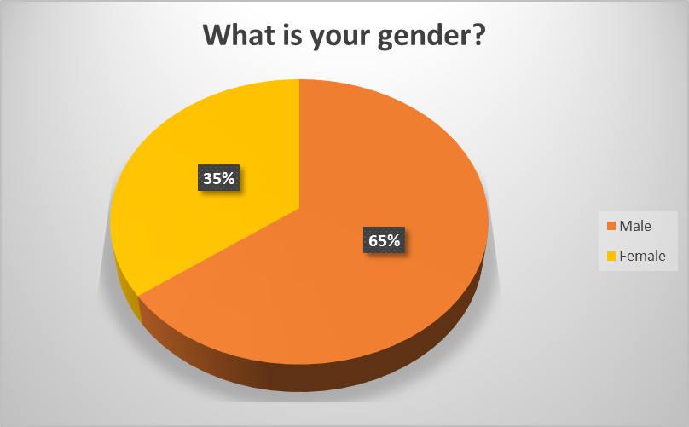
The researcher could approach to 35% female participants where there were 65% male participants among the 20 respondents.
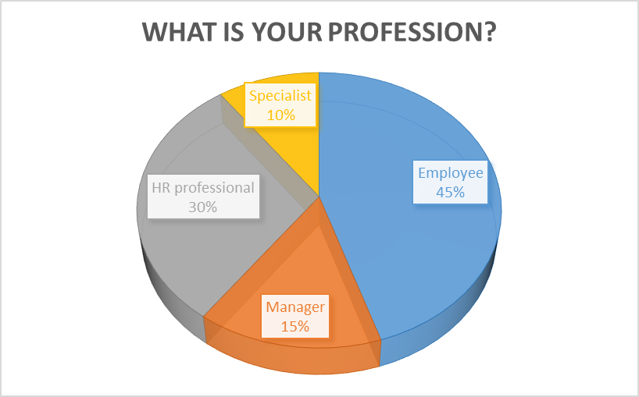
A varied profession was identified among respondents who were employees, managers, HR professionals, etc. A large number of respondents were employee comprising of 45% and other 30% were HR professional.

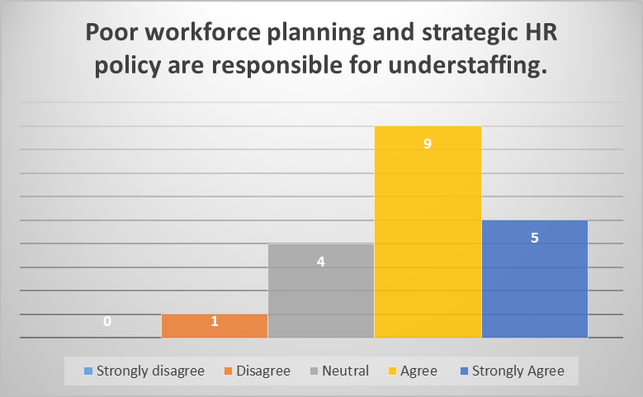
About 70% respondents agreed to the statement that Poor workforce planning and strategic HR policy are responsible for understaffing. 20% of the respondents remained neutral in the survey period.
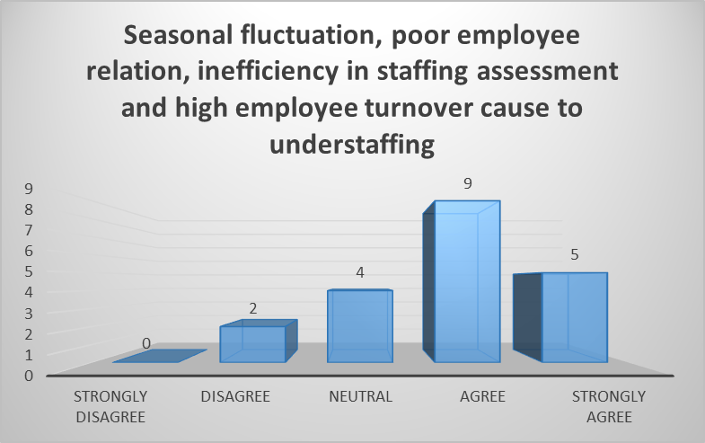
In response to the question, 70% respondents replied that Seasonal fluctuation, poor employee relation, inefficiency in staffing assessment and high employee turnover cause to understaffing.
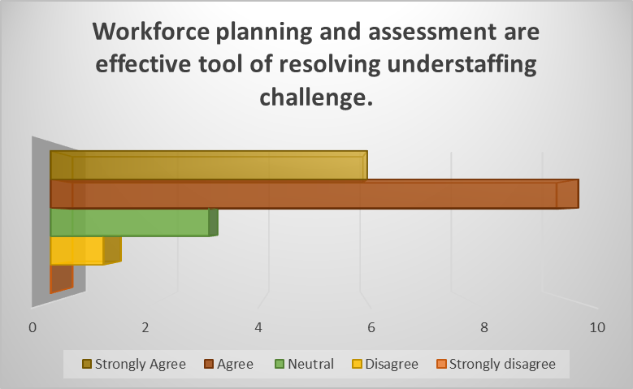
The researcher asked a question regarding the wayout of resolving understaffing challenge where the possible solutions were identified from secondary source analysis. This question was designed highlighing two possible strategies for overcoming challenge where respondents replied positively. About 80% respondents agreed that Workforce planning and assessment are effective tool of resolving understaffing challenge.

This question was designed focusing on two useful strategy for resolving challenge of understaffing where these solutions were found by various specialists. In response, 65% respondents agreed that Contractual recruitment and motivation can be used for resolving challenge of understaffing. On the other hand, 25% respondents remained neutral in sharing their response with the researcher.

This question focus on the impact of understaffing on organisational performance where the researcher included two major impacts on organisation. From the analysis it is found that 85% of the respondents replied positively. They stated that Understaffing reduces employee productivity and organisational performance.
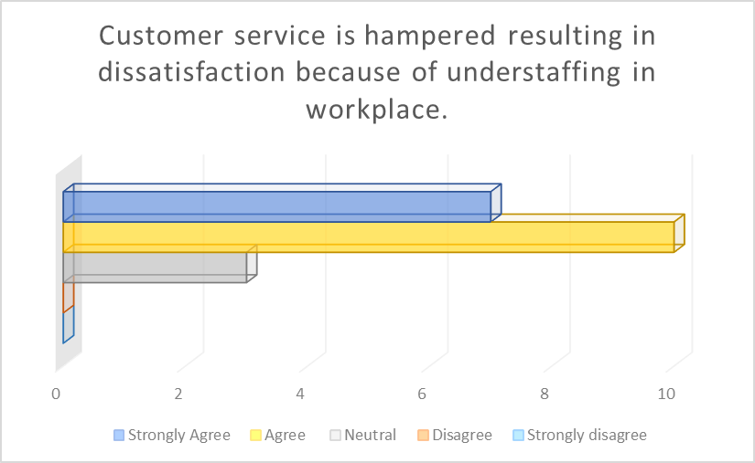
It was found understaffing can cause to poor customer service where customers can become dissatisfied customers. This finding was evaluated by the researcher in survey. About 85% respondents agreed to the statement that Customer service is hampered resulting in dissatisfaction because of understaffing in workplace.
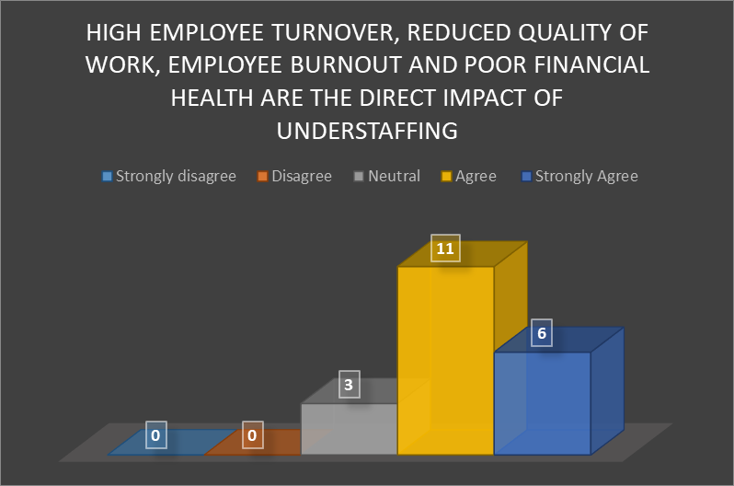
Some direct effects of understaffing were identifed by researcher in secondary sources analysis. In this context, the researhcer evaluated those with the survey among respondents. In response, 85% respondents agreed with the statement that High employee turnover, reduced quality of work, employee burnout and poor financial health are the direct impact of understaffing.
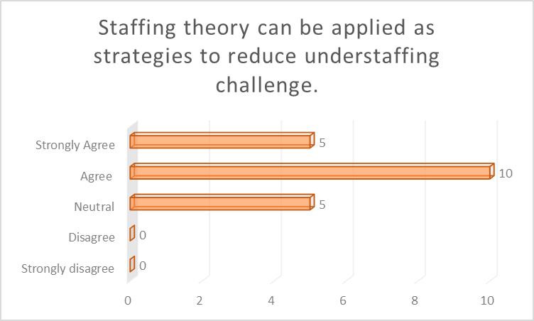
The researcher proposed a theory that can be implemented in the management of human resource. Staffing theory can be applied for identifing right requirement of staff and recruitment policy for avoiding the challenge of understaffing. In this context, most of the respondents agreed to the statement where about 75% respondents replied positively.
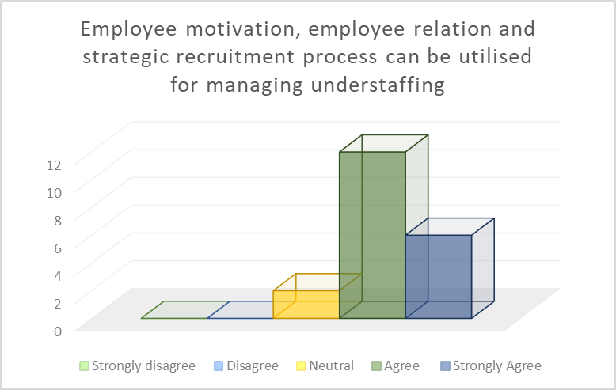
Employee motivation can be crucial strategy of retaining employees and supporting in the period of extensive work hour. Moreover, the management of an organisation needs to maintain strategic recruitment process to overcome understaffing and to plan for balanced recruitment. 90% respondents replied positively that Employee motivation, employee relation and strategic recruitment process can be utilised for managing understaffing. This can be stated that these strategies create positive change in organisation and human resource management for the ideal situation of employment.
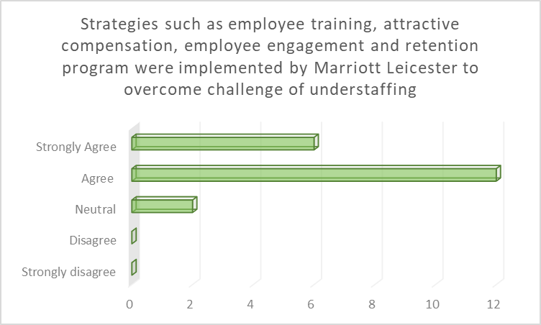
The management of Marriott Leicester adopted various strategies for overcoming the challenge of understaffing where those strategies were found appropriate and impactful. These strategies were implemented in workplace to manage understaffing and to recruit more for balancing the gap. In this context, respondents where found positive to this statement where 90% respondents agreed that Strategies such as employee training, attractive compensation, employee engagement and retention program were implemented by Marriott Leicester to overcome challenge of understaffing
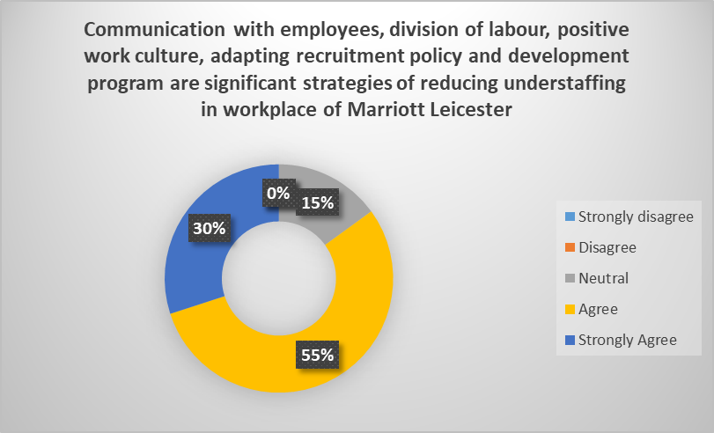
Researcher proposed some strategies that were applied in the process of reducing understaffing in the workplace of Marriott Leiceseter. Strategies include communication, division of labour, positive work cutlure, etc. could be effective tools for the situation. The research prepared a question highlighting all these proposed strategy for the improvement of service. In response, 85% agreed that Communication with employees, division of labour, positive work culture, adapting recruitment policy and development program are significant strategies of reducing understaffing in workplace of Marriott Leicester.

Qualitative analysis
How is understaffing and its causes explained in the context of human resource management?
According to (Mukherjee and Yadav, 2020), understaffing in human resource management is a situation when there are found a fewer employees than requirement. On the other hand, Jackson, Schuler and Werner (2018) explained that the situation of employees suffering with over workload refers to understaffing. In such situation, employers don’t find enough employees for performing business activities to achieve goals. There are found different causes to understaffing in the context of human resource management. In this context, Mello (2015) cited that poor human resource planning is a crucial reason of understaffing where the management can’t develop planning of requirement of employees for available job position. On the other hand, Pandey, Gajjar and Shah (2021) stated that absence of staffing theory and workforce planning generates understaffing issue where the organisation doesn’t plan for right human resource for the organisational function. From the analysis of Stone et al., (2015), various causes of understaffing include poor working condition, high employee turnover, sudden business growth and seasonal fluctuation creating the situation for the organisation where the management finds some employees for a large amount of work. On the other hand, Tucker (2022) cited that an organisation having improper employee relation and motivation plan experiences challenge of understaffing. In another context, poor retention strategy for organisation is another major cause to understaffing in workplace.
How does HR management address and resolve understaffing to overcome challenge of understaffing in organisations of tourism and hospitality industry?
The researcher has observed that business leaders need to address understaffing promptly for overcoming challenge of business loss and reduced performance. Weiss and Hoegl (2016) cited that sudden understaffing should be addressed with the process of contractual recruitment where this can support in meeting prompt need for the organisation. On the other hand, Pandey, Gajjar, and Shah (2021) reported that HR department needs to develop strategic workforce planning for assessing staffing requirement and effective recruitment process. According to Phillips (2023), staffing theory is found effective strategy of identifying human resource requirement, adaptive recruitment policy and employee relation for managing the situation of understaffing in workplace. This theory is applied for analysing issues of understaffing and overstaffing where it provides an insight of changes, impact and solution of the issue to management for making effective decision. Ogumeyo and Ekeh (2023) reported that organisations in tourism and hospitality industry need to adopt prompt action for managing situation where this can lead to poor customer service and high customer dissatisfaction. In this context, Sparkman (2018) cited that a strong communication with employees can support in understanding their needs which leads to strategic human resource management for avoiding such incidence. From the analysis of Stone et al. (2015), technology can be a significant tool for resolving challenge of understaffing where digital technology can be integrated with human resource process for developing system to automatic human resource management. Ratna et al. (2024) cited that strategic development, offering development opportunities of employees and prioritisation of work are deployed for resolving understaffing in the organisations of tourism and hospitality industry for overcoming challenges.
How does understaffing impact on organisational performance of Mariott Leicester hotel?
Understaffing can create manifolds impact on organisation and its performance. Jackson, Schuler and Werner (2018) cited that reduction of employee morale is a direct impact of understaffing. On the other hand, Heyes and Tomlinson (2021) reduced productivity of employee and organisational performance are the major impact of understaffing where organisations can manage activities with limited number of employees. In addition, the loss of efficiency among employees is another effect of understaffing. According to Hudson and Shen (2015), high employee turnover is the result of understaffing where employees can’t cope up with the increased workload in workplace. Employee dissatisfaction and switching job are found as common issues from the understaffing where employees get disappointed with the stress and work pressure in workplace. In another context, Ekwoaba, Ikeije and Ufoma (2015) reported that customer satisfaction is greatly decreased among the customers who experience delayed response and poor quality of service from the organisation having understaffing issue. From the analysis of Dessler (2020), it is found that organisation often finds degradation of employer brand image because of understaffing challenge where employees switch to other organisations over dissatisfaction. Eventually, organisations incur financial loss because of understaffing where reduced customer satisfaction and employee productivity lead to poor organisational performance. AlAli (2020) reported that understaffing creates great impact on employee health where employees face work stress and high absenteeism due to working in such undesirable workplace. The analysis of Boxall and Purcell (2022) reports that an organisation experiences loss in brand image, customer share, financial health, productivity, skilled employee turnover, etc. for the availability of understaffing in workplace.
What are the strategies taken by HRM of Marriott Leicester hotel in resolving challenges of understaffing?
From the analysis of secondary sources, the researcher has identified that human resource department applied employee training and attractive compensation program for managing understaffing. In this context, Hudson and Shen (2018) stated that employee training offers career development opportunity where employees gets satisfied with the employer. There is also found the implementation of employee engagement strategy by the management for overcoming the challenge. The researcher also identified that management of Marriott Leicester have implemented effective retention strategy for recruiting and retaining skilled employees for the organisation. According to Boxall and Purcell (2022), retention strategy is effective for assessing human resource requirement, selecting appropriate and right employees for the right job position and retaining them with proper management and opportunity. The management of Marriott Leicester was also found enhanced communication with employees for understanding their needs and feedback where this restored a way of designing effective employee strategy. There was also found the importance of labour division which was applied by the management of prioritising work among the available employees to lessen their work load. Following the situation of understaffing, the management of Marriott Leicester has been creating an optimum work culture for the employees who are in charge of developing the business. From the analysis of Jansson et al. (2020), a strategic and adaptive recruitment policy can be impactful for the management of understaffing where this ensures the need of staffing for the workplace. In another context, MacKenzie Jr (2018) highlighted the importance of technology integration for designing HR system to automate management of employees in organisation to overcome challenge of understaffing. However, the analysis of Mutua (2019) reports that the organisation can design and implement staffing theory for overcoming challenge of understaffing and overstaffing to boost organisational performance.

Conclusion and recommendations

Conclusion
The researcher conducted this study for identifying issues of understaffing in human resource management where an organisation facing such situation finds not enough employees for performing organisational activities. In this context, this research project was conducted in the light of Marriott Leicester for evaluating its situation and strategies of overcoming the challenge. At the outset, the researcher prepared an introduction giving background of the researcher issue, designing research aim and some objectives of the research project where research questions were devised to find out solution and achievement of selected issue. After that, the researcher developed a literature review that has created an understanding and insight of the selected research issue. In the section, the researcher analysed different perspective of research issue considering human resource management and practice in the tourism and hospitality industry. A methodology was developed to guide researcher in a structure way to complete research project where the researcher applied positivism research philosophy. Mixed research method including both quantitative and qualitative research method was applied for this study where this method supported properly to the researcher in achieving research objectives. From the analysis, the researcher identified that more than 70% respondents agreed that understaffing can reduce productivity, efficiency, financial health, brand image, and high employee turnover for Marriott Leicester. More than 75% respondents reported that the management of this organisation was capable of managing challenge of understaffing through effective employee communication, retention strategy, strategic workforce planning and employee engagement in business operation. From the secondary source analysis, the researcher can conclude that an organisation hospitality and tourism industry needs to adopt strategies such as workforce planning, effective selection and recruitment policy, employee relation, motivation and proper assessment for overcoming challenge of understaffing that can create high customer dissatisfaction, turnover of skilled employees, inefficiency, reduced productivity, damage to brand image, etc.

Recommendation
Following analysis and findings, the researcher has proposed some recommendations below to overcome challenge of understaffing and to develop effective human resource policy:
- Staffing theory should be deployed in workplace to manage overstaffing and understaffing. With this theory, the management can design effective HR policy to assessing right staffing requirement, selection and recruitment, employee relation, management of employees, retention policy, etc. to management strategic human resource in workplace of Marriott Leicester.
- The management can operate effective retention strategy for managing employees where this supports in designing strategy for selecting right employees for right position. Moreover, this guides in developing employees’ career development opportunity, motivation, retaining skilled employees, employee relation for retaining skilled employees.
- As communication with employees, division of labour, positive work culture, adapting recruitment policy and development program are significant strategies for managing understaffing challenge, the management of this organisation should enhance the practice of these strategies.
- Sudden situation of understaffing due to seasonal fluctuation and increased business should be addressed with contractual recruitment where gap of employees will be fulfilled with the short notice recruitment of contract employees.
- A bridge between policy leaders and human resource department should be tied for communicating information and reviews. This bridge will assist in planning for future employee requirement and process of selection and recruitment of employees.
- An internal analysis should be conducted for analysing workloads, comparing staffing to benchmark and monitoring employee feedback for assessing the business requirement of human resource for the organisation. The result of such researcher will be communicated with top management for developing effective human resource planning.
- The management of Marriott Leicester should integrated technologies with human resource management for developing system of digital HR. With the digital tools such as AI, HR system, tracking, performance review, employee feedback, employee database, etc. the organisation can monitor supply of employees to organisational function and gap in the workplace to fulfil quickly.
- A good work environment is necessary for employees to work with dedication where this organisation should nurture an optimum workplace for its employees. In this context, it needs to develop proper employee relation, motivation, development program, compensation, prioritising work, division of labour efficiently to design a healthy work environment for reducing understaffing in workplace.
- HR policy should be designed in a way that supports in developing a pipeline of employee recruitment where a periodical recruitment process needs to be established. In this context, the human resource managers will prepare yearly requirement plan for human resource where this will be implemented by the management.

References
- Amadhila, O., 2022. Examining the effects of understaffing on employee performance at the Forensic Pathology Division, Namibia Police Force (Doctoral dissertation, University of Namibia).
- Aragon-Correa, J.A., Martin-Tapia, I. and de la Torre-Ruiz, J., 2015. Sustainability issues and hospitality and tourism firms’ strategies: Analytical review and future directions. International Journal of Contemporary Hospitality Management, 27(3), pp.498-522.
- Ali, A., Rasoolimanesh, S.M. and Cobanoglu, C., 2020. Technology in tourism and hospitality to achieve sustainable development goals (SDGs). Journal of Hospitality and Tourism Technology, 11(2), pp.177-181.
- AlAli, M.S., 2020. Staffing Level, Wages and Banks Financial Performance. International Research Journal of Finance and Economics, 180, pp.48-53.
- Abdiyev, A.C. and Alimardonov, A.A., 2022. Personnel Management in the field of Tourism. Scientific progress, 3(2), pp.495-501.
- Baum, T., 2018. Sustainable human resource management as a driver in tourism policy and planning: a serious sin of omission?. Journal of Sustainable Tourism, 26(6), pp.873-889.
- Baum, T. ed., 2016. Human resource issues in international tourism. Elsevier.
- Boxall, P. and Purcell, J., 2022. Strategy and human resource management. Bloomsbury Publishing.

- Belias, D., Trivellas, P., Koustelios, A., Serdaris, P., Varsanis, K. and Grigoriou, I., 2017. Human resource management, strategic leadership development and the Greek tourism sector. In Tourism, Culture and Heritage in a Smart Economy: Third International Conference IACuDiT, Athens 2016 (pp. 189-205). Springer International Publishing.

- Cascio, W.F., 2015. Managing human resources. New York, NY, USA:: McGraw-Hill.
- DeCenzo, D.A., Robbins, S.P. and Verhulst, S.L., 2016. Fundamentals of human resource management. John Wiley & Sons.

- Dessler, G., 2020. Fundamentals of human resource management. Pearson.

- Dvouletý, O., 2023. Underemployment and overemployment in Central Europe. Economics and Business Letters, 12(2), pp.147-156.

- David, N. and Jane, B., 2019. Business in Context: An Introduction to Business an its Environment. Cengage Learning, Inc.

- Daniels, J.D., Radebaugh, L.H. and Sullivan, D.P., 2019. International business: Environments and operations. Pearson.

- Devi, P.S., 2017. Research methodology: A handbook for beginners. Notion Press.

- Daniels, J.D., Radebaugh, L.H. and Sullivan, D.P., 2019. International business: Environments and operations. Pearson.

- De Moortel, D., Dragano, N., Vanroelen, C. and Wahrendorf, M., 2018. Underemployment, overemployment and deterioration of mental health: the role of job rewards. International archives of occupational and environmental health, 91, pp.1031-1039.

- Ekwoaba, J.O., Ikeije, U.U. and Ufoma, N., 2015. The Impact of Recruitment and Selection Criteria on Organizational Performance.

- Edgell Sr, D.L., 2019. Managing sustainable tourism: A legacy for the future. Routledge.

- Ebert, R.J. and Griffin, R.W., 2020. Business essentials. Pearson.

- Flick, U., 2015. Introducing research methodology: A beginner's guide to doing a research project. Sage.

- Gupta, A. and Gupta, N., 2022. Research methodology. SBPD publications.

- Grant, R.M., 2024. Contemporary strategy analysis. John Wiley & Sons.

- Giousmpasoglou, C. and Marinakou, E., 2024. Human Resources Management in Hotels. In The Contemporary Hotel Industry: A People Management Perspective (pp. 129-158). Cham: Springer International Publishing.

- Hudson, C.K. and Shen, W., 2018. Consequences of work group manpower and expertise understaffing: A multilevel approach. Journal of Occupational Health Psychology, 23(1), p.85.
- Hudson, C.K. and Shen, W., 2015. Understaffing: An under-researched phenomenon. Organizational Psychology Review, 5(3), pp.244-263.
- Heyes, J. and Tomlinson, M., 2021. Underemployment and well-being in Europe. Human Relations, 74(8), pp.1240-1266.
- Heneman, H.G., Judge, T.A. and Kammeyer-Mueller, J.D., 2019. Staffing organizations. McGraw-Hill.

- He, F., Chaussalet, T. and Qu, R., 2019. Controlling understaffing with conditional Value-at-Risk constraint for an integrated nurse scheduling problem under patient demand uncertainty. Operations Research Perspectives, 6, p.100119.

- Higgins-Desbiolles, F., 2018. Sustainable tourism: Sustaining tourism or something more?. Tourism management perspectives, 25, pp.157-160.

- Hecklau, F., Galeitzke, M., Flachs, S. and Kohl, H., 2016. Holistic approach for human resource management in Industry 4.0. Procedia cirp, 54, pp.1-6.
- Jansson, M., Ohtonen, P., Syrjälä, H. and Ala‐Kokko, T., 2020. The proportion of understaffing and increased nursing workload are associated with multiple organ failure: A cross‐sectional study. Journal of advanced nursing, 76(8), pp.2113-2124.
- Jackson, S.E., Schuler, R.S. and Werner, S., 2018. Managing human resources. Oxford University Press.
- Kumari, S.K.V., Lavanya, K., Vidhya, V., Premila, G.A.D.J.S. and Lawrence, B., 2023. Research methodology (Vol. 1). Darshan Publishers.
- Kotler, P., Bowen, J.T., Makens, J.C. and Baloglu, S., 2017. Marketing for hospitality and tourism. Pearson.

- MacKenzie Jr, W.I., 2018. Human capital: The importance of staffing levels. University of South Carolina.

- Mukherjee, A.S. and Yadav, P., 2020. Impact of Recruitment and Selection Process on Employee's Job Satisfaction in Samsung. Amity Management Review, 9.

- Marriott, M. (2025) Marriott Bonvoy Hotels: Book directly & get exclusive rates, Marriott Bonvoy Hotels | Book Directly & Get Exclusive Rates. Available at: https://www.marriott.com/ (Accessed: 13 February 2025).
- Mukherjee, S.P., 2019. A guide to research methodology: An overview of research problems, tasks and methods. CRC Press.

- Mishra, S.B. and Alok, S., 2022. Handbook of research methodology.

- Mani, V., Kesavan, S. and Swaminathan, J.M., 2015. Estimating the impact of understaffing on sales and profitability in retail stores. Production and Operations Management, 24(2), pp.201-218.

- Mello, J.A., 2015. Strategic human resource management. Cengage Learning.

- Mutua, A.M., 2019. The Impact Of Human Resource Planning On Organizational Performance (Doctoral dissertation, University of Nairobi).
- Nasirian, A., Abbasi, B., Cheng, T.C.E. and Arashpour, M., 2022. Multiskilled workforce planning: a case from the construction industry. Journal of Construction Engineering and Management, 148(5), p.04022021.
- Noe, R.A., Hollenbeck, J.R., Gerhart, B. and Wright, P.M., 2020. Fundamentals of human resource management. McGraw-Hill.
- Narayanan, A., Rajithakumar, S. and Menon, M., 2019. Talent management and employee retention: An integrative research framework. Human Resource Development Review, 18(2), pp.228-247.

- Ogumeyo, S.A. and Ekeh, K.I., 2023. Effect of understaffing and overstaffing constraints on recruitment and wastage manpower planning model. Dutse Journal of Pure and Applied Sciences, 9(3a), pp.10-18.

- Ohnos, T., 2021. Taiichi Ohnos Workplace Management. McGraw-Hill Education.
- Otterbach, S., Charlwood, A., Fok, Y.K. and Wooden, M., 2021. Working-time regulation, long hours working, overemployment and mental health. The International Journal of Human Resource Management, 32(22), pp.4659-4686.

- Pandey, P., Gajjar, H. and Shah, B.J., 2021. Determining optimal workforce size and schedule at the retail store considering overstaffing and understaffing costs. Computers & Industrial Engineering, 161, p.107656.

- Prajogo, D.I., 2016. The strategic fit between innovation strategies and business environment in delivering business performance. International journal of production Economics, 171, pp.241-249.

- Phillips, J.M., 2023. Strategic staffing. SAGE Publications.
- Pandey, P. and Pandey, M.M., 2015. Research methodology: Tools and techniques.
- Reuters, R. (2025) Reuters Reuters | Breaking International News & Views. Available at: https://www.reuters.com/ (Accessed: 13 February 2025).
- Rossides, N., 2022. Engaging the workforce: the grand management challenge of the 21st century. Routledge.
- Ratna, S., Saide, S., Putri, A.M., Indrajit, R.E. and Muwardi, D., 2024. Digital transformation in tourism and hospitality industry: a literature review of blockchain, financial technology, and knowledge management. EuroMed Journal of Business, 19(1), pp.84-112.

- Stone, R.J., Cox, A., Gavin, M. and Carpini, J., 2024. Human resource management. John Wiley & Sons.

- Shen, W., Chang, K., Cheng, K.T. and Kim, K.Y., 2019. What to do and what works? Exploring how work groups cope with understaffing. Journal of occupational health psychology, 24(3), p.346.

- Sudha, A.G. and Peterkumar, F.J., 2021. Effective workforce management using HR analytics. International Research Journal on Advanced Science Hub, 3(6S), pp.82-86.
- Sparkman, R., 2018. Strategic workforce planning: Developing optimized talent strategies for future growth. Kogan Page Publishers.
- Statista - the statistics portal for market data, market research and market studies (2025) Statista. Available at: https://www.statista.com/ (Accessed: 13 February 2025).
- Shenkar, O., Luo, Y. and Chi, T., 2021. International business. Routledge
- Singh, D., 2019. A literature review on employee retention with focus on recent trends. International Journal of Scientific Research in Science and Technology, 6 (1), 425, 431.

- Snell, S. and Morris, S., 2019. Managing human resources. Cengage Learning.
- Stone, D.L., Deadrick, D.L., Lukaszewski, K.M. and Johnson, R., 2015. The influence of technology on the future of human resource management. Human resource management review, 25(2), pp.216-231.
- The Conversation, T.C. (2025) In-depth analysis, research, news and ideas from leading academics and researchers., The Conversation. Available at: https://theconversation.com/global (Accessed: 13 February 2025).
- The Guardian, T.G. (2025) The Guardian. Available at: https://www.theguardian.com/international (Accessed: 13 February 2025).
- Tucker, E., 2022. Strategic workforce planning: from closing skills gaps to optimizing talent. Strategic HR Review, 21(1), pp.14-19.
- Vergara, S., Del Villar, J., Masson, J., Pérez, N., Henao, C.A. and González, V.I., 2020, December. Impact of labor productivity and multiskilling on staff management: A retail industry case. In International Conference of Production Research–Americas (pp. 223-237). Cham: Springer International Publishing.
- Vance, C. and Paik, Y., 2015. Managing a global workforce. Routledge.

- Wei, N., Wang, Z., Li, X., Zhang, Y., Zhang, J., Huang, Z. and Wang, X., 2024. Improved staffing policies and practices in healthcare based on a conceptual model. Frontiers in Public Health, 12, p.1431017.
- Wendsche, J., Hacker, W. and Wegge, J., 2017. Understaffing and registered nurses’ turnover: The moderating role of regular rest breaks. German Journal of Human Resource Management, 31(3), pp.238-259.
- Weiss, M. and Hoegl, M., 2016. Effects of relative team size on teams with innovative tasks: An understaffing theory perspective. Organizational Psychology Review, 6(4), pp.324-351.
- Wild, J.J. and Wild, K.L., 2019. International business: The challenges of globalization. Pearson.

Appendix
Research Questionnaire
What is your gender?
- Male
- Female
What is your profession?
- Employee
- Manager
- HR professional
- Specialist
Poor workforce planning and strategic HR policy are responsible for understaffing.
- Strongly disagree
- Disagree
- Neutral
- Agree
- Strongly agree
Seasonal fluctuation, poor employee relation, inefficiency in staffing assessment and high employee turnover cause to understaffing.
- Strongly disagree
- Disagree
- Neutral
- Agree
- Strongly agree
Workforce planning and assessment are effective tool of resolving understaffing challenge.
- Strongly disagree
- Disagree
- Neutral
- Agree
- Strongly agree
Contractual recruitment and motivation can be used for resolving challenge of understaffing.
- Strongly disagree
- Disagree
- Neutral
- Agree
- Strongly agree
Understaffing reduces employee productivity and organisational performance.
- Strongly disagree
- Disagree
- Neutral
- Agree
- Strongly agree
Customer service is hampered resulting in dissatisfaction because of understaffing in workplace.
- Strongly disagree
- Disagree
- Neutral
- Agree
- Strongly agree
High employee turnover, reduced quality of work, employee burnout and poor financial health are the direct impact of understaffing.
- Strongly disagree
- Disagree
- Neutral
- Agree
- Strongly agree
Staffing theory can be applied as strategies to reduce understaffing challenge.
- Strongly disagree
- Disagree
- Neutral
- Agree
- Strongly agree
Employee motivation, employee relation and strategic recruitment process can be utilised for managing understaffing.
- Strongly disagree
- Disagree
- Neutral
- Agree
- Strongly agree
Strategies such as employee training, attractive compensation, employee engagement and retention program were implemented by Marriott Leicester to overcome challenge of understaffing.
- Strongly disagree
- Disagree
- Neutral
- Agree
- Strongly agree
Communication with employees, division of labour, positive work culture, adapting recruitment policy and development program are significant strategies of reducing understaffing in workplace of Marriott Leicester.
- Strongly disagree
- Disagree
- Neutral
- Agree
- Strongly agree

