University of Wales Trinity Saint David London
Programme: BSc Cloud Computing
Module: ACCC5001 DATABASE MANAGEMENT SYSTEMS
Name: Celdwan Bandeira
ID:1812407

Table of Contents

Abstract 3
Introduction 3
Section I – Database Case Study 4
Tables Entities and Attributes 4
Advantages of a distributed DBMS solution. 6
REFERENCE LIST 8

Abstract

In a distributed database system, the data are stored on several computers (nodes), in Pet Care Case Study database of several branches are located in different regions and the system allow each branch to store data and access them through communication network.

Introduction

This is the database report of Pet Care, an animal clinic that is implementing a Database Management System (DBMS) server for recording daily and essential business activities, such as recording customer details, their pets, types of treatment offered and payments made during the clinic visits. The clinic’s activities are developed at various branches, located in different regions and connected by a database network, which will allow a greater and dynamic in their activities.
The project was run through SQL Server Management Studio, the essential tool for developing a database.
In a database the computer system may keep or store large quantity of data organized in a manner that enable efficient storage and manipulation.

Section I – Database Case Study

Tables Entities and Attributes
As mentioned above, the Pet Care clinic database design was developed by SSMS as follows: Initially tables were created, where each table corresponds to an entity that in turn has attributes that represent columns of each table.
According to Burroughs et al. (2011), the most prevalent database model is known as a relational database. In a relational database the data are organized in tables, also referred to as relations. Each data element in a table is indexed by its row and column in the table. Each row, also known as a tuple, represents an entity that is useful or meaningful to the business or other database user, and each column in that row refers to a data element that defines a characteristic or attribute of that entity.

Figure 1: Structure of the tables
(Source: Developed in SQL Server Management Studio)

To explain the relationship between primary key represented as (PK) and foreign key (FK), primary key is a column in a table that uniquely identifies each record in the table. A foreign key is a column in the same table or in another table that maps to the primary key to form a relationship in or between the tables (Figure 2). The relationship between the primary key and the foreign key is referred as a “primary key – foreign key relationship”. The primary key – foreign key relationship helps in fetching records queried by a user of the database quickly without having to access numerous tables in an enterprise, thereby saving time and effort.
As per Goyal et al. (2019) the relationship between primary key and foreign key allows determination of data flow in a schema whenever any form of perturbation, insertion, or deletion occurs to any record in the database.

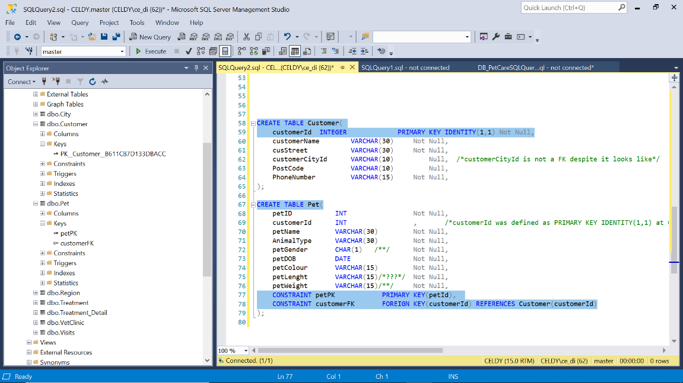
Figure 2: Primary and Foreign Keys relationship
(Source: Developed in SQL Server Management Studio)

Advantages of a distributed DBMS solution.
For the Pet Care, deploying the DBMS in their role will bring advantages as:
Rapid access to data - End users usually work with only a subset of company data, stored locally;

Faster data processing - A DBMS divides the system's workload, processing data in several locations;

Reduced operating costs - From a cost perspective, it is more efficient to add workstations to a network than to upgrade a mainframe system. Development work is done more quickly and cheaply on low-cost PCs than on mainframes;

Expansion facility - It is possible to add new locations to the network without affecting the operations of other locations;

User-friendly interface - PCs and workstations are often equipped with an easy-to-use graphical user interface;

Improvement of communications - As the local sites are smaller and closer to customers, they promote better communication between departments and between customers and the company's team;

Processor independence - The end user can access several available copies of the data and their requests are processed by any processor at the data location.

According to Alkhatib et al. (2020), the performance of the system will improve, since several machines take care of distributing the load of the CPU and the I/O. Also, the expansion of the distributed system is relatively easy, since adding a new location doesn’t affect the existing ones.

There are different ways to implement a DBMS, and the companies interested in developing this technology to evaluate the best solution, always taking into consideration the cost / benefit, without leaving aside the questions related to security, availability, confidentiality, integrity, transparency.

REFERENCE LIST

Key words: foreign key and primary key pdf
1- Burroughs, T.K., Gansemer, S.J., Lee, W.D., Voldal, E.E., Rogers, C.A. and Zaborowski, L.J., International Business Machines Corp, 1999. Schema mapping to a legacy table with primary and foreign key support. U.S. Patent 5,956,725, pp.19-28.

2- Goyal, R.D. and Mahajan, R., Io-Tahoe LLC, 2019. Inclusion Dependency Determination In A Large Database For Establishing Primary Key-Foreign Key Relationships. U.S. Patent Application 15/673,511, pp.30-56.

3- Alkhatib, G. and Labban, R.S., 2020. Transaction Management in Distributed Database Systems: the case of Oracle’s Two-phase commit. Journal of Information Systems Education, 13(2), p.4, pp.2-11.

w3schools.com (2020). SQL like. Available at:
https://www.w3schools.com/sql/default.asp [Accessed on: 06 May 2020].

