

BA (Hons) Computer Games Design Independent Project

Is Game Design a Suitable Tool for Preserving History and Historical Sites

Philip Richmond (2212266)
2212266@student.uwtsd.ac.uk

Supervisor Adam Head
Project submitted as part of the requirements for the award of
BA Computer Games Design
Date 01/05/2026
Contents
Table of Figures 4
Declaration 5
Form of Consent 5
Abstract 6
Key Terms. Definitions and Abbreviations 7
Introduction 8
Background to Digital Heritage 8
Personal Motivation and Selection of HMS Victory 8
The Research Problem 8
Research Question, Aim and Objectives 9
Scope and Limitations 9
Structure of the Dissertation 9
Literature Review 10
Critical Gaming: Interactive History and Virtual Heritage 2024 10
Chapter 4: Game Base History and Historical Simulation 10
Playing with the Past: Digital Games and the Simulation of History 2013 13
Chapter 14: History Veneers: Anachronism, Simulation, and Art History in Assassin’s Creed II 13
Virtual Heritage A Guide Edited by Erik Malcolm Champion 2021 15
Chapter 6: Video Games as Concepts and Experiences of the past 15
Literature Review Conclusion 17
Case Studies 19
Video Game: Assassin’s Creed Unity 2014 Unity Ubisoft Montreal 19
Video Game: Kingdom Come Deliverance 2018 CryEngine / Autodesk 3ds Max 21
Connection to the HMS Victory Project 22
Video game: The Oregon Trail 1971 23
Teaching Methods and the Role of Immersive Technology 26
Methodology and Project Planning 28
Methodology 28
Project Planning / Gantt Chart 30
Testing 32
Analysis of Testing Results and Iterative Development 32
Comparison Between Test 1 and Test 2 34
Key Findings 34
What Was Learned 34
Final Findings 35
Conclusion 37
Evaluation 38
What Went Well 38
What Could Be Improved 38
What Was Learned 38
References 40
Bibliography 43
Appendices 45
Appendix A 45
SMART Objectives 45
Appendix B 46
Appendix C 46

Table of Figures
Figure 1 Screenshot from Sid Meier’s Civilization VI showing a historical strategy simulation of political, technological, and territorial development. [8] 11
Figure 2 Screenshot of the nearly completed digital reconstruction of the HMS Victory middle gun deck created in Unreal Engine. The environment allows users to explore the layout and spatial organisation of the historical ship interior. 12
Figure 3 Example of Renaissance Florence as represented in Assassin's Creed II. The game recreates historical architecture and urban environments that allow players to explore and interact with a simulated historical city. [16] 13
Figure 4 Example of historical architecture recreated in Assassin's Creed: Brotherhood. The game includes detailed recreations of landmarks such as the Pantheon in Rome, allowing players to explore simulated historical environments based on real architectural sites. [24] 16
Figure 5 Examples of historical landmarks recreated in the video game Minecraft, including a Maya Pyramid temple, like those found at Chichen Itza, as well as reconstructions of Stonehenge, Arc de Triomphe, Tower Bridge, and Brandenburg Gate. These examples demonstrate how players use game environments to recreate and explore historical architecture. [26] 16
Figure 6 Video Game VS Reality [29] 19
Figure 7 A Notre Dame cross section made from Andrew Tallon's scans [31] 20
Figure 8 Kingdom Come Deliverance 2 Game vs reality [36] 22
Figure 9 Kingdom Come Deliverance 2 Game vs reality [36] 22
Figure 10 To play the original version of Oregon Trail, users connected to an HP 2100 minicomputer with a teletype machine. [37] 23
Figure 11 Screenshot from the original text-based version of The Oregon Trail (1971), personally tested to analyse how historical records were translated into rule-based gameplay mechanics. [38] 24
Figure 12 HV 1st Phase Block out walkthrough 28
Figure 13 Desktop HV 2nd Phase Walkthrough 29
Figure 14 HV 3rd Phase VR Walkthrough 29
Figure 15 Gantt Chart 30
Figure 16 1ST Phase Block out walkthrough test results 32
Figure 17 shows some of the second walkthrough questionnaire results, including the Likert scale responses and feedback on cohesion and historical appropriateness. 33
Figure 18 shows most participants identified the space as a warship or pirate ship rather than specifically HMS Victory. This shows that stronger signage and historical context are needed to improve recognition 35

Declaration

I, Philip Richmond declare that I am the sole author of this Project; that all references cited have been consulted; that I have conducted all work of which this is a record, and that the finished work lies within the prescribed word limits.

This work has not previously been accepted as part of any other degree submission.

Date: 01/05/2026

Form of Consent

I, Philip Richmond hereby consent that my Project, submitted in candidature for the BA Computer Games Design degree, if successful, may be made available for inter-library loan or photocopying (subject to the law of copyright), and that the title and abstract may be made available to outside organisations.

Date: 01/05/2026

Abstract
This dissertation investigates whether game design can be used as an effective method for preserving history and historical sites, using HMS Victory as the main case study. Traditional museum learning often relies on display boards, guided tours, and written information, which can make it difficult for visitors to fully understand the size, layout, and function of historical spaces. This project explores whether interactive digital environments and Virtual Reality (VR) can offer a stronger and more engaging way to experience heritage.
The practical outcome was the creation of a historically informed 3D reconstruction of HMS Victory’s middle gun deck. The environment was produced using Autodesk Maya for asset creation, Adobe Substance 3D Painter for materials and surface detail, and Unreal Engine 5 for final environment building and interaction. A desktop walkthrough version and a VR version were both developed. The desktop version was used for formal user testing, while the VR version focused on immersion and interactive object information.
The research combines academic study of digital heritage, immersive learning, and historical simulation with practical case studies such as Assassin’s Creed Unity, Kingdom Come: Deliverance, and The Oregon Trail. These examples show how games can support public understanding of history by translating research into explorable spaces and interactive systems.
Testing was completed in two walkthrough stages using both qualitative and quantitative methods with Year 1 and Year 2 Games Design and Animation students. The desktop version was used for consistent controls and accessibility. The first test used paper-based questionnaires, while the second test used Microsoft Forms to collect responses. Both included open ended questions and Likert scale responses focused on scale, lighting, atmosphere, and historical recognition. Most participants were aged between 18 and 21, which created a limitation as their familiarity with 3D environments may have influenced their judgement compared to a general museum audience. Results showed that scale and spatial layout were successful from the early block-out stage, while lighting, atmosphere, and historical clarity needed further improvement. Feedback also showed that visual accuracy alone was not enough, and that users needed object information, interaction, and context to better understand the environment.
The final findings show that game design is a highly valuable tool for historical preservation and museum education. While it cannot replace the physical site itself, it significantly improves accessibility, engagement, and understanding by allowing users to actively explore historical spaces, interact with key objects, and experience scale and layout in ways that traditional museum displays alone cannot provide.

Key Terms. Definitions and Abbreviations
- Digital Heritage:
The use of digital technology to preserve and present historical sites and cultural information.
- Historical Simulation:
A digital representation of historical environments or events based on research and interpretation.
- Virtual Reality (VR):
A fully immersive digital environment experienced through a headset, placing the user inside the space.
- Augmented Reality (AR):
Digital elements placed into the real-world using devices such as smartphones or tablets.
- User Experience (UX):
How a user interacts with and experiences a system, including ease of use and engagement.
- Qualitative and Quantitative Data:
Qualitative data is descriptive user feedback, while quantitative data is numerical data such as ratings (e.g. Likert scale).
- Simulacrum:
A digital version or representation of a real historical place that looks authentic but is not an exact copy of the original.
- Anachronism:
Something placed in the wrong historical time-period such as architecture or objects from a later date appearing in an earlier setting.
- Constructivist Ideas:
A learning theory where users build knowledge through experience, interaction, and active participation rather than only receiving information passively.
- Past Play:
The way players engage with history through gameplay, where they experience historical themes, spaces, or events by interacting with them rather than only reading about them.
- Passive Teaching:
A traditional teaching method where learners mainly receive information through reading, listening, or observation without active participation or interaction
- HMS Victory = HV
- Game Design = GD

Introduction

Background to Digital Heritage
Cultural heritage preservation has traditionally relied on physical conservation,[1] archival documentation, and museum display. While these methods protect artefacts and historic sites, they inherently limit access to those who can physically attend in person. In recent years, digital technologies have increasingly been explored as alternative or supplementary preservation tools. This dissertation investigates whether game design (GD) is a suitable tool for preserving history and historical sites, using HMS Victory (HV) as a focused case study. Suitability is evaluated through historical accuracy, user engagement, accessibility, and how effectively the environment helps users understand the scale, layout, and function of the historical space. Specifically, it evaluates the development of a 3D interactive recreation of the ship’s middle gun deck and assesses its effectiveness as a digital heritage experience.

Personal Motivation and Selection of HMS Victory
The idea for this project emerged from a long-standing interest in maritime history and an awareness of the physical and interpretive limits of museum spaces. HV [2] represents a significant moment in British naval history, particularly through its role as Admiral Nelson’s flagship during the Battle of Trafalgar [3] and its connection to Britain’s long-term naval supremacy. Nelson’s victory at Trafalgar helped secure the safety of the British Isles from invasion and established British sea power for more than a century, reinforcing Victory’s importance as both a military and cultural symbol [4]. However, access to the ship is shaped by practical constraints such as narrow passageways, controlled visitor flow, restricted access areas, and interpretive reliance on signage. These limitations prompted consideration of whether interactive 3D reconstruction could extend access while maintaining historical integrity. The ship presents an ideal test case because it is both historically important and spatially complex, making it suitable for evaluating immersive reconstruction as a preservation method.

The Research Problem
Historic sites such as HV, located at Portsmouth Historic Dockyard, present broader accessibility challenges beyond physical space. Travel cost, geographical distance, mobility limitations, and conservation restrictions all affect who can meaningfully experience the site [5]. Traditional museum displays are useful, but they usually rely on information boards or guided tours. This can make it harder for visitors to fully understand the space or feel physically connected to it. GD, especially through interactive 3D environments and virtual reality (VR), offers a different approach. It allows people to move through reconstructed spaces, interact with objects, and experience the size and layout of a place in a way that static images or written descriptions cannot achieve

Research Question, Aim and Objectives
This research asks: Is GD a suitable way to preserve history and historic sites? To answer this, the project combines research into digital heritage and immersive learning with a practical case study. The practical work involves building a historically accurate 3D model of HV middle gun deck using industry standard software. The experience is mainly designed for desktop use, with the option to adapt it for virtual reality (VR). Interactive features, including a working cannon simulation, are included to explore whether people understand and engage with history more when they actively take part rather than simply observe.
This dissertation has three main objectives:
- Review research on digital heritage and immersive technology:
- Design and create a historically informed 3D environment;
- Evaluate whether GD can genuinely improve historical preservation and accessibility.

Scope and Limitations
The scope is intentionally limited to the middle gun deck rather than the entire ship. While a full reconstruction would provide greater historical coverage, it exceeds realistic time and technical constraints within an undergraduate research framework. Focusing on a defined section allows greater attention to historical reference, spatial accuracy, and interaction design while maintaining analytical depth.

Structure of the Dissertation
The following chapters explore relevant theory, outline the methodology, analyse the case study, and ultimately assess whether interactive game environments can function as credible tools for historical preservation.

Literature Review

Critical Gaming: Interactive History and Virtual Heritage 2024

Chapter 4: Game Base History and Historical Simulation
This section draws on the work of Erik Champion, whose research focuses on digital heritage and the use of interactive technologies to represent historical environments. His book Critical Gaming: Interactive History and Virtual Heritage are particularly relevant to this study because it explores how GD can be used to simulate historical systems and spaces. Champion’s work provides a theoretical foundation for understanding how interactive environments can support historical learning and engagement, which directly relates to the aims of this dissertation.
GD has increasingly been explored as a method for presenting and understanding historical events. Champion argues that digital games allow players to interact with historical systems rather than simply read about them, creating a more active form of learning [6]. This approach helps players explore how historical spaces, decisions, and social structures function instead of only observing them through text or static images. However, this method also has limitations. While interactivity can improve engagement, it can also lead to historical simplification if gameplay is prioritised over accuracy. Douglas N. Dow, in Playing with the Past: Digital Games and the Simulation of History, similarly argues that historical games often balance authenticity with playability, meaning some details are altered or removed to support player experience [14]. This creates an important connection to the next literature review section, where Dow’s analysis of Assassin’s Creed II explores how historical accuracy and gameplay design must work together when recreating real historical spaces.
Champion also suggests that history is often communicated in different ways depending on the audience. Academic history focuses on research and documented evidence, while public history is often experienced through museums, media, and cultural interpretation [6]. Digital games and simulations can help connect these two forms of history by presenting researched historical ideas through interactive game systems.
However, Champion notes that historical games should not be seen purely as entertainment. They can also function as historical simulations, where gameplay mechanics represent historical conditions, events, or decisions [7]. In these systems, players interact with simplified versions of historical environments or situations. Although these representations cannot fully recreate the past, they can still model important relationships between social, political, and environmental design.
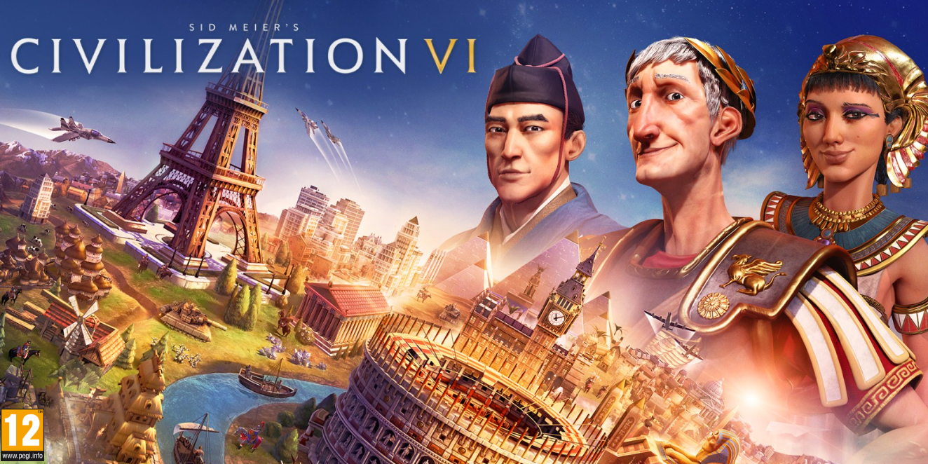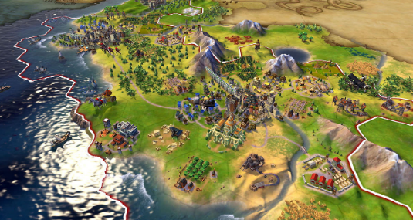
Figure 1 Screenshot from Sid Meier’s Civilization VI showing a historical strategy simulation of political, technological, and territorial development. [8]
Champion also describes the difference between models and simulations. A model is a simplified representation of a real system, while a simulation attempts to show how that system behaves over time [9]. Historical games often combine both approaches. They present simplified environments but allow players to interact with systems that represent historical processes.
Designing historical simulations also introduces several challenges. One issue is balancing historical accuracy with gameplay design. A system designed purely for entertainment may distort historical information, while a system that focuses too heavily on academic accuracy may become difficult or less engaging for players [10]. Developers must therefore carefully decide how historical content is represented.
Another challenge comes from the nature of historical evidence. Historical knowledge often comes from incomplete records such as diaries, written documents, and archaeological discoveries [11]. Because of this, reconstructions and simulations sometimes require interpretation when information is missing. Designers must consider how to represent this uncertainty without presenting misleading information.
Champion also highlights that interactive systems can present multiple perspectives of historical events [12]. By allowing players to explore different viewpoints or outcomes, games can show that history is made up of many different experiences rather than a single fixed narrative.
Champion concludes that historical simulations can support learning by encouraging players to explore historical systems and understand how decisions influence outcomes [13]. Instead of presenting history only as fixed information, simulations allow users to investigate how events may have developed.
In relation to this dissertation’s research question, ‘Is game design a suitable tool for preserving history and historical sites? Champion’s work suggests that GD can support historical understanding when it is based on research and careful interpretation. While digital simulations cannot replace historical documents or physical heritage sites, they can provide interactive environments that allow users to explore historical spaces and systems.
Champion’s discussion of historical simulation is relevant to the reconstruction of HV developed in this project.
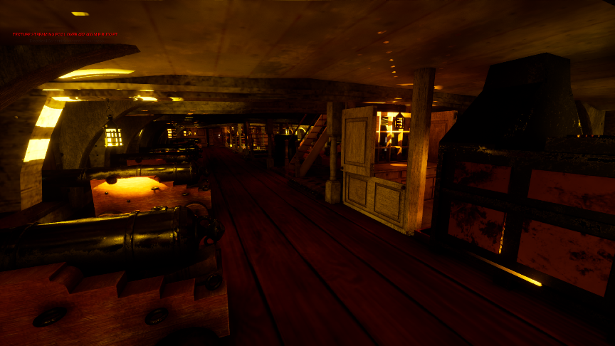
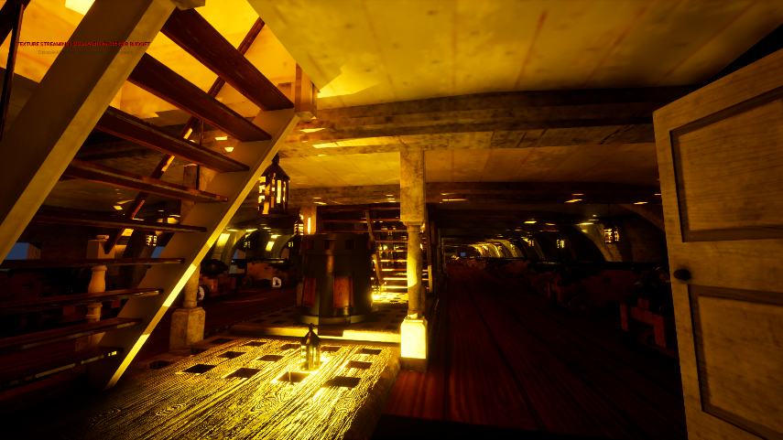
Figure 2 Screenshot of the nearly completed digital reconstruction of the HMS Victory middle gun deck created in Unreal Engine. The environment allows users to explore the layout and spatial organisation of the historical ship interior.
By modelling the space in Unreal Engine 5, users can experience the scale and structure of the ship rather than only viewing static images or written descriptions. This interactive approach reflects Champion’s argument that simulations can help users explore historical systems and environments directly [13].
While Champion highlights the educational potential of historical simulations, it is also important to recognise their limitations. Digital simulations cannot perfectly recreate historical reality because they rely on simplified models and incomplete historical records. As Champion notes, many reconstructions require interpretation where historical evidence is missing [11]. This means that game environments represent a version of history rather than a complete or fully accurate reconstruction. However, despite these limitations, simulations can still provide valuable insight into historical environments and systems. When combined with careful research and historical sources, GD can support historical understanding while making complex historical information more accessible to a wider audience.

Playing with the Past: Digital Games and the Simulation of History 2013

Chapter 14: History Veneers: Anachronism, Simulation, and Art History in Assassin’s Creed II
An important perspective on historical representation in games is provided by Douglas N. Dow, who analyses how digital environments interpret the past. His chapter is relevant to this study as it explores the balance between historical accuracy and gameplay design, particularly within the Assassin’s Creed series. Dow’s work highlights both the potential and the limitations of using to represent historical sites, which directly supports the focus of this dissertation.
Historical video games often attempt to recreate past environments in ways that allow players to interact with history rather than simply observe it. Dow examines how Assassin's Creed II presents Renaissance Florence through a detailed digital reconstruction of historical locations [14]. The game recreates cities such as Florence, Venice, and Tuscany with architectural landmarks and urban layouts inspired by historical sources. Through this design, players can explore historical spaces and interact with them in ways that traditional historical media cannot provide
Dow explains that this form of digital environment creates what he describes as a “simulacrum” of Renaissance Florence [15]. While the game visually resembles the historical city, it is not an exact reconstruction. Instead, it represents a version of Florence shaped by gameplay requirements and design decisions. Certain buildings or architectural details may reflect structures from different time periods or include features that did not exist at the exact historical moment represented in the game.
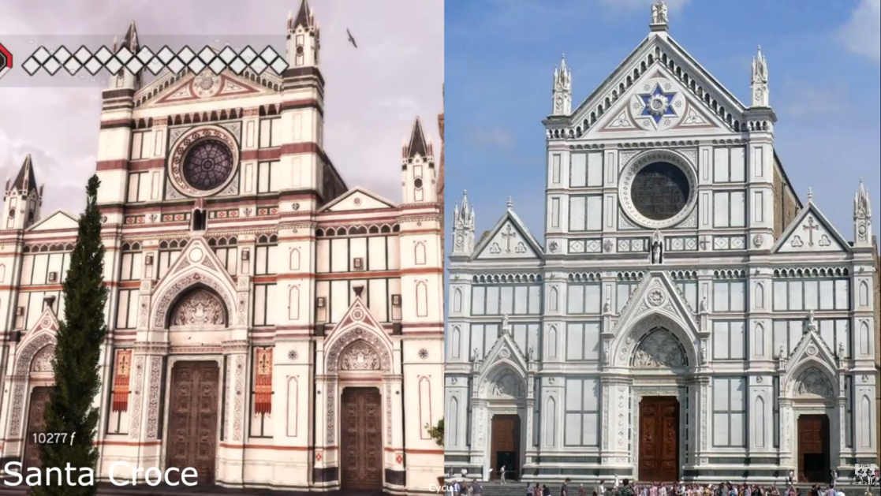
Figure 3 Example of Renaissance Florence as represented in Assassin's Creed II. The game recreates historical architecture and urban environments that allow players to explore and interact with a simulated historical city. [16]
One issue discussed by Dow is the presence of anachronism, where elements from different historical periods appear together in the same environment. For example, some buildings in the game include architectural features that were constructed decades after the time period represented in the narrative [17]. These differences are not always obvious to players, and the visual realism of the environment can make the reconstruction appear historically accurate even when certain details are simplified or altered.
Dow suggests that these design choices demonstrate how historical games balance authenticity with playability. While the game attempts to represent Renaissance architecture and culture, it also modifies historical details to support gameplay mechanics such as climbing buildings or navigating rooftops [18]. This means that the city becomes a playable environment rather than a strict architectural reconstruction.
Despite these limitations, Dow argues that games like Assassin’s Creed II still provide meaningful engagement with historical environments. By exploring the city, players encounter important landmarks such as churches, streets, and public spaces that reflect Renaissance urban design [19]. Even though the reconstruction is not fully accurate, it can still influence how players understand historical architecture and culture.
However, Dow emphasises that digital simulations should not be mistaken for fully accurate historical reconstructions. The game environment represents an interpretation of Renaissance Florence rather than a perfect historical model [20]. Because of this, historical games should be understood as creative representations that combine research with gameplay design.
In relation to the research question of this dissertation. Is game design a suitable tool for preserving history and historical sites? Dow’s discussion shows both the strengths and limitations of historical simulations. Games like Assassin’s Creed II can recreate historical environments in ways that allow players to explore architecture, landscapes, and cultural spaces interactively. At the same time, the presence of anachronism and design modifications demonstrates that digital reconstructions must balance historical accuracy with gameplay requirements.
Overall, Dow’s work suggests that historical video games can contribute to public engagement with history, but they should be understood as interpretative simulations rather than exact reproductions of the past [21]

Virtual Heritage A Guide Edited by Erik Malcolm Champion 2021

Chapter 6: Video Games as Concepts and Experiences of the past
A further perspective on digital heritage is provided by Aris Politopoulos and Angus Mol, who examine how video games shape the way people experience the past. Their chapter is relevant to this study as it explores how interactive environments influence engagement with history and cultural heritage. The authors focus on how games are not only forms of entertainment but also platforms where historical ideas can be explored and understood through player interaction.
Video games are increasingly recognised as tools that allow people to experience and interact with representations of the past. Politopoulos and Mol explain that many people now encounter history not only through books or museums but also through digital media such as games and virtual environments [22]. These interactive platforms can provide new ways of exploring historical ideas and cultural heritage.
The authors describe this interaction with the past through the concept of “past play” This term refers to the way players engage with historical themes, environments, or narratives through gameplay [22]. Instead of passively receiving information, players actively participate in systems that represent historical events, locations, or cultures. Through this interaction, games can encourage curiosity and interest in historical subjects.
However, the authors emphasise that historical accuracy in games is often influenced by design decisions and technological limitations. In many cases, entertainment value and player engagement take priority over strict historical reconstruction [23]. As a result, games may present simplified or modified versions of historical events. Despite this, the interactive nature of games can still stimulate interest in the past and encourage players to explore historical topics further
Politopoulos and Mol also discuss how the mechanics of games shape how players understand history. Game rules, objectives, and systems influence how players interact with historical environments and narratives [23]. For example, strategy games may focus on political decisions and territorial expansion, while exploration-based games may emphasise environments and cultural landmarks. These systems shape the way historical knowledge is experienced within the game.
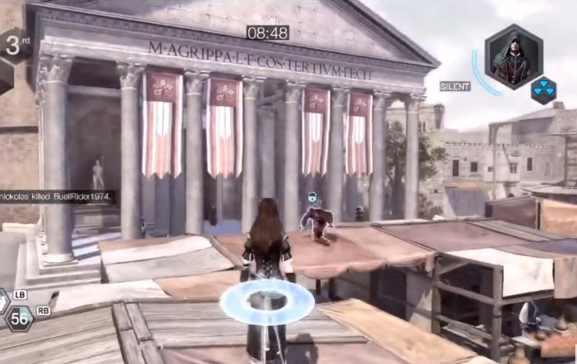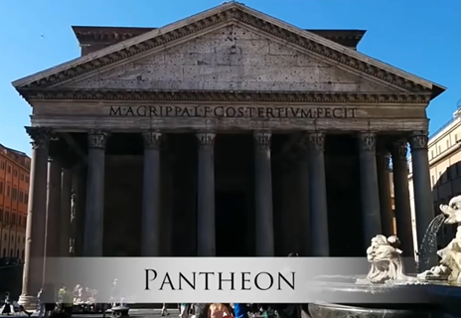
Figure 4 Example of historical architecture recreated in Assassin's Creed: Brotherhood. The game includes detailed recreations of landmarks such as the Pantheon in Rome, allowing players to explore simulated historical environments based on real architectural sites. [24]
The authors also highlight that digital games can support cultural heritage projects. One example discussed is the use of games such as Minecraft to reconstruct historical sites and landscapes. In these projects, players collaborate to rebuild structures based on archaeological evidence or historical research [25]. This demonstrates how games can be used as tools for community engagement and public interaction with heritage.
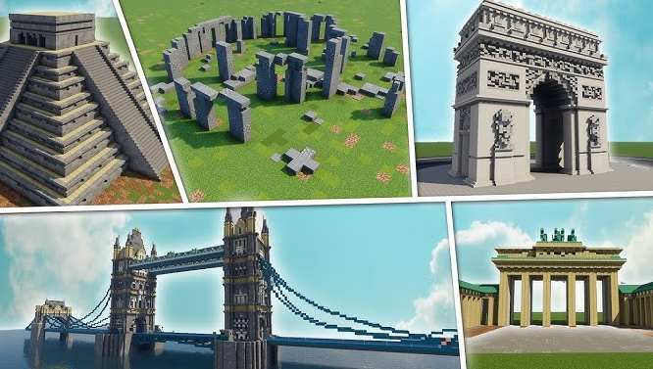
Figure 5 Examples of historical landmarks recreated in the video game Minecraft, including a Maya Pyramid temple, like those found at Chichen Itza, as well as reconstructions of Stonehenge, Arc de Triomphe, Tower Bridge, and Brandenburg Gate. These examples demonstrate how players use game environments to recreate and explore historical architecture. [26]
Another example discussed in the chapter is the use of game environments to support archaeological research. Projects such as the No Man’s Sky Archaeological Survey explored how players could document and investigate digital environments in ways like archaeological fieldwork [27]. Although these environments are fictional, the project demonstrated how game spaces can be used to study digital landscapes and community interaction with virtual heritage.
When considering the research question of this dissertation. Is game design a suitable tool for preserving history and historical sites? This chapter suggests that games can contribute to public engagement with cultural heritage. While digital environments cannot replace traditional historical sources or physical heritage sites, they can offer accessible ways for players to explore historical ideas and environments interactively
Overall, Politopoulos and Mol demonstrate that video games can function as platforms for experiencing the past through interaction and exploration. When combined with historical research and thoughtful design, game environments can help communicate historical knowledge and support new forms of engagement with cultural heritage.

Literature Review Conclusion
The literature discussed in this chapter shows that digital games and interactive environments can play an important role in how people experience and understand history. Authors such as Erik Champion highlight how historical simulations allow players to explore systems and environments from the past rather than simply reading about them. By interacting with these systems, players can develop a deeper understanding of historical events, locations, and social structures.
Douglas N. Dow analysis of Assassin’s Creed II demonstrates how video games recreate historical cities and architecture through digital environments. These reconstructions allow players to explore spaces such as Renaissance Florence, creating an immersive experience of the past. However, Dow also notes that these environments are not exact reconstructions. They often include design choices or anachronisms that balance historical representation with gameplay mechanics. This highlights an important limitation of historical games: they are interpretations of the past rather than perfectly accurate reconstructions.
Aris Politopoulos and Angus Mol further expand this discussion by introducing the concept of, Past Play, where players engage with historical ideas through gameplay. Their work shows that games can encourage curiosity about history and cultural heritage, even when they simplify or adapt historical events for entertainment purposes. Examples such as heritage reconstructions in Minecraft and archaeological exploration within digital environments demonstrate how games can be used for education, public engagement, and collaborative heritage projects.
Together, these sources suggest that GD offers new ways for people to interact with historical content. While digital games cannot replace traditional historical research, museums, or physical heritage sites, they can provide interactive spaces where historical environments and ideas can be explored.
This research supports the argument of this dissertation that GD has potential as a tool for historical preservation and engagement. By combining historical research with interactive technologies, digital environments such as the reconstruction of HV in this project can allow users to explore historical spaces in ways that traditional media cannot easily provide.

Case Studies

Video Game: Assassin’s Creed Unity 2014 Unity Ubisoft Montreal
Building on the literature discussion in Chapter 14: History Veneers: Anachronism, Simulation, and Art History in Assassin’s Creed II, where Dow explores how Assassin’s Creed II represents historical environments through simulation and interpretation, this case study examines how similar design approaches are applied in Assassin’s Creed Unity. While Dow highlights how historical environments are shaped by gameplay requirements and may include anachronisms, this case study extends that argument by analysing how a later title in the series was positioned within real-world discussions of cultural heritage and reconstruction following the Notre-Dame fire. This provides a practical example of how GD techniques move beyond representation and into wider debates about digital preservation.
In April 2019, a fire caused severe damage to Notre Dame Cathedral, destroying the roof and spire. Shortly after the disaster, public discussion emerged around whether the detailed 3D recreation of the cathedral in Assassin’s Creed Unity could support restoration efforts. Ubisoft, the developer of the game, announced a €500,000 donation toward the restoration and made its detailed digital model of Notre Dame available to architects, engineers, and designers involved in the rebuilding process. The model had originally been created using historical records, architectural plans, and photographs, resulting in a highly detailed recreation of the cathedral’s interior and exterior. This positioned GD technology within a wider conversation about digital preservation and cultural heritage, showing how a game asset could contribute to both public engagement and historical reconstruction [28].
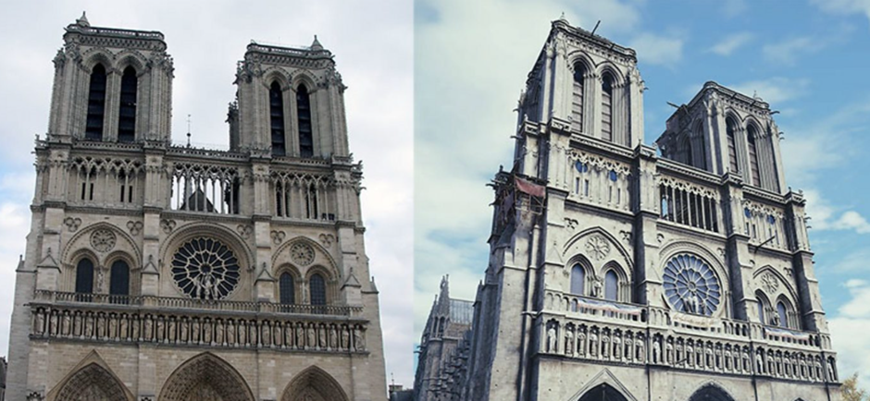
Figure 6 Video Game VS Reality [29]

Developed by Ubisoft and released in 2014, Assassin’s Creed Unity recreated eighteenth century Paris, including a full digital reconstruction of Notre Dame Cathedral. The cathedral was modelled inside and out, allowing players to explore it at human scale in real time. The project took over 14 months and around 5,000 hours of modelling work. Although built for gameplay rather than restoration, it showed strong visual and structural detail. Some changes, such as added entrances, were made for player navigation, showing the limits of game-based reconstruction. While not precise enough for full restoration, it effectively preserved spatial experience, accessibility, and public engagement with history, which directly supports this dissertation’s focus on GD as a tool for historical preservation [30].
The Notre Dame case shows the difference between technical reconstruction and experiential preservation. While Assassin’s Creed could not provide the engineering accuracy needed for rebuilding, it preserved a navigable version of the cathedral that millions of players could experience. This type of immersive access supports cultural memory and public engagement in ways that photographs or architectural drawings cannot. After the fire, people were still able to explore the cathedral’s scale, atmosphere, and architectural presence through the game environment.
In contrast, the official restoration relied on detailed laser scans created by Andrew Tallon before the disaster. His model captured precise structural measurements and spatial geometry from more than fifty scan locations, providing the accuracy needed for architectural reconstruction. This difference between scan-based documentation and Ubisoft’s interactive game model shows the gap between technical heritage recording and experiential digital preservation. Together, they show that while GD cannot replace architectural surveying, it can still play an important role in preserving cultural experience and public understanding [31].
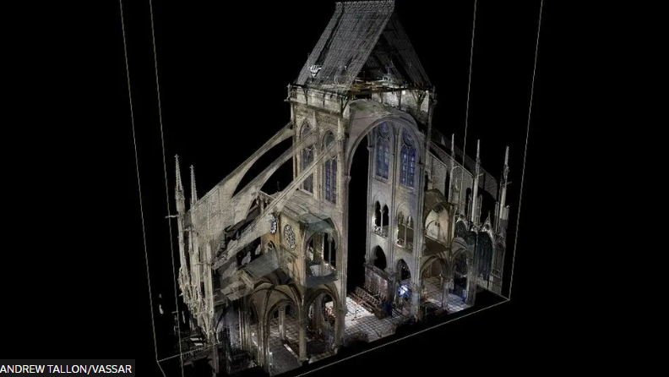
Figure 7 A Notre Dame cross section made from Andrew Tallon's scans [31]

Video Game: Kingdom Come Deliverance 2018 CryEngine / Autodesk 3ds Max
Kingdom Come: Deliverance, developed by Warhorse Studios and released in 2018, shows a historically grounded recreation of early fifteenth century Bohemia now the Czech Republic [32]. Set in 1403 during political conflict within the Kingdom of Bohemia, the game deliberately avoids fantasy, make believe and instead positions historical authenticity as a central design principle.
The project was led by Daniel Vavra [33], who said that the aim was to create a medieval world based on historical literature, historical research, original source documents, and expert advice instead of exaggerated or fictional versions of the Middle Ages. Danial Vavra and his team worked with historians and researchers to consult period texts, architectural studies, and historical records. Real locations were used and digitally reconstructed based on surviving structures, archaeological evidence, and documented settlement layouts. This reliance on historical literature and real-world geography distinguishes the project from stylised medieval fantasy games. [34]

Daniel Varva said:
“In every Hollywood movie you see such things that looks cool so they put it there and they don’t care about how it was and very often the actual reality they could research looks better” [34]

The landscape in the game was based on the real geography of the Czech countryside. Castles were designed using historically accurate defensive features instead of unrealistic fantasy-style towers. Monasteries and town markets were laid out in ways that reflected how medieval towns were organised, including how social roles and daily life worked. This shows how game developers can use historical research directly in their 3D modelling process.
However, some design choices had to be interpreted. Not all historical details still exist, so the team had to make informed decisions where information was missing. Certain spaces were also adjusted to improve gameplay and performance. Because of this, the environments are historically grounded recreations rather than exact architectural match. [35]
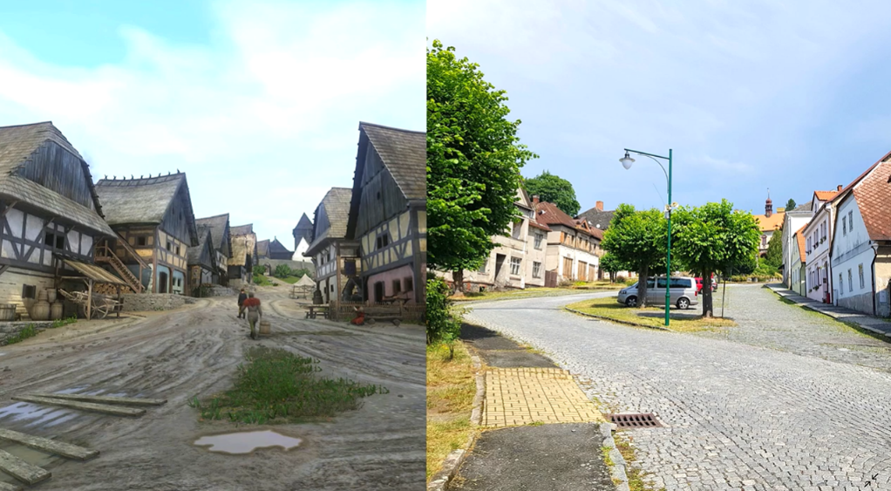
Figure 8 Kingdom Come Deliverance 2 Game vs reality [36]
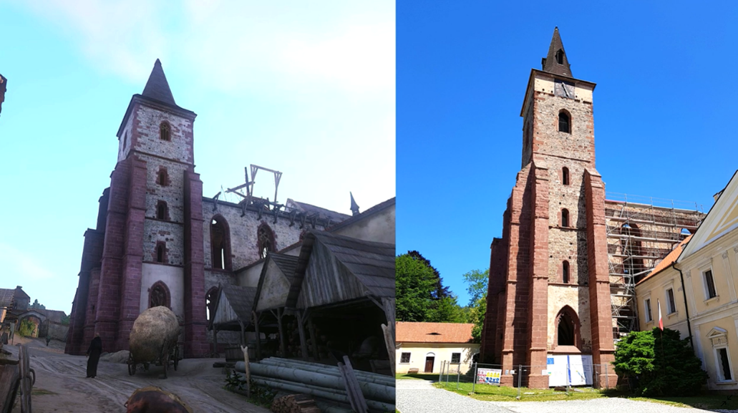
Figure 9 Kingdom Come Deliverance 2 Game vs reality [36]

Connection to the HMS Victory Project
The methodology in these case studies parallels the reconstruction of HV within this dissertation. Both projects
- Begin with historical documentation and reference analysis
- Translate archival material into 3D spatial environments
- Use real time engines to simulate embodied experience
- Balance authenticity with technical constraints
Where Kingdom Come: Deliverance applies research within a commercial RPG framework, the HV reconstruction applies similar techniques within an explicitly preservation focused academic context. Both demonstrate that GD technologies when used by credible historical research can function as tools for digital heritage preservation.

Video game: The Oregon Trail 1971
The Oregon Trail was originally developed in 1971 by three Teachers: Don Rawitsch, a history teacher, alongside mathematics teachers Bill Heinemann and Paul Dillenberger. The project began as a classroom experiment designed to teach students about nineteenth century westward migration in the United States. Rather than relying solely on textbooks, the teachers created an interactive simulation that allowed students to experience the logistical and decision-making challenges faced by pioneers travelling along the Oregon Trail.
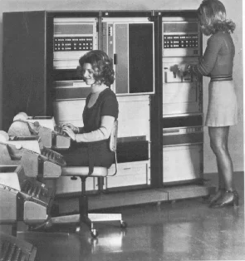
Figure 10 To play the original version of Oregon Trail, users connected to an HP 2100 minicomputer with a teletype machine. [37]
Although the original version had no graphics, it was built on careful historical research. Don Rawitsch studied real pioneer diaries, letters, and historical records from the 1800s. These documents described common dangers such as cholera, dysentery, river accidents, food shortages, and harsh weather. The game included these risks because they were recorded repeatedly in primary sources from the time.
The distances travelled, typical supply costs, wagon limitations, and seasonal timing were also based on documented historical data. For example:
- Disease outbreaks reflected known medical conditions affecting settlers
- River crossings were dangerous because historical accounts described frequent drownings
- Food shortages and hunting reflected real survival challenges
- Travel pace was limited by oxen strength and terrain conditions

This shows that the game was not random or fictional. It translated real historical evidence into a rule-based system. Students had to manage resources in ways like real families travelling the trail. If they left too late in the season, winter conditions became deadly. If they mismanaged supplies, starvation or illness followed. These outcomes reflected patterns found in archival records from the nineteenth century.
The game simplified some elements for classroom use. It did not cover every political, economic, or cultural detail of westward expansion. Complex historical issues were reduced into manageable mechanics suitable for students. However, the core survival systems were based on documented settler experiences drawn from diaries, letters, and historical reports.
As the game was later remade and technologically upgraded, the research foundation continued rather than being removed. Later versions retained historically accurate disease names and terminology that matched the wording found in original pioneer journals and medical records. Conditions such as cholera, dysentery, typhoid, and measles reflected the language used in historical documentation. This continuity shows that even as graphics improved and platforms evolved, the commitment to research-based design remained central.
The key strength of The Oregon Trail was its use of historical records as the foundation for gameplay logic. The teachers began with primary sources, identified common risks and patterns, and converted those into interactive systems. This is the same research method used in modern historical GD. The technology has advanced, but the underlying process has remained consistent: study the evidence first, then build mechanics around it.
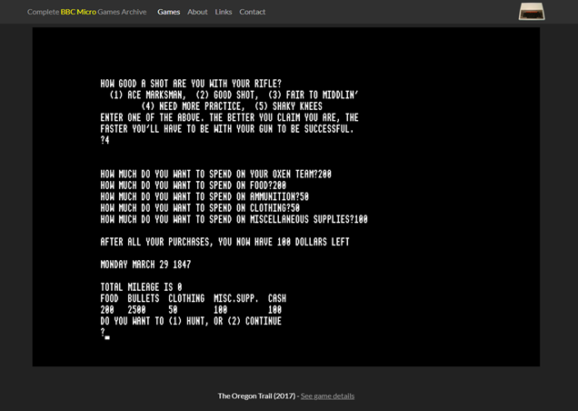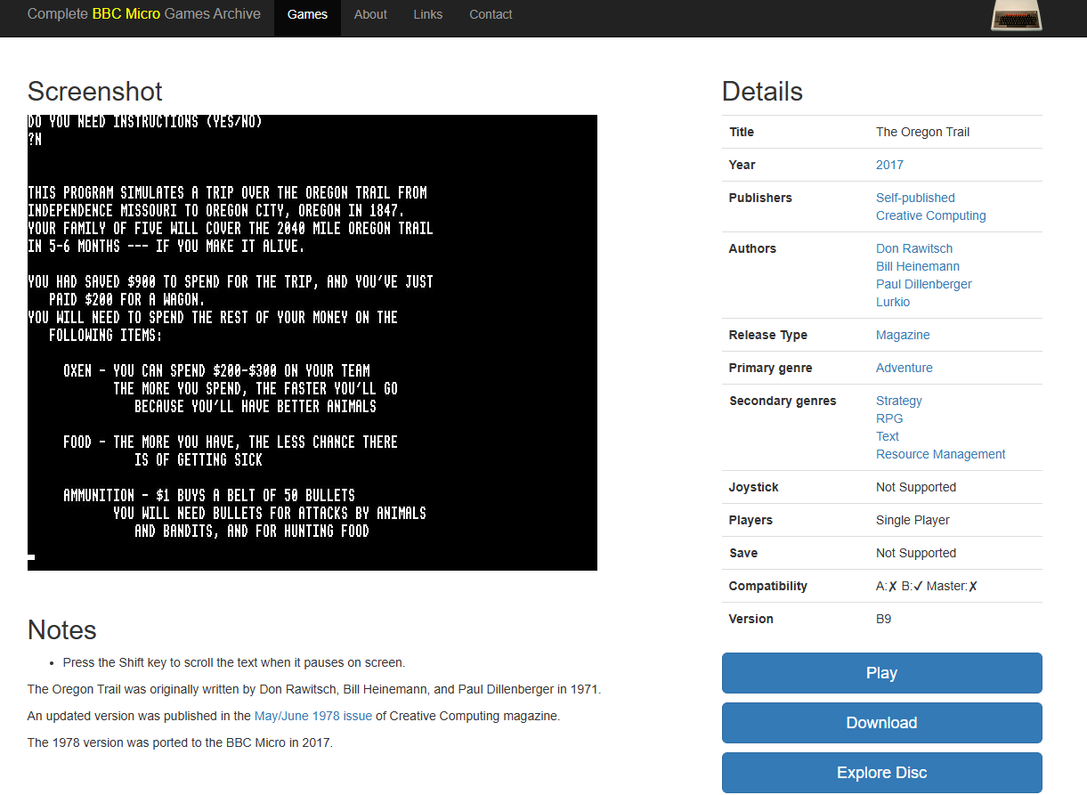
Figure 11 Screenshot from the original text-based version of The Oregon Trail (1971), personally tested to analyse how historical records were translated into rule-based gameplay mechanics. [38]
In relation to the question. Is game design a suitable tool for preserving history and historical sites? This case provides strong evidence. Even without advanced visuals, the game preserved knowledge of nineteenth century migration by allowing students to experience historically accurate challenges. It encouraged active learning based on documented evidence rather than fictional storytelling.
This connects directly to the reconstruction of HV in this project. The approach also begins with studying historical records, identifying key environmental and structural details, and translating them into interactive design. The difference lies in technology, not method. The Oregon Trail demonstrates that research-based simulation has long been an effective educational tool. Modern 3D engines extend the same logic into spatial and immersive environments.
Together, this case supports the argument that GD can function as a legitimate tool for historical preservation when it is rooted in documented evidence, consistent terminology, and structured research rather than fictional interpretation. [39]

Teaching Methods and the Role of Immersive Technology
Traditional teaching methods often rely on reading, listening, and observation. These approaches can provide clear information, but they are usually passive and may not fully help learners understand scale, space, or real - world experience. Immersive technology offers a different teaching method by allowing learners to take a more active role in the learning process. [40]
In the lecture Immersive Technologies-A Pathway to Learning, Professor Nelly Deutsch (Ed.D) described immersive technologies as tools that place learners inside an experience rather than outside it [40]. The session focused on Virtual Reality (VR), Augmented Reality (AR), and Mixed Reality (MR). VR creates a fully immersive digital environment through the use of a headset, allowing users to feel physically present within the space. AR overlays digital content onto the real world through devices such as smartphones and tablets, while MR combines elements of both physical and digital environments, allowing them to interact in real time. [40]
A key point from Deutsch’s lecture was that immersive technologies support experiential learning. Instead of only reading about a topic, learners can interact with digital objects and spaces. This makes learning more active and can improve understanding. As Freeman, S states in Designing VR Experiences – Expectations for Teaching and Learning in VR, “Students learn by doing things and think about what they are doing,” showing that active participation improves understanding more effectively than passive teaching methods.[41] The lecture also linked immersive learning to constructivist ideas, where learners build knowledge through interaction and experience.
Several benefits of immersive technology were discussed:
- Increased engagement
- Better understanding and retention
- Greater creativity
- Collaboration
- Inclusivity and accessibility
- Opportunities for reflection and storytelling
Professor Deutsch also directly explained that immersive technology can be used for visiting historical and educational sites, especially when students do not have the opportunity, money, or access to visit these places physically. She described how virtual visits can allow learners to experience places of historical importance through interactive and immersive environments, making learning more engaging than traditional classroom methods alone.
An important difference was made between VR and AR. VR was described as highly immersive, but also more expensive and limited by headset use and possible side effects such as nausea. Sessions are usually recommended for no more than 20 minutes. AR was presented as more accessible because it can be used on smartphones or tablets, often works offline, and is more suitable for schools with limited resources.
Another strong point from the lecture was that immersive learning is not only about technology. Storytelling and reflection are also important. Learners should reflect on what they experienced and what they learned. This helps turn an engaging activity into meaningful learning.
This is relevant to the HV project. The environment is designed not only to show a historical space, but to help users understand it through movement, scale, and interaction. The VR version supports this by placing the user directly inside the middle gun deck and allowing interactive information points to be triggered around the environment. Although testing in this project was carried out on the PC version, the VR version still demonstrates how immersive technology can support historical learning in a more engaging way than static methods alone.

Methodology and Project Planning

Methodology
This project aims to explore whether game design is a suitable tool for preserving history and historical sites through the digital reconstruction of HV middle gun deck. The practical outcome is a historically informed 3D environment built in Unreal Engine 5, with assets created in Autodesk Maya and textured using Adobe Substance 3D Painter.
Development followed a block-out first workflow. The environment was first created using simple geometry to establish accurate scale, layout, and proportions before adding detailed assets, materials, and lighting. This ensured the space was structurally correct before refinement began. Block outs are important because they allow designers to test the basic structure, flow, and navigation of a level before spending time on final assets and polished visuals. It is much faster and cheaper to adjust simple grey geometry than to rebuild completed art assets later in development. As Robert Yang explains, “you can’t playtest a design document or a layout sketch, but you can playtest a block out,” showing that the block-out stage is where layout, metrics, and wayfinding can be properly tested and refined before final production. [42]
Project planning also followed SMART objectives (Specific, Measurable, Achievable, Relevant, and Time-bound) to maintain clear structure and realistic development targets throughout production. This helped ensure each stage of modelling, testing, and refinement remained focused and achievable within the project timeframe. A full breakdown of these SMART objectives can be seen in Appendix A.
The project was developed in both a PC walkthrough version and a VR version.
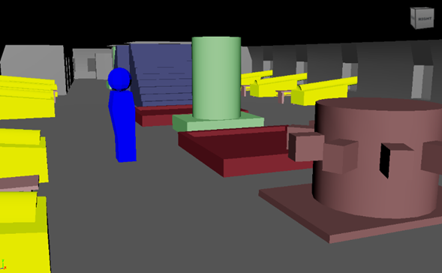
Figure 12 HV 1st Phase Block out walkthrough
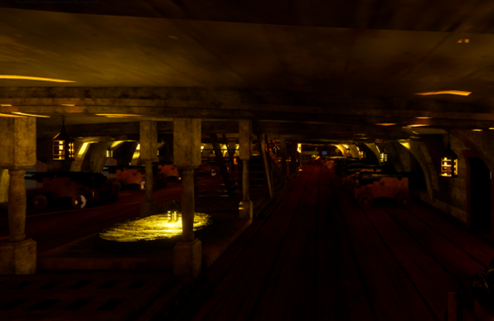
Figure 13 Desktop HV 2nd Phase Walkthrough
Main Development Tools
- Unreal Engine 5: Environment building and final implementation
- Autodesk Maya: Asset modelling
- Adobe Substance 3D Painter: Texturing and materials
- Adobe Photoshop: Reference editing and presentation images
Platform Versions
- PC Version: Used for all walkthrough testing due to accessibility and consistent controls
- VR Version: Developed as a secondary version to explore immersion and full-scale interaction with Interactive information points added in VR to provide historical details on key objects around the deck
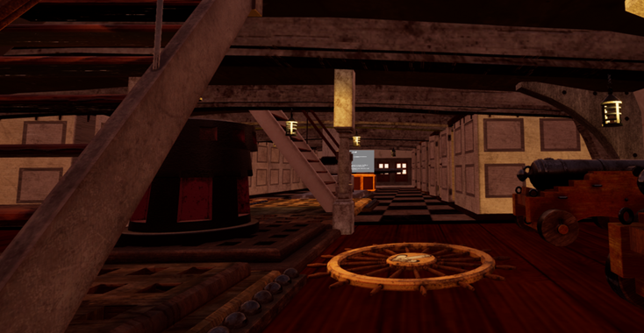
Figure 14 HV 3rd Phase VR Walkthrough

Project Planning / Gantt Chart
The project was organised using a Gantt chart to manage development, research, testing, and final submission
Planned Stages:
- Research and literature review
- Reference gathering
- Block-out creation
- Asset production
- Texturing and lighting
- PC and VR development
- User testing
- Evaluation and dissertation writing

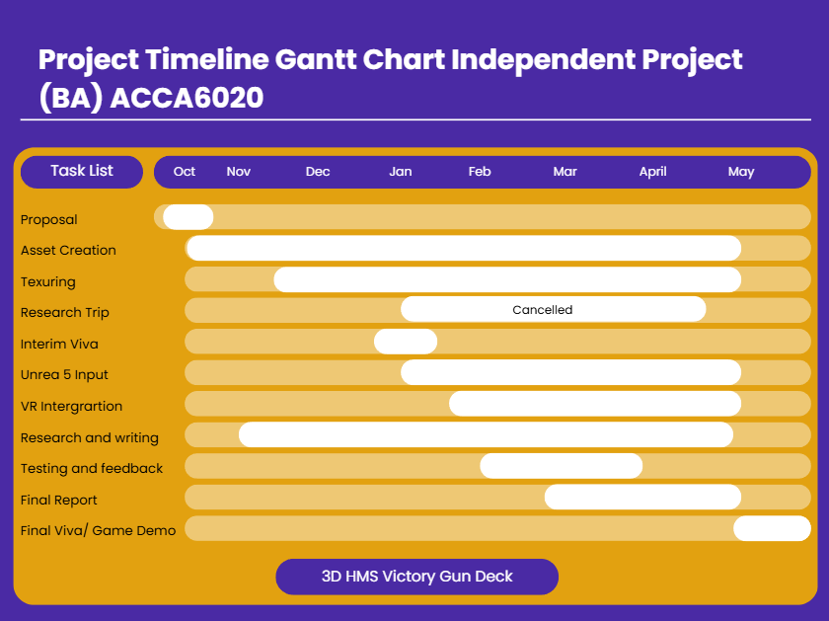
Figure 15 Gantt Chart
A visit to Portsmouth Naval Museum and HV was originally planned to support reference gathering. However, due to restrictions, administrative delays, and access limitations from the HV team, the visit became difficult to organise within the project timeframe.
There was also a risk that visiting too late in development would lead to major design changes, which could delay the project significantly.
As a result, the decision was made not to proceed with the visit. Instead, alternative references were used, including:
- Over 2000 images from TripAdvisor
- Online walkthrough videos
- Historical ship plans and reference books (Appendix B)
This allowed development to continue without affecting deadlines. Asset creation, texturing, and VR integration were moved forward in the schedule to maintain progress.

Testing

Analysis of Testing Results and Iterative Development
The first block-out test and the second walkthrough test were used to compare how the environment improved during development. Both tests used quantitative data from Likert scale questions and qualitative data from open-ended responses to evaluate scale, lighting, atmosphere, and user understanding. A total of 21 responses were collected across the testing process, with the full questionnaire findings included in Appendix C. The testing was limited to my cohort and peers from Games Design and Animation courses, as they were the most accessible participants within the university environment. While this provided useful feedback from users familiar with 3D environments and level design, it also created a limitation within the study. Selection bias is a potential concern because participants may have judged the environment differently from a general museum audience with no design background. A major drawback of this approach is that the sample does not fully represent wider public users, which reduces the reliability of applying the findings to broader heritage and museum visitors.
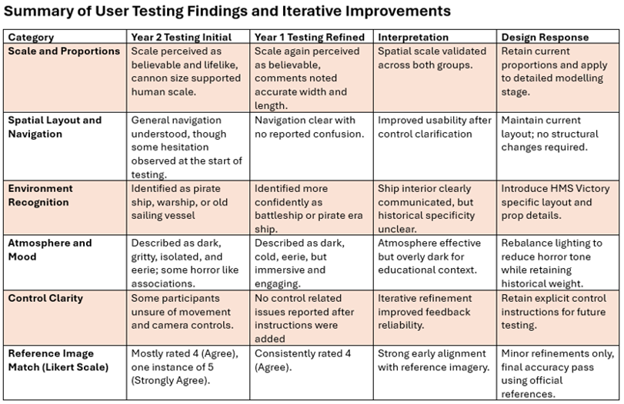
Figure 16 1ST Phase Block out walkthrough test results
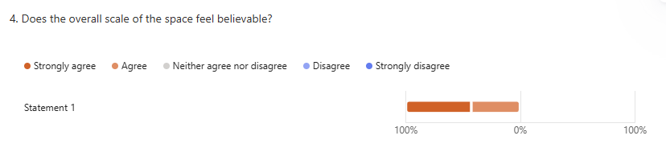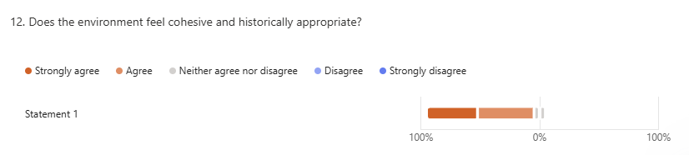
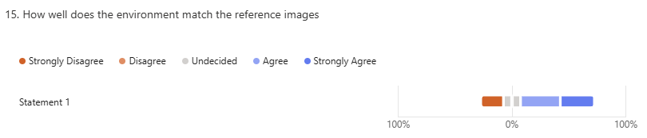
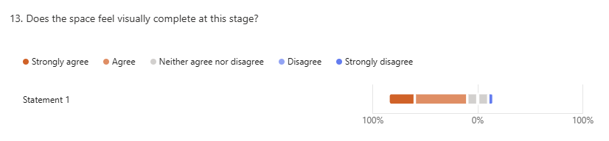

Figure 17 shows some of the second walkthrough questionnaire results, including the Likert scale responses and feedback on cohesion and historical appropriateness.

Comparison Between Test 1 and Test 2
The first test showed that the scale and proportions of the environment were already strong. Participants described the cannon and deck spacing as believable, confirming that the block out stage was successful. However, lighting was a major weakness, with many users describing the environment as too dark and giving it an eerie or horror-like feeling.
In the second test, lighting and clarity improved after refinement. Quantitative responses were more positive, with stronger agreement that the environment felt cohesive and historically appropriate. Navigation also improved due to clearer instructions and better layout flow.

Key Findings
- Scale and proportions remained strong across both tests
- Lighting improved significantly between the first and second walkthrough
- Users found the environment more cohesive in the second test
- Participants still identified the space as a ship, but not specifically HV
- Historical recognition still needs clearer information and more interactive features for users to fully understand the environment

What Was Learned
The results show that iterative testing was effective. Early testing helped identify major issues before final development. Lighting was one of the strongest improvements between both walkthroughs. In the second test, 52.4% of participants strongly agreed and 47.6% agreed that the lighting suited the environment being represented, showing a clear improvement from the first block out stage where the space was often described as too dark and eerie. The main lesson learned was that accurate modelling alone is not enough; users also need information and interaction to fully understand the history and space they are interacting with. Due to the lack of initial signage and contextual information, many testers recognised the environment only as a generic warship or pirate ship rather than specifically identifying it as HV. This showed that historical accuracy in layout and modelling must be supported by clear educational features to create stronger historical understanding. To improve this further, a start screen could be added to clearly explain that the environment represents HV and provide historical context before the walkthrough begins. See figure18 below for the question “What environment do you believe this space represents?” which demonstrates how participants commonly identified the space as a warship rather than HV specifically.

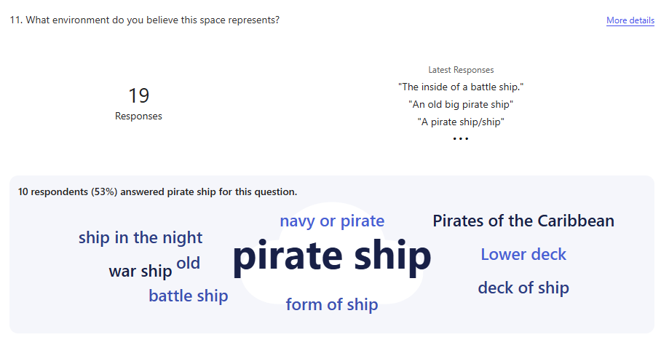
Figure 18 shows most participants identified the space as a warship or pirate ship rather than specifically HMS Victory. This shows that stronger signage and historical context are needed to improve recognition

Final Findings
This project explored whether GD is a suitable tool for preserving history and historical sites through the digital reconstruction of HV middle gun deck. The aim was to test how interactive 3D environments and immersive technology, including Virtual Reality (VR), could improve historical learning compared to traditional methods such as books, museum panels, and guided explanation.
The literature review strongly supported this idea. Erik Champion explains that historical simulations allow users to interact with historical systems and spaces rather than only reading about them. [6] This was reflected in the HV project, where users could walk through the middle gun deck and understand its layout, scale, and function more clearly than through static images alone. Champion also states that simulations help users understand how historical environments work, which directly supports the project findings from both walkthrough tests.
The case studies also reinforced this. Assassin’s Creed Unity showed how the digital reconstruction of Notre Dame preserved public access to the cathedral after the 2019 fire, even though it could not replace the technical accuracy of laser scans.[28] This links closely to HV, where the goal was not perfect architectural replacement, but preserving spatial understanding and historical experience. Similarly, Kingdom Come: Deliverance demonstrated how historical research can be translated into believable explorable environments, while The Oregon Trail showed that educational GD can preserve history through interaction rather than passive teaching. [39]
The testing results supported these ideas. The first block - out test showed that the scale and proportions were already strong, with participants describing the cannon size and deck spacing as believable. This confirmed that the early block - out stage was successful and that the environment felt realistic. However, lighting was too dark, creating an eerie feeling rather than an educational atmosphere.
After refinement, the second walkthrough produced stronger quantitative and qualitative results. Likert scale responses showed stronger agreement that the environment felt cohesive and historically appropriate. Navigation also improved through clearer instructions and layout adjustments.
Key Findings:
- GD is a highly effective tool for preserving history because it allows users to actively explore, interact with, and experience historical spaces in ways that go beyond passive observation, creating stronger engagement, understanding, and long-term educational value
- The literature review demonstrated that researchers such as Erik Champion support GD in digital heritage, as interactive environments improve engagement and understanding.
- Case studies such as Assassin’s Creed Unity, Kingdom Come: Deliverance, and The Oregon Trail showed that games can preserve history through accurate reconstruction and interactive learning.
- User testing confirmed that the HV block - out had strong scale and believable proportions, while lighting and atmosphere needed improvement.
- Contextual details such as information points, storytelling, and interaction are needed for stronger historical understanding.
- The VR version increased immersion and supported learning through full - scale interaction, while the PC version provided the most reliable testing platform.
A major finding was that accurate modelling alone is not enough. Users also need object information, storytelling, and interaction to fully understand the historical meaning of the space. This connects directly to Professor Nelly Deutsch’s discussion of immersive learning, where she explained that VR and AR improve education through active engagement, reflection, and virtual visits to historical sites. [40]

Conclusion
Overall, the literature review, case studies, and practical testing all support the same conclusion: GD is a strong tool for preserving history and historical sites. While it cannot replace the original location, it improves accessibility, engagement, and understanding for wider audiences.
This project shows that combining accurate modelling, historical research, interaction, and immersive technology create a stronger learning experience than traditional static methods alone. GD can therefore be considered a valuable method for digital heritage preservation and museum education.

Evaluation
This project tested my ability as both a designer and developer and helped me improve my overall workflow throughout production. It pushed my skills in modelling, texturing, environment building, and problem - solving while also improving my understanding of project management and iterative design. Creating a historically accurate HV middle gun deck required both technical skill and strong planning, especially when adapting to delays and unexpected problems.

What Went Well
- Accurate block - out creation helped establish correct scale and proportions early
- User testing identified problems with lighting, navigation, and clarity
- Feedback allowed improvements between the first and second walkthrough tests
- The PC version provided consistent testing conditions
- The VR version added immersion and interactive information points for key objects
- The project improved my confidence using Autodesk Maya, Adobe Substance 3D Painter, and Unreal Engine 5

What Could Be Improved
- Modelling speed was slower than expected, especially for detailed historical assets, as time was often spent recalling older technical workflows and modelling processes in Autodesk Maya, which slowed overall production.
- Some models developed double extrusion problems, causing mesh errors and extra cleanup
- Texturing took longer than planned, particularly for realistic wood and metal surfaces
- I often needed to look up older Maya workflows and techniques, which slowed progress
- Lighting in Unreal Engine required multiple adjustments as the early version felt too dark
- Some imported models appeared misshapen in VR before Nanite settings were corrected

What Was Learned
- This project tested my ability to manage both practical work and academic research at the same time
- It helped me improve my workflow by planning tasks more effectively and solving problems faster
- One of the strongest lessons learned was that accurate modelling alone is not enough; users also need clear information, interaction, and historical context to fully understand the space and its significance.
- Testing early helps prevent larger development problems later
- Iterative refinement improves both quality and usability
- Better time management is essential when working on detailed modelling and texturing tasks

References
[1]T. But, “Preserving history through modern technology,” Historica.org, Oct. 16, 2024. https://www.historica.org/blog/preserving-history-through-modern-technology (accessed Feb. 16, 2026).
[2]“HMS Victory: The Big Repair Information Hub | National Museum of the Royal Navy,” Nmrn.org.uk, 2025. https://www.nmrn.org.uk/HMSvictory-the-big-repair (accessed Nov. 10, 2025).
[3]A. Tikkanen, “Battle of Trafalgar | Summary, Facts, & Significance,” Encyclopedia Britannica, Mar. 19, 2025. https://www.britannica.com/event/Battle-of-Trafalgar-European-history (accessed Feb. 09, 2026).
[4]T. Pocock, “Horatio Nelson | Facts, Battles, & Death | Britannica,” Encyclopædia Britannica. 2020. Accessed: Feb. 10, 2026. [Online]. Available: https://www.britannica.com/biography/Horatio-Nelson
[5]F. Johnson, “What are the Negatives of Museums: A Comprehensive Look at the Challenges and Criticisms Facing Cultural Institutions - Wonderful Museums,” Wonderful Museums, Jul. 17, 2025. https://www.wonderfulmuseums.com/museum/what-are-the-negatives-of-museums/ (accessed Feb. 09, 2026).
[6]E. Champion, CRITICAL GAMING : interactive history and virtual heritage. S.L.: Taylor & Francis, 2020, p. 75.
[7]E. Champion, CRITICAL GAMING : interactive history and virtual heritage. S.L.: Taylor & Francis, 2020, p. 77.
[8]S. Meier’s, “Sid Meier’s Civilization VI,” Nintendo of Europe SE, 2018. https://www.nintendo.com/en-gb/Games/Nintendo-Switch-games/Sid-Meier-s-Civilization-VI-1460609.html?srsltid=AfmBOoqUFhdkRRgUEOGCjmZ5IOxP1BgPYRmh97QmsoyhRuLDIuPu07HV#Overview (accessed Jan. 16, 2026).
[9]E. Champion, CRITICAL GAMING : interactive history and virtual heritage. S.L.: Taylor & Francis, 2020, p. 78.
[10]E. Champion, CRITICAL GAMING : interactive history and virtual heritage. S.L.: Taylor & Francis, 2020, p. 81.
[11]E. Champion, CRITICAL GAMING : interactive history and virtual heritage. S.L.: Taylor & Francis, 2020, p. 88.
[12]E. Champion, CRITICAL GAMING : interactive history and virtual heritage. S.L.: Taylor & Francis, 2020, p. 86.
[13]E. Champion, CRITICAL GAMING : interactive history and virtual heritage. S.L.: Taylor & Francis, 2020, p. 90.
[14]M. Kapell and A. B. R. Elliott, Playing with the past : digital games and the simulation of history. New York: Bloomsbury Academic, 2013, p. 215.
[15]M. Kapell and A. B. R. Elliott, Playing with the past : digital games and the simulation of history. New York: Bloomsbury Academic, 2013, p. 219.
[16]Cycu1, “Assassin’s Creed 2 Game vs Real Life - Florence Landmarks Comparison,” YouTube, Feb. 01, 2017. https://www.youtube.com/watch?v=aljQV92icuQ (accessed Feb. 07, 2026).
[17]Matthew Wilhem Kapell and A. B. R. Elliott, Playing with the past : digital games and the simulation of history. New York: Bloomsbury Academic, , Cop, 2013, p. 220.
[18]Matthew Wilhem Kapell and A. B. R. Elliott, Playing with the past : digital games and the simulation of history. New York: Bloomsbury Academic, , Cop, 2013, p. 216.
[19]Matthew Wilhem Kapell and A. B. R. Elliott, Playing with the past : digital games and the simulation of history. New York: Bloomsbury Academic, , Cop, 2013, p. 222.
[20]Matthew Wilhem Kapell and A. B. R. Elliott, Playing with the past : digital games and the simulation of history. New York: Bloomsbury Academic, , Cop, 2013, p. 224.
[21]Matthew Wilhem Kapell and A. B. R. Elliott, Playing with the past : digital games and the simulation of history. New York: Bloomsbury Academic, , Cop, 2013, pp. 227–228.
[22]E. Champion, Virtual heritage : a guide. London: Ubiquity Press, 2021, p. 82.
[23]E. Champion, Virtual heritage : a guide. London: Ubiquity Press, 2021, p. 83.
[24]Architectural Lab, “Assassin’s Creed: Architectural History Across Eras!,” YouTube, Oct. 10, 2023. https://www.youtube.com/watch?v=IwiOpZ6k4BA (accessed Feb. 26, 2026).
[25]E. Champion, Virtual heritage : a guide. London: Ubiquity Press, 2021, p. 88.
[26]Bubbaflubba, “I built Famous Landmarks in Minecraft!,” YouTube, Apr. 06, 2024. https://www.youtube.com/watch?v=gW4o1-1rqCQ (accessed Feb. 14, 2026).
[27]E. Champion, Virtual heritage : a guide. London: Ubiquity Press, 2021, p. 89.
[28]K. Handy, “Bridging the Gap Between Gaming and History: How Assassin’s Creed Unity is Helping Rebuild Notre-Dame,” Artstation.com, Mar. 08, 2023. https://www.artstation.com/blogs/dioeye/1dYG/bridging-the-gap-between-gaming-and-history-how-assassins-creed-unity-is-helping-rebuild-notre-dame (accessed Feb. 08, 2026).
[29]BBC Newsround, “How a video game could help restore Notre Dame,” BBC Newsround, Apr. 18, 2019. https://www.bbc.co.uk/newsround/47963744 (accessed Jan. 28, 2026).
[30]Laurent de Sortiraparis, “Notre-Dame de Paris: how did Ubisoft contribute to its reconstruction with Assassin’s Creed Unity?,” Sortiraparis.com, Dec. 09, 2024. https://www.sortiraparis.com/en/what-to-do-in-paris/gaming/articles/322372-notre-dame-de-paris-how-ubisoft-helped-rebuild-the-city-with-assassin-s-creed-unity (accessed Dec. 13, 2025).
[31]“Notre-Dame fire: Assassin’s Creed’s maker pledges aid,” BBC News, Apr. 17, 2019. Accessed: Dec. 16, 2025. [Online]. Available: https://www.bbc.co.uk/news/technology-47963835
[32]The Editors of Encyclopedia Britannica, “Bohemia | historical region, Europe,” Encyclopædia Britannica. Sep. 26, 2017. Accessed: Feb. 15, 2026. [Online]. Available: https://www.britannica.com/place/Bohemia
[33]Wikipedia Contributors, “Daniel Vávra,” Wikipedia, Apr. 29, 2024. https://en.wikipedia.org/wiki/Daniel_V%C3%A1vra (accessed Feb. 13, 2026).
[34]Digital Dragons, “DD2018: Dan Vavra - Designing historical open world RPG,” YouTube, May 25, 2018. https://www.youtube.com/watch?v=puXwyIDCQCg (accessed Jan. 20, 2026).
[35]EXP, “Historian & Armour Expert Reacts to Kingdom Come: Deliverance 2’s Story & World | EXP,” YouTube, May 14, 2025. https://www.youtube.com/watch?v=RghkfJwhZtk (accessed Jan. 24, 2026).
[36]SxyBiscuit, “Kingdom Come Deliverance VS Real Life,” YouTube, Jul. 03, 2019. https://www.youtube.com/watch?v=-u9khmaIa6M (accessed Jan. 24, 2026).
[37]Jaz Rignall, “A Pioneering Game’s Journey: The History of Oregon Trail,” VG247, Apr. 19, 2017. https://www.vg247.com/a-pioneering-games-journey-the-history-of-oregon-trail (accessed Feb. 20, 2026).
[38]“Oregon Trail,” Bbcmicro.co.uk, 2017. https://bbcmicro.co.uk/game.php?id=2716 (accessed Jan. 20, 2026).
[39]Gaming Historian, “The Story of The Oregon Trail,” YouTube, Apr. 11, 2024. https://www.youtube.com/watch?v=8QbjlHeoLdc (accessed Jan. 17, 2026).
[40]N. Deutsch, “- YouTube,” www.youtube.com, Apr. 16, 2025. https://www.youtube.com/watch?v=eNf2JofXPGM (accessed Apr. 20, 2026).
[41]M. Holly, J. Pirker, S. Resch, S. Brettschuh, and C. Gutl, “Shibboleth Authentication Request,” Oclc.org, Apr. 2021. https://go-gale-com.uwtsd.idm.oclc.org/ps/i.do?p=AONE&u=walamp&id=GALE%7CA659748020&v=2.1&it=r (accessed Apr. 15, 2026).
[42]“Blockout | The Level Design Book,” Leveldesignbook.com, Mar. 03, 2024. https://book.leveldesignbook.com/process/blockout?q=Yang (accessed Apr. 21, 2026).
.

Bibliography
B. D. Oladokun, Y. A. Ajani, B. C. N. Ukaegbu, and E. A. Oloniruha, “Cultural Preservation Through Immersive Technology: The Metaverse as a Pathway to the Past,” Preservation, Digital Technology & Culture, vol. 53, no. 3, pp. 157–164, Jul. 2024, doi: https://doi.org/10.1515/pdtc-2024-0015.
V. Daniels, “4 Reasons Why Museums Can Limit Our Understanding of History,” Age of Awareness, Jun. 10, 2021. https://medium.com/age-of-awareness/4-reasons-why-museums-can-limit-our-understanding-of-history-bbb68b291aec (accessed Feb. 16, 2026).
“Bridging the Gap: Differences of Traditional Game Design and VR,” Kodex, Apr. 24, 2024. https://kontrol.gg/bridging-the-gap-differences-of-traditional-game-design-and-vr/ (accessed Feb. 20, 2026).
M. A. Neroni, A. Oti, and N. Crilly, “Virtual Reality design-build-test games with physics simulation: opportunities for researching design cognition,” International Journal of Design Creativity and Innovation, vol. 9, no. 3, pp. 139–173, May 2021, doi: https://doi.org/10.1080/21650349.2021.1929500.
M. A. Muhanna, “Virtual reality and the CAVE: Taxonomy, interaction challenges and research directions,” Journal of King Saud University - Computer and Information Sciences, vol. 27, no. 3, pp. 344–361, Jul. 2015, doi: https://doi.org/10.1016/j.jksuci.2014.03.023.
“SCHOOL TRIPS AT RISK OF BEING CONSIGNED TO HISTORY | English Heritage,” English Heritage, 2023. https://www.english-heritage.org.uk/about/search-news/school-trips-at-risk-of-being-consigned-to-history/ (accessed Mar. 24, 2026).
R. Parry, Museums in a digital age. London ; New York: Routledge, 2010.
Q. To, “Kingdom Come: Deliverance Official Kickstarter Video,” Quarter To Three Forums, Jun. 19, 2012. https://forum.quartertothree.com/t/warhorse-historical-realistic-rpg-on-cryengine-3/69622 (accessed Feb. 24, 2026).
“Blocked,” Artstation.com, 2026. https://pfpictor.artstation.com/projects/YGZK8X (accessed Jan. 28, 2026).
Game Developers Session, “GDS 2014: Dan Vávra - Practical Game Design III,” YouTube, Jan. 06, 2015. https://www.youtube.com/watch?v=emH7N-g33qQ (accessed Feb. 21, 2026).
M. Lorber and F. Zimmermann, History in Games: Contingencies of an Authentic Past, 1st ed. transcript Verlag, 2020. doi: https://doi.org/10.2307/j.ctv371c92n.
“Accessibility in Heritage: Adaptations to Support Autistic Students – Humanities & Heritage,” Lincoln.ac.uk, 2025. https://history.lincoln.ac.uk/2025/07/22/accessibility-in-heritage-adaptations-to-support-autistic-students/ (accessed Jan. 18, 2026).
A. D. Samala, S. Rawas, S. Rahmadika, S. Criollo-C, R. Fikri, and R. P. Sandra, “Virtual reality in education: global trends, challenges, and impacts—game changer or passing trend?,” Discover Education, vol. 4, no. 1, Jul. 2025, doi: https://doi.org/10.1007/s44217-025-00650-z.
“The value of heritage education,” GEM. https://gem.org.uk/our-work/value-of-heritage-education/ (accessed Jan. 24, 2026).

Appendices

Appendix A

SMART Objectives
- Specific
To create a historically accurate 3D reconstruction of HV middle gun deck in Unreal Engine 5, focusing on key areas such as cannon placement, officer quarters, the Brodie Stove, and overall deck layout. The project will use Autodesk Maya for modelling and Substance 3D Painter for texturing.
- Measurable
To complete two rounds of user testing with at least 20 participants using qualitative and quantitative questionnaires, including Likert scale responses. This will measure user understanding of scale, atmosphere, historical clarity, and overall immersion within the environment.
- Achievable
To develop both a desktop walkthrough version and a secondary VR version within the university project timeframe, using available hardware including Meta Quest 3 and existing software knowledge in Unreal Engine 5, Maya, and Substance Painter.
- Relevant
To evaluate whether GD can improve historical preservation and museum education by allowing users to actively explore and interact with historical spaces rather than relying only on traditional passive teaching methods such as museum signs and guided tours.
- Time bound
To complete all stages of research, literature review, block - out creation, asset production, testing, evaluation, and final dissertation submission within the academic year, using a Gantt chart to track milestones and ensure deadlines are met.

Appendix B

Appendix C

