
MBA Strategic Management
BMMB7013
Tutor：Jayne Williams
Fanbing Luo
2006502
Date of Submission: 17th March 2021
MBA
Course Title: Strategic Management
Course Code: BMMB7013
Tutor：Jayne Williams
Student Name: Fanbing Luo
Student Number: 2006502
Word Count:4971
References Count: 975
Date of Submission: 16th April 2021

Report:Strategic Analysis for Southwest Airlines 3
Executive summary: 3
1. Introduction: 3
2. Strategy formulation analysis 4
2.1 Analysis of the external macro-environment 4
2.1.1 PESTEL Analysis. 4
2.1.2 Porter's Five Forces Analysis 7
2.2. Analysis of internal micro-environment 10
2.2.1 Analysis of resources and capabilities (VRIO framework) 10
2.2.1.1 Resources 10
2.2.1.2 Ability 13
3. The limitation of the strategy implementation process 15
4. Analysis of Customer Needs and Strategies Under COVID-19 15
5. Recommendation and Conclusion 16
References 17
Appendix 22

Strategic Analysis for Southwest Airlines
Executive summary
The main purpose of this report is to conduct a detailed strategic analysis of Southwest Airlines Company(for short LUV), and at the same time analyze the impact of the specified new strategy on LUV in light of the overall environment of the COVID-19. This report analyzes the internal and external environment of LUV and points out the basis of strategy formulation. At the same time, according to the designation and development of the new environment and new strategies, it finds the high-quality resources belonging to LUV and helps LUV make reasonable use to maintain sustainability Advantage. The research methods of this article include consulting airline official website data, collecting relevant literature, analyzing annual reports, etc.
The COVID-19 has had a great impact on the world. Many countries have begun to restrict citizens' travel to control the spread of COVID-19. This decision is undoubtedly a huge challenge to the US aviation industry. Many airlines went bankrupt and their stocks fell. In contrast, LUV' flight cancellation rate and inventory decline rate are much lower than other airlines. In the case of black swan, LUV has taken new measures. First, it "actively seeks new sources of income" by adding new routes to its network and expanding the share of business travelers. Secondly, it adopts technological transformation, sets up a GDS system, integrates artificial intelligence and machine learning into its reservation system to compensate for ongoing travel cancellations, delays and fewer people, regain the trust of customers, and improve its performance.
Nowadays, LUV should add new routes and airports, focus on maintaining customer loyalty, reducing customer churn rate and making adequate preparations after the full resumption of flight operations. They should also focus on digital experience, using artificial intelligence and big data analysis to ensure the best services.
1.Introduction
Southwest Airlines is known as the "low-cost airline." It is the originator of the "low-cost airline" business model in the civil aviation industry (Thomas, M, 2015). Its unique sales proposition is that it is the largest low-cost airline in the United States, taking the lead in implementing free travel and providing free baggage flight service for everyone (the first two checked bags have size and weight restrictions). The airline's vision is to "become the most popular, most capable, and most profitable airline in the world." LUV is committed to providing customers with high-quality services, full of enthusiasm, friendliness, personal pride and corporate spirit.
COVID-19 was first discovered at the end of 2019. So far, we have seen that the COVID-19 has had a huge impact on the world economy. The transportation industry in the United States, especially the aviation industry, is more disruptive. Billionaire Warren Buffett sold the four major U.S. airlines (United Airlines, American Airlines, LUV, and Delta Airlines). The total value of all its aviation stocks is as high as $4 billion. In Buffett's view, due to the impact of the COVID-19, the entire airline has undergone tremendous changes (Klebnikov, Sergei, 2020). Such a unique company lost US$1.2 billion in the third quarter of 2020 (LUV reports the results of the third quarter of 2020, ) due to the COVID-19, but still maintains a relatively high passenger flow among the four major U.S. airlines the amount.
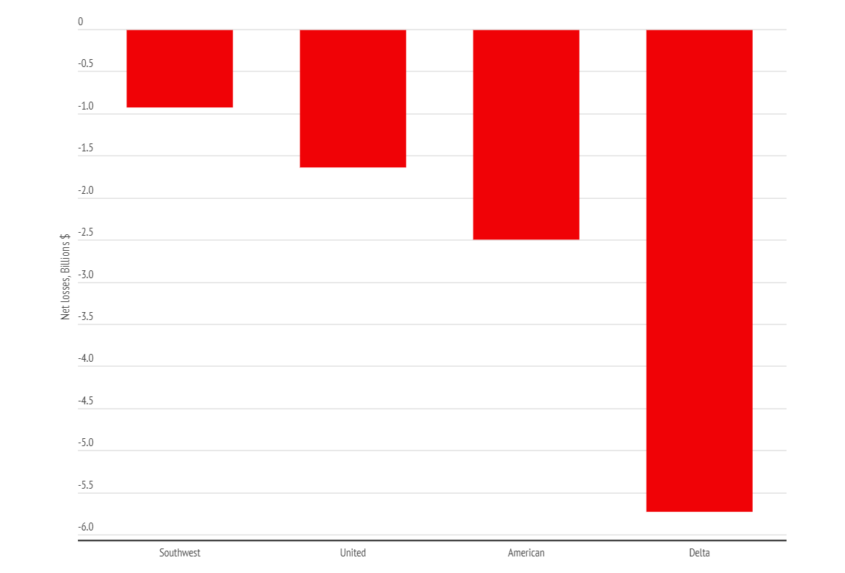
Figure 1
（Figure from Aerotime hub）

2. Strategy formulation analysis
To stand firm in the aviation industry and adapt to the changing environment, LUV needs to be determined by the external macro and internal micro environment, the company's organizational ability, and the ability to execute and implement the strategy.Enterprises are diversified, and they need to manage and deal with various internal departments, as well as cooperate and compete with other enterprises. Therefore, in modern business environment, enterprise strategy is a subject of great academic significance and practitioner importance (Feldman,2020).
The aviation industry is one of the most globalized industries. Many uncertain factors bring opportunities and threats to the aviation industry. Politics, technology, environment, economy, population, company culture, organizational structure, etc. will trigger changes in the aviation industry from different directions. Therefore, in order to ensure the sustainability, development potential, and greater economic and social benefits of the aviation industry, it is necessary to comprehensively analyze the external and internal environment of the aviation industry.

2.1 Analysis of the external macro environment
2.1.1PEST Analysis
PEST can formulate long-term strategic plans, update data every year, and quickly and easily evaluate the industry's market trends(Shtal, T. et al,2018). With the development of globalization, the flow of people and goods has become more automated and globalized, but the instability of the global environment may also lead to higher "walls" between countries. Every airline can't get rid of this big environment. The volatility of the global economy is unlikely to decrease in the next 30 years. Although the aviation industry already has a robust economic model, it also needs to transform new strategies to help companies monitor and prevent hazards.
Political Factors
Before 1978, the United States implemented air traffic control, but only supervised airlines flying across states. After 1978, the US government deregulated and the sky was liberalized. Only low-cost small airlines such as LUV could develop. The 2014 Wright Amendment Act was officially abolished. Thanks to this, LUV can increase more airline services. The political environment has profound influence on the operation of the global aviation industry.
In the face of the outbreak of the COVID-19 epidemic, the US government has also issued corresponding policies to help organizations tide over the difficulties. The 116th Congress of the United States passed and signed the Coronavirus Aid, Relief, and Economic Security Act (CARES Act, 2020) in response to the impact of the COVID-19 pandemic on the U.S. economy. Before the CARES Act is launched, LUV will accept a higher federal statutory tax rate. The Coronavirus Aid, Relief, and Economic Security (CARES) Act, created the Payroll Support Program (PSP1) for air carriers and certain contractors. And The Consolidated Appropriations Act, 2021, created the Payroll Support Program Extension (PSP2) for passenger air carriers and certain contractors(Payroll Support Program Extension ,2021).
Economic Factors
There are many macro factors affecting the aviation industry, such as the market economic cycle, economic system, economic development level and policy, social inflation level, etc. These factors determine the total demand and total investment in the US economic market. The aviation industry is very sensitive to fluctuations in the market economic environment, and demand is constantly changing. In particular, the aviation industry is greatly affected by fuel costs, and rising oil prices have a major impact on LUV' profitability. However, in the past ten years, the US economy has developed steadily, citizens’ incomes have grown steadily, and entertainment consumption has increased, stimulating consumption in the aviation industry. Therefore, the US aviation industry has maintained a steady growth rate. After the COVID-19 outbreak, the U.S. economy recovered in the third quarter, increasing by 33.1%. Although it has improved, it is not enough to offset previous losses, including a 5% year-on-year decline in real GDP in the first quarter, which marks the beginning of the 2020 recession. The sudden destruction of the economic environment is also fatal to the aviation industry.
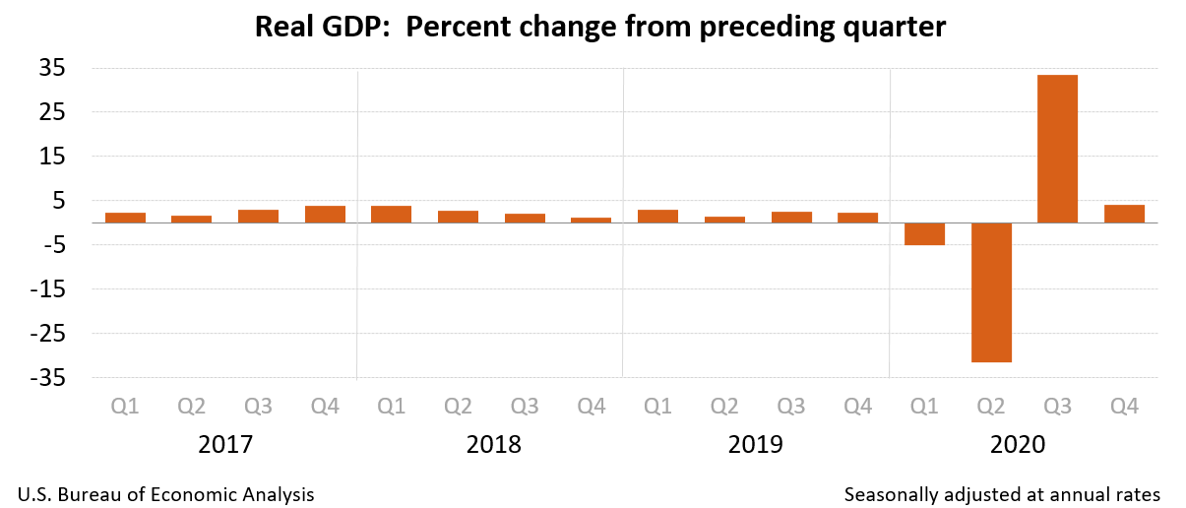
Figure 2
(Data resource from www.bea.gov)
Social Factors
The culture of society will greatly affect the culture of the company. LUV fully integrated the personality, psychology and culture of residents in different regions to design and promote products appropriately, which increased the company's affinity to a certain extent and gained the support and recognition of the general public. Whenever a strong competitor adopts unfair competition against LUV, people’s sympathy will start to favor LUV. At the same time, they will show solidarity and support to the company in various aspects, and will also increase the priority of LUV when travels. At the same time, LUV has invested a lot of resources in environmental protection and social welfare and other undertakings. Employees will also voluntarily donate to charities and participate in various community projects. All these demonstrate to the public LUV’ strong sense of social responsibility and deeds.
Technical factors
Companies should analyze the speed of industry and technology's impact at the same time. The speed of technology's impact will determine whether the company has enough time to make corporate decisions and help companies get more profits.
For the aviation industry, technology is an important determinant of industrial development. The safety performance, convenience, and efficiency of the aviation industry have attracted more and more attention from the industry. The aviation industry's technology mainly focuses on fuel efficiency, model research and development, and more intelligent and safe flight technology (Pratap, A., 2020).
In addition to the technology research and development of the aircraft itself, digital mobile services are also areas where LUV will invest more. Mobile digitalization is a major development trend in the future. The use of convenient and simple information transmission channels can improve customer satisfaction and experience.

2.1.2Porter's Five Forces Analysis
Porter’s Five Forces Model is based on industrial organization (IO) economics. Prior to a firm defining its business level strategy(Baxter, 2019), any organization should fully understand the power of its competitors when formulating its business strategy (Ahlstrom, 2010). Porter’s model focuses on the five forces in an industry (buyers, suppliers, new entrants, substitution, and rivalry) that impact each other. The collective strength of the five forces determines the ability of a firm competing in an industry to earn.(Porter,2008)
The Threat of Rivalry
Commercial aviation is one of the toughest markets with the lowest profit margins and strongest forces with established rivals competing vigorously on price and customers (Porter, 2008). In the market, every individual company is inseparable, that is, an ally is also a competition If you want to win in the competition, you must establish your own advantages. Therefore, companies need to flexibly and accurately determine their position (Porter, 2020).
As shown in Figure 4, competition in the aviation industry has become increasingly fierce, especially the four major airlines. Under the impact of the new concept of the epidemic, the differences in consumer groups have become smaller. In the context of economic recession, competition among similar airlines will gradually intensify. JetBlue's aviation quality rating and satisfaction are also gradually increasing, which means that consumers have begun to shift, and user loyalty is worth pondering (Airline Quality Rating 2019, 2019).
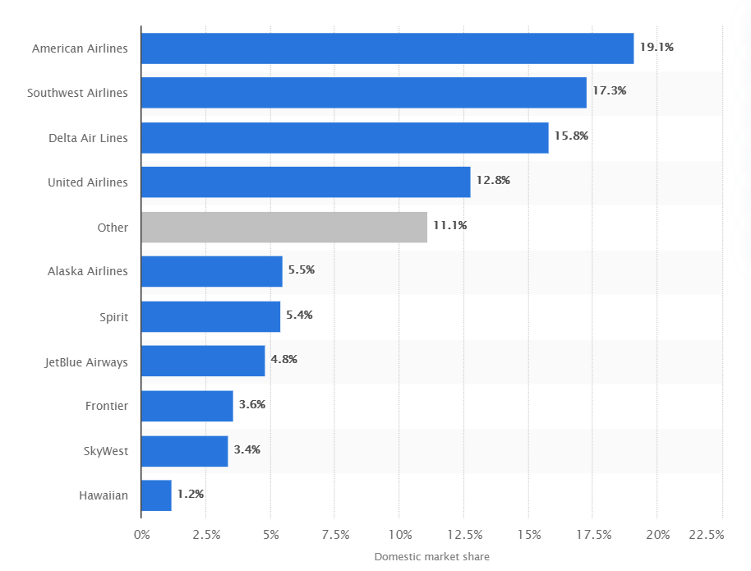
Figure 3
(Figure from Statista.com)
Domestic market share of leading U.S. airlines from December 2019 to November 2020

According to Pest’s Political Factors analysis, after the deregulation of the aviation industry, competition within the industry pushed fares to such a low level that many airlines only bear variable costs. The aviation industry has high costs and low cost variability, so such companies can make profits by allocating fixed costs to multiple output units (such as air tickets). For airlines, this combination creates an impetus for economic growth. Therefore, such economies of scale have led to a monopoly of a few large airlines. Therefore, low-cost airlines stepped in and reintroduced market competition. Many low-cost airlines including Spirit Airlines and Frontier Airlines began to expand their routes (Maidenberg, 2017). Such carriers increase market competition by catering to price-sensitive flyers. Since "economy class" passengers are a large proportion of all passengers, this group of people has become an attractive target group for many airlines.
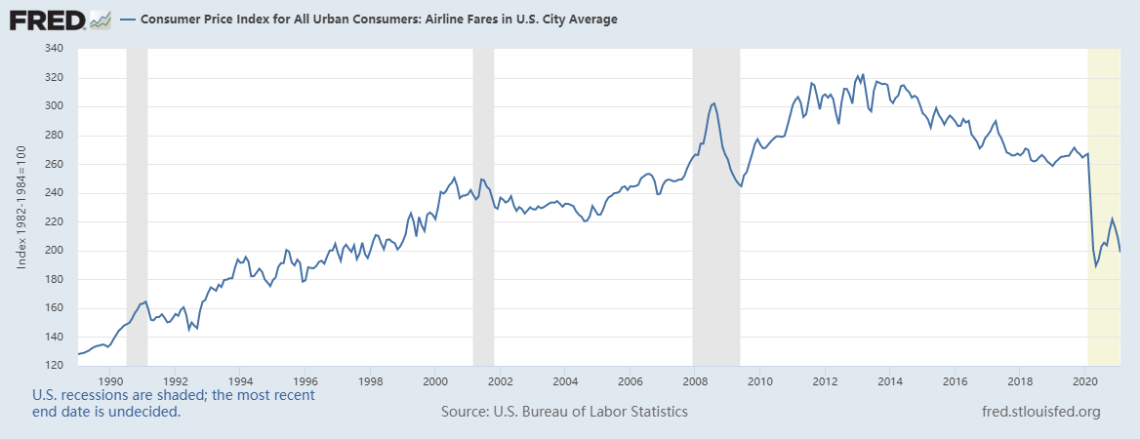Figure 4
(Figure from fred.com)
The Threat of Bargaining power of the supplier
In the following situations, suppliers can bargain with buyers: only a few large companies have the right to supply; there are no comparable substitutes; the buyers are just scattered customers; the products purchased are necessities of the buyers; the products of the suppliers account for A large proportion of the operating costs of the buyer's company; supplier integration, and the possibility of entering the company's industry is very high.
The fixed cost of aviation is very high, mainly including the purchase and maintenance of the aircraft fleet (Scott A. Wolla, 2018), and LUV only uses Boeing 737 series aircraft, which means that Boeing is the only supplier of LUV. The operating cost of aviation does not rashly increase other aircraft, so there is no better alternative. In this way, Boeing has almost 100% price control power, while LUV can only passively "be beaten" (Pratap, A., 2020).
The Threat of Bargaining power of buyers.
Buyers have strong bargaining power with airlines because the cost and effort required to switch from one carrier to another is very small. In particular, the emergence and popularity of third-party travel booking websites and smartphone applications have exacerbated this problem for airlines. LUV was established in 1967 at a time when the American population was migrating, and the demand for airplanes by the crowd rose rapidly. LUV has also become one of the many options for travel. In addition, in the mid-1970s, 1980s, and early 1990s, the United States was plunged into an economic crisis and an oil crisis one after another, and the low-fare LUV became a favorite of travelers (Lohmann ,Spasojevic, 2018).
The Threat of Substitutes
Road transportation and rail transportation such as cars and buses are the most threatening alternatives to air transportation. Compared with airplanes, they are cheaper (Wang, Yixiao et al., 2020), so LUV has taken care of this. To reduce costs, thereby reducing the price of his air tickets, allowing more customers to choose airplanes instead of railways and roads. In contrast, the safety of aircraft is also higher.
Although road and rail transportation are cheaper, LUV has similar prices, but it saves time and is more convenient. From this point of view, other alternatives are not yet replaceable, and the threat of substitution is weak.
The Threat of New Entrants
The establishment of airlines has a huge principal, fierce price battles and a profit model of high costs and low profits, making it more difficult to make money in this industry. Therefore, it is normal for airlines to suffer losses. If they want to enter the aviation industry, they need to adapt and reduce losses as soon as possible (Ma, Chao, 2019). In addition, the competition for take-off and landing positions at US airports is fierce, and it is difficult for new entrants to obtain it. LUV has already taken the lead in the market by virtue of its unique strategy. Coupled with the special regulations of the aviation industry, potential threats are relatively small.

2.2 Analysis of internal micro-environment
2.2.1 Analysis of resources and capabilities (VRIO framework)
Want to analyze the internal micro-environment of LUV more clearly, use the VRIO framework for analysis. The VRIO framework is designed to evaluate a specific organization based on a resource-based perspective (Barney, 2007). The competitive advantage of an organization depends on the company’s unique resources and capabilities. These resources and capabilities are not only valuable, but also rare, inimitable and Irreplaceable (Peteraf, Barney, 2003).
2.2.1.1 Resources
Brand
Branding is about the coordination of strategic vision, stakeholder image and organizational culture (Hatch, Schultz, 2014). In marketing, a brand is defined as "a link that reflects the set of functional and emotional value created by the company and how consumers perceive these values (Chernatony, Riley, 1999)." Customer service is the establishment of a respected service brand Crucially, at the same time, customers' love of the company's brand can indeed affect the company's profitability, which in turn affects higher brand value (Barker, R, 2015). LUV Named to FORTUNE's list of World's Most Admired Companies for 2020; ranked 14 (World’s Most Admired Companies, 2021). It was rated as the airline with the highest customer satisfaction in the "J.D. Power 2020 North America Satisfaction Study". It was named "Best North American Airline", "Best American Airline", "Best Economic North American Company" and "Best Low-Cost North American Airline" in the 2020 TripAdvisor Travelers' Choice Awards. Brand culture can connect the organization with the story behind it, so that consumers can truly connect the brand and its meaning, and become a part of consumers' lives(Hilgemann, E. 2019). When customers believe that these products are unique or superior to competing products, a competitive advantage emerges.
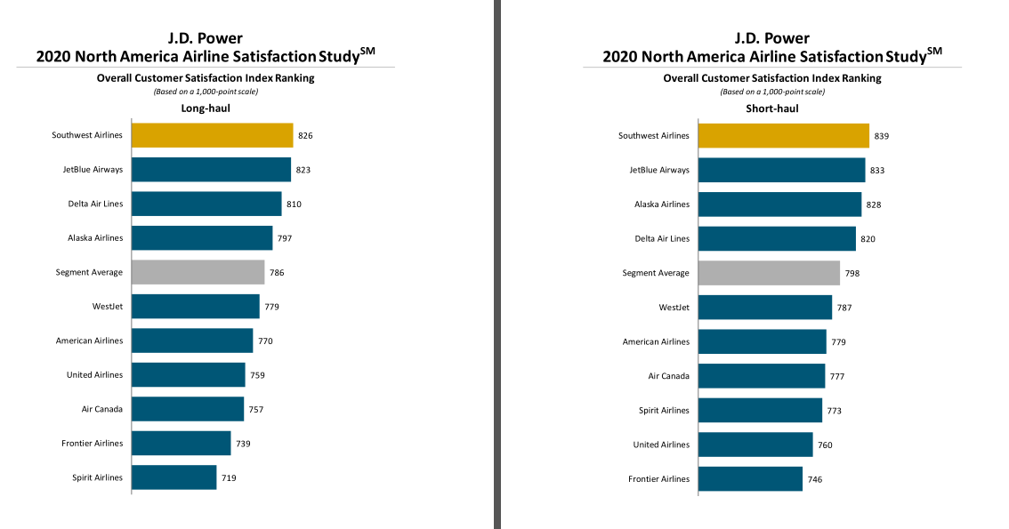
Figure 5
(Figure from J.D. Power 2020 North America Airline Satisfaction Study）
Customer data
In 2019, more than 134 million customers chose to fly LUV (2019 Southwest Airlines One Report). LUV provides another improvement in customer service by analyzing real-time data such as social media analysis. Their customers provide tailor-made quotes. With the help of big data, LUV knows when and through which channels to promote which products to which customers. This personalized experience can lead to higher conversion rates and increase customer satisfaction. LUV not only uses big data to provide the best customer service, but also uses big data to improve air safety.

Human Resources
Human resource management includes recruitment, salary, performance, training, allocation and many other aspects. Research shows that employees’ knowledge and abilities are one of the company’s effective strategic resources and can directly affect the company’s benefits (Crook et al., 2011). Of course, the unique dedication demonstrated by LUV employees has contributed to the company's outstanding performance over the decades.
The lack of pilots is a potential industry shortage threat in the future, and entry barriers such as cost and time hinder many people from pursuing the career of pilots. In recent years, army downsizing has led to a reduction in the number of qualified retired pilots. As the number of retirements in the aviation industry increases in the next decade, the demand for qualified professional pilots may increase. Therefore, LUV launched an innovative career plan called "Destination 225" in July 2019 (2019 Southwest Airlines One Report). The program aims to meet the current experience level of future high-potential pilots and provide ways to help them become highly skilled and qualified future opportunities at LUV.
In the face of the COVID-19, LUV introduced voluntary resignation plans and extended emergency leave options for its employees. More than 25% of the company’s employees plan to choose long-term leave or permanent resignation as the company’s response to the economic impact of the COVID-19. Part of the cost-saving measures taken. Approximately 4,400 employees chose the buyout plan, and approximately 12,500 employees expressed their interest in extending their holidays. This ensures a small loss of human resources and preserves the talent base for the full return of business travel routes.
Community
LUV' concern for the community is a natural extension of Southwest's people-oriented citizenship. In 2019, LUV donated 3,628 tickets through the Time Ticket Program. Donate a free round-trip ticket to qualified organizations every 40 hours. From 2013 to 2019, LUV Community Center plans to cooperate with the Public Space Project (PPS) to provide more than 4.4 million US dollars in grants and location production technical assistance to 20 organizations in the United States and Mexico City (2019 Southwest Airlines One Report). People through the continuous use of these public spaces can be transformed into brand cohesion and consumption vitality.

2.2.1.2 Ability
Sufficient funding and physical foundation
On December 31, 2020, the company’s current and non-current debt was 10.3 billion U.S. dollars. After deducting transaction costs, the company raised approximately 18.9 billion U.S. dollars. As of January 27, 2021, the company had cash and short-term investments of approximately 13.9 billion U.S. dollars. . The company has 718 aircraft, including 41 737 MAX 8 aircraft(2019 Southwest Airlines One Report).
Company culture
Culture is defined as "a shared default hypothetical model that is learned by a team when solving its external adaptation and internal integration problems. (Schein, 2017). "LUV focuses on connecting people with important things in life, providing customers with excellent services, and thus becoming the best airline. In the introduction of LUV' website, you can know that they divide the values of the organization into two categories: living the way of LUV and working the way of LUV. They emphasized that employees need to have the spirit of warrior, the heart of servants and the attitude of loving life, which is the way of life of LUV. At the same time, it also emphasizes that employees need to work safely, win customers, and maintain low costs. This is the way LUV works. This kind of corporate culture seems to stimulate the enthusiasm of employees, thereby improving service quality, customer satisfaction and profitability. From 1973 to 2019, Southwest has turned losses into profits every year. He is also the only company in the United States with such a corporate culture (Schleckser, 2018).
Technology
LUV plans to provide GDS access for corporate travelers in 2020, and has now joined the Airline Reporting Corporation (ARC) ticketing and settlement services through Amadeus' GDS platform and Travelport's multiple GDS platforms (including Apollo, Worldspan and Galileo) . The company’s enhancement of the GDS channel strategy complements the direct connection (NDC) exchange and the existing SWABIZ option expanded through the airline tariff issuing company (ATPCO)’s new distribution capabilities, with the aim of reaching more corporate travelers through its preferred channel Distribute its daily low-cost air tickets (Southwest Airlines, 2021).
In order to seek new insights into what happens during each flight, LUV became the first US domestic airline to use a big data system developed by GE Flight Efficiency Services (FES). The system uses cloud computing and cutting-edge software and analysis to run on a secure industrial Internet. It can use its flight analysis function to gain insight into each aircraft and flight to discover how the decision of each flight changes its profitability.
Airport network
The position of the airport in the carrier hub hierarchy will affect changes in the network structure and other markets to a certain extent. Therefore, airport community resources are one of the important values of airlines. The link between city size and air service is complex;The ways in which airlines provide services to cities of different sizes are worth exploring (K. O 'Connor, 2013).The configuration of nodes and contact methods between airports determine the configuration of the entire airport network.LUV flights are evenly distributed across several major airports, with more flights connecting outside the community, so LUV has less impact on the airport community.(Wu,W, 2019).LUV is a typical low cost airline.It offers limited service at low prices in specific parts of the network (such as regional airports) and is dominant mainly on a peer-to-peer basis.The old operation mode and strategy can not adapt to the new environment, and the network structure needs to be adjusted. So in general, LUV' flight scheduling has higher frequency and flexibility, which makes branch routes more important and has a greater impact on the robustness of the entire network.
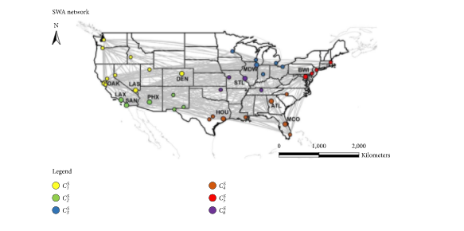
Community detection of LUV networks
Figure 6
(Figure from Wu, W)
In the aviation industry, a variety of customer attraction strategies and marketing strategies coexist with low prices and high-quality services. However, a large amount of customer information that can be accurately analyzed, the company's cultural philosophy that treats employees as family members, and a strong human resources and material foundation are difficult to imitate for other airlines and have important values. These advantages help LUV accurately locate customers and provide a better user experience. At the same time, LUV has further consolidated and expanded its position in the U.S. aviation industry based on LUV' strong investment and learning in various aspects of technology, community, and airport network.

3.The limitation of the strategy implementation process
Strategy implementation is to assign a strategic plan to practical actions, which is more important than strategy formulation. Because in the actual implementation process, various unexpected situations will be encountered.
3.1 Over-reliance on Boeing 737 MAX aircraft
Since the airline's Boeing 737MAX plane crashed, the Federal Aviation Administration has ordered a ban on such planes. However, LUV is an airline that relies heavily on Boeing aircraft, and the grounding of Boeing aircraft has had a serious impact on the company's route network expansion plan. This effect has led to a decline in company revenue (Anon, 2016). In the face of the decline in capacity caused by the new crown epidemic, as of December 31, 2020, the company has temporarily stored 60 737-700 aircraft and continues to discuss with Boeing to reorganize its orders after 2021.
3.2 Income imbalance
According to LUV’ annual financial report, in 2019, passenger revenue accounted for 93% of total revenue, freight revenue was less than 1%, and other revenue accounted for 6% of total revenue（2019 Southwest Airlines One Report）. Because the income ratio is so uneven, any obstacle to the tourism industry or other emergencies will bring a huge disaster to LUV.
3.3 Subject to the control of the US market.
Since LUV does not provide any international flights, many factors that determine revenue (such as passenger flow and order volume) are completely controlled by the US domestic market

4.Analysis of Customer Needs and Strategies Under COVID-19
According to the above analysis of LUV, after the COVID-19 outbreak, the most obvious blow to airlines is the plummeting of the number of flights, the number of tourists, and the trust relationship between tourists. As the external environment changes, the potential needs of customers and the customer strategy formulation industry change accordingly. According to Maslow’s hierarchy of needs theory, customer requirements for LUV mainly come from the following 7 aspects: Transportation Safety Requirements; Service Time Requirements; Service Attitude Requirements; Facilities Requirements; Product and Service Functional Requirements; Economic Requirements; Service Information Requirements( Wu, et al, 2013)(The detailed analysis table is in the appendix).
However, under the COVID-19 environment, the needs of LUV customers have changed. The first is Transportation Safety Requirements. Customers pay more attention to hygiene and safety. This is due to the changes brought about by the virus characteristics of COVID-19. The second is the Economic Requirements. Not only the LUV, but the entire U.S. aviation industry has seen a significant increase in the rate of refunds and changes. The third is Service Attitude Requirements, because the increase in flight cancellation rates leads to increased customer dissatisfaction, so a friendly after-sales service attitude has become more important. Finally, there is Service Information Requirements. The degree of flight changes has increased, so the demand for timely update of information has also increased.
Customer flow is an important factor to ensure airline profitability. Therefore, in this special period, maintaining good customer relationships, stabilizing customer trust relationships, calming customer psychology, and actively solving customer problems are important measures to ensure customer churn rate (Amankwah- Amoah, Joseph 2020). Especially in mainstream crises, communication is very necessary and vital (Miller, Michael, 2020). Therefore, LUV can adopt the following customer strategies:
First of all, a good customer experience is one of the ways for AirAsia to gain competitiveness among many airlines. LUV should ensure that it provides safe and good services during the COVID-19 pandemic and maintains good remote communication with customers.
Secondly, strengthen the application of information technology. From airport configuration to employee office to customer service, it is necessary to adopt the technical solutions of the aviation industry to deal with the epidemic, formulate a recovery plan to improve the new crown pneumonia epidemic, and meet customer needs. Digitization and networking will inevitably be the general trend of future enterprise development and the only way to go. LUV currently supports online and application ticket purchases, and can also add more digital projects, including route optimization, flight forecasts, passenger flow forecasts, online services, etc. It can not only facilitate customer travel and improve customer satisfaction, but also help LUV reduce business costs by improving business efficiency and more refined flight management.

5.Recommendation and Conclusion
The spread of COVID-19 inevitably caused most flights to be grounded, posing an unprecedented threat to the aviation industry. With the gradual control of COVID-19 and the continuous development of airlines and governments, many airlines’ losses have improved compared to a year ago, but huge challenges remain. Before the demand for business travel is fully restored, LUV needs to try a new way out. The purpose of adding new routes and airports is to capture a small number of leisure consumers and their income, not to increase the most profitable routes. As all airlines are in a state of continuous losses, the expansion of business scope has given greater opportunities for profit. At the same time, LUV still needs to focus on maintaining customer loyalty, reducing customer churn rate, and making adequate preparations after the full resumption of flight operations. Therefore, LUV needs to correctly determine the challenges the company faces and the business goals that need to be completed after the new concept of the epidemic. However, the current technological innovation has broken industry restrictions and brought unlimited advantages to the world. Therefore, LUV should focus on all channels and give priority to digital experience. Multiple channels will increase consumer satisfaction during the journey. LUV needs to learn from artificial intelligence and big data analysis to ensure that it meets customer expectations that have changed after COVID-19. Nowadays, airlines no longer provide simple transportation and ticket sales services, but add derivative value-added services contained in a sense of experience, security, service, and convenience. The main body and main consumers of these services are passengers. Cars should make full use of the developed Internet to provide passengers with better and more convenient services, thereby creating greater value for the company, attracting customers, and enhancing market competitiveness.For example, LUV can use data to collect and analyze consumer travel interests in the past, and provide multiple choices of flight schedules or alternative plans to reduce flights that have been grounded due to the epidemic. Waiver, adjust and cancel fees and allow convenient rebooking will help increase brand awareness, customer feedback and eliminate any confusion for those who wish to book future trips . LUV needs to review the company's strategy customization to ensure that it provides the best service and maximizes the company's value.

References
Company introduction
Southwest Airlines is a passenger airline headquartered in Dallas, Texas, providing scheduled air transportation services to the United States and its surrounding international markets. On June 18, 1971, Rollin King and Herb Kelleher founded LUV. The maiden flight from Dallas to Houston and San Antonio is a short-haul route, only providing a simple meal plan without additional services. Currently, the company operates 723 Boeing 737 aircraft in 101 destinations in 40 U.S. states and 9 international countries near the U.S. Compared with other domestic competitors, it is known for its "discount routes" and has been profitable every year since 1973. This airline has always stood out for its outstanding customer service, serving approximately 130 million passengers every year. As of January 2020, the company has approximately 60,800 employees.

- Ahlstrom, D.; Bruton, G.D. International Management: Strategy and Culture in the Emerging World;South-Western Cengage Learning: Mason, OH, USA, 2010.
- Airline Quality Rating 2019, Available at: https://commons.erau.edu/cgi/viewcontent.cgi?article=1029&context=aqrr
- Amankwah-Amoah, Joseph, 2020. Note: Mayday, Mayday, Mayday! Responding to environmental shocks: Insights on global airlines' responses to COVID-19. Transportation Research: Part E, 143, p.N.PAG.
- Anon, 2016. Southwest Airlines Co. SWOT Analysis. Southwest Airlines Co. SWOT Analysis, pp.1–11.
- Barney JB (2007) Gaining and sustaining competitive advantage, 3rd edn. Prentice Hall, Upper Saddle River
- Barker, R., Peacock, J., & Fetscherin, M. (2015). The power of brand love. International Journal of Market Research, 57(5), 669-672.
- Baxter, G. (2019). A strategic analysis of Cargolux Airlines International position in the global air cargo supply chain using Porter’s Five Forces Model. Infrastructures, 4(1), 6.
- Chernatony, L. D., & Riley, F.D. (1999). Experts Views About Defining Services Brands and the Principles of Services Branding. Journal of Business Research , 46 (2), 181–192. doi:10.1016/s0148-2963(98)00021-6
- Consumer Price Index for All Urban Consumers: Airline Fares in U.S. City Average https://fred.stlouisfed.org/series/CUSR0000SETG01
- Counting losses of US Big Four: who is hit the most? Available at: https://www.aerotime.aero/25491-counting-losses-of-us-big-four-who-is-hit-the-most
- Crook, T. R., Todd, S. Y., Combs, J. G., Woehr, D. J., & Ketchen, D. J. (2011). Does human capital matter? A meta-analysis of the relationship between human capital and firm performance. Journal of Applied Psychology, 96(3), 443–456.
- Domestic market share of leading U.S. airlines from December 2019 to November 2020.Available at: https://www.statista.com/statistics/250577/domestic-market-share-of-leading-us-airlines/
- Feldman, E. R. (2020). Corporate strategy: Past, present, and future. Strategic Management Review, 1(1), 179-206.
- Hatch, M. J., & Schultz, M. (2014, August 01). Are the Strategic Stars Aligned for Your Corporate Brand? Harvard Business Review . Retrieved from hbr.org/2001/02/are-the-strategic-stars-aligned-for-your-corporate-brand.
- Hilgemann, E. (2019). The Alignment between Corporate Culture and Branding in the Airline Industry.
- How Big Data and the Industrial Internet Can Help Southwest Save $100 Million on Fuel.Available at: https://www.ge.com/news/reports/big-data-industrial-internet-can-help-southwest-save-100-million-fuel
- J.D. Power 2020 North America Airline Satisfaction Study，Available at: https://www.jdpower.com/sites/default/files/file/2020-05/2020051%20N.A.%20Airline%20Satisfaction.pdf
- K. O’Connor and K. Fuellhart, “Change in air services at second rank cities,” Journal of Air Transport M
- Klebnikov, Sergei, 2020. Warren Buffett Sells Airline Stocks Amid Coronavirus: 'I Made A Mistake'. Forbes.com, p.N.PAG.
- Lohmann, G., & Spasojevic, B. (2018). Airline business strategy. The routledge companion to air transport management, 139-153.
- Ma, Chao, 2019. Does capital structure differently affect incumbents' responses to entry threat and actual entry? Journal of Economics & Management Strategy, 28(4), pp.585–614.
- Maidenberg, Micah. "How Low-Cost Airlines Alter the Economics of Flying." New York Times, September 1, 2017;Available at: https://www.nytimes.com/2017/09/01/business/budget-airlines-ticket-prices.html.
- Miller, Michael, 2020. COVID-19 Affects Oil and Gas. Business Credit, 122(5), pp.14–16.
- Payroll Support Program Extension (PSP2) Available at: https://home.treasury.gov/policy-issues/cares/preserving-jobs-for-american-industry/psp2
- Peteraf MA, Barney JB (2003) Unravelling the resource-based tangle. Manag Decis Econ 24(4):309–323
- Porter Analysis. 2020. Porter’S Five Forces Analysis Model Of LUV|Porter Analysis. [online] Available at: <https://www.porteranalysis.com/porters-five-forces-analysis-model-of-southwest-airlines/> [Accessed 14 December 2020].
- Porter, M.E.( 2008).Competitive Strategy: T echniques for Analyzing Industries and Competitors with a New Introduction;The Free Press: New York, NY , USA,=.
- Porter, M.E (2008) The five competitive forces that shape strategy. Harv Bus Rev. 86(1):78-93.
- Post-COVID-19 Customer Strategy Implications,Available at: https://www.pwc.de/de/im-fokus/customercentrictransformation/post-covid-19-customer-strategy-implications.pdf
- Pratap, A., 2020. LUV Pestel Analysis. [online] notesmatic. Available at: <https://notesmatic.com/2019/12/southwest-airlines-pestel-analysis/> [Accessed 14 December 2020].
- Pratap, A., 2020. Porter's Five Forces Analysis Of LUV. [online] notesm
- PUBLIC LAW 116–136—MAR. 27, 2020. Available at: https://www.congress.gov/116/plaws/publ136/PLAW-116publ136.pdf
- Schein, E. H. (2017). The Corporate Culture Survival Guide . John Wiley & Sons.
- Schleckser, J. (2018). Why Southwest has been profitable 45 years in a row. Inc. Retrieved from https://www.inc.com/jim-schleckser/why-southwest-has-been-profitable-45-years-in-a-row.html
- Scott A. Wolla, Carolyn Backus.2018.The Economics of Flying: How Competitive Are the Friendly Skies?. Available at: https://research.stlouisfed.org/publications/page1-econ/2018/11/01/the-economics-of-flying-how-competitive-are-the-friendly-skies/
- Shtal, T., Buriak, M., Ukubassova, G., Amirbekuly, Y., Toiboldinova, Z., & Tlegen, T. (2018). Methods of analysis of the external environment of business activities.
- Southwest Airlines Reports Fourth Quarter And Annual 2020 Results.Available at: https://www.prnewswire.com/news-releases/southwest-airlines-reports-fourth-quarter-and-annual-2020-results-301216824.html#financial-modal
- Southwest Airlines Uses Big Data To Deliver Excellent Customer Service. Available at: https://datafloq.com/read/southwest-airlines-uses-big-data-deliver-excellent/371
- Southwest Airlines. (n.d.). Culture. Retrieved from https://careers.southwestair.com/culture
- Southwest Reports Third Quarter 2020 Results. Available at: http://www.southwestairlinesinvestorrelations.com/news-and-events/news-releases/2020/10-22-2020-114529650
- Thomas, M, 2015. Strategic principles at LUV. Strategic direction (Bradford, England), 31(8), pp.10–12.
- Wang, Yixiao et al., 2020. Effects of introducing low-cost high-speed rail on air-rail competition: Modelling and numerical analysis for Paris-Marseille. Transport policy, 99, pp.145–162.
- World’s Most Admired Companies，2021. Available at: https://fortune.com/worlds-most-admired-companies/2021/search/?ordering=asc
- Wu, C., Zhang, X. Y., Yeh, I. C., Chen, F. Y., Bender, J., & Wang, T. N. (2013). Evaluating competitiveness using fuzzy analytic hierarchy process—A case study of Chinese airlines. Journal of advanced transportation, 47(7), 619-634.
- Wu, W., Zhang, H., Zhang, S., & Witlox, F. (2019). Community detection in airline networks: An empirical analysis of american vs. southwest airlines. Journal of Advanced Transportation, 2019

Appendix
1.PEST Analysis
Political Factors | Only low-cost small airlines could develop after the sky was liberalized; CARES act and support from the US federal government.
Economic Factors | The profitability is connected to the price of oil; Increase in individuals’ entertainment consumption leaded to an increase in aviation industry; Aviation industry is under attack because economic environment is destructed by COVID-19.
Social Factors | Specially designed products according to different regions gain support from public; people support LUV when it is under unfair competition; investments in environmental protection and social welfare show great sense of social responsibility.
Technical Factors | The use of convenient and simple information transmission channels supported by mobile digitalization can improve customer satisfaction and experience; fuel efficiency, model development and more intelligent and safe flight technology attract attention of aviation industry.

2.Porter's Five Forces Analysis
Five Forces | Analysis
The threat of Rivalry | Competition in the aviation industry has become increasingly fierce among similar airlines; recent economies of scale have led to a monopoly of a few large airlines; many low-cost airlines increase market competition by catering to price-sensitive flyers.
The threat of Bargaining power of the supplier | Boeing is the only supplier of LUV, which means Boeing has almost 100% price control power.
The threat of Bargaining power of buyers. | Buyers have a strong bargaining power because they can easily change from one airlines to another especially with the booking websites and smartphone applications.
The threat of Substitutes | LUV has similar ticket prices with those of road and rail transportation, but it saves time and is more convenient. So the threat of substitution is weak.
The threat of New Entrants | It is very difficult to make money in aviation industry due to the profit model of high costs and low profits; the competition for take-off and landing positions at US airports is fierce; there are some special regulations of the aviation industry, making potential threats of new entrants  relatively small.

3.VRIO Framework Analysis
Resource/Capability | Valuable | Rare | Difficult to Inimitable | Organized
Brand | yes | yes | yes | yes
customer data | yes | no | no | yes
Human Resources | yes | yes | yes | yes
Community | yes | no | no | yes
Sufficient funding and physical foundation | yes | no | no | yes
company culture | yes | yes | yes | yes
Technology | yes | yes | no | yes
Airport network | yes | no | no | yes

- 7 Level of Maslow’s Hierarchy of Needs theory
Transportation Safety Requirements | Safety of life, Property, Health, etc.
Service Time Requirements | Flight on time,Boarding, Waiting time, etc.
Service Attitude Requirements | Service Civilization, Friendliness, etc.
Facilities Requirements | Comfort, Cleanliness and Integrity of Ground and Aircraft Facilities Comfort, cleanliness and integrity of ground and aircraft facilities
Product and Service Functional Requirements | Destination, Arrival Time, Flight Density, Route Arrangement, etc.
Economic Requirements | Ticket Price, Handling Fee for Refund and Change, etc.
Service Information Requirements | Accuracy and Timeliness of Flight Information, Price Information, etc.

