Ian Brewis 1503509

Power Electronics And Drives
Module code: ACDA6004 Lecturer: Dr Steve Mosey
Contents
3
Abstract 4
Introduction 4
Literature Review 4
Power factor 4
Three Phase Inverters 8
Overcurrent protection 11
Method 12
15
Results 16
Discussion 20
Power factor correction 20
Power factor correction Fault. 22
Three phase Inverter. 23
Over-Current Protection 25
Single-Phase Synchronous Motor fault 28
Conclusion 31
Bibliography 32

Table of Figures


Abstract

This report is to gain understanding and test three different electrical power subject matters that are widely used in the electrical Power industry. The subject maters in the report are Power factor Correction, Three Phase Inverters and Overcurrent Protection. The report will document general principles and key points of theory in each of the subject matters by researching literature papers and validated sources. The gold is to prove the subject matter theory through experiments that replicate the conditions where readings and observations can be taken. The findings gained in the experiments will be documented in tables and later used in a discussion to reflect against the researched theory.

Introduction
In this laboratory experiment the concepts of three different electrical power subject matters were tested. The concepts were firstly, the ability to improve an inductive AC circuits power factor with the addition of capacitors. Secondly, how invertors generate AC waveforms with pulse width modulation. Lastly the operation of overcurrent protection. The method for each experiment with be explained and the results will be listed in tables and as visual screen shots. The results will be used to discuss the subject matters and with the aid of screen shots and math the concepts will be proven. The experiments are based around the ideas in the following literature review.

Literature Review

Power factor

Power Factor could be described as ratio of real or actual power (P) that is transferred to a load in an AC circuit. [1] When a reactive load is introduced into an AC circuit it introduces Reactive power (Q) into the circuit, this means that the circuits voltage and current will always be slightly out of phase, the more out of phase the less power is delivered to the load causing more current to be required. The resulting total power consumed in the circuit now will be the apparent power (S). [2]The more reactive power in the circuit increases the phase angle (ϴ). [3]

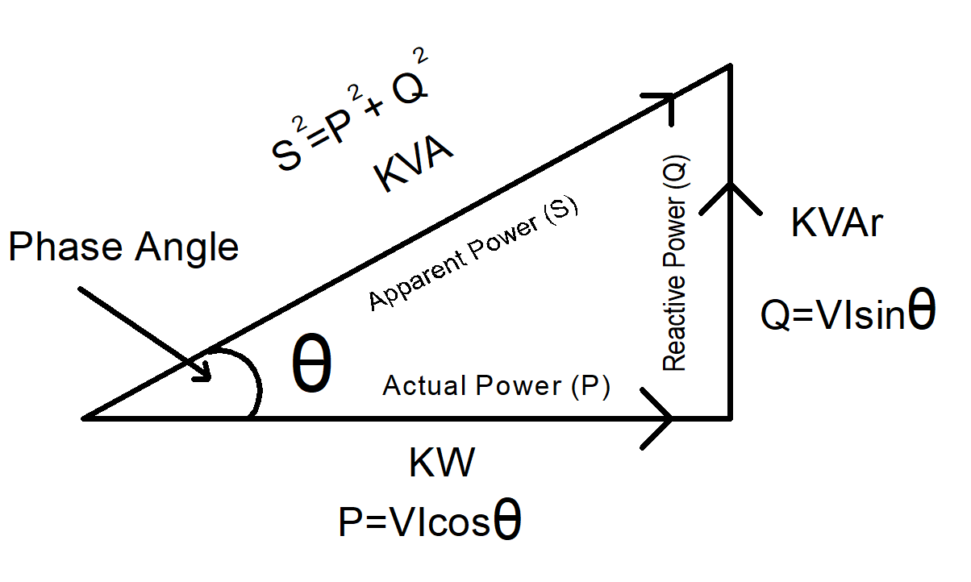
Figure 1 Power Triangle of an AC circuit.
Calculating Power Factor

Power factor is the ratio between the actual power being used and the apparent power being drawn.

Apparent Power = VI

Actual Power = VI cos(θ)

Power Factor = Actual Power
Apparent Power

Also, if the power factor is known the phase angle can be calculated.
Phase Angle (θ) = cos ⁻¹ x Power Factor
The power factor (PF) ratio sits between 0-1, if it was 1 this would mean that all the current in the circuit is in phase with the voltage and if the power factor was 0 this would mean that the current would be 90⁰ out of phase to the voltage. So, a PF of 1 would deliver all the power to the load because the voltage and current are in phase and the circuit would be 100% efficient. If the PF was 0 this would mean no power would be delivered to the load due to the current and voltage being 90⁰ out of phase and the circuit would be 100% inefficient delivering no power to a load. In reality the PF ratios in circuits sit between 1 and 0 and getting the power factor as close to one is desired because more of the power transferred from the source to the load is Real or Actual power.

Power factor correction in industry
Power factor and power factor correction are very important in industry and commercial business because they pay for electricity by KW kilo watts that they use, but they also pay an additional demand charge expressed as KVA kilo volt amperes. The KW represents the real or actual power and the KVA is the apparent power. The higher the KVA charge the worse the PF is so there is a real incentive to correct the PF to save money. Also having a poor PF requires more unnecessary current in a circuit, requiring thicker cables and machines will run at higher temp reducing the equipment’s life.

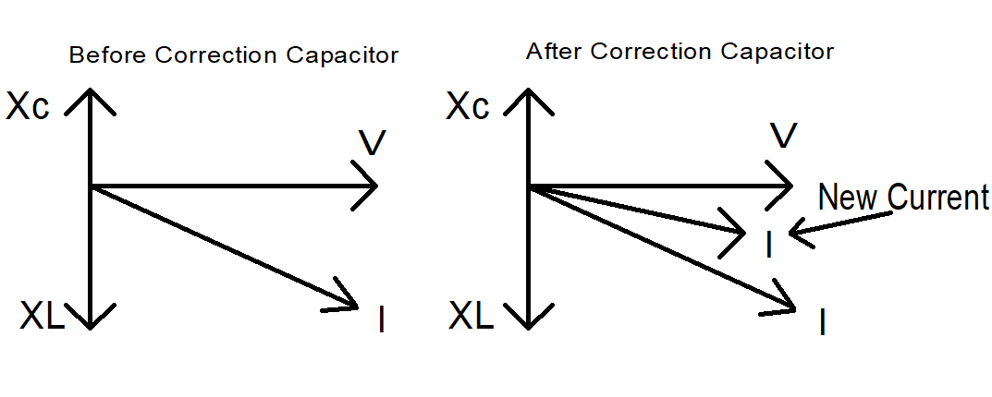
Figure 2 showing that current (I) is larger before and smaller after correction capacitor is added.
Application in industry
In AC circuits reactive loads can be either capacitive or inductive. However, in industry inductive reactance is far more common than capacitive reactance. Machines and equipment such as transformers, motors and lighting produce an inductive reactance through the magnetic flux. The result is that the voltage leads and the current lags.
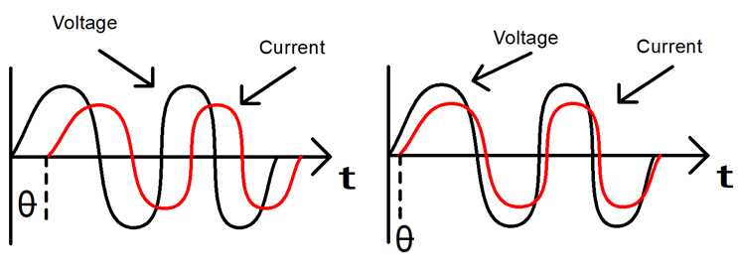
Figure 3 Voltage leading current.
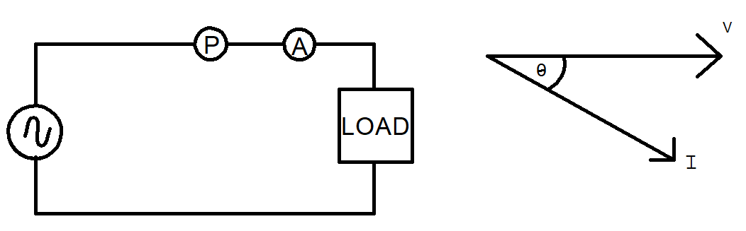
Figure 4 Inductive load in an AC circuit.
To counter this inductive reactance in the circuit and to bring the current and voltage phase closer. A capacitive reactance is introduced in the circuit by adding capacitor (Shunt) across the load.
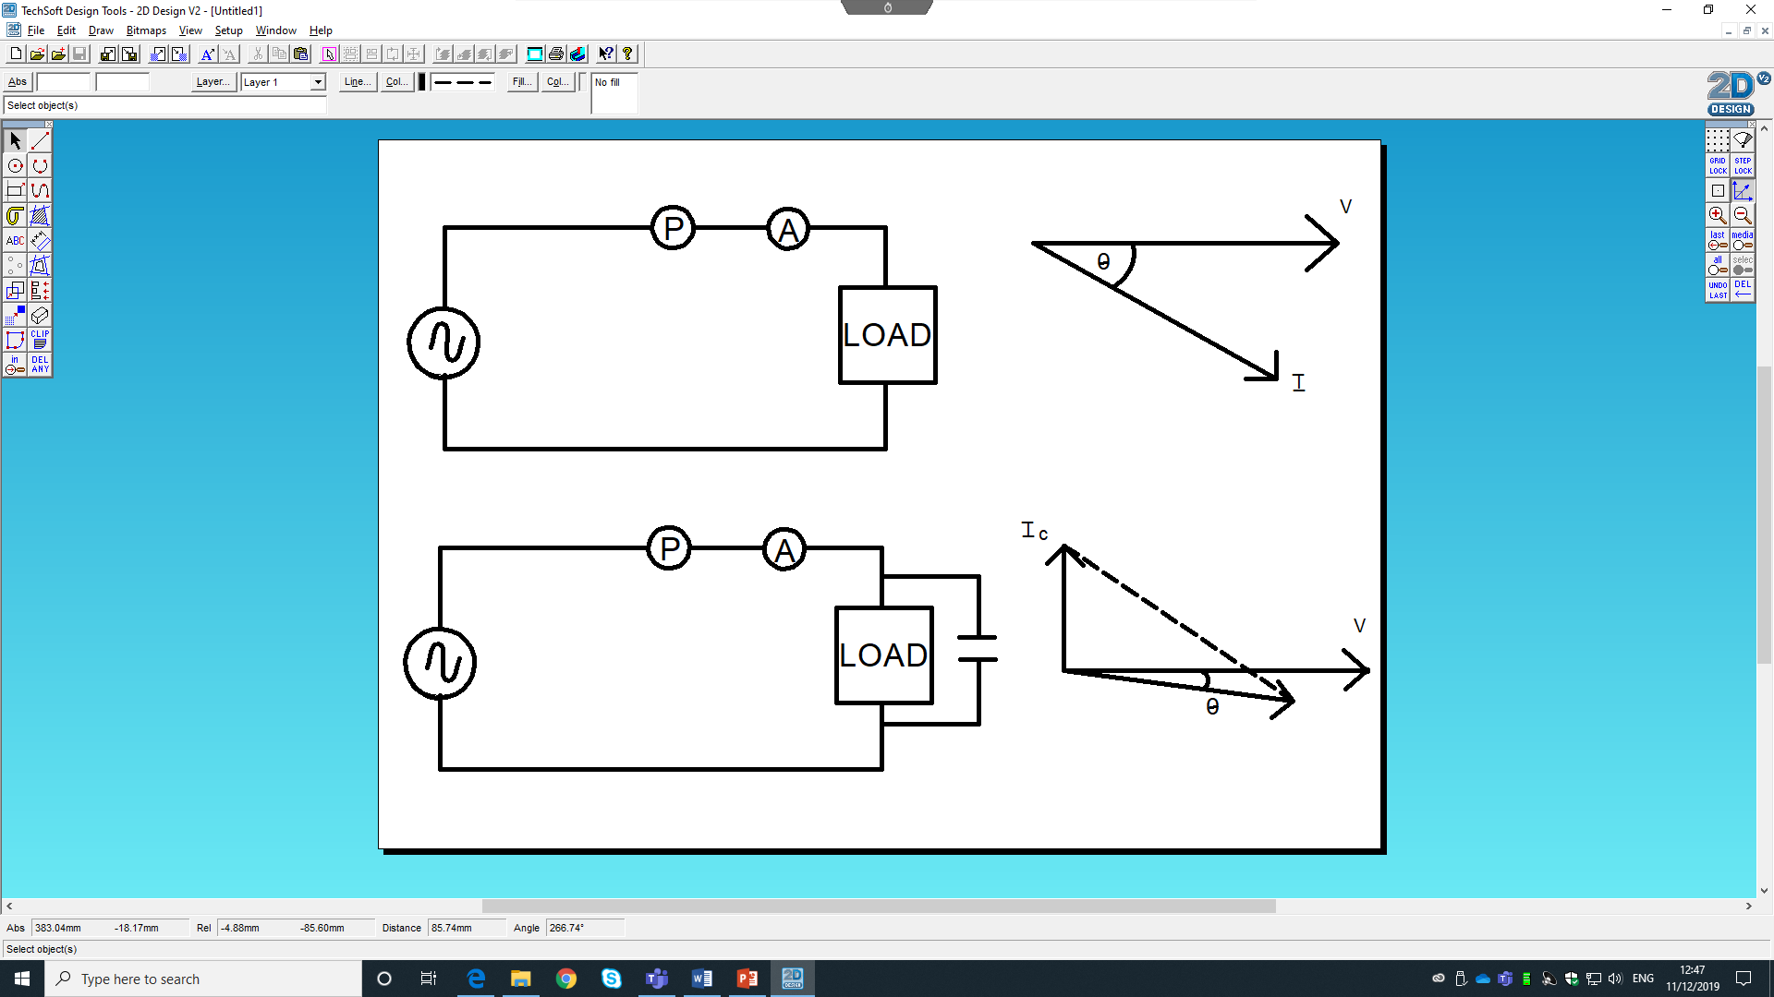
Figure 5 Inductive load with a capacitor placed in parallel across it to reduce its inductive reactance.
By placing capacitor across inductive loads the circuits reactive power KVAr can be reduced to make to circuit less inductive, this will reduce the apparent power in the circuit thus improving the circuits power factor.
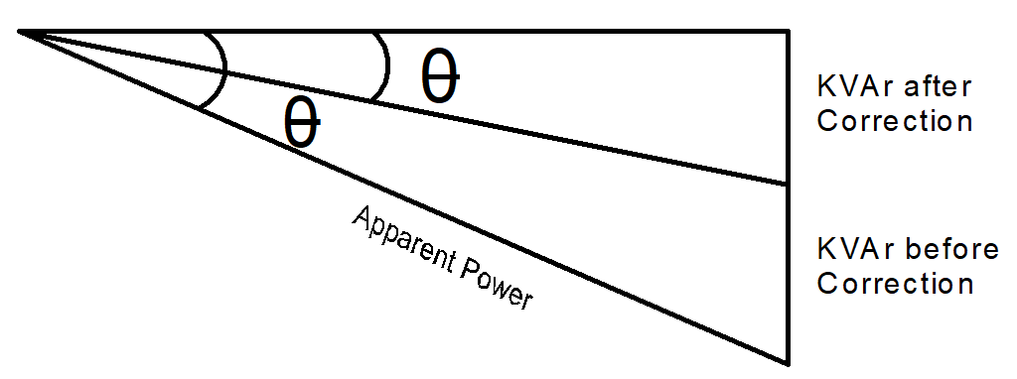
Figure 6 Phaser diagram showing difference in KVAr before and after correction capacitor and the effect it has on apparent power.

Before the capacitor was added to the inductive circuit the current was lagging the voltage; this would cause the circuit to not be able to deliver much power to the load. After the capacitor is added to the circuit the current is not lagging the voltage as much and more power can be delivered to the load reducing wasted power.

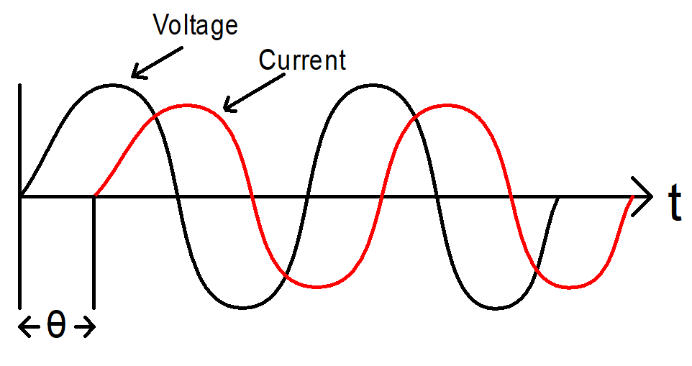
Figure 7 Voltage and Current waveform very much out of phase before correction capacitor.
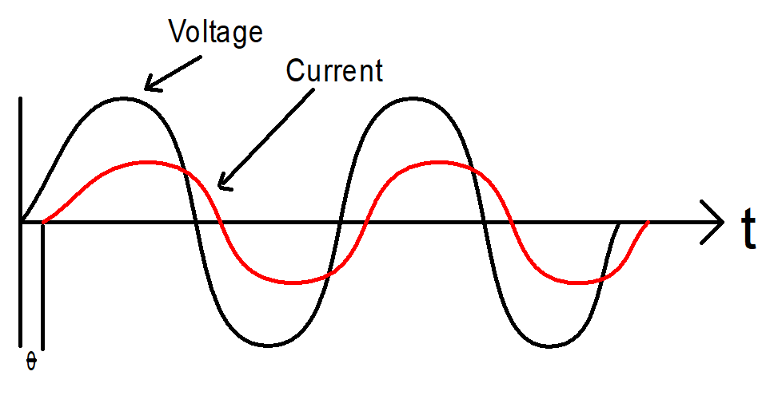
Figure 8 Voltage and Current waveform closer after correction capacitor.

To explain how PF is measured and how it is correct the following term will be used:
kW Kilo Watts This is the measure of Actual power (P) or real power that preforms useful work.
KVAR this is the Reactive power (Q) that motor relays need to produce the magnetizing flux and is none useful power.
KVA is the Apparent power (S) and the total power consumed.

Three Phase Inverters

An inverter is a device that is able to convert Direct Current DC in to an Alternating Current AC and also regulate voltage current and frequency.
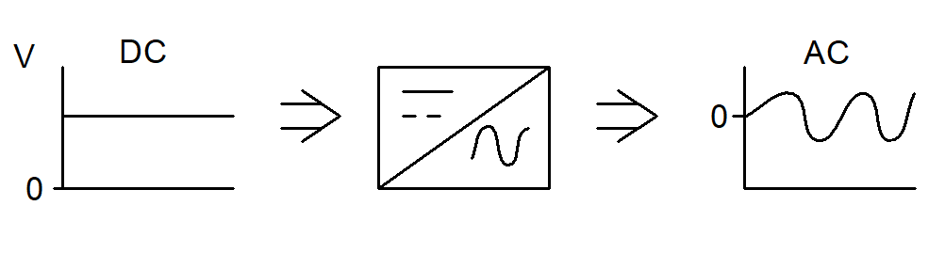
Figure 9 Direct Current converting to Alternating Current.

Three phase inverters are commonly used to convert the DC power produced by solar panels to AC so the power can be used to power AC appliances in domestic homes. Three phase inverters are used in vehicles to convert the DC power from the battery to AC power for small appliances. [4]
In industry, inverters are used to control speed, torque and direction by integrating them into variable frequency drivers for high precision and increased efficiency.

In powerful three-phase inverters the circuit works by using a controller to send signals to Insulated Gate Bipolar Transistors IGBTs telling them to open or close like switches.

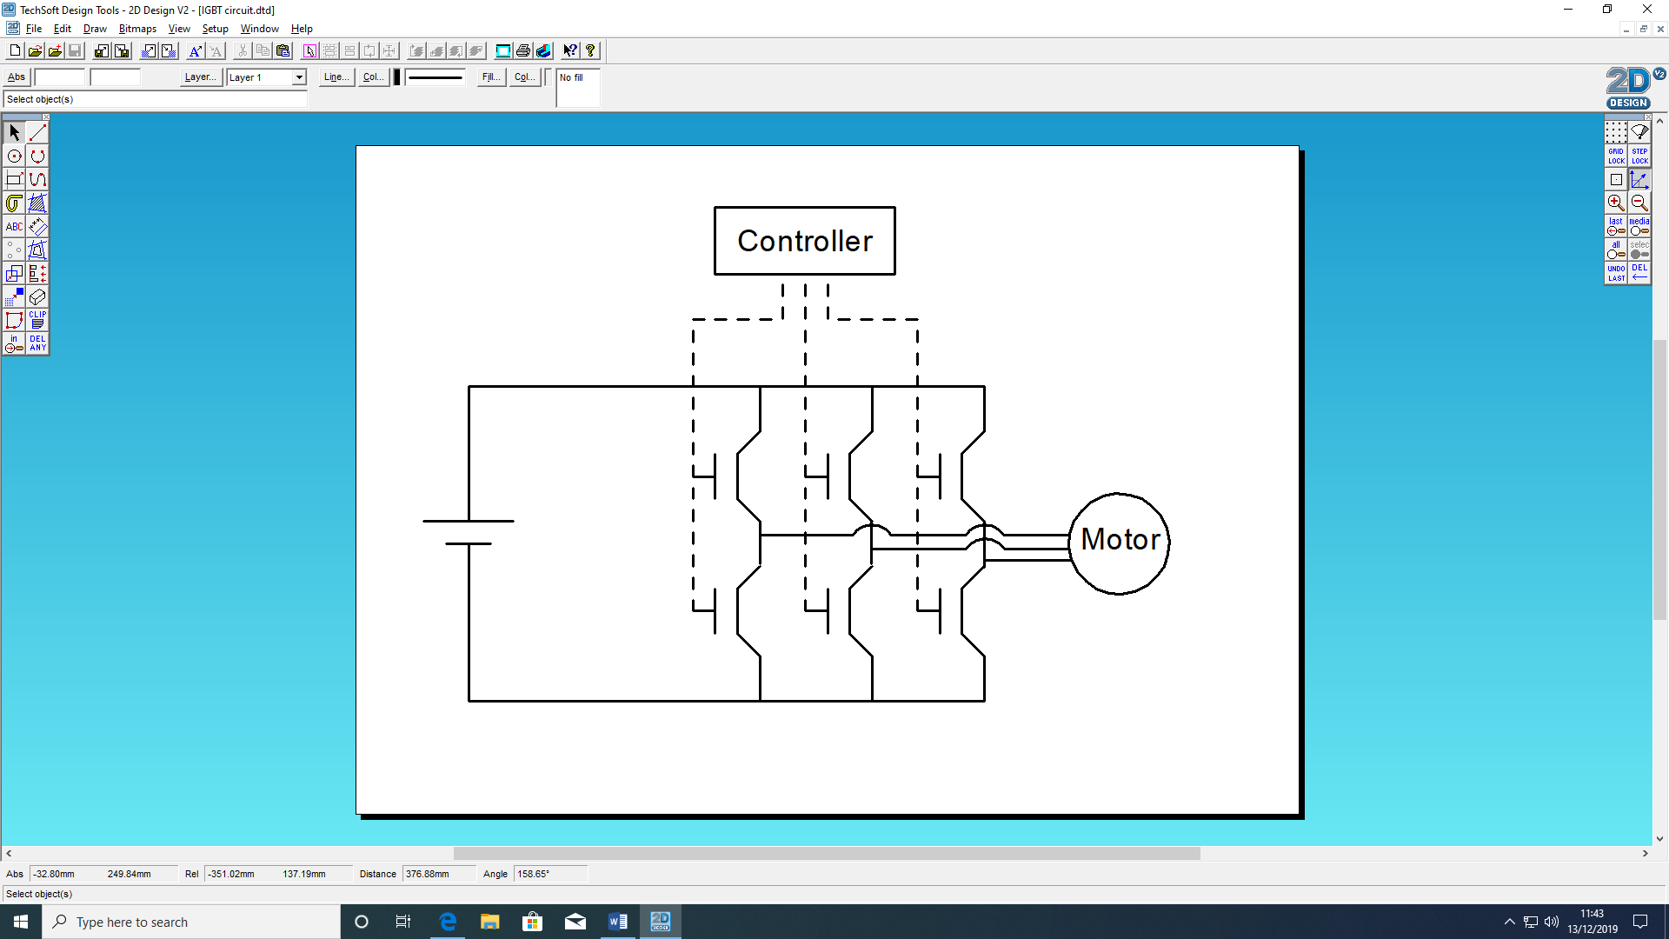
Figure 10 Basic inverter schematic.

The IGBTs are controlled in pairs and when controller tells them to close, current can pass through them allowing power to the motor. For an AC wave form to be created the controller follows a set cycle of opening and closing pairs of IGBTs.

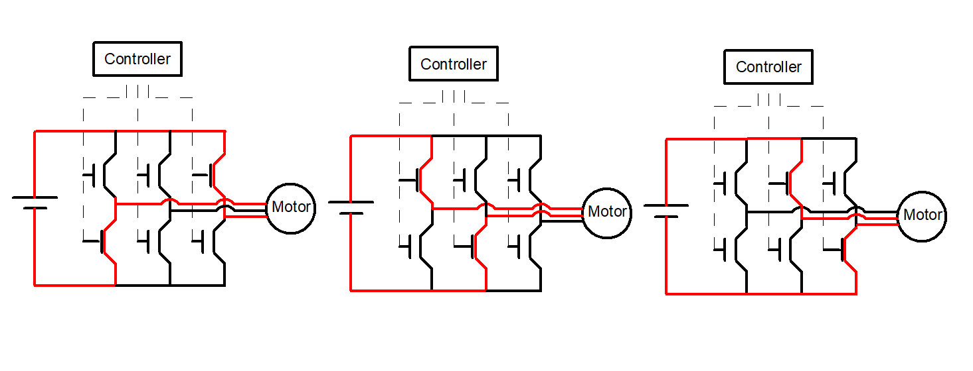
Figure 11 Showing different paths current takes when paired IGBT are activated by controller.

The speed is controlled by the controller telling pairs of IGBTs to open and close for varying amounts of time; this happens multiple times each cycle known as Pulse Width Modulation PWM. By doing this the cycle is broken up into multiple segment with the controller telling the IGBTs how long to open or close for.

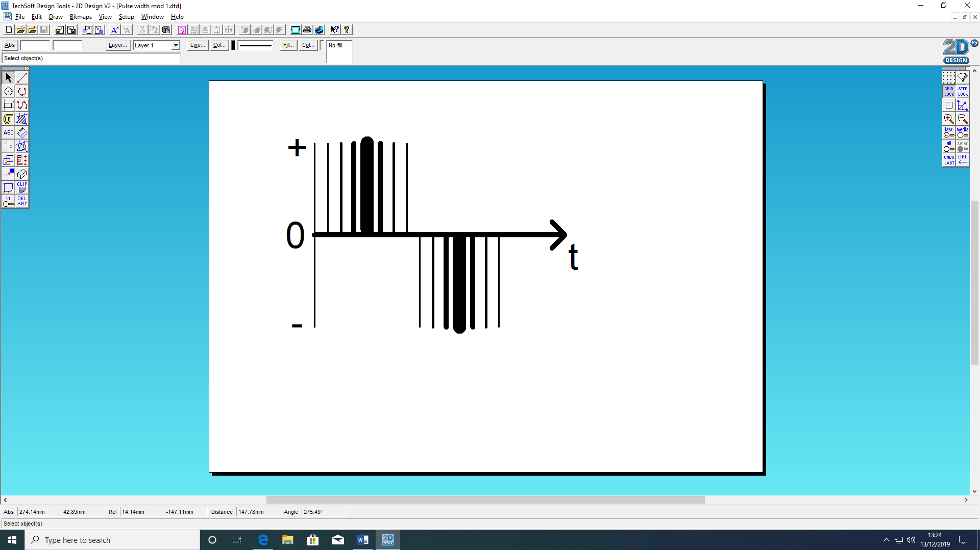
Figure 12 Current pulses produces by the controller opening and closing paired IGBTs.
By breaking the cycle up into many different segments, the IGBT can allow varying amounts of current to flow through the circuit and into the motor. This will produce an average amount of power over each segment. The result is that the motor will experience a sine wave.

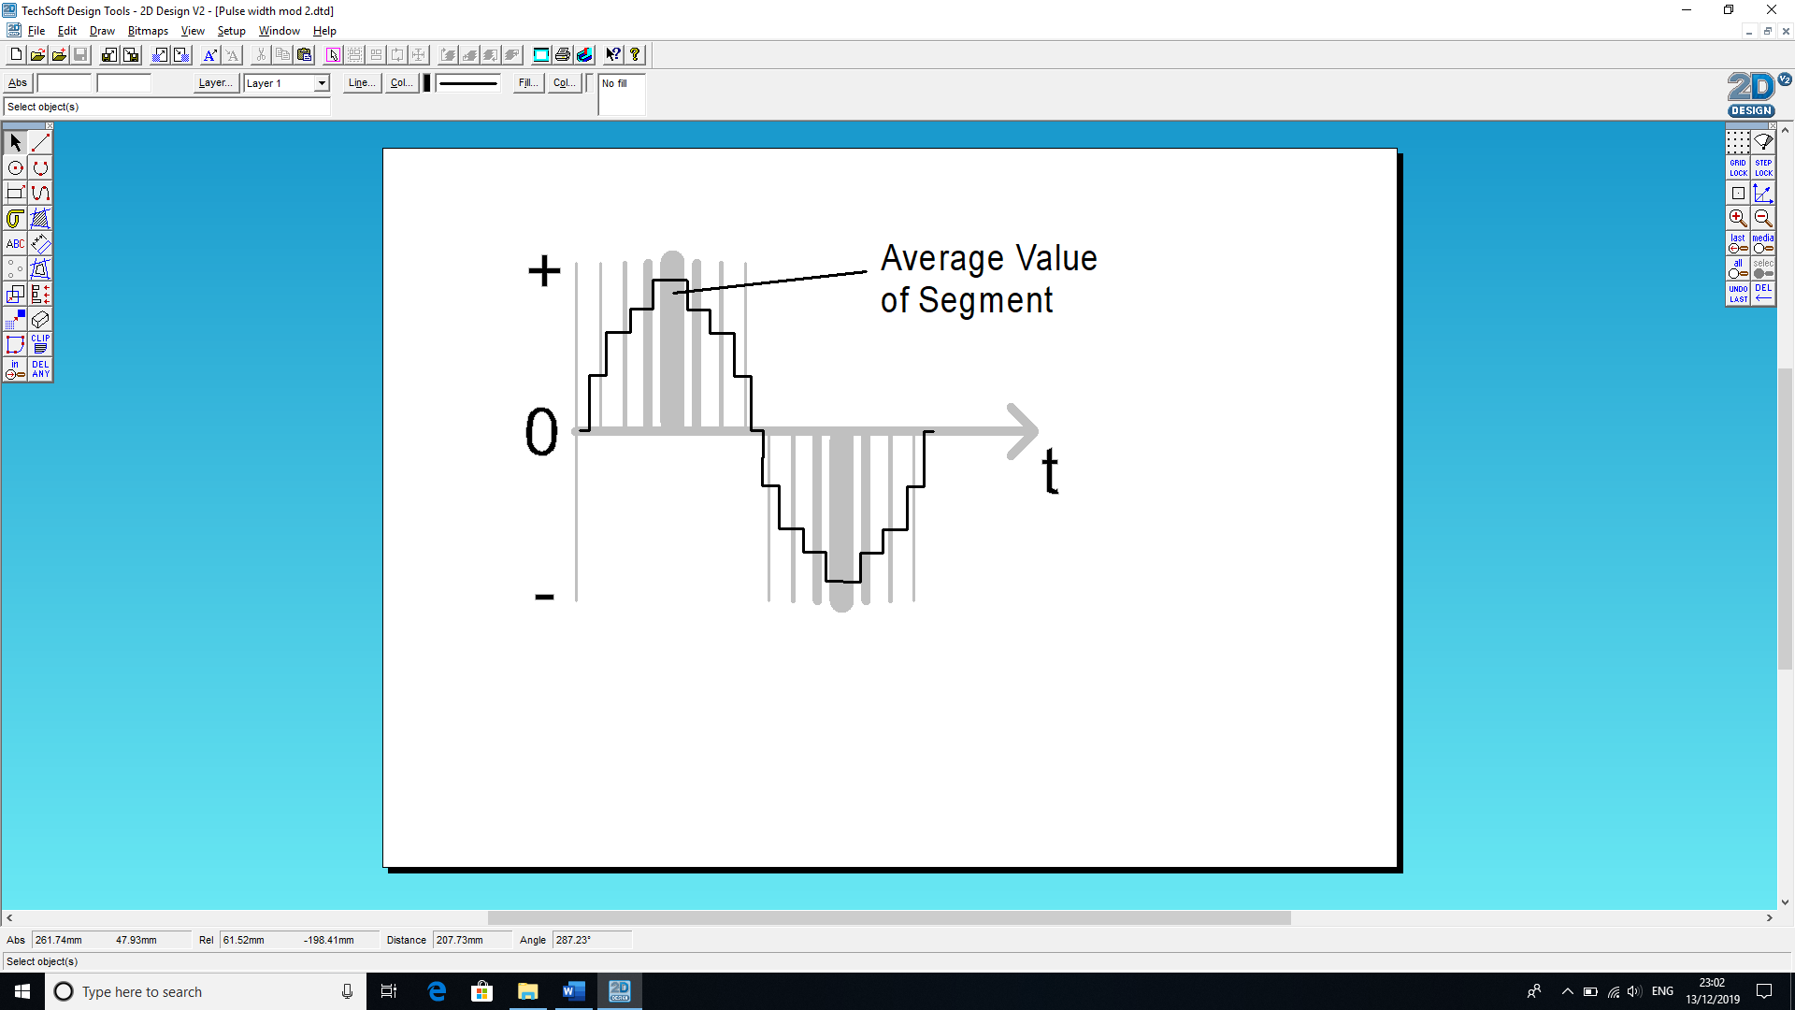
Figure 13 Current pulses average out into a staggered waveform.
The controller can change the output voltage by changing the amount of time the pulses are on or off. The longer the pulses stay on for the wider the pulses are so they average out a higher voltage output. Figure 14 shows how the pulse widths average out to form a sine waveform, the wave form in figure 15 has narrower pules widths due to the controller reducing the time the IGBTs are switch on for.
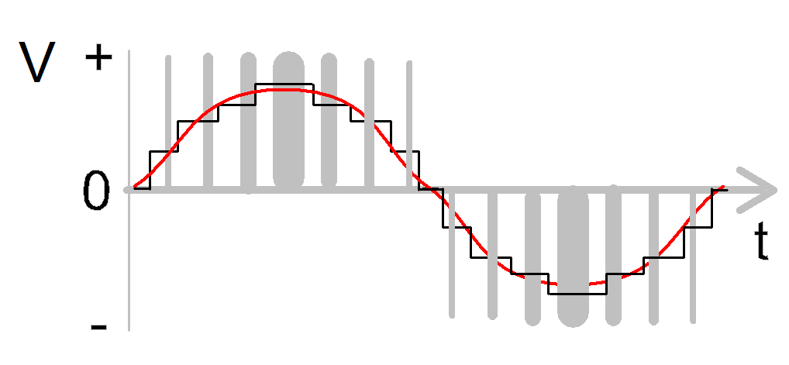

Figure 14 Outline of waveform produced by PWM.
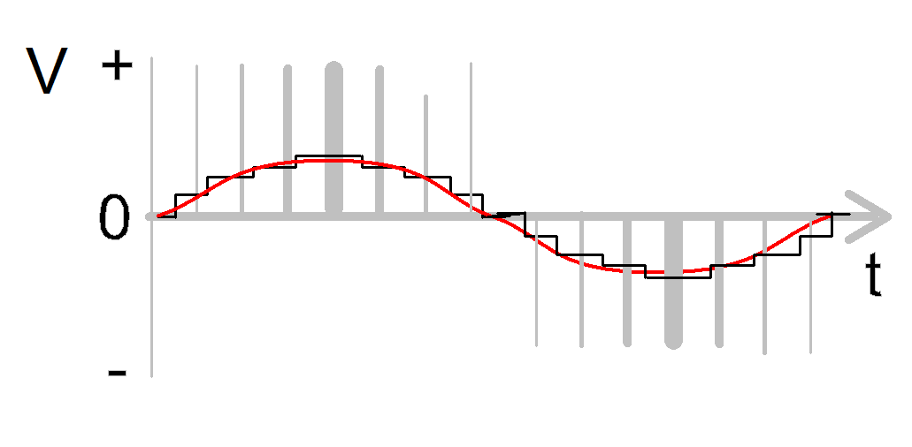
Figure 15 Same wave frequency as figure 14 but Narrow Pulses producing lower output voltage.

Overcurrent protection

Overcurrent protection is the means by which the circuit or system is protected from unintended excessive currents that could cause the system excessive heat leading to fire or components damaged or failure. [5] The common cause of overcurrent is overloading the circuit or by a short circuit and ground faults. Overcurrent protection devises are designed to protect the system by opening the device when the current reaches a set value that could cause excessive temperature in the system. They are generally fuses or thermal-magnetic circuit breakers that can respond to overcurrent, short circuit and ground faults. Some protection systems will break the circuits current path as soon as it reaches a set current limit. There are also protection systems that allow excessive currents for a set time period or up to the point when they reach certain thermal temperature and only break circuit path if the current stays at the excessive level past the time period or temperature. An example of this are the inductive machines such as large industrial motors that require very large start-up currents that can exceed the protection device current rating, but once up to speed the current reduces to an acceptable current level. Thermal circuit breakers work by disconnecting the circuit when the high level of current heats a bimetal that deflects (switches or bends). Thermal circuit breakers are well suited to motor and fans and transformer due to their initial start-up requirement of large currents due to small impedance, but then current reduces once back emf rises causing impedance to rise. [6]

Method
Power Factor correction
The circuit was constructed using 16 LJCREATE Virtual instrument platform. Observations and reading were taken visually using oscilloscope measuring tools.

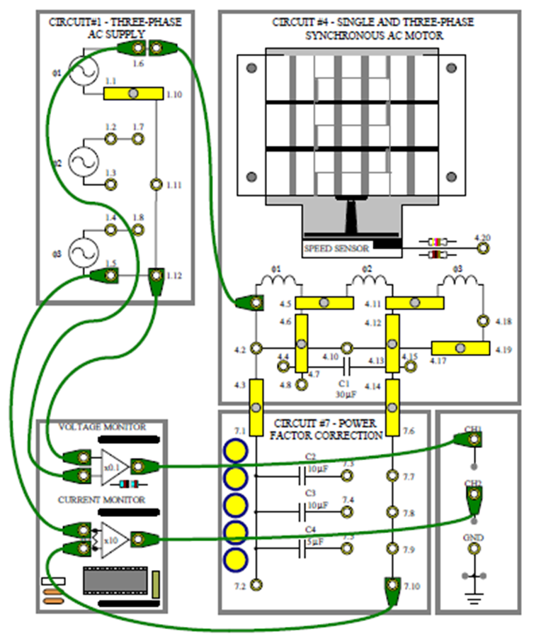
Figure 17 LJCREATE Virtual instrument platform for PF correction experiment.
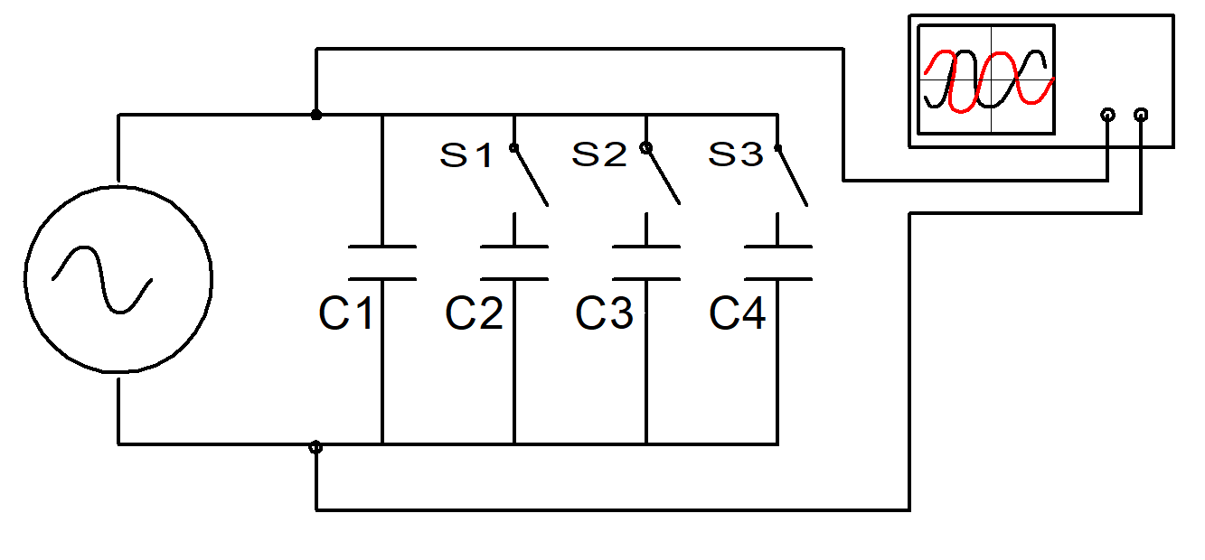
Figure 18 Simplified schematic of how the circuit was set up.
Phase Angle and Current Amplitude
Oscilloscope set to time base to 1ms/div and bot Ch.1 and CH.2 to 1V/div.
Voltage readings were taken at milli volt level and time periods were taken in milli and micro seconds.
Step 1: The oscilloscope was used to measure time period of one cycle the voltage waveform; the reading was recorded as the Time Period (T) in seconds (s).
Step 2: With S1, S2 and S3 open the oscilloscope was used to measure the time period difference (t) between the voltage wave form and the current wave form, this reading was recorded in seconds as the Phase Angle time period with no correction capacitors. The peak to peak value of the current waveform was measured and the reading recorded in volts (V). The state of the current wave form was recorded as being leading or lagging. Step 2 was then repeated but with the addition of a correction capacitor C2, with switch 1 closed. Then with both correction capacitors C2 + C3 so switches S1 and S2 closes. Finally, with correction capacitors C2 and C4 so switches S2 and S3 closed. Reading were recorded in a table.
Step 3: The Phase Angle Time Period results were used to calculate the Phase angle in degrees by the following formula and added to the results table.
$$Phase angle θ= \frac{ Time period difference (t) }{Time Period (T) } X 360$$

Step 4: The current waveforms peak to peak results were used to calculate the current amplitude in mA by using the following formula and added to the results table.
$$\frac{2 ×peak ×1000}{10}$$

Three Phase Inverter
The circuit was constructed using LJCREATE Virtual instrument platform for PVM Observations and reading were taken visually using oscilloscope.
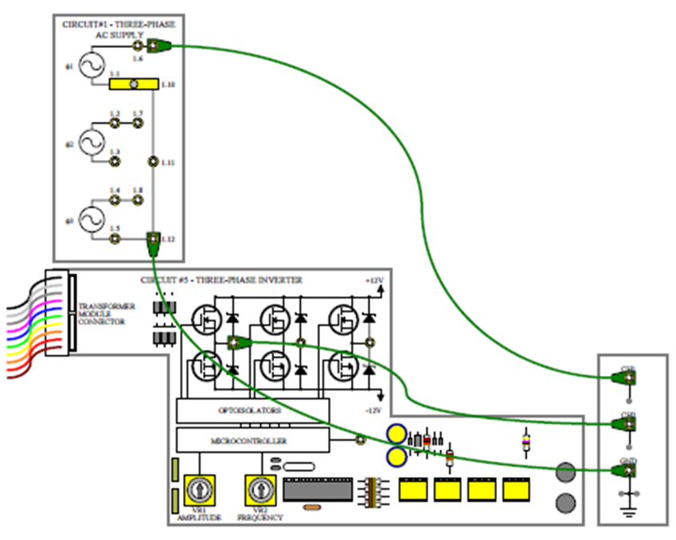
Figure 19 LJCREATE Virtual instrument platform for three phase inverter experiment.
The PWM out put is controlled by a Microcontroller and the pules are generated from its EPROM memory.
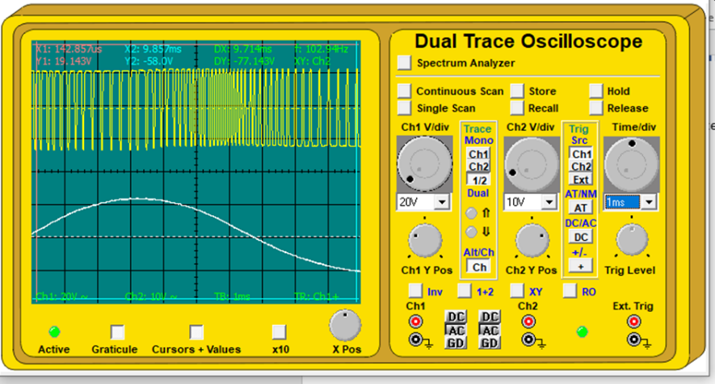
Figure 20 LJCREATE Virtual instrument platform for PVM and oscilloscope.

Over Current Protection
The circuit was constructed using LJCREATE Virtual instrument platform for PVM and observations and reading were taken visually using oscilloscope as well as mutimeters measuring Voltage and Current in mA.

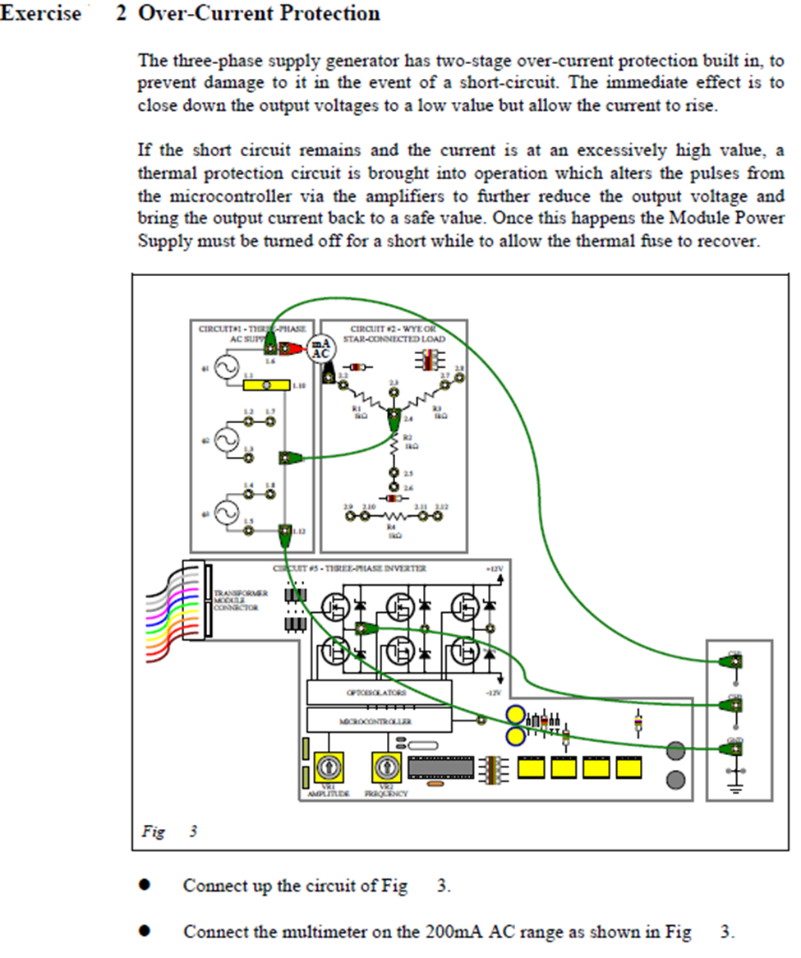
Figure 21 LJCREATE Virtual instrument platform for Over current experiment.

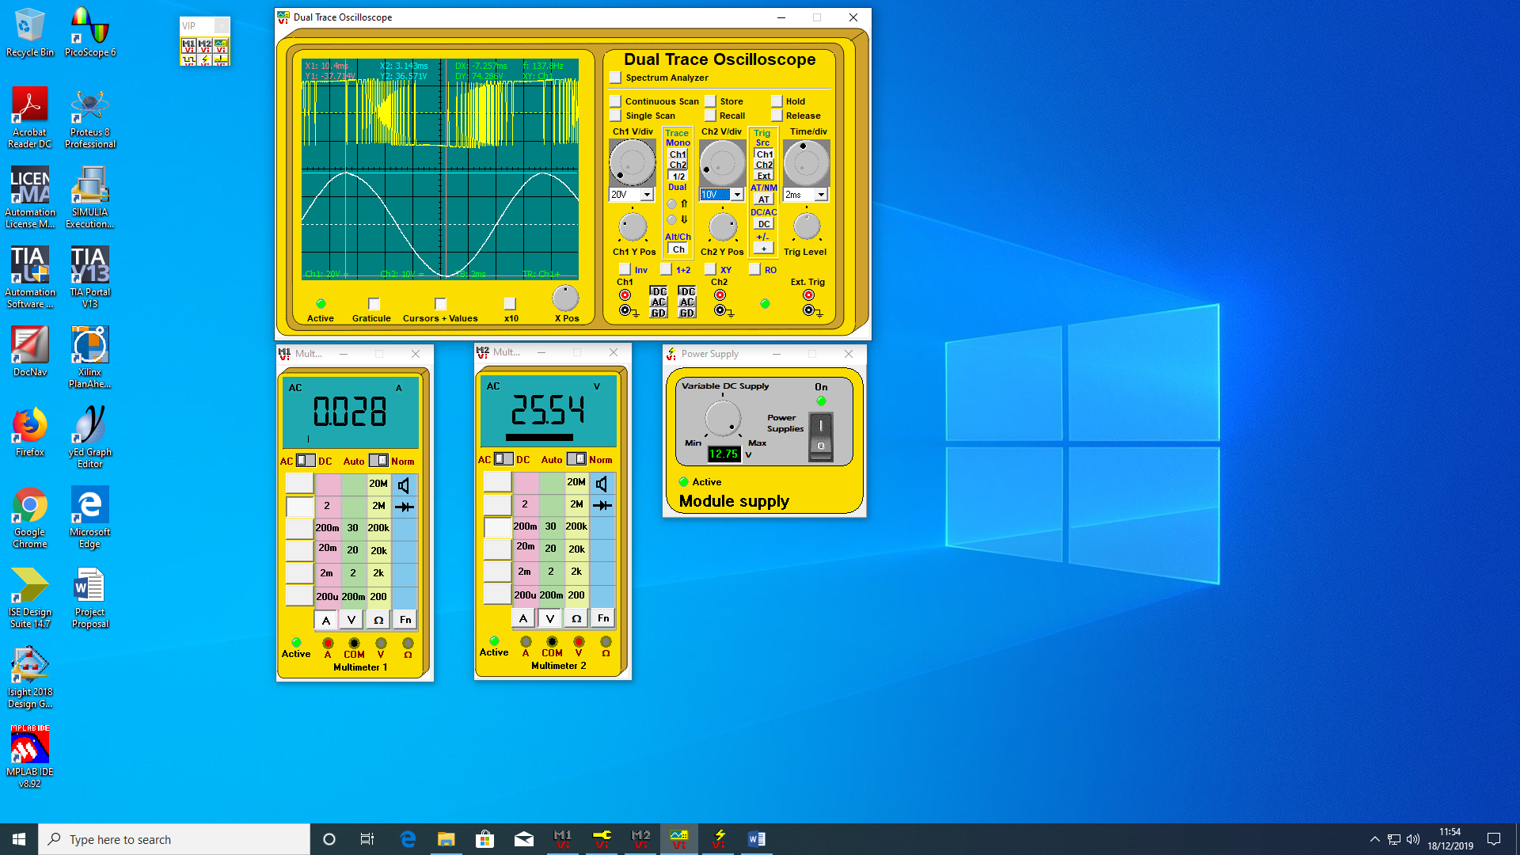
Figure 22 How the Oscilloscope and mutimeters were set out.

Results

Power Factor correction
Time Period of current waveform = 14.286ms
Reference voltage 5.457
Table of Capacitor values
Correction  Capacitor | None | C2-10μF | C2+C3=20μ | C2+C4=15μF
Phase angle  (Lead/Lag) | 1.229ms  30.97°  Lagging | 271.429µs  6.83°  Lagging | 742.8µs  18.71°  Leading | 324.8µs  8.18°  Leading
Power Factor | 0.78 | 0.99 | 0.94 | 0.98
Current (P-P) amplitude | 5.31V 531mA | 4.543V 454.3mA | 4.914V 491mA | 4.62V 462mA
Note: Voltage monitor is X0.1
Table 1 Results of Power factor correction experiment.
Power Factor correction under fault condition.

Table of results for management computer inserted fault.
Time Period of current waveform = 14.286ms
Correction  Capacitor | None | C2-10μF | C2+C3=20μF | C2+C4=15μF
Phase angle  (Lead/Lag) | 1.429ms  36.1°  Lagging | 1.457ms  36.7°  Leading | 2.114ms  53.27°  Leading | 1.886ms  47.5°  Leading
Current (P-P) amplitude | 5.17V 517mA | 5.343V 534mA | 6.343V 634.3mA | 5.771V 577mA

Table 2 Results of power factor correction with fault condition.

Three Phase Inverter

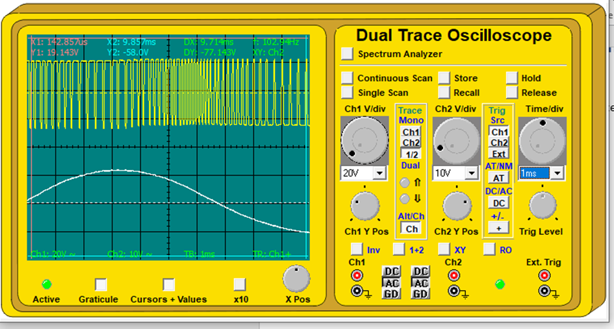
Figure 23 Shows the sine wave when the inverter is initially switched on.
Over Current Protection
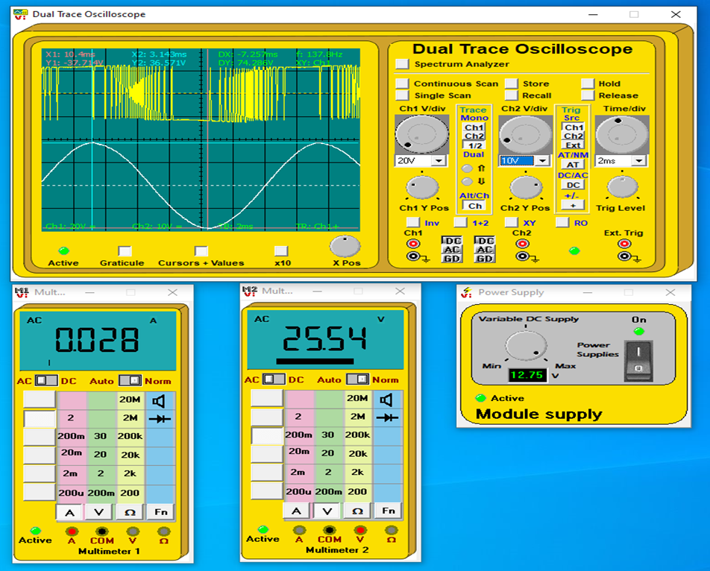
Figure 24 Showing the mutimeters and oscilloscope set up.

Over Current Protection fault.
Without fault inserted
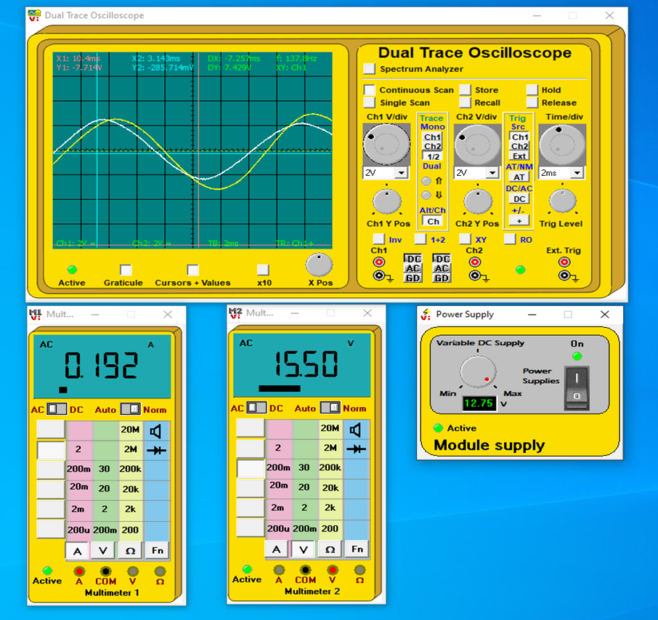
Figure 25 Fault circuit before fault is inserted.
With fault inserted 0-10seconds
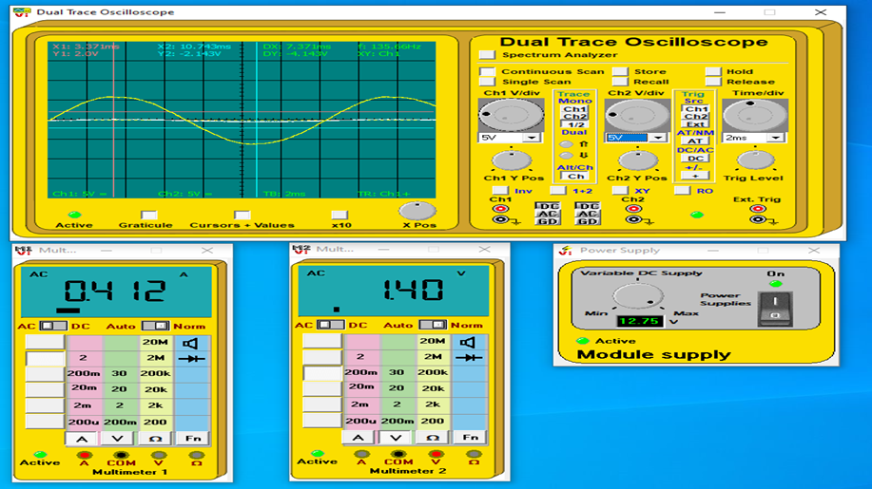
Figure 26 Fault circuit between 0-10 seconds after fault is inserted.

After 20 seconds
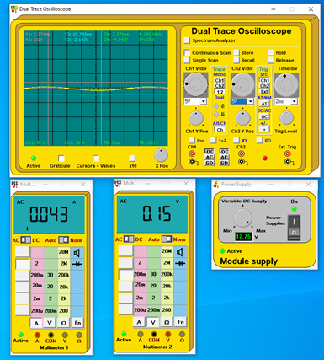
Figure 27 Fault circuit after 20 second when fault is inserted.

Discussion
Power factor correction.
Power factor improvement
From looking at the results table the first reading with no capacitors has a phase angle of 30.97˚ with the current of 531mA, lagging due to the inductive reactance of the load.
The best power factor should reduce the phase angle and current to a minimal, the capacitor that achieved this was capacitor C2.
When C2 is put in the circuit the phase angle is reduced to from 30.97˚ to 6.83˚ and the current is reduced from 531mA to 454.3mA so less current is being drawn.
The change is current is due to the improvement in power factor.
Power Factor Before C2 = Cos (30.97) = 0.85
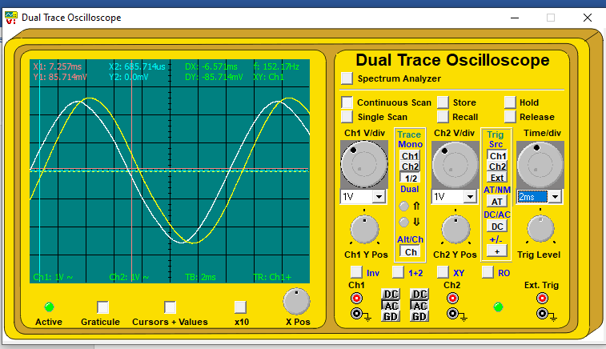
Figure 28 Voltage and current waveforms with no correction capacitors.
Power Factor After C2 = Cos (6.83) = 0.99
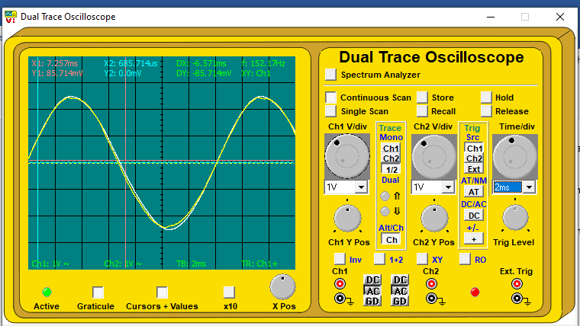
Figure 29 Voltage and current waveform with capacitor C2 added to the circuit.
A power factor of 0.99 is very good and demonstrates that using shunt or capacitors in circuits with inductive reactance can improve the power factor.
This is a power factor improvement of 0.14.
The capacitor reduces the amount of current that is supplied to the circuit this can be seen by using the formula P=V x I cos(ϴ)
8

The power consumed in the circuit before C2 shunt:
Average power P =V x I COS(θ)
8
Average Power = Supply voltage (54.57V p-p) x Current (517mA p-p)
54.57 x 0.517 COS (30)
8 =3.02Watts

Power consumed by the circuit after C2 shunt is added:
Average power P = V x I COS(θ)
Average Power = Supply voltage (54.57V p-p) x Current (517mA p-p)
54.57 x 0.454 COS (6.83)
8 =3.07Watts
This shows that the circuit is producing the same power while requiring less current when C2 is added. As stated in literature review the capacitor (shunt) has changed the inductive reactance by adding capacitive reactance and reducing the reactive power thus reducing the apparent power. This means that less power is wasted and in industry the apparent power (KVA) charges would be lowed saving money.

Power factor correction Fault.
By looking at the results table and observing the waveforms on the oscilloscope to detect a inserted fault in the circuit. It is clear to see that capacitor C2 is clearly larger than the 10µF it is stated to be. When capacitor C2 is placed in the circuit is causing a phase shift of around 72˚.

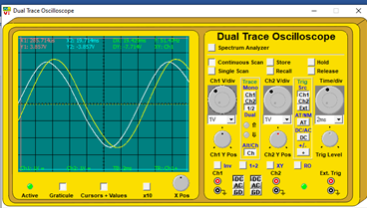
Figure 30 Voltage and Current waveforms before C2 in inserted.
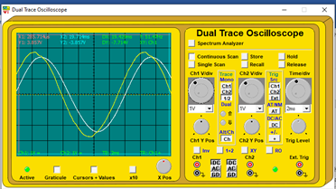
Figure 31 Shows that the Current waveform is now leading voltage.
When capacitor C3 is added to the circuit it only increases the phase angle by around 17˚ this is 4 time less phase shift than C2 causes when both capacitors are stated to be 10µF. To be certain that C2 is larger than its stated value it can be seen by comparing its influence to the circuits phase angle when paired with C4. When C2 is paired with C4 the phase angle 47.5˚ meaning a phase angle gain of 10.8˚ this is in proportion to the 5µF that C4 is stated to be. This also shows that reactance is proportion to the size of the capacitor.

Three phase Inverter.
From observing the oscilloscope, wave form that is produced by the pulses is a sinewave. As the sine wave reaches its peak the pulses become broader and as the sine wave amplitude decreases the pules become narrower.

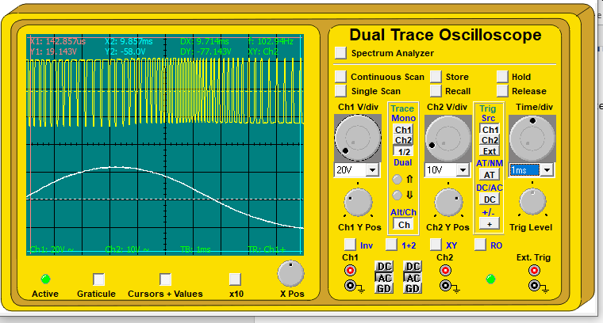
Figure 32 This is the output pulses created be the Micros program stored in it EPROM and the sine wave it produces.
The width of the pulses behaves the same on the negative part of the sine wave.
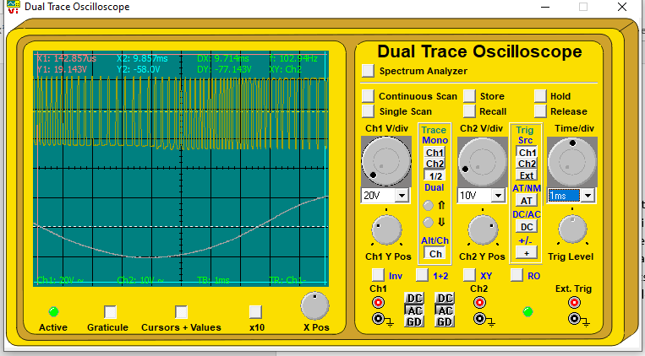
Figure 33 This is the result of inverting the pulses.
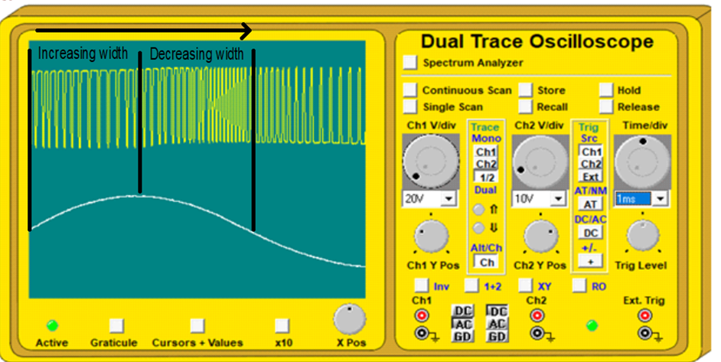
Figure 34 Showing pulse widths.
There are 60 pulses of varying width in each half cycle of the waveform. This pulse width modulator produces 120 pules for every full wave. The frequency is controlled by the microcontrollers clocking rate.

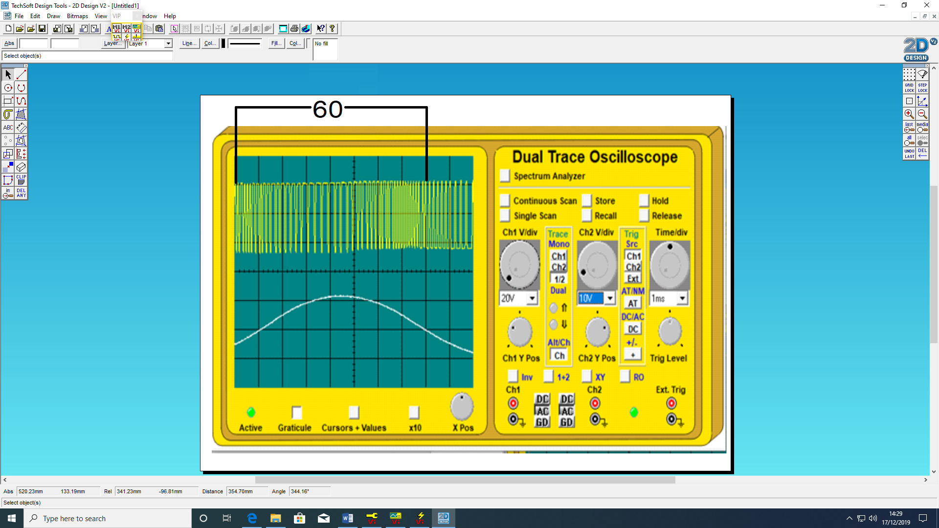
Figure 35 Showing the half cycle and its pulse component.
This shows that an AC sinewave can be produced by a pulse of DC current. As the sine wave is larger there is some ripple visible this is more visible at the positive and negative peaks.

Over-Current Protection
This circuit has a two stage over current protection built in.
- First it reduces the output voltage and allows current to rise.
- If the short circuit remains and the current goes very high a thermal protection circuit operates, it changes the pulses from the micro that brings the voltage further down and this brings the current down to a safe level. The circuit will require turning off to allow the thermal fuse to recover before it can reoperation.
When the circuit is operating normally the voltage wave form is 74V P-P. The voltage mutimeter measure is 25.6VRMS and this can verify by:
$\frac{74}{2\sqrt{2}}$=26V rms

The current is stable at 74v Peak to Peak
$\frac{0.074}{2\sqrt{2}}$= 26mA rms
From the reading and calculation both mutiments are correct.
Figure 36 Shows the PWM pules creating a sinewave and the measuring mutimeters place in and across the circuit.

When a short is placed across the load the supply voltage reduces to 0.14V (Zero). The current increases to maximum of 0.440A (440mA) this is almost 16 times what it was before the fault.

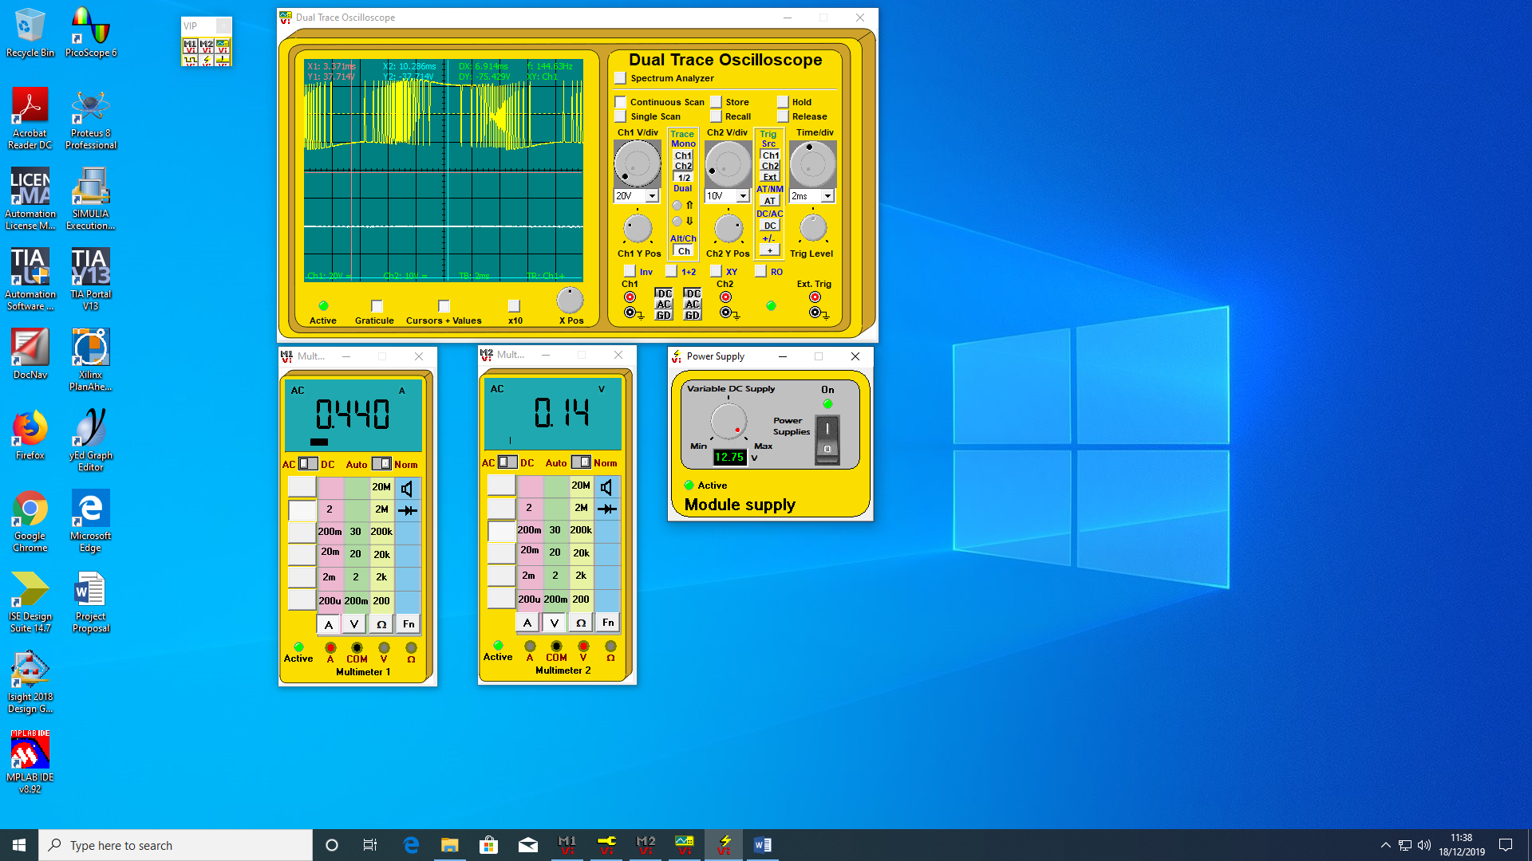
Figure 37 Shows that the voltage is reduced instantly when the fault is placed in the circuit.
It takes around 25 seconds before the current is reduced from 0.440A to 0.044A a tenth of the maximum fault current and the voltage is reduced to zero. You can see that the pules have changed to alter the waveform to a straight line of zero volts. The will not return to normal, the circuit returns to normal working order after it is switch off for a few seconds, this may be to protect the circuit from being automatically restarted before faults have been taken out.
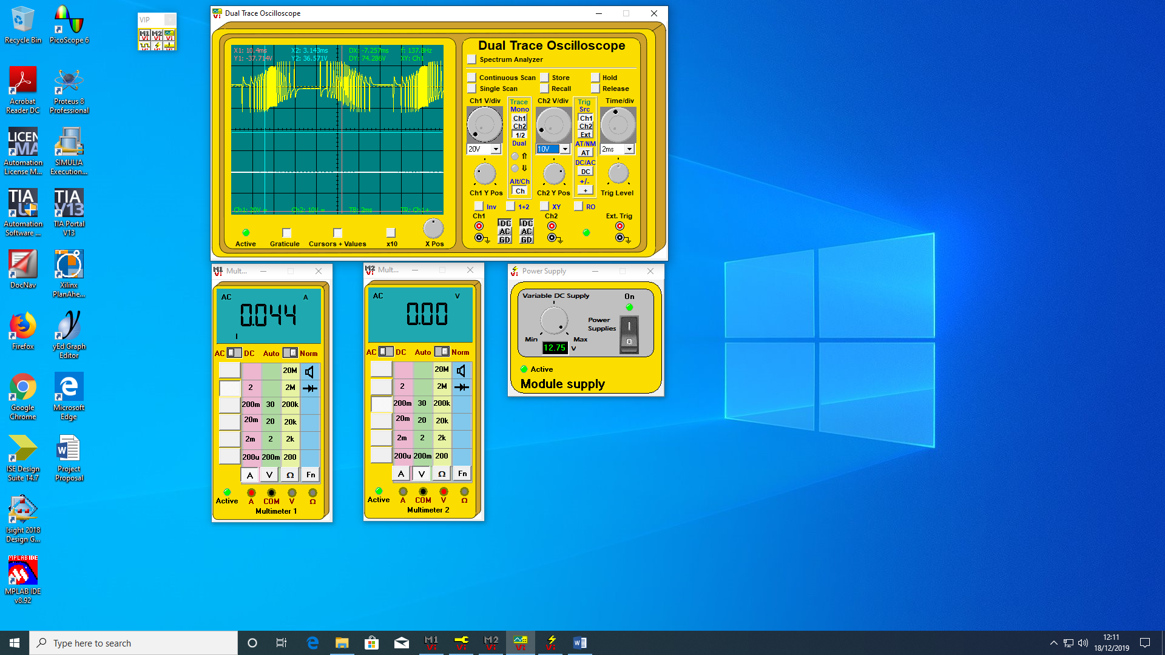
Figure 38 Both Voltage and Current have been reduced to negligible amounts.
By using the oscilloscope and multi meters to visualise the circuits waveforms, current and voltage output the two-stage protection system can be verified to be working and is most likely a thermal circuit breaker design type.

Single-Phase Synchronous Motor fault
Before the capacitor is placed between sockets 4.3 and 7.1 the motor is running and the waveform is stable with current leading voltage slightly. The mutimeters give a reading of 15.5Volts and 192mA.
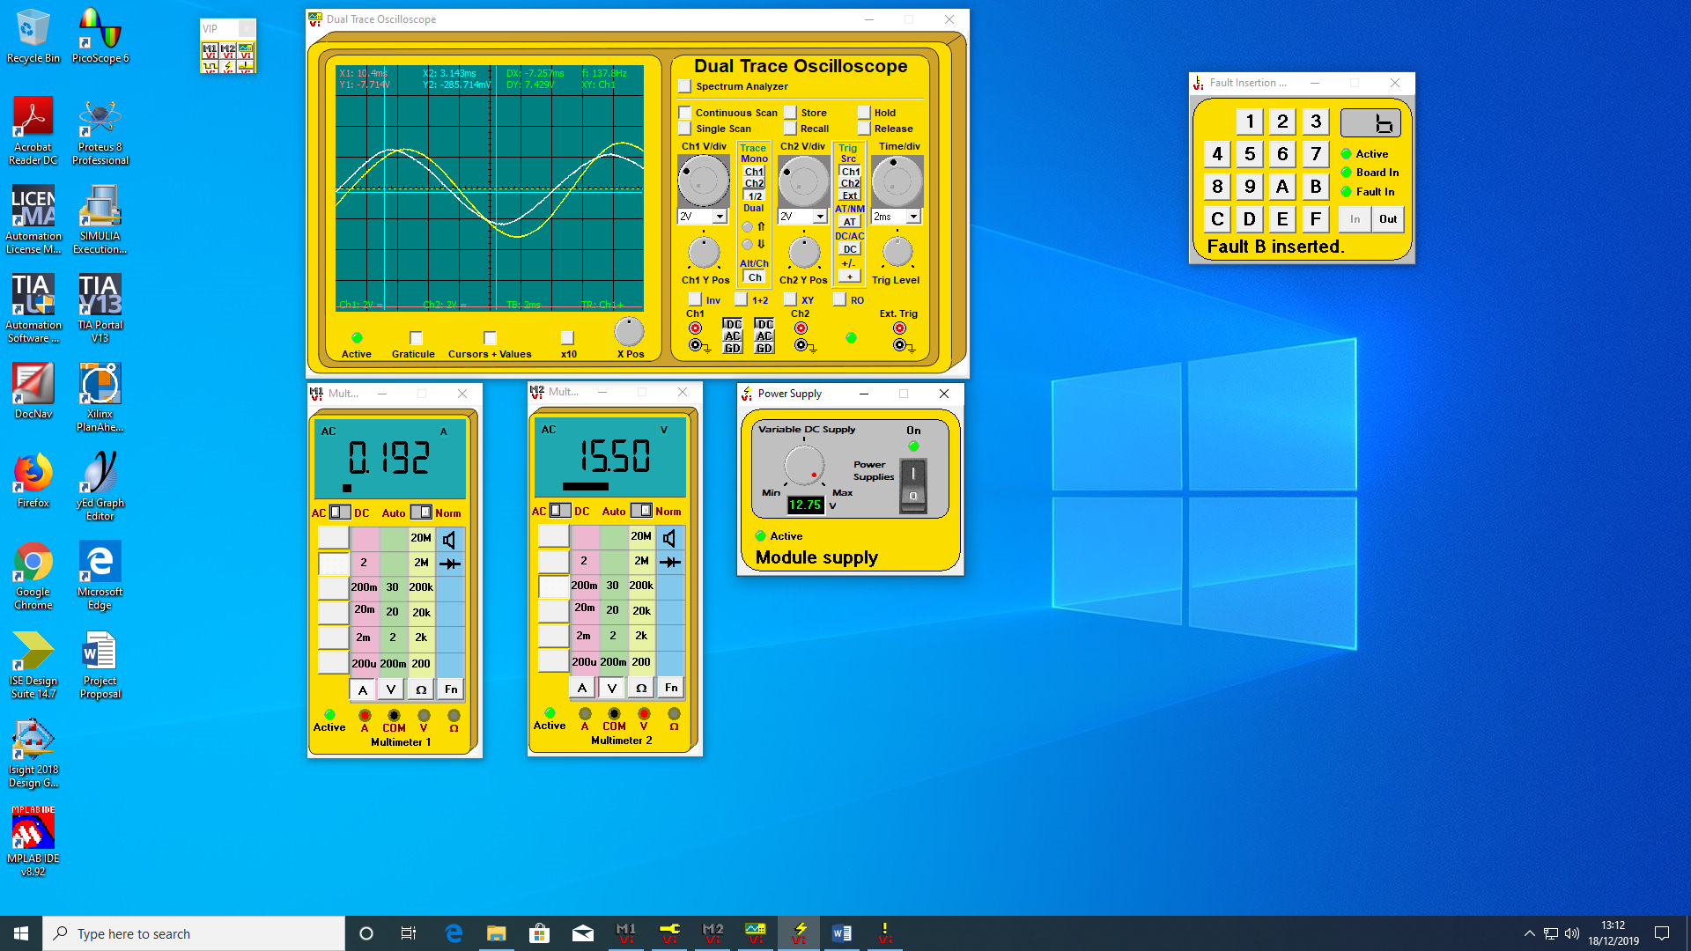
Figure 39 Voltage and Current Waveforms before the capacitor is insrted.
When the capacitor is placed across 4.3 and 7.1 the motor immediately stops working. The voltage drops to 1.40V and the current rises to 412mA this is twice the current was before the capacitor was inserted. The circuit voltage and current remain at these levels for about 10 seconds before the current begins to drop off.

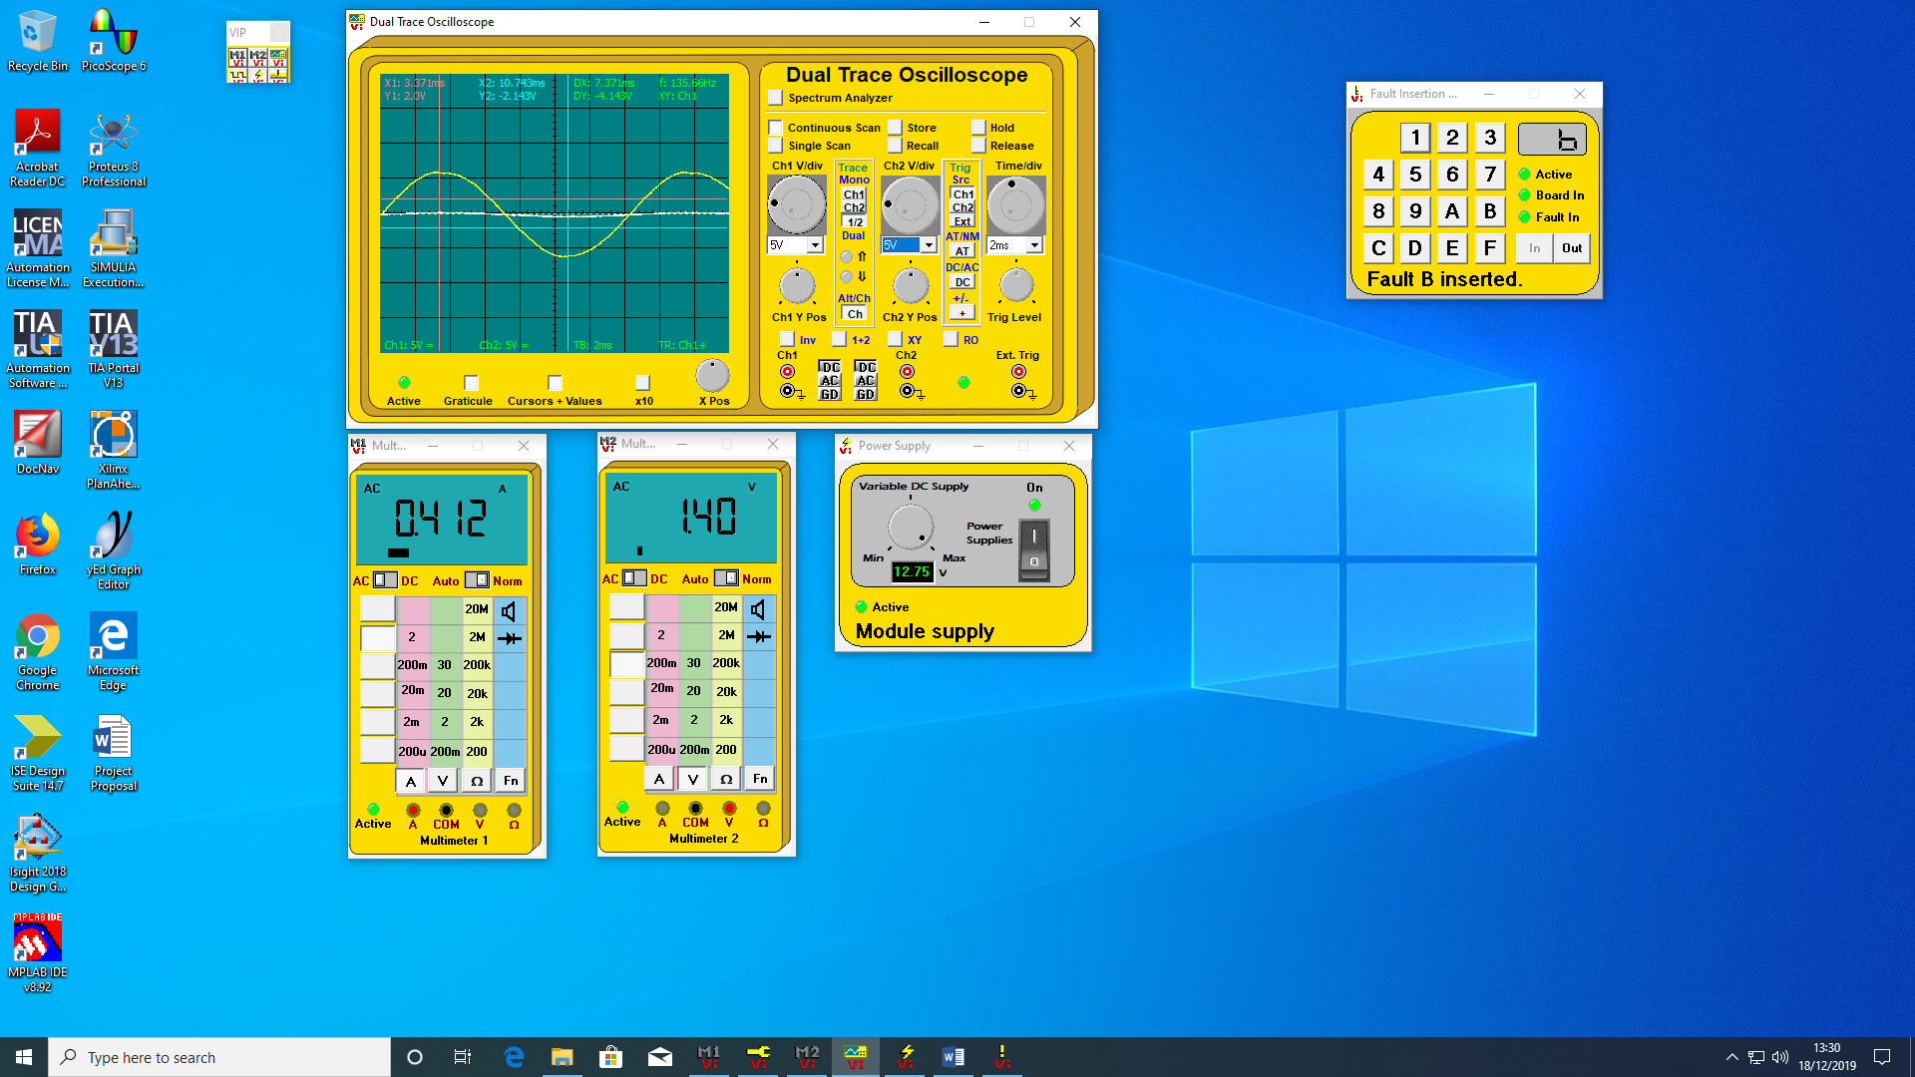
Figure 40 Show that the voltage waveform has been reduced and current has increased.

After
After about 15 seconds the circuit current has dropped off to 43mA and the voltage is down to 0.15 (zero). The circuit will not return to normal until the circuit has been switched off.
The circuit probably developed a short between the capacitors and the common causing a path of low reissuance and causing such high currents. The overload protection system worked well by lowering the voltage and then lowering the current after it had exceeded the devise time period of around 15 seconds.

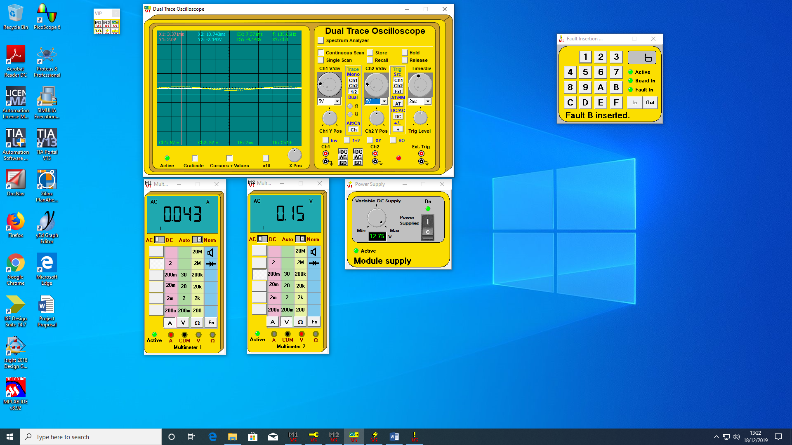
Figure 41 Show that Voltage and current have been reduced to negligible amounts.
The device was also tested by inserting the fault for a short time of around 5 seconds and then taken out, the circuit did return to normal. This demonstrates that the circuit can operate at high current for short periods before the thermal protection kicks in.

Conclusion

From results gained in the experiment and the visual screen shots and calculations in the discussion section of the report the following can be verified.
Power Factor Correction. An AC circuits PF can be altered with the addition of capacitors placed parallel to an inductive load. Circuits with better power factor can deliver the same power to a load with less current.
Three phase inverters. The experiment shows that a three-phase invertor can generate a AC waveform with a PWM and control the output voltage with varying the time of the pulses.
Overcurrent protection. A supply generator can be protected from overcurrent with a two stage overcurrent protection system. The sudden rises in current can be detected and the generator voltage reduced. Also, the circuit can be automatically disconnected and remain disconnected if the thermal effect of overcurrent persists.

Bibliography

[1] | A. Butterfield and J. Szymanski, “A Dictionary of Electronics and Electrical Engineering,” Oxford University Press, Oxford, 2018.
[2] | G. Rizzoni, “Electrical engineering,” in The CRC Handbook of Mechanical Engineering, London, Taylor Francis, 2004, pp. 5-41.
[3] | M. Brumbach, Industrial Electricity, New York: Thomsons, 2005.
[4] | G. Holmes, Thomas and . A. Lipo, Pulse Width Modulation for Power Converters: Principles and Practice, Hoboken: John Wiley & sons INC., 2003.
[5] | K. Keller, “Overcurrent Protection: Science Direct,” 2019. [Online]. Available: https://www.sciencedirect.com/topics/engineering/overcurrent-protection. [Accessed 17 12 2019].
[6] | T. Bishop, “Whats causing your high motor current,” PutmanMeadia, 23 Febuary 2018. [Online]. Available: https://www.plantservices.com/articles/2018/md-whats-causing-your-high-motor-current/. [Accessed 5 December 2019].

