Name: Aqil Hussain
Student Number:2535721
Course Title: CertHE Computing Skill for Workplace
Module name: ACCA4025 Learning in the Digital Era
Lecturer: Malik Mehmmod
Date: 20/06/2026

Table of Contents
Introduction 2
Portfolio Link 3
Task 1A – Essential Skills 3
Task 2a – Teamwork Mind Map 5
Task 2b – Academic Poster 6
Learning in the Digital Era 6
Introduction 6
Key Teamwork Skills 6
Problem Solving 6
Time Management 7
Digital Tools 7
Academic Benefits 7
Career Benefits in Computing 7
Conclusion 7
Task 3a – Virtual Collaboration Summary Su 9
Task 3b – Automatic Referencing Tool 11
Task 4 – E-Portfolio Review 12
Introduction 12
Benefits of Creating an E-Portfolio 12
Challenges Encountered 13
Skills Developed 13
Conclusion 13
REFERENCES 15

Introduction
This document serves as proof that the Learning in the Digital Era e-portfolio has been successfully completed. Activities pertaining to employability skills, cooperation, academic poster design, virtual collaboration, and automated referencing were included in the portfolio that was created using Google Sites. Included in this document with the portfolio link are screenshots that demonstrate the accomplished tasks and their accompanying proof.

Portfolio Link
https://sites.google.com/view/aqil-hussain-portfolio/home

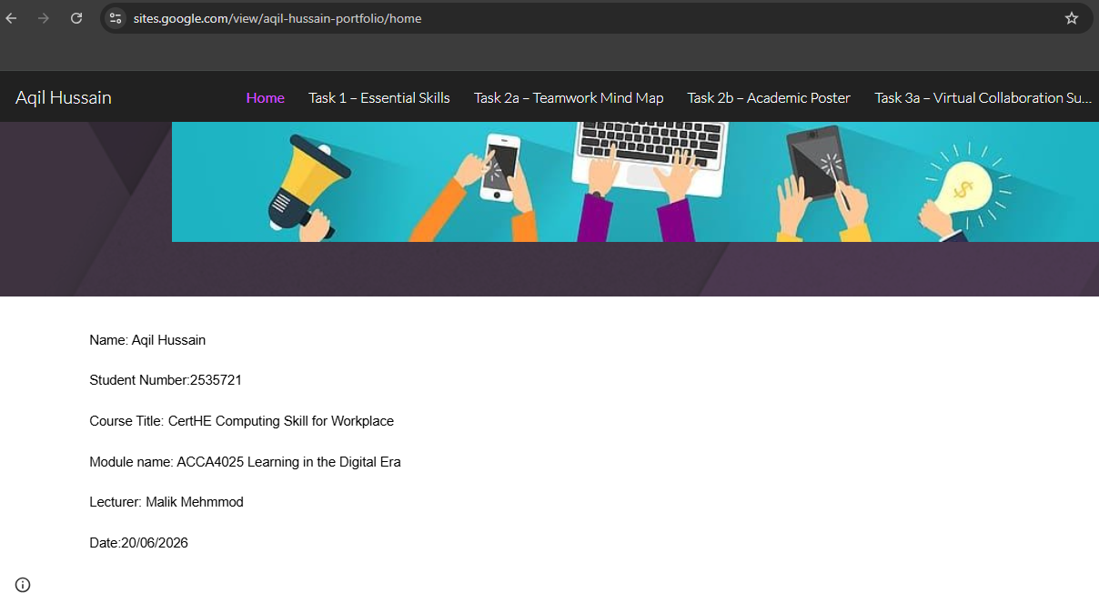

Task 1A – Essential Skills

To be successful in college and after graduation, you need to have strong academic and job skills. Graduates in the area of Computing are anticipated to have the ability to function efficiently in ever-changing digital settings by combining technical knowledge with transferrable abilities [1]. Skills such as being able to use technology effectively, communicate effectively, work in a team, think critically, and be flexible are essential.
The frequent use of software programs, programming tools, databases, and new technologies makes digital literacy a must for anyone working in the computer industry. Graduates with strong problem-solving abilities are better able to assess problems, find solutions, and create new systems [2]. Experts in the field can build and execute technology solutions with more confidence when they can think critically and assess information objectively.
Since computer professionals often collaborate with stakeholders, customers, and teams from other fields, strong communication skills are essential. Collaboration and project success are enhanced when technical topics can be explained simply. The ability to work well with others in a team is crucial for success in software development teams and other workplace settings [3]. Technology is changing at a quick pace, therefore it's important for professionals to be able to adapt and upgrade their skills and knowledge on the go.
Having honed these abilities during my time at university, I will be better prepared for a job in computing and artificial intelligence when I enter the workforce. Skills in technical knowledge, as well as those in communication, teamwork, and analysis, are in high demand among employers. My ability to have a lasting impact in the digital business, find practical solutions to challenges, and advance my career depends on honing these fundamental abilities [4].

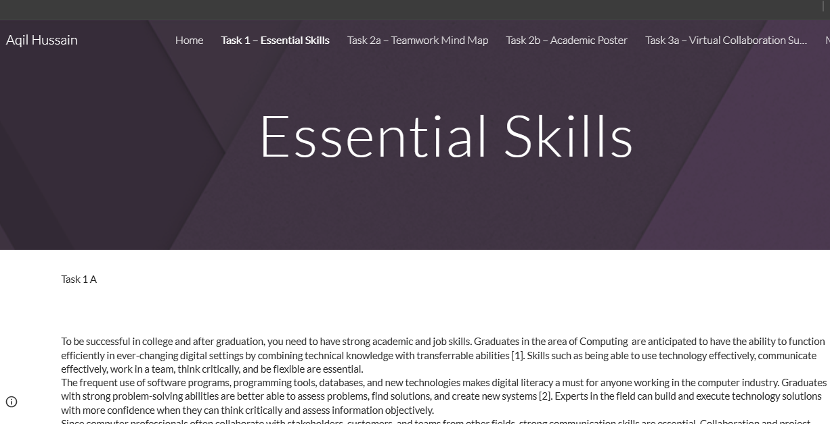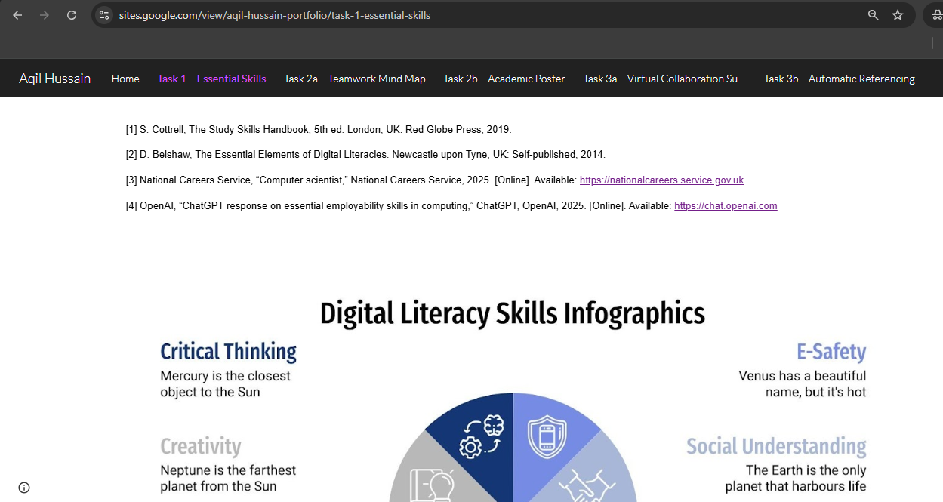

Figure. Screenshot of Essential Skills page.

Task 2a – Teamwork Mind Map
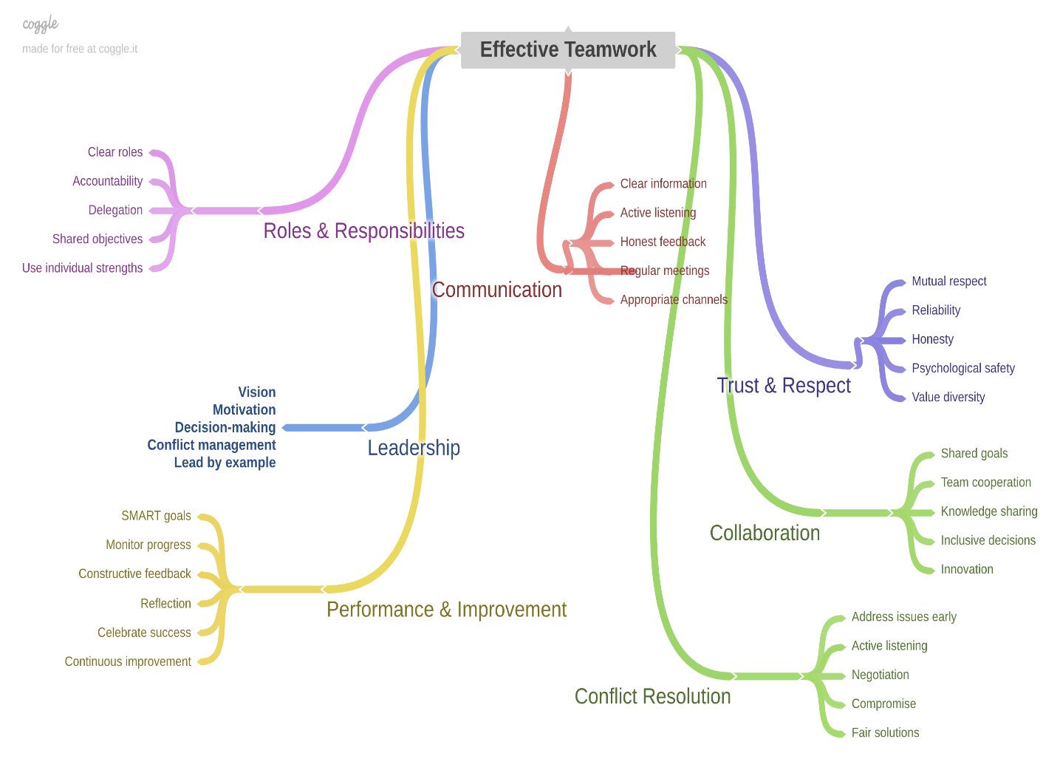
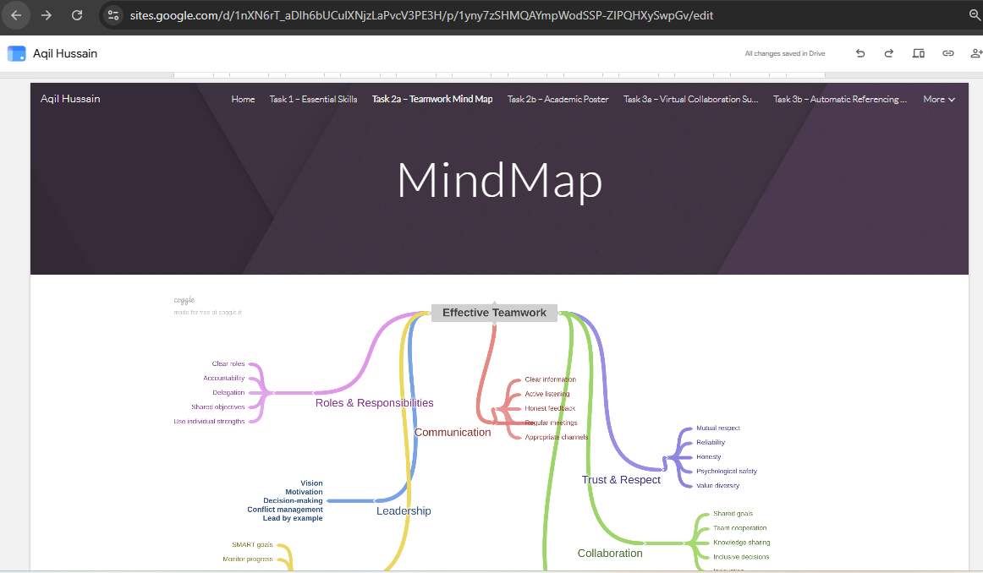

Task 2b – Academic Poster

Learning in the Digital Era

Introduction
Teamwork is an essential skill for students and professionals in computing. Most computing projects require individuals to work together to solve problems, share knowledge and complete tasks successfully. In higher education, teamwork helps students develop communication, confidence and collaborative learning skills. In professional environments, teamwork supports software development, data analysis, cyber security and IT project management activities [1], [2].

Key Teamwork Skills
Communication
For cooperation and project results to be successful, members must be able to articulate their thoughts clearly, listen attentively, and explain technical concepts clearly and concisely [1].
Collaboration
When people collaborate, they are able to pool their resources, learn from one another, and accomplish more as a group [2].

Problem Solving
It is common practice for computer scientists to collaborate in teams to investigate and, hopefully, find solutions to complex technological problems [4].
Leadership
Being a leader means taking charge, making decisions, and directing your team to success [1].

Time Management
Team performance and project completion are greatly impacted by effective planning and fulfilling deadlines [1].

Digital Tools
In today's contemporary classrooms and businesses, digital collaboration systems like Google Sites, Microsoft Teams, and Google Meet facilitate communication and cooperation [2].

Academic Benefits
Teamwork helps students succeed in school because it promotes learning from one another, helps them become better communicators, facilitates the exchange of information, and boosts their self-assurance when working on group projects [1].

Career Benefits in Computing
Software engineers, system analysts, cyber security experts, and project managers are common members of interdisciplinary teams where computing professionals often participate. Possessing strong cooperation skills enhances one's employability, performance at work, and chances for professional advancement [2, 4].

Conclusion
The ability to work well with others is an essential qualification for many IT jobs. Students may improve their academic performance and get a head start on a future in technology by honing their skills in communication, teamwork, leadership, and problem-solving [1, 2].

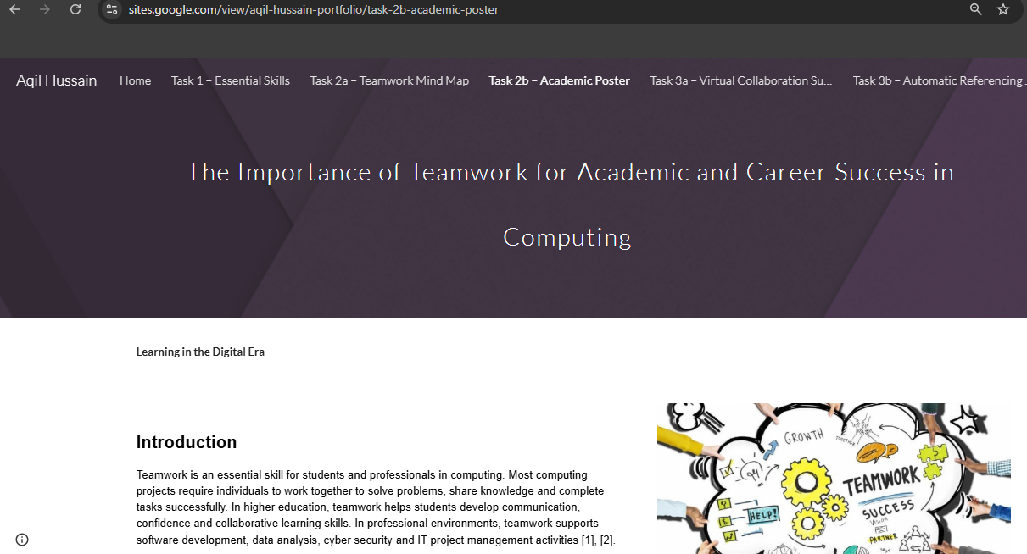
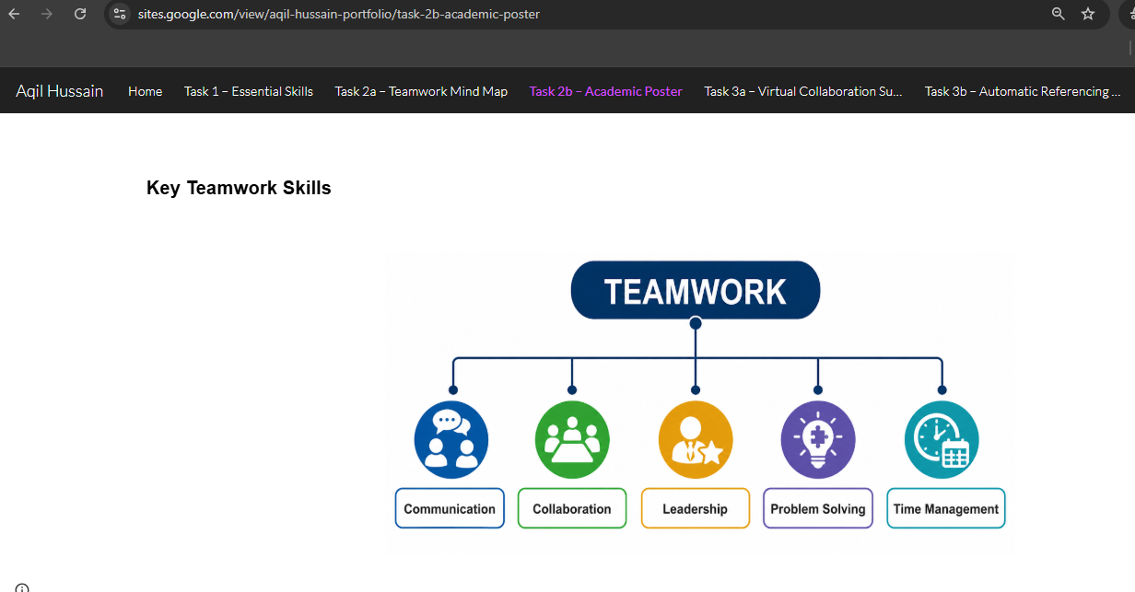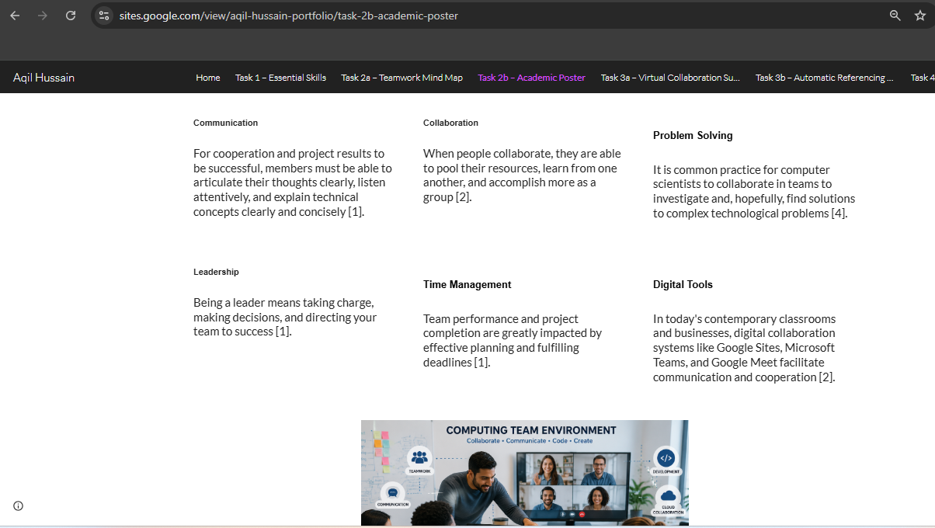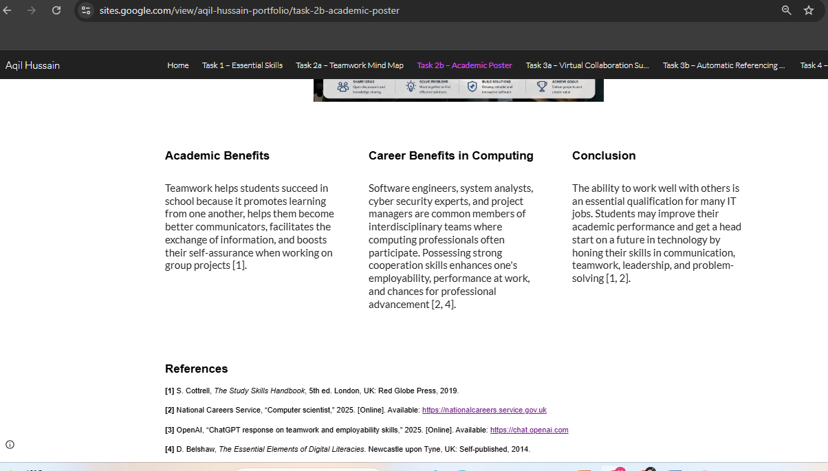

Task 3a – Virtual Collaboration Summary Su
People from various places may work together effectively in virtual teams because of the many digital tools available for communication and collaboration. A large number of IT support, data analysis, software development, and cyber security projects need virtual collaboration due to the distant or cross-site nature of the team members involved. Users are able to converse, exchange files, schedule meetings, and work on papers concurrently via online collaboration platforms like Google Drive, Microsoft Teams, Zoom, and Google Meet.
The ability to adapt is a big plus for virtual teams. No longer is it necessary for students and workers to be in the same room to collaborate and share information. Modern digital workplaces and remote learning are both facilitated by this. Because everyone on the team has constant, online access to the same papers, meeting notes, and project files, virtual collaboration technologies boost efficiency even further.
But there are difficulties associated with virtual teams as well. Team performance could suffer due to issues including ineffective communication, slow internet, time zone differences, and absence of physical meeting. Consequently, virtual teams need established norms of communication, mutually agreed upon due dates, division of labour, and frequent face-to-face gatherings. These abilities are crucial in the computer industry, since technological tasks often call for precise communication, analysis, and collaboration.
Nowadays, many organisations want graduates who are comfortable working with digital platforms, so honing my virtual collaboration abilities will be a boon to my computer employment prospects. Project management, client communication, and remote teamwork are all made easier with these solutions for IT pros. Consequently, in this digital age, academic achievement and career advancement depend on familiarity with virtual teams and online collaboration technologies [1-4].

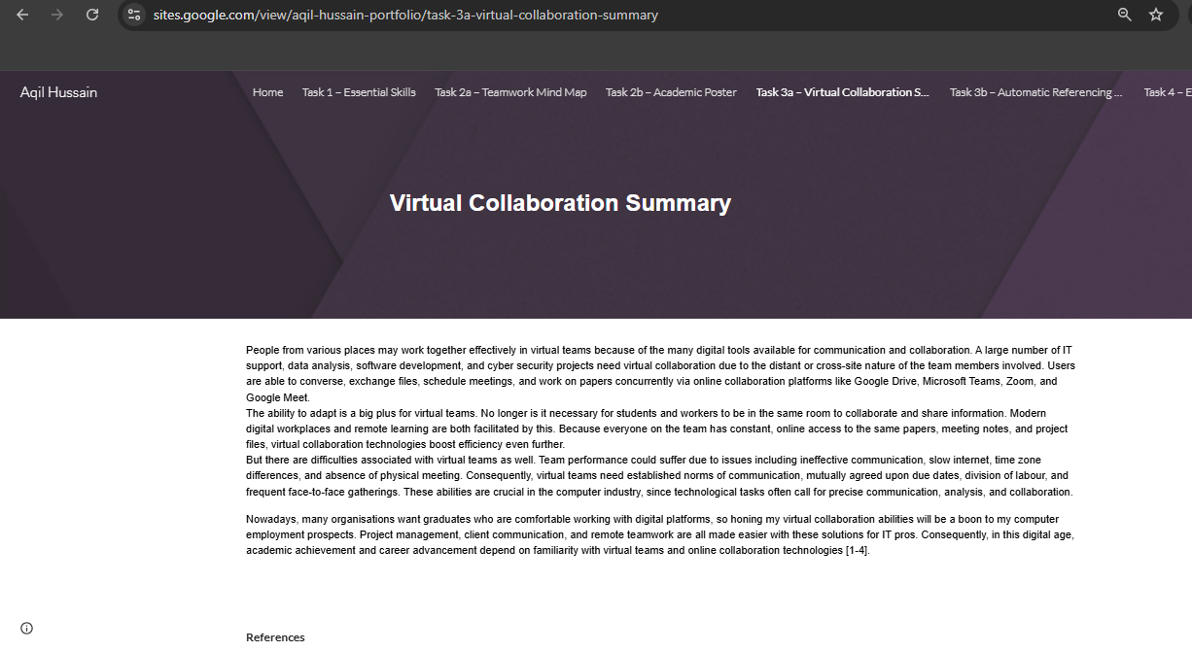
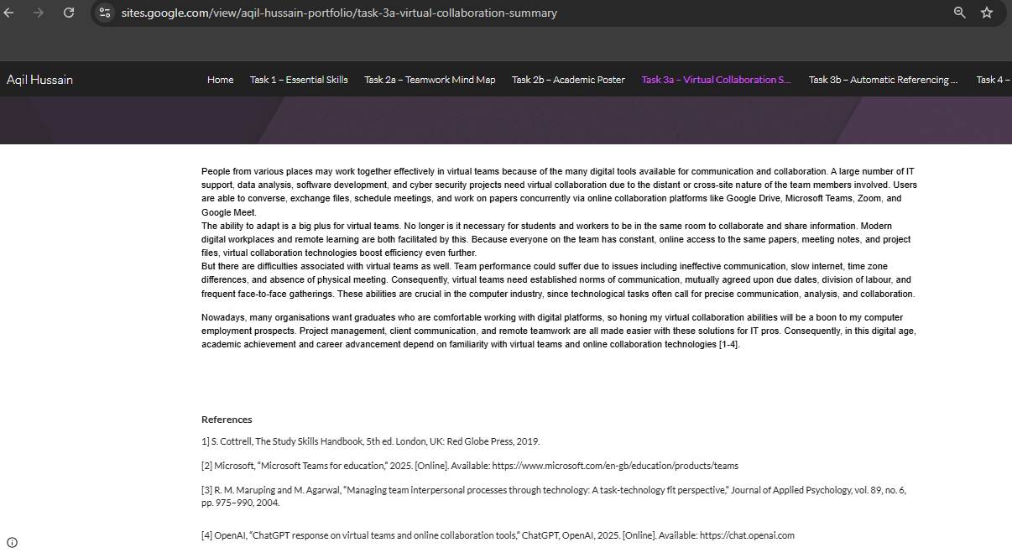

Task 3b – Automatic Referencing Tool

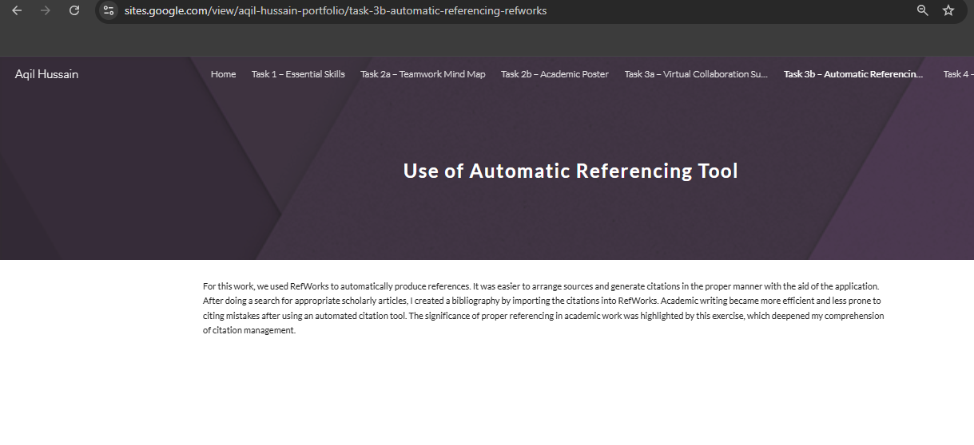

Task 4 – E-Portfolio Review

Introduction
With my electronic portfolio, I hoped to show that I had mastered the course material for the Learning in the Digital Era module and that I had improved my academic and technological abilities. Skills in cooperation, virtual collaboration, automated reference, and employability were the focus of my professional Google Sites portfolio, which I built during the course of the project. Participating in the portfolio allowed me to put my academic knowledge to use in a real-world digital setting, all while honing skills that will serve me well in college and beyond [1].

Benefits of Creating an E-Portfolio
Making an online portfolio allowed me to hone my computer literacy abilities, which was a major perk. Through my experience with Google Sites, I have gained the skills necessary to create and maintain websites, upload and arrange digital material, and provide information in an organised and polished manner [2]. Since I was in charge of the e-portfolio's development, creation, and maintenance, it also promoted self-management and autonomous learning. The portfolio also served as a repository for all of my work and academic accomplishments, which was really helpful.

Challenges Encountered
The growth of the portfolio was not without its share of difficulties, despite the numerous advantages it brought. At first, I struggled to figure out how to arrange the site's structure and select how various sections should display information. It took more time and effort to learn how to utilise automated citation tools and to create visual material like the academic poster [4]. Nevertheless, I gained self-assurance in my ability to use digital technologies and had the chance to learn from these problems.

Skills Developed
I was able to hone many valuable academic and professional abilities by working on this project. Academic writing, research, critical thinking, website design, digital communication, and reference were all part of the package. Essential for any career in computers, I also improved my knowledge of virtual collaboration tools and the concepts of cooperation [2]. My skills in efficiently creating and presenting information via the use of technology were also honed by the task.

Conclusion
In sum, I feel that my academic and technological skills were much improved after working on the e-portfolio. While building practical abilities that will benefit my future education and job in computers, the activities performed throughout the portfolio enhanced my awareness of employability skills, teamwork, and online collaboration [3].
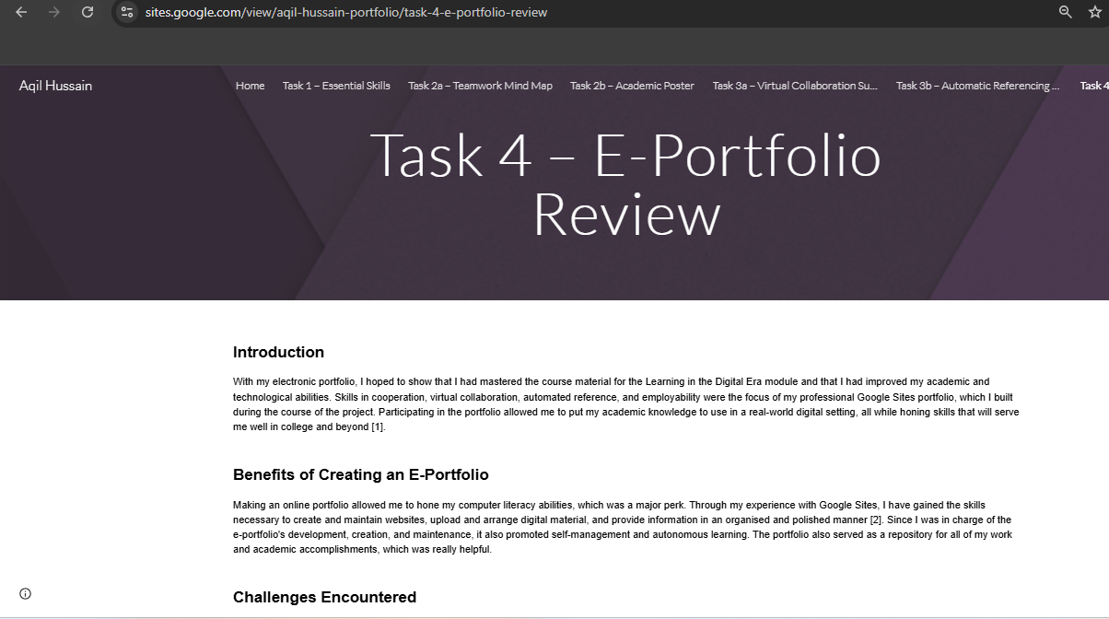
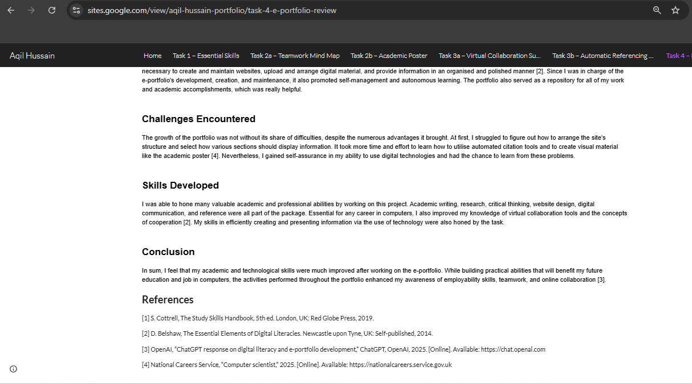

REFERENCES
[1] S. Cottrell, The Study Skills Handbook, 5th ed. London, UK: Red Globe Press, 2019.
[2] D. Belshaw, The Essential Elements of Digital Literacies. Newcastle upon Tyne, UK: Self-published, 2014.
[3] National Careers Service, “Computer scientist,” 2025. [Online]. Available: https://nationalcareers.service.gov.uk. [Accessed: 18-Jun-2026].
[4] Microsoft, “Microsoft Teams for Education,” 2025. [Online]. Available: https://www.microsoft.com/en-gb/education/products/teams. [Accessed: 19-Jun-2026].
[5] R. M. Maruping and M. Agarwal, “Managing team interpersonal processes through technology: A task-technology fit perspective,” Journal of Applied Psychology, vol. 89, no. 6, pp. 975–990, 2004.
[6] OpenAI, “ChatGPT response on essential academic and employment skills, teamwork, virtual collaboration and digital literacy,” ChatGPT, OpenAI, 2026. [Online]. Available: https://chat.openai.com. [Accessed: 19-Jun-2026].
[7] Google, “Google Sites Help,” 2025. [Online]. Available: https://support.google.com/sites. [Accessed: 18-Jun-2026].
[8] Canva, “Canva Design Platform,” 2025. [Online]. Available: https://www.canva.com. [Accessed: 19-Jun-2026].
[9] Indeed Editorial Team, “Employability Skills: Definitions and Examples,” Indeed Career Guide, 2025. [Online]. Available: https://uk.indeed.com/career-advice/career-development/employability-skills. [Accessed: 18-Jun-2026].
[10] Prospects, “Employability Skills,” 2025. [Online]. Available: https://www.prospects.ac.uk/careers-advice/interview-tips/employability-skills. [Accessed: 19-Jun-2026].

