Task 1

A model for assessing a specific individual or an organization's leadership or leadership style is the managerial grid system. The Leadership Grid is a two-dimensional leadership model that describes the key leadership styles by measuring both care and concern for production. The model's original name was the Managerial Grid, but Blake and McCance did change it to The Leadership Grid (1991). The Leadership Grid is used to explain leadership behaviors along a grid with two axes: concern for people and concern for production or results. It builds on the work of the Ohio State and Michigan studies. (Doyle, 2019)

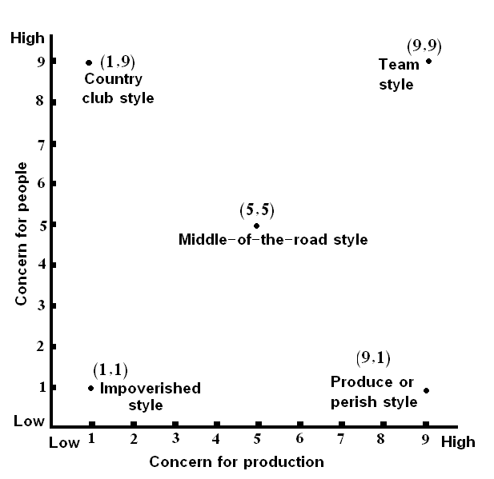
Three stars is handed to this Grosvenor Hotel in Torquay. Only owner of this hotel is Keith Richardson (Grosvenor hotel, 2022). A comedian named Mark Jenkins bought this from Mike to pay for the harm Mike's ownership and management approach created. The actual age of comedian and entertainer Mark Jenkins is 51. He has started businesses since he was a young man and has a solid work ethic. He used the "stack ‘me high, sell ‘me cheap" methods when running the Grosvenor Hotel. He works hard to provide tourists the sorts of memorable memories he was unable to give when he was younger. He worked hard to achieve success by using the Grosvenor hotel (Company Rescue, 2018). Employees who taken problems with his standards or management style were put in his renowned relegation zone. Mark insisted that his guests' pleasure come first. He often gave in to his desires. (Doyle, 2019)

To ensure management style, using Managerial Grid

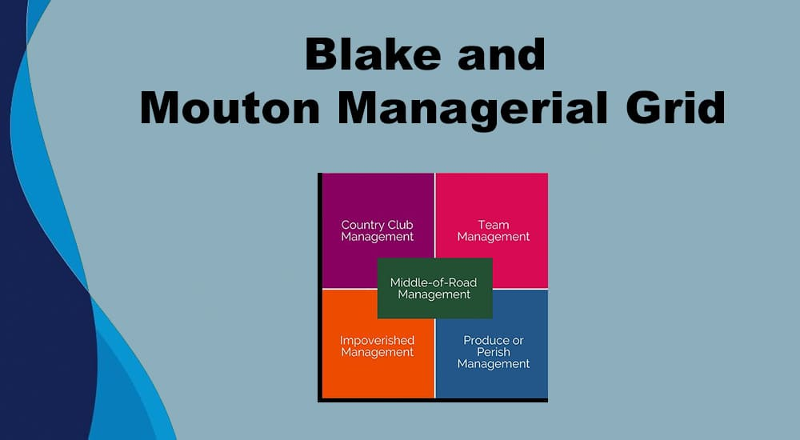

Some observations about way have been made based on Mark Jenkins' efforts, where he behaves like a great person. Someone with a sense of humor and the ability to keep a lively yet stable society. While he may have had the best of intentions, his organizational visual management, and the lack of support from of the team led him to deal in a lot of areas. Lack of team management is the first problem that must be fixed (Blake, & McCance, 1991). It could be believed that everyone kept imposing their views on each other instead of evaluating the advantages and disadvantages of a situation and come up with a solution. It could be said that everyone kept imposing their views on each other instead of evaluating the features and drawbacks of a situation and come up with a solution. A lack of organization and planning is the second observation. A leader must be strong and confident in favor for his team members to respect him. When a customer wants or has a demand, Mark Jenkins gets extremely tempted. Instead of being anxious and feeling uncertain, he should have calmed, think of a making thing simple, thoroughly discussed it with the other team members, and gave them it goes to execute it. That would have been all his or anyone's workplaces easier. A leader must be humble and dedicated to satisfying the needs of the followers, and Mr. Jenkins had those skills in plenty. That is a rare and valued trait in a leader. (Juneja, 2015)
Another amazing result for Mr. Jenkins is that he reacts to customer interests and complaints. While it puts the deal difficult for him as well, he doesn't contest the facts as he never likes to let a customer down. Mr. Jenkins also never appear to be capable of making people aware of it. When the wedding coordinator chose to leave, Mr. Philipps was free to spend the time and money needed to find out about issues his team was facing, talk to them about them, hear what they had to say, and then break. That, in a view, is essential. The skill to detect, recognize, and provide a customer's needs top priority without first denying it is another characteristic and action of this leader (Nahar, 2014). Faye had exacting quality for her wedding as a client. Even though he and the other team members lacked good coordination, Mr. Jenkins tried to please his customers instead of turning them away. More than his desire for production, it shows his devotion to hard work. (Juneja, 2015)

5 components described below
The Blake and Mouton Managerial Reference (Grid management, 1981) lists the following 5 categories: Country clubs use team management, middle-of-the-road management, poor management, and authority-compliance management strategies. (The Business Professor, LLC, n.d.)
The management of the country club emphasizes the significance of keeping a pleasant work via strong leadership and careful care to people's needs for satisfying relationships, that results in a warm and inviting environment.
Teamwork is the ability to collaborate, to disagree to agree by evaluating advantages and disadvantages to respect each other, and to complete a task thru a "common stake," resulting in a great bond. (Cleverism, 2018)
Management Consultants: The ability to accomplish a work spite of various barriers and expressions of disagreement, even if it just needed striking a balance and not maintaining morale and ethics. (Cleverism, 2018)
When you only devote the minimum necessary of time to the tasks required to keep membership, you are exercising poor management. In summarizing the results, it would be nice to say that he has average management abilities. Also, he seemed to strive to find a balance between all these elements. By stressing the need of earning points fast and effectively to full, he also contributes to poor management. (Cleverism, 2018)

Task 2

The simple Action-Centered Leadership model that John Adair is a great guide for tackling any team, group, or group's leadership and tasks. Its clarity of the Action Centered Leadership model makes it simple to remember, put into and adapt to your own situation. The three key elements of the Action Centered Leadership model should be entirely in the hands of good managers and leaders, who should also be able to use each element based on the situation. The capability to do all these things whilst retaining the balance is a sign of a successful manager and leader since it improves morale, improves quality, builds teams, and maximizing the profit. His infamous relegation zone was created for those group members or staff who couldn't catch pace with his management approach and demanding standards (Boddy, 2014). Mark stressed that the pleasure of his guests was his top priority. He replied to all his queries. n.d. (www.businessballs.com).

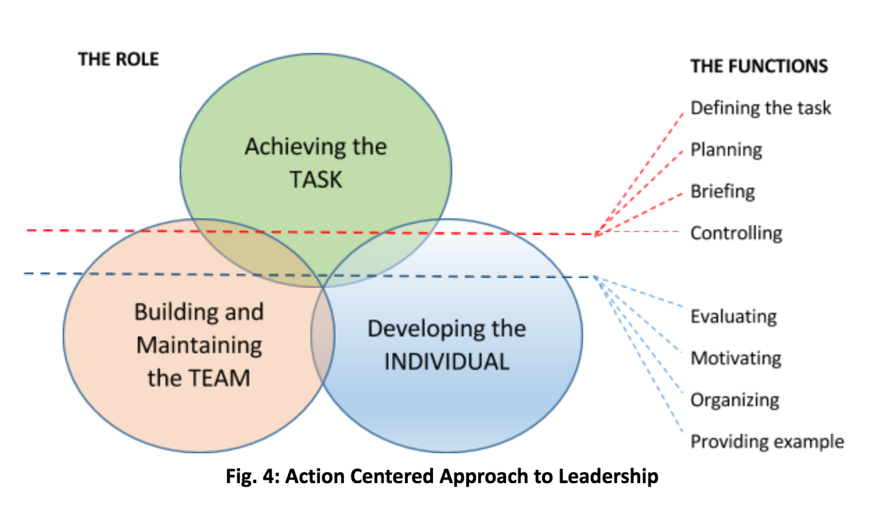

For evaluating a human's level of leadership and thoroughly judging someone based on the model properties, these three categories have subclasses. Key points are briefly and broadly discussed together with these. The first is task functions, which, in line with the Action Centered Leadership Model, include the following key points and an explanation of the observations made. (British Library, 1934)


Supporting the group's work goals: Mr. Mark Jenkins puts a focus on successes. Observations that he is incapable of select, define, and assign the group's goals on a personal basis. His work therefore is useless. For example, if the bride Faye had booked the destination wedding, Mr. Jenkins could have begun planning and working in open places. To understand more about the family's expectations and requirements for the event, he must spend a large amount of time with them. (British Library, 1934)
Mr. Jenkins generally puts in the effort to work with it to accomplish tasks. He is clearly not a team player. For example, when the wedding was planned and the guests arrived at the hotel, no welcome remarks were given. The guests' choices and pleasure with the services just weren't to be discussed. As a manager and a leader, Mr. Jenkins had a duty to prepare his teams for such fundamentals. Planning the work is not Mr. Jenkins' strongest point. For example, he did not plan for the services that would be needed when a guest came. He felt prepared for surprise and anxiety when the guests' wish lists was submitted, and he lacked calm. Even though he gave an explanation, he lacked the personality to offer unexpected services. Tying up duties and obligations Mr. Jenkins were able to alleviate Miss. Faye's worries about the venue and the requirement that the bar be shut before the wedding day. Long before the wedding, the bar already was open, but attendees were still restricted to the rooms. It shows his careless attitude. (British Library, 1934)
Controlling Quality and Assessing Progress: Mr. Jenkins is result-driven, so he does not manage or control quality. For example, he neglected to modify his job in line with the wedding guests who stayed for the night. There was nothing he might have accomplished.

Importance of discussion with employs
The group oversees maintaining team morale, encouraging the group, creating cohesion between participants of a working unit, enforcing the rules, maintaining discipline, creating channels of communication within the group, organizing the group's training, and assigning followers (Leading In, 2022). As per estimates, Mr. Jenkins inspires the group with words and a powerful enough fire to guarantee that "Failure is not an option. Each moment, we have had to win. But just distributing positive vibes and catchy stock phrases won't cut it. One must work on that as a leader. The reservation manager, Miss. Alison, and Mr. Jenkins frequently argue and fight about various issues. Specifically, while planning for the decoration of the wedding site, the empty lot, the Deputy Manager's duties, and Mr. Phillips' resignation as the wedding coordinator. (Ainomugisha, 2019)

Caring self- digitation
Take care of the needs of the group members, analyzing personal problems, giving praise and status, reconciling the needs of the group and the individual, and providing suggestions are all part of this group. As a result, Mr. Jenkins was able to pull off the events, but his management and planning were clearly lacking. He was still able to make the event a success so he could take better care of the customers' personal matters, even if it meant he really cannot really make the best of his time with the team. In answer to Miss Faye and Mr. Mike's demands, he did it. As Mr. Jenkins and Ms. Alison were unable to reach an agreement and the deputy manager was unable to solve Mr. Phillips' leaving or assign Miss Faye to make a better choice, he was responsible enough to enable himself to take over. A team leader must ensure everyone is satisfied. should be planned and organized, which Mr. Jenkins clearly needs, praise the team when they do a good job, and forgive when they make a mistake (Boddy, 2014). The Action Centered Leadership Model has been used to show that, when taking into consideration every single action Mr. Jenkin takes, his managerial skills are not very effective. (University of Bradford, n.d.)

Reference
www.tripadvisor.com. (n.d.). Is Mark Jenkins still working there or was it... [online] Available at: https://www.tripadvisor.com/FAQ_Answers-g186259-d1110018-t384986-Is_Mark_Jenkins_still_working_there_or_was_it.html [Accessed 21 Oct. 2022].
Harappa. (2020). Managerial Grid Theory of Leadership. [online] Available at: https://harappa.education/harappa-diaries/managerial-grid-theory-of-leadership/.
www.businessballs.com. (n.d.). The Managerial Grid and Behavioral Leadership Model – BusinessBalls.com. [online] Available at: https://www.businessballs.com/leadership-styles/behavioural-leadership-managerial-grid/ [Accessed 21 Oct. 2022].
Juneja, P. (2015). Blake and Moutons Managerial Grid. [online] Managementstudyguide.com. Available at: https://managementstudyguide.com/blake-mouton-managerial-grid.htm.
www.iedunote.com. (2017). Managerial Grid Model of Leadership Explained. [online] Available at: https://www.iedunote.com/managerial-grid-model-leadership-styles#:~:text=The%20Managerial%20Grid%20Model%20helps [Accessed 27 Oct. 2022].
Anon, (2021). Leadership moments: how to take benefit of these opportunities to influence. [online] Available at: https://www.carolinekennedy.com.au/leadership-moments-use-the-opportunity/ [Accessed 21 Oct. 2022].
www.linkedin.com. (n.d.). Taking Advantage of ‘Leadership Moments’. [online] Available at: https://www.linkedin.com/pulse/taking-advantage-leadership-moments-ramon-henson-ph-d- [Accessed 21 Oct. 2022].
www.businessballs.com. (n.d.). Action-Centered Leadership - John Adair. [online] Available at: https://www.businessballs.com/leadership-styles/action-centred-leadership-john-adair/.
www.ifioque.com. (n.d.). Managerial Grid Model of Leadership Definition | Ifioque.com. [online] Available at: https://www.ifioque.com/miscellaneous/Leadership-Grid.
www.businessballs.com. (n.d.). Action-Centred Leadership - John Adair. [online] Available at: https://www.businessballs.com/leadership-styles/action-centred-leadership-john-adair/.
British Library (1934). John Adair: Action-centred Leadership Thinker. The British Library. [online] doi: https://www.bl.uk/people/john-adair.
Mulder, P. (2019). Action Centered Leadership (ACL) by John Adair explained | toolshero. [online] ToolsHero. Available at: https://www.toolshero.com/leadership/action-centered-leadership-acl/.
www.coachingoutofthebox.com. (n.d.). 10 Important Actions of Leadership. [online] Available at: https://www.coachingoutofthebox.com/coaching-resources/blog/10-important-actions-of-leadership.
Page, M. (2017). 8 Critical Qualities of a Competent Leader | Michael Page U.S. Matt Page Available at: https://www.michaelpage.com/advice/management-advice/development-and-retention/8-must-have-qualities-effective-leader.
Snyder, J. (2014). The Importance of Open Communication in the Workplace - Palmer Group | Central Iowa Job Search. [online] Palmer Group | Central Iowa Job Search. Available at: https://thepalmergroup.com/blog/the-importance-of-open-communication-in-the-workplace/.
University of Bradford. (n.d.). Identity and performance management is skills you may develop. [online] Available at: https://www.bradford.ac.uk/careers/develop-skills/self-management/#:~:text=Being%20able%20to%20manage%20yourself [Accessed 27 Oct. 2022].
Uzialko, A. (2019). How to Write a Performance Evaluation Self-Assessment. [online] Business News Daily. Available at: https://www.businessnewsdaily.com/5379-writing-self-assessment.html.
http://facebook.com/careersidekick (2017). 10 Leadership Experience Examples for Interviews and Resumes - Career Sidekick. [online] Career Sidekick. Available at: https://careersidekick.com/what-are-your-leadership-experiences/.
Juneja, P. (2015). Blake and Moutons Managerial Grid. [online] Managementstudyguide.com. Available at: https://managementstudyguide.com/blake-mouton-managerial-grid.htm.

