BA International Hotel Management

Student name: Constantin Bogdan Rusu(2014305)

BMIH5007 Financial Management for the Hotel Industry

Business Report - Comparison of Corinthia Hotels and Ibis Hotels

Word count: 2,080

Executive summary

Financial management (FM) represents a critical business function that informs top management decisions that are related to developing growth plans, investments, the capital market, and finances, and its main aim is to plan and organise the achievement of organisational financial objectives.
The report compares and critically analyses the tactics related to FM conducted by Corinthia Hotels and Ibis Hotels, two leading corporations in the hospitality sector.
The critical evaluation encompasses strategies and practices, including key aspects that influence organisational performance and sustainability, such as total revenue, market positioning, growth potential, and financial commitment to corporate social responsibility (CSR).
Both Accor and IHI reported higher revenues than in the previous year, and they have growth plans that include geographical expansion and sustainable development.
Ibis Hotels should consider enhancing their growth strategy performance by adapting to trends such as digitalization, CSR, and especially sustainability.
Corinthia Hotels should consider focusing more on enhancing digitalization and sustainability through more impactful CRS strategies in order to increase brand equity.

Table of Contents
Executive summary 2
1. Introduction 4
2. Company overview 4
3. Total Revenue 5
4. Market Position 8
5. Growth Potential 9
6. Financial Commitment to CSR 10
7. Conclusive Remarks and Recommendations 11
8. References 12

Figure 1. International Hotel Investments p.l.c. - Corinthia Group 5
Figure 2. Ibis Hotels 2022 5

Introduction

Financial management (FM) represents a critical business function that informs top management decisions that are related to developing growth plans, investments, the capital market, and finances (Myers and Pogue, 1974; Atrill, 2006). The main aim of financial management is to plan and organise the achievement of organisational financial objectives (Otley and Berry, 2019).

The purpose of the report is to critically evaluate and compare the approach to FM conducted by Corinthia Hotels and Ibis Hotels, two leading corporations in the hospitality sector.

The critical evaluation of their FM approaches encompasses strategies and practices, including key aspects that influence organisational performance and sustainability, such as total revenue, market positioning, growth potential, and financial commitment to corporate social responsibility (CSR). The findings of the assessment lay the foundation for recommendations related to the optimisation of their FM approaches.

Company overview

Corinthia Hotels (2023a) is an international luxury hotel chain fully owned and operated by International Hotel Investments (IHI) p.l.c., which is the holding company for a group that includes hotel management, ownership of hotels and real estate, development, design, engineering, and project management, and catering. Please see the following illustration of the company’s structure.
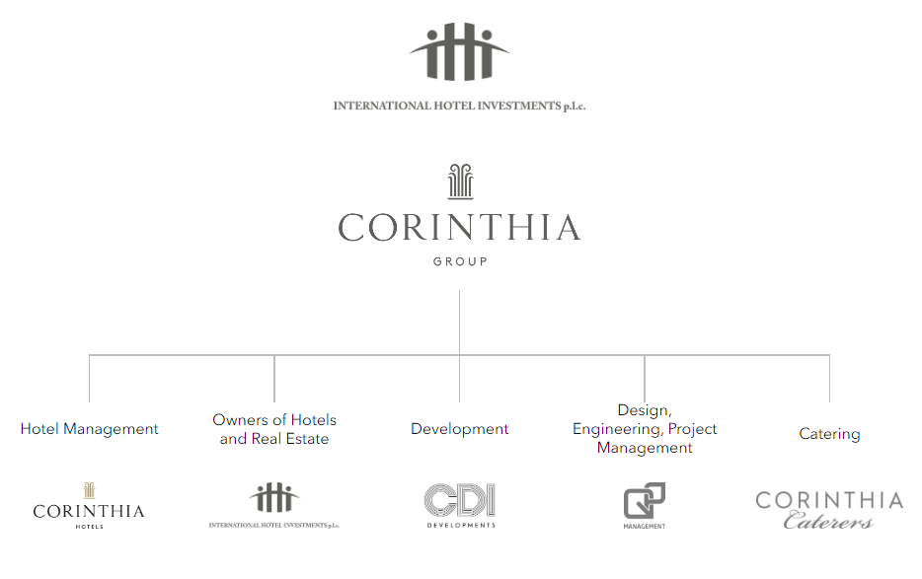
Figure 1. International Hotel Investments p.l.c. - Corinthia Group
Source: IHI, 2024
Ibis Hotel (Ibis.com, 2024) is an economy hotel brand operated by Accor SA (Accor, 2024), which is a leading brand in the global hospitality industry, owning 40 brands and operating over 5,400 hotels in over 110 countries (Accor, 2023a). In 2022, the Ibis network encompassed 1,269 Ibis hotels, 642 Ibis Styles hotels, and 644 Ibis budget hotels, in total 292,810 rooms (Accor, 2023a, p. 59), distributed on five continents, as detailed in the following picture.

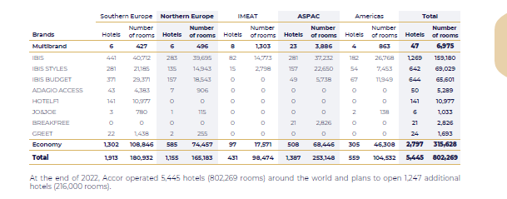
Figure 2. Ibis Hotels 2022
Source: Accor, 2023a, p. 59

Total Revenue

Income of the business is an important metric in FM, which demonstrates how the company achieves the financial objectives (Brigham and Houston, 2013). Income management is part of corporate finance which, according to Levy and Sarnat (1994), is responsible for increasing the profitability of the capital invested while reducing financial risks, and, according to Pike and Neale (2006), for devising and maintaining the financial statements.

According to Robinson (2020), an income statement offers a synthesis of the financial performance of the organisation over a specified period, including the balance sheet and the cash flow brief. Bartov and Mohanram (2014) explain that this document is significant because it offers information regarding organisational revenues, correlating stock returns, and the sources of earnings, and it can lay the foundation for forecasting future revenues.

Total revenues is a metric used in FM that expresses the gross revenues or total turnover earned by a company in a specific reporting period (Henry, Robinson and Van Greuning, 2012). According to Wang cheng
(2015), in the hospitality, the management of revenues has an important significance, and it is known as the concept of Total Hotel Revenue Management (THRM), which aims to capture revenue potential that includes all the revenue streams as a holistic approach.

FM generally controls the revenue streams, focusing on pricing, inventory allocation, product configuration, and duration control (Harrison et al., 2021). The focus on pricing focuses on the manner in which different customer segments appreciate the specific value of products and services (Harrison et al., 2021). The inventory allocation refers to situations when the organisation produces in correlation with the current demand and the level of prices that are accepted by different customer segments (Harrison et al., 2021). The product configuration is when the organisation effectively designs, customises, and innovates in regard to its offerings to meet the demands and expectations of various customer segments, and it also adjusts the prices for those different segments (Harrison et al., 2021). The principle of duration control refers to situations when the organisation enhances the resource limitations to meet the demands and expectations of various customer segments by addressing internal blockages and also influencing customer behaviour (Harrison et al., 2021).

Accor focuses on pricing and product configuration, while Corinthia Group focuses on pricing and duration control.

There are no data regarding Ibis’ revenues, its results being reported as part of the Group’s economy segment. The total revenue of Accor in FY 2022 was reported as €4,224 million (Accor, 2023a, p. 292) and the revenue streams include economy, midscale, and luxury.
For Corinthia Hotel Group, the total revenue in FY 2022 was reported as €238,207,000 (IHI, 2023, p. 19), and the revenue streams encompassed the three business units.
The difference between total revenues is explicable by the size of the chain and their geographical scope. Accor (2023a) has a network of over 5,400 hotels and circa 802,000 rooms, while Corinthia Group (IHI, 2023, p. 6) has a network of that includes 12 owned hotels and nine managed hotels.
In the UK, the subsidiaries of these two leading brands in hospitality have reported the following total revenue in FY 2022:

- Accor UK Economy Hotels Limited (2 September 2023, p. 16): £218,207,000
- Corinthia Hotels (UK) Limited (July 7, 2023, p. 11): £2,357,354

Accor UK owns and leases 62 Ibis, Ibis Styles, and Ibis Budget hotels (Companies House, September 2, 2023), while Corinthia Hotels (UK) Limited has only one hotel in London.

Accor and IHI reported higher revenues than in the previous reporting period, considering that the demand in the hospitality market is recovering after the impact of the COVID-19 pandemic, which, according to Gursoy and Chi (2020), has profoundly disrupted the profitability in the sector. Considering the change in demand curve, the hotels have supplied more products and services to meet the customer need and expectations.

Market Position

Market position is a marketing concept that is related to how customers perceive a brand or company in terms of quality of offerings, their attributes, value, and prices, and it is associated with the image of the brand in customers’ minds (Oghojafor, Ladipo and Rahim, 2013). CFI Education (2024) explains that marketing strategies for positioning can be centred on the product and service benefits, pricing strategies, overall quality, use and application of the product and service, and rivals.

Recent statistics (Patrizi, 2023) show that Accor occupies the first position in the European market considering the size of the organisation and the sixth position worldwide. Based on revenues, Accor has a 9.6% market share, and it is over ranked by Marriott (42.7%), Hilton (17.6%), and Hyatt (11.5%) on a global scale (Patrizi, 2023).
Accor (2023b) emphasises that the group enhances its global leadership position in the extended stay market, which last year was weighted at $54.5 billion and is expected to reach $166.5 billion in the next eight years.

The global market share of Corinthia can be estimated to be around 0.5% based on the revenues in FY 2022 and the total size of the global market.

According to the last financial statement of Accor (2023a), Ibis is positioned as economic, and it targets low-income customers, categorised within three distinct echelons (MBA School Team, 2024):
- lower (basic) through the Ibis budget concept,
- middle through Ibis,
- and upper through Ibis Styles.

Contrastingly, Corinthia Hotels targets luxury travellers (IHI, 2023).

The geographical segmentation of Ibis audiences pursues global tourists, in contrast with Corinthia, which targets mainly travellers in Europe and the Middle East, but it has been announced that the geographical span will be enhanced in 2024 (IHI, 2023).

Demographic segmentation is also very contrasting for the two leading hotel brands, considering their positioning:
- Ibis: low-budget customers (Cheng, 2019) ,
- Corinthia: luxury customers.

Growth Potential

The strategic growth plan of Accor is based on expanding their geographic reach worldwide for all their market segments. The last FY financial statement emphasises that the organisation launched 299 new hotels in 2022, expanding the number of rooms by 43,362, of which 34 percent were economy hotels (Accor, 2023a). This expansion has grown the economy segment of Accor to 60% of the entire global chain in 2022 (Accor, 2023a). The organisation emphasises that it aims to organically grow the size of the hotel chain by following the trends on the market and customising the offerings. With respect to the Ibis Hotels chain, Accor invested in 2022 in an expansion of 2% that has included new hotels on the Asia-Pacific and American continents (Accor, 2023a).

Contrastingly, Corinthia Hotels has a growth strategy that aims for a well-targeted expansion of the network focused on diversification and strategic agreements in targeted geographies. This year, the company plans to launch a new concept in the upscale segment (IHI, 2023).

Accor (2023a) emphasises opportunities such as increasing demand and megatrends that include digitalization to support performance and innovation, as well as enhancing corporate social responsibility. Moreover, embedding digital tools and strategies leads to enhanced performance, innovation, and quality. Furthermore, becoming a more sustainable business model can increase brand reputation and lead to the maximisation of profits. Ibis hotels implemented in 2020 a sustainability programme named Planet 21 that focuses on enhancing the sustainability of food offerings and of owned and leased buildings (Ibis Accor, 2020).

On the other hand, Corinthia Hotels aims to seize opportunities that include strategic partnerships in Europe and the Middle East with like-minded partners (IHI, 2023). Furthermore, Corinthia Hotels also aims to enhance the sustainability of their business model based on the implementation of the UN’s SDGs (IHI, 2023).

The geopolitical influences on the hospitality market, health crises, economic downturn (Ozdemir, Erkmen and Han, 2023), inflation, the continuous change in customer trends, climate change, the continuous change in regulatory and legal systems worldwide, technological advancement, and associated risks can be barriers to their potential growth (Wang et al., 2021).

Financial Commitment to CSR

With respect to sustainability practices, Accor (2023a) reported an increased focus on enhancing CSR to raise brand awareness and equity and to position itself on the market as a responsible and sustainable business model.

In the case of the Ibis brand, Accor decided to implement the Planet 21 programme, which focuses on enhancing the sustainability of food offerings and of owned and leased buildings (Ibis Accor, 2020). Another CSR programme is named Plant for the Planet, which saves money and finances tree planting by asking guests to reuse their towels, which reduces the energy and water bills of the hotel chain (Ibis Accor, 2020). In 2020, this programme will have successfully resulted in planting a tree every minute (Ibis Accor, 2020). Another programme focuses on providing eco-certified toiletries to travellers and using eco-certified products for cleaning (Ibis Accor, 2020).

In the case of Corinthia Hotels, the CSR strategy is focused on designing and developing an organisational culture that enhances the personal development of employees (IHI, 2023). Moreover, the organisation aims to deliver excellence to customers based on sustainable products and services, to make a positive impact on local communities, to enhance environmental protection through innovation, and to implement the principles of the SDGs (IHI, 2023).

Both companies aim to enhance community commitment and make a positive impact on the local communities where they operate, which also has a positive impact on brand equity and consequently on organisational profitability.

Hence, Ibis hotels (Ibis Accor, 2020) are focused on responsibly sourcing food from local providers and reducing the environmental impact by minimising food waste, recycling, and banning the consumption of endangered species. Additionally, Ibis has implemented for many years a programme that aims to eliminate child sexual exploitation through raising awareness among travellers (Ibis Accor, 2020).

Accordingly, Corinthia Hotels emphasised their aim to fulfil organisational obligations towards society based on sound CSR principles and strategies. Their CSR includes programmes dedicated to supporting communities, local culture, sports, and the arts (IHI, 2023).

Accor (2023a) states that the organisation conducts business practices that are based on ethics, the regulatory and legal framework, loyalty, zero tolerance for corruption, and responsibility for lobbying.

Accordingly, Corinthia Hotels states its focus is on practicing ethical conduct based on the highest standards, respecting human rights, enhancing and supporting diversity, and firmly fighting corruption (IHI, 2023).

Conclusive Remarks and Recommendations

The report critically analysed the tactics related to FM conducted by Corinthia Hotels and Ibis Hotels, two leading corporations in the hospitality sector.

Both Accor and IHI reported higher revenues than in the previous year, and they have growth plans that include geographical expansion and sustainable development.

Ibis Hotels should consider enhancing their growth strategy performance by adapting to trends such as digitalization, CSR, and especially sustainability.

Corinthia Hotels should consider focusing more on enhancing digitalization and sustainability through more impactful CRS strategies in order to increase brand equity.

References

Accor (2023a) 2022 Universal Registration Document. Available at: https://group.accor.com/-/media/Corporate/Investors/Documents-de-reference/ACCOR_DEU_2022_US_PDF_UA.pdf (Accessed: 15 January 2024)
Accor (2023b) Accor’s global leadership position in the increasingly popular extended stay market continues to accelerate. Available at: https://press.accor.com/accors-global-leadership-position-in-the-increasingly-popular-extended-stay-market-continues-to-accelerate/?lang=en (Accessed: 22 January 2024)
Accor (2024) Accor – World-leading hotel group in hospitality. Available at: https://group.accor.com/en (Accessed: 15 January 2024)
Atrill, P. (2006) Financial management for decision makers. London: Pearson Education.
Bartov, E. and Mohanram, P.S. (2014) ‘Does income statement placement matter to investors? The case of gains/losses from early debt extinguishment’. The Accounting Review, 89(6), pp. 2021-2055. Available at: https://doi.org/10.2308/accr-50839
Brigham, E.F. and Houston, J.F. (2013) Fundamentals of financial management. 13th edn. Mason, OH: South-Western Cengage Learning.
Cheng, J. (2019) ‘Research and Suggestions on Declining Market Shares of Ibis Budget Hotels’. Open Journal of Social Sciences, 8(1), pp. 253-261. Available at: DOI: 10.4236/jss.2020.81018
Accor UK Economy Hotels Limited (2 September 2023) Accor UK Economy Hotels Limited Company Number 01244907 Full accounts made up to 31 December 2022. Available at: https://find-and-update.company-information.service.gov.uk/company/01244907/filing-history/MzM5MTI1NzE5M2FkaXF6a2N4/document?format=pdf&download=0 (Accessed: 22 January 2024)
Corinthia Hotels (UK) Limited (7 July 2023) Corinthia Hotels (UK) Limited Company number 11874049 Accounts for a small company made up to 31 December 2022. Available at: https://find-and-update.company-information.service.gov.uk/company/11874049/filing-history/MzM4NTEyOTIzOWFkaXF6a2N4/document?format=pdf&download=0 (Accessed: 22 January 2024)
Corinthia Hotels (2023a) Corinthia Hotels. Available at: https://www.corinthia.com/ (Accessed: 15 January 2024)
Corinthia Hotels (2023b) Corinthia London. Available at: https://www.corinthia.com/en-gb/london/ (Accessed: 22 January 2024)
Gursoy, D. and Chi, C.G. (2020) ‘Effects of COVID-19 pandemic on hospitality industry: review of the current situations and a research agenda’. Journal of Hospitality Marketing & Management, 29(5), pp. 527-529. Available at: https://doi.org/10.1080/19368623.2020.1788231
Harrison, J., Ng, F., Rouse, P. and Swain, M. (2021) ‘The Four Levers of Revenue Management’. Strategic Finance, 103(5), pp. 32-41. Available at: https://www.proquest.com/openview/250d501a0af28d7a8edcdd0258ef99e7/1/advanced (Accessed: 23 January 2024)
Henry, E., Robinson, T.R. and Van Greuning, J.H. (2012) ‘Financial analysis techniques’. Financial reporting and analysis, pp. 327-385. Available at: https://www.academia.edu/download/64659493/Financial%20Ana%20CFA.pdf (Accessed: 23 January 2024)
Ibis Accor (2020) With Planet 21, Accor aims to provide a positive hospitality experience. Available at: https://ibis.accor.com/sustainable-development/index.en.shtml (Accessed: 23 January 2024)
Ibis.com (2024) Book ibis, ibis Styles, and ibis budget hotels. Available at: https://ibis.accor.com/united-kingdom/index.en.shtml (Accessed: 15 January 2024)
IHI (2023) Financial Statement for the year ended 2022 – PDF. Available at: https://www.corinthiagroup.com/wp-content/uploads/2023/06/37547-CORINTHIA-ANNUAL-REPORT-2022_WEB-min.pdf (Accessed: 15 January 2024)
IHI (2024) Corinthia Group – Owners, Developers & Operators of Corinthia Hotels and real estate. Available at: https://www.corinthiagroup.com/ (Accessed: 15 January 2024)
Levy, H. and Sarnat, M. (1994) Capital investment and financial decisions. 5th edn. London: Pearson Education.
Myers, S.C. and Pogue, G.A. (1974) ‘A programming approach to corporate financial management’. The journal of Finance, 29(2), pp. 579-599. Available at: https://doi.org/10.2307/2978829
Oghojafor, B.A., Ladipo, P.K. and Rahim, A.G. (2013) ‘Approaches for generating and evaluating product positioning strategy’. International Journal of Business Administration, 4(1), pp. 46-52. Available at: http://ir.unilag.edu.ng:8080/xmlui/handle/123456789/1815 (Accessed: 15 January 2024)
Otley, D.T. and Berry, A.J. (2019) ‘Control, organisation and accounting’. In Management Control Theory. London: Routledge, pp. 101-114.
Ozdemir, O., Erkmen, E. and Han, W. (2023) ‘EPU and financial performance in the hospitality and tourism industry: Moderating effect of CSR, institutional ownership and cash holding’. Tourism Management, 98. Available at: https://doi.org/10.1016/j.tourman.2023.104769
Patrizi, L. (2023) Accor: A European Hospitality Giant With A Promising Potential. Available at: https://seekingalpha.com/article/4583297-accor-european-hospitality-giant-promising-potential (Accessed: 22 January 2024)
Pike, R. and Neale, B. (2006) Corporate finance and investment: decisions & strategies. 5th edn. London: Pearson Education.
Robinson, T.R. (2020) International financial statement analysis. 4th edn. Hoboken, New Jersey: John Wiley & Sons.
Wang, C., Wang, D., Abbas, J., Duan, K. and Mubeen, R. (2021) ‘Global financial crisis, smart lockdown strategies, and the COVID-19 spillover impacts: A global perspective implications from Southeast Asia’. Frontiers in Psychiatry, 12, pp. 643-783. DOI 10.3389/fpsyt.2021.643783
Wang, X.L., Yoonjoung Heo, C., Schwartz, Z., Legohérel, P. and Specklin, F. (2015) ‘Revenue management: progress, challenges, and research prospects’. Journal of Travel & Tourism Marketing, 32(7), pp. 797-811. DOI 10.1080/10548408.2015.1063798

