Developing relationships and workplace achievement

Student Name: Corina Popescu
Student ID: 2026257
Lecturer: Sujeewa Herath
Module: Developing Relationships and Workplace achievement
Module code: BMSW 5102

Table of Contents

Developing relationships and workplace achievement 1
Introduction 3
Overview of “Fresh Direct” 3
1. What are the benefits of developing individual staff members to “Fresh Direct”? 3
2. How can training and development be used to manage an individual’s expectations in respect of personal development in “Fresh Direct”? 5
3. Critically evaluate the development vehicles available to an organisation appropriate to the development needs of the individual 8
Component 2: SMART & PDP 10
SMART 10
SWOT Analysis 11
Personal Development Plan 12
Conclusion 13
References 14

Introduction

This report is represented as the specialist HR manager in “Fresh Direct”. This report is based on workplace relationships and individual development in the organisation. First, the report will discuss the benefits of individual development in the organisation. The training and development options on individual expectations management will be demonstrated about “Fresh Direct”. In the end, the total overview of the development drivers will be demonstrated for the organisation with critical evaluation. Overall, the total individual performance enhancement actions and workplace relationships will be explored for the company (Rožman, et al, 2021).

Overview of “Fresh Direct”

“Fresh Direct” is a British food delivery service which operates online. The organisation is based in Birmingham, UK. The company was established in 2010 as a family business. The company is operating with more than 100 employees. Mission is To bring up the best fresh foods on the online platform and Vision is To be the best online delivery system in the market (Saks, 2022).

Figure: “Fresh Direct” logo (Riyanto, et al, 2021)

1. What are the benefits of developing individual staff members to “Fresh Direct”?
Developing individual staff members in an organisation like “Fresh Direct” brings up various kinds of benefits as below:
Performance Enhancements
Developing in “Fresh Direct” will bring up better performance because of the learning individually through different actions. This will also bring up better employee development through individual learning. If employees want to have a look at workers' current and projected overall performance during overall performance opinions, managers might also use the nine-field grid, which gives a visible reference that can comprise assessment and evaluation information. This will also bring up the best results where the employees will help the organisation to outperform the competitors in the market (Saks, 2022).
Better Solution to Unexpected Situations
Staff members will bring up the best solutions throughout the brainstorming with their newly developed skills through the development process. “Fresh Direct” will have the best actions throughout the critical market situations where the best results will be driven with the least cost and effort. This will bring up higher effectiveness through the employees to attain the goals and objectives of the company (Chanana, 2021).
Due to the fact pass-education is frequently extra powerful than bringing in new workers, employers cherish it. Through the usage of era to beautify pass-education projects, many managers take those efficiencies to the following level. Because move-education allows them to diversify their skill sets, many workers cost it (Saks, 2022).
Better Cultural Development
The company culture in “Fresh Direct” will be best for everyone through the development of individual staff members. Here, the staff members will be able to understand the organisational policy and the organisational goals will be more clarified. This will lead them to act according to the goals and organisational policies. This behaviour development will help the organisation to bring up the best relationships with the staff members where they will be generous with each other in “Fresh Direct” (Riyanto, et al, 2021).
Better Innovation and Responsibility
Through the development of individual staff members in “Fresh Direct”, the employees will become more motivated and dedicated to the achievement of the goals and objectives of the organisation. Training needs to be dealt with like any other strategic goal (Saks, 2022). A method to get outcomes, competent coaches, and a follow-up evaluation are essential for successful implementation on the part of each the commercial enterprise and the character receiving education. See a way to create a training lifestyle and training within the place of work. Here, the staff members will focus on more innovative actions throughout the online channel based on the goals and objectives of the organisation (Yousf, et al, 2021).
Higher Employee Involvement and Responsiveness
The employees get involved more with the process and the managers through the individual staff member development in “Fresh Direct”. This will bring up more response to the actions and the commands of the upper-level management because they will be more motivated where they will think of themselves as an integral part of the organisation. The performance of the employees tells who is satisfied and who is not satisfied. This brings up the expectation of meeting the process progress of the organisation. This will bring up the best results in the organisation with bringing up the best efficiency where the goals and objectives of the organisation will be achieved (Rožman, et al, 2021).

2. How can training and development be used to manage an individual’s expectations in respect of personal development in “Fresh Direct”?

The training and development process is an important part of the human resources in an organisation like “Fresh Direct”. HR department and managers must bring up the best efforts in this part or task so that the employees can bring up the best results. This can also manage an individual’s expectations with personal development. Here are the ways that it does so (Saks, 2022).
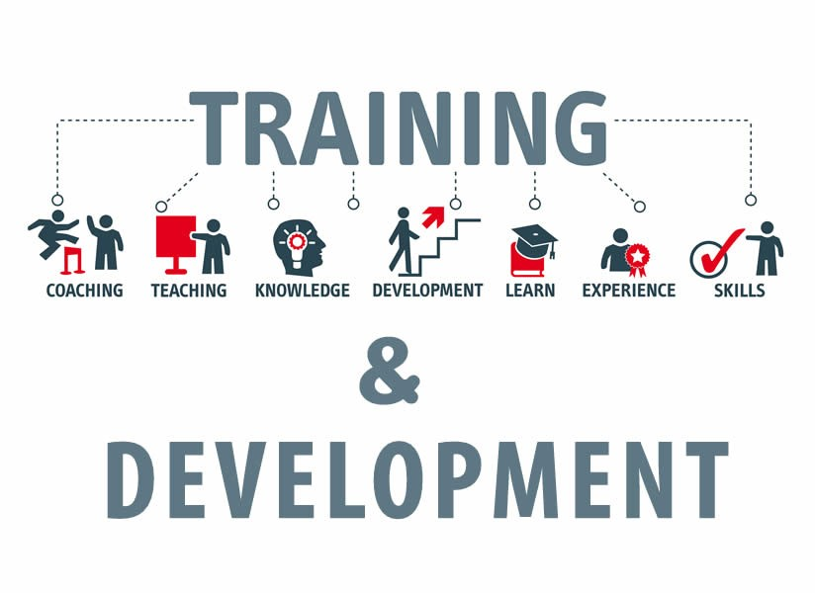
Figure: Training and Development (Ababneh, 2021)
Continuous Communication
As continuous communication is done through the training and development process in “Fresh Direct”, the employees will be freer with the managers. This will bring up the best results through the expression of the needs and views of the employees to the managers and leaders. This will ensure the needs are fulfilled and the views are analysed and considered where the employee can develop himself personally and their expectations are managed (Yousf, et al, 2021).

Boosting Confidence
The confidence of the employees in “Fresh Direct” is boosted throughout the process of training and development where the employee is highly motivated and developed. The skill development of the employees also brings up a potential confidence boost for employees. This personal development will ensure the best motivations of the employees where the organisation will help the employees to be the best of them and communicate properly with the process where their expectations will be met (Chanana, 2021).

Expectation Clarification
The expectation of the employees gets more clarified through the training and development process where they are supervised thoroughly with their actions in “fresh Direct”. This helps the managers to track the employees with their desires where the actions are done by the managers in the organisation to bring up the best alternatives and results to meet the employee expectations (Saks, 2022).
Employee Development Methods
Coaching
Coaching is the technique of giving an employee advice and route from a extra knowledgeable or experienced man or woman a good way to help them increase new abilities, carry out better, and enhance the first-class of their careers. The traits of coaching are that it is individualised and tailored, that it has a clean commercial enterprise intention, and that it's far frequently accomplished one-on-one over the years (Saks, 2022).
Mentoring
Professional or informal programmes, mentoring pairs up employees with differing tiers of know-how with extra seasoned co-workers- For women and those of shade, formal mentorship programmes may improve performance and the workplace climate whilst lowering attrition and improving recruiting. (Rožman, et al, 2021).

Individual development plans
Agencies can also utilise a character development plan to quicken the velocity of worker learning. A worker's intents, studying goals, and the assistance required to assist her or him reach specific development desires are all defined in this report. Individual development plans which might be beneficial include people who include grownup studying methodologies, experiential mastering, and symbolic engagement (Rožman, et al, 2021).
The 9-box grid
The nine-container grid is a way for assessing every man or woman employee's diploma of present and destiny organisational contribution. The grid is regularly used in succession planning as a technique for assessing an employer's talent pool and spotting potential leaders. Managers may also create Individual development plans for the usage of the grid's information (Saks, 2022).
Cross-training
It is the preparation of making ready individuals to execute duties that aren't generally a part of their job description. The instruction of go-education may be continuous and deliberate, or it is able to be a brief or ad hoc restore. Despite the fact that move-training seldom ends in a short promotion, it does display that an employee is keen to pick out up new talents. His or her capability to work with a selection of talents might also assist them qualify for subsequent professional development (Saks, 2022).

3. Critically evaluate the development vehicles available to an organisation appropriate to the development needs of the individual

There are some main development vehicles in “Fresh Direct” that include motivation, leadership management, engagement, and others. These bring up the proper development of the individuals in the organisation. This brings up the development needs fulfilled in the organisation where the organisation derives the best results in the market. Here are those presented below:
Motivation
Motivation is one of the most important things in an organisation where “Fresh Direct” brings up the best motivation to the employees. The organisation brings up all kinds of motivations for the employees including both negative and positive. The best-performing employee gets both intrinsic and extrinsic rewards like bonuses, recognition, promotion, and others. It enables HR specialist specialists to build at the corporation culture—that is distinct from technical knowledge and knowledge—that worker presently has instead of starting from starting. Usual, education or on boarding newly recruited people might not be as effective at bringing human assets as much as organisational necessities as further developing an individual might (Saks, 2022).
The organisation provides support to the low-performing employees so that the employees can be more effective later. Whilst accomplished nicely, workforce improvement does take a economic, time, and effort commitment from the business, but those investments will extra than pay for itself in the long run. If the employees seem to be doing or performing bad actions, the employee is treated with negative motivation such as demotion, task punishment, and others. This brings up the best development of the individuals as well as the organisation (Riyanto, et al, 2021).
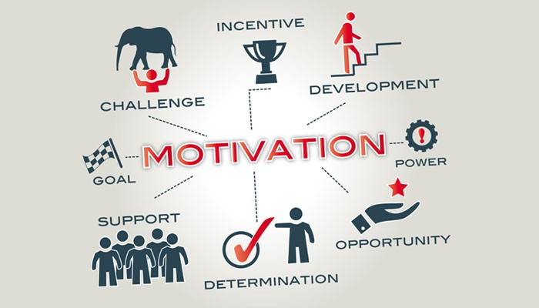
Figure: Motivation (Raza, et al, 2021)

Leadership Management
The leaders are very effective where “Fresh Direct” brings up the best leaders with effective management so that the best effect can be ensured. The leaders and managers are very effective and generous, and they can easily connect with the employees and make a very good connection with them. These results in effective communication where the employees get better attention, and the organisation can make up more effective task communication.
Better task communication by the leaders will encourage the employees more and the performance of the employees will be boosted. This will develop the employee skills as well where the employees will be encouraged more towards the development of the organisation so that the goals and objectives of the organisation can be ensured. The employees will also develop better with the trust of the leaders where the leaders will make them work better for the organisation resulting in the best market actions (Yousf, et al, 2021).
Engagement
Employee engagement is the most important thing in an organisation like “Fresh Direct” where the organisation will be able to drive the best results with the employees. The employees will be more developed with the continuous communication and the transaction of emotion by the organisation. The employees are engaged best in “Fresh Direct” where the employees bring up the best performance. Worker development is basically recounted as a strategic instrument for an organisation's long-time period boom, productiveness, and capability to hold directly to key employees. Employee improvement processes may be time-ingesting for organisations, frustrating for people, and of questionable price to each event if key obstacles are unnoticed. See workers worry that their employers are not offering sufficient opportunities for professional and ability development.
This also makes the learning of the employees better where the employees’ development at the best level to ensure the best competitive advantages. The company brings up the best engagement process in the workplace ensuring the best actions in the company culture so that employees interact more effectively, and they will spend less time wasting. Eventually, this will bring up the best results in the process and the improvement of the employees (Chanana, 2021).

Component 2: SMART & PDP

SMART

SMART goals are the combination of specific, measurable, achievable, relevant, and time bound. The organisation provides more positive motivations to the employees based on their performance.
Specific
Here I must be specific about what type of goal I must achieve using the newly recruited employees for Fresh Direct. Here some specific topics must maintain such as what and who should I be involved in to reach the goal. This specific should be the mission statement of the goal.
Measurable
This part determines what metrics I am going to use to measure the progress. To meet the goal measurable plays an important role and makes the goal more tangible. As an HR manager at “Fresh Direct” I must use this part appropriately (Chadwick et al, 2018).
Achievable
This part determines the importance of the goal and what I can do to make the goal more achievable. Though to do this, it may require a new changing attitude and situation and new skills (Kristanto et al, 2020)
Relevant
The relevant part of the SMART goal concentrates on that created specific sense with huge business goals. Here the business and business objectives should be relevant to each other. As an HR manager, I must maintain relevance to the entire system and newly recruited employees to get a better and sequential outcome from them
Time-Bound- Every task and goal should have specific timing and should be completed within that time. In the context of the business and its goal, it is highly essential to give a target date for deliveries. This process is known as time-bound (Kshatriya, 2018)
SWOT Analysis
Strengths  - I have strength as the newly recruited employees can get a chance to take huge information from internal sources (Baier et al, 2022).  - Using technologies in “I” will support to increase in technological skills and business growth. | Weaknesses  - I have Lack of proper maintenance can be a weakness for the “Fresh Direct” company.  - Due to the lack of proper training skilled employees, I can fail to operate their activities.  - Lack of competitors unorganized situation can be the weakness of me and the employees of “Fresh direct”.
Opportunities  - I have found that using various technological terms and tools can be a great advantage for the newly recruited employees to increase their career development.  - I have found that appropriate business theory can maintain the balance of the employee's career.  - I have found that the different business operations can support a lot to the employees to get different business vibes. | Threats  - I may be threatened by the change in leadership, and they occasionally may lose the actual path.  - I have found that highly skilled and experienced employees can be a threat to newly recruited employees (Fontaine, 2018).  - An unorganized HR manager like me can be a threat to the newly recruited employees (Kshatriya, 2018)

SWOT Analysis

Personal Development Plan

Focus Area | Where now | Will be | How known | Activity | Resources | Time | Reward
Creating training plan | developing | Gain interpersonal and leadership skills. | By analysing the SMART goals | Group work and experiences | Various business papers and documents | Within 1 year
Following training plan | Could be better | Can maintain the situation in any condition (Petrakis et al, 2021) | By doing a SWOT analysis | Self-practice | My group members | Within 3 months | Net running kit.
Maintaining | Maintain all the employees appropriately. | I can manage all the teams and activities properly. | By doing self-practices | Teamwork and more practice | My teammates | Within 6 months

Conclusion

After all the discussion, it can be concluded that “Fresh Direct” has been very effective in managing the employees properly where the organisation has effectively inspired and motivated the employees. The organisation could also do better with close interaction and monitoring where the needs of the employees can be fulfilled better. This will bring up the best effectiveness of the employees and the organisation can get success in achieving the organisational goals and objectives more efficiently. The organisation also has very good leadership that motivates the employees properly to bring up the best results to be the best online food delivery actions with beating all the competitors and maximum customer satisfaction (Kshatriya, 2018)

References

Ababneh, O.M.A., 2021. How do green HRM practices affect employees’ green behaviors? The role of employee engagement and personality attributes. Journal of Environmental Planning and Management, 64(7), pp.1204-1226.
Ali Ababneh, O.M., Awwad, A.S. and Abu-Haija, A., 2021. The association between green human resources practices and employee engagement with environmental initiatives in hotels: The moderation effect of perceived transformational leadership. Journal of Human Resources in Hospitality & Tourism, 20(3), pp.390-416.
Baier, M.S., Lockl, J., Röglinger, M. and Weidlich, R., 2022. Success factors of process digitalization projects–insights from an exploratory study. Business Process Management Journal.
Chadwick, A. and Leigh, J.A., 2018. Identifying and developing clinical leadership in relation to transition’: in. Transition to nursing practice: from student to registered nurse, pp.116-133.
Chanana, N., 2021. Employee engagement practices during COVID‐19 lockdown. Journal of public affairs, 21(4), p.e2508. Saeef_Nabil
Fontaine, S.J., 2018. The role of reflective practice in professional development. The Veterinary Nurse, 9(7), pp.340-347.
Hurtienne, M.W., Hurtienne, L.E. and Kempen, M., 2022. Employee engagement: Emerging insight of the millennial manufacturing workforce. Human Resource Development Quarterly, 33(2), pp.137-156.
Kristanto, T., Hadiansyah, W.M., Nasrullah, M., Amalia, A., Anggraini, E.Y. and Firmansyah, A., 2020. Strategi Pemasaran Digital Dalam Peningkatan Penerimaan Mahasiswa Baru Menggunakan Analisis SWOT. MULTINETICS, 6(2), pp.128-133.
Kshatriya, S., 2018. A case study of empowerment: Linking adult training to employment through innovative learning approaches. International Journal of Research in Social Sciences, 8(7), pp.44-75.
Petrakis, E.G., Kontochristos, I. and Rastsinskagia, K., 2021, May. Fi-SWoT: Secure Federated Service Oriented Architecture for the Semantic Internet of Things. In International Conference on Advanced Information Networking and Applications (pp. 200-214). Springer, Cham.
Raza, A., Farrukh, M., Iqbal, M.K., Farhan, M. and Wu, Y., 2021. Corporate social responsibility and employees' voluntary pro‐environmental behavior: The role of organizational pride and employee engagement. Corporate Social Responsibility and Environmental Management, 28(3), pp.1104-1116.
Riyanto, S., Endri, E. and Herlisha, N., 2021. Effect of work motivation and job satisfaction on employee performance: Mediating role of employee engagement. Problems and Perspectives in Management, 19(3), p.162.
Rožman, M. and Štrukelj, T., 2021. Organisational climate components and their impact on work engagement of employees in medium-sized organisations. Economic Research-Ekonomska Istraživanja, 34(1), pp.775-806.
Saks, A.M., 2022. Caring human resources management and employee engagement. Human Resource Management Review, 32(3), p.100835.
Wu, J., Inoue, Y., Filo, K. and Sato, M., 2022. Creating shared value and sport employees’ job performance: The mediating effect of work engagement. European Sport Management Quarterly, 22(2), pp.272-291.
Yousf, A. and Khurshid, S., 2021. Impact of employer branding on employee commitment: employee engagement as a mediator. Vision, p.09722629211013608.

