Dissertation
Impact of COVID-19 on the UK Banking Sector
Student name: C C Pichiu
Student ID: 1816569
Submission date: 03.01.2023

Table of Contents
Chapter 1: Introduction 4
1.1 Background 4
1.2 Problem Statement 5
1.3 Research question 5
1.4 Research objective 6
1.5 Significance of the study 6
1.6 Research Framework 6
1.7 Ethical Consideration 7
1.8 Research Methodology 7
1.9 The organisation of the Study 7
Chapter 2 – Literature Review 8
2.1 Introduction 8
2.2 UK banking sector 8
2.3 The Impact of the conditions in Banking Sectors 8
2.4 Roles of banks 11
2.5 Theories of digitalization 13
2.6 Needs for digitalization in the UK banking sector 16
2.7 Advantages of digitalization 17
Chapter 3: Methodology 19
3.1 Introduction 19
3.2 Research Methodology 19
3.2.1 Research Philosophy 19
3.2.2 Research Approach 19
3.2.3 Research Design 20
3.2.4 Data Collection Method 20
3.2.5 Data Collection Source 20
3.2.6 Sampling 21
3.2.7 Data Analysis 21
3.2.8 Ethical Considerations 21
3.3 Summary 21
3.4 Conclusion 22
Chapter 4: Findings 23
4.1. Increase in lending by credit cards 23
4.2 increased interest rate 23
4.3 Decrease in earnings in the banking sectors 24
4.4 Banking revenues 25
4.5 Increased use of ML and DS 26
Chapter 5: Analysis 28
5.1 Introduction 28
5.2 Analysis 28
5.2.1 Increase in lending by credit cards 28
5.2.2 Increase in Interest Rate 29
5.2.3 Decrease in the earnings of the UK banking sectors 30
5.2.4 Increased banking revenue 31
5.2.5 Increased demand for ML and DS in banking operations 31
Chapter 6: Conclusion, Recommendations and Reflection 33
6.1 Conclusion 33
6.2: Recommendations 33
6.3. Reflection 35
Reference List 36

Chapter 1: Introduction

1.1 Background
The operations of the London Goldsmith-Bankers between 1650 and 1700 are where the foundation of the United Kingdom’s financial system could be traced (Gelderblom and Trivellato, 2019). The fundamental idea of accepting interest-bearing deposits, making loans with the money provided by the surplus unit and developing these was created by the Goldsmith Bankers of the UK. However, such deposits made it possible for the bank to generate their own banknotes or promissory notes and permitted depositors can utilise ‘drawn notes’ to access their accounts. The 17th century is generally regarded as the beginning of banking in the United Kingdom. During the 19th century, the British banking sector underwent major changes (Singh and Das, 2018). England was a nation with many tiny banks throughout the first half of the century.
A fatal virus, which emerged out of nowhere in Wuhan, China, in December 2020, slowly spread to other nations, including the UK. Following investigations, the World Health Organisation gave the virus the name of Corona Virus (COVID-19). In addition to claiming millions of lives, the pandemic’s emergency brought about an economic catastrophe in the UK that influenced the country's financial industry. The Government of the UK and its Prime Minister decided to implement a lockdown as a precaution to stop the disease's spread, which affected the UK economy as a whole and had severe effects on the country's financial sector.
Fears about COVID-19's results have already had a huge effect on the global economy, with important merchandise losing its value so far by 20-50% in 2021 (Mumtaz et al., 2021). With the harmony of global GDP extension for 2020 at 2.6% and the International Monetary Fund forecasting the likely emergence of depressional circumstances, several economists and institutions have lowered their projections. The reason behind this is to fight the economic breakdown due to COVID-19. A new similar pattern is anticipated in the UK, where financial growth is predicted to slow down in the first half of 2020 and continue to do so if the disease is not curbed in due course. (UK Government, 2022). The downturn has negatively affected many industries in the UK, particularly, the payment and the banking sector (Wójcik and Ioannou, 2020). Some of the results of the global pandemic on the UK economy and banking sector are the main topic of this research. The researcher thoroughly compares pre-COVID-19 estimates and amended prediction of the total contract, customer, and loan balances of credit cards and balances deposits. Therefore, this offers an indication in terms of growth and value rates based on our exclusive datasets. Additionally, it includes details on the steps the government has taken to battle the effects of the global pandemic.

1.2 Problem Statement
Since the beginning of the global emergency called COVID-19, more loans have been made available to customers and businesses, in contrast to what happened during the 2008 global financial crisis. During the COVID-19 outburst, households' holdings of deposit strength streamed considerably, in part as a result of the forced savings brought on by public health laws (UK Government, 2022). Due to the cloudier business environment, businesses also increased the number of deposits they held. This move may have been preventive in nature. Numerous studies indicate that UK consumers are using credit more frequently than usual, likely in response to rising living costs. Since the start of 2022, there has been an increase in business deposits, which can be a sign of growing uncertainty and a fall in the company’s confidence (UK Government, 2022).
The global pandemic's effect on household loan borrowing has been unfavourable in response to the global financial crisis, although the holdings of loan liabilities have essentially reverted to their pre-pandemic levels (Sánchez Serrano, 2022). The Bank of England gives more information on data related to total lending to individuals. The yearly rate of total lending to persons originally decreased. The pandemic, however, caused this to rise again to levels that are higher than they were before the epidemic. The banks in the UK have done a great job of maintaining the financial crisis brought on by the epidemic. The UK banks held a special Monetary Policy Committee meeting on March 19, 2020 with the aim of discussing the interest rates (Giese and Haldane, 2020). The official interest rate in the UK is called the Bank Rate. As a base rate or benchmark for various financial products, it is the most significant interest rate in the UK. When interest rates drop, loans for both customers and businesses will be cheaper. This will be underneath the expenses sustained by customers and UK businesses. Due to the effect of digitalisation in the banking sector, the UK has benefited in several ways (Office for National Statistics, 2022). Through the process of digitalisation, people living in the UK managed their money transactions more efficient, which eventually helped the banks to lower their support on liquid cash.

1.3 Research question
- What are the impacts of several conditions that aroused during COVID-19 on the banking sector?
- What are the roles of banks in handling the crisis created by the pandemic?
- What are the advantages of digitalisation in the banking sectors during COVID-19?

1.4 Research objectives
- To analyse the impacts of COVID-19 in the UK banking sector.
- To explore the roles and strategies of banks in handling the crisis created by the pandemic.
- To analyse the need for digitalisation created by the pandemic in the banking system in the UK.

1.5 Significance of the study
The goal of this research is to shed light on some of the core characteristics of the UK banking industry. This study will aid in a better understanding of customer demands, shifting market dynamics and shifting customer preferences. The study also intends to examine the effects of the COVID-19 epidemic on the UK banking industry (Umar, 2022). The study must be done in such a way that it will highlight the roles that the banks have played in resolving the crisis brought on by the epidemic. This study will also propose a unique behaviour for the Central Bank of the UK, as well as other private banks in handling such crisis in the financial sector.

1.6 Research Framework
An overarching framework or module for the group research efforts is provided by a research framework (Safaeinili et al., 2020). However, research in passing made references to it, and even tried to conduct it. Thus, research comes in a wide range of forms, sizes, and focuses and may be utilised to address a wide range of issues related to business, product, and delivery. The conceptual framework has been chosen to show the effectiveness of this research.
How variables are connected to one another can be seen in the conceptual framework. It highlights how a study method relevant goals fit together to establish findings logically. A conceptual framework helps to relate and build an established body of objectives and concepts. Although, this can present major advantages such as increasing the comparability of financial statements between companies.

1.7 Ethical Consideration
The biggest ethical consideration that will be maintained throughout this research is the approval of the author, whose journals will be used. Since it is reducing the burden on survey respondents, the authenticity and relevance of the articles will be checked. Also, checking will be compulsory, which is the years of the journal, because more than 5 years’ old articles will not be used in the research.

1.8 Research Methodology
For this research, a secondary research method will be used; this will reduce the challenges arising as a result of developing survey questionnaires and choosing respondents. Qualitative data analysis will be done for the research.

1.9 The organisation of the Study
The organisation selected for this research is HSBC Holdings Plc. This organisation is relevant for the study; HSBC is one of the major banking organisations in the UK, organisation that has been faced with multiple challenges during the COVID-19 pandemic.

Chapter 2 – Literature Review

2.1 Introduction
In every economy, banks play a very important role in regulating money and controlling the whole economy. Every aspect of the global economy has been severely hit during the pandemic. Just like the other nations, the UK banking sector has also received a major hit due to the global pandemic. This section of the project provides brief details of the UK banking sector and the impact of the pandemic on the banking sector. Along with discussing these facts, the role of the banks is also elaborated in this paper. At the end of the assessment, some theories of digitalization and the implementation of digitalization in the banking sector have also been reviewed.

2.2 UK banking sector
The financial capability of the country gains recognition when the banking sector runs smoothly, as the banking sector is an important part of the economy. The financial operations are well-systematized and valid. The economic welfare of the UK is enhanced because of the presence of modern financial performance, public credibility, and solvency issues (Seyfang and Gilbert-Squires, 2019). The capital structure of the banking sector in the UK is concrete and holds a significant part of the economy. One of the major reasons for the UK's growth and development is the proper implementation of monetary policies and bank rates, which are framed by the banking sector (Dell'Ariccia, Rabanal and Sandri, 2018). In this research paper, there will be a brief discussion about the effects and impacts of the pandemic. The pandemic has shaken the economy, along with the banking sector of the UK. As every business was under lockdown, no financial operations took place (Pleyers, 2020). However, the banking sector tackled the situation conveniently, and played a major role by focusing on the deduction of the rate of interests, which provided relief to businesses and households. In addition, this research paper includes a brief discussion relating to the advantages of digitalization in the banking sector.

2.3 The Impact of the conditions in the banking sector
According to the new reports of Bank of England and the situation worldwide, due to the COVID-19 pandemic, there are several casualties as well as setbacks in every sector. The economic sectors are not an exception in facing the consequences. The banking sector, the economic and finance sector also face severe consequences due to the global pandemic. Regarding the several impacts that happen in the several banking sectors due to the pandemic situations, there are many cases worldwide where bank branches were shutting down due to lack of employees, as well as several security issues. Some other challenges included communication problems, instability of the customers as well as several strategic implementation issues (Seyfang and Gilbert-Squires, 2019).
Several branches shut down
One of the major impacts that are faced by the banking sector during the global pandemic is the need to shut down several banking branches at a steady rate. Due to COVID-19, there is certain alertness that can be identified among banking employees as well as customers. There were also procedures regarding the lockdown that were implemented by several governments, with the aim of preventing the further spread of the virus (Ozili and Arun, 2023). Next, there is a trend of operating some of the banking procedures with the help of the internet, which can be evident among the masses. As a result, there is a sudden loss of employees, which forced some of the bank branches to be permanently closed. The effect of COVID-19 pandemic not only affected important parts of the banking sectors, but also weakened its regulatory structures, along with the long recession as well as high leverage. (Ozili and Arun, 2023). Thus, the situation led to a financial crisis. The banking sector faces tremendous consequences, as a result of the pandemic, and several cases of subprime loans that have been given to the borrowers with the records of impaired credit have been identified. That shows the decaying environment of the banking sector, which is vastly different from the pre-COVID environment.
Loss of Employees and Employment
The shortage of employees is one the most significant negative consequences of the global pandemic in the banking sector. The chaotic consequences of COVID-19 are seen by the whole world. This virus affected several thousand people, and many people lost their lives. As a result, lockdown measures were announced by several countries' governments to prevent the virus from further spreading. The banking sector was faced with several cases of loss of employment as well as several bank branches being permanently closed, which ting increased the unemployment rates in the UK. (Carranza et al., 2020). Thus, it can be said that the adverse consequences of the global pandemic include a sharp increase in the unemployment rates, through lack of work attendance of the employees.
Instability of Customers
Due to the onset of the pandemic, the banking sector of the UK faced a higher level of volatility and instability. The economy around the whole world was very insatiable between 2020 and 2021. This is the main reason why customers developed serious trust issues regarding the safety of their money in the country (Heald and Hodges, 2020). Moreover, according to research conducted by HSBC, it is identified that many customers have converted to using mobile banking methods for conducting any kind of transaction. Moreover, after the pandemic, the relationship between customers and banks mainly shifted toward a predominant use of digital platforms. This increases the expectations of the customers from the financial services provided by the banks, which are more crystallized by the pandemic. On the other hand, customers become highly anxious, uncertain, and insatiable, which increases the need for banking facilities in providing more secure and flexible offers to the customers.
Security Issues
Some banks in the UK have faced serious threats from the rise in threats of cybercrime during the pandemic. Apart from that, many banks need to cut down their overall costs along with their allocations for reducing the risks from cybercrime and fraud and maintaining IT security. The main reason behind this is that many financial institutions face higher levels of losses during that time (Wójcik and Ioannou, 2020). All this increases the security-related issues of the banks, making them even more vulnerable during the crisis. This has a serious impact on the satisfaction of the customers; thus, retaining the customers for a long time becomes difficult for the institutions. Many customers were also unsure about the safety of their money and personal information. This further creates a vicious cycle by decreasing the profit-gaining capability of the banks.
Communication problem
Communication is an essential factor that needs to be maintained within any organization. In a sector like banking, proper flow of communication is necessary because it allows the financial operations to be done properly and authentically. During the pandemic, the employees of the banking sector failed to attend the workplace because of a lockdown which took a long time to solve the financial process. During the pandemic, the banks granted a 0.1% rate of interest so many people applied for loans, but different communication problems led to a fail to grant the loans on time. Loans take time to be granted because they require verification processes which need time to complete. Communication problems led to less scope for collaboration, which delayed the operational system of granting loans. Lack of communication gives rise to the problem of transparency which creates barriers among customers.
Strategic issues
Among the impacts of the COVID-19 that are found in the banking sectors, the problems regarding the handling of strategic issues can also be found. The several occurrences that happen in the banking sector, include the shutting down of several branches, along with increased unemployment rates, as a result of a lack of employees and also customers' instability and cyber security issues and lastly, different communication problems, made the whole situation worse and forced the higher authorities to try and maintain a certain degree of calm. The new digitized facilities regarding banking services are introduced among the customers (Sihotang and Hasanah, 2021). Thus, it can be stated that the strategic management team of the banking sector encounters several obstacles while handling and implementing the new services that show the beginning of a new era (Knight, Daymond and Paroutis, 2020). As a result, some casualties can be recognized; however, things gradually changed, and the system is now well-handled by every customer. It can be regarded as the solution to the strategic issues created during the global pandemic.

2.4 Roles of banks
During the pandemic, the main objective of the UK was to handle the loss of jobs. During COVID-19, people lost their jobs because there was no stability in the economy. There was a long lockdown imposed by the authorities which forced many businesses to close, some of them closing permanently, which caused a loss of jobs. Strict government rules and regulations along with frequent lockdowns failed to hold back the stability of the economy. During the pandemic period, commercial banks provided help to their customers, which is considered to hold a significant role in the economy. Being the most advanced and modern banking sector, the UK banking sector provided help in the following ways.
Cut in bank rate
The UK has an interest rate which is popularly known as the Bank rate. The concept of bank rate can be explained as the rate which is applied by the Central Bank to the commercial banks (also known under the name of “high-street banks”) for lending funds. More precisely, it can be said that commercial banks need to pay the bank rate while lending funds from the central bank (Haas et al., 2020). So, in the context of bank rates, the UK cut its bank rate to 0.1% which allows people to take loans at lower interest for households as well as businesses. The Bank of England has taken the initiative to cut the Bank rate to bring vitalization to the economy. It is considered to be the lowest bank rate in the history of the UK banking sector. The main objective of the UK banking sector was to eliminate the deficit from the economy which has been caused because of the unpredictable pandemic. The UK government knows that the cut in the bank rate will affect the growth and development of the nation adversely. However, to overcome the negative consequences of the global pandemic, the banking sector must adopt the cut policy.
Cut in interest on lending
The banking sector in the UK allows people to lend monies from commercial banks so that they can survive during the pandemic (Buckner and Dowd, 2020). The Bank of England cut the Bank rates to 0.1%, which allows commercial banks to give loans to UK citizens at fewer rates. In general, when the rates are lower, it provides great relief to the public. A low rate of interest leads to the lending of money at cheaper rates. This allows the users to have readily available funds to spend on necessities, which regulates the cash flow in the economy. The people focus on investments, which brings stability to the economy. Another benefit of the cut in the interest on loans is the cash liquidity in the nation. However, public spending can greatly affect the economy, as it tends to create inflation where the price of the commodity gets higher. With the help of the cut in interest, small and medium businesses increase their chances of survival during these challenging circumstances originating from the global pandemic. (Bitar and Tarazi, 2022). The SMEs implement the digitization of their business which enables them to bring stability to their business which indirectly helps the economy to maintain their GDP.
Helped business survive
The UK is a nation that provides ample help and support to businesses. There are rules and policies for the business which allow the business to flourish along with growth and prosperity in the nation. During the pandemic as the nation was under lockdown, the employees of the business organization failed to reach the workplace and accomplished their targeted job. With the help of lower bank rates, the business was able to get the chance to survive during the crisis period (Apergis, 2022). With the help of a lower rate of interest, the business organization pays the staff and suppliers. As their financial operation faces a pause in the economy, their business must pay off the suppliers and staff because during the pandemic cash flow was the main thing that needed to be regulated to maintain consistency in the economy. Moreover, the implementation of digitization allows employees to shift their focus on flexible work working arrangements, which allows slow and steady movement in business. The UK government knows that businesses contributed a significant part to the country's economy, so cutting the lending interest will provide a sigh of relief to the business to run on a progressive track.
Expand lending
During COVID-19, the banking sector of the UK provides benefits to the business, with the aim of offering some form of help. As the pandemic has the scope of international trade through online or digitalization methods, the UK government uses this situation positively. As the bank rate decreased to 0.1%, the banking sector allowed businesses to expand with the help of loans. Here, the government has implemented the theory of law and demand. The theory of law of demand suggests that when there is demand for a product, this affects the price in the market. Similarly, the law of supply refers to the demand for the commodity changing, by keeping all the factors fixed. So, from this theory, it has been understood that when there is demand for the service changes, the supply will get affected. The rate cut will cause inflation, which will increase the price of products and decrease public spending. Expansion in lending allows benefits in tax, which helps stabilize the profitability account of a business.
To sum up, it can be said that by cutting the bank rate to 0.1% the UK government has played a significant role in the UK economy. The lending supported the businesses and people of the UK to survive the tough pandemic situation, with the help of loans provided by commercial banks of the UK, at cheaper rates (Cowling et al., 2021). The cheap rates of interest allow the business to extend the lending to develop the business in a wider way.

2.5 Theories of digitalization
Diffusion of innovation theory
This theory was proposed by E.M. Rogers in 1962. The theory discusses the processes by which a product or idea is being adopted and expanded in society (Avidar, 2018). The theory effectively identifies that the members of a society who adopt new technologies at different places form five different categories. The first category among this is the innovators, who try the innovation first. These are the people who want to take risks and are interested in new ideas. Then, some early adopters generally enjoy leadership roles and effectively embrace the opportunities in the market. This population can be easily convinced, and no extra information is needed to make them adopt a new product or service. The early majority is the third category which first sees the evidence before adopting any innovation. Thus, success stories need to be shared with them as evidence of the effectiveness of an innovation. The late majority is the fourth category, that adopts an innovation only when most of the people are willing to try that particular innovation. Laggards are the fifth category that is very conservative and resistant to change. Thus statistics, pressure, and fear appeal can be used as strategies that will come from other adopter groups. The theory also identifies that five main factors that influence the adoption of innovations such as observability, trialability, complexity, compatibility, and relative advantage. However, the theory has some limitations, such as the theory being suitable for describing the adoption of behaviour and not the prevention of behaviour (Holotiuk and Moormann, 2018). This theory is highly effective in discussing the needs and progress of digitalization in the country. The managers are among the early adopters of digitalization for coping with the challenges proposed by COVID-19 in the country. The citizens in the country were among the early majority population, as they identified that for sustaining their daily life and keeping their business processes flexible, they need to adopt digital facilities provided by the banks in the country. Many people in the country belong to the late majority and laggards’ group, due to the severity of the crisis. Most of the UK banks have already implemented technological advancements in their sector before the situation of the pandemic. However, they need to advance more their technological aspects to deal with these types of circumstances in the upcoming future.
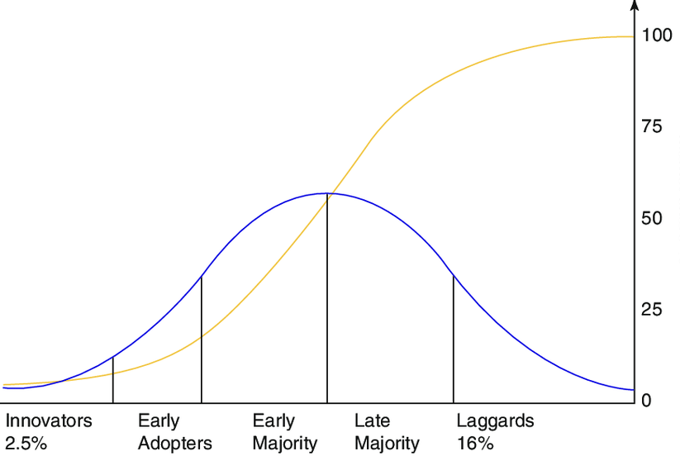
Figure 1: Diffusion of innovation theory
(Source: Avidar, 2018)
UTAUT Model
The model refers to the unified theory of acceptance and the use of technology. This theory is highly effective in explaining the intentions of the users for using an information system. The four key that construct the theory are social influence, performance expectancy, enabling conditions, and effort expectancy. First, performance expectancy determines the degree of people's belief that the innovation will be helpful for them and increases efficiency in their performance (Almetere et al., 2020). Effort expectancy, on the other hand, determines the degree of use that is included in how individuals are regarding the use of the system. Moreover, the theory determines that social influences help define the degree to which a particular personality perceives the view of others regarding their use of a particular new system. Lastly, the facilitating conditions refer to the degree to which a particular person believes how much technologies and infrastructure are present for supporting the use of a particular system. The theory also identifies that the degree of all the key constructs is affected by various factors, such as voluntariness, experience, gender, and age of the users. Age has a high impact on the four predictors, as proposed by the theory. Gender does not have an impact on the facilitating conditions; however, the other three constructs are highly impacted by the gender moderator. Experience also has a high influence on strengthening the relationship between the facilitating conditions, social influence, and effort expectancy. Effort expectancy is very high from the individuals involved in the sector, so that the losses could be handled properly (Merhi et al., 2020). However, voluntariness has a moderating effect on the adoption of technology and the relationship between behavioural intention and social influence. This theory is highly related to the use of digitalization in the banking sector of the UK. By fulfilling the performance expectancy, the banking sector could increase its efficiency in using digital technologies. Social influence and facilitating conditions are currently in question in the country as the banking sector was highly affected by the global pandemic.
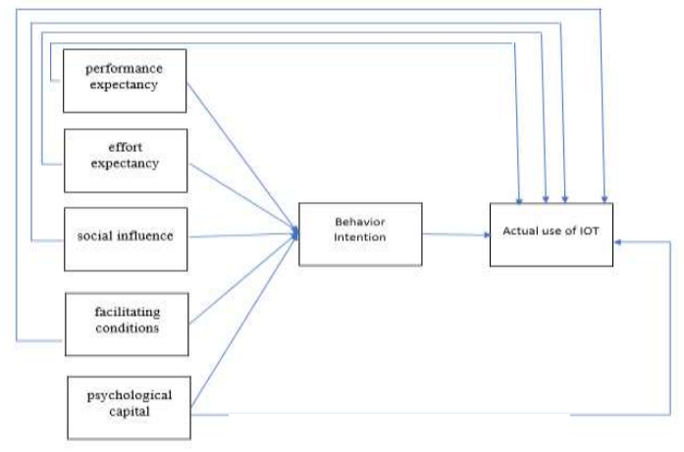
Figure 2: UTAUT framework
(Source: Almetere et al., 2020)

2.6 Needs for digitalization in the UK banking sector
Handling the acute impacts of the pandemic
The banking sector was one of the most impacted sectors in the UK during the pandemic. Around the country, many businesses were not performing well. Banking stocks were highly impacted during the crisis, as there was a sharp decline in the value of stocks, by around 40% during March 2020. Due to this huge loss, many banks had to sell their bonds to bring more liquidity to their institutions (Ozili, 2022).It was also seen that the interest rates of the Bank of England have been dropped by the authorities, so that they can include more new customers in their supply chain. This situation needs to be handled by the banking sector of the country more effectively. Digitalization is the only option left for the banks for continuing their processes effectively. Banks enabled customers to access their money from distant places and enabled them in tracking their transactions effectively. Through technological advancement, the sector restricted further losses and gained the trust of the customers.
Increasing dependency on technology
Customers in the UK have become highly dependent on technology, for doing a wide range of day-by-day tasks (Bilan et al., 2019). During the pandemic, this situation got more practical as physical connection between the citizens with the outer world was highly restricted by the government. Thus, there is a high need that the banking sector highly promotes digitalization in their processes, so that they can increase their relevance in front of customers. Otherwise, it would have been difficult for the banks to provide a higher level of satisfaction to the customers. The banking sector is also growing in complexity and scale, which will in the future increase the issues regarding compliance in the sector.

2.7 Advantages of digitalization
Gaining trustworthiness
In the UK, citizens tend to choose their banks according to their perceptions regarding the institution. The perception of the citizens is shaped by the processes and presence of the financial institution online. However, during the pandemic people were very uncertain regarding the safety of their monies, due to numerous financial crises. Moreover, citizens in the country are highly impacted by social media platforms such as advertisements and websites (Lui and Lamb, 2018). Thus, through digitalization, the banking sector can ensure that it can gain the trust of its customers more effectively. Trust was highly needed during the pandemic as people wanted an institution where their money is safe as well as easily accessible. Through digitalization, the trust of customers was ensured properly by the banking sector.
Acquisition of new customers
The banking sector in the UK currently requires more customers; on the other hand, the customers need the best experience from their financial institutions. The Internet is a great platform for banks attempting to reach out directly to potential customers (Tsindelian et al., 2021). During the pandemic, people were finding affordable and flexible banking options, as they were restricted by various regulations. Digitalization made it easier for customers to locate those banks in the country and identity which institution can fulfil their needs during a crisis. Thus, the acquisition of new customers can become cheaper, using digitization in the banking sector.
Enhanced efficiency
The citizens of the UK highly believe in accuracy and speed, and both can be introduced in the banking sector through digitalization. During the pandemic, citizens could not access the banks physically; however, digitalization was used in various processes of the banking sector. Various essential processes in the banking sector that include the essence of digitalization are quicker transactions, electronic signatures, access to banking applications through smartphones, and many more (Frimpong et al., 2020). Moreover, if the banks do not have appropriate efficiency, they will incur a very less amount of profit as maintaining a consistent customer base will get difficult. Thus, efficiency is highly impacted by the digitalization in the banking sector in the UK which increases people's flexibility in transferring money despite all restrictions.
User-friendly experience
Previously in the banking sector, the experience of the customers was not that much user-friendly as some of the processes were relatively slow. Instead of tiring queues, nowadays the whole banking process has become flexible with the help of smartphones or digital devices. Due to a more user-friendly approach, the users of the banking sector around the country easily transferred money for their daily purposes. Even after the pandemic, the banking sector took very little time for increasing its pace and providing satisfaction to the customer.

Chapter 3: Methodology

3.1 Introduction
The methodology is a research strategy including a system of philosophical assumptions to understand the research objectives and underpin the research methods (Melnikovas, 2018). Logical steps of methodology demonstrate the approach of the research work and ensure reliable, authentic, and valid research findings. Therefore, the research methodology is a crucial part of the present material, to ensure consistency in chosen methods, used philosophies and tools.
This chapter aims to address the logical pattern followed for this research purpose in this dissertation, on the topic of the Impact of COVID-19 on the UK Banking Sector. This chapter has explained the research philosophy, research approach, research design, data collection method, data collection sources, sampling method, data analysis method and ethical considerations.

3.2 Research Methodology

3.2.1 Research Philosophy
This dissertation used interpretivism research philosophy for the research purpose. Interpretivism research philosophy also known as naturalistic philosophy is a method of access to reality through social constructions like shared meanings, consciousness, and language (Norwich, 2020). Interpretivism philosophy follows the tradition of understanding the world through directly experiencing the phenomenon. This research philosophy helped the researcher by providing a brief understanding of the research topic and to conduct this research work strategically. It makes it possible to analyse the research topic deeply considering the cross-cultural differences in the UK banking sectors. It helped to interpret the collected data in a trustworthy way. Particularly interpretivism philosophy helped to observe the social world and phenomena depending on individual interests.

3.2.2 Research Approach
This dissertation chose an inductive research approach for this research purpose. The inductive research approach is a method of moving towards a broad generalisation from specific observations (Walter and Ophir, 2019). Therefore, it follows a bottom-up approach to research work. This research approach helped to observe specific details of the contemporary phenomenon in the banking sector of the UK after COVID-19 and then recognise the pattern of change and finally come to a general conclusion. The inductive research approach did not disregard established theories, while formulating the research objectives and research questions, but helped to retain meaning from the collected data to generate a theory applicable to wider perspectives.

3.2.3 Research Design
This dissertation used an explanatory research design for this research work. Explanatory research design follows a cause-and-effect model, as it helps to explore the causes of a particular phenomenon and thus helps to predict future occurrences. This research investigates the trends and patterns of the collected data which have not been used previously. Thus, this research design helped to analyse the collected data sample and formulate a hypothesis on the studied pattern underlying the data. It has been very apt for the collected qualitative data to study the impact of COVID-19 on the UK banking sector. This research design proved to be the apt choice for analysing the primary data which has been collected through the convenience sampling method, particularly for this research purpose.

3.2.4 Data Collection Method
A qualitative data collection method was used for conducting this research work. Qualitative data collection methods refer to the processes of collecting non-numerical data through observations, group discussion, one-to-one interviews, case studies, record keeping and longitudinal studies (Barrett and Twycross, 2018). The qualitative data collection method is beneficial in setting the parameters to analyse larger data samples. The qualitative data collection method in this dissertation helped to determine the frequency of characteristics and traits of the collected data. Thus, it provided a wider scope of analysing data from diverse perspectives. It helped to provide insight into the reasoning pattern of the collected primary data. Therefore, this data collection method proved to be the best choice for this research methodology.

3.2.5 Data Collection Source
This dissertation used primary data collection method, through open-ended questions. The primary data collection method used in this research purpose helped to organise the exclusive data, which were not used in any other research work. Therefore, the research findings are exclusively based on the particular primary data. Open-ended questions used for qualitative primary data collection provide a wider scope to focus diverse perspectives on the research topic. Thus, this particular data collection source did not limit the scope of research findings in this dissertation.

3.2.6 Sampling
This research topic used a convenience sampling method for collecting data. Convenience sampling is a method of selecting participants who are easily available (Moser and Korstjens, 2018). Therefore, this particular sampling method confirmed the willingness of the participants in this data collection method. It demonstrates the methodology’s maintenance of ethical considerations. It made the data collection method uncomplicated for this research work (Porter et al., 2019).

3.2.7 Data Analysis
The thematic data analysis method was used in this dissertation. Thematic analysis is a convenient choice for the qualitative research purpose as it helps to explore the underlying pattern of the qualitative data from diverse perspectives to build a hypothesis. It helped to identify the connection between different aspects provided by the participants in the convenience sampling method. This flexible approach helped to analyse the qualitative data efficiently (Kiger and Varpio, 2020). Thus, this data analysis method went well with the research methodology used.

3.2.8 Ethical Considerations
The most important factor of research methodology is that it should be aligned with the ethical practices of research work. It refers to the process of taking ethical approval from the participants. Ethical considerations must imply informed consent from the participants (Fleming and Zegwaard, 2018). The participant should be informed of the objectives of the research, the process of research and the potential risks of taking part in the research work. Participants’ anonymity should be maintained by the research conductor. Even the confidentiality of the participants’ information must be taken care of. Conflict of interest between the participants and the research conductor must be resolved. These ethical considerations had been maintained during this research work.

3.3 Summary
This chapter of the dissertation work provides complete guidance on the research methodology. Interpretivism research philosophy was used for designing the qualitative primary collected data in an explanatory frame. Convenience sampling was used to collect responses to the open-ended question from the participants. Thus, thematic analysis helped to confirm the research findings from qualitative data. Ethical considerations were maintained to confirm the ethical practices of research work.

3.4 Conclusion
Conclusively, it can be stated that research methodology is an umbrella term, including different research designs, research philosophies, research methods, data analysis methods and data collection methods with a single alignment. Thus, it provides consistency in the pattern of the research methods.

Chapter 4: Findings

4.1. Increase in lending by credit cards
The graph shows that the credit card lending rates in the UK economy are the highest in 2022 since 1998. According to the Bank of England, the credit card lending rate in 2022 reaches 21.7%, which stands for the highest rate since 1998. Though the rate was quite flat growth between 2016-2018, after COVID-19 the growth rate is rising increasingly. Within 2018-2022 the rate increased to 21.7% from 18%.
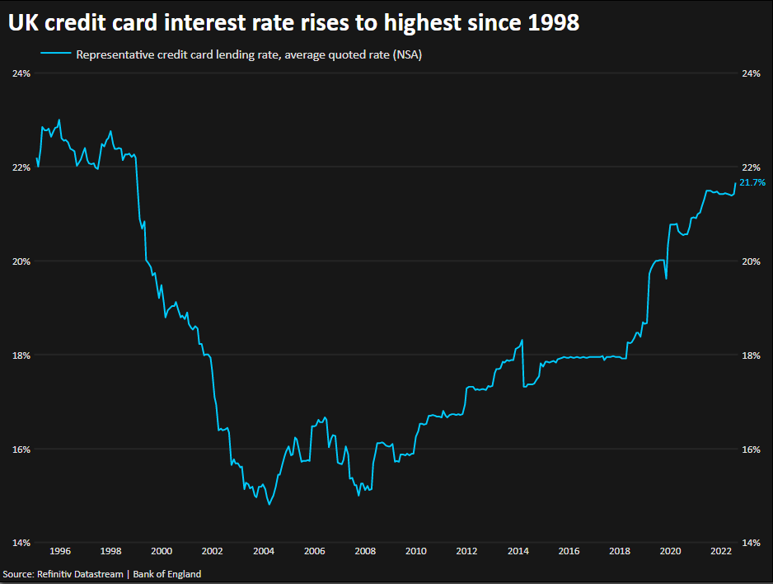
(Source: Milliken, 2022)

4.2 Increased interest rate
The graph depicts the high rise of the inflation rate in the UK because of COVID-19. According to reports of the Bank of England, the inflation rate in the UK in 2022 is almost 10%. The graph also demonstrates the Bank of England’s monetary policy to achieve a 2% rate of inflation by 2025. It also depicts the bank’s forecast of a falling inflation rate after a further rise in the rate from 10%.
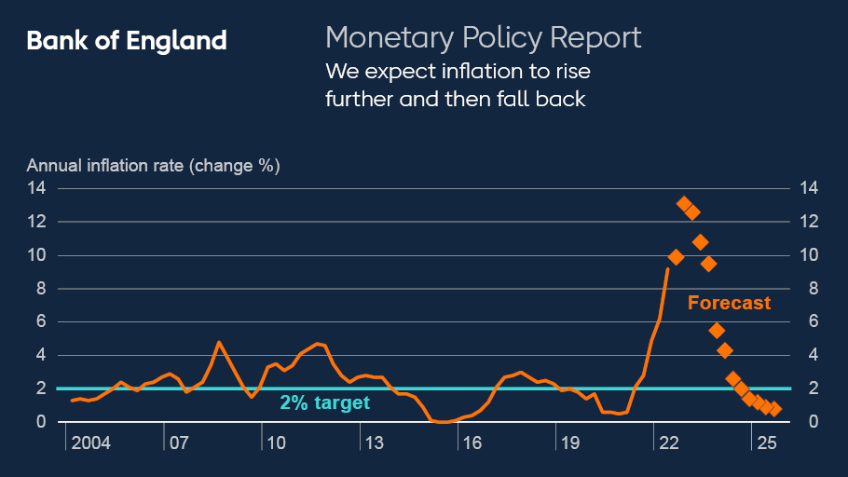
(Source: Bank of England, 2022)

4.3 Decrease in earnings in the banking sectors
The graph shows the fact that the leading UK banking companies are facing a sharp fall in the company’s earnings before provisions and tax in the post-pandemic era. The most affected period between 2019-2020 due to the pandemic spreading across the world shows an uncertain growth and fall of earnings in the UK’s banking sectors. The prominent phenomenon cleared from this graph is that none of the UK’s banking companies faced constant growth in their earnings since 2019.
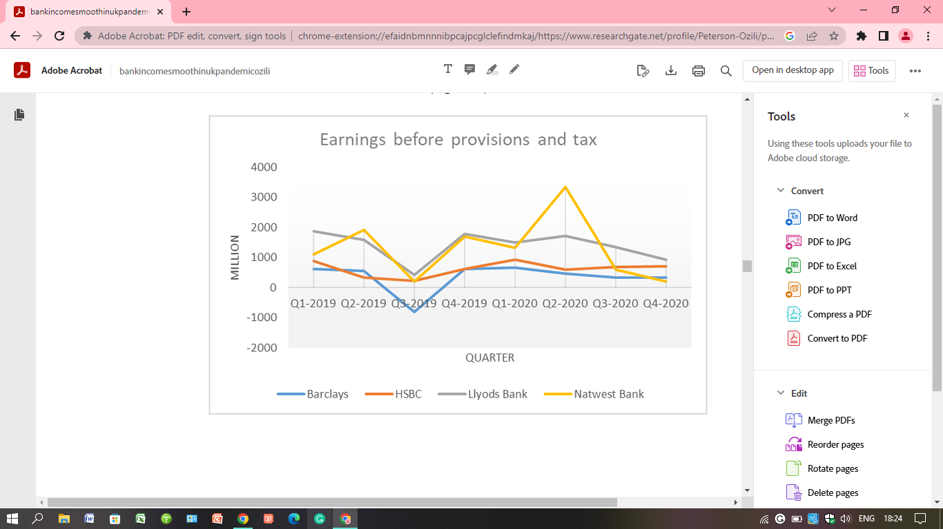
(Source: Ozili, 2022)

4.4 Banking revenue
The graph demonstrates the changing focus of the UK banking sectors in the post-pandemic era. HSBC, one of the UK’s leading banking companies, is focusing on investing its revenue in projects aimed to strengthening wealth and personal banking. The total revenue of HSBC Holdings has decreased by 3% in Q1 of 2021, in comparison with the same period in 2020.
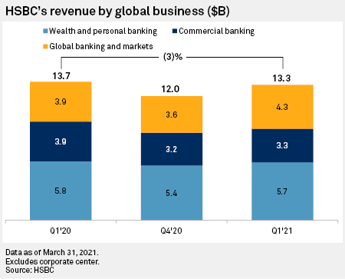
(Source: S&P Global, 2022)

4.5 Increased use of ML and DS
The graph represents the importance of Machine learning (ML) and Data Science (DS) in the present banking operations and future operations. Though the future use of ML and DS is estimated to increase by a large per cent, the ongoing applications show small increases in ML and DS in the contemporary situation.
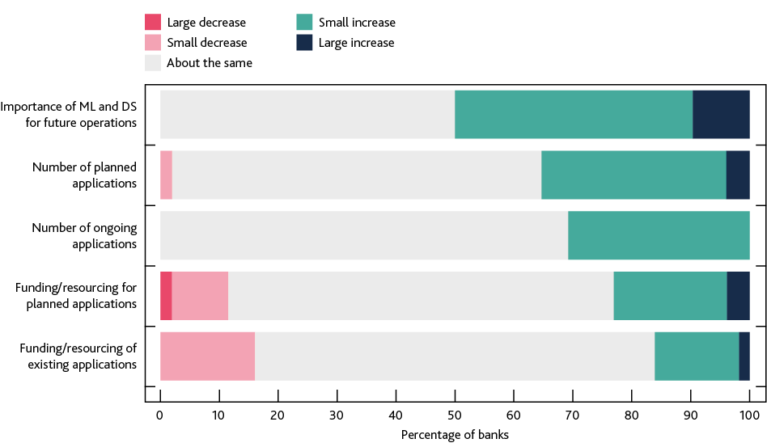
(Source: Bank of England, 2022)

‌

Chapter 5: Analysis

5.1 Introduction
COVID-19 has generated significant uncertainty and volatility in the global financial market. The financial sector has been adversely affected by this pandemic. This situation is not only limited to countries but rather the whole world economy is going through an economic depression and instability. The UK's banking sector are going through great turmoil due to the nation's as well as global financial condition. Because of COVID-19, the trends in the UK's banking sectors have changed dynamically. Most of them are negative, though a digital transformation of banking services has been identified as one of the positive impacts of this pandemic in the UK's banking sectors. Increasing interest rates, changing monetary policies, unstable exchange rates and enhancing pressure on banking operations are shaping the problems of the nation's financial services.
This chapter of the dissertation is going to address the different impacts of COVID-19 on the UK’s banking sector. Analysis of the represented graphs and information in the previous chapter has been provided here. This chapter describes the increasing trends in lending by credit cards, increase in interest rates, decreased earnings of the UK banking sectors, initiatives of enhancing banking revenues and increased implications of Machine Learning and Data Science in the banking sectors of the UK. Thus, it provides an evidence-based analysis of the impact of COVID-19 on the UK’s banking sectors.

5.2 Analysis

5.2.1 Increase in lending by credit cards
According to a report from the Bank of England, credit card borrowings have increased in the post-pandemic era in the UK. Credit card borrowings rose to a net amount of 869 million dollars from 740 million pounds in July 2022. Though this rate was lower than the previous month, which recorded credit card borrowings of 945 million pounds within a month. Still, credit card borrowings in July 2022 recorded the highest rate since 2005 (Milliken, 2022). Figures were 13% higher than in the same period in the previous year. The main reason behind this situation is the higher consumer price inflation and increased household energy tariffs in the UK. This is creating pressure on the UK population, for meeting basic needs. Therefore, individuals are opting for credit card borrowings. The Consumer Price Inflation was 10.1% in July 2022, which was the highest in the last 40 years of the UK economy. The Government have implemented a plan to help with the increase household energy tariffs by 80%. In this global scenario, the Broader Consumer Credit, which was reputed as an unsecured personal loan provider in the UK, also faced the highest credit card borrowings in 2022, March when their credit card borrowings were higher than in March 2019, by 6.9%. The escalating cost of living in the nation is the main driver behind the 17 years record of the fastest annual growth rate in credit card borrowings. According to the report of Opinions and Lifestyle Survey conducted by the Office for National Statistics (ONS), there is an increase in usual credit card use by 14% among adults in the UK in May 2022. In April 2022 this rate was nearly 11%. The EY Independent Treasury Economic Model (ITEM) Club has published its UK Bank Lending Forecast, which indicates that the demand for credit card lending would rise significantly among household consumers because of the continuously increasing pressure of living costs within the nation. The price rise in essential goods and services is creating this situation. In February 2021, consumer credit was -9.8 and credit card selling was at -20.6% but in March 2022 consumer credit has been increased to 5.2% and credit card selling reached 10.6%. Other loans and advances including, dealership finance as well as personal loans were running at -4.8%, but in March 2022 the same figures reached 3.0% (‌Office for National Statistics, 2022). In the pre-pandemic period, consumer credit was 10.2%, credit card selling was 9.6% and other loan and advances 10.6% in January 2018. After that, figures began to fall and the UK banking finance faced a steep fall in these spheres in comparison to January 2021. After February 2021, it started to recover with the normalisation of the pandemic restrictions.

5.2.2 Increase in Interest Rate
According to the Monetary Policy Report 2022 published by the Bank of England, the banking sector in the UK is aiming to achieve an average rate of inflation of 2% (Bank of England, 2022). To support these government initiatives, the banks are increasing their interest rates in the nation. Between 2006-2009, the interest rate in the UK was high, due to the nation’s financial crisis. Then between 2010-2015, the interest rate was low due to the EU referendum. After the pandemic situation in 2020, the interest rate was increasing at a slow growth but after 2022, the government's initiatives to control the inflation rate caused a high surge in the interest rate in the UK. According to reports published by the Bank of England, within the first 8 months of 2022, the UK banking sectors have faced a 1.75% increase in interest rates. Interest rate is constantly rising in the UK, even after the easing of Covid restrictions. With the normalisation of the restrictions over economic activities, business growth is generated, and inflationary pressure is increasing. The service sectors have grown to 60.8%, from 54.1% in the previous year. This growth is the highest since June 2022. Even the manufacturing sector's growth is at 57.3%. This proves that the private sector's performance is at its strongest level after the pandemic situation. This is creating an economic scenario of increasing interest rates. Most economic analysts are predicting that the interest rate will be increased to 0.75% from 0.25% (Elliott, 2022). This is the third consecutive increase in interest rates by the Bank of England. The Bank of England first increased its interest rate after the pandemic in December 2021. Then it increased its interest rate to 0.25% from its historic low rate of 0.1%. The Bank is predicting that the inflation rate of the nation will reach more than 13% in the last three months of 2022. This is forecasted as the highest inflation rate in the last 42 years history of the UK economy. In the context of the Russia-Ukraine war in this post-pandemic world, The Bank of England's monetary policy committee is voting for a rise in interest rate to 1.75%.

5.2.3 Decrease in the earnings of the UK banking sectors
The trends in earnings before tax and provisions (EBTP) for the different banking companies of the UK show inconsistent and unpredictable growth and fall during the pandemic situation. The EBTP of Barclays in the pre-pandemic era, especially in the Q3 of 2019, was negative, which during the pandemic somehow managed to overcome its depressive situation (Ozili, 2022). The EBTP of HSBC was better in Q1 of 2020 than in Q3 of 2019 but after that, it faced a sharp fall in its profits. The EBTP of Lloyds Bank is continuously declining from its position since the 2nd Quarter of 2020. The total EBTP of NatWest Bank recorded the highest growth among the UK’s leading banking companies. Still, the bank had to face dynamic changes in its EBTP during and post-pandemic situation. According to the report, NatWest Bank recorded the lowest EBTP in the fourth quarter of 2020. According to the UK (FTSE) Banks Industry Analysis, the earnings of the UK banking sectors were -4.8% in 2021 and -9.7% in August- October 2022. As a result of the pandemic depression over the nation's economy has caused this scenario but after November 2022 the situation is showing a positive direction. In the 1st week of November, the earnings of the UK banking sector are projected at 1.8%. Lloyds Banking Group is leading in this scenario. The bank has seen a growth of 3.8% in its earnings within the 1st week of November. During the pandemic situation, the bank lost 4.8% in 2021 (Simply Wall St., 2022). The rise of the UK banking sector's earnings is forecasted at 11% annually. In 2021, the total earnings of the UK banking sectors were 6.8 billion pounds which were -76% but in 2022, the total earnings have increased to 25.8 billion pounds which projected a 23% growth. Still, the market capitalisation and total revenue is running at negative growth.

5.2.4 Increased banking revenue
The UK-based banking company HSBC is focusing on the increase of wealth and personal banking. In the post-pandemic era, HSBC is focusing on boosting its wealth management capabilities, by using extra capital in banking acquisition. The instability of the financial market in the post-pandemic global context has increased the UK banking sector's concern over strengthening its wealth management capabilities. HSBC is trying to focus on strengthening its product and distribution capabilities, through more acquisitions aimed to expand its private banking and insurance services throughout the Asian market. The UK banking sectors are chasing higher returns on their revenue. Therefore, HSBC's reinvestment of adjusted revenue reached 2.38 billion dollars in the wealth division in the first quarter of 2020, and this reflects the company's 65% higher investment from the same period in the previous year. As a result of low-interest rates in support of global liquidity and cash management, HSBC faced a 14% fall in commercial banking revenue in the fourth quarter of 2020. Still, the company's total revenue decreased by 3% in 2021 1st Q against the revenue of 1st Q in 2020. The total revenue of the UK banking sector was £378.1 billion in 2020 and in 2021 total revenue decreased to £283.2 billion. Then up to 2022, the revenue of the UK banking sectors increased with the rise of market capitalisation and total earnings. After 2022, it seemed to decrease sharply and in November 2022 it reached £147 billion. In November 2022, the ratio of market capital and total earnings and revenue is 10.1. This ratio was 12.4 at the beginning of 2022, 18.7 in 2021 and 14.7 in 2020. In November 2022, the rate of UK banking sectors' revenue growth is at -57% while this rate was -11% in 2020 and -37% in 2021. At the beginning of 2022, this rate was -7% which was the best performance after the pandemic situation. The consumer finance and insurance services in the UK's banking sectors have contributed positively to the post-pandemic situation. The contribution of consumer finance to the total earnings of the financial sectors is 5.04%.

5.2.5 Increased demand for ML and DS in banking operations
Machine Learning, a subfield within Artificial Intelligence (AI), is a dominating factor in the banking sector in the UK. According to a report published by the Financial Conduct Authority (FCA), two-thirds of the banking sectors used MI in the pre-pandemic era in the UK. Data Science (DS) including ML but not limited to only ML, was also a common phenomenon in the UK’s banking sector. Still, the COVID-19 pandemic has brought an incredible change in the use of ML and DS in the nation’s banking sector. The two most prominent uses of ML in the banking sectors of the UK are customer engagement and risk management. One of the most important areas of using ML and DS in the UK is anti-money laundering processes. According to the report of the Bank of England, almost 33% of the UK's banks are facing an increase in the number of ongoing ML and DS applications in their operations. Almost 16% of banking companies are facing a small increase in the funding or resourcing of existing ML and DS applications in the post-pandemic era (Bank of England, 2022). The percentage is the same for small decreased funding within the sector. 35% of banks in the UK reported an increase in the number of planned applications but among these only 23% of banks confirmed an increase in their funding or resources for ML and DS implementation in the planned applications. 11.5% of banks within the UK have reported a decrease in funding of planned projects for ML and DS applications in their operations. The pandemic situation has intensified the importance of applying ML and DS in banking operations in the UK. It is the positive impact of the pandemic situation on the banking sectors not only limited to the nation but also in the global banking markets. The number of UK financial services firms using ML has increased by 3.5 times in the last three years. 79% of the ML applications used in the UK banking sectors are in the latter stage of development.

Chapter 6: Conclusion, Recommendations and Reflection

6.1 Conclusion
The pandemic situation has caused a tremendous shock to the UK as well as the world economy. In 2020, the UK’s GDP fell by 9.3%. This is the record fall in the UK’s GDP after the WWI recession in the nation. This is the result of the UK’s government's responses to the pandemic spread prevention and economic policies in support of the domestic business sector and common population. The government's borrowings were increased by 330 billion pounds between 2020 and 2022. This has caused a record national debt rise since the 1960s. The sectors contributing positively to the economy of the UK are the accommodation and food service sectors, entertainment and recreation sectors and information and communication sectors. The contribution of the accommodation and food service sectors to the UK’s GDP in the post-pandemic era is 28% while the entertainment and recreation sectors contributed 13%. The percentage of financial and insurance sectors in the UK’s GDP is 0.01 only. The Bank of England is increasing its interest rate for the third consecutive time after the global pandemic to control the pressure of the inflation rate. The BOE has forecasted that the benchmark rate will rise to 1.25% which is the highest since 2009. The valuation of the banks is dropping across the country. The valuation of the HSBC Holdings bank was 0.74% in April 2020, but the valuation dropped to 0.52% in June 2020. The same trends have been found in the case of Barclays Plc and Lloyds Banking Group in the UK. Lending through credit cards has increased immensely, as a result of a sharp increase in the price of essential goods.
The only positive aspect of the global pandemic on the UK’s banking sectors is the increased application of machine learning and data science in banking operations. This could have helped expand its services to wider sections of consumers. Even this can enhance the customers' experience of baking services. Conclusively it can be stated that the banking sector is the most affected business sector of the UK economy following the global pandemic COVID-19.

6.2: Recommendations
After analysing the contemporary situation of the UK's banking sector, the following recommendations have been made to ensure positive growth of the banking assets and revenues, consistency in performance and more profitability in the domestic as well as global market -
- Utilising Customers’ Digital Adoption: The UK banking sector must look beyond the pandemic's gruesome effect and rediscover their role in the new emerging world order. The UK government's main concern in this scenario is to help the population and businessmen to ensure improved economic activity in the nation. The banking sector has the leading opportunities in this governmental initiative. The banking sector can utilise technological support for managing the financial needs of business enterprises. The contemporary business market is more centred around e-commerce and thousands of e-commerce platforms are popping out. Even the existing giant companies are introducing their online services in this scenario. The banking sector can use this trend to increase its profitability. In partnerships with these e-commerce platforms, the banking sector can expand its customer range by improving its online payment methods in those channels. Partnerships with Fintech companies can open great opportunities for providing appropriate digital solutions to customers (Baicu et al., 2020). According to the EY Future Consumer Index, 60% of the population of the world has changed its methods of getting banking services.
- Redesigning New Customer Services: Most UK banks are experiencing growing confusion about the bank's role whether to support their costumers or focus on recovering the non-performing loans. These non-performing loans are causing capital depletion in the UK banking sector. Inclusivity of digital channels for banking services is the most challenging part of reaching the most vulnerable groups of the UK population. Individuals who do not possess digital literacy or digital access should still be given access to banking services. For this, the UK banking sector should focus on redesigning its customer services, with the aim of reaching local vulnerable communities of the nation.
- Harnessing Cloud Services in Managing people: Insurance services are less affected by the pandemic than the banking sector of the UK (Wójcik and Ioannou, 2020). With advanced risk management and analytical capabilities, the cloud services used by the banking sector can portray them as trusted advisors for clients. Cloud service can be harnessed by adopting a hybrid working model in the banking sector. Remote-working groups managed by cloud services can boost the sector’s efficiency and lower the cost of physical maintenance.
- New Post-Crisis Operation Model: Cost optimization and low margin in banking environments are the most discussed topic in the banking sector’s agenda. The banking sectors should restructure their business model in support of resilience in decisions and balance in cost and services. The banking sector should continue with the business model of zero latency, zero paper and zero touches to facilitate the automation of processes in banking operations.

6.3. Reflection
The reflection on the building of new concepts after analysing the data presented in the study paper has been done using Kolb's reflective model. Kolb’s Experiential Learning proposes four different stages of reflection and new concept building. These four stages are - Concrete experience, reflective observation, Abstract conceptualisation, and active experimentation (Behrendt and Machtmes, 2021). These four stages explain how knowledge is created through experience (Chiu, 2019). The contemporary situation has been revisited with the help of existing knowledge. Thus, new concepts about the present scenario of the UK’s banking sectors have been cleared. Newly formed concepts have been presented within the study paper for further implications. Previous knowledge about the banking sector in the UK and the contribution of this sector to the nation’s GDP before the pandemic period is necessary. After that only, the comparative data between the pre-pandemic and post-pandemic performance of the banking sector in the UK can be presented. Analysis of the data helps to form a new concept about the contemporary situation of the nation. Thus, the formation of new concepts can be beneficial for further knowledge development and experiential learning. I have gain so many learnings about the impact of the global pandemic on the banking sector of the United Kingdom by conducting this research. I have identified the economic variations of the UK through this research data. There are several knowledge gaps in this research and I think that the gaps should be identified in different perspectives. This research will be helpful to manage and control the crisis situation effectively and respond to the epidemics in the future.

Reference List
Almetere, E.S., Kelana, B.W.Y. and Mansor, N.N.A., (2020). Using UTAUT model to determine factors affecting internet of things acceptance in public universities. International Journal of Academic Research in Business and Social Sciences, 10(2), pp.142-150. Available at: https://pdfs.semanticscholar.org/d7c3/938fa3902c1636c74e4d83fef5f7ae1001ce.pdf
Apergis, N., (2022). Convergence in non-performing loans across EU banks: The role of COVID-19. Cogent Economics & Finance, 10(1), p.2024952. Available at: https://www.tandfonline.com/doi/pdf/10.1080/23322039.2021.2024952
Avidar, R., (2018). Engagement, interactivity, and diffusion of innovations. Handb. Commun. Engagem, 505. Available at: https://www.researchgate.net/profile/Ruth-Avidar/publication/324821070_Engagement_Interactivity_and_Diffusion_of_Innovations/links/61bcb79763bbd932429dadc1/Engagement-Interactivity-and-Diffusion-of-Innovations.pdf
Baicu, C. G., Gârdan, I. P., Gârdan, D. A., and Epuran, G., (2020). The impact of COVID-19 on consumer behaviour in retail banking. Evidence from Romania. Management & Marketing, 15(s1), pp. 534-556. Available at: https://www.researchgate.net/profile/Gardan-Petronela/publication/346442755_The_impact_of_COVID-19_on_consumer_behavior_in_retail_banking_Evidence_from_Romania/links/600c91fa299bf14088b8da0a/The-impact-of-COVID-19-on-consumer-behavior-in-retail-banking-Evidence-from-Romania.pdf
Bank of England, (2022). The impact of Covid on machine learning and data science in UK banking. [online] Available at: https://www.bankofengland.co.uk/quarterly-bulletin/2020/2020-q4/the-impact-of-covid-on-machine-learning-and-data-science-in-uk-banking.
Barrett, D., and Twycross, A., (2018). Data collection in qualitative research. Evidence-Based Nursing, 21(3), pp. 63-64. Available at: https://ebn.bmj.com/content/ebnurs/21/3/63.full.pdf
Behrendt, M. and Machtmes, K., (2021). Exploring the Catalyst Energizing the Kolb Learning Cycle. Experiential Learning & Teaching in Higher Education, 4(1), pp.73-80. Available at: https://nsuworks.nova.edu/cgi/viewcontent.cgi?article=1084&context=elthe/
Bilan, Y., Rubanov, P., Vasylieva, T.A. and Lyeonov, S., (2019). The influence of industry 4.0 on financial services: Determinants of alternative finance development. Polish Journal of Management Studies. Available at: https://publikace.k.utb.cz/bitstream/handle/10563/1009001/Fulltext_1009001.pdf?sequence=1&isAllowed=y
Bitar, M. and Tarazi, A., (2022). A note on regulatory responses to COVID-19 pandemic: Balancing banks’ solvency and contribution to recovery. Journal of Financial Stability, 60, p.101009. Available at: https://www.researchgate.net/profile/Mohammad-Btar/publication/342313897_A_note_on_regulatory_responses_to_COVID-19_pandemic_Balancing_banks%27_solvency_and_contribution_to_recovery/links/60896c4192851c490fa1e724/A-note-on-regulatory-responses-to-COVID-19-pandemic-Balancing-banks-solvency-and-contribution-to-recovery.pdf
Buckner, D. and Dowd, K., (2020). Can UK Banks Pass the COVID-19 Stress Test?. Available at SSRN 3614865. Available at: https://www.researchgate.net/profile/Kevin-Dowd-3/publication/341767769_Can_UK_Banks_Pass_the_COVID-19_Stress_Test/links/5ed2eeec458515294521e155/Can-UK-Banks-Pass-the-COVID-19-Stress-Test.pdf
Carranza, E., Farole, T., Gentilini, U., Morgandi, M., Packard, T., Santos, I. and Weber, M., (2020). Managing the employment impacts of the COVID-19 crisis: policy options for relief and restructuring. Available at:https://biblioteca.semarnat.gob.mx/janium/Documentos/Ciga/Libros2013/CD003904.pdf
Chiu, S.K., (2019). Innovative experiential learning experience: Pedagogical adopting Kolb’s learning cycle at higher education in Hong Kong. Cogent Education, 6(1), pp.1644720. Available at: https://www.tandfonline.com/doi/pdf/10.1080/2331186X.2019.1644720
Cowling, M., Liu, W. and Conway, E., (2021). Ethnicity and bank lending before and during COVID-19. International Journal of Entrepreneurial Behavior & Research. Available at: http://artbusinessloans.co.uk/content/uploads/2021/09/Ethnicity-and-Bank-Lending-Before-and-During-COVID-research-paper.pdf
Dell'Ariccia, G., Rabanal, P. and Sandri, D., (2018). Unconventional monetary policies in the euro area, Japan, and the United Kingdom. Journal of Economic Perspectives, 32(4), pp.147-72. Available at: https://pubs.aeaweb.org/doi/pdf/10.1257/jep.32.4.147
‌Elliott, L., (2022). Third UK Interest Rate Rise in a Row Looms after Business Growth Jumps. [online] The Guardian. Available at: https://www.theguardian.com/business/2022/feb/21/uk-business-growth-covid-restrictions-private-sector.
Fleming, J., & Zegwaard, K. E. (2018). Methodologies, Methods and Ethical Considerations for Conducting Research in Work-Integrated Learning. International Journal of Work-Integrated Learning, 19(3), pp. 205-213. Available at: https://files.eric.ed.gov/fulltext/EJ1196755.pdf
Frimpong, K., Shuridah, O., Wilson, A. and Sarpong, F., (2020). A cross‐national investigation of trait antecedents of mobile‐banking adoption. Thunderbird International Business Review, 62(4), pp.411-424. Available at: https://strathprints.strath.ac.uk/71752/1/Frimpong_etal_TIBR_2020_A_cross_national_investigation_of_trait_antecedents.pdf
Gelderblom, O. and Trivellato, F., (2019). The business history of the preindustrial world: Towards a comparative historical analysis. Business History, 61(2), pp.225-259. Available at: https://www.tandfonline.com/doi/pdf/10.1080/00076791.2018.1426750
Giese, J. and Haldane, A., (2020). COVID-19 and the financial system: a tale of two crises. Oxford Review of Economic Policy, 36(Supplement_1), pp.S200-S214. Available at: https://www.ncbi.nlm.nih.gov/pmc/articles/PMC7499729/
Haas, J., Neely, C.J. and Emmons, W.R., (2020). Responses of international central banks to the COVID-19 crisis. Available at SSRN 3736262. Available at:https://www.researchgate.net/profile/Christopher-Neely-2/publication/340821263_Central_Bank_Responses_to_COVID-19/links/5fc2a74ba6fdcc6cc67ef3a7/Central-Bank-Responses-to-COVID-19.pdf
Heald, D. and Hodges, R., (2020). The accounting, budgeting and fiscal impact of COVID-19 on the United Kingdom. Journal of Public Budgeting, Accounting & Financial Management. Available at: https://eprints.gla.ac.uk/222917/1/222917.pdf
Holotiuk, F. and Moormann, J., (2018). Organizational adoption of digital innovation: The case of blockchain technology. Available at: https://web.archive.org/web/20200324144645id_/https://aisel.aisnet.org/cgi/viewcontent.cgi?article=1201&context=ecis2018_rp
Kiger, M. E., and Varpio, L., (2020). Thematic analysis of qualitative data: AMEE Guide No. 131. Medical teacher, 42(8), pp. 846-854. Available at: https://www.plymouth.ac.uk/uploads/production/document/path/18/18247/Kiger_and_Varpio__2020__Thematic_analysis_of_qualitative_data_AMEE_Guide_No_131.pdf
Knight, E., Daymond, J. and Paroutis, S., (2020). Design-led strategy: how to bring design thinking into the art of strategic management. California Management Review, 62(2), pp.30-52. Available at: https://asset-pdf.scinapse.io/prod/2999110595/2999110595.pdf
Lui, A. and Lamb, G.W., (2018). Artificial intelligence and augmented intelligence collaboration: regaining trust and confidence in the financial sector. Information & Communications Technology Law, 27(3), pp.267-283. Available at: http://researchonline.ljmu.ac.uk/id/eprint/8512/3/Artificial%20intelligence%20and%20augmented%20intelligence%20collaboration%20Regaining%20trust%20and%20confidence%20in%20the%20financial%20sector.pdf
Melnikovas, A., (2018). Towards an explicit research methodology: Adapting research onion model for futures studies. Journal of Futures Studies, 23(2), pp. 29-44. Available at: /https://www.researchgate.net/profile/Aleksandras-Melnikovas/publication/333388233_Towards_an_explicit_research_methodology_Adapting_research_onion_model_for_futures_studies/links/5d47c8404585153e593cfbec/Towards-an-explicit-research-methodology-Adapting-research-onion-model-for-futures-studies.pdf?_sg%5B0%5D=started_experiment_milestone&origin=journalDetail
Merhi, M., Hone, K., Tarhini, A. and Ameen, N., (2020). An empirical examination of the moderating role of age and gender in consumer mobile banking use: a cross-national, quantitative study. Journal of Enterprise Information Management. Available at: https://bura.brunel.ac.uk/bitstream/2438/24103/1/FullText.pdf
Milliken, D., (2022). UK credit card borrowing rises by the most since 2005 - BoE. Reuters. [online] 30 Aug. Available at: https://www.reuters.com/world/uk/uk-credit-card-borrowing-rises-by-most-since-2005-boe-2022-08-30/ [Accessed 9 Nov. 2022].
Moser, A., and Korstjens, I., (2018). Series: Practical guidance to qualitative research. Part 3: Sampling, data collection and analysis. European journal of general practice, 24(1), pp.9-18. Available at: https://www.tandfonline.com/doi/pdf/10.1080/13814788.2017.1375091
Mumtaz, M., Hussain, N., Baqar, Z., Anwar, S. and Bilal, M., (2021). Deciphering the impact of novel coronavirus pandemic on agricultural sustainability, food security, and socio-economic sectors—a review. Environmental Science and Pollution Research, 28(36), pp.49410-49424. Available at: https://link.springer.com/article/10.1007/s11356-021-15728-y
Norwich, B., (2020). Thinking about the nature of educational research: Going beyond superficial theoretical scripts. Review of Education, 8(1), pp.242-262. Available at: https://ore.exeter.ac.uk/repository/bitstream/handle/10871/37857/Review%20of%20Educ%20Nature%20of%20Ed%20research%20accepted%20paper%20JUne%2019.pdf?sequence=2
‌Office for National Statistics, (2022). UK finance during the coronavirus (COVID-19) pandemic - Office for National Statistics. [online] Available at: https://www.ons.gov.uk/economy/nationalaccounts/uksectoraccounts/articles/impactonukfinanceduringthecoronaviruscovid19pandemic/june2022#:~:text=UK%20finance%20during%20the%20coronavirus%20(COVID%2D19)%20pandemic%3A [Accessed 16 Nov. 2022].
Ozili, P.K. and Arun, T., (2023). Spillover of COVID-19: impact on the Global Economy. In Managing Inflation and Supply Chain Disruptions in the Global Economy (pp. 41-61). IGI Global. Available at:https://mpra.ub.uni-muenchen.de/99850/1/MPRA_paper_99850.pdf
Ozili, P.K., (2022). Bank income smoothing during the COVID-19 pandemic: Evidence from UK Banks. In The New Digital Era: Other Emerging Risks and Opportunities (Vol. 109, pp. 127-139). Emerald Publishing Limited. Available at: https://www.researchgate.net/profile/Peterson-Ozili/publication/350462424_Bank_Income_Smoothing_during_the_COVID-19_Pandemic_Evidence_from_UK_Banks/links/61d5abcdb6b5667157ca0105/Bank-Income-Smoothing-during-the-COVID-19-Pandemic-Evidence-from-UK-Banks.pdf
Pleyers, G., (2020). The Pandemic is a battlefield. Social movements in the COVID-19 lockdown. Journal of Civil Society, 16(4), pp.295-312. Available at: https://dial.uclouvain.be/pr/boreal/object/boreal%3A240907/datastream/PDF_01/view
Porter, C.O., Outlaw, R., Gale, J.P. and Cho, T.S., (2019). The use of online panel data in management research: A review and recommendations. Journal of Management, 45(1), pp.319-344. Available at: https://journals.sagepub.com/doi/pdf/10.1177/0149206318811569
S&P Global, (2022). Digitization & Disruption: The Future of Banking. [online] Available at: https://www.spglobal.com/en/research-insights/featured/markets-in-motion/the-future-of-banking [Accessed 9 Nov. 2022].
Safaeinili, N., Brown‐Johnson, C., Shaw, J.G., Mahoney, M. and Winget, M., (2020). CFIR simplified: Pragmatic application of and adaptations to the Consolidated Framework for Implementation Research (CFIR) for evaluation of a patient‐centered care transformation within a learning health system. Learning health systems, 4(1), p.e10201. Available at: https://onlinelibrary.wiley.com/doi/pdf/10.1002/lrh2.10201
Sánchez Serrano, A., (2022). From Lost Turnover to Nonperforming Loans: The Impact of the COVID-19 Pandemic on the Economy and on the Financial System. Journal of Financial Crises, 4(3), pp.99-164. Available at: https://elischolar.library.yale.edu/cgi/viewcontent.cgi?article=1421&context=journal-of-financial-crises
Seyfang, G. and Gilbert-Squires, A., (2019). Move your money? Sustainability transitions in regimes and practices in the UK retail banking sector. Ecological Economics, 156, pp.224-235. Available at: https://ueaeprints.uea.ac.uk/id/eprint/68304/1/Accepted_manuscript.pdf
Sihotang, M.K. and Hasanah, H., (2021), February. Islamic Banking Strategy In Facing The New Normal Era During The Covid 19. In Proceeding International Seminar Of Islamic Studies (Vol. 2, No. 1, pp. 479-485). Available at:http://download.garuda.kemdikbud.go.id/article.php?article=2448087&val=23378&title=ISLAMIC%20BANKING%20STRATEGY%20IN%20FACING%20THE%20NEW%20NORMAL%20ERA%20DURING%20THE%20COVID%2019
Simply Wall St., (2022). U.K. (FTSE) Financials Sector Analysis. [online] Available at: https://simplywall.st/markets/gb/financials#:~:text=The%20Financials%20industry%20is%20up [Accessed 16 Nov. 2022].
Singh, S. and Das, S., (2018). Impact of post-merger and acquisition activities on the financial performance of banks: A study of Indian private sector and public sector banks. Revista Espacios Magazine, 39(26), p.25. Available at: https://www.researchgate.net/profile/Subhankar-Das-2/publication/327836765_Impact_of_post-merger_and_acquisition_activities_on_the_financial_performance_of_banks_a_study_of_Indian_private_sector_and_public_sector_banks_Impacto_de_las_actividades_posteriores_a_la_fusion_y_adq/links/5ba897bda6fdccd3cb6e552e/Impact-of-post-merger-and-acquisition-activities-on-the-financial-performance-of-banks-a-study-of-Indian-private-sector-and-public-sector-banks-Impacto-de-las-actividades-posteriores-a-la-fusion-y-adq.pdf
Tsindeliani, I.A., Proshunin, M.M., Sadovskaya, T.D., Popkova, Z.G., Davydova, M.A. and Babayan, O.A., (2021). Digital transformation of the banking system in the context of sustainable development. Journal of Money Laundering Control. Available at: https://www.researchgate.net/profile/Mariam-Davydova/publication/352381947_Digital_transformation_of_the_banking_system_in_the_context_of_sustainable_development/links/60ec92220859317dbddb0e96/Digital-transformation-of-the-banking-system-in-the-context-of-sustainable-development.pdf
UK Government, (2022). Coronavirus (COVID-19): What You Need to Do. [online] GOV.UK. Available at: https://www.gov.uk/coronavirus.
Umar, T., (2022). The impact of COVID-19 on the GCC construction industry. International Journal of Service Science, Management, Engineering, and Technology (IJSSMET), 13(2), pp.1-17. Available at: https://www.igi-global.com/gateway/article/full-text-html/273617&riu=true
Walter, D., and Ophir, Y., (2019). News frame analysis: An inductive mixed-method computational approach. Communication Methods and Measures, 13(4), pp. 248-266. Available at: /https://www.researchgate.net/profile/Yotam-Ophir-3/publication/335867777_A_Multi-method_Approach_for_Identifying_and_Grouping_Frame_Elements_with_Topic_Modeling_and_Network_Analysis/links/5f0c8254a6fdcc2f323376aa/A-Multi-method-Approach-for-Identifying-and-Grouping-Frame-Elements-with-Topic-Modeling-and-Network-Analysis.pdf
Wójcik, D. and Ioannou, S., (2020). COVID‐19 and finance: market developments so far and potential impacts on the financial sector and centres. Tijdschrift voor economische en sociale geografie, 111(3), pp.387-400. Available at: https://onlinelibrary.wiley.com/doi/pdf/10.1111/tesg.12434

