

CIPD LEVEL 5
Associate Diploma in People Management
Kate Cox
CIPD Membership Number: 92340301
Module Name: Evidence-based practice
Module Code: CIPD 5CO02
Word Count: 4,268

AC1.1 What is Evidence-Based Practice?
Evidence-based practice helps professionals make more effective decisions by using reliable evidence rather than assumptions, habits, or personal opinion. The Chartered Institute of Personnel and Development (CIPD) defines evidence-based practice ‘as making better decisions by combining critical thinking with the best available evidence.’ (CIPD, 2025).
At its core, evidence-based practice ensures that decision making and choices are not only intuitive but substantiated by reliable data and insights. An important consideration is that there can sometimes be a preference for casual benchmarking and doing what seems to have ‘worked in the past’ (cited in Taylor and Woodhams, 2022 p. 9).
Barends et al., 2014 suggest that most managers prefer to make decisions based on personal experience, but personal judgement is prone to cognitive bias. Pfeffer and Sutton (2000) coined the phrase ‘the knowing-doing gap’ to describe this, where they found that decisions being informed by hunches clashed with what we know about organisations and people. This resulted in bad decisions based on bias, unfounded beliefs and limited understanding of why things go wrong. (Barends et al., 2014).
An evidence-based practice approach follows a clear and structured process. A key consideration is how we use it to prove, improve, disprove and approve, HR decisions to ensure that actions are supported by reliable evidence aligned with organisational needs, (Overton, 2021).
The ability to carry out good research and evaluate the credibility is a skill that is central to thoughtful HR practice (Tailor & Woodhams, 2022 p.114). Professional curiosity and objective evaluation help us recognise and use the evidence that surrounds us. (Overton, 2021). As Rousseau, (2006) pointed out ‘where we have evidence we should use it - an objectively derived evidence-based decision will reduce errors in decisions formed on the basis of subjectively help opinion’ (cited in Taylor & Woodhams, 2022 p.115). It relies on critical thinking and best available evidence replacing trends and personal bias with a rigorous evaluation.
When collating evidence and to help make well-informed evidence-based decisions Barends, Briner and Rousseau’s 4 core sources of evidence can be applied:

1. Scientific Evidence Findings from high quality, peer-reviewed, academic research
2. Organisational Data Internal metrics, statistics and historical performance
3. Stakeholder Perspective Input, values and concern from employees, managers & clients
4. Professional Expertise The experience and judgment of practitioners

To avoid cherry-picking information or relying on blind best practice CIPD recommends a structured six step process for collating evidence from different sources refer to diagram 1 below:

Diagram 1
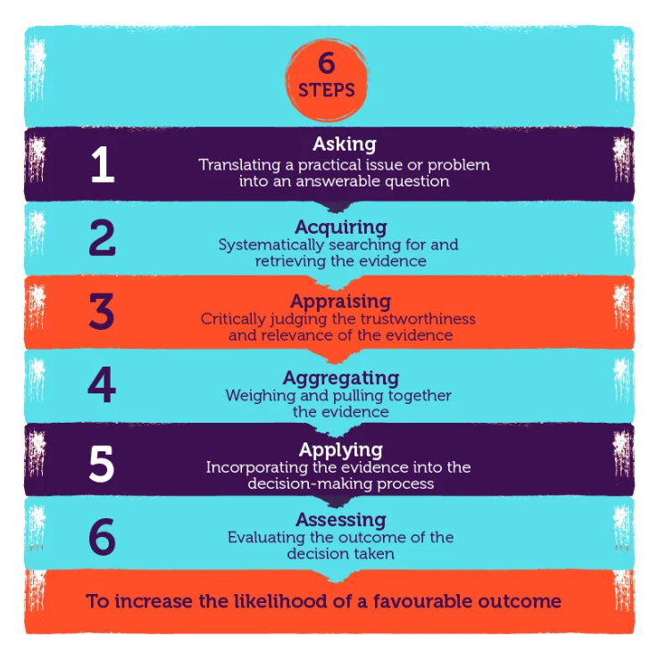
(CIPD, 2025).
Although different types of evidence require different methods of assessment, by applying the four sources of evidence and following the six steps, practitioners can assess whether evidence has been gathered appropriately, represents the best available information, is sufficient to support conclusions, and is free from significant bias, (CIPD 2025).
AC 1.2 Analysis Tools and Methods
The first step to support an issue should be an audit of the internal and external environments. As HR professionals, we are increasingly called upon to guide organisational strategy. Having knowledge of strategic tools, enables HR professionals to contribute more effectively to strategic objectives, (Chermack & Kasshanna, 2007).
A SWOT Analysis is a strategic tool used to support organisational planning and decision making and seeks to identify the Strengths, Weaknesses, Opportunities and Threats involved in a project or organisation. According to Barney (1995), SWOT is a simple framework that points to the importance of external and internal forces enabling HR professionals to better align professional practice with organisational goals, (Chermack & Kasshanna, 2007). Refer to diagram 2.
Diagram 2
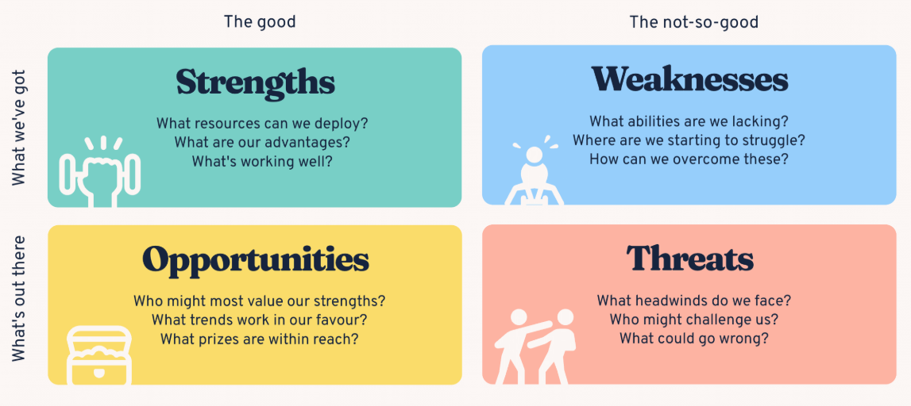
BiteSize Learning, (2026)
For example, conducting a SWOT Analysis before launching a new initiative, ensures that a strategy is both grounded in both internal capabilities and external realities. A SWOT analysis provides HR practitioners with a more comprehensive approach to strategic decision-making, considering both internal and external factors that may influence workforce planning and organisational performance.
Although a SWOT analysis can provide a comprehensive approach to strategic decision-making that considers both internal and external factors, a criticism of SWOT analysis is that they fail to address uncertainty and are rather simplistic. (Taylor & Woodhams, 2022 p. 46). It also lacks a detailed structure, so there is a risk of capturing too much data or missing key elements. Furthermore, to be effective, the process also needs to be repeated on a regular basis (CIPD 2026).
Many research projects involve the use of questionnaires or employee surveys, which can be a quick and low-cost way to capture employee voice (CIPD, 2025). According to Holbeche (2012), employee surveys provide an effective mechanism for measuring engagement and capturing employee views, enabling organisations to make evidence-based improvements. Using employee voice channels can also build trust and help organisations understand what matters most to stakeholders (CIPD, 2025).
For example, gathering employee views was essential within Powys County Council. While their strategic objective was to grow their early career and apprenticeship offer, it was important to first understand the existing early career experience and identify areas for improvement. A pulse survey provided insight into apprentices’ perceptions of their workplace experiences and programme effectiveness. This new evaluative method helped establish a baseline understanding of satisfaction and development needs, allowing the council to shape interventions and measure progress over time.
An important consideration was the type of survey used, the audience, and having clear objectives so it does not appear off-putting (Taylor & Woodhams, 2022, p. 128). Pulse surveys are useful because their speed and flexibility allow organisations to adjust quickly compared to longer annual surveys (Browes, 2021). For Powys County Council, the survey strengthened employee engagement, improved feedback, and ensured employees were considered in shaping the early career strategy. However, such surveys can be limited as they do not always allow individuals to provide detailed information on specific topics or themes (Taylor & Woodhams, 2022, p. 128).
AC 1.3 The Role of Critical Thinking
A central feature of evidence-based practice is critical thinking. Critical thinking is a process of conceptualising, analysing and evaluating information to guide belief or action. The aim is to cut through the 'noise' of opinions to make better informed decisions, (CIPD 2023).
Within the people profession, we face contradictory insights that relies on human decision. Common biases and psychological traps can occur and impair that decision. It is easy to believe something must be correct because it has ‘always been done that way’ (Briner, 2024).
When looking to think critically we are trying to identify cognitive biases in order to limit their effect on our judgement. It’s important to actively look for signs of bias in your own thought processes and how it affects your judgement as well as others. Some common workplace cognitive biases are highlighted in diagram 3 below:
Diagram 3
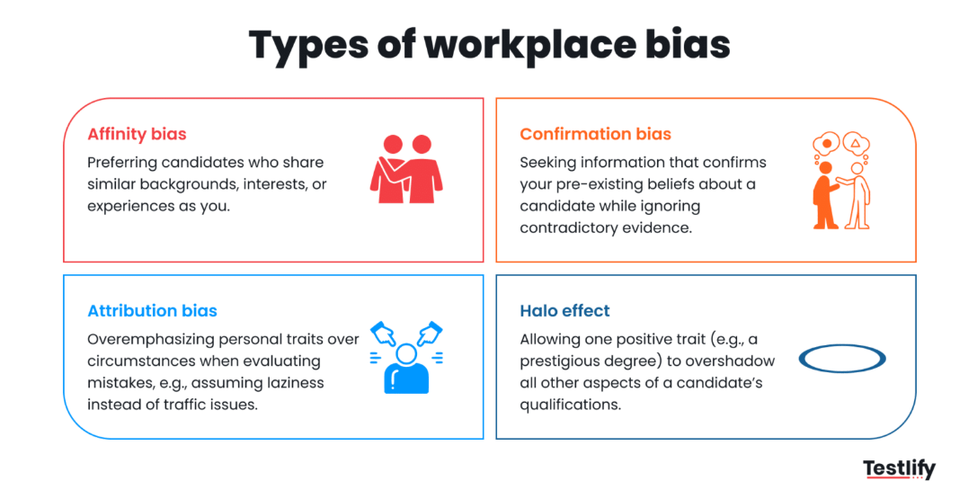
Testlify (2026)
It is natural for all human beings to develop a pattern of thinking that we use to navigate life and work. Critical thinking helps us to break out of those patterns of passive thinking, to question and look for solution, (CPD, 2022). When applying critical thinking the ability to construct a well-reasoned argument, listening to the quality of conversation, to question, validate and negotiate discussions is key. It consists of bringing together evidence, analysing its context and meaning, evaluating and developing your own opinion, as highlighted in diagram 4.
Diagram 4
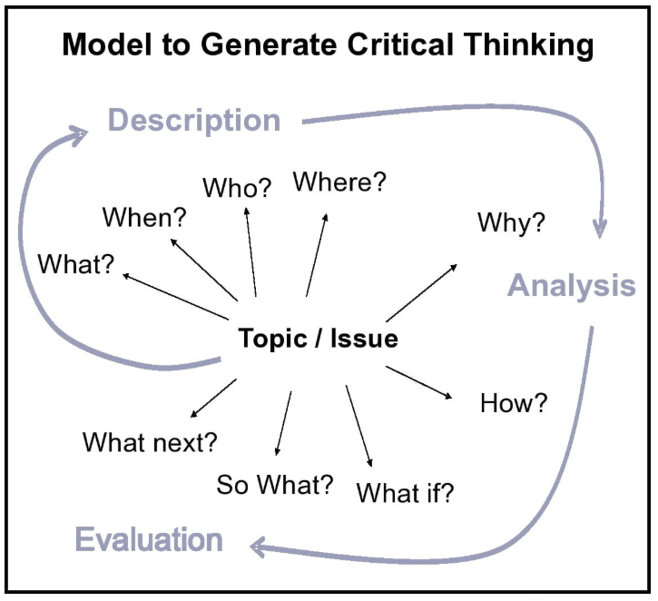
(Norwich University of the Arts, 2026)
Applied effectively it helps HR professionals to better engage and facilitate thinking. As Coburn explains, it provides a structured process and set of principles by which we can judge both our thinking and that of others and allows us to differentiate between fact and opinion, generalisations, jumping to conclusions and historical approaches. (Coburn, 2019).
Managing ambiguity is essential in HR, this involves acknowledging uncertainty, weighing probabilities, and avoiding premature conclusions. (CIPD, 2023). There is a need to be able to engage, persuade and win over opinion in a corporate setting. (Colburn 2019).
Areas for consideration include, ensuring clarity of terminology, differentiating between fact and opinion, as well as being aware of personal agendas, fake news and not taking information at ‘face value’. (CIPD 2023). Applying Triangulation is a useful tool for enhancing the accuracy and credibility of HR practices and improving critical thinking processes. When applied effectively, it draws on multiple sources of evidence, such as survey results, performance data, and feedback, to strengthen conclusions and support a balanced, evidence-based approach. (HR Fraternity, 2026).
AC 1.4 Applying Decision Making Processes
When carrying out evidence-based practice, it is important to consider how research will inform decisions based on the findings (Taylor & Woodhams, 2022, p. 114). Good decision-making helps identify what information is required and how best to use it, while reducing biased assumptions. As Rousseau (2006) stated, “an objectively derived evidence-based decision will reduce errors and decisions formed on the basis of subjectively held opinion” (cited in Taylor & Woodhams, 2022, p. 115).
There are many models and techniques that explain how decisions are made. Edward de Bono’s Six Thinking Hats model (see Diagram 5) is designed to improve the quality of group discussions by encouraging participants to consider six perspectives: factual (White Hat), emotional (Red Hat), critical (Black Hat), optimistic (Yellow Hat), creative (Green Hat), and process-focused (Blue Hat). By separating different modes of thinking, the model aims to reduce conflict and ensure issues are examined from multiple angles. Anderson et al. (2019) highlight that “a key stage of decision making is the need to consider the opinions of various stakeholders before settling on a final area of research and decisions” (cited in Taylor & Woodhams, 2022, p. 117).
Diagram 5
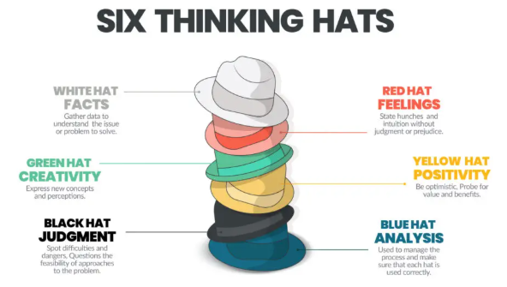
Hidden Door Experiences (2022)
One of the key strengths of the model is that it promotes balanced discussion and can reduce cognitive biases (Thomas, 2026). Another benefit is that people practice professionals need others to help them critically appraise the trustworthiness of the evidence they access and the issues they are trying to solve (Hakemzade & Rousseau, 2024). Edward De Bono stated that ‘we always want to find the right answer, but we don’t pay much attention to our thinking, or treat it as importantly as we should’, and the hats help clear that confusion (cited in Halls, 2023). However, the model does not provide a detailed analysis for identifying root causes, meaning decisions may lack depth if not supported by robust evidence. Additionally, its effectiveness depends heavily on skilled facilitation and participant engagement (Taylor and Woodhams, 2022).
In contrast, the Kepner-Tregoe Rational Method is a systematic framework for identifying root causes, using facts and a step-by-step procedure to reach decisions. The model can be effective for determining a course of action and securing commitment to it. It is most suitable where a straightforward and technical approach is needed, rather than where creative thought is desirable (CMI, 2015). The framework consists of four processes: situation analysis, problem analysis, decision analysis, and potential problem analysis. These add structure to thinking and ensure a data-driven approach rather than relying on assumptions and gut feelings (CMI, 2015). It also helps ensure solutions are fail-proof and focused on measurable criteria and logical reasoning, refer to Diagram 6 below.
Diagram 6
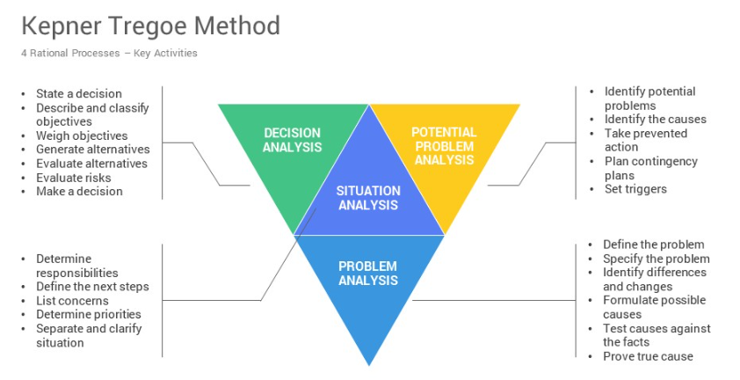
SlideSalad, (2026)
A major strength of the Kepner-Tregoe model is its rigour. It provides a step-by-step audit trail, helping to reduce subjectivity and ensure decisions are justified. (Thomas, 2026). However, its structured can be limited and method time-consuming. It may also feel rigid in situations requiring flexibility and places less emphasis on emotional factors, that could be influenced by preconceived notions, which are often significant in HR contexts. (CMI 2015).
In evidence-based HR practice, the two models can be complementary, combining inclusive discussion with systematic analysis to support well-informed and balanced decision making.
AC 1.5 How different ethical perspectives can influence decision-making
Professionalism and ethics go hand in hand and considering ethics along with principles of decision-making helps to recognise and resolve ethical dilemas whilst creating transparency, trust and integrity (CIPD 2025). The CIPD (2021b) suggest that ethical values ‘provide the moral compass by which we live our lives’. (Cited in Taylor and Woodhams, 2022 p. 152).
Ethical dilemmas occur when competing values or perspectives conflict. Generally, any decisions we take will have to take into consideration four forces – sometimes pulling in the same or different directions and often require balancing business needs, ethics, legal requirements, and personal values to ensure outcomes are fair, effective, defensible and sustainable. (Taylor and Woodhams, 2022 p. 154).
There are different ethical frameworks that people, societies and cultures adopt and rather than a situation being right or wrong it may be seen differently depending our ethical framework. (Taylor and Woodhams, 2022 p.153).
Utilitarianism can be a useful ethical framework for decision-making. This perspective focuses on achieving the greatest good for the greatest number. This is evident in utilitarianism’s ‘Happiness Principle’ stating that ethics must bring ‘the greatest good for the greatest number of people’. (Klikauer, 2014).
Utilitarianism can help evaluate the consequences of decisions and weigh the pros and cons of different options, for example: during restructuring, a manager may justify redundancies if they ensure long-term organisational survival and protect the majority of jobs. (Thomas, 2026). However, applying utilitarianism in HR can be challenging, as action inside companies tends to focus on the opposite of utilitarianisms. Organisational decisions often prioritise business performance over employee wellbeing, highlighting a key limitation of utilitarianism in balancing business and individual interest. While it focuses on outcomes and collective benefit, it may overlook the rights and needs of minority groups, particularly in decisions such as restructuring or redundancies. (Kilkauer, 2014).
In contrast, deontological ethics emphasises moral principles over outcomes. This reflects Kant’s categorical imperative: “individuals must not be treated merely as means to an end.” In HR, this may involve ensuring fair and transparent redundancy or recruitment processes, with decisions based on employee rights and ethics rather than on business benefits. (Thomas 2026). This approach strongly aligns with employment law, legislation and professional HR standards such as the Equality Act 2010, which protects employees from discrimination based on protected characteristics (CIPD 2026), as well as the Employment Rights Act 2025 which also reinforces the need for fair dismissal procedures and employee rights. (CIPD,2025).
Deontological ethics promotes consistency ensuring the same rules are applied fairly across all employees as well as ethical governance and employee rights, but its rule-based approach can be inflexible and may not always produce the best outcomes in complex HR situations.
CIPD’s ethical decision-making supports practitioners to recognise and resolve ethical dilemmas through there eight ethical ‘lenses’ offering appropriate direction of thought when considering ethical predicaments, refer to diagram 7 below, (CIPD 2014). Applied effectively it helps HR professionals to better engage and facilitate thinking.
Diagram 7 – Summary - eight lenses
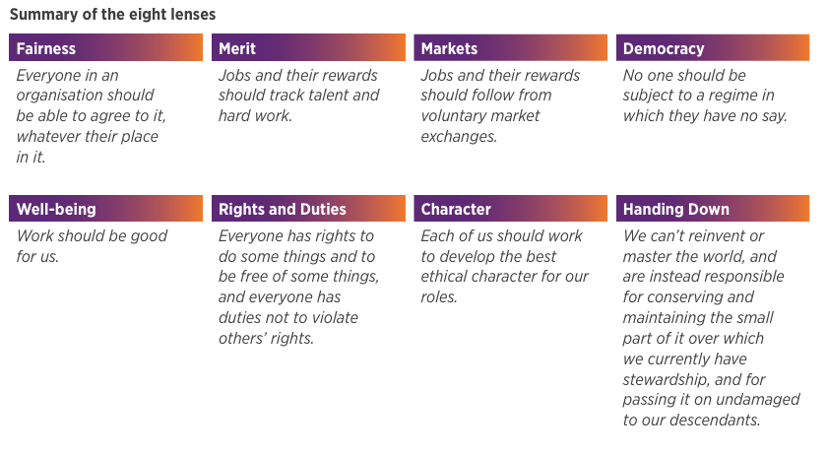
CIPD (2014)
There is no algorithm for navigating workplace dilemas, it requires effort and judgement (CIPD 2025). Rather than acting as the ‘HR police’, people managers can be ambassadors for leading ethical approaches, by considering and applying fair and equitable ethical practice within an organisation. (CIPD, 2024).
AC 3.1 Ways organisation measure financial and non-financial performance
Financial measures help HR to demonstrate both financial and non-financial measures to evaluate performance and how people practices contribute to organisational success. They can focus on both quantitative (how much/how many) and qualitative (opinions and experiences) measures. Having an understanding of how organisations financially perform can help HR understand and provide more strategic value within an organisation (Stobierski, 2020).
One financial measure commonly used to capture quantitative data is employee turnover. This is a metric that highlights the percentage of people who leave an organisation over a specific time and is used to monitor staff retention, identify managerial issues, and evaluate the effectiveness of HR strategies. A strength of this measure is that it provides clear, objective data that can be linked directly to business outcomes (CIPD, 2026). Employees who have good quality jobs and are managed well will not only be happier but more likely to drive productivity (CIPD, 2025).
Employee turnover is a financial measure that highlights the percentage of people who leave an organisation over a specific time. It is used to monitor staff retention, identify managerial issues, and evaluate the effectiveness of HR strategies. A strength of this measure is that it provides clear, objective data linked directly to business outcomes (CIPD, 2026). Employees who have good quality jobs and are managed well are more likely to be happier and drive productivity (CIPD, 2025).
High employee turnover can have a negative impact on organisational performance, as recruiting staff is costly and time consuming. By understanding why staff leave, employers can develop initiatives to reduce turnover and increase retention through effective recruitment, induction, and employee value propositions (CIPD, 2026). The CIPD also highlights the importance of the psychological contract and appreciation for the “human” side of the employment relationship (CIPD, 2025).
It is important to understand why people leave, as there may be “pull”, attraction of a new job or “push” dissatisfaction with existing job (CIPD, 2024). By monitoring turnover and understanding its impact on business performance, HR professionals can identify issues and trends and build strategies in advance to improve retention, reduce costs, and support a more stable and engaged workforce.
Financial and numerical data is not enough, and anecdotal data gathered from viewpoints and employee experience is also important to provide context. A widely used non-financial measure is employee engagement. Engagement is typically measured through employee surveys and feedback tools used to assess satisfaction. According to the CIPD (2025), engaged employees are more likely to contribute positively to productivity, innovation, customer satisfaction, and retention.
As highlighted above in Powys County Council, it was essential to understand the existing early career experience before developing their apprenticeship offer. A pulse survey provided insight into apprentices’ perceptions of their workplace experiences and programme effectiveness, establishing a baseline for satisfaction and development needs and helping to shape interventions and measure progress over time.
A strength of engagement measures is that they provide valuable insight into workforce wellbeing and organisational culture. However, data can be subjective, and positive survey results do not always lead to immediate improvements in organisational performance. In conclusion, employee turnover costs and employee engagement are valuable financial and non-financial measures of performance. Together, they provide a balanced view of organisational effectiveness and help HR demonstrate its contribution to achieving business objectives.
AC 3.2 Measuring impact and value
People professionals are concerned with the day-to-day-people management. From recruitment, talent management, employee engagement and learning and development. (Taylor and Woodahams, 2022 p. 8). Effective people practices boost productively, employee satisfaction and organisational culture acting as a champion for development and change.
It is important for organisations to understand how investment in people links to value and to measure whether those investments are delivering outcomes, (Burke 2016). There is currently a shift in focus to measure employee experience initiatives which can be quantified using metrics through Return on Expectation (ROE). Organisation leaders increasingly ask, how did participants feel? What did they gain? What is the impact?
Undertaking an ROE can help measure the effectiveness of a programme based on investment over the value generated by those experiences. Unlike Return on Investment (ROI), which focuses on financial outcomes ROE measures the qualitative and emotional value of human impact and transformational experiences, not just cost (Naboo, 2025). For HR professionals, ROE helps to highlight the critical link between employee engagement, leadership engagement, and fostering a positive workplace culture that drives organisational success.
Incorporating ROE can help set clear expectations and develop learning and development programmes that are better aligned with company goals. However, some of the drawbacks of ROE, is that it is less tangible and hard to quantify as it focuses on intended outcomes and requires further evaluation during, after for longevity of impact (Denny, 2014). Evaluative results can also be subjective as what is seen as valuable can differ between stakeholders.
Performance management refers to how organisations maximise and assess the value of their employee’s performance and typically involves objectives, self-reflection, development plans and ongoing performance monitoring. HR professionals can use performance reviews to evaluate value of employee performance and align individual goals with organisational objectives, (CIPD 2026).
CIPD has suggested that performance management is not a single technique, and numerous factors make it complex such as personal biases and traits, inconsistent delivery, fear of judgement or confrontation, leading to varying employee experience and value. Traditional approaches to performance reviews are therefore being challenged towards a flexible review systems with greater focus on coaching performance conversations to understand employee challenges, progression and opportunities to help people improve and develop over time, (CIPD 2026).
CIPD suggest applying a strengths-based approach to review processes. The idea of this comes from ‘appreciative enquiry’, where opportunities for individual growth are built on what strengths employees bring to an organisation rather than weakness (Gifford, 2026). Strength based feedback promotes engagement and motivation and through recognising achievements employees feel more valued and are more likely to engage in constructive development efforts. (Shukla, 2025). While performance reviews are vital, they can sometimes be reviewed as a formality, time consuming and counter-productive. Performance measures must therefore be carefully chosen, relevant and align with organisational strategy as a valuable tool for growth.
Part Two: Quantitative and Qualitative Analysis Review
AC 2.1 – Interpret Analytical Data
Table 1: Highlights people practice satisfaction, usage, effectiveness and value.
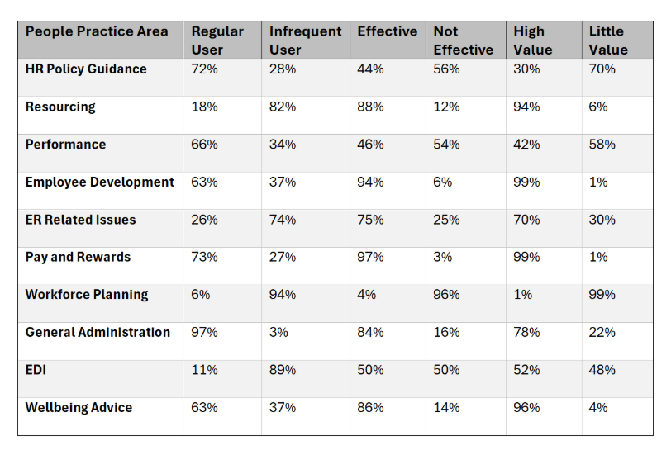
The data in figure 1 below highlights significant variation in the usage of people practice functions. The most frequently people function usage is for General Administration (97%), Pay and Rewards (73%), and HR Policy Guidance (72%). In contrast, the are high percentages of infrequent usage for Workforce Planning (94%), EDI (89%), and Resourcing (82%).
Figure 1:

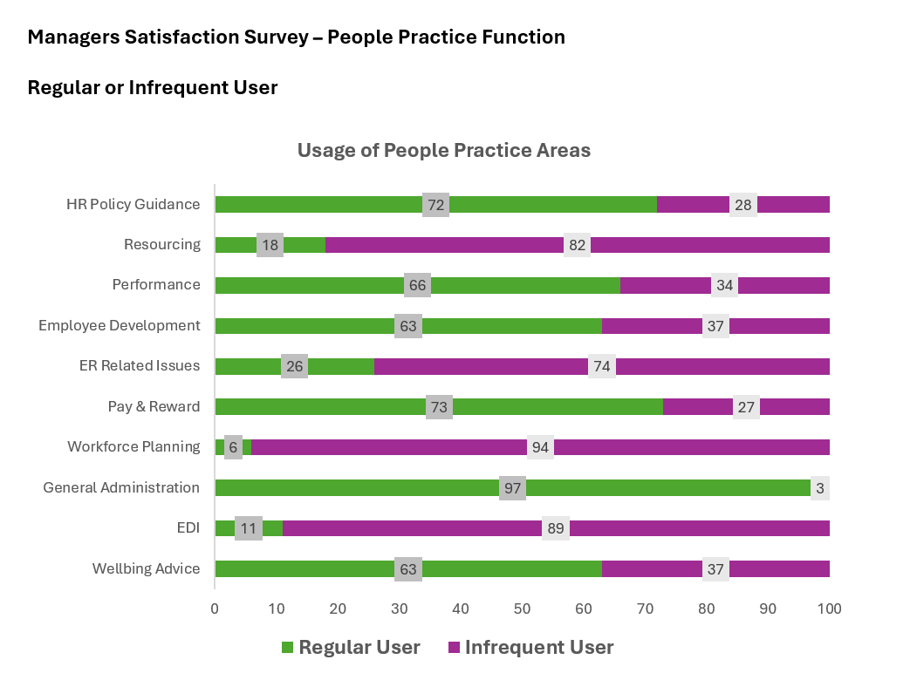
The area that are viewed most effective are Pay and Rewards (97%), Employee Development (94%), and Resourcing (88%) as highlighted in figure 2. These functions are also rated as having high value, with Employee Development and Pay and Rewards both receiving 99% high-value ratings, Resourcing 94% (figure 3). Conversely, Workforce Planning stands out as an area that has limited effectiveness (96%) and perceived largely as having little value 99% by managers, as highlighted in figure 2 and 3. In addition, figure 2 and 3 highlight that HR Policy and Guidance and Performance Management are areas that are used to some extent by managers, but again their effectiveness and values is relatively low. (56%, 54% ineffective, 70% & 58% little value).
Figure 2:

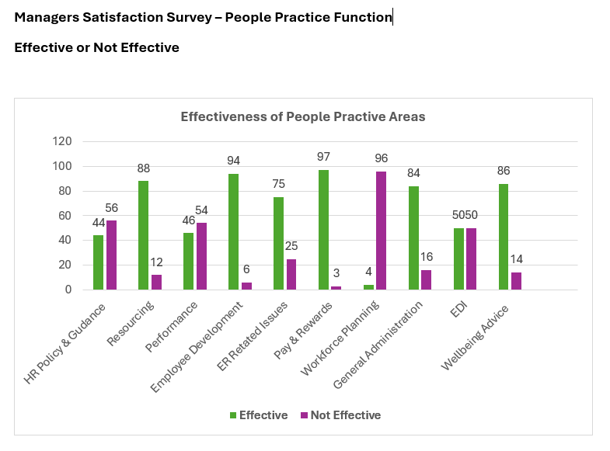
Figure 3:
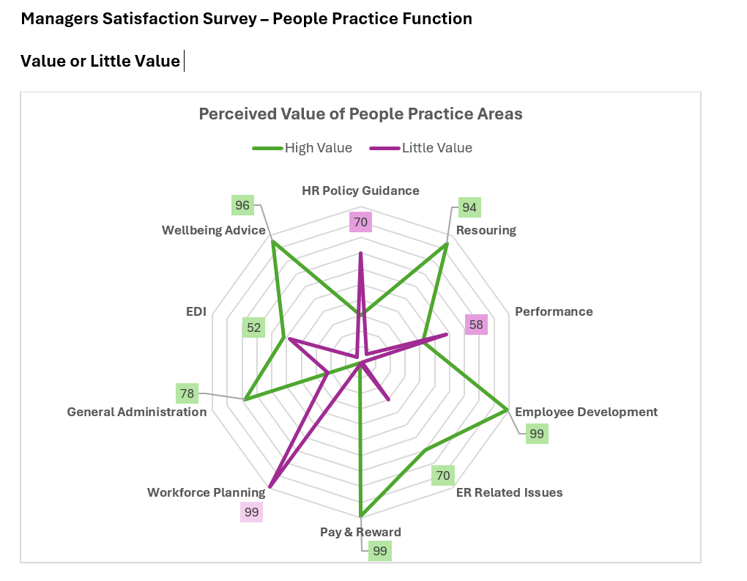
Recommendations
The data shows employee development has high effectiveness (94%) and high value (99%), indicating strong support for learning and development initiatives. However, high employee development alongside low workforce planning suggests managers are effective at improving skills but less effective at forecasting workforce needs. This creates a risk that employees are developed in areas that may not align with future organisational requirements, leading to unnecessary recruitment costs and a lower return on training investment. Employee development should be aligned with workforce planning to support long-term succession planning and future skill requirements.
The data shows employee development has high effectiveness (94%) and value (99%), indicating strong support for learning and development. However, high employee development alongside low workforce planning suggests managers are effective at improving skills but less effective at forecasting workforce needs. This risks developing employees in areas that may not align with future organisational requirements, leading to unnecessary recruitment costs and a lower return on training investment. Employee development should be aligned with workforce planning to support future skill requirements and succession planning.
AC 2.2 Present Key Findings
Management focus group findingg from 15 Section Leaders | 1 | 2 | 3 | 4 | 5
The ratings show represents statements on a scale of 1-5 where:
1 = fully agree, 2 = agree 3 = not sure 4 = disagree 5 = strongly disagree

The people practice team are helpful and provide me with supportive advice on employee matters. | 80% | 7% | 0 | 13% | 0
I’m not sure of the role and purpose of the People Practice team. | 7% | 7% | 0 | 26% | 60%
They provide me with administrative support | 40% | 20% | 7% | 33% | 0
I’m better at handling people related issues as a result of People Practice guidance. | 20% | 40% | 26% | 7% | 7%
The People Practice Team are legal experts. | 33% | 40% | 7% | 20% | 0
I’m confident in handling People related issues without help. | 46% | 0 | 0 | 46% | 8%
They support development of our employees. | 40% | 33% | 0 | 27% | 0
People professionals don’t understand the business. | 13% | 46% | 27% | 7% | 7%
People professionals provide resourcing nad onboarding of new employees. | 40% | 47% | 13% | 0 | 0
I know where to find people related policies and procedures on our system. | 7% | 26% | 0 | 60% | 7%

From the data managers value the People Practice team and trust their expertise as highlighted below:
- People Practice provides helpful and supportive advice (87% fully agree/agree).
- People Practice supports employee development (73% fully agree/agree).
However, many managers appear to lack the confidence or knowledge to manage routine people matters themselves. As a result, it would seem people practice is being used as a first point of contact for operational and administrative issues.
- 54% are not confident handling people issues independently.
- 60% view People Practice as providing administrative support.
- Only 34% know where to find people policies and procedures.
The findings suggest a potential gap in managers' understanding and use of people practioners. This could lead to inconsistent decision-making and compliance risk. Furthermore, opportunities to use policies and procedures as tools to support broader business objectives and organisational challenges are not being fully utlised.
AC 2.3 Recommendations
According to the CIPD, line managers are responsible for leading day-to-day operations while also managing people. They are instrumental in implementing organisational policies and developing their teams. (CIPD, 2025). Training managers on how to confidentaly use policy guidance and embedding into routine tasks would be recommended to help reinforce awareness and use so that managers fully understand how policy can be applied.
If managers continue to rely on people practice for everyday matters, it presents financial risk and operational inefficiencies, reducing HR capacity to focus on higher-value strategic activities. Implementing the AMO (Ability, Motivation, Opportunity) model will help HR support managers to use people practices effectively. In addition, enhancing line managers’ ability through toolkits, guides and training, ongoing motivational support and case studies, and opportunities through searchable platforms to provide easy access to policies improving awareness and consistency (CIPD, 2017).
A further observation is that 60% of managers agree that ‘people professionals don't understand the business’. Managers are not seeing the value or using HR as strategic partners, who can support operational business pressures and needs and/or being able to assist with overarching employee related challenges.
The lack of effective business partnering could result in reduced efficiency, poor use of managers and HR time and costs associated with poor workforce decisions as well as impacting organisational effectiveness and competitiveness over time.
Creating people practice business partners would be benficial to reduce reliance on HR for transactional tasks and being available to support strategic organsiational development. Where line managers can develop solutions to HR issues together with their HR business partner with more alignment to business strategy. (CIPD, 2025). Developing people practice business partners would reduce reliance on HR for transactional tasks and strengthen strategic organisational support. Business partnering enables people professionals to work closely with managers to align HR solutions with business strategy (CIPD, 2025). This ongoing relationship supports better long-term solutions and improves impact on strategic business objectives.

Bibliography
BiteSize Learning (2026) The SWOT analysis, explained. Available at: The SWOT Analysis, Explained + Examples & Templates — BiteSize Learning (Accessed 14th June 2026).
Barends, E., Rousseau, D.M. and Briner, R.B. (2014) Evidence-Based Management: The Basic Principles. Amsterdam: Centre for Evidence-Based Management. Available at: CEBMa PDF (Accessed: 17th May 2026).
Briner R. (2024) What is evidence based HR and why is it important?. Podcast. Available at: WHAT IS EVIDENCE BASED HR AND WHY IS IT IMPORTANT? (Interview with Rob Briner) (Accessed 22nd May 2026).
Brougham-Chandler, A. (2023) What is a PESTLE analysis and why is it important to HR. Available at: What is a PESTLE analysis and why is it important to HR? (Accessed: 16th May 2026.
Browes, E. (2021) Masterclass: How to use pulse surveys effectively: People Management CIPD. Available at: https://www.peoplemanagement.co.uk/article/1741217/masterclass-how-to-use-pulse-surveys-effectively (Accessed 16th May 2026).
Burke, E. (2016) Why organisations need to up their game on understanding, measuring and leveraging human capital. Available at: people-and-the-creation-of-value_tcm18-19955.pdf (Accessed 16th June 2026).
Chermack, T.J. and Kasshanna B.K. (2007) The Use and Misuse of SWOT Analysis and Implications for HRD Professionals: Human Resource Development International. Available at: The Use and Misuse of SWOT for HRD Professionals Pdf (Accessed: 20th May).
CIPD (2024) Benchmarking employee turnover: What are the latest trends. Available at: Benchmarking employee turnover: What are the latest trends and insights? | CIPD. (Accessed June 14th 2026).
CIPD (2023) Building an evidence-based people profession. Available at: Building an evidence-based people profession | CIPD (Accessed 22nd May 2026).
CIPD (2026) Discrimination in the workplace. Available at Discrimination in the workplace | CIPD (Assessed 6th June 2026).
CIPD (2025) Employee engagement and motivation. Available at: Employee Engagement & Motivation | Factsheets | CIPD
CIPD Employment Law. Available at: Employment law | CIPD (Assessed 6th June 2026).
CIPS Employee turnover and retention. Available at: Employee turnover and retention | Factsheets | CIPD (Assessed 14th June 2026).
CIPD (2025) Employment Rights Act 2025: A Complete Breakdown. Available at: https://www.hr-inform.co.uk/employment-rights-act/breakdown, (Assessed 6th June 2026).
CIPD (2025) Employee voice channels: Guide for people professionals. Available at: https://www.cipd.org/uk/knowledge/guides/employee-voice-channels-guide-for-people-professionals/ (Accessed: 16th May 2026).
CIPD (2024) Ethics at work: An employer’s guide. Available at Ethics at work: An employer’s guide | CIPD (Assessed 20th May 2026).
CIPD (2025) Ethical decision-making: Eight perspectives on workplace dilemmas. Available at: ethical-decision-making-2015-eight-perspectives-on-workplace-dilemmas_tcm29-9564.pdf (Assessed 24th May 2026).
CIPD (2025) Ethical practice and the role of people professionals. Available at: Ethical practice and the role of people professionals | Factsheets | CIPD (Accessed 30th May 2026).
CIPD (2025) Evidence-based practice for effective decision-making. Available at: Evidence-based practice for effective decision-making | Factsheets | CIPD (Accessed: 14th May 2026).
CIPD HR Inform Equality | CIPD HR-inform (Assessed 30th May 206).
CIPD (2025) Line Managers Role in Supporting the People Profession. Available at: Line Managers' Role in Supporting the People Profession | Factsheets | CIPD (Assessed 17th June 2026)
CIPD (2017) HR and line managers – getting the relationship right. Available at: HR and line managers – getting the relationship right | CIPD (Assessed 17th June 2026)
CIPD (2026) Performance Management: An introduction. Available at: Performance Management | Factsheets | CIPD. (Accessed 14th June 2026).
CIPD (2024) Professional Map. Available at: The Profession Map | CIPD
CIPD (2025) The psychological contract. Available at: Psychological Contract | CIPD (Accessed 14th June 2026).
CIPD (2026) SWOT analysis. Available at: SWOT analysis | Factsheets | CIPD (Accessed: 16th May 2026).
CMI, (2015) Rational Decision Making: Kepner and Tregoe’s Model. Available at: Rational_decision_making.pdf (Accessed 30th May 2026).
Coburn (2019) Podcast 154: Critical Thinking. Podcast. Available at: Podcast 154: Critical Thinking - CIPD | Podcast on Spotify (Accessed 24th May 2026).
CPD Certification Service (2022) How to develop critical thinking skills. Available at: How to develop critical thinking skills (Accessed 23rd May 2026).
Denny, K. (2014) How to Measure ROI & ROE. Available at: How To Measure ROI & ROE In People Managing | Resources (Accessed 14th June 2026).
Gifford, J. (2026) Changing trends in Performance Management. Available at: Changing trends in performance management (Accessed 14th June 2026).
Hidden Door Experiences (2022) Leadership: Six Hats Model. Available at: Leadership: Six Thinking Hats Model (Assessed 15th June 2026).
HakemZadeh, F. and Rousseau D.M (2024) Evidence-based decision-making is a social endeavor: Sage Journals. Available at: https://journals.sagepub.com/doi/10.1177/23794607241265206 (Accessed 24th May 2026).
Halls, D. (2023) Unveiling Edward De Bono’s Six Thinking Hats: A Strategic Approach to Thinking: The People Development Magazine. Available at: Edward De Bono's Six Thinking Hats For Strategic Thinking (Accessed: 24th May).
Holbeche, L. and Matthews, G. (2012) Engaged: Unleashing Your Organization's Potential Through Employee Engagement. San Francisco: Jossey-Bass.
HR Fraternity (2026) Unveiling the Power of Triangulation: A Key Strategy for Precision and Accuracy. Available at: https://hrfraternity.com/education-excellence/unveiling-the-power-of-triangulation-a-key-strategy-for-precision-and-accuracy.html (Accessed 24th May 2026).
Klikauer, T. (2014) Morality 5: HRM and Utilitarianism. In: Seven Moralities of Human Resource Management. Palgrave Macmillan, London. Available at: Morality 5: HRM and Utilitarianism | Springer Nature Link (Accessed 30th May 2026).
McCartney, C. (2025) Thought Leadership | Evidence-based HRM: Navigating evidence for creating effective HR practices. Available at: Evidence-Based HRM: Navigating evidence for creating effective HR practices | CIPD (Accessed 30th May 2026).
Norwich University of the Arts, (2026) Critical Thinking. Available at: Critical thinking - Norwich (Accessed 10th June 2026).
Overton, L. (2021) Evidence-Based Practice in Learning and Development. Podcast. Available at: https://www.cipd.org/uk/knowledge/podcasts/ld-why-does-evidence-matter/ (Accessed: May 2026)
Shukla, A. (2025) The Power of Strength-Based Appraisals in Performance Reviews. Available at: (5) The Power of Strength-Based Appraisals in Performance Reviews | LinkedIn (Accessed: 14th June 2026).
SlideSalad (2026) Kepner-Trego Slide. Available at: Kepner-Tregoe Method Google Slides Template - SlideSalad (Accessed 15th June 2026).
Stobiersk, T. (2020) 13 Financial Performance Measures Managers Should Monitor. Available at: 13 Financial Performance Measures Managers Should Monitor (Accessed: 12th June 2026)
Taylor, S. and Woodhams, C. (eds.) (2022) Studying Human Resource Management: A Guide to the Study, Context and Practice of HR. 3rd edn. London: CIPD Kogan Page.
Testlify (2025) Implicit vs explcit bias: Difference and impact in the workplace. Available at: Implicit vs explicit bias: Difference & impact in workplace. Assessed (14th June 2026).
Thomas, J. (2026) Evidence-based practice in HR. Lecture slides. 5C002: Evidence Based Practice. University of Wales, Trinity St David, 29th April.
Thrive Sparrow (2026) Impact on Return of Experience on Employee Satisfaction. Available at: Impact of Return on Experience on Employee Satisfaction. (Accessed June 14th 2026).

