Module Name and Code:Employablity &Career Development (LCLM4005)
Assignment Title: Mock Interview
Lecture Name: Ibrahim Rufai
Student ID:2525170



Job Advert:

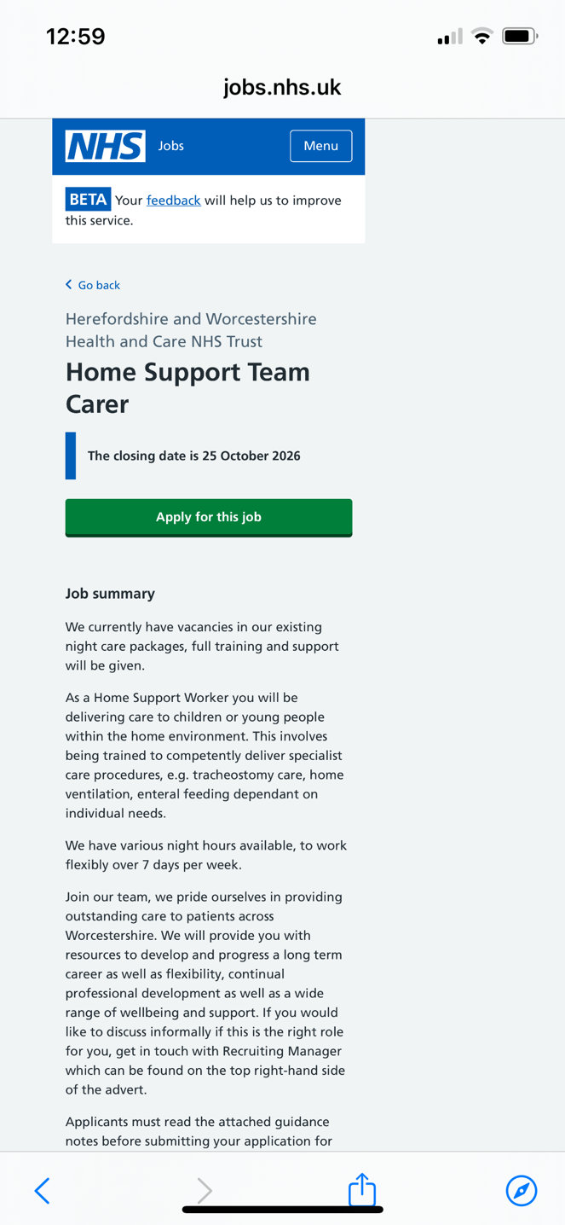
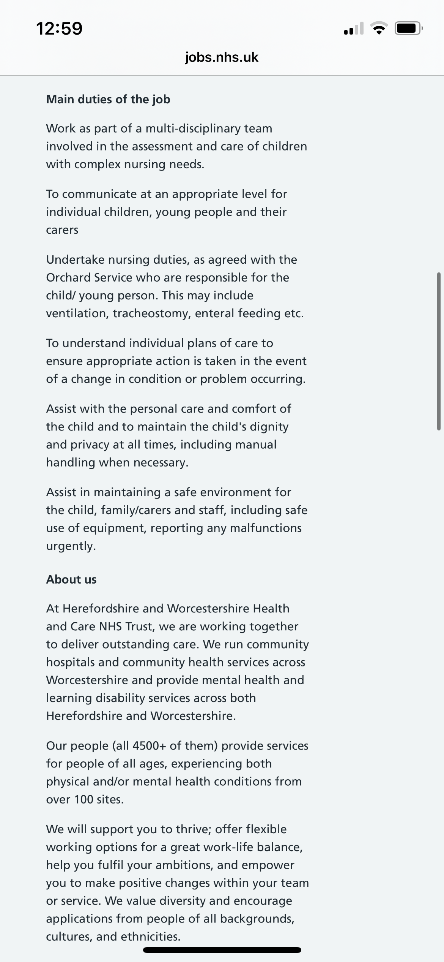

CV:
Aliya Razzaq Bi
Birmingham
bialiya19@gmail.com
07713833439
PERSONAL STATEMENT

As I have completed my health and social care boot camp I am looking for opportunities within the healthcare setting,where I can bring reliability,compassion and a strong work ethic. I am committed to safeguarding patients. I have learned the role of healthcare assistance and what it takes to get the role, by being punctual, active listening, learning the care certificate thoroughly, by having confidence in group discussions and filling documents out accurately. I am comfortable with Microsoft Office and the skills throughout it. My goal is to complete the care certificate in healthcare, by continuously learning,having a positive attitude and being a supportive team member. Some skills that I have been using within healthcare are teamwork by having group discussion, communication, helping others out, problem solving by figuring out what could be done and how to solve problems with patience. I show a sense of resilience in time management as being organised this allows me to get the job done in limited a time frame

KEY SKILLS :
- Communication: Speaking confidently, in presenting in front of audiences, speaking to new people.
- Teamwork Going into breakout room for discussions regarding real life case studies and listening to other thoughts regarding this.ive done group presentation where i was the leader of the group, and rebuild those ideas as one.
- IT skills: Developing different IT skills is a must in making presentations and the simple shortcut to get jobs done quickly, like word skills.
- Collaboration: Dropping down ideas,explaining why you think this important.
- Organisation: Keeping all notes in one place, so it's easier to study them better and keeping a well-kept manner while working in the workplace.
- Safeguarding: looking out for your surroundings, and observing what may be around them.
- Punctual: Always being on time to any training or studying
- Health and safety: By being dedicated to what makes them safe in a way,if it comes to safeguarding ,food prep and how you treat a person.

EXPERIENCE:
Generation Health and Social Care Bootcamp Training, 10/11/2025 -05/10/2025, Birmingham.
- Learning something new about healthcare that I haven't learnt before, dementia,mental health, food and nutrition,
- Communicating with others
- Going over case studies in breakout rooms, by discussing and elaborating our thoughts and ideas in real life scenarios. (this shows teamwork skills)
- We got to experience real life situations online which includes, doing CPR,and choking situations and how fast you will react and what you will do.
- Going through interview practice/mock interviews within healthcare
- Going into depth in what makes a good CV and readjusting it.
- I did basic maths and English mock and L2, going through certain topic in the lesson.

WORK EXPERIENCE:
Little smarties academy, nursery, Birmingham, Date: July 2022
- I supervised children during outdoor playtime (ensuring their safety and enjoyment)
- I assisted in nappy change /feeding newborns around the ages of 3-4 months
- Food preparation/ clean up after duties after preparing children's food. (which links health and safety/fluid management skills)
- Helping staff members with various tasks like putting toys away ,books,and any kitchen cutlery which links to positive attitude and resilience.
- Moving equipment to maintain a safe environment.(which links to safeguarding skills )
- Alongside this I spoke about the children's initial development,as a whole and asked a question to the manager on how we can help them further.

Aspect Housing Association, Admin, Mosely, Date: Feb 2023
- I organised files ,alongside labelling filling which shows good attention to detail
- Contributing to team discussion and thinking critically on what can be done better
- Regularly checking if files where up to date
- Ensuring that information was current and accessible but hidden in right Word/Edexcel documents.
- Made sure timing and logbook were consistently updated regularly.
- Making sure that my desk was kept neat and tidy so it is much easier to access my paperwork easily.
- Making modules/audio

Providence First,Admin/Benefits,Jewellery Quarter, Date: Aug 2025
- I was responsible for different tasks like the benefits/admin side of things, which I had contributed to a good office environment.
- I filled out important tenants documents, sent out emails and letters to customers/post offices
- Filling out every detail without mistake and asking colleagues feedback/questions.
- Labelling and putting files together, checking if each and every file is up to date.
- Making HB calls regarding confidential info that may have been missing (catching up on this everyday).
- Speaking to tenants and filling out their tenancy agreement and sending those documents to the HR department to verify these details and send them out the same day for house viewing.
- Ensuring that my desk was kept neat and tidy so it is much easier to access my paperwork easily. same with online documents in the correct files to send email faster.

EDUCATION AND CERTIFICATIONS
University of Wales trinity Saint David: Birmingham,25/26
Level 4 CertHE business skills for the work placement-current

Matthew Boulton College: Birmingham, 2023-2025
BTEC level 3 business Administration
BTEC level 2 business in Marketing: Merit and Finance: Pass

King Edward VI Handsworth Wood Girl Academy,Birmingham, 2018-2023
GCSE English Literature: Grade 4
GCSE’s in English,maths ,science,religious studies ,child development,design& tech and geography at a 3.

INTERESTS:
I love to do gardening with that having fresh food i love cooking,I have an passion for Henna art as its something i enjoy and hope it will make an impact for me in the future, this artistic side extends to painting and sketching,also love bike riding and horse riding,hairstyling for other,along side having a balance between my creative pursuits and other interest, i have recently started a small business called:Henna Fusion.
References Available
© 2025 Generation: You Employed, Inc.

Cover Letter:
Healthcare Assistant:
Aliya Razzaq Bi
Birmingham
bialiya19@gmail.com
07713 833 439

Date: 15 October 2026
Home support team carer/ NHS Trust / Healthcare Provider

Prince of wales community hospital
Stourbridge road
Bromsgrove
B61 0BB
United kingdom

RE: Application for Healthcare Assistant Position

Dear Hiring Manager,

I am writing to express my strong interest in the Healthcare Assistant role, as advertised. With a completed Health and Social Care Bootcamp, practical experience in care and support settings, and a commitment to compassionate, safe care, I believe I have the skills and dedication to be a valuable member of your team.

Through my training with Generation UK, I gained knowledge of dementia care, mental health awareness, nutrition, health and safety, and safeguarding. I have practiced essential care skills including emergency response (CPR and choking procedures), accurate documentation, and person-centred care, and I am working towards completing the full Care Certificate. I am confident in communicating with patients, families, and colleagues, whether in one-to-one conversations or group settings, and I am comfortable using Microsoft Office to maintain clear, accurate records.

My practical experience includes working at Little Smarties Academy Nursery, where I supervised children’s safety during activities, assisted with personal care and feeding, supported food preparation, and helped maintain a safe, organised environment. I have also held administrative roles at Aspect Housing Association and Providence First, where I developed strong organisation, attention to detail, and time management skills — ensuring files were up to date, confidential information was handled correctly, and tasks were completed efficiently within set timeframes. These roles taught me how to work well in a team, follow procedures, and remain calm and helpful under pressure.

I am reliable, punctual, and resilient, with a positive attitude and a strong focus on safeguarding and patient wellbeing. I enjoy working as part of a supportive team, learning new skills, and making a positive difference to people’s daily lives. Outside of work, I enjoy creative activities, gardening, and outdoor pursuits such as cycling and horse riding — hobbies that help me stay active, patient, and empathetic.

I am eager to bring my compassion, work ethic, and willingness to learn to your organisation. I am available for an interview at your convenience and would welcome the chance to discuss how I can contribute to your care team.

Thank you for considering my application.

Yours sincerely,

Aliya Razzaq Bi

